

Skills for the Workplace
Module Assignment Submission
Student Name: | Sione Mitchell
Student Number: | 1911100
Module No: | BMSK4002
Module Title: | Effective Team Working and Communication  Part 1

Statement of Confirmation of Authenticity
By the act of making this submission, the student declares that this is the work of the student named above. The work has not, in whole or in part, been knowingly presented elsewhere for assessment, or where assessment has been built on a previous assessment, this has been identified. Where materials have been used from other sources it has been properly acknowledged. If this statement is untrue, the student acknowledges that an assessment offence has been committed.
Attention is drawn to the plagiarism and unfair practice policies of both the University and of ILM.

Contents
Introduction 2
Aims and objectives 3
Evaluation of presentation and feedback 3
Conclusion 4
Presentation Content 5
Appendix A 6
Feedback from Viewers 6
Appendix B 7
Accompanying handout 7
Appendix C 9
WhatsApp screen shot 9
References 10

Introduction
Today I am going to be reflecting upon my presentation on Effective team working. I will be looking at how I executed all aspects of the presentation whilst baring in mind the recent circumstances that have arisen at this time so have had to change the delivery and dynamics as I have had to execute it alone rather than in a group.

Aims and objectives
The aim of the presentation is to look at what a group is and what a team is and once these have been identified we looked at the differences between them both. By doing this we were then able to clearly differentiate between groups and teams.
Then we will be looked at effective and ineffective teams and how a study by Katzenbach and Smith identified the flowing traits are necessary to have an effective team.
To have a reasonably sized team in order to have all the knowledge and skills necessary. But if the team is too large it will likely become dysfunctional.
The skills and knowledge possessed by the team should complement rather than replicate those of other team members.
Team members should be committed to the teams aims, be willing to make sacrifices for the team to reach an end goal.
A lack of clarity could lead to frustrations, so goals need to be specific so the team can work cohesively.
The team needs to agree about how it will achieve their goals. Without agreement the team is likely to suffer.
The team has a sense of togetherness with each member supporting every member to trust and rely on each other and act as one regardless of the result.
By knowing this teams are more likely to able to thrive and be more productive.
Then I went on to show Bruce Tuckman’s theory of forming, storming, norming, performing and adjourning and explained the characteristics of each of these stages. By knowing this model teams are able to see what stage they are at and it gives them the motivation to better and develop and progress onto the next stage so they are at their most productive and thrive as a team.
I then went on to show Dr Meredith Belbin and his ' Belbin Team Roles' theory. Belbin believes that each team needs access to each of the nine Belbin Team Role behaviours to become a high performing team. Each Belbin Team Role has strengths and weaknesses, and each Team Role has equal importance. Another important factor when forming an effective team, to utilise people’s key skills and make an effective team. You can take a questionnaire to identify what roles are best suited to yourself (Link in appendices).
I then concluded the presentation and had allocated time for questions.

Evaluation of presentation and feedback

I am looking at the feedback form I have received from my peers (Appendix A) and I have had outstanding feedback from all. I do not think this would have been possible without the support of my team.
I have been given a 5 out of 5 for the first impression given – Even though this is high I feel I should have slowed down my opening and not spoke so quickly. But I did manage to slow down and get my breathing better to ensure everyone could hear me and take in the information I was giving.
Then there was confidence, I feel my voice was a slightly shaky at times and I just needed to remember to take a moment and breathe and take my time.
Then my body language, this I felt was a difficult one to see as I was delivering from home and only with a laptop and no mouse so I had to sit quite close to the screen so it was very difficult for anyone to see my body. If I were able to perform in front of a group in person this would have been more readable. I would make sure I had an open and friendly posture without fiddling with anything in my hands or hair. Not have arms crossed and open hands.
Then there is my tone of voice. I have already mentioned above that my voice was shaking due to nerves but once I took a moment to breathe and relax, I felt this soon improved. The only way I think this would get better is by practicing in front of people and really getting comfortable talking in front of crowds.
Communication is my next point; I think I clearly outlined all my points and delivered them in an understandable manner. I feel I was direct and clear in what I was saying.
My eye contact was probably not my strongest point, as I was reading from a sheet occasionally and where I was delivering on a laptop and had my glasses on it made it very difficult to see my eyes. To improve on this in the future I need to trust in my memory more and not have the paper as a safety net as I knew what I was saying but needed that extra bit of confidence to go on and deliver the presentation without the notes.
All my feedback agreed that the slides I presented reflected the verbal message I was giving. Also, that the handout I gave to accompany the presentation supported the slides too (Appendix B).
My team members also all agreed that they did learn more on the topic of effective teams.

Conclusion

On reflection of the presentation and especially because of the current circumstances we are under I am very happy and proud to be part of such a strong and well-functioning team.
Overall I think my reviews were very good considering that this is the first presentation I have ever delivered and that even though things have had to change with the delivery we have also worked very well as a team through communication via WhatsApp (Appendix C), Microsoft teams and E-mail. I also think none of us would have been as successful putting together these presentations if it wasn’t for out tutor Bethlyn, she has sacrificed her home time by delivering us extra sessions and helping us unite and become a team. Without her guidance through these testing times I would have personally felt lost with the strain of at home learning.
I also felt I was prepared for the questions at the end and managed to answer them effectively, especially doing my research on Shannon and weaver, David Berlo and Lasswell’s communication model.

Presentation Content

Slide | Content | Time
1 | Presentation Title | 20 seconds
2 | Introduction | 30 seconds
3 | What is a group and what is a team? | 30 seconds
4 | Differences between groups and teams | 40 seconds
5 | Effective and ineffective teams | 30 seconds
6 | Elements of an effective team | 1 minutes 10 seconds
7 | Tuckman’s theory | 30 seconds
8 | Forming | 50 seconds
9 | Storming | 30 seconds
10 | Norming | 30 seconds
11 | Performing | 30 seconds
12 | Adjourning | 20 seconds
13 | Belbin’s team roles | 40 seconds
14 | Conclusion | 30 seconds
15 | References | 15 seconds
16 | Questions | 2 minutes

Appendix A

Feedback from Viewers
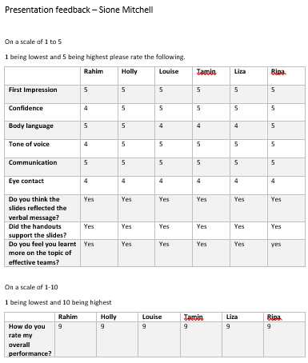

Appendix B

Accompanying handout
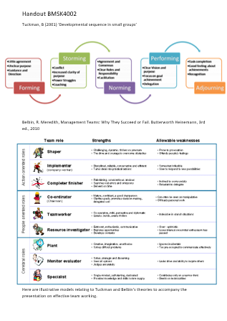
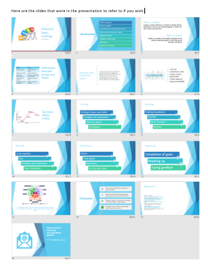

Appendix C

WhatsApp screen shot
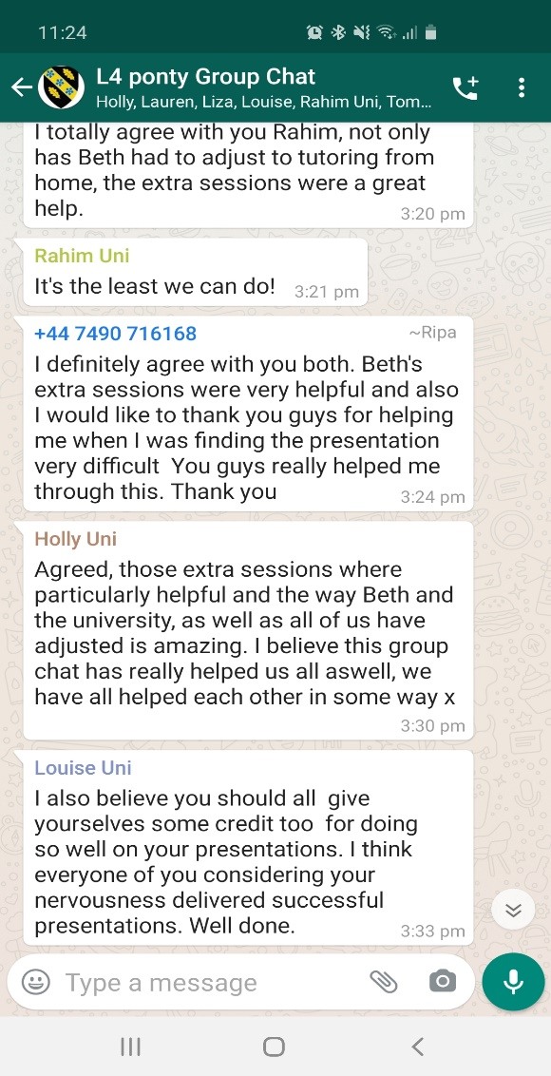

References
Belbin, m. Available at : https://www.belbin.com/about/belbin-team-roles/
Berlo, D (1960) Available at: https://www.businesstopia.net/communication/berlo-model-communication
Kazenback and Smith(1993) Available at: https://www.teambuildingportal.com/articles/effective-teams/qualities-high-performance-teams
Lasswell (1948) Available at : https://www.businesstopia.net/communication/lasswell-communication-model
McGregor (2013) Available at: https://www.eventus.co.uk/effective-vs-ineffective-teams/
Morgan, P (2017) The business students guide to study and employability. Thousand oaks, Sage.
Online Available at: https://agilescrumguide.com/blog/files/Use-Tuckmans-Model-of-Team-Dynamics.html
Tuckman, B (2001) ‘Developmental sequence in small groups’ Group facilitation.
Weaver, S. Available at: https://www.communicationtheory.org/shannon-and-weaver-model-of-communication/

