Module Name: Independent Project
Module Code: LCLM6005
Research Title: The impact of workplace conditions on staff retention: a qualitative study of Hilton Hotels
Dissertation Document
Student Name: Diana Maria Duma
Student ID: 2316296

Acknowledgement
First and foremost, I would like to express my deepest gratitude to my supervisor Dr. Jane Wang for the invaluable guidance, patience, and insightful feedback throughout this research process. I would also like to extend my sincere appreciation to the faculty and staff for equipping me with the analytical tools and academic support required to undertake this study. Finally, I am profoundly grateful to my family and friends. Their endless encouragement, understanding, and emotional support have been my driving force throughout my academic journey and the completion of this research.

Abstract
In the research, the researcher found that workplace conditions significantly drive staff retention at Hilton Hotels by shaping employee satisfaction, morale, and daily engagement. Key factors include physical workspace quality, human-centred leadership, and targeted development programs has also been discussed in this assessment. The literature review chapter has highlighted that flexible working arrangements, career development initiatives, and employee well-being programs can help to improve the workplace conditions of UK-based hotels and enhance employee retention levels. A theoretical framework has also been included, in which the planned behaviour and Herzberg’s Two-Factor Theory have been mentioned. A conceptual framework has also been highlighted to understand the key points which have been included in the literature review. Chapter three highlights the research methodology used by the investigator for gathering the relevant data and information based on the topic. Saunders’ Research Onion has been referred to by the investigator for accumulating the relevant pieces of information based on the research topic. Research Approach, philosophy, and both the research design and strategy have been highlighted in this chapter. A survey was conducted, and answers from 20 workers at the Hilton Hotel were collected to gather primary quantitative results. Through this activity, the opinions of the hotel staff, their perspectives on various matters, their suggestions for addressing issues, and others were collected. The thematic analysis has been conducted in the context of Hilton workplaces, where careful evaluation has been made regarding employee turnover and retention. Hilton uses employee well-being programs and training modules to build a resilient workforce, but operating globally, several challenges hinder the workforce. The interview section has covered the opinions of interviewees about the factors of staff retention in the Hilton Hotel. Having followed a structured interview, work-life balance and financial opportunities have been demonstrated as the major concerns of the staff. Chapter Five of the dissertation concludes the entire research analysis which has been conducted in this study. Recommended strategies, such as providing perks and financial wellness programs, organising training and career development programs and others, have been provided for Hilton Hotels to improve the retention rate. A section on the limitations of the research has also been highlighted in this particular chapter. It can be discussed that the secondary quantitative research method can be considered to be one of the methods through which the investigator can conduct this research in the future.

Table of Contents
Chapter One: Introduction 6
1.1 Introduction 6
1.2 Research Background 6
1.3 Problem Statement 6
1.4 Research Aim, Objectives, and Questions 7
1.5 Research Rationale 7
1.6 Research Significance 7
1.7 Conclusion 8
Chapter Two: Literature Review 9
2.1 Introduction 9
2.2 To explore the main factors of workplace conditions affecting staff retention at hotel companies in the UK 9
2.3 To understand the link between workplace contribution and staff retention on business performance within hotel companies in the UK 10
2.4 Effective strategies for enhancing workplace conditions that can improve staff retention in the UK hotel industry 11
2.5 Theoretical Framework 12
2.6 Conceptual Framework 13
2.7 Research gap 13
2.8 Conclusion 14
Chapter Three: Research Methodology 15
3.1 Introduction 15
3.2 Methodological Framework: Application of Onion Model 15
3.3 Research Philosophy 15
3.4 Research Approach 16
3.5 Research Strategies and Design 16
3.6 Research Method 16
3.7 Time horizon 16
3.8 Data Collection Tools 17
3.9 Analytical Techniques and Procedures 17
3.10 Sampling Techniques 17
3.11 Ethical Issues 17
3.12 Conclusion 17
Chapter Four: Analysis and Findings 19
4.1 Introduction 19
4.2 Secondary Thematic 19
4.3 Primary Survey 23
4.4 Primary Interview 28
4.5 Discussion 31
4.6 Conclusion 33
Chapter Five: Recommendations, Conclusion and limitations of the research 34
5.1 Introduction 34
5.2 Summary of the dissertation 34
5.3 Limitations of this research and suggestions for further research 35
5.4 Practical recommendations 35
5.5 Contribution of the study 36
5.6 Conclusion 36
References 37
Appendix 41
Appendix-Primary Survey 41
Appendix-Primary Interview 44

Chapter One: Introduction

1.1 Introduction
Within the introduction chapter, the researchers are known to lay the foundation for the dissertation with the presentation of the research topic and the specific problem being addressed, and an overview of the study’s structure. This chapter follows an hourglass model, starting with a broad general context and later narrowing it down to the specific research gaps, then further expanding outward to show the overall significance. The chapter first identifies the specific issue or tension and then moves towards explaining the real reason this research matters the most. Within this study, the scope is discussed within the section of research rationale and further allocated with a developed research base associating boundary.

1.2 Research Background
Workplace conditions are heavily influenced by the context of employee retention, as poor environments are seen to drive burnout and high turnover rates. The major players like Hilton are seen to achieve a 93% employee engagement rate and low turnover by leveraging targeted well-being platforms and flexible pay (Kellerman and Seligman, 2023). Qualitative research is vital when it comes to capturing the way how daily workplace realities are known to shape staff decisions to stay. Alongside that, the consideration of qualitative intervention has also been executed with this research. The hospitality sector is known to typically suffer from severe turnover due to physical demands and stress (Kellerman and Seligman, 2023). In this industry, it is clearly seen that up to 82% of the modern service staff face potential burnout without active support (Andersen et al., 2025). The strategic approach considered by the brand is a dedicated mental wellness and support program aimed at personal goal setting.

1.3 Problem Statement
While the food and accommodation industry faces steep attrition, Hilton Worldwide maintain a high employee engagement rate of 93% and a turnover rate roughly half the industry average through programs (Harrison et al., 2022). However, the localised variations in physical work environments allow scheduling flexibility, emotional labour, and shift demands to continue to threaten team member stability at individual properties (Harrison et al., 2022). At present, the current shift considers a specific issue, which happens while corporate-level wellness and travel perks exist. However, it remains unclear through firsthand staff accounts how the daily frontline workplace is known to directly drive or inhibit long-term staff loyalty and retention at specific locations. Therefore, the execution of qualitative aspects is considered in order to explore the lived experiences of Hilton all around the world (Harrison et al., 2022). Considering that, this associates a significant influence element with continuous staff retention and operational efficiency with ongoing service quality.

1.4 Research Aim, Objectives, and Questions
Research Aim
To explore the main factors in workplace conditions that affect staff retention at Hilton Hotels.
To understand the link between workplace contribution and staff retention on business performance.
To identify effective strategies enhancing workplace conditions that can improve staff retention.
Research Objectives
To review existing literature on workplace conditions for staff retention and its impact on the hospitality industry.
To gather views from Hilton staff and managers on workplace conditions for staff retention and performance.
To analyse the strategies considered by Hilton to enhance workplace conditions which can improve staff retention.
Research Questions
What are the main factors in workplace conditions that affect staff retention at Hilton Hotels?
What is the link between workplace contribution and staff retention on business performance?
What effective strategies can enhance workplace conditions that can improve staff retention?

1.5 Research Rationale
The research rationale for the topic was selected to address the high turnover rates within the hospitality sector through the examination of physical and psychological work environments, employee well-being, and retention drivers at Hilton Hotels. As per the available data, the hospitality sector is known to traditionally battle high employee turnover and burnout. Hilton maintains an engagement rate of about 93% and a turnover rate roughly half the industry average (Derowitsch et al., 2025). Investigating Hilton through a qualitative lens uncovers the lived experiences behind these numerical benchmarks. Especially when it comes to understanding how the physical work environments and mental health platforms such as “Thrive at Hilton” and daily pay access influence loyalty. With this research, the researcher has explored subjective perceptions of staff members, which bridges the gap between generalised human resource theory and practical hotel management.

1.6 Research Significance
The research has been associated with the impact of workplace conditions on staff retention at Hilton Hotel, which is a significant issue as it allows highlighting human-centred leadership. This allows mitigating high hospitality turnover costs and provides actionable benchmarks, with data indicating that hat 97% of employees at Hilton consider it a great place to work (Derowitsch et al., 2025). However, a vast majority, which is around 57%, are seen to average for typical U.S. companies (Derowitsch et al., 2025). This includes understanding these specific conditions, which offer a vital blueprint for organisational success (Derowitsch et al., 2025). The practical value of this research includes establishing why human-centred drivers and supportive management outperform traditional perks in fostering loyalty. The research also identifies the link between optimised physical environments, flexible scheduling, and minimised recruitment expenses.

1.7 Conclusion
This chapter summarises the main plot and goal while outlining the base of the remaining chapters, and transitions smoothly into the next part of the dissertation. This chapter has discussed the context of the topic, bridging the connection with the readily available research and the actual concept to focus on. The chapter concludes by summarising the high staff turnover in the hospitality sector and the critical link between poor workplace conditions and employee attrition. The study adopts a qualitative approach to examine these factors specifically within the Hilton Hotels setting the stage for the analysis.

Chapter Two: Literature Review

2.1 Introduction
The introduction of the literature review chapter helps in setting the stage by outlining the core themes of staff retention, workplace conditions, and the hospitality sector (Boamah et al., 2022). It covers the background of employee turnover in hotels, the specific focus on qualitative insights, and the chapter's roadmap. The purpose of this chapter is to show a distinct link between work environment and staff retention, with the execution of readily available information (Boamah et al., 2022). A theoretical context has been evaluated with exploration of work-life balance within the hospitality industry.

2.2 To explore the main factors of workplace conditions affecting staff retention at hotel companies in the UK
Retaining the best talent and skill is considered of great importance as it helps limit the need for numerous expensive procedures like selection, recruitment, or training and replacement. As stated in the study by Chatzoudes and Chatzoglou (2022), there are several sets of determinants of employee retention in European countries, which reveals a more holistic approach with the limitations in the broader picture.
Work-Life Balance and Hours
Erratic work schedules, high burnout, and personal life conflicts are seen to destroy work-life balance and hurt employee retention. Irregular shifts and long, unpredictable hours are known to create daily friction for staff members (Fritz, 2025). Thus, Çivilidağ and Durmaz (2024), argue that when physical and emotional demands pile up without the employees having the liberty to rest enough, then the workers are known to experience severe burnout. This exhaustion drives up turnover rates as employees leave for better conditions. Furthermore, when the job duties bleed into personal time, trust breaks down, and loyalty drops quickly, as per the stated understanding of Sealy et al. (2023). Thus, companies should, as the argument reported in the studies of Irfan et al. (2023), only 10% of issues are related to a lack of technical expertise. This shows that project performance can be associated in a more planned manner.
Compensation and Rewards
The hospitality industry is known to often face challenges regarding the low baseline wages compared to other sectors, and this makes the concept of compensation a critical factor in staff retention. In order to prevent employees from leaving for better-paying jobs, organisations must implement fair rewards, as per the knowledge base of Maslach and Leiter (2022). These strategies can include prospects like competitive pay rates and clear, transparent overtime compensation, which can be used to provide tangible resources and rewards. They can also offer valuable perks such as complimentary meals during shifts, exclusive travel discounts, or memberships to local gyms. As per the knowledge base of Reed and McGonagle (2026), this will allow the companies to have a significant boost in employee morale and loyalty. With the combination of solid base pay levels and attractive extra incentives, hospitality businesses can create a more appealing workplace, reducing high turnover rates, and keep their valued team members engaged and satisfied over the long-term.
Management and Culture
Supportive leadership, recognition and career growth are the three core pillars that shape employee retention and workplace culture, as per the knowledge base of Reed and McGonagle (2026). Poor supervisory styles and unsupportive managers actively drive negative job attitudes and higher attrition, making supportive leadership essential for team stability, as per the stated understanding of Sealy et al. (2023). In contrast, regular appreciation and the concept of being acknowledged by name make workers feel valued, which directly lowers their intent to quit, as per the understanding projected by Corbin and Flenady (2024). Additionally, considering the overall prospect, including clear paths to training, mentorship, and promotions, gives employees a compelling reason so that they can build a long-term future with the company rather than seeking opportunities elsewhere.

2.3 To understand the link between workplace contribution and staff retention on business performance within hotel companies in the UK
In the competitive UK hospitality sector, the aspect of retaining skilled staff prevents the prospect of the heavy financial drain of continuous recruitment, onboarding, and lost productivity. Experienced workers are seen to make fewer mistakes, require less supervision and build rapport with guests, which elevates satisfaction and brand loyalty, as per the stated understanding of Sealy et al. (2023). When hotels actively invest in positive workplace cultures, clear growth paths, and supportive management, they foster higher employee motivation. Concerning this stability, the businesses are able to translate this directly to smoother daily operations, reduced labour friction and superior overall business performance, as per the knowledge base of Guerola-Navarro et al. (2026).
Impact of Workplace Contribution on Performance
Workplace contribution has a powerful and direct impact on service quality, productivity, and consistency in the hospitality sector, as per the understanding view base of Guerola-Navarro et al. (2026). High employee engagement and task performance are known to instantly elevate guest experiences at both the front desk and in housekeeping, leading to happier visitors and better reviews. When the staff members feel motivated and valued, they work with greater efficiency, as per the understanding associated in the Sorn et al. (2023). This maximises financial survival, lowers operational waste, and boosts overall output in the fast-paced service-based industry, as per the understanding associated with Sorn et al. (2023). Furthermore, the deeply engaged workers are also seen to naturally maintain standardised brand offerings across every shift. This steady reliability will allow the brand to attain a competitive advantage. Thus, this ensures that the customers are receiving the same high level of care every single time they return, as per the knowledge base of Maslach and Leiter (2022).
Impact of Staff Retention on Performance
The context of staff retention for a brand begins with a deep transformation in the UK hospitality sector by driving cost reduction. This allows operational stability and boosts overall morale, as per the understanding associated with Sorn et al. (2023). Within this aspect, retaining experienced workers can directly slash the steep and recurring expenses tied to high staff turnover, including recruitment, onboarding, and intensive training programs. In a financial context, this prospect helps to minimise protects profit margins and frees up capital for other business needs, as stated within the understanding associated with the report by Sorn et al. (2023).

2.4 Effective strategies for enhancing workplace conditions that can improve staff retention in the UK hotel industry
Workplace conditions in UK hotel-based organisations have both positive and negative elements that need to be addressed to improve overall employee retention levels. Considering this, UK-based hotels have come up with various unique and effective strategies to mitigate the negative workplace elements while maximising the positive ones to make employees more engaged with the company.
Flexible working arrangements
As stated by Çivilidağ and Durmaz (2024), the UK hotel industry has mostly operated within a fast-paced working environment, which is responsible for increasing work pressure and stress among employees. Considering this, many UK-based hotels have prioritised the inclusion of flexible working arrangements within their workplace, which has positively affected employee retention. Shifrin and Michel (2022) have argued that flexible working has allowed employees to balance both their personal and professional responsibilities, which has enhanced work-life balance and made them satisfied. It further provided them with a reason to stay in the company, though others have argued that flexible working arrangements may not be applicable for the guest-facing roles.
Career development initiatives
As per Ngozi and Edwinah (2022), modern employees highly value organisations that offer them career progression opportunities. It has been identified that many UK-based hotels have adopted this strategy to combat the high staff turnover levels due to its role in engaging employees long-term. Employees participating in career advancement programs are less likely to leave for other organisations or industries. Hence, it has highlighted that career development initiatives can positively affect the guest retention levels within UK hotels. However, such programs may also cause temporary staff shortages as employees have to allocate additional time from their daily working shift to participate in those programs.
Employee well-being programs
According to Gunarto et al. (2026), many organisations in the UK hotel industry have prioritised taking a direct approach to tackle the workplace issues affecting employee well-being to improve their overall retention rates. Targeted employee well-being programs have been identified as a key initiative to address the psychological issues such as stress and burnout faced by employees in the workplace. Other than that, the development of career assistance programs was also valued to provide employees with mental, legal and financial health counselling. However, it has been argued that implementing such programs may increase the overall expenditure of UK hotels, which can further reduce investments in other business areas.

2.5 Theoretical Framework
Theory of Planned Behaviour: As per Chen and Slade (2025), the theory of planned behaviour defines how human behaviour is guided by intention, which is shaped by three factors effectively. These factors are attitudes, subjective norms and perceived behavioural control, which is built on the older theory of reasoned action by Icek Ajzen. This theory helps to understand how poor work conditions create negative employee attitudes toward staying, directly lowering retention intentions. On normative pressure, high turnover can also signal to new hires, weakening the overall organisational commitment. It directly aligns with staff retention while helping to gather views from the staff and managers on the conditions of retention and performance of the staff. The control evaluation identifies barriers such as workload or resource shortages which Hilton staff feel limit their performance and retention, contrasting the frontline employees with the managerial viewpoints.
Herzberg’s Two-Factor Theory: According to Cai and Qu (2026), Herzberg’s Two-Factor Theory explains the two main factors which influence hygiene factors and motivational factors. Here, the hygiene factors include offering competitive pay, comprehensive health insurance, and proper time off to maintain employee morale. The motivational factors include recognition programs, career growth pathways and empowerment with a strong sense of purpose within the company culture. This theory can effectively help to evaluate the strategies which can be used to relate to staff retention within the organisation. It focuses on removing dissatisfaction and creating true motivation, which increases staff retention as well as the overall productivity of the workers within the organisation.

2.6 Conceptual Framework

Figure: Conceptual Framework
Source: (Author)
The first objective in the literature review focuses on understanding the main factors of the workplace conditions that affect staff retention within hotels in the UK. Understanding the key factors, such as Work-Life Balance and Hours, Compensation and Rewards, and Management and Culture, has been included to affect staff retention. Further, the objective in the literature also aims to understand the relationship between workplace contribution and staff retention on business performance within hotel companies in the UK. The relationship has been shown through points such as the Impact of Workplace Contribution on Performance, Impact of Staff and Retention on Performance. Lastly, the third objective focuses on finding the strategies which properly reflect on the hotels in the UK to integrate practices which support better staff retention within the organisation. The key strategies, such as Flexible working arrangements, Career development initiatives, and Employee well-being programs, have been mentioned.

2.7 Research gap
The literature explored to gain an understanding of staff retention and workplace conditions in relation to the UK hotel industry has highlighted the existence of multiple literature gaps. It has been identified that company-specific explorations were very limited, which has affected understanding regarding challenges and strategies of staff retention. On the other hand, the lack of factual information has also made it difficult to ensure the applicability and practicality of arguments placed in past literature.

2.8 Conclusion
Staff retention is a critical factor which plays a crucial role in the hospitality industry, which also allows the business to balance its market share as well as its competitive advantage. The literature review chapter focused on the industry information which aligns directly with the given question of the research. Different theories such as planned behaviour and Herzberg's two-factor motivation have been included to relate to the given points effectively. These factors effectively support understanding the value of staff retention and how it can reflect on the overall organisational performance.

Chapter Three: Research Methodology

3.1 Introduction
This chapter will highlight the different data collection tools and methods that will be used for collecting the relevant data and information based on the topic of the project. The philosophy, approach, strategy and the choice of collecting the particular data and information for this project will be highlighted.

3.2 Methodological Framework: Application of Onion Model
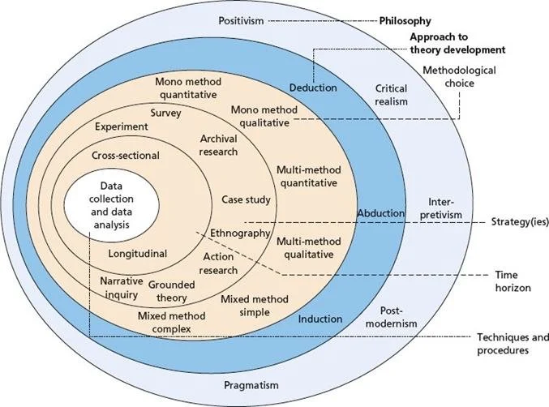
Figure: Saunders’ Research Onion
Source: (Rosie, 2025)
Saunders’ Research Onion refers to a six-layered conceptual framework that helps researchers to systematically design for gathering the relevant piece of information based on the research topic. With the help of this framework, the investigator gets the opportunity to collect the information by following a particular methodological layer (Rosie, 2025).

3.3 Research Philosophy
The term research philosophy refers to the system of beliefs and assumptions for acknowledging the processes for developing the specific knowledge based on the research topic. There are three types of research philosophies that are being followed by the investigator for designing a particular study. Under the categorisation of research philosophy, positivism, interpretivism and pragmatism fall under (Research-methodology.net, 2026). For this research analysis, the investigator has used the pragmatism research philosophy. This research philosophy has been quite effective for the researcher to evaluate both qualitative and quantitative data from the primary and secondary sources.

3.4 Research Approach
This approach is used for investigating the question and the problem of the particular research. There are also three types of research approaches that are being followed by different investigators for gathering the particular piece of data and information of the topic. Inductive, deductive, and abductive are the different research approaches that are being used by different researchers for interpreting the topic of the research (Rutkowski, 2024). For completing this project, the investigator has used the abductive research approach. With the help of this research approach, the research has remained quite successful in gaining insight into the latest trends that are being followed by the Hilton Hotels.

3.5 Research Strategies and Design
The overall plan and the approach that is being followed by the investigator for accumulating the relevant piece of data is termed as the research strategy (Ellis and Hart, 2023). The process that is adopted by the researcher for evaluating the particular piece of information for research objectives is referred to as the research design. Different researchers use various types of strategies for completing the entire study. The three types of research design are exploratory design, descriptive design and conclusive design (Johannesson and Perjons, 2021). The investigator has used the descriptive research design and a case study approach. This research strategy and research design have been quite helpful for the investigator to gain an understanding of the current working conditions of the different employees in Hilton Hotels.

3.6 Research Method
The technique and procedure that is being referred to by an investigator for gathering the data for addressing the questions and objectives of the research is termed as research method. The three types of research methods are mono, mixed, and multi-methods, which are utilised by the investigators for interpreting the specific pieces of information on the topic of the research (Walliman, 2021). To effectively gather the particular data and information on the topic, the investigator has referred to the mixed research method. By following this research method, the investigator has been quite successful in accumulating the information by conducting a survey and an interview by following a primary research method. Additionally, the investigator has also referred to conducting a thematic analysis by following the secondary qualitative research method.

3.7 Time horizon
The particular period over which research is conducted and analysed is termed as the time horizon. The two types of time horizons that are followed by different types of researchers for collecting and interpreting the data and information are cross-sectional and longitudinal time horizons. The investigator for this research has used the cross-sectional time horizon (Gazmararian, 2025). With the help of this time horizon, the investigator has remained quite successful in completing this research within the allocated time period.

3.8 Data Collection Tools
The particular instruments and devices that are used by the investigators for gathering the different types of information on the research topic are termed as the data collection tools. Under the categorisation of the data collection tools, primary data collection and secondary data collection tools fall. In this research, both primary and secondary data collection tools have been used by the investigators for conducting a thorough analysis of the research topic (Carter et al., 2021). 20 surveys and two interviews have been conducted by the researcher to gather information regarding the current working conditions of the Hilton Hotel. By following both the primary and secondary data collection tools, the investigator has significantly gained knowledge about the current market situation.

3.9 Analytical Techniques and Procedures
This layer of the research onion encompasses a variety of methods to interpret and further make sense of the collected data. The two types of data analysis are quantitative data analysis and qualitative data analysis. The researcher has referred to utilising both of these analytical procedures. In terms of quantitative data analysis, the researcher has conducted questionnaire surveys of the employees of the Hilton Hotel (Tabuena and Hilario, 2021). Thematic Analysis has also been conducted by the investigator using books and relevant websites.

3.10 Sampling Techniques
Sampling Techniques are the methods that are used by the investigators for selecting a subset of individuals from a larger population. The researcher for this study used simple random sampling and asked around 20 participants, a manager and one of the staff members of Hilton Hotel (Pitard and Pitard, 2026).

3.11 Ethical Issues
The researcher has adhered to the principles and guidelines that have ensured the dignity, rights and the well-being of the participants who were involved. The principles of the Data Protection Act of 2018 have been followed by the investigator to ensure the confidentiality of the involved participants (Ico.org.uk, 2026). The researcher has ensured crediting of the original authors of the books and journals.

3.12 Conclusion
This chapter has discussed the overall methods and instruments that have been adopted by the investigator for collecting the data and information for researching the topic. Elements like sampling technique, time horizon and other necessary aspects have been highlighted in this chapter.

Chapter Four: Analysis and Findings

4.1 Introduction
Analysis and findings are the fourth chapter of the dissertation, and it is considered one of the core chapters. In this section, all the data and information that have been gathered throughout the research have been presented in an organised way. Hence, the key purpose of this chapter is to report all the facts and show how these insights align with the research objective. In this Analysis and Findings chapter, all the real metrics are used to answer the set research questions. Both qualitative and quantitative data have been used to make the research study highly relevant and valuable. Both primary and secondary methods have been followed to gather and analyse all the data. A secondary thematic analysis will be done in the section below, where themes will be generated from the research objectives. For gathering real-time literary and numerical data, interviews and surveys will be conducted within the research study. Lastly, a discussion section will be presented as well, where a brief understanding of all the collected data will be elaborated.

4.2 Secondary Thematic
Theme 1: Workplace Culture and Leadership Styles' Impact on staff retention in Hilton
The workplace cluster is the shared set of values, beliefs and habits that shape how people act at work. It matters because it directly drives employee engagement, reduces staff turnover, boosts daily productivity, and protects mental well-being, turning a group of individuals into a unified team (Monteiro and Joseph, 2023). Maintaining a workforce culture by setting clear goals and supportive values motivates staff and enhances overall productivity. The Hilton, which is a premier hotel chain, operates in the UK and globally faces critical staff turnover issues, which significantly deteriorate their operation at global and domestic levels (O'Neill, 2025). Effective HRM simultaneously contributes to employee turnover when workplace conditions remain poor. Tourism businesses need effective service quality, which can be delivered with proper team management. Poor working conditions increase the employee turnover rate, which gradually decreases the service quality. Effective leadership shapes workplace conditions by directly influencing psychological safety, team trust and stress levels (Jerab and Mabrouk,2023).
Theme 2: Limited opportunity for the growth of the existing staff led to staff turnover and its impact on Hilton Hotel
Supporting employee growth allows an organisation to maintain a good workplace by boosting morale, increasing job satisfaction and building trust (Sorn et al., 2023). Further implementing career progression options for existing employees enhances positive working culture. On the contrary, limited career growth opportunities and poor leadership often pose a significant threat to organisations like Hilton. Operating as a global business requires strong leadership skills, which can provide extensive career progression opportunities for employees, which will elevate the productivity of their organisation (Romford, 2025). But organisations fail to motivate employees due to the integration of digital technology to streamline operations. Manual labourers always give productive results, but modern-day businesses often rely on digital tools, which reduces the employee workforce.
Theme 3: Views from Hilton staff on workplace conditions for staff retention and performance
According to Hilton’s workplace culture, staff retention and performance are driven by human-centred leadership, a strong sense of purpose and mutual mentorship. Employees report that they are feeling valued by managers and receiving flexible work arrangements, which directly improve their performance (stories.hilton, 2026). But on several platforms, older staff and new joinees highlight recurring pain points. The heavy workload during peak season and limited communication from upper management pose significant service disruptions, which gradually disrupt customer service (seek, 2026). Poor salary structures and unequal wage distribution also pose a significant threat to the hotel business. Additionally, stagnant promotion tracks at individual property levels frustrate the high-performing employees seeking career growth. These issues significantly reduce the organisation's working climate and pose concerns for new employees and gradually decrease the quality of services. To navigate these challenges and maintain competition with Marriott, the hotel must implement strategic solutions to address these ongoing challenges. Implementing an employee well-being program and offering more promotional compensation will help the organisation maintain its brand visibility on a global level. Further, to maintain market scalability, the hotel needs to reduce the toxic working environment and needs to change the leadership styles as well.
Theme 4: Views from Hilton managers on workplace conditions for staff retention and performance
The managers of the hospitality sector play a vital role in shaping the positive workplace conditions that result in boosting staff retention (Giousmpasoglou et al., 2021). This indicates that organisational managers are responsible for developing the workplace conditions that lead to the development of employee relations. Having aimed at improving workplace conditions, managers of hospitality brands are involved in boosting staff communication. As a result, managers can evaluate staff concerns and initiate strategic decisions that contribute to staff retention. Additionally, organisational leaders are strongly concerned with the development of a workplace in which the staff feel valued. As a prominent hospitality brand, the organisational managers of Hilton Hotel aim to develop staff communication, which is an integral part of a positive organisational culture (hilton, 2025). The effectiveness of organisational culture allows the company to value the staff's contribution, which is a core component of fostering staff retention. Additionally, the responsiveness of organisational managers encourages the staff to gain career opportunities in the workplace. It leads to maximum motivation among staff, as the career opportunities influence the staff to access promotions and rewards. A strong concern of organisational leaders with workplace conditions allows Hilton Hotel to be a best workplace in the contemporary job market.
Theme 5: Strategies like employee Well-being and offering Flexibility to increase staff retention in Hilton
Employee retention in hotel businesses lowers hiring and training costs, stabilises service quality and boosts guest satisfaction. Retained staff build positive relationships with guests first and create a smoother, more efficient daily operation, which aids profits. Hilton enhances workplace conditions and staff retention through its ‘Thrive at Hilton’ program (stories.hilton, 2026). They offer physical, mental, and financial wellbeing resources like free education, financial support, and real-time coaching. These approaches help the business to maintain complete engagement with their employees and create a unified team that enhances organisational productivity. On the other hand, the organisation offers safe care services through the platforms, which help employees earn early wages and avail medical care for themselves, which helps the organisation to balance engagement with employees and upper management. Within the tourism business, employee satisfaction is important as they provide the best service for the consumer on behalf of the organisation. Therefore, the strategies of well-being and providing financial stability help the business to increase employee engagement. But on the other hand, integration of digital tools reduces employee engagement and increases burnout by causing digital overload and blurring work-life values as well.
Theme 6: Guiding employees for Growth and Career Development to increase staff retention in Hilton
An employee career progression approach helps organisations keep top workers, boost daily output, and fill open leadership roles from within (Elsafty and Oraby, 2022). By giving staff a path to growth, companies build stronger loyalty, lower hiring costs, and adapt faster to new industry demand. The changing travel demand and economic shifts have changed the tourism business; therefore, offering a career-oriented path helps the tourism business to develop engagement with the staff. Hilton supports employee growth by filling nearly two-thirds of leadership roles internally, promoting employees to managerial roles in the business, which increases employee trust and loyalty and increases productivity. The hotel business provides flexible training by partnering with platforms like Harvard and LinkedIn Learning, as well as with the help of a customisable AI application; the brand increases the employees' digital skills. By increasing the skills, the organisation streamlines its business, and it shapes the business environment as well (Kitterman, 2025). Though operating a business globally, several uncertainties pose hurdles to the business, which gradually decrease operational fluency. The organisation needs to navigate these aspects to propose a subtle solution to improve the workforce.

4.3 Primary Survey
Question 1
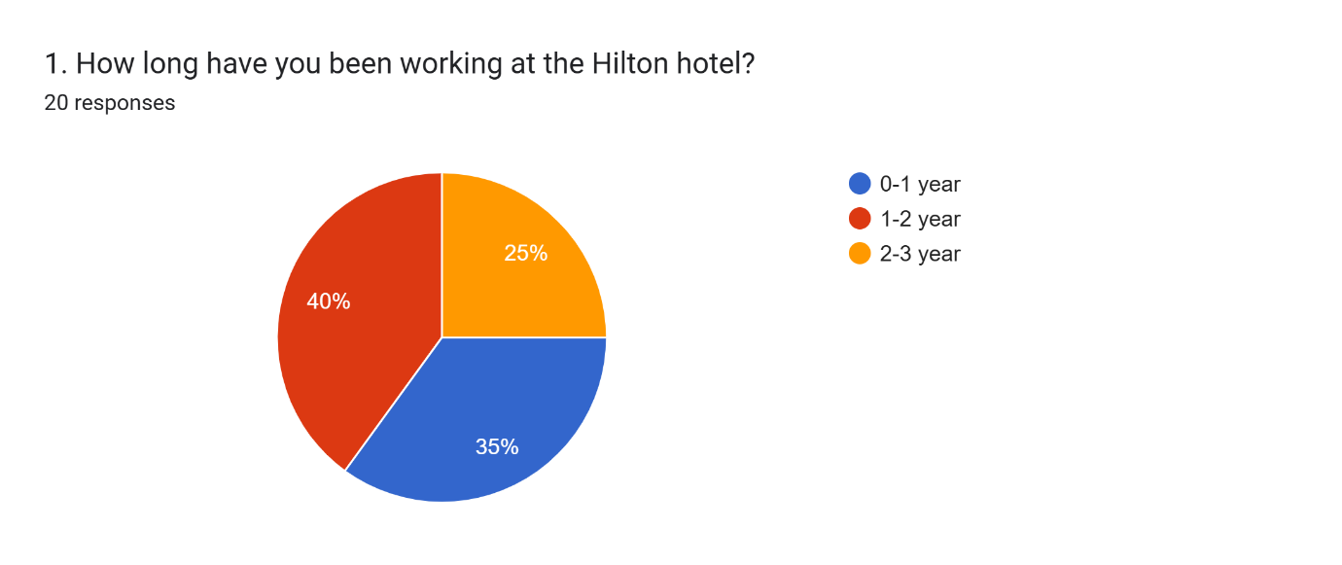
Source: (Author, 2026)
A survey has been conducted among the workers of the Hilton Hotel to understand how long they have been working at the hotel. According to reports and research, it is known that the number of employees at the Hilton Hotel is very large. After conducting the survey, it was understood that 40 per cent of the entire workforce is very new and has been working within the company for less than 1 year. Along with that, the survey has helped in comprehending that workers do not work at the hotel for many years. Only 25 per cent of the staff among the entire employee base have been working at Hilton for 2-3 years. Also, the survey has indicated that 35 per cent of the staff of Hilton are working within the company for 1-2 years.
Question 2
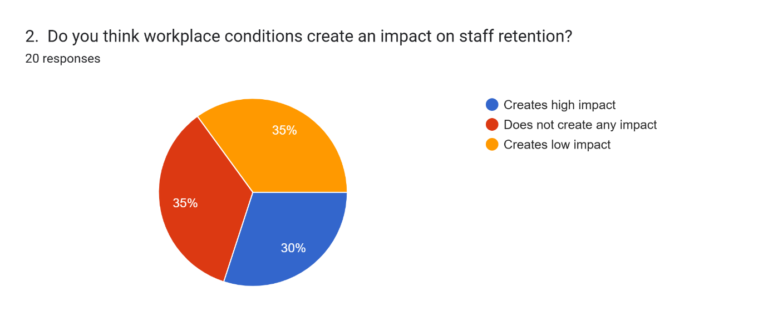
Source: (Author, 2026)
The environment of the workplace plays a vital role in creating an impact on employee retention and their job satisfaction. To understand the opinion of the workers of the company, the survey has asked this specific question. According to the results, it is understood that 35 per cent of the company’s employees think that the work environment creates a very minimal impact on staff retention. However, 30 per cent of the whole workforce of Hilton Hotel believe that workplace conditions have a high impact on staff retention. Lastly, the survey has indicated that only 35 per cent of the workers think that no impact is created on staff retention by workplace conditions.
Question 3
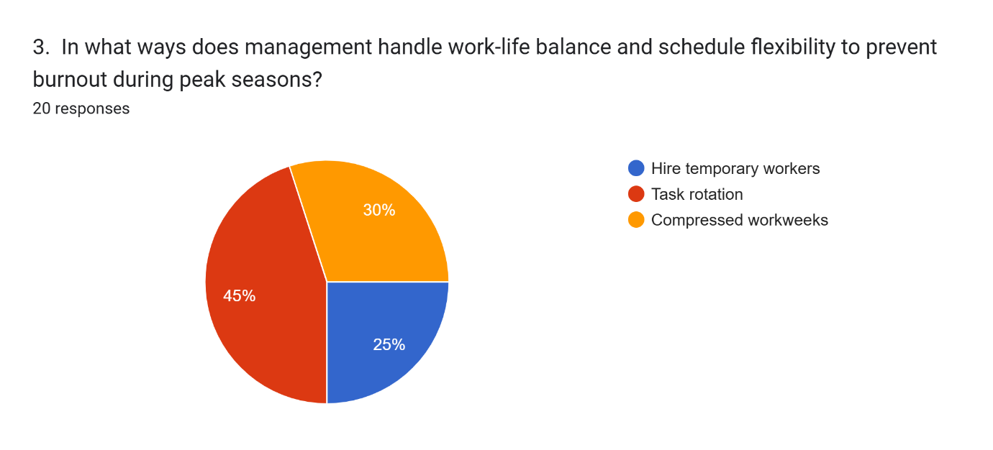
Source: (Author, 2026)
Balancing work life and professional life is highly important within a hotel business. Along with that, workers often feel highly burned out, especially during the peak seasons; hence, schedule flexibility is also a crucial way to achieve work-life balance. The employees were asked about the ways the management of Hilton Hotel handles work-life balance. Most of the workers (which is 45 per cent) chose the option ‘Task rotation’. This indicated that tasks are given to many employees very frequently, so that they do not feel highly pressured. Along with that, 25 per cent of the workers agreed that Hilton Hotel hire temporary workers for scheduling flexibility during peak seasons. Lastly, compressed workweeks were another option, which was chosen by 30 per cent of the workers at Hilton.
Question 4
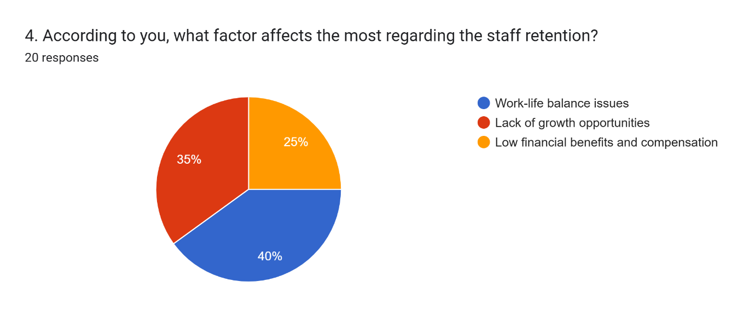
Source: (Author, 2026)
There are various factors which can affect the retention of staff within an organisation. The workers of this hotel were asked about the factors that they think affect it the most. 35 per cent of the staff have stated that the lack of growth opportunities has a very significant effect on staff retention. On the other hand, 40 per cent of workers have chosen work-life balance issues as a crucial factor that affects staff retention. Lastly, only 25 per cent of the staff of the organisation think that fewer financial benefits and other compensation often affect staff retention.
Question 5
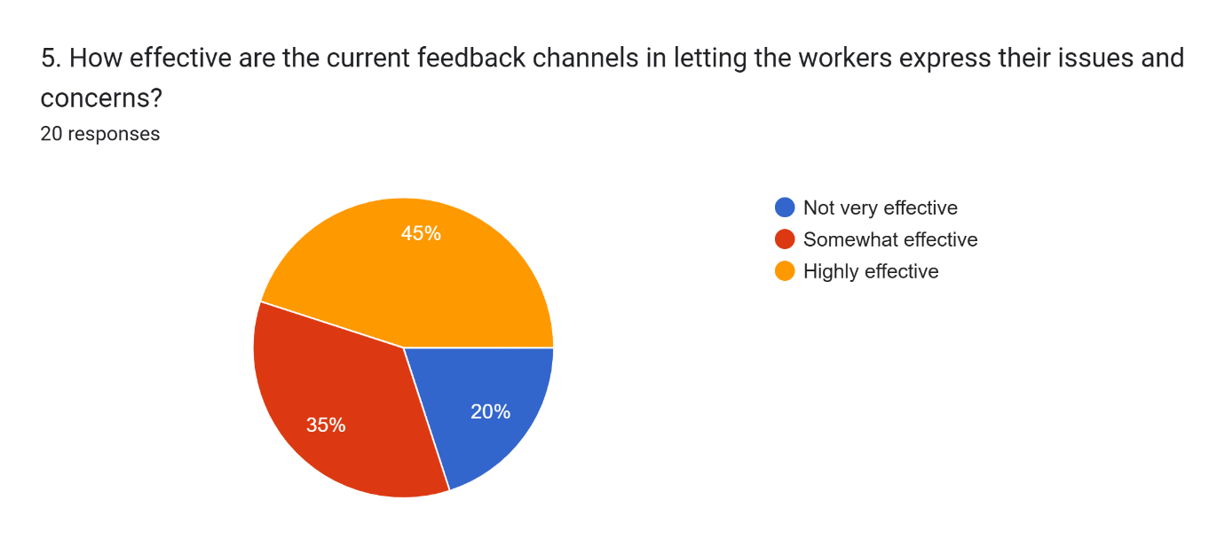
Source: (Author, 2026)
The Hilton hotel has their own feedback channels, and these channels and platforms are especially made for the workers. The workers were asked if the feedback channels and platforms are effective for them in expressing their concerns and queries. 45 per cent of the staff have expressed that the feedback channels are highly effective. Also, only 20 per cent of the employees have mentioned that these feedback channels are not effective for them. On the other hand, 35 per cent of workers mentioned that these feedback channels are somewhat effective for them.
Question 6
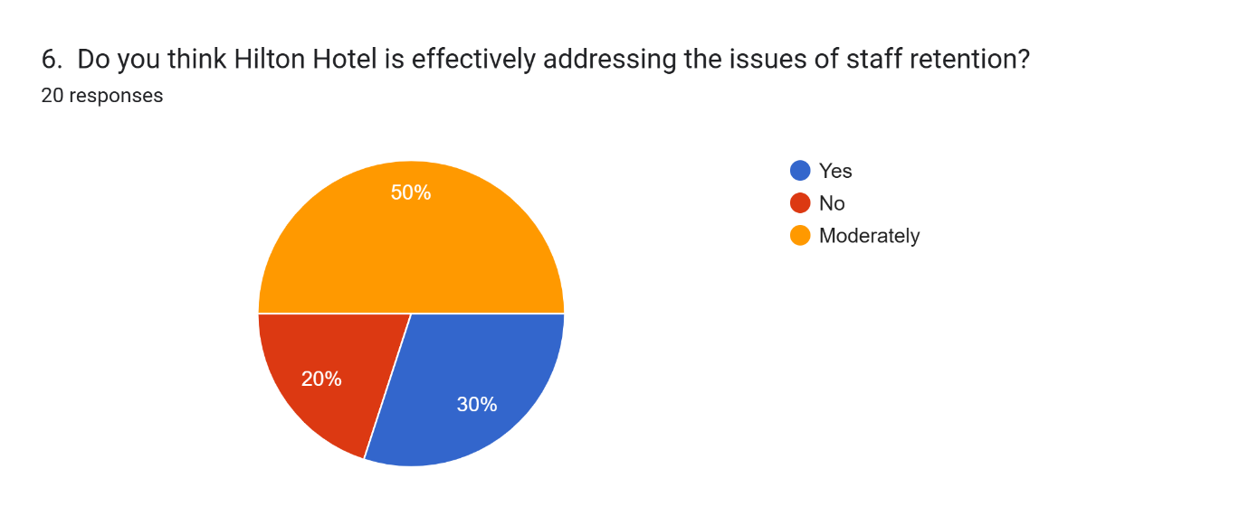
Source: (Author, 2026)
Addressing the issues of staff retention is highly important for any company. Hence, in the survey, a question was asked of the workers whether they think the organisation is taking any effective steps to address and mitigate the issues. More than 50 per cent of the staff have stated that all the issues are addressed moderately. On the other hand, more than 20 per cent of the staff think Hilton Hotel is not addressing the issues effectively. On the contrary, more than 30 per cent of staff have mentioned that Hilton Hotel is effectively addressing these issues.
Question 7
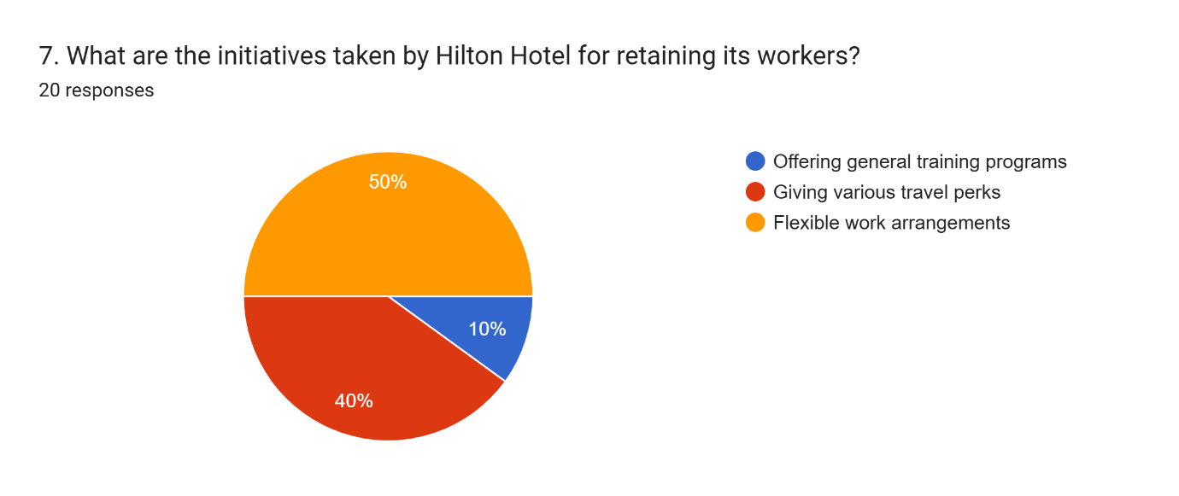
Source: (Author, 2026)
Retaining workers is very important for a company to achieve success and gain competitive advantages. The staff of Hilton were asked about the initiatives for staff retention. More than 50 per cent of employees said that the hotel gives flexible work arrangements to them. Almost 40 per cent mentioned that travel perks are given to the workers as retention strategies. However, only 10 per cent stated that they are given general training by the company,
Question 8
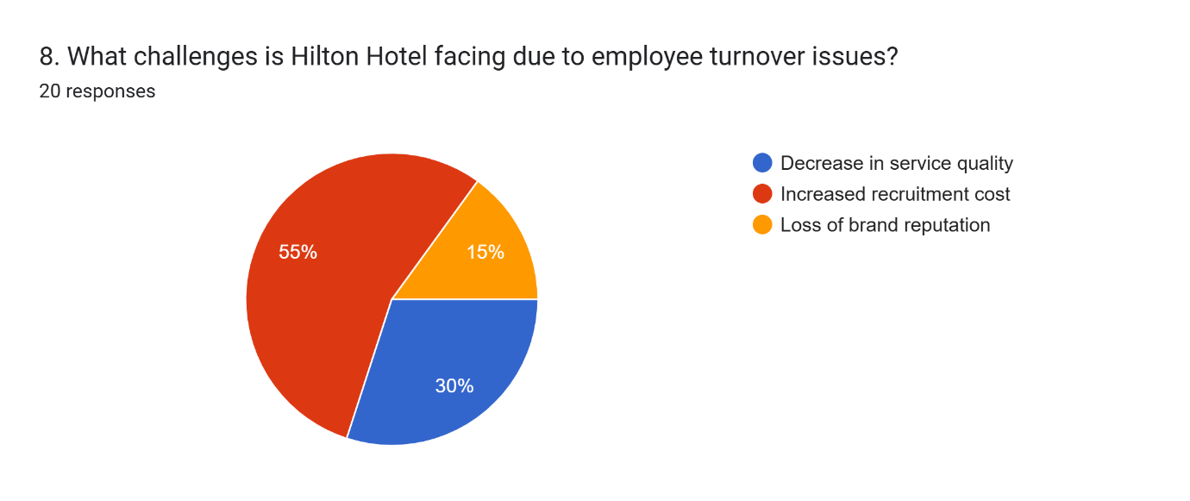
Source: (Author, 2026)
Turnover issues are faced by many hotels, including Hilton. Due to employee turnover issues, the brand has faced many challenges. More than 55 per cent of staff have mentioned that turnover issues have increased recruitment costs for the brand. On the other hand, 30 per cent of Hilton staff have mentioned that service quality has decreased a lot. Lastly, only 15 per cent of workers mentioned loss of brand reputation as a challenge from employee retention issues.
Question 9
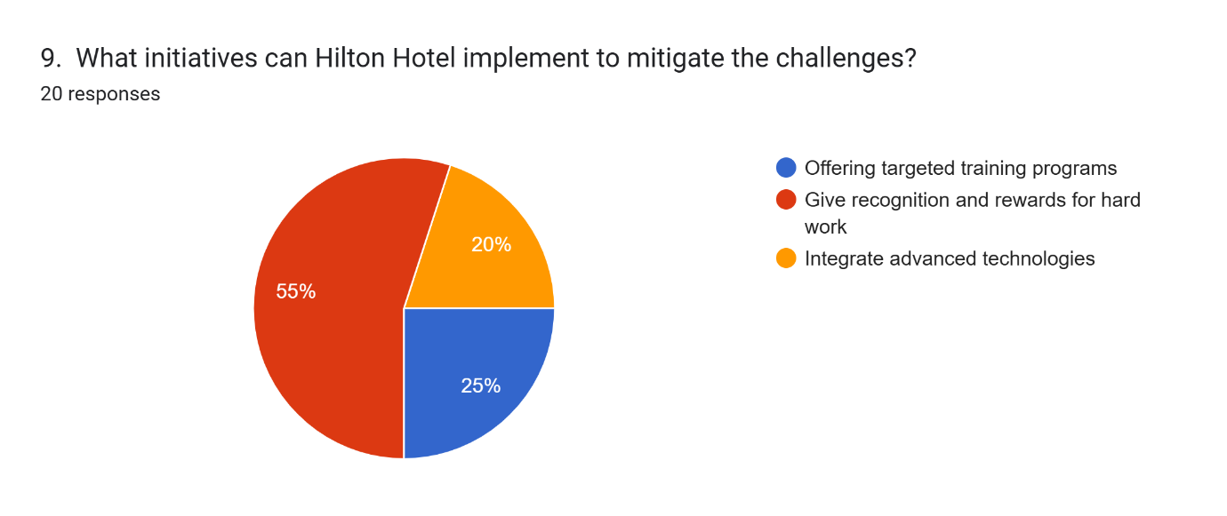
Source: (Author, 2026)
Addressing these issues is highly important for any company; thus, workers were asked, according to them, what initiatives Hilton can implement. 55 per cent of staff said that giving recognition and rewards is a good initiative. 25 per cent of the staff chose the option of offering targeted training programs as mitigation initiatives. Only 20 per cent of workers said that integrating advanced technologies can be an effective mitigation strategy.
Question 10
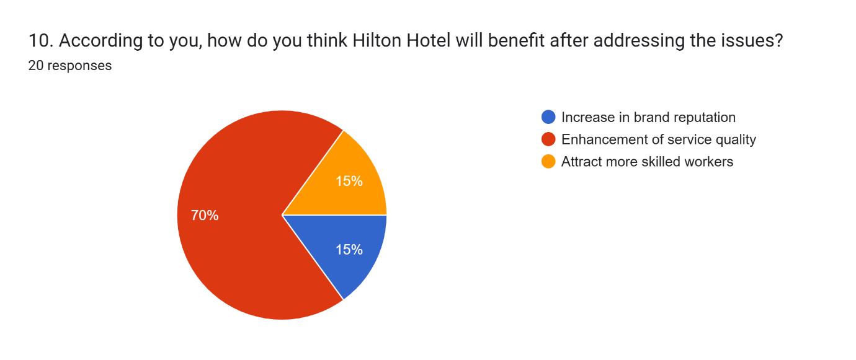
Source: (Author, 2026)
Addressing these issues will help the hotel brand provide various benefits and advantages. 70 per cent of the workers have mentioned that the service quality of Hilton Hotel will improve. Also, 15 per cent of staff have stated that the organisation can attract skilled workers after mitigating the ongoing issues of employee turnover. Similarly, the same percentage of staff mentioned that Hilton can increase its brand reputation by mitigating the mentioned issues.

4.4 Primary Interview
Question 1
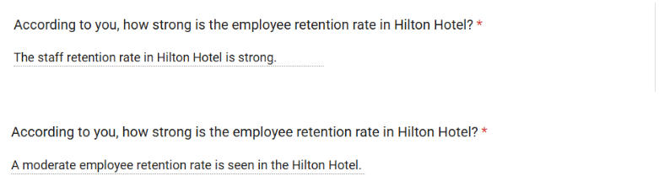
Source: (Author, 2026)
As per the first interviewee, the staff retention rate at the Hilton Hotel is strong, and this aspect is a key component of driving operational performance. However, according to the second interviewee, Hilton Hotel has witnessed a moderate staff retention rate in the contemporary business context.
Question 2
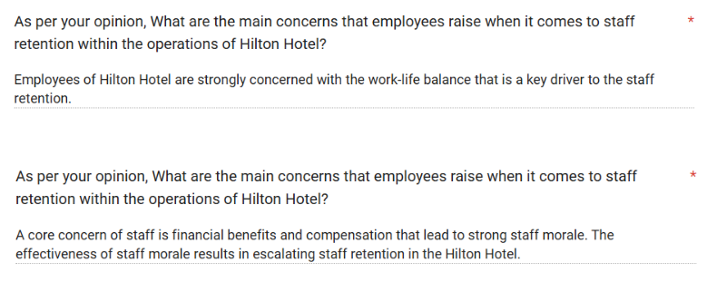
Source: (Author, 2026)
The first interviewee agreed that work-life balance is a key concern of the staff at Hilton Hotel. It indicates that the employers of Hilton Hotel are interested in offering flexible working time, which has resulted in boosting work-life balance. A strong work-life balance increases job satisfaction, which leads to staff commitment towards an organisation. Having improved staff commitment, Hilton Hotel experiences staff retention and mitigates staff turnover problems. Meanwhile, as per the opinion of the second interview participant, compensation and financial benefits are a key component of gaining staff retention. This participant agreed that strong financial benefits foster staff morale, which is a leading aspect for increasing staff retention in the business. It indicates that the effectiveness of compensation plays a vital role in the Hilton Hotel in maximising staff engagement. A lack of financial opportunities can result in a decline in staff morale that leads to staff turnover in this brand.
Question 3

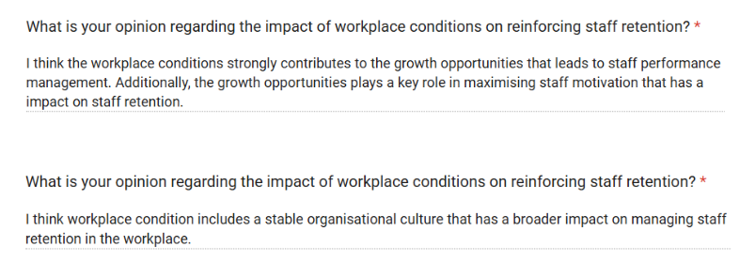
Source: (Author, 2026)
Workplace conditions are considered a significant aspect for reinforcing staff engagement in hotel brands. Based on the opinions of the first participants in the interview, working conditions are associated with growth opportunities for the staff. Positive working conditions lead to extensive growth opportunities for the workforce and boost motivation, which influences staff retention. Having developed the working conditions, Hilton Hotel generates career growth opportunities for its employees, who are motivated by accessing the growth opportunities in the workplace. The growth opportunities allow the staff to access the promotional benefits and performance-based rewards that enhance staff motivation. A motivated workforce development influences the hotel to boost staff retention. However, the second interviewee has become concerned with the organisational culture in the context of sharpening staff retention in the hotel brands. It signifies that the development of organisational culture allows the leaders to offer equal respect to all staff. Due to this, the staff of Hilton Hotel feel valued and appreciated by the organisation, and this aspect is a crucial factor for strengthening staff retention in the hotel brands.
Question 4
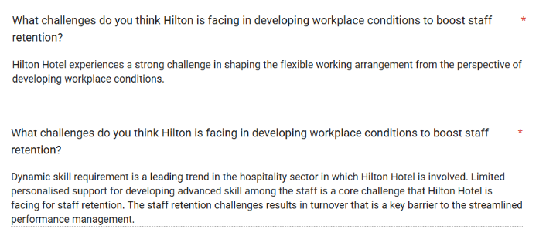
Source: (Author, 2026)
According to the first interviewee, a core challenge for Hilton Hotel is to shape flexible working arrangements. It is seen that growing demand in the hospitality sector is a key barrier to the improvement of flexible working arrangements. A lack of flexible working arrangements leads to hectic pressure on the staff of Hilton Hotel, which faces problems in managing working hours. The working pressure in the company contributes to lower staff morale, which is a variable in staff turnover. However, as per the view of the second interviewee, the contemporary hospitality sector has to be responsible for strengthening staff skills to respond to the dynamic business environment. The individuals at Hilton Hotel have different skill gaps and require personalised assistance for mitigating these skill limitations. A failure of the organisation to align with the dynamic skill requirements results in limited people management efforts. Due to this, the staff of Hilton Hotel are deprived of accessing skill development support based on their skill gaps. This results in increased staff turnover, which is a core limitation of shaping the streamlined operational process.
Question 5
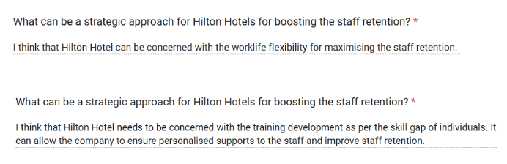
Source: (Author, 2026)
The first participant in the interview stated that work-life flexibility can be a core strategic solution that can be initiated by Hilton Hotel to improve staff retention. It signifies that the company can implement flexible working hours that can be beneficial for boosting work-life balance. Work-life balance can allow staff to be responsible for managing personal and professional duties. Additionally, the effectiveness of flexible working arrangements can enable staff to mitigate stress, which is a core aspect of staff well-being. Having designed the staff well-being benefits like flexible working terms, Hilton Hotel can be involved in improving employee retention. On the contrary, according to the second interviewee, training development can be an effective solution for Hilton Hotel to achieve strong employee retention. It indicates that the organisational leaders of this company can be responsible for identifying the individuals’ skill gaps. This aspect can result in designing training programmes that can be a core personalised effort for staff management. Due to this, Hilton Hotel can drive staff engagement that has broader consequences for improving staff retention.

4.5 Discussion
Thematic analysis has been done at the beginning of the report, where themes have been generated from the set research objectives. Through this secondary research, it was understood that the culture of the workplace and leadership styles create a huge impact on the retention of the workers. When there is a positive work culture, employees feel more engaged with their work, and they are motivated to put in extra effort. A positive workplace focuses on the physical and mental well-being of the workers. Hence, workers feel valued within the organisation, and this creates a positive impact on staff retention. The secondary research has helped in understanding that the lack of growth opportunities for the workers has contributed towards the staff turnover issues. Not being able to achieve growth in their professional setting has increased dissatisfaction towards the job role, which hampers the quality of the work. The thematic analysis has helped in understanding the perspective and view of the staff of the Hilton Hotel regarding the workplace conditions, and how it is affecting the staff retention and performance. Similarly, the views and contributions of the hotel managers have been understood as to how workplace conditions affect staff retention. Managers of the Hilton Hotel ensure that clear communication is maintained among the hotel staff, which helps in reducing confusion and enhancing their satisfaction level. Hilton Hotel is one of the famous hotel chains, which uses various strategies to promote employee well-being. Strategies like offering free resources for maintaining physical and mental well-being, safe care services, and others were mentioned. Retaining staff is very important for a company to achieve success, and the thematic analysis has pointed out how Hilton Hotel guides its employees for growth and career development. Flexible training is provided by the hotel brand by partnering with platforms like LinkedIn. To increase the digital skills and knowledge of the workers, Hilton Hotel integrate various advanced AI technologies within the business process.
Apart from this thematic analysis, a primary survey has been conducted, and answers from 20 employees of Hilton Hotel were collected. The first question was asked to understand how long the workers have been working within the brand. The graph has helped in understanding that more staff joined the company very recently, and very few workers have been working for more than 2 years at Hilton. The perspectives of the workers were understood in terms of whether they think the workplace culture creates staff retention. Through this survey, it is understood that a low percentage of workers think staff retention is highly impacted by the workplace conditions. Employees have stated that managers follow task rotation strategies the most and handle work-life balance. These initiatives are mainly followed to make the workers feel less burned out due to the intense work pressure. Also, workers have mentioned that the issues regarding work-life balance create the most impact on staff retention. Research has helped identify that the hotel brand has its own feedback channels for its workers. Most of the workers have agreed that these feedback channels are highly effective, which made them feel heard and valued. Half of the workforce at Hilton believes the hotel is only moderately addressing staff retention issues. Various approaches are taken by the company, and from the staff, it is understood that Hilton Hotel is highly focused on giving flexible working arrangements to workers. This helps the brand maintain employee retention, as well as job satisfaction. Workers have said that many negative impacts are created on Hilton due to employee turnover issues, and an increase in recruitment costs is the most crucial one. Through the survey, it is clearly understood that staff think giving rewards and recognition can effectively address staff turnover issues.
The interview has helped in realising that the employee retention strategies of the Hilton are moderate to strong. Also, interviewees have mentioned that the issues regarding work-life balance and lack of financial benefits create a negative impact on staff retention. Through the interview, it was clear that workplace conditions and growth opportunities play a huge role in reinforcing staff retention. Hilton is facing many issues while boosting staff retention, such as shaping flexible working arrangements, the requirement of various skills and others. The managers have mentioned that focusing on work-life flexibility, offering training and other measures will help boost staff retention.

4.6 Conclusion
The fourth chapter of the dissertation has helped in presenting all the data and information in an organised way. For the qualitative data, which have been collected through the secondary method, thematic analysis was done. In total of 6 six themes were developed, and data were collected at the Hilton Hotel. Furthermore, 10 questions were asked to 20 members of the hotel to gather real-time quantitative information. All of these were presented in the section through graphs and charts. Along with that, 5 interview questions were set and asked to 2 managers of the hotel brand, and qualitative insights were gathered. Lastly, a discussion section was presented within the report, where the overall understanding of the collective data was presented.

Chapter Five: Recommendations, Conclusion and limitations of the research

5.1 Introduction
This chapter will highlight a summary of the entire research that is conducted by the investigator. A section on limitations and suggestions for further research will be discussed. Recommendations will be provided based on the topic of the particular research. The role of this research in contributing to the study will be highlighted.

5.2 Summary of the dissertation
The aspect of workplace conditions in the organisational network in one of the prominent hotel organisations, Hilton Hotels, has been thoroughly explained by the researcher in this dissertation. The investigator has described that employees are considered to be one of the major components for a company to reach success and gain a competitive advantage. Being one of the major enterprises, Hilton Hotels has remained quite successful in implementing the strategies that are required for improving the engagement of the different employees. A brief research rationale has been highlighted, where the investigator has highlighted that psychological and physical work environments affect the turnover rates of the existing working members. The researcher has evaluated the working conditions of the employees that affect staff retention in the hotel companies in the United Kingdom in the literature review chapter. Factors like compensation and rewards and flexible working hours are considered to be the major factors that help in improving the retention rate of the employees in the organisational network. It has also been highlighted in this section of the literature review that flexible working environments and career development initiatives can also be provided for the workers. Theory of Planned Behaviour and Herzberg's Two-Factor Theory have been used by the investigator for an in-depth analysis. Saunders' Research Onion has been used by the researcher to accumulate the particular piece of data and information for evaluating the impact on staff retention at Hilton Hotels. With the help of this model, it has been highlighted that the researcher has utilised the abductive research approach and completed this research analysis using a cross-sectional time horizon. The investigator has used both secondary and primary research methods for gaining insight into the current situation of the hospitality sector. Surveys have been conducted by the researcher to gain knowledge about the condition of the employees in the Hilton Hotels. It can be summarised that approximately 40% of the working members have been working in the business network for less than one year. Based on this evaluation, the investigator has evaluated that the current organisational culture has created a positive impact on the working members.

5.3 Limitations of this research and suggestions for further research
The researcher has utilised the primary and secondary research methods for collecting the particular information for analysing the impact of workplace conditions on the staff retention of the Hilton Hotels. In terms of limitations of the survey, the investigator has faced the issue of misinterpretation by existing workers. Furthermore, the researcher has experienced the challenge of high transportation costs and time issues for interviewing the two participants. On the other hand, it is suggested that the investigator use secondary thematic analysis for gathering the information. This creates a limitation in this particular research, as the researcher failed to highlight the figures and the latest statistics of the situation of employee retention in the hotel sector. Hence, for future research, the investigator can use secondary quantitative analysis to gain in-depth insight into the contemporary situation of the retention rates of the various employees. With the help of this method, the researcher will be able to highlight the graphs and charts for the current situation of staff retention in the hotel organisations in the sector (Kelly, 2024).

5.4 Practical recommendations
Organising Career Development and Training Programs: The hotel sector of the United Kingdom is characterised by significant competition and integration of the latest innovative technologies in the business culture (Carlisle, 2021). Hence, it is suggested that the senior administrators and other team leaders of Hilton Hotels need to organise development and training programs to improve the skills of the employees. Being one of the major businesses in the industry, Hilton Hotels needs to stay competitive in the current business landscape. By enhancing the skills and proficiencies of the employees in the hotel company, the senior administrators will get the opportunity to strengthen the workforce. The workers will also feel encouraged to accomplish the organisational goals within the necessary period with the help of this strategy (Chavez, 2025).
Offering perks and financial wellness: Different senior administrators of Hilton Hotels can offer various perks and financial benefits to the existing workers. With the help of this initiative, senior workers will be able to establish a link between business performance and the retention rate of the different members (Harrison, 2026). This initiative will be quite effective for the senior workers to show value to the existing workers in the organisational environment of the Hilton Hotels. Staff members will be significantly encouraged to reach the goals and objectives of this hotel enterprise in the current situation with the help of this initiative, ultimately improving staff retention.
Implementation of the latest digital technologies for monitoring: The senior leaders can use the latest innovative technologies for monitoring the performance and activities of the different employees in the business network. Implementing the latest innovative technology tools in the organisation will help in reducing employee turnover by reducing daily friction and further optimise the work schedules (Blacet, 2026). Therefore, this initiative would be quite effective for Hilton Hotels to enhance the retention rate of the various types of workers.

5.5 Contribution of the study
This study has analysed the aspect of staff retention of the various employees in one of the major hotel businesses, the Hilton Hotel. Therefore, this research has helped in highlighting the insights on the engagement of the employees and the aspect of leadership in the existing workforce of this hotel business.

5.6 Conclusion
This chapter has summarised the research which has been conducted by the investigator in this dissertation. Recommendations like offering perks, financial wellness, and others have been provided for improving the staff retention rate of the existing employees in Hilton Hotels.

References
Andersen, L.P., Andersen, D.R. and Pihl-Thingvad, J., (2025). Reducing the risk of burnout in human service professions: identifying practical strategies to manage emotional demands: A mixed-methods study in Denmark. BMC public health, 25(1), p.3895.
Blacet, B., (2026). A Guide to Digital Employee Experience Monitoring: How To Measure, Improve, and Modernize the Workplace. [Online] Available at: https://www.moveworks.com/us/en/resources/blog/digital-employee-experience-monitoring-benefits-and-best-practic [Accessed 05 August 2026].
Boamah, S.A., Hamadi, H.Y., Havaei, F., Smith, H. and Webb, F., (2022). Striking a balance between work and play: The effects of work–life interference and burnout on faculty turnover intentions and career satisfaction. International journal of environmental research and public health, 19(2), p.809.
Cai, J. and Qu, J.L., (2026). Review of Herzberg's Two‐Factor Theory: Limitations and Improvements. Systems Research and Behavioral Science.
Carlisle, S., (2021). The digital skills divide: evidence from the European tourism industry. [Online] Available at: https://www.emerald.com/jtf/article/9/2/240/449768/The-digital-skills-divide-evidence-from-the [Accessed 05 August 2026].
Carter, S.M., Shih, P., Williams, J., Degeling, C. and Mooney-Somers, J., (2021). Conducting qualitative research online: Challenges and solutions. The Patient-Patient-Centered Outcomes Research, 14(6), pp.711-718.
Chatzoudes, D. and Chatzoglou, P., (2022). Factors affecting employee retention: Proposing an original conceptual framework. International Journal of Economics and Business Administration, 10(1), pp.49-76.
Chavez, A., (2025). Workforce Training And Career Support: Key Drivers For Long-Term Business Success. [Online] Available at: https://www.forbes.com/councils/forbesbusinesscouncil/2025/10/21/workforce-training-and-career-support-key-drivers-for-long-term-business-success/ [Accessed 05 August 2026].
Chen, X. and Slade, E., (2025). Theory of planned behaviour: A review.
Çivilidağ, A. and Durmaz, Ş., (2024). Examining the relationship between flexible working arrangements and employee performance: A mini review. Frontiers in Psychology, 15, p.1398309.
Corbin, T.A. and Flenady, G., (2024). Quiet quitting as compensatory respect: meaningful work, recognition, and the entrepreneurial ethic. Philosophy of Management, 23(4), pp.461-480.
Derowitsch, J., Ngo, T., Katt, T., Henning, M. and Soukup, L., (2025). Strategic Audit: Hilton Worldwide Holdings, Inc.
Ellis, J.L. and Hart, D.L., (2023). Strengthening the choice for a generic qualitative research design. The Qualitative Report, 28(6), pp.1759-1768.
Elsafty, A. and Oraby, M., (2022). The impact of training on employee retention: An empirical research on the private sector in Egypt. International Journal of Business and Management, 17(5), pp.58-74.
Fritz, C., (2025). Sacred Routine: A guide to creating morning and evening routines that have a powerful impact on productivity, focus, and life balance. HGU Publishing.
Gazmararian, A.F., (2025). Valuing the future: Changing time horizons and policy preferences. Political Behavior, 47(2), pp.553-572.
Giousmpasoglou, C., Marinakou, E. and Zopiatis, A., (2021). Hospitality managers in turbulent times: the COVID-19 crisis. International Journal of Contemporary Hospitality Management, 33(4), pp.1297-1318.
Guerola-Navarro, V., Oltra-Badenes, R., Guzmán-Duque, A. and Gil-Gomez, H., (2026). Customer relationship management (CRM) and Innovation: an empirical study about their impact on firm performance. International Entrepreneurship and Management Journal, 22(2), p.104.
Gunarto, B., Sandjaya, A., Arafah, W., Santosa, W. and Wahyudi, A.S., (2026). A Review of Employee Retention Strategies in Travel Companies. Indonesian Journal Economic Review, 6(3), pp.1071-1084.
Harrison, J., (2026). Why Financial Wellness Is Important in the Workplace. [Online] Available at: https://www.webmdhealthservices.com/blog/why-financial-wellness-is-important-in-the-workplace/ [Accessed 05 August 2026].
Harrison, J.S., Kelso, A., Reilly, P. and Sadler, W., (2022). Hilton Worldwide Holdings Inc.
hilton, (2025). Hilton Again Named No. 1 World’s Best Workplace. [Online] Available at: https://stories.hilton.com/releases/hilton-named-2025-no-1-worlds-best-workplace [Accessed 06 August 2026].
Ico.org.uk, (2026). What are the research provisions?. [Online] Available at: https://ico.org.uk/for-organisations/uk-gdpr-guidance-and-resources/the-research-provisions/what-are-the-research-provisions/ [Accessed 05 August 2026].
Irfan, M., Khalid, R.A., Kaka Khel, S.S.U.H., Maqsoom, A. and Sherani, I.K., (2023). Impact of work–life balance with the role of organizational support and job burnout on project performance. Engineering, Construction and Architectural Management, 30(1), pp.154-171.
Jerab, D. and Mabrouk, T., (2023). The role of leadership in changing organizational culture. Available at SSRN 4574324.
Johannesson, P. and Perjons, E., (2021). Research strategies and methods. In An introduction to design science (pp. 41-75). Cham: Springer International Publishing.
Kellerman, G.R. and Seligman, M., (2023). Reimagining HR for better well-being and performance. MIT Sloan Management Review, 64(3), pp.38-43.
Kelly, M. M., (2024). Secondary Data Analysis: Using existing data to answer new questions. [Online] Available at: https://www.sciencedirect.com/science/article/abs/pii/S0891524524000531 [Accessed 05 August 2026].
Kitterman, T., (2025). What Makes Hilton the No. 1 Workplace in the World. [Online] Available at: https://www.greatplacetowork.com/resources/blog/hilton-no-1-worlds-best-2025 [Accessed 06 August 2026].
Maslach, C. and Leiter, M.P., (2022). The burnout challenge: Managing people’s relationships with their jobs. Harvard University Press.
Monteiro, E. and Joseph, J., (2023). A review on the impact of workplace culture on employee mental health and well-being. International Journal of Case Studies in Business, IT and Education (IJCSBE), 7(2), pp.291-317.
Ngozi, D. and Edwinah, A., (2022). Employee engagement and talent retention: A review. South Asian Research Journal of Biology and Applied Biosciences, 4(5), pp.188-197.
O'Neill, S., (2025). Hilton and Marriott Take on the Hotel Talent Crisis. [Online] Available at: https://skift.com/2025/11/17/hilton-and-marriott-take-on-the-hotel-talent-crisis/ [Accessed 06 August 2026].
Pitard, F.F. and Pitard, M.A., (2026). Theory of sampling and sampling practice. CRC Press.
Reed, B.N. and McGonagle, A.K., (2026). Rethinking food at work: an examination of structural and social constraints and resource loss across the work-home interface. Journal of Business and Psychology, pp.1-21.
Research-methodology.net, (2026). Research Philosophy. [Online] Available at: https://research-methodology.net/research-philosophy/ [Accessed 05 August 2026].
Romford, J., (2025). How the Impact of Technology in the Workplace Shapes the Service Industry. [Online] Available at: https://agilityportal.io/blog/impact-of-technology-in-the-workplace [Accessed 05 August 2026].
Rosie, (2025). What is Research Onion and Its Role in Research Papers?. [Online] Available at: https://www.bestassignmentwriters.co.uk/blog/its-role-in-research-papers/ [Accessed 05 August 2026].
Rutkowski, A. S.-H. a. D. J., (2024). Embracing complexity: abductive reasoning as a versatile tool for analyzing international large-scale assessments. [Online] Available at: https://link.springer.com/article/10.1007/s11092-024-09449-2 [Accessed 05 August 2026].
Sealy, W.C., Jenkins, P. and Jalley, A., (2023). The recruitment crisis in the British hospitality industry: a case for more sustainable practices. In Embracing Business Sustainability Through Innovation and Creativity in the Service Sector (pp. 31-46). IGI Global Scientific Publishing.
seek, (2026). Hilton. [Online] Available at: https://au.seek.com/companies/hilton-hotels-n-resorts-433064/reviews [Accessed 06 August 2026].
Shifrin, N.V. and Michel, J.S., (2022). Flexible work arrangements and employee health: A meta-analytic review. Work & Stress, 36(1), pp.60-85.
Sorn, M.K., Fienena, A.R., Ali, Y., Rafay, M. and Fu, G., (2023). The effectiveness of compensation in maintaining employee retention. Open Access Library Journal, 10(7), pp.1-14.
stories.hilton, (2026). Hilton Unveils New Workplace Research Showing That Even as AI Is Reshaping Work, the Real Advantage Is Human. [Online] Available at: https://stories.hilton.com/releases/2026-trends-hospitality-mindset-release [Accessed 06 August 2026].
Tabuena, A.C. and Hilario, Y.M.C., (2021). Research data analysis methods in addressing the K-12 learning competency on data analysis procedures among senior high school research courses. International Journal of Recent Research and Applied Studies, 8(3), p.1.
Walliman, N., (2021). Research methods: The basics. Routledge.

Appendix

Appendix-Primary Survey

Source: (Author, 2026)
Source: (Author, 2026)
Source: (Author, 2026)
Source: (Author, 2026)
Source: (Author, 2026)
Source: (Author, 2026)
Source: (Author, 2026)
Source: (Author, 2026)
Source: (Author, 2026)
Source: (Author, 2026)

Appendix-Primary Interview
- According to you, how strong is the employee retention rate in Hilton Hotel?
- As per your opinion, what are the main concerns that employees raise when it comes to staff retention within the operations of Hilton Hotel?
- What is your opinion regarding the impact of workplace conditions on reinforcing staff retention?
- What challenges do you think Hilton is facing in developing workplace conditions to boost staff retention?
- What can be a strategic approach for Hilton Hotels for boosting the staff retention?

Element 2 : Research Process Reflection

Module Name: Independent Project
Module Code: LCLM6005
Research Title: The impact of workplace conditions on staff retention: a study of Hilton Hotels
Assignment Name: Research Process Reflection
Assignment Type: Essay
Student Name: Diana Maria Duma
Student ID: 2316296
Introduction
This essay will highlight the experience shared by the student in completing the particular research. Gibbs' Reflective Cycle will be used to explain the experience shared by the student in different stages.

Discussion
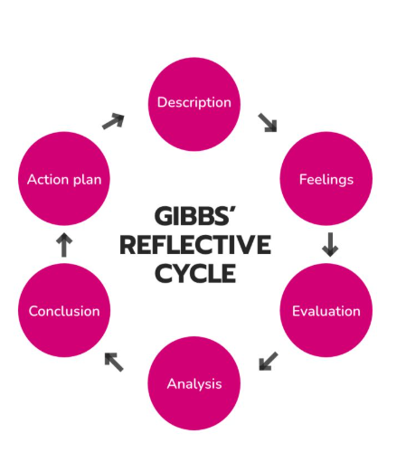
Figure: Gibbs Reflective Cycle
Source: (Stoller, 2021)
I have conducted a thorough analysis to evaluate the aspect of workplace conditions on staff retention at Hilton Hotels. To further discuss my experience while completing this dissertation, I will be using the Gibbs Reflective Cycle. After receiving this research topic, I conducted thorough market research to become aware of the situation of different employees in the hotel sector. I realised that employees are considered to be one of the important elements for a particular entity to achieve success (Stoller, 2021). I also realised that the human resource manager of the business is needed to recruit skilled and proficient working members to meet the organisational needs. Fulfilling the different types of organisational needs helps a company to gain a competitive advantage in the sector. As stated earlier, I conducted this thorough evaluation on the company Hilton Hotels. Currently, the senior administrators have remained quite successful in enhancing the engagement of the existing workers in the business environment. However, I faced various challenges while conducting a thorough evaluation of the current situation regarding the impact of the strategies on the retention rates of the employees in Hilton Hotels. One of the major hurdles that I encountered was that I failed to gather specific information about this hotel business due to the lack of keywords (Margie Warrell, 2023). Realising this mistake, I conducted my research by using the particular keywords. Apart from this challenge, I also faced hurdles in completing the entire topic within the required time period. Being an academic student, completing the dissertation is considered to be one of the major goals that I needed to complete. Therefore, these are the various challenges that I encountered while researching this particular topic of the study. Regarding these situations, my teachers and seniors have helped me gather the data and information based on the topic of improving employee retention rates in the business. Hence, I can say that these are considered to be both the positive and negative experiences that I experienced while completing this specific research. Completing this research analysis, I have enhanced my research abilities and time management abilities (Forbes, 2026). My teachers have helped me maintain a specific schedule for gathering the specific pieces of data and information based on the topic of the research. Utilising the particular keywords has helped me to accumulate the particular data in the current market situation of the employees of Hilton Hotels. For the future, I can say that I need to maintain a proper timetable for conducting a thorough evaluation of this specific topic.

Conclusion
This essay has used the Gibbs Reflective Cycle to explain the experience that the student gathered while completing this particular research. Skills like time management and research abilities have been thoroughly discussed to explain the research.

References
Forbes, (2026). Why Most Time Management Techniques Fail High-Achievers. [Online] Available at: https://www.forbes.com/sites/cynthiapong/2026/06/14/why-most-time-management-techniques-fail-high-achievers/ [Accessed 05 August 2026].
Margie Warrell, (2023). Failing Is Hard, But Not Near As Hard As Learning From It.. [Online] Available at: https://www.forbes.com/sites/margiewarrell/2023/12/19/think-failure-is-hard-try-learning-from-it/ [Accessed 05 August 2026].
Stoller, K., (2021). Employees Are More Vital To A Company’s Success Than Shareholders, New Survey Finds. [Online] Available at: https://www.forbes.com/sites/kristinstoller/2021/05/20/employees-are-more-vital-to-a-companys-success-than-shareholders-new-survey-finds/ [Accessed 06 August 2026].

Element 3: Poster and Methodology Summary

Module Name: Independent Project
Module Code: LCLM6005
Assignment Type: Poster
Element 3: Methodology Poster

Research Title: The impact of workplace conditions on staff retention: a study of Hilton Hotels
Student Name: Diana
Student ID: 2316296

Table of Contents
Poster 3
Research process 4
Research output 5
References 6

Poster
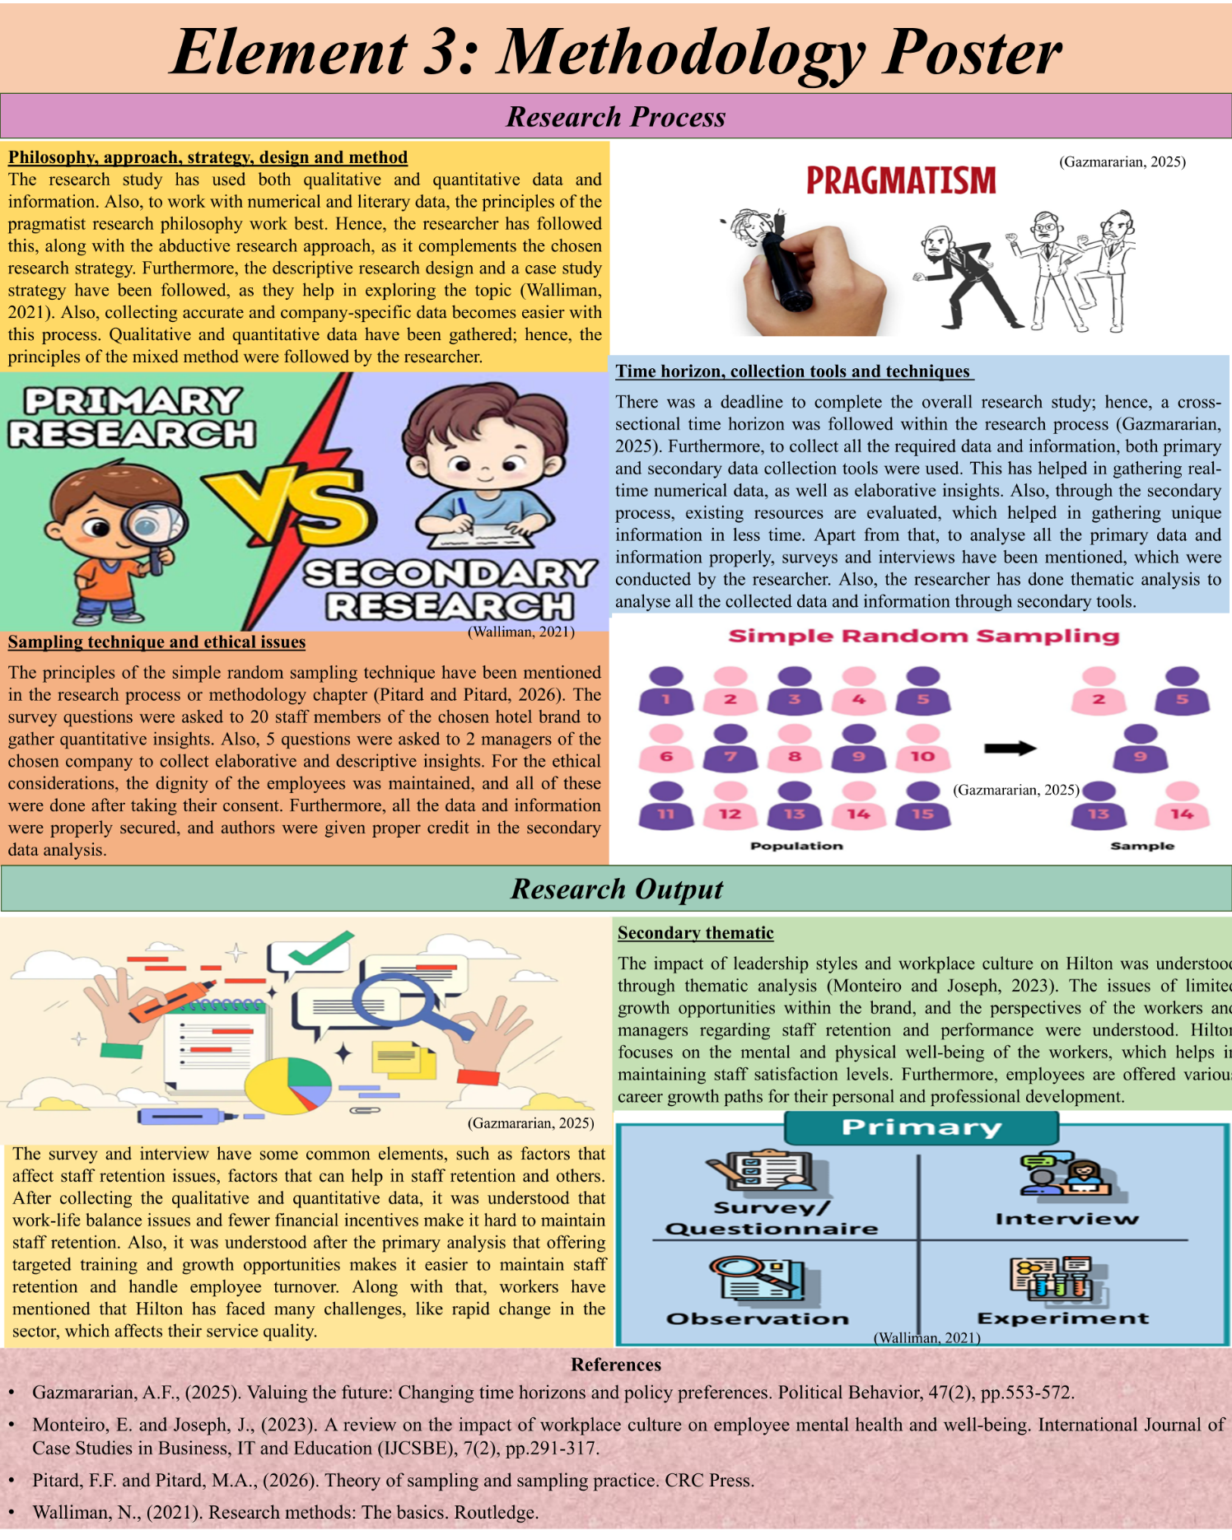

Research process
Philosophy, approach, strategy, design and method
The research study has used both qualitative and quantitative data and information. Also, to work with numerical and literary data, the principles of the pragmatist research philosophy work best. Hence, the researcher has followed this, along with the abductive research approach, as it complements the chosen research strategy. Furthermore, the descriptive research design and a case study strategy have been followed, as they help in exploring the topic (Walliman, 2021). Also, collecting accurate and company-specific data becomes easier with this process. Qualitative and quantitative data have been gathered; hence, the principles of the mixed method were followed by the researcher.
Time horizon, collection tools and techniques
There was a deadline to complete the overall research study; hence, the cross-sectional time horizon has been followed within the research process (Gazmararian, 2025). Furthermore, to collect all the required data and information, both primary and secondary data collection tools have been used. This has helped in gathering real-time numerical data, as well as elaborative insights. Also, through the secondary process, existing resources are evaluated, which helped in gathering unique information in less time. Apart from that, to analyse all the primary data and information properly, surveys and interviews have been mentioned, which were followed by the researcher. Also, the researcher has done thematic analysis to analyse all the collected data and information through secondary tools.
Sampling technique and ethical issues
The principles of the simple random sampling technique have been mentioned in the research process or methodology chapter (Pitard and Pitard, 2026). The survey questions were asked to 20 staff members of the chosen hotel brand to gather quantitative insights. Also, 5 questions were asked to 2 managers of the chosen company to collect elaborative and descriptive insights. For the ethical considerations, the dignity of the employees was maintained, and all of these were done after taking their consent. Furthermore, all the data and information were properly secured, and authors were given proper credit in the secondary data analysis.

Research output
Primary survey and interview
The survey and interview have some common elements, such as factors that affect staff retention issues, factors that can help in staff retention and others. After collecting the qualitative and quantitative data, it was understood that work-life balance issues and fewer financial incentives make it hard to maintain staff retention. Also, it was understood after the primary analysis that offering targeted training and growth opportunities makes it easier to maintain staff retention and handle employee turnover. Along with that, workers have mentioned that Hilton has faced many challenges, like rapid change in the sector, which affects their service quality.
Secondary thematic
The impact of leadership styles and workplace culture on Hilton was understood through thematic analysis (Monteiro and Joseph, 2023). The issues of limited growth opportunities within the brand, and the perspectives of the workers and managers regarding staff retention and performance were understood. Hilton focuses on the mental and physical well-being of the workers, which helps in maintaining staff satisfaction levels. Furthermore, employees are offered various career growth paths for their personal and professional development.

References
Gazmararian, A.F., (2025). Valuing the future: Changing time horizons and policy preferences. Political Behavior, 47(2), pp.553-572.
Monteiro, E. and Joseph, J., (2023). A review on the impact of workplace culture on employee mental health and well-being. International Journal of Case Studies in Business, IT and Education (IJCSBE), 7(2), pp.291-317.
Pitard, F.F. and Pitard, M.A., (2026). Theory of sampling and sampling practice. CRC Press.
Walliman, N., (2021). Research methods: The basics. Routledge.

;

