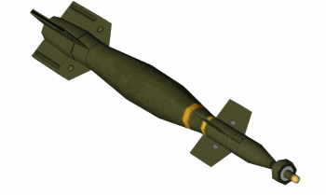

Munitions Assignment
  - Testing of enhanced paveway ii bomb
George Atkins |Test Range Engineering | 01/07/2017
Contents
Introduction 1
Paveway II 2
Data Capture 3
Trials Safety 5
Trial Conduct 6
Trial Set-up 6
Works Cited 7

Introduction
The purpose of this document is to detail a potential solution for delivering a trial to trial various attributes of an UK in-service Enhanced Paveway II Bomb. A description of the munition shall be given as well as the command methods used to deliver the munition to its intended target. A proposed trial set-up that achieves all the customer requirements will be detailed, this set-up has considered all data capture and safety aspects involved with the trial in order for the test to successfully acquire all the necessary data whilst maintaining exemplary levels of safety to both trials staff and members of the public. The justification for this trial set up shall be covered in the data capture and trials safety sections of the document. A brief description of trial conduct shall then be given, followed by a conclusion.
  - Aim of trial
- Evaluate the accuracy and warhead performance of the UK in-service Enhanced Paveway II Bomb.
  - Objectives
- Recordings of the laser spot positions on the selected target must be provided.
- Measurements of the distance between the laser spot and point of munition warhead detonation must be provided.
- The fragmentation pattern of the detonated warhead must be provided.

Paveway II
“The Paveway™ family of laser guided bombs has revolutionized tactical air-to-ground warfare by converting "dumb" bombs into precision guided munitions. Paveway bombs have been put to the test in every major conflict and proved themselves, time and again, as the weapon of choice by the end-users. They made up more than half the air-to-ground precision guided weapons used in Operation Iraqi Freedom.” (1)
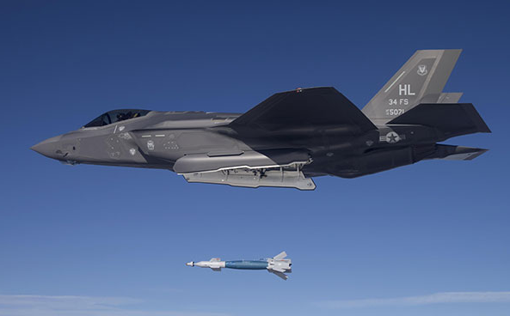
An Enhanced Paveway II bomb being dropped from an F-35A Jet (Photo: U.S. Air Force)
The Enhanced Paveway II (EPWII) entered service in to the Royal Air Force in 2001 and is carried to war on the Tornado GR4 fixed wing aircraft. The EPWII is based on the previous Paveway II bomb and uses the same warhead and fin sections. The addition of a modified guidance section and accommodation for the wiring of a Global Positioning System Aided Inertial Navigation System (GAINS) makes the weapon enhanced.
During poor weather conditions, the weapon can be guided to its target using Global Positioning System (GPS) information as well as guidance from its on-board inertial navigation unit (GAINS). In good weather, the weapon may be guided using laser guidance, which can be provided from the air or from ground forces. (2)
The EPWII specifications are shown in the below table. (3)
All-up weight | 545Kg
Warhead weight | 450KG
Warhead composition | PBXN-109
Length of bomb | 3.55m
Diameter of Bomb | 1.67m (fins deployed)

Data Capture
There are three observations on the trial that the customer wishes to make during the trial.
- Laser spot positions on the target.
- Distance between the laser spot position and point of warhead detonation.
- Fragmentation pattern produced by the detonation of the warhead.
The potential methods for recording each of these shall be discussed and then the justification for the method chosen shall be disclosed.
The laser spot position on the target can be recorded in several ways, the first of which is direct measurement. When the laser is shone onto the target, the spot can physically be measured using a calibrated tape to give a horizontal and vertical distance from a known datum (traditionally bottom left corner of target) to the laser spot. This requires the laser to be operating whilst it is measured just before firing however, which may present a safety concern depending on the strength of the laser. This method can be replicated remotely, by having a measurement grid painted, projected or otherwise affixed to the target and then using a remotely operated CCTV camera to see where the laser marker strikes the target. The grid must have known distances between the lines on it which can vary depending on how accurate the customer wants to be. The author believes that whilst there is merit to the first solution, the second is the most suitable in this case, as continual CCTV coverage of the laser spot shall ensure that even if the spot moves slightly during firing, the most up-to-date laser spot shall be recorded.
The exact distance between the laser spot and the point at which the warhead impacts the target shall be very difficult to measure due to the speed at which the event will occur. One method of recording this dimension is to repurpose some target velocity foils, whereby the target is covered in a grid of velocity foils which produce a short-circuit when metal hits them. When the bomb lands on a foil, a short circuit is produced, this is recorded by the SABRE system, as each foil has its own channel going into the system it is apparent which foil has been short circuited, therefore giving you a location of bomb strike. However, it is also possible to achieve by slightly altering the grid target method mentioned above. Instead of utilizing regular speed CCTV cameras to observe the laser spot positions, an array of high speed video cameras can be used (typically phantom cameras). These high-speed cameras can be capable of recording footage at very high frame rates, meaning that they will be capable of seeing the exact moment that the nose of the warhead strikes the target and therefore, an accurate measurement of the distance between the laser spot and the point of impact should be achievable. The opinion of the author is that there is a lot that can go wrong with the foil method, false returns can be a problem with velocity foils and they are unsuitable for use in rainy conditions. Also, there is the potential for the warhead fragmentation to impact the foils microseconds after detonation, causing further short-circuits, this can lead to confusion when trying to identify which short-circuit was the warhead, rather than a fragment. It therefore makes sense to use the grid technique coupled with high-speed digital photography, thereby recording two observations with a single method, the laser spot position and the distance between said laser spot and the point of impact.
Measuring the fragmentation pattern of the warhead is probably the simplest requirement to achieve as capturing and measuring fragmentation patterns is something that the author is familiar with, unlike the previous two requirements. Fragmentation can be captured in thick strawboard packs which are made up of many thinner cards. After the trial, the packs are analysed one card at a time and the position of all the fragments in the card are plotted, any fragments found in that card are collected and weighed and the process is repeated, card by card. Usually these packs are arranged in a semicircular fashion around a test item and the fragments therefore only captured on one side, however due to the EPWII being dropped from the sky, it seems prudent to the author that a full circle arena can be used to accurately plot fragmentation patterns.
Proposed Trial Set-up for Data Capture
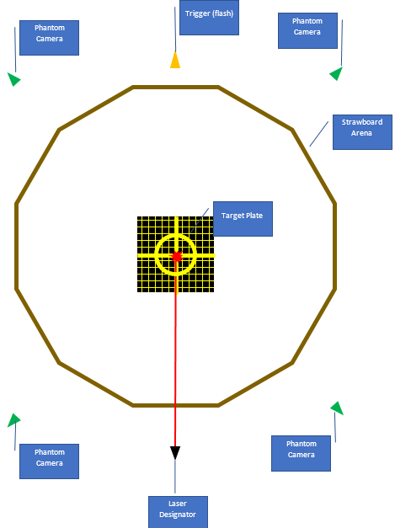
Based on the potential methods discussed earlier, the diagram to the left shows what the author believes to be the most suitable data capture method. A 12-sided arena of packs shall provide the means to capture the majority of fragments produced. Each pack shall be 10m long, giving a target centre to pack distance of 19m. The laser designator shall be mounted on a stand looking over the packs and trained onto the centre of the target. Phantom cameras shall be similarly mounted on stands in four corners looking in, these four cameras shall record the distance between laser spot and impact and provide video of the explosion.

Trials Safety
In any trial, it is a requirement that a safe system of work is established prior to the commencement of any activity. A safe system of work consists of four parts:
- A safe place to conduct the activity.
- Safe equipment to conduct the activity with.
- Safe people to conduct the activity.
- Safe working practices to conduct the activity to.
A safe place to conduct the trial is required. A safe place should be safe for the people who are working there but should also keep people who aren’t working there safe specifically, the general public. Due to this trial involving military aircraft dropping live ordnance, a large area of airspace free from other aircraft is required. This is achieved by applying a notice to airmen. “A Notice to Airmen (NOTAM) is a notice filed with an aviation authority to alert aircraft pilots of potential hazards along a flight route or at a location that could affect the safety of the flight.” (4) The airspace can be monitored to ensure that is clear by a variety of different RADARs, if the RADAR picks up a contact that is not the aircraft delivering the munition, then the trial shall not go ahead until said aircraft is out of the airspace.
The public must also be kept away from the land element of the range, for two reasons: their own safety; and to keep them away from information that could potentially be sensitive. This is done in a fairly standard fashion: fences around the perimeter of the site; regular guard patrols; and strict admittance policies such as pass control.
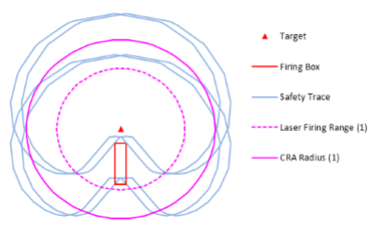
The safe equipment includes the EPWII bomb and all trials equipment used during the trials preparation, firing and de-prep phases. The EPWII bomb has several safety features, the bomb can be guided using either laser designation or GAINS of a combination of both. If the laser is hidden by clouds or something then the weapon can be delivered using GPS, which controls the canard fins using a compressed gas generator. If the cloud cover clears before impact the bomb can lock on to the laser again for a more accurate delivery. Therefore, with both laser designation and accurate GPS co-ordinates being provided to the aircraft, the bomb should not miss its target. A safety trace shall be constructed to make it obvious what areas need to be clear for this job, an example safety trace is shown here.
Other safety concerns include the generic trials prep and de-prep and the risks associated with these tasks. Although trials staff are well versed in the construction of strawboard arenas using plant machinery etc. risk assessments for the trials prep and de-prep tasks would have to be carried out. During the conduct of the trial there are several hazards that are present, noise and blast being the main ones. Noise measurements are to be carried out and hearing protection must be worn during the trial, all staff are to be located in the blast-proof bunkers during the firing.
The people conducting the trials activity must be trained and competent to the level required for the trial. It is assumed that the Tornado pilot is competent to fly the aircraft and drop bombs and that he hasn’t just been given the keys to a £30 million jet plane with no training. The trials staff must be competent to construct the trials arena and trials safety staff must be competent to keep the desired airspace sanitised and to control the approach and time of release of the tornado aircraft.

Trial Conduct
outline of Firing Plan
The EPWII bomb is to be dropped onto the target plate designated by a ground deployed laser. The exact co-ordinates of the target cone shall also be supplied to the bomber, to allow the EPWII to use GAINS to find its target should the weather be poor. The bomb shall be dropped from a Tornado attack craft. The altitude from which the bomb is to be dropped is yet to be decided as is the approach angle of the aircraft, due to potential weather constraints on the appointed day of firing.
  - Trials preperation
The preparation for this trial shall be carried out by trained and competent agency staff, who are tasked with the construction of the strawboard arena. Prior to firing all staff, including the jet pilot, will be briefed on what is expected of them from the trial and what their roles and responsibilities are.
conducting the firing
The trial is to be conducted alongside the RAF whose own procedures shall cover all activities pertaining to the aircraft, including (but not limited to): loading of munition to aircraft; releasing munition from aircraft; safe flight of aircraft; and delivery of munition to the laser spot. All instrumentation and safety aspects post munition release from the aircraft are the concern of the agency tasked with this job.

Conclusion
This concludes an extremely basic trials design solution for a trial from a very basic set of customer requirements in an area of trials with which the author is not familiar. However, the thought process of capturing the correct data and ensuring that everything is carried out safely has hopefully been showcased by the author. The inclusion of the described target set up would theoretically capture all of the data required but the author has some reservations about the method, mainly the arena would have to be massive so as not to be destroyed by the blast effects of the warhead. Other areas that the author could have improved upon was the method of maintaining sanitised airspace and how that is actually achieved, he just applied the procedure that he knows from working at MoD Pendine where only a small airspace is NOTAMed, the airspace for this EPWII trial would have to be much larger.

Works Cited
1. [Online] http://www.raytheon.co.uk/capabilities/products/paveway-laser-guided-bomb/.
2. [Online] https://www.raf.mod.uk/equipment/enhancedpaveway.cfm.
3. Air Warfare Centre. Trials Specifications EPW2,PW2,PW3,EPW3, PW4. Aberporth : Range Coordination Unit, 2016.
4. [Online] https://en.wikipedia.org/wiki/NOTAM.

