MSC PUBLIC HEALTH AND SOCIAL CARE IN PRACTICE

ASSIGNMENT TITLE: COMPONENT 1 INFORMATION BOOKLET OF LONG-TERM CONDITION MANAGEMENT

MODULE CODE: LCHS7003
Programme Name: MSC Public Health and Social Care in Practice
Student Name: Nilesh Patil
Student ID: 2523930
Submission Date: 19th March
Lecturer: Muhammad Khan

Institution: University of Wales trinity saint David London Campus
City, Country: London UK

Table of Contents
Introduction 3
Main Body 3
Analysis of long-term health condition 3
Critical evaluation of influence of long-term condition by focusing on social, psychological and physical implications 4
Analysis of theoretical perspectives 7
Examination of implementation of national and local political health and social care agendas 9
Recommendations for improvement of person-centered care 11
Conclusion 11
References 12

Introduction
Heart Failure has been identified as a major health concern leading to negative implications on the lives of individuals in the long run. Heart Failure has been a complex syndrome affecting socio-economic, psychological and physical health of individuals (Yang et al. 2024). The information booklet presents long-term health conditions of Heart Failure and conditions of management in the UK. The analysis of the health conditions in the psychological, physical and social dimensions are explored along with referring to theoretical perspectives. The booklet covers national and local political health along with agendas of social care in regard to Heart Failure.

Definition
Heart failure is a serious health condition where the heart muscle lacks the ability to pump sufficient blood to meet the needs of the body. Moreover, the heart health in the UK has been declining and is considered a worrying trend in the UK market. It is evident that there is a 21% rise in the individuals diagnosed with heart failure in the UK to the recorded margin of 785,000 in 2024 compared to 2020 (Kirby, 2025). The development of risk of Heart failure has occurred due to specific etiologies such as “premature vascular dysfunction”, cardio-toxic responses and metabolic stress. Hypertension has been identified as the major risk factor leading to the health condition of Heart failure (Domengé et al. 2022). Therefore, the long period instances of hypertension have raised the risk of occurrence of Heart Failure disrupting normal health conditions.
The Heart Failure related to aspects of high morbidity and mortality along with lack of functional capacity and poor life quality have raised the substantial burden on the system of healthcare. The main reason for the rise of prevalence of Heart Failure has been because of the aging population. The rise in the rates of Heart Failure incidents encountered by individuals globally have resulted in increasing the healthcare cost (Shahim et al. 2023).

- Prevalence
3.1 National Prevalence (UK)
Heart Failure has been a major health issue in the UK along with in the global landscape. It is evident that nearly 920,000 individuals have suffered Heart Failure in the UK with nearly 200,000 diagnosed newly every year (NHS, 2025). Heart Failure has reduced the life-expectancy with nearly survival rate for one year after the diagnosis process. The rise in incidence of Heart Failure have resulted in rising burden on the healthcare system in regard to bed utilisation and cost prospects (Kwok et al. 2025). Heart diseases have raised the cost of the healthcare system in regard to the treatment process along with raising the financial burden among individuals in obtaining better diagnosis and treatment facilities. It is evident that heart disease has been estimated to cost the healthcare system of the UK by nearly £7.4 billion on a yearly basis (Bawden, 2024).
3.2 Worldwide
It is evident that Heart failure has affected nearly 64 million individuals in the global context and prevalence rate is high among patients aged above 60 years (World Heart Federation, 2025)

- Risk factor
Furthermore, Coronary artery disease has been the main reason for Heart Failure that has risen due to buildup of fatty deposits in arteries. The specified deposits have narrowed down the arteries leading to reduction of blood flow and rising instances of heart attack. The irregular heartbeats, sleep apnea, obesity and congenital heart disease are main causes and risk factors of rising incidents of Heart Failure (Mayo Clinic, 2025). The risk factors have impacted on deterioration of health conditions of individuals through getting chances of Heart Failure. The above mentioned risk factors have reduced the ability of the heart to pump the blood resulting in reduction of physical capability and instances of Heart Failure. The lack of management of the risk factors at the initial stage have caused detrimental impact leading to impairing the long period of life quality and health conditions of individuals.

5. Critical evaluation of influence of long-term condition by focusing on social, psychological and physical implications
The Heart failure symptoms have varied in context of different individuals leading to physical implications. Heart failure common symptoms are fatigue, fainting, feeling lightheaded, swollen legs, ankles and breathlessness (NHS, 2022). The mentioned symptoms encountered by individuals physically have resulted in limiting mobility along with daily functioning of activities.
On the other note, patients suffering from Heart failure have encountered psychological aspects like anxiety and depression. These factors are related to negative outcomes like decreasing adherence towards poor function and treatment (Sumaqa et al. 2023).

Apart from this, patients with the issue of Heart failure have experienced social isolation related to the rise of the risk of expenditures for healthcare, mortality and morbidity. Lack of interaction and movement are main aspects of Heart failure contributing towards negative implication on social life (Polikandrioti, 2022). However, in regard to reducing the negative implication of Heart failure on the lives of people “National Health Service (NHS)” have implemented evidence based treatment approaches. The “mineral corticoid receptor antagonists”, “Angiotensin-converting enzyme (ACE)” inhibitors, beta blockers, sacubitril valsartan and others are considered as main medicines by the NHS for addressing Heart failure health conditions.(NHS, 2023) The common devices utilised for controlling and monitoring the health rhythm and preventing heart failure are “implantable cardioverter defibrillators (ICDs)”, “cardiac resynchronisation therapy (CRT) devices” and pacemakers (NHS, 2022). The integration approach of medicine and devices by the NHS has been identified for management of the health condition of Heart failure.
- Wider Implications on Families and Caregivers
The journey of Heart Failure has adversely impacted on the social, mental along with physical aspects of patients as well as caregivers. The instance of Heart Failure can lead to rise uncertainty, isolation, anxiety, depression and fear among patients and families involved in the care delivery process. The management of Heart Failure has been complex and raises the need of balancing the psychological requirements and the physical activity. It has been evident that patients suffering from Heart failure have developed depression and severe anxiety leading to worsening physical activity and reduction of self-care approaches (Shamiri et al. 2023). However, lack of effective management of psychological distress raises the risk of heart failure among patients.Figure 1 indicates that socio-economic deprivation has been responsible for worsening and long term negative impact on lives of individuals due to Heart Failure. Poverty, poor housing, unemployment, low education level, healthcare underutilisation, low accessibility towards nutritional foods and environmental stressors have raised exposure towards risk factors of Heart failure. (British Heart Foundation, 2023; World Health Organization, 2023). This has also reduced the aspect of attaining preventive care and delayed the process of diagnosis. This further has led to rise in disability, financial toxicity due to medical cost, social isolation, decreased quality of the life and care giving burden on the family (Akpabio et al. 2025). In this regard, the environmental stressors such as air pollution have also an underlying impact on the rise of Heart Failure. It is evident that individuals residing in the UK have experienced the worst levels of air pollution ranging to 27% leading to development of Heart Failure in comparison of cleanest air areas (Gregory, 2025). Therefore, socio economic factors and psychological stress factors are responsible for deterioration of heart health and implying negative condition of Heart Failure on individuals.

7. Analysis of theoretical perspectives

7.1 UK Model- House of Care
An essential framework for treating chronic illnesses like heart failure in the National Health Service is provided by the Chronic Care Model. In order to improve long-term health outcomes, the model highlights the significance of enhancing interactions between proactive healthcare staff and informed patients. The Chronic Care Model's tenets underpin the transition in the UK healthcare system from hospital-centered to more integrated and community-based heart failure management strategies (Wagner et al., 1996; NHS, 2022). Self-management support, which encourages patients to actively participate in managing their disease, is one of the model's key components. In order to help people with heart failure effectively manage their symptoms and take their prescriptions as directed, the NHS system offers patient education, lifestyle modifications, and routine monitoring programs. These strategies have been demonstrated to lower hospital admissions and enhance heart failure patients' quality of life (NHS, 2022). The delivery system design, which encourages coordinated care through interdisciplinary cooperation, is another essential element of the approach. In the UK, multidisciplinary teams (MDTs) comprising cardiologists, specialized nurses, pharmacists, and general practitioners are frequently used to provide heart failure therapy. This cooperative strategy guarantees thorough and ongoing care in various healthcare environments (NHS, 2024). Additionally, the model highlights the use of clinical information systems and decision support, which allow medical professionals to successfully monitor patient outcomes and adhere to evidence-based guidelines. The NHS's digital health records and monitoring technologies make it easier to spot problems early and take prompt action, which eventually improves heart failure management (NHS, 2022). As a result, the Chronic Care Model's implementation in the UK healthcare system promotes integrated care delivery and improves long-term management techniques for people with heart failure.

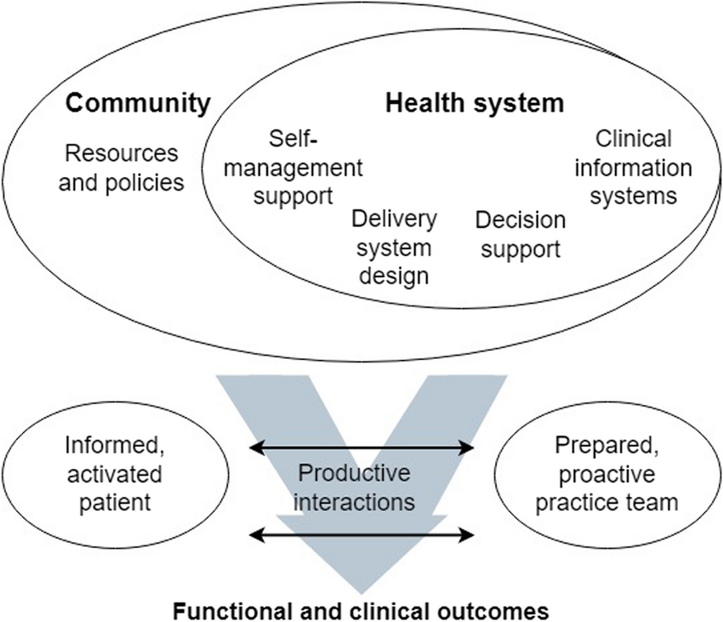
Figure 3: Chronic Care Model
(Source: Bemd et al. 2024)
7.2 International Model
The “Chronic Care Model” is the internationally identified framework for effective management of long-term health conditions. The model illustrates that the health system has to focus on self-management, decision support, clinical information and delivery systems along with referring to community prospects. The informed patients through productive interactions has been possible by presence of proactive teams (Bemd et al. 2024). The effective system of health and better workforce ensures the reduction of the instances of hospitalisation of individuals through ensuring psychological well-being. The “Chronic Care Model” has provided the insights regarding the enhancement of effectiveness and quality of “chronic disease management”. The six vital components of “Chronic Care Model” are self-management support, decision support, community resources, delivery system design, health system organisation and Clinical information system. The systematic approach has been highlighted by the “Chronic Care Model” that directs the approach in management of chronic diseases. This has indicated the proactive and patient-centered care segment through effective collaboration among the system of healthcare (Peyroteo and Lapão, 2025). In the context of Heart Failure instances, self-management has supported in empowering patients with adequate skills and knowledge for management of long term health conditions. Decision support aids in providing evidence based care and tracking of patients and outcomes through clinical information systems reduces long term negative implication of Heart Failure. The effective management of clinical outcomes and adequate knowledge along with better health prospects have nurtured the long period of health conditions suffering from Heart Failure. However, Jin et al. (2025), stated that poor knowledge, inadequate practices and negative attitudes have been associated with the adverse outcomes. Therefore, the informed knowledge and better health care facilities are considered to deliver better health services in regard to management of the problem of Heart Failure.

8. Examination of implementation of national and local political health and social care agendas
The policies introduced by the NHS through the “NHS Long Term Plan” have intended towards prevention, early phase diagnosis and long period management of the issue of Heart failure. NHS has focused on initiation of management of Heart failure at home through remote monitoring. Moreover the enabling of the supported aspects of self-management for understanding symptoms and signs of Heart failure for seeking interventions have ensured the avoidance of unnecessary admission to hospitals (NHS, 2025). However, shortage of staff has limited the capability of the NHS in delivering quality and quantity care services. This also impacted the well-being of staff and disrupted the work outcomes in terms of care service delivery (NHS, 2024). Apart from this, the “Integrated care systems (ICSs)” are referred to as partnerships that ensure bringing together the organisation of NHS and local authorities in taking collective action and responsibility. This eases the planning of care services, enhancing health delivery and reduction of inequalities across diversified geographical locations (Charles, 2022). Therefore, national and local health care agendas and approaches have promoted development prospects for treating aspects of Heart Failure.
The “Department of Health and Social Care” have recognised the aspect of digital transformation of adequate health services as the main priority for the Government as well as for the NHS. The digital health initiatives undertaken by “Department of Health and Social Care” part of Government of the UK has included applications, wearable’s and smart phones. This has included the context of activity tracker and connected patches for sensors of heart rate and glucose monitor. Moreover, the automated digital therapy such as Sleepio identified as a personalised programme towards addressing insomnia have ensured in delivering better health outcomes (UK Parliament, 2022). This directs that automated and digital approaches in health prospects have aided support towards addressing long term implications of Heart Failure disrupting the quality life prospects. The “BEAT-Heart Failure campaign” has been recognised as the first UK based awareness campaign for the disease of Heart Failure. The main intent of the campaign has been regarding improvement of awareness of Heart Failure through the early identification of major symptoms such as Ankle swelling, exhaustion and breathlessness (Walsh, 2025). The above mentioned initiatives have been responsible for driving the promotional initiatives for management of long-term health conditions related to Heart Failure in the UK. Awareness of people along with digital health approaches have shaped the lives of individuals suffering with Heart Failure and positive implications on long-term health management.
The services of “Heart failure specialist nurse (HFSN)” have been established in the UK for ensuring adequate management of long term conditions of Heart Failure. The mentioned services have led to reduction of hospital admission along with associated costs for the treatment of Heart Failure. The cardiac rehabilitation, palliative and social care have helped in engaging patients and raising accessibility for treatment of Heart Failure (British Heart Foundation, 2022). The ICBs has worked with the "cardiac clinical networks” for understanding needs of the population suffering from Heart Failure for effective delivery of better care at wards. The main care agendas or identified drivers for the change process are early diagnosis, co-morbidity management, personalisation, advanced care planning and optimal treatment along with secondary prevention (NHS, 2023). The above mentioned agendas have been responsible for the early process of diagnosis, prevention and delivery of personalised care for reduction of hospital admissions and rate of mortality related with the risk of Heart Failure. Therefore, the political and social agendas have ensued in promotion of development prospects in regard to management of the long period condition of Heart Failure.

9. Recommendations for improvement of person-centered care
Strengthening programs of self-management: Structured information and knowledge regarding self-management need to be focused by healthcare services for effective addressing of instances of Heart Failure. Planned, patient-centered and structured programmes have ensured better developments in practices of self-care among patients suffering from Heart failure (Jasser et al. 2026). Moreover, self-management growth along with shared decisions with family enhances management of risk aspects of Heart failure.
Integrating early phase care planning: The effective planning at early phase through support and evaluation of care preferences assists in enhancing care services. Planning through lowering blood pressure, healthy behaviors and adequate lipid management assists in reduction of risk of Heart failure (Upadhya et al. 2023). Effective planning enhances life quality and prevention of life threatening instances in regard to the incident of Heart Failure disrupting long term health.
Community based support: The community based system of support has ensured reduction of isolation and promotion of the shared learning among caregivers and patients. As stated by Silva et al. (2025), community based initiatives of support have ensured in strengthening the social bonds along with addressing the psychological problems. This has ensured in empowering individuals for regaining control over their own lives and management of the recovery process. The support network extends benefits in delivering person-centered care through ensuring better social, physical and psychological support extending assistance in addressing the health issue of Heart Failure disrupting quality living of individuals.

10. End-of-Life Care in Heart Failure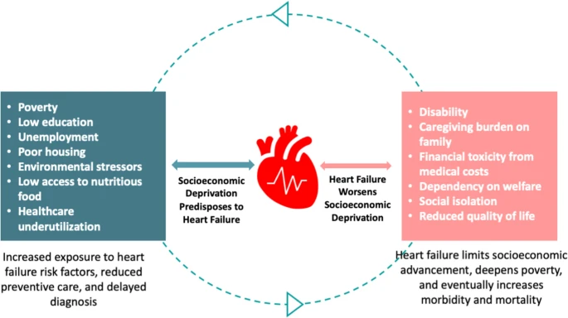
Figure 1: Relationship among socio-economic deprivation and rising of Heart failure
(Source: Akpabio et al. 2025)
The cognitive impairment has been the common factor in cases of Heart Failure leading to rise in the risk of dementia. The “Anatomical brain changes” has been evident among patients suffering from Heart Failure leading to poor functional independence, self-care and physical activity. This has resulted in instances of frequent hospitalisation along with rising risk of mortality. The figure 2 indicates that Heart Failure has close connection with brain changes leading to poor outcomes in daily lives of people. Heart Failure leading to cerebral hypo perfusion, impaired auto regulation, systemic inflammation, thromboembolic disease and the infarction along with proteotoxicity from the protein misfolding. This impact on brain changes such as cognitive and anatomical changes leading to reduction of self-care, rise in hospitalisation and poor physical activity (Goh et al. 2022). However, absence of emotional support from family and living alone of patients have been major concerns for raising psychological distress among Heart Failure patients. In this regard, social support provided from family and friends have been associated with lowering the rate of readmission and effective adherence to medication (Shamali et al. 2025). The information highlights that management of Heart Failure as the complex chronic situation has a requirement of integration of the person-centered care for development of well-being of patients with Heart Failure. Therefore, Heart Failure have exerted profound impact on patients and their families social, physical and psychological segment of life.
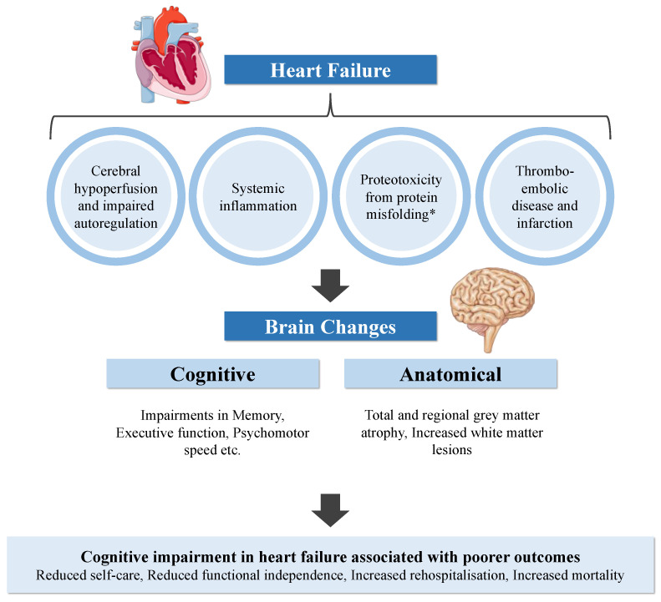
Figure 2: Heart failure impacting on cognitive impairment
(Source: Goh et al. 2022)

11.Conclusion
The effective management and adherence to treatment process have ensured prevention and management of the issue of Heart failure. Heart Failure has remained as the main long term period challenge in the UK leading to profound impact on psychological, social and physical implication on individuals and their families. The ageing population and risk factors related to lifestyle are major drivers towards raising burden on the healthcare system due to the Heart Failure incident. The strengthening of person-centered care can be focused through community based initiatives associated with supporting the individuals suffering from Heart Failure. Recommended measures are figured out in regard to ensure delivery of person-centered care services. The community assistance can ensure a reduction of feelings of social isolation leading to better cognitive ability of patients in management of Heart Failure long term condition.

12.References
Akpabio, E.I., Ilonze, O.J., Appiah, D., Fonkoue, I.T. and Ebong, I.A. (2025). An overview of the association between socioeconomic deprivation and heart failure. Heart Failure Reviews.
Bawden, A. (2024). Less than half of eligible people received NHS ‘midlife MOT’ since 2019, says watchdog. Available at: https://www.theguardian.com/society/2024/nov/13/less-than-half-of-people-received-nhs-health-check. (Accessed on: 28.02.2026)
Bemd, M. van den , Koks-Leensen, M., Cuypers, M., Leusink, G.L. and Schalk, B. (2024). Care needs of chronically ill patients with intellectual disabilities in Dutch general practice: patients’ and providers’ perspectives. BMC Health Services Research, 24(1).
British Heart Foundation (2022). Heart failure specialist nurses: managing care in the community. Available at: https://www.bhf.org.uk/for-professionals/healthcare-professionals/innovation-in-care/heart-failure-specialist-nurses. (Accessed on: 28.02.2026)
Charles, A. (2022). Integrated Care Systems Explained. Available at: https://www.kingsfund.org.uk/insight-and-analysis/long-reads/integrated-care-systems-explained (Accessed on: 24.02.2026).
Domengé, O., Fayol, A., Ladouceur, M., Wahbi, K., Amar, L., Carette, C., Hagège, A. and Hulot, J.-S. (2022). Trends in prevalence of major etiologies leading to heart failure in young patients: An integrative review. Trends in Cardiovascular Medicine, 34(2), pp.80–88.
Goh, F.Q., Kong, W.K.F., Wong, R.C.C., Chong, Y.F., Chew, N.W.S., Yeo, T.-C., Sharma, V.K., Poh, K.K. and Sia, C.-H. (2022). Cognitive Impairment in Heart Failure—A Review. Biology, 11(2).
Gregory, A. (2025). Millions of Britons face higher risk of heart failure due to dirty air, study suggests. Available at: https://www.theguardian.com/environment/2025/sep/08/millions-of-britons-face-higher-risk-of-heart-failure-due-to-dirty-air-study-suggests. (Accessed on: 28.02.2026)
Hextell, L., Bilbrough, A., Callaghan, D., Hett, D., Mahmood, F., Maynard, C., Rogers, K., Spanjers, K. and Wells, E. (2025). Heart Failure Targeted Funding Programme 2023/24 Evaluation Final Report. Available at: https://www.strategyunitwm.nhs.uk/sites/default/files/2025-10/HFTFP%202023-24%20Evaluation%20Final%20Report%20-%20v1.pdf (Accessed on: 28.02.2026)
Jasser, N.F.A., Hayajneh, F.A. and Abdalrahim, M.S. (2026). The Effect of Educational Programs on Self-Care Behaviors Among Patients with Heart Failure: An Integrative Literature Review. Sage Open Nursing, 12.
Jin, P., Shu, Z., Cui, K., Ou, Z., Li, H. and Luo, Y. (2025). Knowledge, attitudes, and practices regarding heart failure among Chinese patients: a cross-sectional study. BMC Public Health, 25(1).
Kirby, J. (2025). Heart health in the UK is declining rapidly in ‘worrying trend’. Here’s why. Available at: https://www.independent.co.uk/life-style/health-and-families/heart-failure-symptoms-health-bhf-b2754194.html. (Accessed on: 24.02.2026)
Kwok, C.S., Piper, S.E., Deaton, C., Masters, J. and Duckett, S. (2025). Heart failure services from the hospital perspective in the UK: a cross-sectional survey. British Journal of Cardiology.
Mayo Clinic (2025). Heart failure. Available at: https://www.mayoclinic.org/diseases-conditions/heart-failure/symptoms-causes/syc-20373142. (Accessed on: 28.02.2026)
NHS (2022). Heart failure - Symptoms. Available at: https://www.nhs.uk/conditions/heart-failure/symptoms/. (Accessed on: 24.02.2026)
NHS (2022). NHS Long Term Plan. Available at: https://www.england.nhs.uk/long-term-plan/. (Accessed on: 24.02.2026)
NHS (2022). Treatment - Heart Failure. Available at: https://www.nhs.uk/conditions/heart-failure/treatment/. (Accessed on: 24.02.2026)
NHS (2023). NHS England» Guidance note: virtual ward care for people with heart failure. Available at: https://www.england.nhs.uk/long-read/guidance-note-virtual-ward-care-for-people-with-heart-failure/. (Accessed on: 28.02.2026)
NHS (2024). 2024/25 Priorities and Operational Planning Guidance. Available at: https://www.england.nhs.uk/long-read/2024-25-priorities-and-operational-planning-guidance/. (Accessed on: 28.02.2026)
NHS (2024). NHS England - NHS Long Term Workforce Plan. Available at: https://www.england.nhs.uk/long-read/nhs-long-term-workforce-plan-2 (Accessed on: 24.02.2026).
NHS (2025). NHS England» Managing heart failure @home. Available at: https://www.england.nhs.uk/nhs-at-home/managing-heart-failure-at-home/. (Accessed on: 28.02.2026)
NHS (2025). NHS England» Managing heart failure @home.Available at: https://www.england.nhs.uk/nhs-at-home/managing-heart-failure-at-home/. (Accessed on: 24.02.2026)
Peyroteo, M. and Lapão, L.V. (2025). Strategic scenarios for the digitalisation of chronic disease care management: A 10-year foresight case study in Lisbon’s primary healthcare setting. Technological Forecasting and Social Change, 220.
Polikandrioti , M. (2022). Perceived Social Isolation in Heart Failure. Journal of Innovations in Cardiac Rhythm Management, 13(6), pp.5041–5047.
Shahim, B., Kapelios, C.J., Savarese, G. and Lund, L.H. (2023). Global Public Health Burden of Heart Failure: An Updated Review. Cardiac Failure Review, 9.
Shamali, M., Østergaard, B., Svavarsdóttir, E.K., Shahriari, M. and Konradsen, H. (2025). The Role of Nurse Social Support in Hospital Readmission in Patients With Heart Failure: A Cross‐Sectional Study. Health Science Reports, 8(3).
Shamiri, M.Q.A., Almushawah, A.A., Alsomali, A.H., Alsuwayegh, M.B., Aljaffer, M.A., Hayajneh, A.M., Prajjwal, P., Alshamiri, M., Almushawah, A.A., Alsomali, A., Alsuwayegh, M., Aljaffer, M.A., Hayajneh, A. and Prajjwal, P. (2023). The Prevalence of Depression and Anxiety in Heart Failure Patients in Saudi Arabia: An Original Study. Cureus, 15(4).
Silva, C., Henriques, A., Ventura, F. and Lalloo, E.C. (2025). Adaptation of a person-centred care intervention to enhance self-efficacy in patients following a myocardial infarction (P2MIR): a qualitative study exploring the needs and preferences of key stakeholders within a Portuguese healthcare context. BMC Health Services Research, 25(1).
Sumaqa, Y.A., Hayajneh, F., Alhamory, S., Rayan, A., Alnaeem, M.M., Tarawneh, A., Assaf, A., Abu-abbas, M., Suhemat, A. and Ayasreh, I. (2023). Consequences of Psychological Aspects: From Jordanian Heart Failure Patients’ Beliefs. SAGE Open Nursing, 9.
UK Parliament (2022). Digital transformation in the NHS - Health and Social Care Committee. Available at: https://publications.parliament.uk/pa/cm5803/cmselect/cmhealth/223/report.html. (Accessed on: 28.02.2026)
Upadhya, B., Hegde, S., Tannu, M., Stacey, R.B., Kalogeropoulos, A. and Schocken, D.D. (2023). Preventing new-onset heart failure: Intervening at stage A. American Journal of Preventive Cardiology,16.
Walsh, A. (2025). New national heart failure programme launched to improve early diagnosis and patient outcomes. Available at: https://thehealthinnovationnetwork.co.uk/news/new-national-heart-failure-programme-launched-to-improve-early-diagnosis-and-patient-outcomes/. (Accessed on: 28.02.2026)
World Heart Federation (2025). Heart Failure. Available at: https://world-heart-federation.org/what-we-do/heart-failure/. (Accessed on: 24.02.2026)
Yang, M.S., Abdallah, M.B., Bashir, Z. and Khalife, W. (2024). Heart Failure Beyond the Diagnosis: A Narrative Review of Patients’ Perspectives on Daily Life and Challenges. Journal of Clinical Medicine, 13(23).

