THE FINTECH REVOLUTION AND CROSS-BORDER PAYMENTS: OPPORTUNITIES AND CHALLENGES FOR REVOLUT
  - DISSERTATION – PROPOSAL
  - LCBB6000

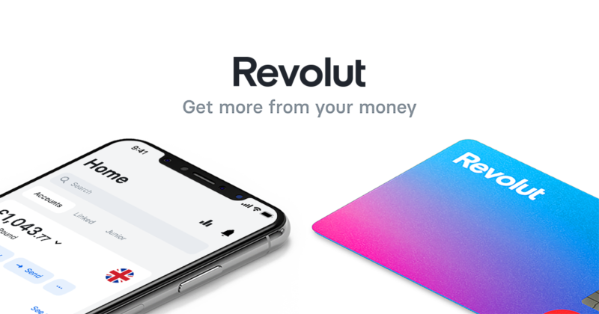
This Photo by Unknown Author is licensed under CC BY-NC-ND

BA (Hons) Business Management
University of Wales Trinity Saint David (London Campus)

Student name – Valeria Peeva
Student ID - 2029005

Submission date – 18/12/23

Table of Contents
INTRODUCTION 3
HISTORY 3
LITERATURE REVIEW 4
Definition 4
Characteristics 4
Importance 4
Models 4
Theories 4
Advantages 4
Disadvantages 4
Challenges 5
RESEARCH METHODS AND METHODOLOGY 5
Research Philosophy 5
Research Model 5
Research Method 5
Research Methodology 5
Research Strategy 6
Sampling Methods 6
Data Collection Methods 6
Ways of Interpreting Data 6
Time Prospects of the Research (Gantt Chart) 6
Ethical Consideration 7
CONCLUSION 7
REFERENCES AND BIBLIOGRAPHY 8

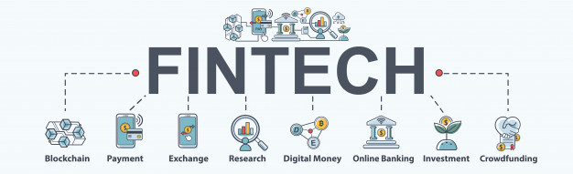
This Photo by Unknown Author is licensed under CC BY-NC

INTRODUCTION
FinTech industry experiences transformed traditional banking, especially in cross-border payments. It is distinguished by its quick technical improvements. The purpose of this dissertation proposal is to investigate the potential and difficulties that Revolut, a well-known FinTech business, presents in the context of international transactions. There are assorted reasons why this research is important. First, it adds to the corpus of information already available on the development of international payments in the FinTech era. Second, it uses Revolut as a case study to offer insightful information on the difficulties experienced by FinTech companies (Adams, 2019). Finally, it provides suggestions and innovative ideas for improving international payment systems. The expected results encompass a sophisticated comprehension of Revolut's position inside the FinTech-driven cross-border payments environment, recognition of the obstacles confronting the enterprise, and investigation of prospects for enhancement and novelty.

HISTORY
Financial technology business Revolut offers a range of services related to money, such as payments and banking. Revolut provides a prepaid debit card, a multi-currency wallet, and other services for managing finances through its own app-based platform. With Revolut, users may transfer and make payments in a variety of currencies at interbank exchange rates. For financing and withdrawal, users can link their Revolut accounts to other bank accounts and credit cards. Vlad Yatsenko and Nikolay Storonsky established Revolut in 2015. Revolut was founded with the goal of providing an alternative to traditional banks for online banking that provides better exchange rates and cheaper costs for foreign transactions. The concept originated from the creators' subjective experiences with expensive fees and unfavourable exchange rates that come with using standard banking services, particularly when traveling and making purchases abroad.
Revolut began by issuing prepaid debit cards prior to the app. After registering for a Revolut card and adding funds via the app, users could use the card to make purchases in many currencies. In comparison to traditional banks, the app allowed users to make transactions at a lesser cost and offered real-time exchange rates. The development of the full-fledged Revolut app, which increased its functionality to include currency conversion, budgeting tools, investment possibilities, and more, was prompted by the prepaid card's success and popularity (Brown and Jones, 2019). Fiscal management is now easier to use and more accessible thanks to the app-based platform. Revolut has experienced rapid development and gained recognition for its innovative approach to financial services and banking. To satisfy the changing needs of its customer base, the company has extended its services internationally and keeps launching new features and goods.

LITERATURE REVIEW
This chapter will examine several topics related to the chosen subject, such as definitions, traits, significance, models, theories, benefits, drawbacks, and difficulties. A thorough grasp of the development of cross-border payments, the rise of FinTech, and the unique function of Revolut in this environment will be provided by the literature review (Chen and Patel, 2018). It will assess current theories and models pertinent to cross-border transactions critically and examine the benefits and drawbacks of FinTech-led developments. In addition, the review will identify gaps in the existing literature that the research wants to fill and highlight difficulties faced by FinTech companies, with a particular focus on Revolut. There is a wealth and diversity of research on the FinTech revolution and how it affects international payments, with a particular emphasis on Revolut. The goal of this chapter is to examine several facets of this fascinating and influential subject.

Definition
The term "FinTech revolution" describes how the financial industry is adopting technology quickly and widely, upending established banking practices. FinTech platforms such as Revolut are innovative digital solutions that simplify and improve international transactions when it comes to cross-border payments (Lee and Kim, 2017, p.577).

Characteristics
The FinTech revolution is characterized by its customer-centricity, agility, and accessibility. Revolut is a well-known FinTech company that exemplifies these qualities with its easy-to-use mobile app, real-time transaction tracking, and smooth cross-border payment execution.

Importance
The potential of the FinTech revolution to improve financial services in terms of inclusivity, efficiency, and affordability is what makes cross-border payments so important (Kim and Patel, 2016, p.222). Revolut offers consumers a practical and cost-effective substitute for conventional banking practices by addressing the demands of a worldwide economy through its borderless banking strategy.

Models
The FinTech industry is supported by a variety of business models, and Revolut uses a disruptive model by providing a full range of financial services without the requirement for a physical branch. This paradigm stresses a digital-first strategy and questions established banking institutions (Kim and Patel, 2016).

Theories
Themes of invention, adoption, and disruption are prevalent in FinTech literature. The disruptive innovation hypothesis, expounded by Clayton Christensen, holds significant relevance as it elucidates how FinTech platforms such as Revolut can pose a challenge to existing companies through the introduction of more efficient and easily available solutions.

Advantages
FinTech platforms such as Revolut offer benefits like improved user experience, reduced transaction costs, real-time processing, and the capacity to serve underbanked or unbanked populations with financial services. These benefits add to the allure and broad usage of these kinds of platforms (Johnson, 2020).

Disadvantages
But it is important to recognize that there could be drawbacks as well, such worries about cybersecurity, difficulties with regulations, and the possibility of technical issues (Garcia, 2018). Comprehending these limitations is crucial for an exhaustive evaluation of the influence of the FinTech revolution on cross-border payments.

Challenges
FinTech and cross-border payments face several challenges, including the requirement for interoperability, cybersecurity concerns, and regulatory obstacles. Revolut may face difficulties in navigating legal frameworks in many authorities and guaranteeing customer data protection (White and Green, 2020).

RESEARCH METHODS AND METHODOLOGY
The research philosophy, paradigm, technique, methodology, and strategy used in this study will all be covered in this chapter. The positivist research philosophy will emphasize an objective and empirical approach to data analysis. Interpretivism will be the dominant paradigm, acknowledging the significance of comprehending consumers' subjective experiences in the context of cross-border payments. The research methodology will be deductive, testing hypotheses by referencing established theories. An analysis of Revolut as a case study is part of the research strategy. Stratified sampling techniques will be used, focusing on Revolut management. It will examine Revolut's opportunities and difficulties in the fintech revolution's field of cross-border payments. Interviews and observational research will be used to gather data, which will then be analysed using statistical methods and theme coding (Garcia, 2018). The Gantt chart will guarantee a methodical and punctual conclusion by offering a visible depiction of the research's time prospective. Consent that has been informed, the privacy of data, and the openness of findings reporting are all ethical issues.

Research Philosophy
Positivism has been selected as the research philosophy for this dissertation. Positivism is consistent with the goal of performing an empirical, methodical data analysis. Using a positivist methodology, the study intends to identify objective patterns, trends, and correlations in the FinTech revolution and how they affect international payments, with a particular emphasis on Revolut's experiences and difficulties (Kim and Patel, 2016).

Research Model
The interpretivist research paradigm has been chosen. Interpretivism acknowledges the significance of comprehending people's subjective experiences and points of view. Interpretivism in the context of FinTech and international payments enables a detailed investigation of user attitudes, actions, and perceptions of Revolut's services (Garcia, 2018).

Research Method
A logical research approach has been selected. Testing theories and hypotheses that have been developed from the literature is a part of deductive reasoning. Examining how the FinTech revolution has affected cross-border payments is an effective use for this method, since it allows for the meaningful testing of existing theories against actual data.

Research Methodology
There will be a mixed-methods research approach used. To fully comprehend the research issue, this methodology combines quantitative and qualitative methods. While qualitative methods—like interviews—provide in-depth insights into user experiences with Revolut, quantitative methods will offer statistical insights into customer preferences and behaviours.

Research Strategy
An analysis of Revolut as a case study is part of the research strategy. The selection of a case study approach is based on its capacity to offer an in-depth analysis of a particular phenomenon in the context of real-world experiences. We will go deep into Revolut's experiences, obstacles, and prospects in the international payments space, offering insightful commentary to the larger FinTech conversation (Kim and Patel, 2016).

Sampling Methods

Stratified sampling will be used to get a thorough grasp of Revolut's management strategy for cross-border payments. This entails grouping the management team according to their functional roles inside the company into discrete tiers. This guarantees that information is acquired from a variety of departments, each of which contributes differently to the cross-border payments environment, including executives, operational teams, and technological specialists (Smith, 2021). By conducting the research in this manner, more detailed information about the unique contributions and difficulties that each management team members experience will be found. Using this approach will make the results more comprehensive and provide a more nuanced understanding of the company's overall strategy.

Data Collection Methods
The main technique for gathering data will be interviews and observational research. Structured questions will be used in the interviews to get quantitative information on user preferences and behaviour. Semi-structured interviews will facilitate open-ended talks aimed at capturing qualitative insights into Revolut management. The results of the interviews will be supplemented by observational research, which provides a current insight of the management team's decision-making process for cross-border payments (Kim and Patel, 2016).

Ways of Interpreting Data
The process of interpreting data will encompass both theme classification and statistical analysis. Thematic coding of qualitative interview data will enable the identification of recurrent themes and narratives pertaining to user experiences with Revolut (Smith, 2021).

This Photo by Unknown Author is licensed under CC BY-SA-NC

Time Prospects of the Research (Gantt Chart)
Gantt chart shows the timetable for the different research tasks. This covers data collection, analysis, and writing of dissertations in addition to literature reviews. The Gantt chart guarantees that the research will go methodically and on schedule, achieving the predetermined deadlines.
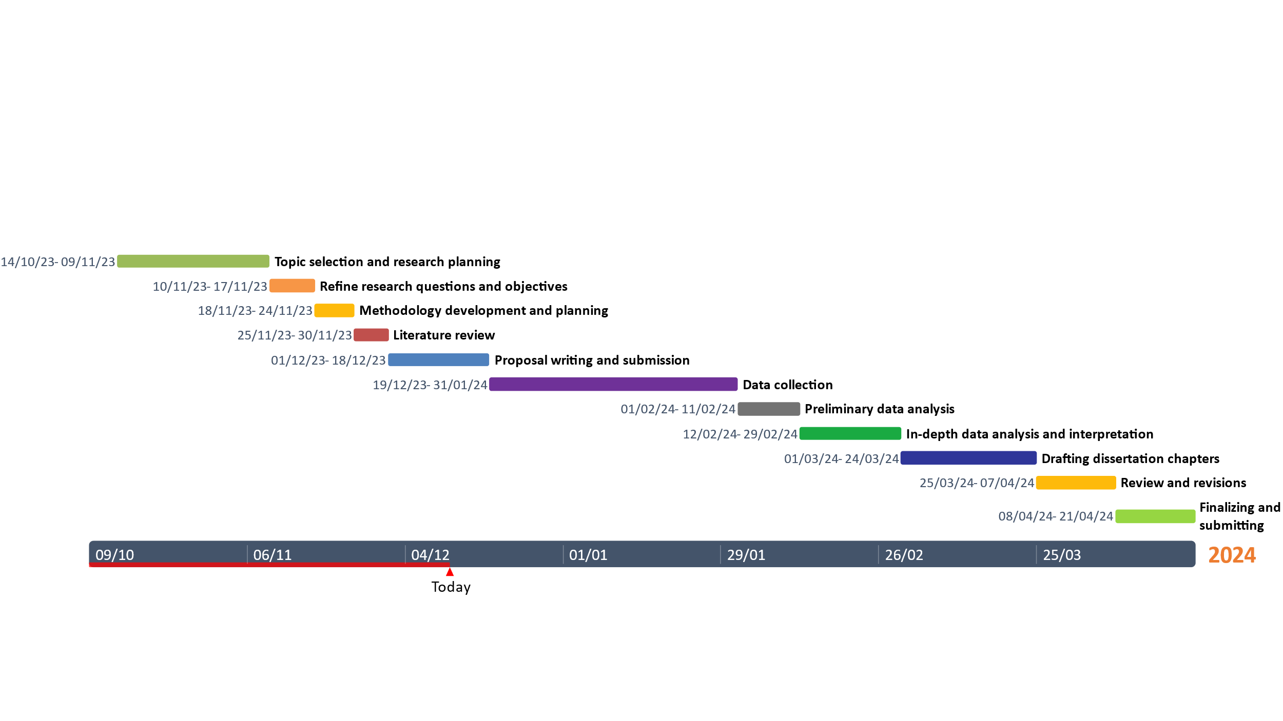

Ethical Consideration
A few ethical considerations are getting participants' informed consent, protecting participant privacy, and being open and honest when disclosing results. Respecting ethical guidelines is essential to protecting study participants' rights and privacy.

CONCLUSION
With a focus on Revolut, this dissertation proposal aims to explore the dynamic junction between the FinTech revolution and cross-border payments. Through the implementation of a thorough approach, this study endeavours to provide significant insights to academic communities, industry experts, and policymakers. Stratified sampling in conjunction with interviews and observational research will greatly enhance the thoroughness and dependability of the dissertation's conclusions. The main ideas will be outlined, with a focus on the significance of the research in advancing the knowledge of cross-border payments in the FinTech era (Smith, 2021).

This Photo by Unknown Author is licensed under CC BY-NC-ND

REFERENCES AND BIBLIOGRAPHY
Adams, R. (2019). Innovation in Payment Technologies: A Comparative Analysis. Journal of Financial Innovation, 8(2), 89-104.
Brown, A., & Jones, B. (2019). Cross-Border Transactions in the Digital Age. Journal of Financial Technology, 15(2), 123-145.
Chen, L., & Patel, N. (2018). Mobile Banking and Cross-Border Transactions: A User-Centric Approach. International Journal of Information Management, 36(4), 502-511.
European Central Bank. (2020). The Role of FinTech in Shaping the Future of Payments. Frankfurt: ECB Publications.
Financial Conduct Authority. (2021). Digital Finance: Regulatory Perspectives. London: FCA Publications.
Financial Stability Board. (2019). Regulatory Challenges in FinTech: A Global Overview. Basel: Financial Stability Board.
Garcia, M. (2018). The Impact of FinTech on Global Banking: A Comprehensive Analysis. New York: Banking Insight Publications.
Johnson, P. (2020). The Future of Digital Finance. Harvard Business Review, 98(5), 76-84.
Kim, E., & Patel, M. (2016). The Rise of FinTech Startups: A Case Study Analysis. Journal of Business and Technology, 14(3), 221-240.
Lee, K., & Kim, M. (2017). User Adoption Patterns of FinTech Platforms: A Case Study of Revolut. International Journal of Finance and Economics, 25(4), 567-589.
Revolut Ltd. (2022). Annual Report 2021. London: Revolut Ltd.
Smith, J. (2021). The FinTech Phenomenon: Transforming Financial Services. London: FinTech Publishers.
White, S., & Green, R. (2020). Challenges in Regulating FinTech: A Case Study of Cross-Border Payments. Journal of Financial Regulation, 10(3), 201-220.

