Exam
Q1a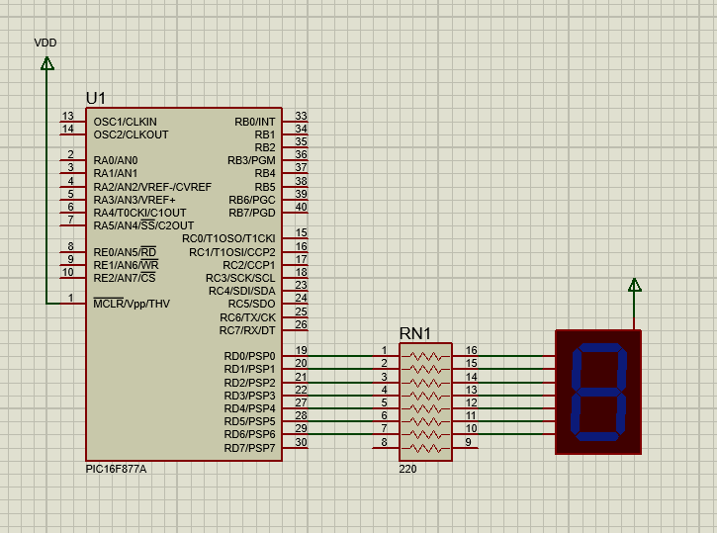
Q1b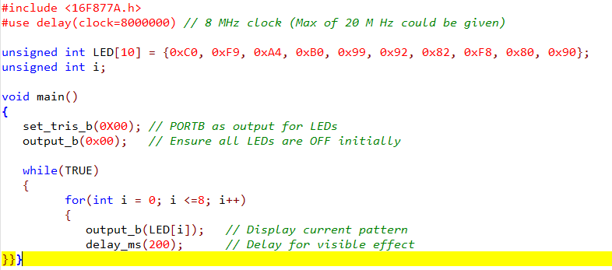
Q1c
Q2a 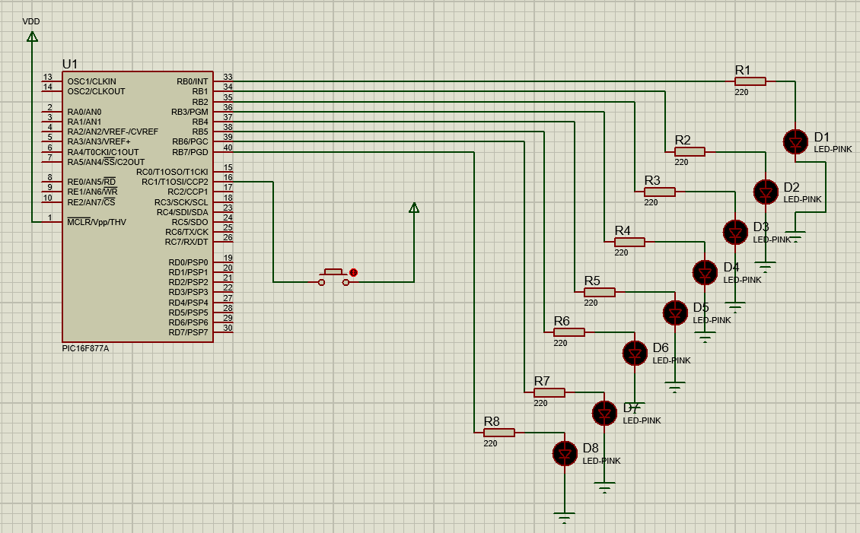
Q2b 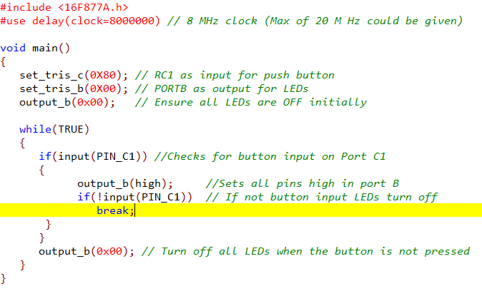
Q2c
Q3a
The circuit is a moisture sensor. It can detect the amount of moisture in the air, soil or other environment. These are helpful in agriculture or gardens and can automate things like the watering of plants or dehumidifying an area.
Q3b
The circuit revolves around an LM393 Op Amp and 2 potentiometers. If the voltage going into the inverting terminal is lower when compared to the voltage into the non-inverting terminal, then the LED D1 will stay off. If then, the voltage in the inverting terminal is higher it will turn LED D1 on. This is all possible as the Op-Amp is checking the values being input from 2 potentiometers, RV1 and RV2. RV1 defines the moisture base level to trigger the system and then RV2 is the actual moisture sensor and is changed to represent moisture in the system. Together the Op-Amp and the potentiometers will allow the system to detect moisture and therefore trigger LED D1 to output showing sufficient moisture levels.
Q3c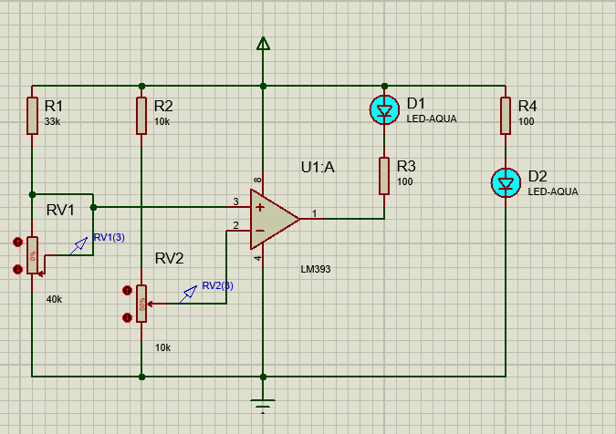
Circuit diagram
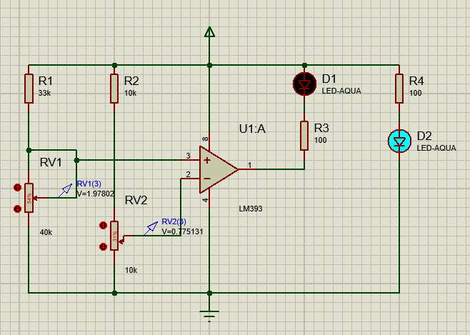
Sensor with not enough moisture as indicated by potentiometer values and LED D1 turned off.
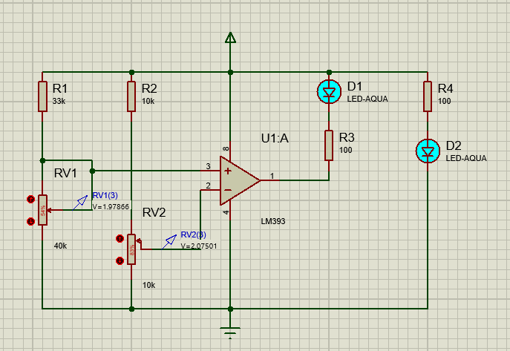
Sensor saturated with moisture as the LED D1 is on.
Q4a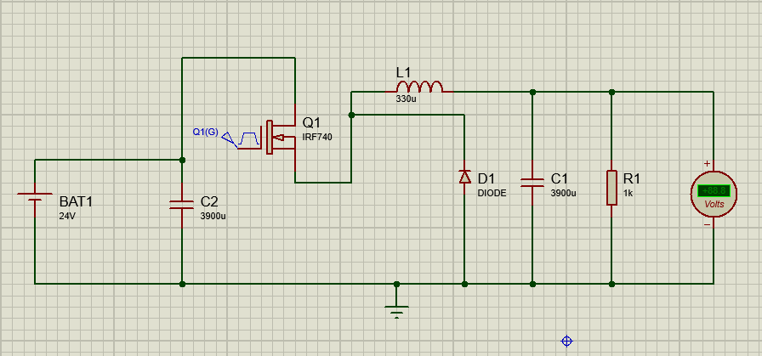
Q4b
The circuit above is a buck converter this circuit is used to drop the voltage in a system from a given power supply. It first uses the battery to take in power. Then the transistor Q1 has a duty cycle applied the percentage of which represents the voltage outputted to the load or the voltmeter shown above. When the transistor is allowing current to flow it is charging up the inductor (L1). At this stage the diode D1 is reverse biased now allowing current to flow. Once the transistor flips back it allows the inductor to discharge, charging the capacitor at C1 and dissipating power through the load. Then the diode (D1) is now forward biased and allows current to flow through the system.
Q4c
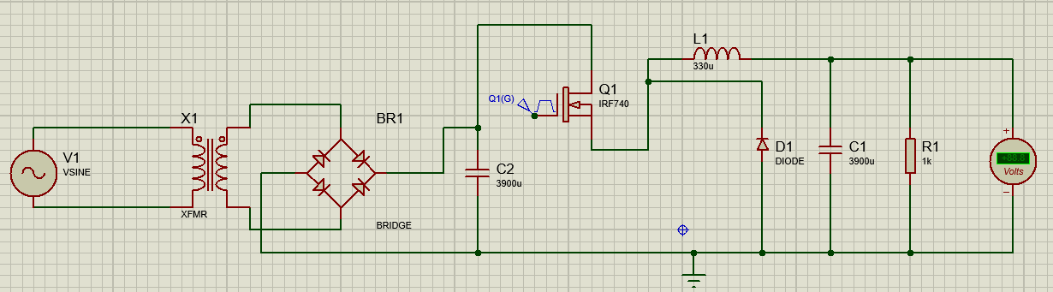
The circuit above is what I think would be used to make a switch mode power supply using a buck converter.
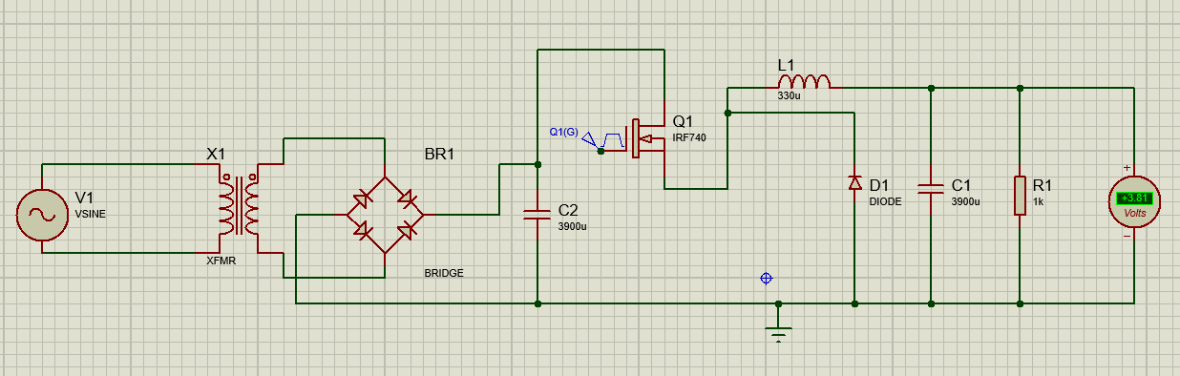
This is the system with a 20% duty cycle.
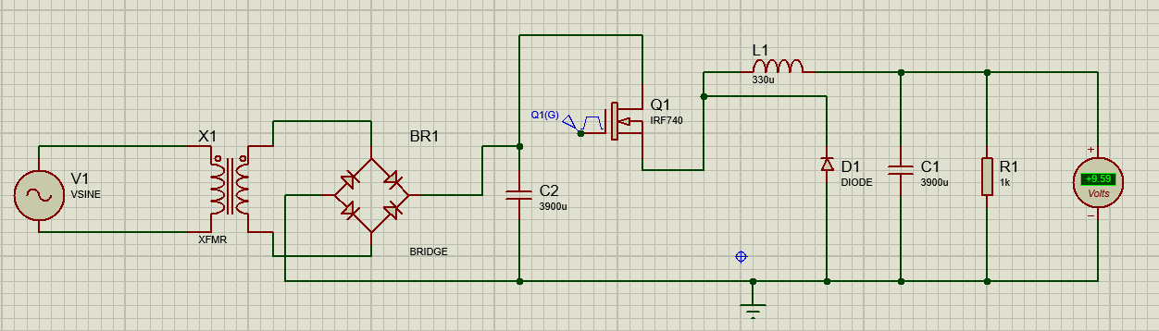
This is the system with a 70% duty cycle.
As shown when you compare the 2 images the circuit using a far lower duty cycle is outputting a much lower voltage to the load however as you increase the duty cycle it will increase the voltag.

