Business Report - Comparison of Two Hospitality Organisations

Module Code: BMIH5007
Student Name: Alina-Maria Cimpian
Student ID:2207461
Lecturer: Tristan Hawkins

Executive summary
The report has identified the differences between Corinthia Hotels and Ibis Hotels. However, the differences between the two hotels have been identified based on some of the essential factors of the organisations, such as their total revenue, the potential for growth, market position, and financial commitment to CSR Corporate Social Responsibility. The report has also provided recommendations to both the organisations Corinthia Hotels and Ibis Hotels based on their issues so that they could improve these issues for further and effective growth.

Table of Contents
Introduction 4
Comparison between Corinthia Hotels and Ibis Hotels based on Total Revenue 5
Comparison between Corinthia Hotels and Ibis Hotels based on Market Position 6
Comparison between Corinthia Hotels and Ibis Hotels based on Growth Potential 8
Comparison between Corinthia Hotels and Ibis Hotels based on financial commitment to CSR Corporate Social Responsibility 9
Recommendations 11
Conclusion 12

Introduction
The report identifies the differences between the Corinthia Hotels and Ibis Hotels. However, the differences between Corinthia Hotels and Ibis Hotels will be identified based on their total revenue, market position, potential for growth, and financial commitment to CSR Corporate Social Responsibility. After identifying the differences, the report will also provide recommendations to the organisations regarding improving their overall growth activities and performance. Therefore, the report aims to evaluate the respective approaches of the organisation to financial management and consider different critical areas that affect the financial performance and sustainability of the organisation.

Comparison between Corinthia Hotels and Ibis Hotels based on Total Revenue
Year | 2019 (€’000) | 2020 (€’000) | 2021 (€’000)
Gross profit | 825 | 389 | 19.4
Revenue from operating activities | 464 | 441 Corenthia Group (2024) | 244
Table 1: Revenue of Ibis Hotel
(Source: Self-Developed)
Ibis Hotels is part of the group All-Accor Group. All-Accor is a French group with many chains targeted at different segments. Ibis is value regarding the chain of money budget. However, the group of All-Accor has a chain of well-known hotels like Novotel, Sofitel, Adagio, Mercury and Fairmont (Ibis.accor.com, 2024). As a chain, the group of All-Accor was able to emphasise the value of money. Thus, it is the region where most visitors look regarding Ibis type of hotels. The whole portfolio of the Ibis hotels is identified within the group of Accor as Economy hotels. The budget of Ibis Hotel is slightly cheaper in comparison to the leading brands of Ibis Hotel (Ishraq et al., 2020). However, the theory is also essential regarding amenities and needs for a location in the centre of Paris. On the other hand, the Corinthia Hotels is a collection of luxurious hotels founded by the Pisani family of Malta in 1962. However, now the organisation is owned by the International Hotel Investments (IHI) (Corinthiagroup.com, 2024).
Year | 2019 (€’000) | 2020 (€’000) | 2021 (€’000)
Gross profit | 34116 | 37,953 | 63,646
Revenue from operating activities | 62,850 (Group.accor.com,) | 29,749 | (2965)
Table 2: Revenue of Corinthia Hotel
(Source: Self-Developed)
The Hotel Corinthia is well known for its luxurious accommodations. The organisation has a diverse portfolio of hotels, including hotels in the city centre, spa retreats, and beach resorts. However, according to the annual report of Corinthia Hotels for 2022, it was £62.0 million (Corinthiagroup.com, 2024). After research and analysis, Zippia's data science team identified some of the essential factors regarding Corinthia Hotels. However, it has been identified that Corinthia Hotels has 3,000 employees, and the revenue of the employees ratio is approximately £20,666.
On the other hand, the revenue of Ibis Hotel was £4.52 billion in 2022. Therefore, based on the revenue of both hotels, it has been identified that the revenue of Corinthia Hotels is better than that of Ibis Hotels. Ibis Hotels is a budget-friendly hotel, whereas Corinthia Hotels is a luxurious hotel.

Comparison between Corinthia Hotels and Ibis Hotels based on Market Position
The guests of Corinthia Hotels are constantly impressed by the accommodations, amenities, wealth, and quality of the hotel's services (Kadirova, 2022). The rooms and suites of Corinthia Hotels have contemporary decor and modern conveniences such as free Wi-Fi access, Nespresso coffee machines, and marble bathrooms with heated floors. However, some of the consumers of Corinthia Hotels have complained that the rate of nighty rooms is expensive (Corinthiagroup.com, 2024). However, the ranking is given to the guest and calculated using the data provided under the license through TripAdvisor. Thus, the rating given by the guests to the Corinthia Hotels is five on a scale of one to five.
On the other hand, the targeted market of Ibis Hotels are families, individuals, and couples to whom the organisation feels their offers are appealing (Ibis.accor.com, 2024). However, the organisation's target consumers are those who travel to a particular destination and are required to spend their needs in a hotel and to get some sleep, mainly on the transport routes. The Ibis Hotels are the most famous hotel chain that serves consumers worldwide with the help of their resorts, hospitality services and hotels. However, the organisation has a strong strategy regarding its market, which supports success in the market (Hendriyatmoko and Poernomo, 2023). The organisation provides seasonal and festival discounts to its consumers to attract them. However, the organisation also guarantees its consumers the best price, which is one of the main parts of its pricing strategy. However, Ibis Hotels has a well-known brand image for its vibrant and open atmosphere (Rachmawati et al., 2023). Ibis Hotels is open to all individuals and welcomes those who keep an open mind and trust in Ibis Hotels. Ibis Hotels is well known worldwide for its unique design and distinct personalities, which reflect the brand's bright and energetic spirit.
The model of Porter's Generic strategies is the framework that highlights the three most essential strategy options for achieving sustainable competitive advantages for the organisation. However, the strategies involve focus, differentiation, and cost leadership (Islami et al., 2020). Cost leadership aims to provide products at low prices, whereas differentiation strategy aims to differentiate the products of the organisation in comparison to its competitors. The focus strategy aims to provide particular products that are aligned with the particular requirements of the consumer.
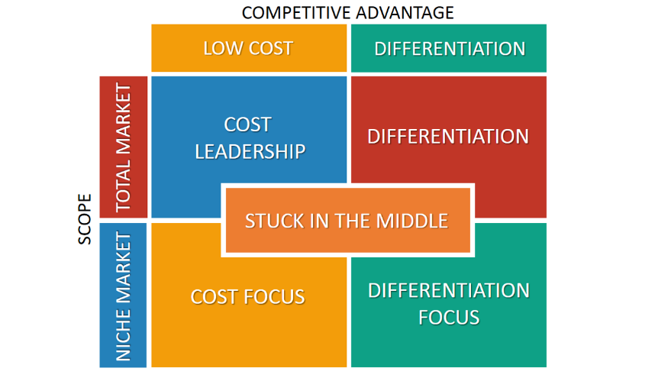
Figure 1: The model of Porter’s Generic strategies
(Source: Islami et al. 2020)
The model of Porter’s Generic strategies helps both the organisations Ibis and Corinthia to identify the consumers' requirements (Islami et al., 2020). Thus, it will help organisations provide consumer sources based on their requirements and fulfil their needs.

Comparison between Corinthia Hotels and Ibis Hotels based on Growth Potential
Ibis Hotels has a chain of mid-segment. However, there is the expectation that Ibis Hotels will grow its top line by 25% to touch the 1,000-crore market in 2023. The organisation expected that by the end of 2023, it would have a market of 1,000 crores (Ibis.accor.com, 2024). However, in 2022, the Ibis Hotels had a revenue of 800 crores. However, the statement has been given through JB Singh, who has been the president as well as chief executive of Interglobe Hotels since 2024, through which Ibis Hotels started its operations it is profitable. However, it has also been said through JB Singh that in the coming five years, the revenue of Ibis Hotels will be doubled when Ibis Hotels has 6,000 rooms compared to the current 4,000 rooms (Ibis.accor.com, 2024).
On the other hand, Corinthia Hotels focuses on expanding its portfolio of luxury hotels as well as resorts all over the world.
However, according to the annual report of Corinthia Hotels for 2022, the organisation plans to open future hotels like Corinthia Hotels, Bucharest. In Bucharest, the organisation expects to have 30 rooms and to be open in 2024 (Corinthiagroup.com, 2024). Another hotel in Budapest is the Aquincim Hotel, which has 310 rooms. Corinthia Hotels Doha expects to open in 2025 and have 110 rooms. Khartoum Corinthia Hotels is expected to open in 2024 and have 230 rooms. On the other hand, the organisation is also planning to open hotels in New York, Prague, and Rome, which will open in 2024 (Meshack and Prusty, 2020). Further, the organisation has also signed an agreement with the United Development Company regarding managing and operating the Corinthia brand hotels in Gewan Island, Doha.

Comparison between Corinthia Hotels and Ibis Hotels based on financial commitment to CSR Corporate Social Responsibility
Nowadays, CSR has become one of the strategic tools for the growth of an organisation (HALkOS & NOMIkOS, 2021). Corinthia Hotels' CSR policy aims to effectively contribute towards sustainable development by safeguarding the well-being of the organisation's people and the communities within which the organisation is required to operate (Kirui and Siddig, 2023). Additionally, the organisation Corinthia Hotels also aims to consider all the expectations of its stakeholders so that they fulfil all of their expectations. The organisation also aims to comply with all applicable laws and international norms regarding behaviour (Lagarias et al., 2022). Additionally, the organisation will also combine corporate sustainability by the firm and practice it in the organisation's relationship with its third parties.
On the other hand, Corinthia also continued sponsoring Just a Drop (JAD), an international water aid charity (Algareu et al., 2021). However, JAD aims to contribute positively to reducing the mortality of children due to poor sanitation and unsafe water by decreasing the number of people who do not have access to clean water. The organisation works with local parties at the grassroots level (Grottke et al., 2020). JDA provides lean water supply with the help of appropriate solutions with engineers to some of the poorest communities in the world.
On the other hand, Ibis Hotels is committed to a global sustainable transformation (Wulandari & Subanti, 2023). Additionally, the organisation aims to develop a model in which it makes more contributions than it takes and effectively collaborates with its hotel owners and teams to implant sustainability over all its activities with people and nature. However, according to the Ibis Hotels, the stakes regarding sustainable transformation are high. Biodiversity loss, social changes, and climate changes are giving shape to the ecosystem and impacting business and growth. For instance, the travel and tourism industry emits 9-12% of greenhouse gasses (Group.accor.com, 2024). Additionally, the organisation believes that hospitality has an essential role to play in the area. Thus, the organisation is embarking on all of its stakeholders and collaboration across sectors to achieve industry-wide sustainable transformation (Osman, 2020). Additionally, the organisation has also committed that it will develop limitations on the impacts of Ibis Hotels' activities on the planet and its inhabitants.
The triple bottom line theory is the business concept that evaluates the importance of measuring the organisation's environmental and social impacts and financial performance. The components of the triple bottom line are the planet, people, and profit (Birkel and Müller, 2021). However, the framework encourages organisations to provide importance to their social and environmental responsibilities to increase their financial profitability.
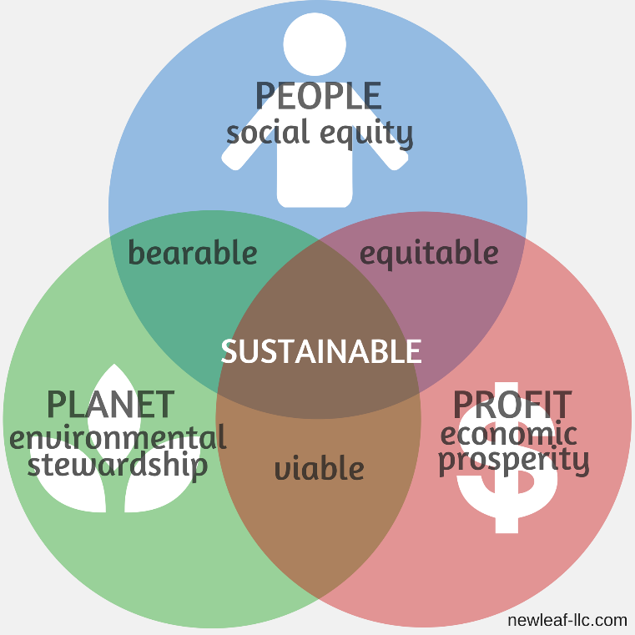
Figure 2: Triple bottom line
(Source: Birkel and Müller, 2021)
Through adopting strategies for a sustainable environment, the organisation's Ibis and Corinthia were able to make a positive impact on society and the environment by achieving their own success. It will also help both organisations create a positive image for their consumers by providing information regarding their contribution to the environment and society (Birkel and Müller, 2021). Thus, it will help the organisation attract more consumers and achieve its goal of success.

Recommendations
The Corinthia Hotels Group was required to focus on investing in emerging markets.
Based on the annual report of Corinthia Hotels for 2022, the organisation is focused on developing Corinthia Hotels as a brand of global luxury hotels by developing, operating, and acquiring Corinthia Hotels (Tiong et al., 2021). The operations of Corinthia Hotels were rapidly increasing in Southeast Asia, China, and India. However, the organisation must focus on investing in these countries' markets to grow its business effectively. Additionally, the organisation must focus on sustainability due to increased concern for climate change (Kapoor et al., 2023). Thus, `the organisation is required to focus on eco-friendly practices, like reducing energy consumption, utilising renewable energy, and minimising waste.
Ibis Hotels is required to focus on increasing its market share.
It has been identified that the market share of Ibis Hotels is declining. The market share of Ibis Hotels is declining because of its complex environment as well as fierce competition regarding the budget hotel industry, which prevents Ibis Hotels from achieving its desired goals. Additionally, the rapid creation of economy hotels, as well as Airbub, grabbed the market share of Ibis and decreased sales growth rate between 2012 and 2018 (Group.accor.com, 2024). Thus, to solve the issue, Ibis Hotels can develop a marketing mix strategy for achieving the strategy of each segment's positioning. For instance, the organisation could give queen-sized bedrooms to consumers who do not like single beds. Therefore, it will help the organisation properly utilise its resources effectively by satisfying the requirements of all the segments (Kaya, 2020). It will help the organisation attract more consumers, generate revenues, and enhance its market share.

Conclusion
It was determined that the All-Accor Group includes the Ibis Hotels. Well-known hotel brands like Novotel, Sofitel, Adagio, Mercury, and Fairmont are part of the All-Accor chain. Nonetheless, the cost of lodging at Ibis Hotel is marginally less expensive when compared to its top brands. Additionally, it has been noted that the Hotel Corinthia is well regarded for its opulent lodgings. The Corinthia Hotel offers a wide range of lodging options, such as beach resorts, spa getaways, and hotels in the city's heart. A few customers of Corinthia Hotels also expressed dissatisfaction over the high cost of the nightly accommodation charge. Ibis Hotels targets individuals, couples, and families that they believe would find their offers attractive.

References
Algareu, A., Abdunnabi, M., Mabruk, M. and Elmaghrabi, A.M., 2021. Legionella Bacteria Activity investigation in Domestic Water Heating Systems: Tripoli-Libya as a case study. Solar Energy and Sustainable Development Journal, 10(2), pp.11-20.
Birkel, H. and Müller, J.M., 2021. Potentials of industry 4.0 for supply chain management within the triple bottom line of sustainability–A systematic literature review. Journal of Cleaner Production, 289, p.125612.
Corinthia Group (2024).The revenue of Corinthia Group Hotels. Available at: https://www.corinthiagroup.com/investors/financial-report/> [Assessed on 27th January 2024]
Corinthiagroup.com, 2024. Information about the future growth of Corinthia Group Hotels. Available at: <https://www.corinthiagroup.com/wp-content/uploads/2023/06/37547-CORINTHIA-ANNUAL-REPORT-2022_WEB-min.pdf> [Assessed on 19th January 2024]
Corinthiagroup.com, 2024. The CSR responsibility of Corinthia Group Hotels. Available at: <https://www.corinthiagroup.com/insider/overview-of-our-recent-csr-activities/> [Assessed on 19th January 2024]
Grottke, M., Helm, P., Karl, A., Rehak, J., Kovar, A., Novak, F., Biasizzo, A. and Panhuber, C., 2020, November. Electricity from a Golden Solar Generator for the Golden City Prague. In Sixteenth European Photovoltaic Solar Energy Conference (pp. 2727-2729). Routledge.
Group.accor.com, (2024). The CSR responsibility of Ibis Hotels. Available at: <https://group.accor.com/en/commitment/approach/sustainability-strategy> [Assessed on 19th January 2024]
HALkOS, G. and NOMIkOS, S., 2021. Corporate social responsibility: Trends in global reporting initiative standards. Economic Analysis and Policy, 69, pp.106-117.
Hendriyatmoko, D. and Poernomo, M.I., 2023. Communication Of The Crisis Of Hotel Ibis Budget Daan Mogot Jakarta In Facing The Covid-19 Pandemic. International Journal Of Humanities Education and Social Sciences, 3(2).
Ibis.accor.com, 2024. Information about the future growth of Ibis Hotels. Available at: <https://ibis.accor.com/sustainable-development/index.en.shtml > [Assessed on 19th January 2024]
Islami, X., Mustafa, N. and Topuzovska Latkovikj, M., 2020. We are linking Porter's generic strategies to firm performance. Future Business Journal, 6, pp.1-15.
Kapoor, R., Singh, A. and Manchanda, G., (2023). Hospitality internships and green leaders: Analysing the engagement of interns with hotel sustainable development practices. Worldwide Hospitality and Tourism Themes, 15(3), 295–307.
Kaya, B., (2020). A hotel recommendation system based on customer location: a link prediction approach. Multimedia Tools and Applications, 79, pp.1745-1758.
Kirui, O.K. and Siddig, K., 2023. 2022 annual research and policy conference: Agricultural transformation and food security in Sudan (Vol. 3). Intl Food Policy Res Inst.
Lagarias, A., Zacharakis, I. and Stratigea, A., 2022. Assessing the coastal vs hinterland divide using multitemporal data: Case study in Corinthia, Greece. European Journal of Geography, 13(2), pp.001-026.
Meshack, H.E. & Prusty, S. (2020). Terrorism and tourism in the hotel industry in Tanzania: a case of northern regions. International Journal of Qualitative Research in Services, 4(1), 1–19.
Osman, A., (2021). Where is Wakanda? Who is T’Challa? The Sustainable African City Re-Imagined as a Livable and Lovable City. Towards Implementing Sustainability Concepts in Developing Countries (pp. 29–39). Springer International Publishing.
Zhang, Q., & Ahmad, S. (2022). Linking Corporate Social Responsibility, Consumer Identification and Purchasing Intention. Sustainability, 14(19), 12552.Abdel-Gayed, A., Hassan, T., Hassan, T., Abdelmoaty, M., Saleh, M., & Salem, A. (2023). Travelers’ Subjective Well-Being as an Environmental Practice: Do Airport Buildings’ Eco-Design, Brand Engagement, and Brand Experience Matter? International Journal of Environmental Research and Public Health, 20(2), 938.Wulandari, F. and Subanti, G., 2023. AN ANALYSIS OF SPEAKING FLUENCY LEVEL OF FRONT OFFICE STAFFS OF HOTEL IBIS PONTIANAK CITY CENTER. ELSA, 4(1), pp.32-43.
Hadi, A., Sentosa, I., & Wahid, R. (2023). The Effects Of Entrepreneurial Plan And Intention On Indonesian Student's Commitment In Entrepreneurship: A New Conceptual Framework. International Journal of Information, Business and Management, 15(2), 124-132.

