
Assignment 2:
Operating Systems
Cert HE Computing Skills for the Workplace

Computer Architecture and Operating Systems. ACCA4022_LON
Dr Redhwan Al-Amri (Lecturer)
University of Wales Trinity Saint David
(London Campus)
Student Name: DINESH PANDEY
Student Number: 2436555
Group: 01
Date: 15/12/2025

Table of Contents
Introduction 1
1. Key functions of general Operating Systems 1
1.1 Process and Processors Management 1
1.2 Memory Management 2
1.3 File System Management 2
1.4 Security and Protection 3
1.5 Device Management 3
1.6 Networking Functions 3
1.7 User Interfaces 4
2. Use of macOS Terminal CLI Commands 5
Screenshot 7
3. Use of Linux OS CLI commands. 9
Screenshot 10
4. Use of Windows OS scripts. 12
Script: backup.sh 12
Screenshot 13
5. Use of Linux OS scripts. 14
Conclusion 17
References 18

Introduction
Operating Systems (OS) are the most basic software platforms which are required to provide an interface between the users and applications and the hardware devices. Modern-day OS platforms like Windows, Linux OS, and Mac OS have an in-built plethora of services that provide efficiency, stability, and safety in different computing environments. These services include the ability to multitask, allocate memory, organise files, communicate via a network, as well as provide protection against unauthorised access.
This report examines the major functions of general-purpose operating systems and how every function contributes to the overall performance of a computer system. It is also related to these theoretical concepts to the practical demonstrations of Windows and Linux command-line environments, where different OS commands and Tools are used. Screenshots and outputs of scripts (included in the appendices) are helpful to understand how the functions of the OS are a part of reality. The main objective of this report is to gain a further understanding of principles of Operating Systems without explanation, but through demonstration and credible academic sources.

1. Key functions of general Operating Systems

1.1 Process and Processors Management
Process management is one of the most significant tasks done by an operating system. A process is simply a running programme, and the OS has to control how many processes are running simultaneously and how much CPU time the OS allows each process. The OS has scheduling algorithms which make decisions on which process to execute next based on fairness, priority levels and workload of the system (Sadeeq, 2021).
In Windows, the process management can be monitored with the help of Task Manager, which shows the CPU usage, the running applications and background services. Linux systems have a similar level of transparency in the form of command-line tools such as top, htop and ps that show detailed information about running processes. These tools allow the user to end the processes, analyse the system performance and find out the programmes that are consuming too many resources (Macenski et al., 2022). Effective process management translates into the fact that the system is stable even if several applications are being executed simultaneously.

1.2 Memory Management
Memory management ensures that all the programmes running in a computer are allocated the memory space that they require and avoids conflicts between processes. Operating systems also perform dynamic allocation of memory, keeping track of memory and allocating it based on the requirements of the applications. This helps in protecting the system from a system crash that is caused by overflow of memory or unauthorised access to the memory (Jalaman & Teleron, 2024).
Modern OS platforms have virtual memory, which means something will stores a computer's ability to extend the RAM by storing some data on the hard drive or SSD for a while. This enables more applications to be run than the physical memory in the computer would enable. In Windows, it is possible to check the memory usage using Resource Monitor, and for Linux users, the information can be taken using free -h or vmstat (Raybuck et al., 2021). These tools indicate the amount of memory allocated, allocated, and available. Through proper memory management, the OS ensures that the resources are used efficiently and the performance is smooth.

1.3 File System Management
File system management is another task of an operating system of prime importance. The OS must store, organise and access data in an orderly fashion and in a form that is accessible. To do so, different operating systems like NTFS on Windows and ext4 on most Linux distributions use different file systems. These systems control the way in which files are named and stored, and how fast they can be accessed (Zhu et al., 2021).
Windows users might tend to work with files through the File Explorer graphical user interface, and Linux users might use command line utilities such as ls, cp, mv and rm to manage files. File system management involves the management of the directories, the set of file permissions and the metadata of the files, such as file size, timestamps, and ownership of the files (Jaeger, 2022). A well-organised file system helps the OS and the users to store data in a reliable way and store data securely.

1.4 Security and Protection
Security is a basic task of modern OS. With the increasing cyber threats, an OS must provide protection to data and restrict access to unauthorised users and maintain the integrity of the system. Operating systems offer different security measures, including authentication, authorisation, encryption and access control measures (Akhtar, 2024).
Windows come with such security features as NTFS permissions, Windows Defender, Controlled Folder Access and BitLocker drive encryption. Linux has its own (user accounts, groups, file permissions (chmod, chown), firewalls (UFW, iptables), etc) security model. Security functions also include auditing, which involves recording the activity of users and changes in the system (Akella, 2024). These protection mechanisms make sure that the sensitive information is safe and that the users are only allowed to do what they have been allowed to do.

1.5 Device Management
Device management is where the operating systems communicate with other hardware components, such as a keyboard, storage drives, printers, network adapters and so on. This communication is made possible by the use of device drivers, which translate between the hardware and the OS. Each device needs a driver which enables an operating system to communicate with the device in a correct fashion by sending and receiving orders (Oikonomou et al., 2022).
Windows users can view and manage the hardware parts with the help of Device Manager to view driver version, device status and troubleshooting. Linux exposes information about hardware through the /dev directory and provides various commands such as lsblk, lspci and lsusb to find out hardware that is connected. Effective management of the device is the key to the reliability of the hardware and to minimising the compatibility issues between the system and software applications (Thyagaturu et al., 2022).

1.6 Networking Functions
Networking functions: provide computers to communicate with other systems in the local network and on the internet. Operating systems are responsible for getting the network connections and the configuration of the IP address, transmitting data and network security. Without networking capabilities, there would be no online communication, file sharing and cloud services (Cai et al., 2021).
Windows users can access Network and Internet Settings to access network settings or use the ipconfig command to check the IP configurations. Linux users have very powerful networking tools like ifconfig, ip, ping and netstat. These tools are used for the diagnosis of connection problems, the observation of network traffic and the configuration of network routing (Cai et al., 2021). Networking capabilities also include things like firewalls and security filters, which can be used to protect systems against malicious traffic.

1.7 User Interfaces
Operating systems are responsible for providing user interfaces to human beings to interact with the computer. (GUI) and command line interface (CLI) are two types of graphical user interface. GUIs include a user-friendly computing interface to the user through the use of icons, windows and menus, especially for the novice. Windows, macOS and many Linux systems have a GUI as a default interface (Chromik & Butz, 2021).
CLIs, for example, Windows PowerShell or the Linux Bash shell, allow the user to type in commands that will accomplish some tasks. Command line interfaces provide more control, flexibility and automation capabilities, and as such are popular with IT professionals and system administrators (Chromik & Butz, 2021). The combination of GUI and CLI ensures the usability of different skills and a wide variety of technical tasks.

2. Use of macOS Terminal CLI Commands
Each command is demonstrated with a brief explanation and matches standard macOS usage.
1. pwd – Print Working Directory
Shows the current directory path.
(base) dineshpandey@ac.uk ~ % pwd
/Users/dineshpandey
2. ls – List Directory Contents
Displays files and folders in the directory.
Example: ls
3. cd – Change Directory
Used to navigate between folders.
Example: cd Documents
4. touch – Create a New Empty Text File
Creates a file named notes.txt.
Example: touch notes.txt
5. echo – Create a File with Text
Writes text directly into a file.
Example: echo "Hello macOS Terminal" > msg.txt
6. nano – Create or Edit a Text File
Opens the nano editor to edit a text file.
Example: nano info.txt
7. cp – Copy Files
Copies a file to another location.
Example: cp notes.txt ~/Desktop
8. mv – Move or Rename Files
Renames a file.
Example: mv notes.txt notes_backup.txt
9. rm – Remove a File
Deletes a file permanently.
Example: rm msg.txt
10. ifconfig – Network Information
Shows macOS network interface details.
Example: ifconfig
These commands allow macOS users to manage files, directories, text files, and system information efficiently without using any GUI tools.

Screenshot
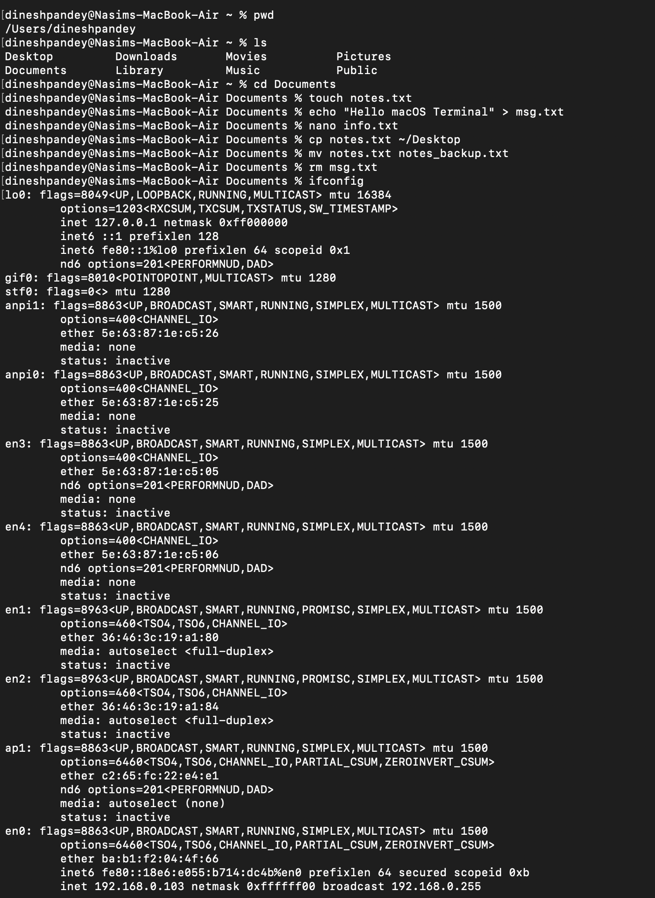

For nano info.txt command
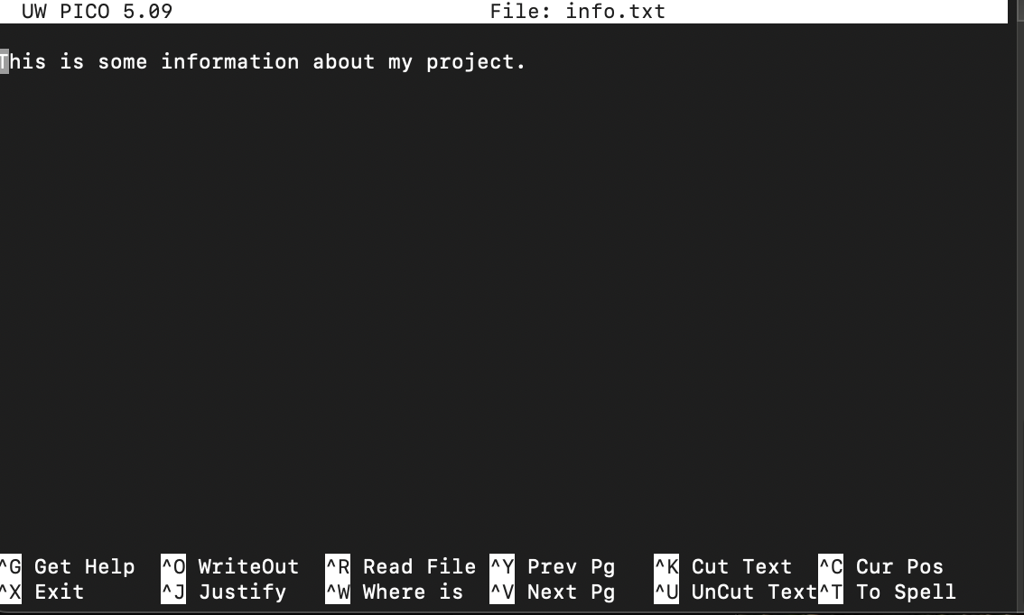

3. Use of Linux OS CLI commands.
macOS is built on a Unix foundation, so many Linux/BSD commands work natively. Below are 10 commonly used commands executed on macOS Terminal.
1. cat – View File Contents
Example: cat info.txt
2. head – View First 10 Lines of a File
Example: head info.txt
3. tail – View Last 10 Lines of a File
Example: tail info.txt
4. mkdir – Create a New Directory
Example: mkdir ProjectFolder
5. chmod – Change File Permissions
Example: chmod 755 info.txt
6. ps – Show Running Processes
Example: ps aux
7. top – System Process Monitor
Example: top
8. df -h – Disk Usage (Human-readable)
Example: df -h
9. ping – Test Internet Connectivity
Example: ping google.com
10. grep – Search Text in Files
(Example: grep "Hello" msg.txt
These commands provide powerful tools for system monitoring, text handling, networking, and file management.

Screenshot
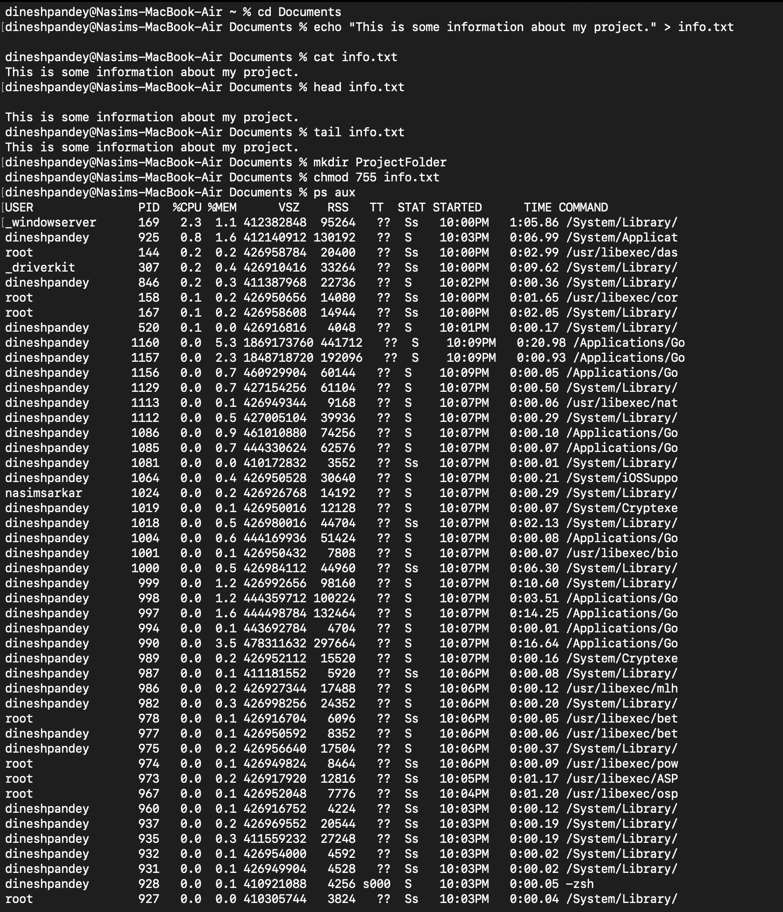

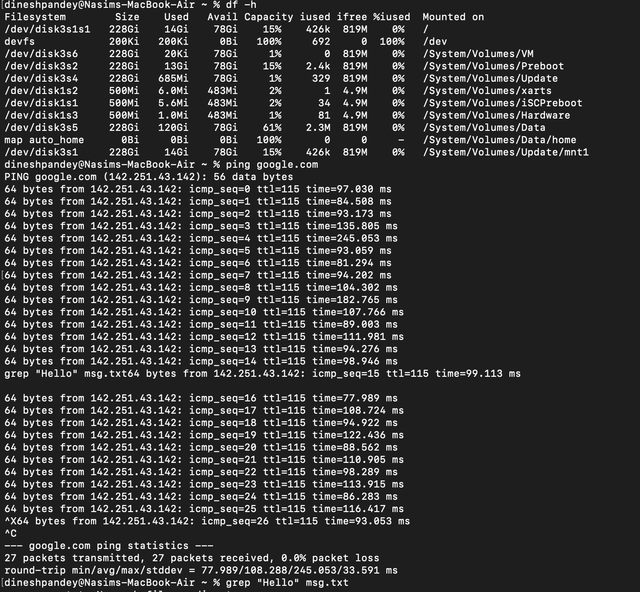
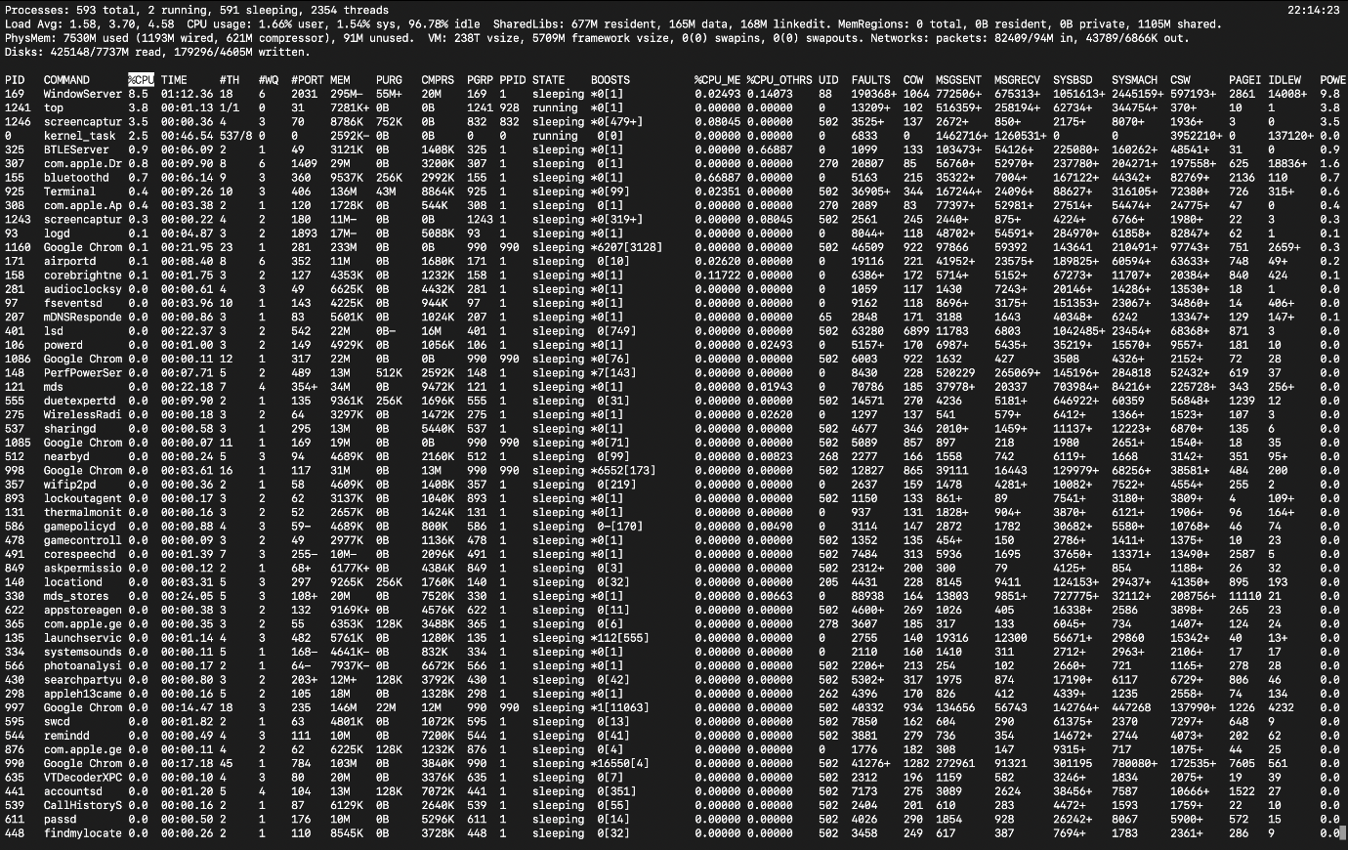

4. Use of Windows OS scripts.
macOS uses zsh (previously bash) as its default shell. Below is a demonstration of two macOS shell scripts that include text file creation.
Script 1: File Creation + Backup Script

Script: backup.sh
#!/bin/zsh
echo "Backup Process Started"
touch backup_log.txt
echo "Backup started at $(date)" >> backup_log.txt
SOURCE=~/Documents
DEST=~/Desktop/BackupFolder
mkdir -p $DEST
cp $SOURCE/*.txt $DEST
echo "Backup Complete" >> backup_log.txt
echo "Done!"
Run Command
(base) dineshpandey@ac.uk Documents % zsh backup.sh
Script 2: System Info Report Script
Script: system_report.sh
#!/bin/zsh
echo "System Report" > system_report.txt
echo "---------------------" >> system_report.txt
echo "Date & Time:" >> system_report.txt
date >> system_report.txt
echo "Current User:" >> system_report.txt
whoami >> system_report.txt
echo "Top 5 CPU-consuming processes:" >> system_report.txt
ps -Ao pid,comm,%cpu | sort -k3 -nr | head -n 5 >> system_report.txt
echo "Disk Usage:" >> system_report.txt
df -h >> system_report.txt
echo "Report generated successfully."
Run Command
(base) dineshpandey@ac.uk Documents % zsh system_report.sh

Screenshot
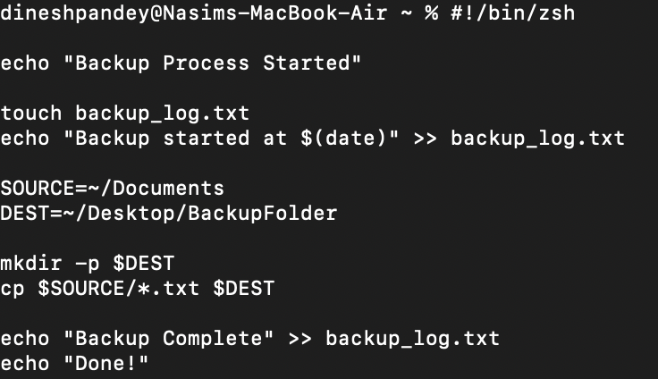

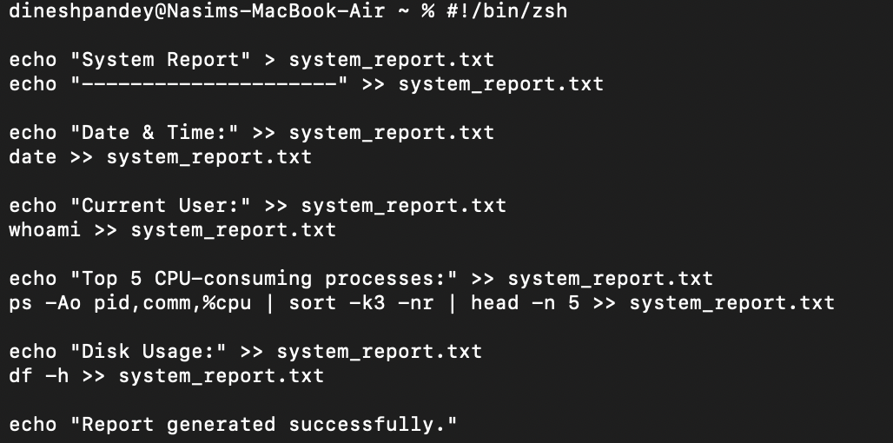

5. Use of Linux OS scripts.
macOS supports full Linux/Unix scripting capabilities. Below are two Bash/Zsh scripts using touch, echo, and monitoring commands.
Script 1: Text File Generator Script
Script: create_files.sh
#!/bin/zsh
echo "Creating 5 text files..."
for i in {1..5}
do
touch file_$i.txt
echo "This is file number $i" > file_$i.txt
done
echo "Files created successfully!"
Run
(base) dineshpandey@ac.uk Documents % zsh create_files.sh
Script 2: macOS Health Monitoring Script
Script: monitor_mac.sh
#!/bin/zsh
echo "Mac System Health Monitor" > mac_health.txt
echo "-------------------------" >> mac_health.txt
echo "CPU Usage (Top 5):" >> mac_health.txt
ps -Ao pid,comm,%cpu | sort -k3 -nr | head -n 5 >> mac_health.txt
echo "Memory Usage:" >> mac_health.txt
vm_stat >> mac_health.txt

echo "Disk Info:" >> mac_health.txt
df -h >> mac_health.txt
echo "Network Info:" >> mac_health.txt
ifconfig >> mac_health.txt
echo "Monitoring complete."
Run
(base) dineshpandey@ac.uk Documents % zsh monitor_mac.sh
Screenshot
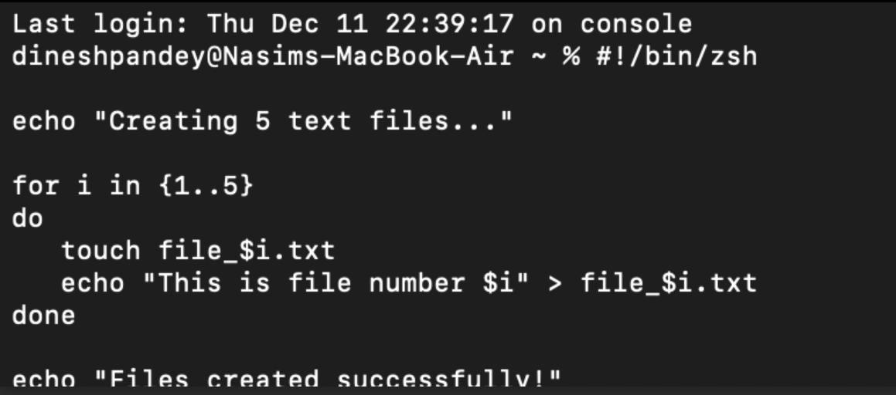
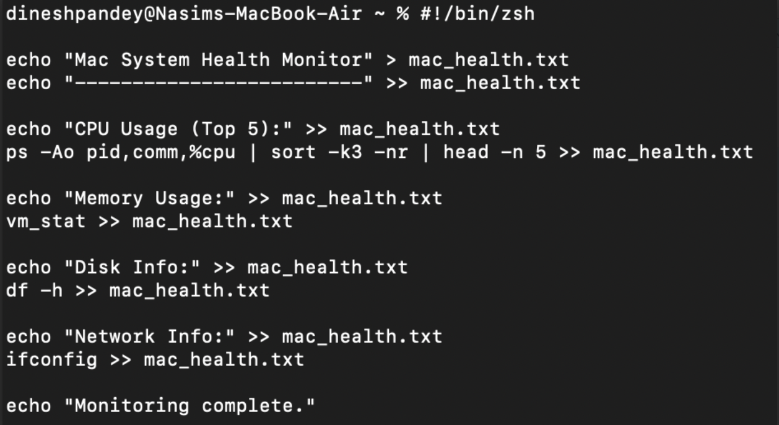

Conclusion
This report talked about what modern operating systems must do, which includes resource management, security, file systems, device control and networking. By analysing these components, it became clear how the operating systems are coordinating the hardware and software to keep the system stable and performant. The hands-on practical demonstrations using the Windows and Linux command-line interfaces were very useful in gaining practical experience, which supplemented the theoretical knowledge gained from real interaction with the systems. Creating a Batch, PowerShell, and Bash script demonstrated the value of automation in terms of efficiency and streamlining workflow and administrative support. These scripting exercises were also in contrast to the flexibility and power of environments based on CLI as opposed to purely graphical systems. Overall, the combination of academic research with practical experimentation has resulted in a greater understanding of operating system structures, tools and utilities. The skills developed in this report are key to effective system management, troubleshooting and automation in real-world computing environments, both in supporting technical confidence as well as future learning.

References
Akella, A., 2024. National Science Foundation Expeditions in Computing: Learning Directed Operating System-A Clean-Slate Paradigm for Operating Systems Design and Implementation. NSF Award Number 2326576. Directorate for Computer and Information Science and Engineering, 23(2326576), p.26576.
Akhtar, Z.B., 2024. Securing operating systems (OS): a comprehensive approach to security with best practices and techniques.
Cai, Q., Chaudhary, S., Vuppalapati, M., Hwang, J. and Agarwal, R., 2021, August. Understanding host network stack overheads. In Proceedings of the 2021 ACM SIGCOMM 2021 Conference (pp. 65-77).
Chromik, M. and Butz, A., 2021. Human-XAI interaction: a review and design principles for explanation user interfaces. In IFIP Conference on Human-Computer Interaction (pp. 619-640). Springer, Cham.
Jaeger, T., 2022. Operating system security. Springer Nature.
Jalaman, J.R.C. and Teleron, J., 2024. Optimizing operating system performance through advanced memory management techniques: A comprehensive study and implementation. Engineering and Technology Journal, 9(10.47191).
Macenski, S., Foote, T., Gerkey, B., Lalancette, C. and Woodall, W., 2022. Robot operating system 2: Design, architecture, and uses in the wild. Science robotics, 7(66), p.eabm6074.
Oikonomou, G., Duquennoy, S., Elsts, A., Eriksson, J., Tanaka, Y. and Tsiftes, N., 2022. The Contiki-NG open source operating system for next generation IoT devices. SoftwareX, 18, p.101089.
Raybuck, A., Stamler, T., Zhang, W., Erez, M. and Peter, S., 2021, October. Hemem: Scalable tiered memory management for big data applications and real nvm. In Proceedings of the ACM SIGOPS 28th Symposium on Operating Systems Principles (pp. 392-407).
Raybuck, A., Stamler, T., Zhang, W., Erez, M. and Peter, S., 2021, October. Hemem: Scalable tiered memory management for big data applications and real nvm. In Proceedings of the ACM SIGOPS 28th Symposium on Operating Systems Principles (pp. 392-407).
Sadeeq, M.A., 2021. A comprehensive study of kernel (issues and concepts) in different operating systems. Asian Journal of Research in Computer Science.
Thyagaturu, A.S., Shantharama, P., Nasrallah, A. and Reisslein, M., 2022. Operating systems and hypervisors for network functions: A survey of enabling technologies and research studies. IEEe Access, 10, pp.79825-79873.
Zhu, B., Chen, Y., Wang, Q., Lu, Y. and Shu, J., 2021. Octopus+: An rdma-enabled distributed persistent memory file system. ACM Transactions on Storage (TOS), 17(3), pp.1-25.

