FINANCIAL MANAGEMENT: WILLIAM HILL PLC. AND PADDY POWER BETFAIR PLC.

ASSESSMENT-1

STUDENT NAME : MOHAMMADJUNAID KHWAJA
STUDENT ID NUMBER : 1711085
MODULE CODE : SBMA7100
MODULE TITLE : FINANCIAL MANAGEMENT ASSESSMENT - 1
MODULE LECTURER NAME : ISAIAH OINO

Table of content

PART 1 3
Introduction 3
Background of the companies 4
Financial Analysis of both the companies 4
Better position in terms of PE ratio has been seen in the company William Hill than Paddy Power, which is a good sign. 16
Suggestions for investment decisions 16
Recommendation 17
Conclusion 18
PART- 2 19
Capital budgeting Appraisal & Cash flow 19
A. Determination of Payback period and Net present value (NPV) 19
B) The average rate of Return 23
C) Recommendation with a reason for the project to be adopted 25
D. Critically discussion on payback and NPV techniques to evaluate capital projects 25
E) Non-Financial Factors for Investment Appraisal process 27
References 28
Appendices 31

PART- 1

Introduction
In this era of globalisation, it has become a beneficiary factor for all the companies to file their own financial statements with each one of their related authority. For creating structure of the company’s growth and development in this global market analysis of the financial statements of a company is an demanding factor. Here in this study, an analysis of the financial statement of two famous bookmaking companies of United Kingdom namely William Hill Plc and Paddy Power Betfair Plc has been carried. A thorough review Profitability Ratio , Liquidity Ratio, Efficiency Ratio, Gearing ratio & Investment ratio has been carried out respectively. This study will help Tim Farrow, in providing a complete report of the financial statements of both the companies. Tim will also be able to make the decision of investment in respect with the review of the reports.

Back-ground of the respective companies
William Hill Plc. was founded in 1934 and is one of the most trusted and demanding brands in the international market in terms of customer service. It has 16,000+ employees spread over 9 countries. Moreover to the UK retails and Australia based companies, its online business has its HQ(head quarter) in Gibraltar running strongly with its customer services across the Philippines , Israel & Bulgaria . It is a competitive bookmaking company and is continuously innovating to stay ahead in the global competition. In the United Kingdom it is famous name where it has 2,342 of the 8,500 Licensed Betting Offices ( L B O’s) . The Retail business of William Hill Plc. is chiefly based in the United Kingdom respectively, it generated about 56% of the Group Net Revenue in 2016 financial year (williamhillplc.com, 2017).

Paddy Power Betfair Plc was founded in 2016. It is also a global multi-channel sports-betting & gaming operating company. The company operates on total 4 betting brands namely Paddy Power, Betfair, Sports Bet & TVG. It has over 5 million customers worldwide. Along with its subsidiaries provides it services over countries like Australia, UK, USA, and Ireland. The retail services mainly operate in the UK while the online services operate in Australia. The company made revenue of £1745.54 million in the financial year 2017 (paddypowerbetfair.com, 2017). It's an Ireland based online betting company which has earned outstanding growth in the betting and gaming industry. It proposed a closing dividend of 135.0 per share which will be paid in May 2018 (Referred to Appendix 1).

Financial Analysis of both the companies
The financial performance’s of the companies named William Hill Plc. & paddy power Betfair Plc evaluated through the analysis of every Financial Ratio of the Financial Feport as in Profitability Ratio , Liquidity Ratio , Efficiency Ratio’s & Investment Ratios (Mathuva, 2015).
Profitability- Ratio:
William hill plc. & Paddy power Betfair plc. both of the company are highly concerned with their profitability. The calculation of profitability ratio is an exigent factor for analysing the financial statements of the companies. William hill plc. & paddy power Betfair plc. overall Performance’s is calculated below. The margin ratios invested further to calculate and evaluate the Gross profit margin and Operating profit margin of above companies respectively.
- Return Shareholders’ Fund
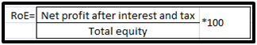
Figure 1: Return on Shareholders’ Fund formula
(S: Van Assche & Van Biesebroeck, 2017)

- Operating Profit Margin
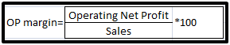
Figure 2: Operating Profit Margin formula
(S:: Van Assche & Van Biesebroeck, 2017)
- Gross Profit Margin

Figure 3: Gross Profit Margin formula
(Source: Van Assche & Van Biesebroeck, 2017)

A clear examination of the Profitability Ratio of Ted Baker all through the three consecutive financial years of 2015, 2016 and 2017 has been calculated. In the following yr 2016 the Return On Shareholders fund for William hill plc. (williamhillplc.com, 2017) came out to be £4.11 millions and repectively Paddy Power Betfair Plc came £0.2 millions in the Opening Financial year. But in the next year of 2017 the RoE for William hill plc. came out to be £18.40 million pounds and Paddy Power Betfair came out to be £5.619 millions .By these values, it is pretty clear as the shareholder's return on the business of William Hill Plc. is more as compared to that of Paddy Power Betfair. The RoE rose up for Paddy Power Betfair Plc. by a huge amount in the financial year of 2017 but still couldn't match up with the performance rate of William Hill Plc.
This means the business completion rate is high for William Hill Plc.
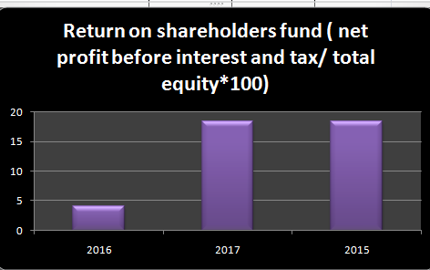
Graph 4: RoE for William Hill Plc.
(Source: Created by author)
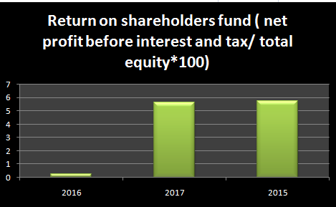
Graph 5: ROE graph for Paddy Power Betfair Plc.
(Source: Created by Author)
ROE analysis clearly shows that william hill stands in better position in comparision to the company paddy power.
The operating profit margin William Hill Plc. for the financial years of 2015 2016 and 2017 came out to be £53.13 millions & £63.6 millions etc. This shows that the profit on the operation costs after exclusion of the operating operating cost got an growth from 2015 to 2017. It clearly reveals that the company's business is running for profit. But at other hand, The Operating Profit Margin paddy power Betfair plc. for financial yrs of 2015 2016 and 2017 came out to be £2.962 millions & £70.92millions (paddypowerbetfair.com 2017). This gives that the profit on the operation expense after exclusion of the operating cost got a remarkable increment from 2015 to 2017. It reveals the thought of its negligible amount of profit in the first financial year, 2017 gave Paddy Power Betfair Plc a enormous boost to the business per-taining to the gaining of operational revenue. The operating margin of the company has reduced to 0.93, which has further shown fluctuation in the result.
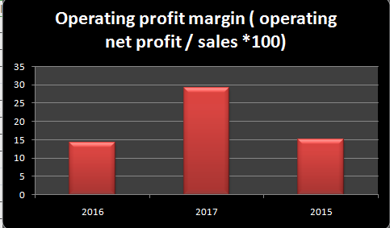
Figure 6: Operating Profit Margin graph for William Hill Plc.
(Source: Created by author)
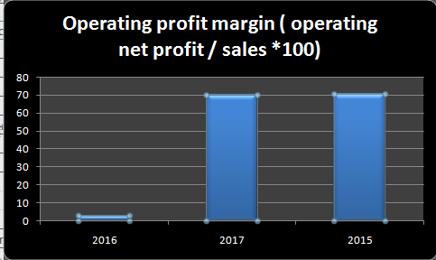
Figure 7: Operating Profit Margin graph for Paddy Power Betfair Plc
(Source: Created by author)

The Gross Profit Margin for William Hill Plc. Was about £103millio £296.08 millions GBP & £455.820 million pounds in the respective years of 2016 and 2017 (williamhillplc.com, 2017). This denotes that the gross profit over various departments such as sales and marketing, product technology operations has increased by an abrupt amount. However, the gross profit margin for Paddy Power Betfair Plc was out to be £407.50 millios GBP & £387.283 millions GBP in the respective years of 2016 and 2017. This indicates that the gross profit for Paddy power Betfair endured a decrement in the gross profit by a huge amount pertaining to the expenses in the sales and operational methods. The gross profit of the William Hill in 2015 and 2017 has remained the same as compared to the last year. Decreasing trend in the ratio has been seen as an alarming sign of inefficiency as comparsion to the Paddy power.
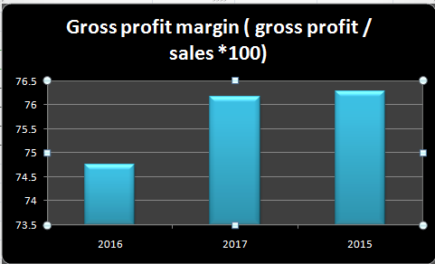
Figure 8: Gross profit margin graph for William Hill Plc.
(Source: created by author)
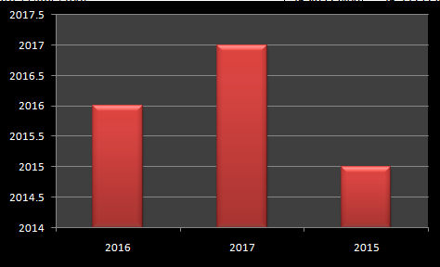
Figure 9: Gross Profit Margin graph for Paddy Power Betfair Plc
(Source: created by author)

Liquidity ratio
- Current ratio
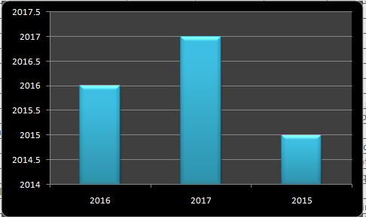
Figure 10: Current ratio graph for William Hill Plc.
(Source: created by author)

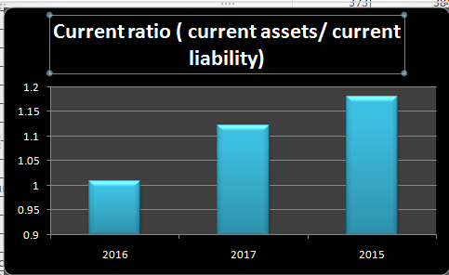
Figure 11: Current ratio graph for Paddy Power Betfair Plc.
(Source: created by author)
Liquidity Ratio of the company is enhanced from 0.17 to 1.12, that shows the company balance due position is not good as compared to Paddy Power. It can be further stated that the company needs to improve to debt position by reducing the expenses. William Hill on the other hand has reported reduction in the value of the current liabilities that helps the company to stand in superior position as comparision with Paddy Power. The company ability to pay obligation on debts has been got by analysing the liquidity ratio of the company. It has been done through calculation of current ratio. The internal analysis involves the inclusion of multiple periods of accounting and comparing them to the current period to see the change in business. Liquidity Ratio helps in the determination of the working capital for both William Hill Plc. and Paddy power Betfair Plc. For the financial yrs of 2015 2016 & 2017 the Current Ratio for william hill Plc. got out to be 0.711 and 0.823 (williamhillplc.com, 2017). It states an increase in that the capacity of the company to disburse its debts in times of emergency in the form of liquid assets. moreover, for the financial yrs of 2015 2016 & 2017 the current ratio for Paddy Power Betfair Plc. came out to be 1.08 & 1.12 . It states that a consistency in the paying of debts in the form of liquid assets was being maintained by the company for two consecutive years.
Efficiency ratio
- Gearing Ratio
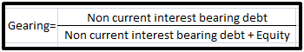
Figure 12: Gearing ratio formula
(Source: Van Assche & Van Biesebroeck, 2017)
The measurement of a company's financial leverage is being measured by computing the efficiency ratio. Under efficiency ratio, the computation of gearing ratio helps in producing a concrete structure of the leverage. This does not indicate the poor condition of a company but it typically indicates the high gearing ratio company faces a riskier financing structure as compared to low gearing ratio company. However, most of the industries which use costlier fixed assets have a higher gear ratio as these industries use fixed assets which are mostly financed by debt. Gearing ratio is also known by solvency ratio. In the financial years of 2016 and 2017, the gearing ratios for William Hill Plc came out to be 1.22 and 0.99 . A lowering of the gearing ratio indicates that the financial structure of the company is not at risk. On the other hand for Paddy Power Betfair Plc. it got to be 0.30 and 0.36 for 2016 and 2017. A lower value of gearing ratio indicates high value of performance pertaining to the well structured financial statement.
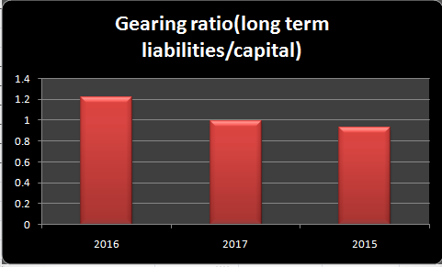
Figure 13: Gearing ratio graph for William Hill Plc
(Source: created by author)
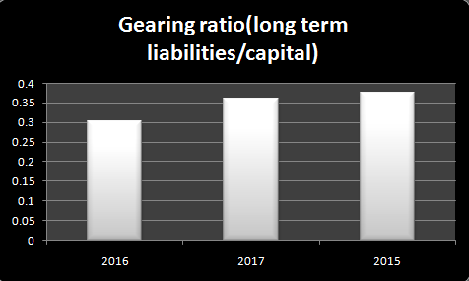
Figure 14: Gearing ratio graph for Paddy Power Betfair Plc
(Source: created by author)
Gearing ratio states that the company William Hill has reported rising trend that is to be reduced. The gearing ratio of the Paddy Power has reported declining trend from 0.36% to 0.35%, which shows that correct debt administration has been followed by the company.
- Investment ratio
When it comes to computing and analysing investment ratio of both the companies EPS value and price per earnings came out to be the exigent factors (Easton & Monahan, 2016). The Earnings per Share (EPS) of william Hill plc. and Paddy power betfair plc. both can be measured through investment ratio which in turn measures the profit earnings from each share being issued. EPS of the company has reduced from 5.45 to 14.5, which is certainly a superior sign for the company. Moreover lower earnings of the company shows that the William Hill Company stands in superior position as comparision to the other firm.
It also helps both the companies to measure per-earnings ratio which mainly involves the payment of the investors per dollar. It helps in comparing the values of the investors of both Comapnies. EPS value for William Hill Plc came out to be 0.195 and 0.106 for the fiscal years of 2016 and 2017. This shows that the growth of the company is slowing down and the net profit earned from each share decreased. But for Paddy Power Betfair Plc came out to be 0.07 and 2.55 for the fiscal years of 2016 and 2017. This denotes that a enormous loss in the net profit earn per share by the company in 2016 was greatly improved on the next financial year. This denotes the growth to be rapid.
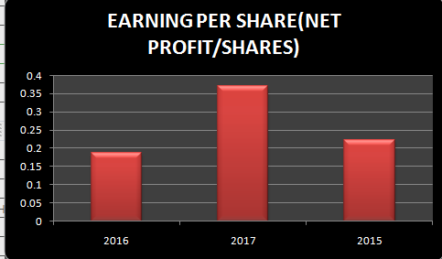
Figure 15: EPS value graph for William Hill Plc
(Source: created by author)

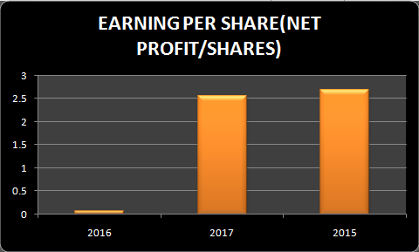
Figure 16: EPS value graph for Paddy Power Betfair Plc.
(Source: created by author)

The Price-Earnings (P/E) ratio of William Hill Plc is to be 7.476 and 14.445 respectively. It denotes a decrement in the investor value between 2016 and 2017 (williamhillplc.com, 2017). It denotes that the investors have become active with the stock engagements It also highlights a point that the stock is not the bargain. On the other hand price-earnings (P/E) ratio of Paddy Power Betfair Plc. came out to be 82.786 and 26.78 for financial yrs of 2016 and 2017. This denotes a big decrement in the benefit of the investors on the company's stocks. It also denote that the company's stock is in the bargain.
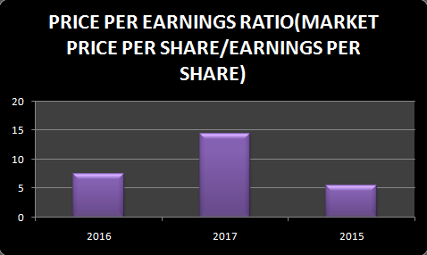
Figure 17: P/E ratio graph for of William Hill Plc
(Source: created by author)
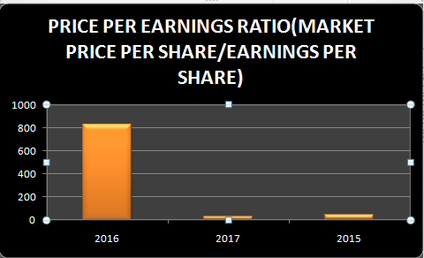

Figure 18: P/E ratio for of Paddy Power Betfair Plc
(Source: created by author)

Better position in terms of PE ratio has been seen in the company William Hill than Paddy Power, which is a good sign.

Suggestions for investment decisions
Tim Farrow's decision on investing on one of the above company will be based on the scrutinised report provided to him. In respect to maximise the investments, Tim has an approach of taking high risks & always looking forward to a higher productivity profit & a stable financial statement. He is occupied in taking least risks of taxation. However, less liabilities will be an benefit for any shareholder like Tim to invest a part of a share in any organisation. From the calculations provided, suggestion in the form of risk prevention techniques are being put forward
- In relation of return to shareholders, Tim should OPT William Hill Plc. since it will ensure a high amount of profit income before the tax liability. The performance rate of William Hill Plc is steady and consistent in terms of RoE which denotes a stable rise in equity.
- In Profitability ratio, Tim should OPT for William Hill Plc. as the company's current ratio, Operating profit ratio & gross ratio shows a stable growth between the financial years of 2016 and 2017. It will help Time in getting a positive return on investment (americanexpress.com, 2017). It will gain him profit in business and a long-term framework for profitability. The profit in terms of operational expenses will be achieved.
- In terms of Gearing Ratio, Tim should opt for William Hill Plc. over the other company. The company shows a decrease in the long-term liabilities and taxation. This will provide a sense of motivation to Tim, to invest in the company. In order to look forward to a long-term investment, Tim must go for William Hill Plc.
- In terms of Investment ratios, the EPS value as well as the P/E ratio of William Hill Plc. are positive and shows a steady growth. It denotes that the shares will be valued and will face a genuine and consistent rise in price. Tim should definitely go for this company.
- The NPV method tells the investors that either the investment creates value for the company or not and if it does also how much can be gained in terms of dollars.

Recommendation
In the form of recommendation, the suggestion can be provided for the companies William Hill Plc. & Paddy Power Betfair Plc. in the form of reduction of expenses
- In the first place, the supply costs should be cut off. It helps in maintaining the operational costs of the company. This can be done by looking outside the pool of traditional vendors (Easton & Monahan, 2016). The inclusion of local vendors and usage of local raw materials will also help in achieving this strategy.
- Secondly, production costs should be cut off by cutting off material costs and optimising the resources. (Easton & Monahan, 2016). This can be done by tracking the operational efficiency of the business. Setting up performance parameters reflecting the goals of efficiency and then offering incentives after completion will bring a positive turn around.
- Thirdly, by reducing the financial expenditures. This can be done by consolidating insurance policies (Easton & Monahan, 2016). Evaluating insurance policies to make sure that the company is not over-insured. Avoidance of taking unnecessary debts also helps in maintaining this strategy.

Conclusion
This detailed study has anaylised the financial analysis of two companies William Hill Plc & Paddy Power Betfair Plc. The financial statement of both these companies is collected for the year 2016 and 2017. A perfect analysis and comparison of Profitability Ratios, Liquidity Ratios, efficiency ratios, Gearing ratios and Investment ratios have been done all the way through. After analysing the whole, it is pretty clear that William Hill Plc had a much higher Profitability Ratios for the chosen financial years, as compared to Paddy Power Betfair Plc. while they had lower Liquidity Ratios. The net profit and gross profit margin are discussed along with appropriate graphs drawn on the Excel Sheet. A additional analysis on the return of shareholders’ fund has been shown.

Part 2

Capital budgeting Appraisal and Cash flow
There is variously advanced technique, to assist the decision makers in evaluating the expected profit and investment in the future venture. The value of time and money is taken into consideration which affects while evaluating the expected return in some of the designed technique. Some of the decision of investment does not take money value into consideration for evaluating the future investment assuming that it won't affect the stakeholders' venture. Decision for investment of capital is known as the budgeting of capital (Easton & Monahan, 2016). It is a planning tool used for determining and facilitating the concerning firm's investment for both long-term expenses and short-term investment primarily. Before investing on the project, the company's factors, previous cash flows, the structure of financial year profit or loss and depreciation in the market should be considered.

A. Determination of Payback period and Net present value (NPV)
1. Payback Period
The manufacturing company owned by Patel Metro wants to buy two projects, expecting to generate profit in future. The initial value investment on Project A requires £160,000 and investment on Project B requires £220,000, ending the project in last 6 years. There is a salvage value of Project A £20,000 and Project B £10,000 at the end of 6th year.
According to Lin & Ahmad (2016), the simplest method of analyzing the alternatives of the project on investment is Payback period method. The holders can recognize the time span required for budgeting on capital, returns on the investment done initially on capital. The main benefit of the payback period method is, determining the time of returns on investment and recovering the amount with better investment at less risk period (Fong & Lee, 2016).
 | Cash flow |  | Cumulative value
Year | Project A | Project B | Project A | Project B
0 | £160,000 | £220,000 | £160,000 | £220,000
1 | £45,000 | £60,000 | £45,000 | £60,000
2 | £45,000 | £60,000 | £90,000 | £120,000
3 | £45,000 | £60,000 | £135,000 | £180,000
4 | £45,000 | £60,000 | £180,000 | £240,000
5 | £45,000 | £60,000 | £225,000 | £300,000
Scrap value 6 | £20,000 | £10,000 | £205,000 | £310,000
Table 1: Payback Period
(Source: Created by Author)
Annual cash flow is even in project A, where the payback period is calculated with a formula
Payback period
Project A = Numbers of years to full recovery + Unrecovered cost at the start of the year
Cash flow during full recovery year
No. of yrs to full recovery = 3rd Yr of Cumulative Value of Project A
Unrecovered cost at the start of the yr = £160,000 - £135,000 = £25000
Cash flow during full recovery yr = £180,000 - £135,000 = £45,000
So, Payback period of Project A =3 + £25,000 / £45,000
= 3.5555
=4 Years (Approxi)
When a firm is having liquidity problems, the project having shorter time span of returning at the rate of return is lower, then the project is assumed to be less risky. The aggregate value of payback period on project A is 4 years, where a situation arises that the project may be useful for Patel Metro.

Project B = Numbers of years to full recovery + Unrecovered cost at the start of year
Cash flow during full recovery year
No. of years to full recovery = 3rd Year of Cumulative Value of Project A
Unrecovered cost at the start of the yr = £220,000 - £180,000 = £40,000
Cash flow during full recovery year = £240,000 - £180,000 = £20,000
So, Payback period of Project B =
= 3 + £40000 / £20000
= 5 Years
According to the evaluation of payback period, the investment on the Project A would be more desirable than investing in Project B. Project A has the shorter time span or returning on
Investment of 4 Years (approx), Project B has 5 years of returning payback period on capital investment. It is considered that Project A can be recovered quickly on initial capital investment. The investment on project is only accepted when the payback period is of short time span.
2. Net Present Value
Considering the two projects A and Project B owned by Patel Metro with an initial investment of £160,000 and £220,000, lasting for 6 years. The cash flow is even throughout the calculating years with a residual value of £20,000 on Project A and £10,000 on Project B at the 6th year. The NPV becomes higher by adding the risk to the rate of discount for adjusting the risk inaccurately. When the extra risk is compounded to the incorporated rate of discount, it results in lowering down of Net Present Value.
 | Cash flow
Year | Project A | Project B | Cost of capital@ 7% | P.Vof Project A | P.V of Project B
0 | £160,000 | £220,000 |  | (£160,000) | (£220,000)
1 | £45,000 | £60,000 | 1.07 | £42,056 | £56,075
2 | £45,000 | £60,000 | 1.14 | £39,305 | £52,406
3 | £45,000 | £60,000 | 1.2250 | £36,733 | £48,978
4 | £45,000 | £60,000 | 1.310796 | £34,330 | £45,774
5 | £45,000 | £60,000 | 1.4025517 | £32,084 | £42,779
Scrap value 6 | £20,000 | £10,000 | 1.5007303 | £13,327 | £6,663
 |  |  | Net Present value | £37,836 | £32,675
Table 2: NPV
(Source: Created by Author)
The Net Present value is calculated by assuming the cost of capital @ 7% for 6 years. The investment on capital is calculated by evaluating NPV by summing up the present value of the cash inflow (£197,835) in Project A and (£252,675) in project B, having positive sign in the total year, with the cash outflow which is denoted with a negative sign. The cost of capital @ 7% is taken into consideration as (0.07) which is added up by the formula of (1+0.07) increased by multiplying each year. While calculating present value of a project the residual value of project A (£20,000) and Project B (£10,000) is also deducted from the total value arises out of cash flow. The aggregate Net Present value in both the project is positive, project A is £37,836 and project B is £32,675.
The NPV measures the inflows of the cash where it falls short or exceeds, after assuming time payback period are met with the capital investment (Leyman & Vanhoucke, 2016). The objective of a cash flow is always driving towards the positive impact or outcome of net present value. The relation between Net present value and the discount rate is always inversely correlated. If the discount rate is high it would decrease the aggregate present value a project. An increase in the rate of interest would increase the rate of discount over a payback period, due to which the net present value becomes wary while deciding (Referred to Appendix 2).

B) The average rate of Return
According to the given data of budgeting of capital, Patel Metro is concerned in evaluating the viability of both the project A and Project B for investment on capital and planning for the business. The Accounting Rate of Return is concerned for determining the project to be adopted by the organization or an individual and selecting among the several projects competing in the market, whichever is profitable.
Calculation of Average Rate of Return
 | Cash flow |  | Depreciation
Year | Project A | Project B | Project A | Project B | Average Investment
0 | £160,000 | £220,000 | £160 ,000 | £220 ,000
1 | £45 , 000 | £60 ,000 | £110 ,000 | £158 ,000 | Proj A | £160000 + £20000 / 2
2 | £45 , 000 | £60 ,000 | £110 ,000 | £158 ,000 |  | 170000
3 | £45 , 000 | £60 ,000 | £110 ,000 | £158 ,000
4 | £45 , 000 | £60 ,000 | £110 ,000 | £158 ,000 | Proj B | £220000 + £10000 / 2
5 | £45 , 000 | £60 ,000 | £110 ,000 | £158 ,000 |  | 225000
Scrap value 6 | £20 , 000 | £10 ,000 | (£180 , 000) | (£230 ,000)
 | Average Annual Profit |  | £61,667 | £93,333
Table 3: ARR
(Source: Created by Author)
The Average Return Rate helps in selecting the project having highest reward and on the similar time with less risk, an alternative to other.
Project A
Average annual profit = Sum of depreciated Cash flow - (Scrap value + Initial investment) divided by total year of the project.
= £550,000 - (£160,000 + £20,000) / 6
=£61,667
Project B
= Average annual profit = Sum of depreciated Cash flow - ( Scrap value + Initial investment) divided by total year of the project.
= £790,000 - (£220,000 + £10,000) / 6
= £93,333
Annual investment
Project A = Initial investment of project A + Salvage value / 2
= £170,000
Project B = Initial investment of project B + Salvage value / 2
= £225,000
The Average Rate of Return is calculated by the formula =Average Annual profit divided by Average investment
ARR of Project A= £170,000 / £61,667
2.756741855 = 3% (approx)
Project B = £225,000 / £93,333
2.410722895 = 2% (approx)
The Average Rate of Return method in Project A is 3% whereas in Project B is 2% offering the uniqueness to the manufacturing company of Patel Mintro in management, by providing suggestion in a useful way to compare the expenditure of capital on Project A and Project B. The percentage rate of return on Project A by 3% on the Average annual profit of £61,667 and Average investment of £170,000 and Project B by 2% where the annual profit is £ 93,333 and Average investment is £225,000 allows the company in responding to the project easily and rapidly whenever the opportunities arises.

C) Recommendation with a reason for the project to be adopted
As per the above calculation, the appraisal on investment for the project is discussed and considered in three different techniques for purchasing of capital. The Annual rate of return on Project A is 3% whereas the annual rate of return on Project B is 2% which is less rewarding in comparison to Project A. The project A is useful for Patel Metro to invest on as its initial value was £160,000 which was less in comparison to Project B £220,000 but even after the residual value the Net Present value of Project A is less by £37,836 in comparison to Project B £32,675. The payback period of the Project A for (4 years) is also less than Project B (5 Years). presumptuous that return on investment on a project A could be recovered quickly and easily than Project B. The capital investment on Project A is beneficial to the following manufacturing company for enhancing the venture in future and retaining the return on investment would also be higher.

D. Critically discussion on payback and NPV techniques to evaluate capital projects
NPV Method
The net present value method is one of the best ways to analyze the profitability of the company while making investments. This method carries few unique disadvantages and advantages which is not useful for making any investment decisions. The net present value helps in calculating the future cash flows present values which shows the excess of the present value in the investment outlay. In the case of net positive value is positive, one can go for choosing the project.
Advantage of NPV method:
- One of the basic advantages of net present value method is it takes into account that the future dollar is worthless compared to the dollar at present. This technique states that the cash flows are discounted by some other period of capital cost.
- The NPV method tells the investors that either the investment creates value for the company or not and if it does also how much can be gained in terms of dollars. In the calculations it has been shown that the investments will help the organization to increase the company value. All the cash flows has discounted today.
- NPV method takes the risk inherent and cost of capital into account for making the investment projections about the future. This technique also states that cash flows that have been projected for further in the future have less impact on the NPV than the predictable cash flows is more than the earlier period.
Disadvantage of NPV method:
- Net present value method requires some of the guess works regarding the firms cost of capital. Based on this technique it has been assumed that when the cost of capital is too low, than it will result in suboptimal investments. Net present value method also assumes that when the cost of capital is very high than it will results too many good investments in result.
- Another disadvantage of this technique is that this method is not useful in case of comparing more than two projects of different size. This method generally gives results in the form of dollars and the size of NPV is determined based on the size fo input.
Payback techniques
The selection of shortest payback period among two or more investments has determined through dividing the amount used in case of starting the project to the amount generated from the project per year (Jim Woodruff, 2018). The projects having shorter payback period is generally implies of higher returns.
Advantage of Payback techniques:
- This technique is very simple and many companies generally use the employs to analyze the capital budget.
- The technique offers quick evaluation in order to determine the projects are generating faster returns or not. Generally mangers have been assigned for evaluating the projects having smaller investments and short payback period (Bryan Keythman, 2018).
Disadvantage of Payback techniques:
- One of the major disadvantages of this tool is that it ignores the time value of money. It can be also stated that the investment can be of long term. The companies generate income even when they have paid the initial startup capital at the beginning.
- This method mainly emphasizes on the factor of liquidity rather focusing on profitability.
- This technique only considers the cash returns within the period.

E) Non-Financial Factors for Investment Appraisal process
Major investment of capital to the company plays the key role in capital budgeting. Small companies assume for expansion of ventures in future by adopting newer activities in the market (Shu, Zeithammer & Payne, 2016). The factors of capital budgeting are based on a response of decision maker, market activities, and stakeholders. Three of the basic techniques is underlined here for appraisal of investment. The outline of respective limitation, function, benefits, and objectives is calculated and decided with the help of investment appraisal various technique by comparing it unique and different (Chiaroni et al. 2017). The Nonfinancial factors affecting the appraisal of the investment are as under
The Green activities are widely accepted in the market expansion, as the companies which are not acting toward the preservation of the environment they are working in, the public would be unsympathetic towards such companies. The demand and goodwill of that company and its shareholders decline. The staff should be motivated and the customer investing in the project of the company should be pleased to their needs, before taking decision by the organization to invest in the new project. The environmental effect of an investment must be taken into account, or it will emerge in the factors of financial evaluation.

References
Kaufmann, W. (2017). Going by the book: The problem of regulatory unreasonableness. Abingdon: Routledge.
Hoyle, J. B., Schaefer, T., & Doupnik, T. (2015). Advanced accounting. New York: McGraw Hill.
Van Assche, A., & Van Biesebroeck, J. (2017). Functional upgrading in China's export processing sector. China Economic Review.Retrieved on 23rd march 2018. From: https://www.sciencedirect.com/science/article/pii/S1043951X17301037
Kajola, S. O., Adewumi, A. A., & Oworu, O. O. (2015). Dividend pay-out policy and firm financial performance: Evidence from Nigerian listed non-financial firms. International Journal of Economics, Commerce and Management, 3(4), 1-12. Retrieved on 23rd march 2018. From: http://www.lcbr-archives.com/media/files/Kajola-and-Adewumi-Dividend-payout-policy.pdf
Mathuva, D. (2015). The Influence of working capital management components on corporate profitability. Retrieved on 23rd march 2018. From:https://su-plus.strathmore.edu/handle/11071/3382
Doh, L. E., & Prince, D. R. (2015). THE IMPACT OF RESEARCH AND DEVELEOPMENT ON REVENUE GENERATION AND INVESTMENT VALUATION OF INFO-TECH CORPORTIONS. Journal of Business Economics and Finance, 4(4). Retrieved on 23rd march 2018. From: http://dergipark.ulakbim.gov.tr/jbef/article/view/5000167590
Ostad-Ali-Askari, K., & Shayannejad, M. (2015). Developing an optimal design model of furrow irrigation based on the minimum cost and maximum irrigation efficiency. International Bulletin of Water Resources & Development, 3(2), 18-23.Retrieved on 23rd march 2018. https://www.researchgate.net/profile/Kaveh_Ostad-Ali-Askari/publication/299437398_Construction_management_and_development_of_water_transport_arteries_Case_Study_Sefidrood_irrigation_network_Gilan/links/56f6ec0208ae81582bf2fb63.pdf
Easton, P. D., & Monahan, S. J. (2016). Review of Recent Research on Improving Earnings Forecasts and Evaluating Accounting‐based Estimates of the Expected Rate of Return on Equity Capital. Abacus, 52(1),35-58. Retrieved on 14th April 2018 from https://onlinelibrary.wiley.com/doi/full/10.1111/abac.12064
Lin, B., & Ahmad, I. (2016). Energy substitution effect on transport sector of Pakistan based on trans-log production function. Renewable and Sustainable Energy Reviews, 56, 1182-1193. Retrieved on 14th April 2018 from https://www.sciencedirect.com/science/article/pii/S1364032115013957
Fong, K. F., & Lee, C. K. (2016). System analysis and appraisal of SOFC-primed micro cogeneration for residential application in subtropical region. Energy and Buildings, 128, 819-826.
Retrieved on 14th April 2018 from https://www.sciencedirect.com/science/article/pii/S0378778816306703
Leyman, P., & Vanhoucke, M. (2016). Payment models and net present value optimization for resource-constrained project scheduling. Computers & Industrial Engineering, 91, 139-153. Retrieved on 14th April 2018 from https://www.sciencedirect.com/science/article/abs/pii/S0360835215004544
Shu, S. B., Zeithammer, R., & Payne, J. W. (2016). Consumer preferences for annuity attribute: Beyond net present value. Journal of Marketing Research, 53(2), 240-262. Retrieved on 14th of April 2018 from http://journals.ama.org/doi/abs/10.1509/jmr.13.0004?code=amma-site
Chiaroni, D., Chiesa, V., Franzò, S., Frattini, F., & Latilla, V. M. (2017). Overcoming internal barriers to industrial energy efficiency through energy audit: a case study of a large manufacturing company in the home appliances industry. Clean Technologies and Environmental Policy, 19(4), 1031-1046. Retrieved on 14th April 2018 from https://link.springer.com/article/10.1007/s10098-016-1298-5
Websites
wsj.com (2017). Balance sheet of William Hill Plc. Retrieved on 23rd March 2018. From: http://quotes.wsj.com/IE/PPB/financials/annual/balance-sheet
williamhillplc.com (2017). Annual report of William Hill Plc. Retrived on 23rd March 2018. From: https://www.williamhillplc.com/newsmedia/newsroom/corporate-news/2017/2016-annual-report-and-accounts/
williamhillplc.com (2017). Final results of William Hill Fiancial Statement. Retrieved on 23rd march 2018. From: https://www.williamhillplc.com/media/12073/wmh-final-results-statement-22-feb-18.pdf
americanexpress.com (2017). Simple ways to cut off expenses. Retrieved on 23rd march 2018. Retrieved on 23rd march 2018. From: https://www.americanexpress.com/us/small-business/openforum/articles/10-simple-ways-to-cut-business-costs/
paddypowerbetfair.com (2017). Balance sheet of Paddy Power Betfair Plc. Retrieved on 23rd march 2018. Retrieved on 23rd march 2018. From : https://www.paddypowerbetfair.com/~/media/Files/P/Paddy-Power-Betfair/documents/ppb-2017-prelims-07-03-2018.pdf
williamhillplc.com (2017). About the company. Retrieved on 23rd march 2018. From: https://www.williamhillplc.com/about/our-businesses/retail/
paddypowerbetfair.com/ (2017). About the company. Retrieved on 23rd march 2018. From: https://www.paddypowerbetfair.com/our-business/priorities
Bryan Keythman (2018), Advantages and Disadvantages of Payback Capital Budgeting Method [Online] Retrieved on 25th March 2018 from https://yourbusiness.azcentral.com/advantages-disadvantages-payback-capital-budgeting-method-10195.html
Jim Woodruff (2018), Advantages & Disadvantages of Payback Capital Budgeting Method [Online] Retrieved on 25th March 2018 from http://smallbusiness.chron.com/advantages-disadvantages-payback-capital-budgeting-method-14206.html

Appendices

Appendix 1
Part 1: Financial analysis and interpretation
2016 | 2017 | 2015 | Paddy Power Betfair Plc
 |  |  | Liquidity ratio | 2016 | 2017 | 2015
0.711463415 | 0.823184767 | 0.517038601 | Current ratio ( current assets/ current liability) | 1.008043 | 1.122396 | 1.1792717
291.7 | 393.4 | 342.9 | Current assets | 376 | 431 | 421
410 | 477.9 | 663.2 | current liability | 373 | 384 | 357
2016 | 2017 | 2015
 |  |  | Profitability ratio | 2016 | 2017 | 2015
0.041121671 | 0.184088127 | 0.18448758
43.7 | 225.6 | 224.3 | Return on shareholders fund ( net profit before interest and tax/ total equity*100) | 0.00278 | 0.056195 | 0.0574713
1062.7 | 1225.5 | 1215.8 | Net profit before tax | 12 | 247 | 250
 |  |  | Total equity | 4316.6 | 4395.4 | 4350
14.31983157 | 29.05094385 | 15.08805031
229.5469 | 243.1564 | 239.9 | Operating profit margin ( operating net profit / sales *100) | 0.02963 | 0.70028 | 0.7055556
1603 | 837 | 1590 | Operating profit | 12 | 250 | 254
253 | 268 | 240 | Sales | 405 | 357 | 360
9.27% | 9.27% | 10%
1.222640444 | 0.993227254 | 0.930169436 | Gearing ratio(long term liabilities/capital) | 0.304202 | 0.361061 | 0.3764706
1299.3 | 1217.2 | 1130.9 | Long term liabilities | 372.8 | 383.7 | 384
1062.7 | 1225.5 | 1215.8 | capital | 1225.5 | 1062.7 | 1020
74.75308281 | 76.16909839 | 76.28930818 | Gross profit ratio ( gross profit / sales*100) | 76.89232 | 76.77323 | 108.31134
1279.1 | 1221.6 | 1213 | Gross profit | 1154 | 1340 | 1354
1711.1 | 1603.8 | 1590 | sales | 1500.8 | 1745.4 | 1250.1

(Source: Created by the author)

Appendix 2

Part 2: Capital budgeting Appraisal and Cash flow

 | Calculation of Payback period and Net Present Value
2. A
 |  | Cashflow |  | Cumulative value
 | Year | Project A | Project B | Project A | Project B | Rate of return @ 7% | P.V of Project A | P.V of Project B
 | 0 | 160,000 | 220,000 | 160,000 | 220,000 |  | (160,000) | (220,000)
 | 1 | 45,000 | 60,000 | 45,000 | 60,000 | 1.07 | 42,056 | 56,075
 | 2 | 45,000 | 60,000 | 90,000 | 120,000 | 1.1449 | 39,305 | 52,406
 | 3 | 45,000 | 60,000 | 135,000 | 180,000 | 1.225043 | 36,733 | 48,978
 | 4 | 45,000 | 60,000 | 180,000 | 240,000 | 1.31079601 | 34,330 | 45,774
 | 5 | 45,000 | 60,000 | 225,000 | 300,000 | 1.40255173 | 32,084 | 42,779
 | Scrap value 6 | 20,000 | 10,000 | 205,000 | 310,000 | 1.50073035 | 13,327 | 6,663
 |  |  |  | Net Present Value |  |  | 37,836 | 32,675
 | Payback period
 | Project A | 3 + 25000 / 45000
 |  | 3.555555556
 |  | 4 years (approx)
 | Project B | 3 + 40000 / 20000
 |  | 5
 |  | 5 years
 | Calculation of Average Rate of Return
 |  | Cash flow |  | Depreciation
B. | Year | Project A | Project B | Project A | Project B | Average Investment
 | 0 | 160,000 | 220,000 | 160,000 | 220,000
 | 1 | 45,000 | 60,000 | 110,000 | 158,000 | Project A | 160000 + 20000 / 2
 | 2 | 45,000 | 60,000 | 110,000 | 158,000 |  | 170000
 | 3 | 45,000 | 60,000 | 110,000 | 158,000
 | 4 | 45,000 | 60,000 | 110,000 | 158,000 | Project B | 220000 + 10000 / 2
 | 5 | 45,000 | 60,000 | 110,000 | 158,000 |  | 225000
 | Scrap value 6 | 20,000 | 10,000 | (180,000) | (230,000)
 |  | Average Annual Profit |  | 61,667 | 93,333
 | Depreciation |  |  | ARR
 | Project A | 160000 - 20000 / 4 |  | Project A | 170,000 / 61,667
 |  | 155000 |  |  | 2.756741855
 |  |  |  |  | 3% (approx)
 | Project B | 220000 - 10000 / 5 |  | Project B | 225,000 / 93,333
 |  | 218000 |  |  | 2.410722895
 |  |  |  |  | 2% (approx)

(Source: Created by the author)

