Re
Michael Oldham (2235684)
2235684@student.uwtsd.ac.uk
data security & Compliance
Research and case scenario in Data Security & Compliance

Contents

Introduction 0
Task 1 – Research in Data Security and Compliance (Security Technologies) 0
Facebook Data breach (April 2019) 0
Firewalls 1
Virtual Private Networks (VPNs) 3
Anti-Virus software 5
Conclusion 0
Task 2 – (Case Scenario) 0
Management’s Role in Information Security 1
Organisation structure/chart 1
Policies & Procedures 4
Data Protection Compliance 6
Security Standards 7
Contingency Planning 8
Governance and Strategic Planning for Security 9
Risk Management 10
References 11

Introduction

This assignment in relation to Data Security & Compliance addresses the key issues associated with protecting information assets, determining the levels of protection and response to security incidents, and designing a consistent, reasonable information security system, with appropriate intrusion detection and reporting features.
In the assignment, I’m going to look further into Security Technologies such as firewalls, VPNs and Anti-Virus software, looking at why modern organisations need to create an environment that protects, detects, reacts and safeguards applications using its IT systems and infrastructure.

Task 1 – Research in Data Security and Compliance (Security Technologies)

Facebook Data breach (April 2019)

In April of 2019, Facebook revealed that individual’s personal information had been leaked into the public internet through two datasets from Facebook Apps. This included details such as phone numbers, account names and Facebook IDs. This impacted more than 530 million Facebook users. [1]
A Company named UpGuard found the massive cache of data on unsecured Amazon Servers used by the Mexican social media firm. UpGuard explained that the data about the Facebook users was found as part of regular checks completed by the firm on Amazon S3 servers. Once the breach had been flagged to Facebook, they helped Amazon remove the data which had been made available. [2]
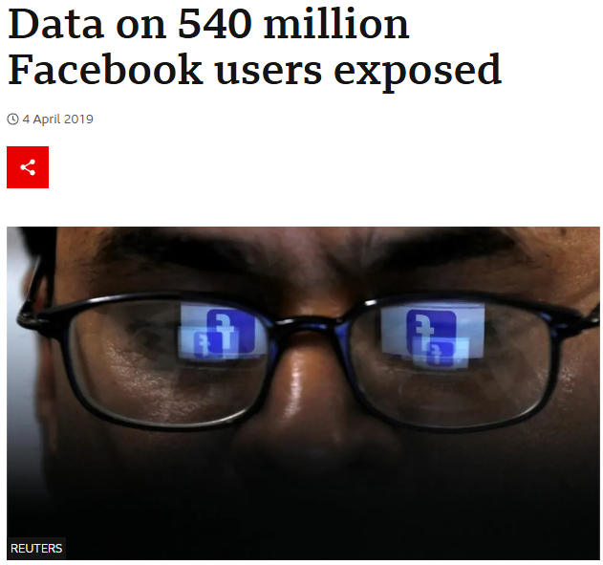

In relation to many data breaches that happen each year such as that of the one in Facebook 2019, it is important for companies and organisations to keep their security procedures and policies up to date and to the highest standard, improving them regularly to ensure safety of personal information and to keep the trust of their customers along with the reputation of the business.
Some counter measures that companies and businesses put in place to help keep their systems and data secure include security technologies such as Virtual Private Networks (VPNs) Anti-Virus software and firewalls.
Within this report, I am going to take a further look into some of these technologies to help understand what they are, why they are important and how they help organisations with data security.

Firewalls
A firewall is a protective system designed to monitor and regulate network traffic flow according to specific security guidelines. Typically positioned between a secure internal network and an external network such as the internet and acts as a barrier. [3]
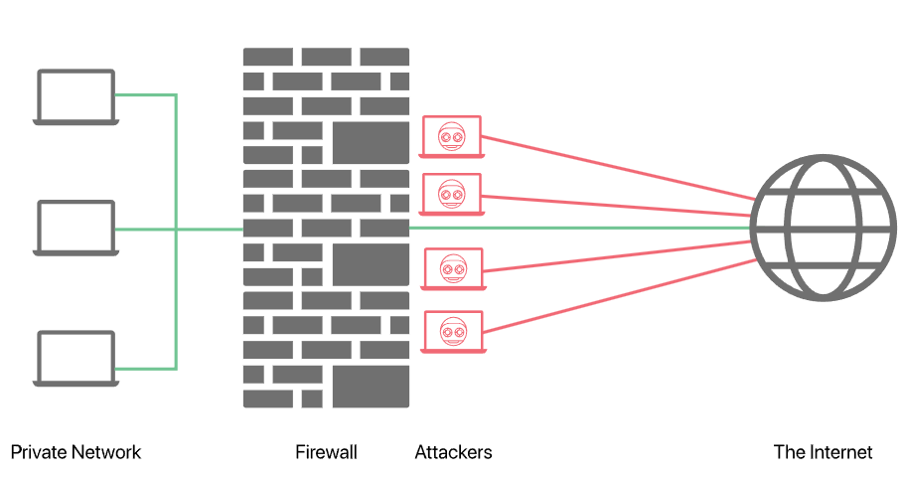

Firewalls are primarily used for security purposes. They can intercept harmful incoming traffic before it reaches the network and prevent sensitive information from leaving the network. Additionally, firewalls can be used for content filtering. For instance, they can be configured to prevent young users from accessing adult or graphic content.

There are different types of firewalls, including Packet-Filtering Firewalls, Proxy Firewalls, Next-Generation Firewalls (NGFW), Cloud Firewalls, and Network Address Translation (NAT) Firewalls. Each type operates differently and has its advantages and disadvantages, but they are all designed to inspect incoming and outgoing data and filter out potentially harmful or malicious content.

Packet-Filtering Firewalls inspect units of data (packets) transferred between computers. They examine the headers of packets to check the source and destination IP addresses, port numbers, and protocols. While they are simple, fast, and efficient for basic filtering, they are limited in their ability to inspect the actual data payload being transmitted.

Proxy Firewalls act as a link between end-users and the web resources they access. They filter the traffic at the application layer, enabling them to inspect the data part of the packets. These firewalls provide a high level of security, as they can filter specific content and implement user authentication.

A next-generation firewall (NGFW) is a network security solution that offers advanced features beyond those of a standard firewall. While traditional firewalls generally perform stateful inspection of network traffic, NGFWs enhance security with capabilities such as application awareness and control, built-in intrusion prevention, and threat intelligence delivered via the cloud. [4]
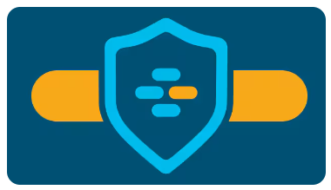
Cloud Firewalls are software-based network devices on the cloud which help with the security of unwanted access to private networks. They provide their protection in the cloud as opposed to on-premises hardware. These firewalls help to protect the cloud infrastructure and services. Advantages of this include scalability and are easy to manage, whilst some disadvantages include being dependant on an internet connection and cloud service providers. [5]
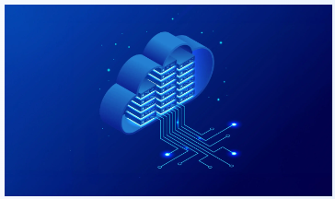
NAT Firewalls are features that can be applied on a network router to add filters between the devices on the network and the internet. Again focused on security and protection, it monitors the traffic on the network. Incoming data is directed to a public IP address, where it is then translated to an internal IP address by the firewall before reaching its final destination. The NAT Firewall compares things you have searched for to the results returned on the internet as a way of filtering out things you have not requested. This adds extra layers of security to prevent unwanted traffic which has not been requested reaching the private network. [6]

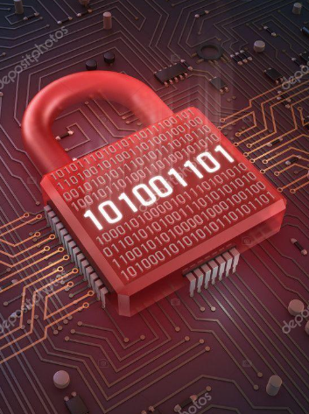
[7]
In summary, firewalls are essential for safeguarding organisational security for a variety of reasons. They serve as a primary barrier against unauthorised access and cyber threats by analysing and managing network traffic according to security protocols. By blocking potentially malicious incoming data and controlling the flow of sensitive information, firewalls play a crucial role in preventing data breaches and loss. They also offer additional security features such as content filtering and intrusion detection, which enhance overall protection. Implementing an effective firewall allows organisations to protect their data, comply with regulatory requirements, ensure continuous operations, and maintain customer trust. With cyber threats increasing, firewalls are a fundamental component of a strong security strategy, helping to mitigate risks.

Virtual Private Networks (VPNs)
A Virtual Private Network (VPN) allows users to connect to another network securely over the internet. It has many different purposes such as being able to access region-restricted content or websites that could not normally be accessed on certain networks. It can also hide your browsing activity if you were to be connected to a public network. Whilst they can be used for non-security purposes such as accessing certain audio or video content/tv shows which are not shown in certain countries, security aspects of VPNs include protection whilst using Wi-Fi hotspots. If these are untrustworthy or you are unsure of its privacy/security using a VPN helps to keep your data and details secure. [8]

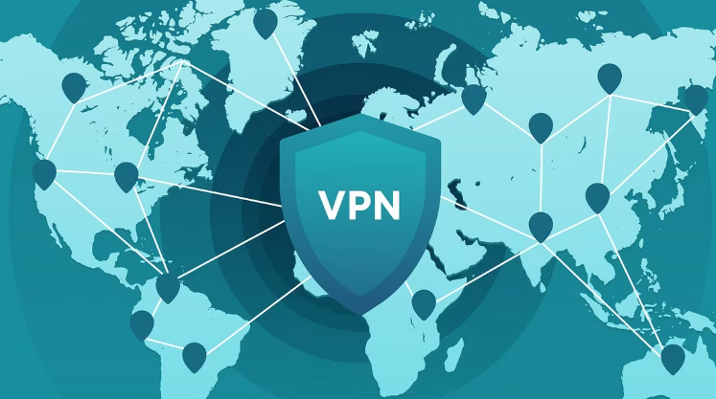

Another important feature of VPNs is encryption. This is where it converts the actual data into coded unreadable information to help block unauthorised users from intercepting or reading the content in the internet traffic.
Some VPN providers offer a No-Log or Zero-Log policy where they agree to never keep record of online activities of the users. Whilst some companies do offer these or similar policies, some data may still be stored which is why it is important to check with the providers' terms and conditions. If you can check which type of servers they use, those using RAM-only servers could give peace of mind due to the fact that these servers only save data temporarily which is then erased once the hardware is turned off. [9]
It is important for organisations to use Virtual Private Networks in order to protect its data whilst being transmitted to remote users and the network. They make it difficult for cybercriminals to intercept and decipher this sensitive information. They help safeguard the data by creating private tunnels over the internet which cannot be easily penetrated.

When companies use these VPNs it can make it easier for the security teams to detect any anomalies in the network in order to identify any potential threats or attacks that are made.


Compliance and regulatory requirements are contributing factors taken into consideration by businesses when looking at VPNs as there are stringent regulations requiring the protection of data to prevent unwanted parties from accessing it.
Due to the features provided by VPNs, these help organisations to comply with these rules such as GDPR (General Data Protection Regulation) and in the US HIPAA (Health Insurance Portability and Accountability Act).

Whilst there are clear advantages of companies making use of VPNs there are also some disadvantages depending on the features and capabilities with different providers. These includes things like slower internet speeds, configuration problems, sudden connection drops, the added technology complexity in a business, the cost and the VPN provider being able to see your data if a Zero policy is not in place. It is also illegal to use VPNs in certain countries like North Korea, Belarus and Iraq. In other countries like China, Russia and the UAE, only government-approved VPNs are legal. This is likely due to them allowing the authorities to monitor users and essentially undermining the privacy that VPNs should be able to provide.
In 2017 Russia banned VPN providers which had not been approved. The only ones which had approval are likely again to allow the Russian government to access or request this information. [10]


Anti-Virus software
Antivirus software is a program designed to safeguard a computer or device from harmful software, known as malware. It works by scanning files and system activities to detect and eliminate threats such as viruses, worms, trojans, and spyware. The software can perform scans on demand or automatically, and it uses various techniques like signature recognition, heuristic analysis, and behaviour monitoring to identify potential dangers. Additionally, antivirus programs offer real-time protection to prevent threats from causing harm as they arise. Regular updates to the software help keep it effective against the latest threats.
Some different stages of this include scanning, detection, quarantine, removal and real-time protection.
In the scanning stage the software checks files and programs including system memory or known signatures of malware. This can either be done manually or can be set up to scan at scheduled times.
Once the scanning has completed, the detection stage is where the software identifies any threats using a database to compare these known signatures. Another method which some software use is called heuristic analysis. This is a technique where the software evaluations any potential threats based on their characteristics rather than relying only on known malware or virus signatures. It also uses code analysis by inspecting the code for patterns,
sequences and structures commonly found in malware. Once it has been detected, this is then moved into quarantine which is a secure location that isolates the threats from the rest of the system to prevent any harm during further analysis. Once all analysis and checks have been completed, the software attempts to remove the malware from the system. If this is not possible, a repair is attempted on the affected file and if this is also not possible, it will remove it completely.
Real-time anti-virus software protection is another feature which is used to continuously monitor a computer for threats. If the malware attempts to execute within the system, the real-time protection defends against this immediately. This software is often running in the background, intermittently scanning the system for potential virus/malware and suspicious activity. [11]


Conclusion

In conclusion, implementing firewalls, antivirus software, VPNs, and other security technologies is crucial for safeguarding an organisation's IT infrastructure and systems. These tools provide security essential for protecting against cyber threats, each playing a role in securing the organisation’s data.
Firewalls act as the first line of defence by controlling network traffic and blocking unauthorised access. They create a barrier between trusted internal networks and untrusted external networks, like the internet, to prevent malicious threats from exploiting vulnerabilities. Firewalls can be set up to enforce security policies, filter harmful content, and monitor network traffic for suspicious activity, helping to stop potential attacks before they happen.
Antivirus software continuously scans for and removes malware, ensuring system integrity. It detects, quarantines, and eliminates viruses, worms, trojans, and other malicious software before they can cause significant damage. By providing real-time protection, antivirus programmes help identify and remove threats as they arise, reducing the risk of data breaches.
VPNs (Virtual Private Networks) secure data transmission by encrypting internet connections, protecting sensitive information from interception. This is especially important for remote workers and businesses with teams in different locations, as it ensures that data remains confidential and secure. VPNs also mask the user's IP address, providing an extra layer of privacy and protection against cyber-attacks.
Together, these technologies not only prevent potential attacks but also detect and respond to threats in real-time, reducing damage. Firewalls and antivirus software offer proactive measures against threats, while VPNs ensure secure communication channels. The combination of these tools creates a strong security framework that can help detect threats and protect the systems.
By combining these security measures, organisations can effectively protect their data, maintain operations, and build trust with stakeholders. A comprehensive security strategy is essential in today’s digital age, where cyber threats are increasing.

Task 2 – (Case Scenario)
For this task, as a manager who has been tasked with setting up a new information security unit in my organisation, I will be creating a report for the executive directors that outlines the approach I will take to mee the needs of the company in creating the new information security unit. This will include the organisation structure, policies and procedures, data protection and compliance, security standards, contingency planning, governance and strategic planning for security and risk management.

Management’s Role in Information Security
As a manager setting up a new information security unit within my organisation, it is my responsibility for setting information security objectives, establishing the policies and procedures that need to be put in place, allocation of resources, promoting a culture of security awareness, risk management and compliance, incident response and business continuity, monitoring and reporting and continuous improvement.

Organisation structure/chart
Below I have set out the structure of my organisation to show where the different roles sit within the hierarchy.

Chief Information Security Officer (CISO)
The responsibility of the CISO includes overall security strategy and implementation and reports to the CEO. Some of the key functions include, strategic planning, policy development, risk management, regulatory compliance and coordination with other executive members. Other duties include developing secure processes and systems in order to prevent, detect, mitigate and recover from cyberattacks. [12]

Deputy CISO
A Deputy CISO assists the CISO in managing the organisation's data security, focusing on strategy implementation, risk management, and incident response. They ensure compliance with regulations, oversee security technologies, and lead the security team. [13]

Information Security Manager
An Information Security Manager develops and enforces security policies, manages security projects, and coordinates risk assessments. They lead the security team to protect data and systems from threats and ensure regulatory compliance. [14]

Security Administrators
Security Administrators manage and maintain security systems, configure tools like firewalls, control user access, and monitor network activities to prevent breaches and ensure system integrity. [15]

Security Architect
A Security Architect designs robust security frameworks, selects appropriate technologies, and develops models to safeguard the organisation's information assets against cyber threats. [16]

Security Engineers
Security Engineers implement and maintain security measures, conduct vulnerability assessments, and respond to incidents. They ensure the resilience of systems through configuration and troubleshooting. [17]

Compliance & Risk Analysts
Compliance & Risk Analysts ensure adherence to legal and regulatory requirements by conducting risk assessments, identifying gaps, and developing mitigation strategies to maintain security and compliance. [18]

Incident Response Team
The Incident Response Team manages and mitigates security incidents by investigating breaches, containing threats, and implementing recovery procedures to minimise damage and improve future responses. [19]

Policies & Procedures
Within my organisation, it is important that Information Security Policies are created to show guidelines and procedures that must be adhered to so that information assets can be protected. Some of the policies that will be in place include, Remote Access, Data Management, Network Security, Acceptable Use, Incident Response, Data Protection, Password protection and Email Security. Here’s how I plan to develop and implement these policies:

Remote Access Policy
I will create a Remote Access Policy that specifies the secure methods and protocols for accessing the company's network and resources remotely. This policy will include the use of virtual private networks (VPNs), multi-factor authentication, and encryption. Training will be provided to ensure all employees understand the importance of secure remote access and how to implement it.

Data Management Policy
I will develop a Data Management Policy to regulate the creation, storage, handling, and disposal of data. This policy will categorise data based on its sensitivity and set protocols for data encryption, access controls, and regular audits. Employees will be trained to understand data classification and the appropriate handling procedures to minimise the risk of data breaches.

Network Security Policy
I will implement a Network Security Policy that outlines the security measures necessary to protect the company's IT infrastructure. This includes firewalls, intrusion detection systems, and regular vulnerability assessments. I will work with the relevant IT teams to ensure the network is resistant against potential threats and that security patches and updates are applied promptly.

Acceptable Use Policy
I will create an Acceptable Use Policy that clearly outlines the permitted use of company resources, such as computers, the internet, and email. This policy will set expectations for professional conduct and ban activities that could compromise the organisation's security.

Incident Response Policy
I understand the importance of being prepared for security incidents. Therefore, I will establish an Incident Response Policy that details the steps to take in the event of a security breach or other cyber incidents. This policy will cover incident identification, containment, eradication and recovery. A dedicated incident response team will be trained to act rapidly and effectively to minimise the impact of security incidents.

Data Protection Policy
To comply with legal and regulatory requirements, I will develop a Data Protection Policy to ensure the privacy and protection of personal data. This policy will address data processing practices, consent management, and individuals' rights. Regular audits will be conducted to ensure compliance with data protection regulations such as GDPR.

Password Protection Policies
I will enforce strong Password Policies to enhance the security of accounts. This policy will require strong, unique passwords that are changed regularly with the addition of two-factor-authentication. I will also promote the use of password managers to help secure access to sensitive information.

Email Security Policy
Knowing the risk of phishing attacks, I will implement an Email Security Policy to educate employees on recognising and reporting suspicious emails. This policy will include guidelines for email encryption, secure attachments, and regular mock phishing emails to maintain a high-level of security awareness.

I am committed to creating an effective Information Security Unit that protects our information assets and promotes the principals of security awareness within the business. By developing and applying clear and practical policies and procedures, I will ensure our company's information security is strong and compliant with regulations. [20]

Data Protection Compliance

I understand that adhering to data protection laws, like the General Data Protection Regulation (GDPR), is crucial. To make sure my organisation follows data protection laws and meets these requirements, I will put the following steps in place:

Handling Personal Data
I will set up clear policies on how we collect, process, and store personal data. We’ll make sure data is collected for specific, genuine reasons and is handled fairly and transparently.

Managing Consent
I will create simple and clear ways for people to give their consent for us to use their data. This includes consent forms which are easy to understand and processes for them to withdraw their permission whenever they choose. Training will be provided to ensure everyone knows how to follow these consent rules and policies.

Respecting Individual Rights
I will make sure we respect people’s rights regarding their data. This includes their right to access their data, correct any mistakes, request that information is deleted, or limit how their data is used. We’ll have procedures in place to respond quickly to these requests through different channels and teams.

Risk Assessments
For any new projects or processes involving personal data, I will carry out Data Protection Impact Assessments. This will help us find and address any risks to data privacy from the beginning to keep risk minimal.

Regular Checks
I will ensure that regular audits take place to make sure we’re following data protection rules. This will involve reviewing our data handling practices, updating our policies as needed, and keeping an eye on compliance through regular checks.
By taking these steps, I will ensure our organisation meets data protection standards, keeps personal data safe, and maintains trust with our customers. [21]

Security Standards

The current standard for information security management is ISO/IEC 27001. This is an internationally recognised standard in data security within all aspects of an organisation. Regardless of the business size, this particular standard is suitable for the management of customer, staff and supplier data. Cloud security is also covered by this standard as it is also held in a physical location. Therefore, it is paramount to ensure that such standards are implemented and maintained to help against cyber attacks which are becoming more frequent in the current digital era.

Adopting the ISO/IEC 27001 standard will help to establish trust and confidence in our customers and stakeholders, knowing that the security practices are of the best class and internationally recognised.

I will ensure that our senior management team is well-trained in the ISO/IEC 27001 framework. Their understanding and support are essential for embedding these practices throughout the organisation. We will hold regular training sessions and workshops to keep them updated. Certification for ISO/IEC 27001 lasts for three years, but we need to show ongoing improvement to stay certified. I will set up regular reviews and updates of our security practices, including internal audits and management reviews.
Keeping the team up to date with the necessary training and certification is key. I will implement a training programme for all staff, not just within our IT departments. This will cover the basics of the frameworks, security standards, the importance of information security, and how to stay compliant.

Ensuring that the department are always kept up to date with any required training and certification, I will promote the use and implementation of security standards so that sensitive data can be protected whilst held by the organisation.
By following these steps, I will ensure our organisation adopts the ISO/IEC 27001 standard and maintains a high level of information security. This will protect our data and support our strategic business goals which remaining compliant with GDPR. [22]

Contingency Planning

Implementing a contingency plan is essential for ensuring my organisation can quickly respond to different events and recover from them. Here’s a high-level overview of how I will approach this:

Firstly, I will develop an in depth contingency plan that includes identifying potential risks and assessing their impact on our operations. This plan will cover a wide range of scenarios, such as natural disasters, cyber-attacks, and power outages. To ensure the plan is effective, I will involve key stakeholders from different departments in the planning process and hold regular checkpoint meetings to ensure all basis are covered.

I will help to establish clear roles and responsibilities for all staff members during an emergency. This will include creating an incident response team trained to act swiftly in these situations. Regular training sessions and drills will be conducted to ensure everyone knows their role and can act efficiently when required.

Additionally, I will ensure that critical data and systems are backed up regularly and stored securely. Offsite backups and cloud storage solutions will be used to protect against data loss. I will also implement redundancy for key systems to ensure they remain operational during a disaster.

Communication is crucial during a crisis, so I will set up a robust communication plan. This will include multiple channels, such as email, phone, and messaging apps, to ensure information can be communicated quickly and effectively.

Finally, I will establish a process for regularly reviewing and updating the contingency plan. This will involve post incident reviews and making necessary adjustments to improve our response to future incidents.

By putting these measures in place, I will ensure that our organisation is prepared to handle any unexpected events and can continue to operate with as little disruption as possible. [23]

Governance and Strategic Planning for Security
As a manger in Information Security, it is part of my role to set the security objectives, establish the policies and procedures that will be put in place and also allocate the resources. It will also be down to me to ensure that the business is promoting a culture of security awareness by ensuring that all staff of all levels are regularly trained and where required, complete certification in the different aspects of frameworks and security standards.

I must ensure that risk management assessments are carried out to keep check on the everchanging rules and regulations whilst ensuring compliance to the requirements of these standards.

Part of my role also involves developing and maintaining an effective incident response plan. This plan will outline the steps to take in the event of a security breach, including identification, containment, eradication, and recovery. I will establish an incident response team trained to act quickly and efficiently during any security incident. Regular drills and simulations will ensure that the team is prepared and that any gaps in the response plan are identified and addressed.

Business continuity planning is equally important. I will develop a business continuity plan to ensure that essential business functions can continue during and after a disaster. This includes identifying essential services and processes, establishing backup systems, and defining recovery time objectives.

Security is a never-ending task, and keeping up with new threats means we have to keep improving. I will encourage a habit of always looking for ways to get better by regularly checking and updating our security rules, procedures, and tools. This means we will carry out regular security checks and reviews to find where we can do better and make the needed changes.

We'll use what we learn from incidents, audits, and training sessions to improve our security strategies and practices. I'll also stay updated on the latest security trends and technologies to make sure our security measures are always effective and current.

Risk Management

To meet my company's needs in risk management, I will start by identifying the potential risks we face in our daily operations. This involves looking at everything from cyber threats to physical hazards. I will work with different teams to get a clear picture of these risks and understand their potential impact on the business. Once we know what we’re up against, we can prioritise which risks need the most attention.

Next, I will put together practical plans to reduce these risks. This might include things like improving our security systems, updating software, and training staff on best practices. Regular training sessions will ensure everyone knows how to spot potential threats and what to do if they encounter one.

We will also set up a regular schedule for reviewing our risk management strategies. This means keeping track of new threats and changing our plans as needed to stay ahead. I’ll make sure we have a clear process for reporting and responding to incidents quickly and effectively.

To make sure we’re always ready, I will organise regular drills and simulations. This will help us see how well our plans work in real situations and where we can improve. By taking these steps, we can manage risks effectively, keep our operations running smoothly, and protect our company from potential harm. This approach ensures that we are always prepared and can quickly adapt to any changes or new threats that come our way.

In conclusion, to create our new information security unit, I will do the following:

- Set up a clear organisational structure with defined roles and responsibilities.
- Implement policies and procedures to guide our security systems.
- Ensure we comply with data protection regulations and adopt relevant top security standards.
- Prepare for emergencies with robust contingency plans and regular drills.
- Promote a culture of security awareness and stay updated on the latest security trends with adequate training.
- Focus on risk management to identify and address potential threats.

By covering these key areas, I will help to build a strong security unit that meets our company's needs.

References
[1] 2. https://www.csoonline.com/article/534628/the-biggest-data-breaches-of-the-21st-century.html.
[2] BBC News (bbc.co.uk), "Data on 540 million Facebook users exposed," 2019. Available: https://www.bbc.co.uk/news/technology-47812470.
[3] Anonymous "What is a firewall? | Network firewalls | Cloudflare," Available: https://www.cloudflare.com/en-gb/learning/security/what-is-a-firewall/.
[4] Anonymous "What Is a Next-Generation Firewall (NGFW)? - Cisco," Available: https://www.cisco.com/c/en/us/products/security/firewalls/what-is-a-next-generation-firewall.html.
[5] Anonymous "What is a Cloud Firewall?" Available: https://www.netgate.com/blog/what-is-a-cloud-firewall.
[6] Anonymous "NAT firewall: what is it, and do you need one in 2024?" Available: https://surfshark.com/blog/nat-firewall.
[7] Anonymous "Firewall Wallpapers - Top Free Firewall Backgrounds - WallpaperAccess," Available: https://wallpaperaccess.com/firewall.
[8] Anonymous "What Is a VPN, and Why Would I Need One?" Available: https://www.howtogeek.com/133680/htg-explains-what-is-a-vpn/.
[9] Fawad Ali, "Explained: 8 Important VPN Features and How They Work," 2022. Available: https://www.makeuseof.com/important-vpn-features-explained/#:~:text=Explained%3A%208%20Important%20VPN%20Features%20and%20How%20They,Leak%20Protection%20...%208%208.%20IP%20Shuffle%20.
[10] Anonymous "Are VPNs legal? Reasons why they might be illegal | NordVPN," Available: https://nordvpn.com/blog/are-vpns-legal/.
[11] Anonymous "What is Antivirus Software? The 3 Types You Need to Know," Available: https://softwarelab.org/blog/what-is-antivirus-software/.
[12] Anonymous (). What Is a CISO? Chief Information Security Officer. Available: https://www.cisco.com/c/en/us/products/security/what-is-ciso.html.
[13] Anonymous (). What is a Deputy Chief Information Security Officer?. Available: https://www.theknowledgeacademy.com/blog/deputy-chief-information-security-officer/.
[14] Anonymous "Information security manager roles and responsibilities | Infosec," Available: https://www.infosecinstitute.com/resources/management-compliance-auditing/roles-and-responsibilities-of-the-information-security-manager/.
[15] Anonymous (-03-03T22:14:19+00:00). What is a Security Administrator? | Skills and Career Paths. Available: https://www.cyberdegrees.org/jobs/security-administrator/.
[16] Anonymous (-11-29). What Is a Security Architect (and How Do I Become One)?. Available: https://www.coursera.org/gb/articles/how-to-become-a-security-architect?msockid=39e37f60c9c969fd108c6b29c8ee68ec.
[17] Anonymous (-04-01). What Is a Security Engineer? 2024 Career Guide. Available: https://www.coursera.org/articles/what-is-a-security-engineer?msockid=39e37f60c9c969fd108c6b29c8ee68ec.
[18] Anonymous (). What Is Compliance Risk Analysis and Why Is It so Important?. Available: https://www.eqs.com/compliance-blog/compliance-risk-analysis/.
[19] Anonymous (). What is an Incident Response Team? Roles and Responsibilities. Available: https://www.techtarget.com/searchsecurity/definition/incident-response-team.
[20] Anonymous "Information Security Policy: Examples & 11 Key Elements," Available: https://www.hackerone.com/knowledge-center/information-security-policy.
[21] Anonymous (-11-08T00:00:00.000). What Is Data Compliance? | IBM. Available: https://www.ibm.com/topics/data-compliance.
[22] Anonymous "ISO/IEC 27001 | ISO Specialists | IMSM LTD," Available: https://www.imsm.com/gb/iso-27001/.
[23] Anonymous (). Information System Contingency Planning Guidance. Available: https://www.isaca.org/resources/isaca-journal/issues/2021/volume-3/information-system-contingency-planning-guidance.

