Student: Ovidiu-Mario Trasc
Student number: 2206244
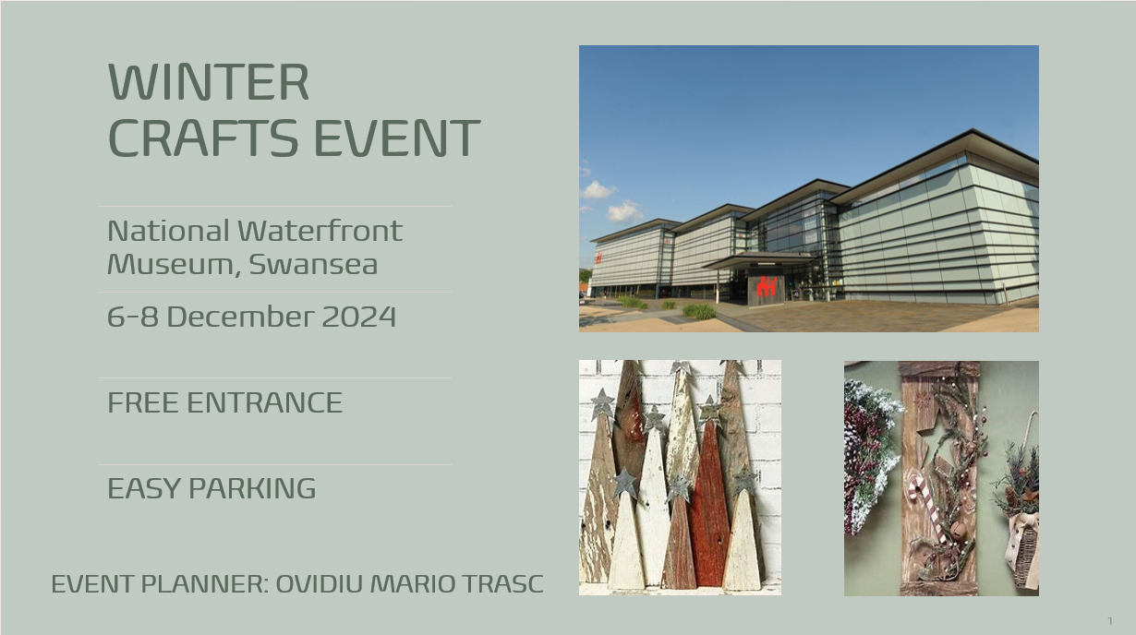

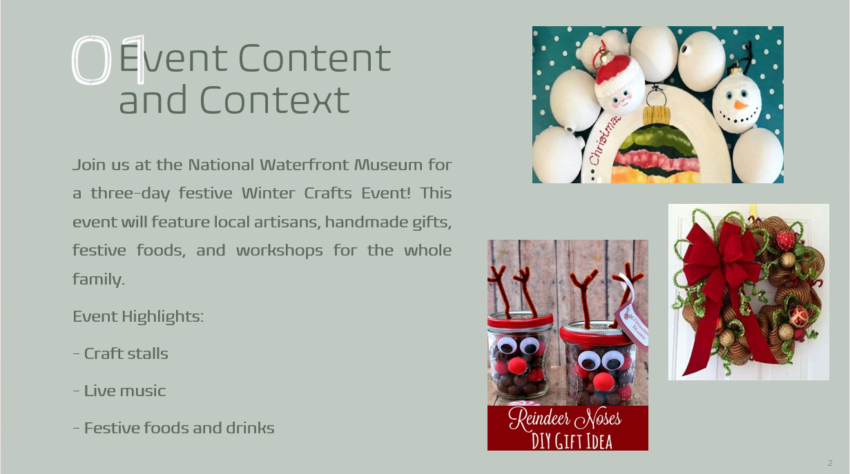

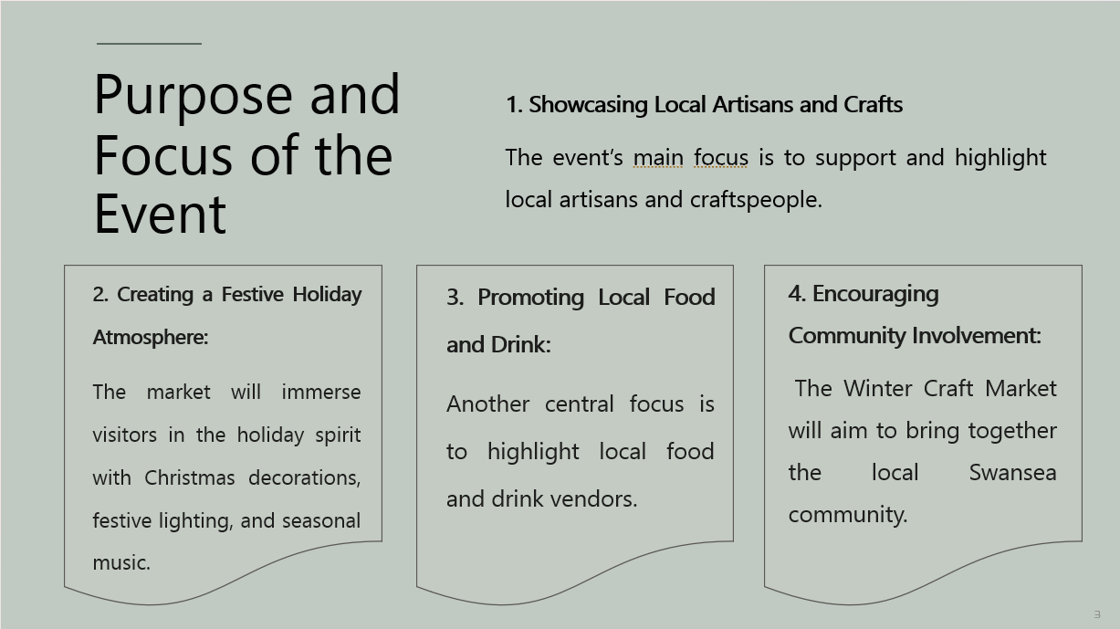

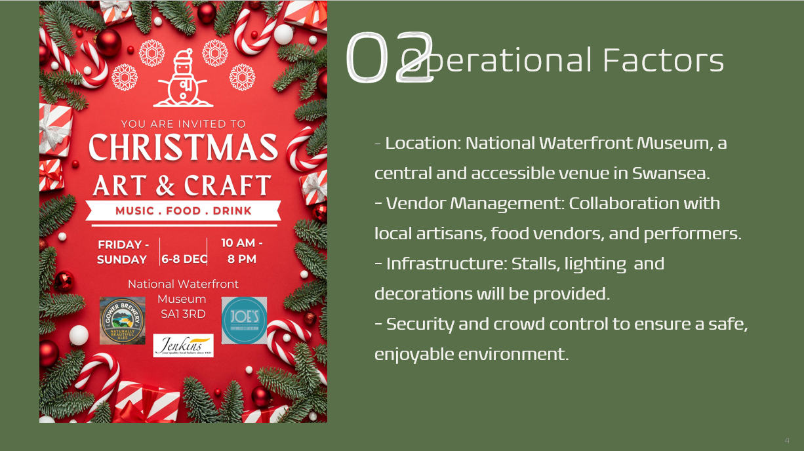

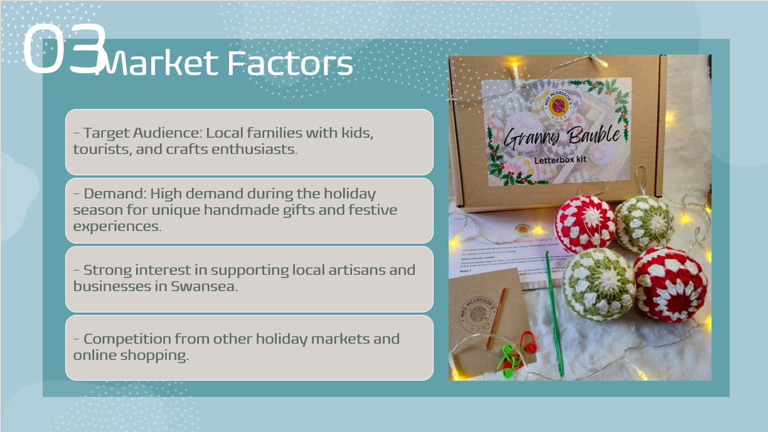

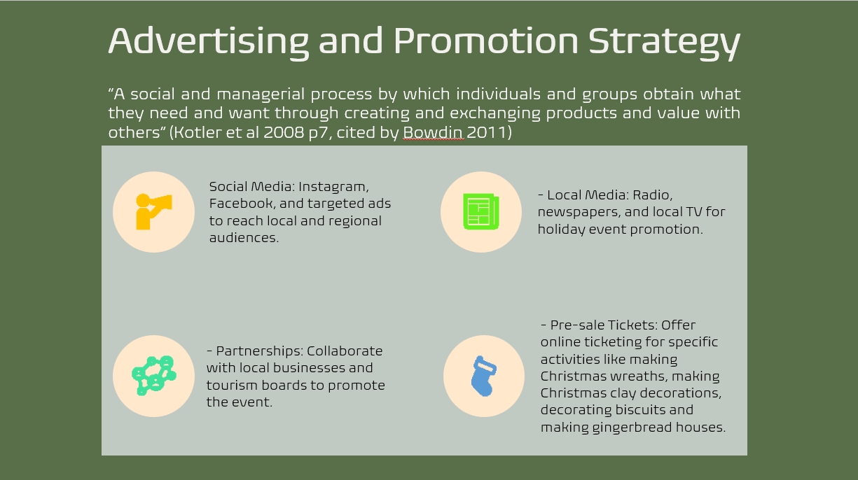

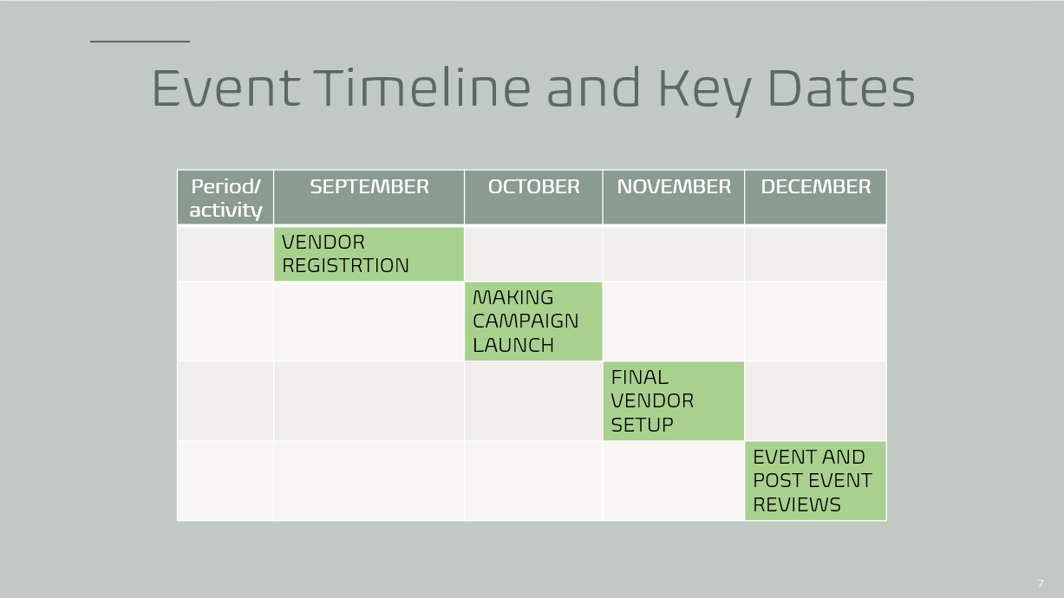

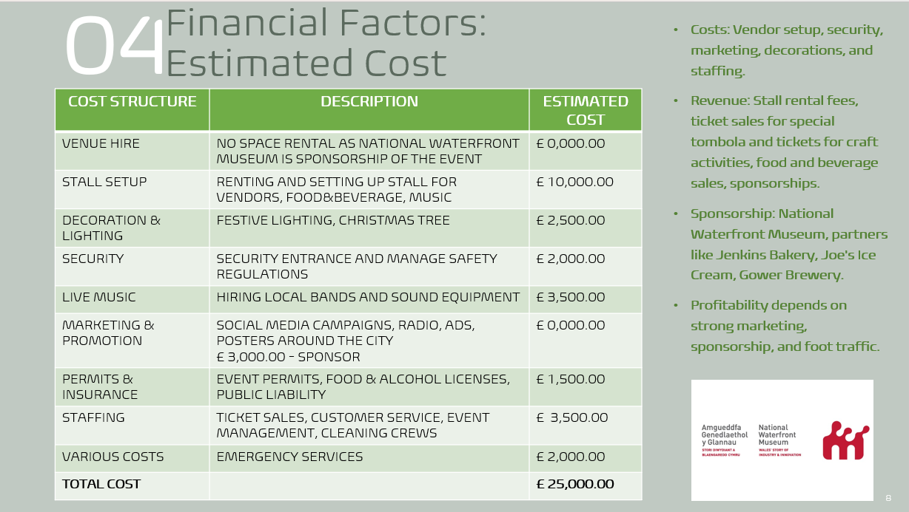

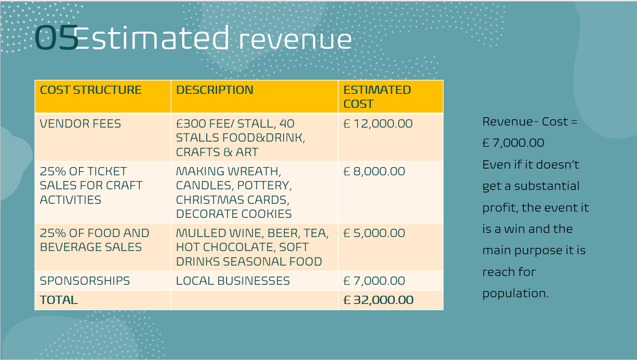

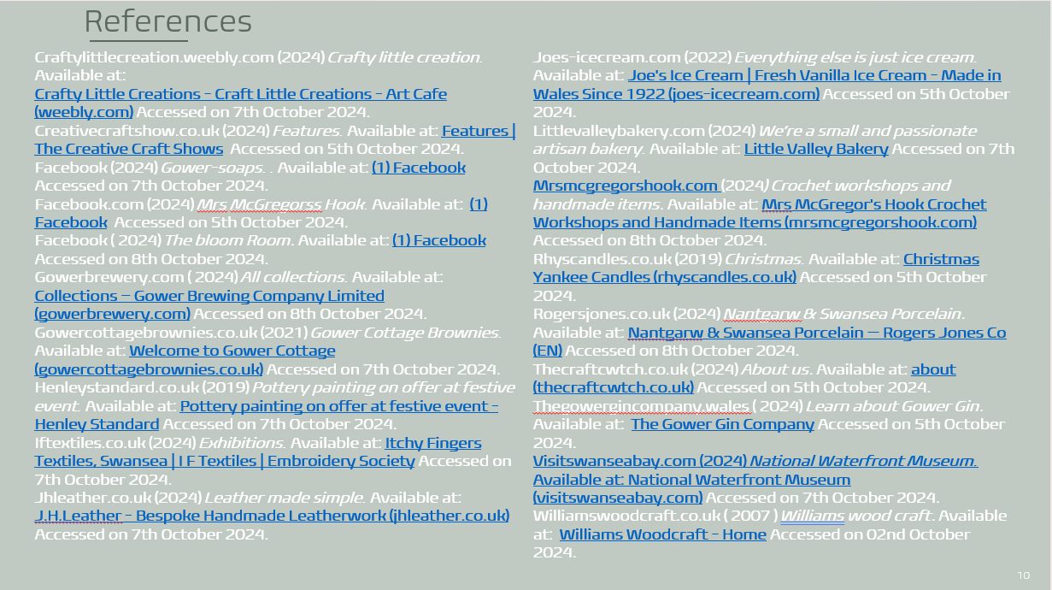

Reference list:
Craftylittlecreation.weebly.com (2024) Crafty little creation. Available at:
Crafty Little Creations - Craft Little Creations - Art Cafe (weebly.com) Accessed on 7th October 2024.
Creativecraftshow.co.uk (2024) Features. Available at: Features | The Creative Craft Shows Accessed on 5th October 2024.
Facebook (2024) Gower-soaps. Available at: (1) Facebook Accessed on 7th October 2024.
Facebook.com (2024) Mrs McGregorss Hook. Available at: (1) Facebook Accessed on 5th October 2024.
Facebook ( 2024) The bloom Room. Available at: (1) Facebook Accessed on 8th October 2024.
Gowerbrewery.com (2024) All collections. Available at: Collections – Gower Brewing Company Limited (gowerbrewery.com) Accessed on 8th October 2024.
Gowercottagebrownies.co.uk (2021) Gower Cottage Brownies. Available at: Welcome to Gower Cottage (gowercottagebrownies.co.uk) Accessed on 7th October 2024.
Henleystandard.co.uk (2019) Pottery painting on offer at festive event. Available at: Pottery painting on offer at festive event - Henley Standard Accessed on 7th October 2024.
Iftextiles.co.uk (2024) Exhibitions. Available at: Itchy Fingers Textiles, Swansea | I F Textiles | Embroidery Society Accessed on 7th October 2024.
Jhleather.co.uk (2024) Leather made simple. Available at: J.H.Leather - Bespoke Handmade Leatherwork (jhleather.co.uk) Accessed on 7th October 2024.
Joes-icecream.com (2022) Everything else is just ice cream. Available at: Joe's Ice Cream | Fresh Vanilla Ice Cream - Made in Wales Since 1922 (joes-icecream.com) Accessed on 5th October 2024.
Littlevalleybakery.com (2024) We’re a small and passionate artisan bakery. Available at: Little Valley Bakery Accessed on 7th October 2024.
Mrsmcgregorshook.com (2024) Crochet workshops and handmade items. Available at: Mrs McGregor's Hook Crochet Workshops and Handmade Items (mrsmcgregorshook.com) Accessed on 8th October 2024.
Rhyscandles.co.uk (2019) Christmas. Available at: Christmas Yankee Candles (rhyscandles.co.uk) Accessed on 5th October 2024.
Rogersjones.co.uk (2024) Nantgarw & Swansea Porcelain. Available at: Nantgarw & Swansea Porcelain — Rogers Jones Co (EN) Accessed on 8th October 2024.
Thecraftcwtch.co.uk (2024) About us. Available at: about (thecraftcwtch.co.uk) Accessed on 5th October 2024.
Thegowergincompany.wales (2024) Learn about Gower Gin. Available at: The Gower Gin Company Accessed on 5th October 2024.
Visitswanseabay.com (2024) National Waterfront Museum. Available at: National Waterfront Museum (visitswanseabay.com) Accessed on 7th October 2024.
Williamswoodcraft.co.uk ( 2007 ) Williams wood craft. Available at: Williams Woodcraft - Home Accessed on 02nd October 2024.

