STUDENT LEARNING LOG
Module: Managing Hotel Administration
Module code: (BMIH6004)
Lecturer name: Kathryn Roberts
Student name: Maria Mihaly (2210756)

Introduction
The Cheshire-based Crewe Hall Hotel and Spa combines historical building design and contemporary hotel facilities that deliver complete hospitality services to guests. The hotel contains three departments, along with Reception, Back Office, and HR, which offer dining services through its bar and restaurant from morning to evening. The organisation of the hotel contains its main reception, while its newly constructed section does not feature a standalone reception, leading to operational difficulties. My placement experience is focused on shadowing a supervisory role in the Back Office, providing me with hands-on experience in hotel administration. This placement entails four main learning targets:
- Gaining practical experience in hotel administration.
- Developing work-based skills, including communication, teamwork, task management, and guest service.
- Enhancing technical knowledge in hotel operations and management.
Section 1: Reflection on Experience and Personal Development
I will employ Gibbs’ Reflective Cycle to analyse my experiences during back-office observation at Crewe Hall Hotel. Hotel administration operations rest on the support of this department, which overlooks administrative duties and guest service requirements as well as department communication between Reception, Housekeeping, and Food & Beverage (Fallon & Rutherford, 2010). Back-office supervision guided me in two areas of work: inventory control and resource distribution and guest request processing through internal operations.
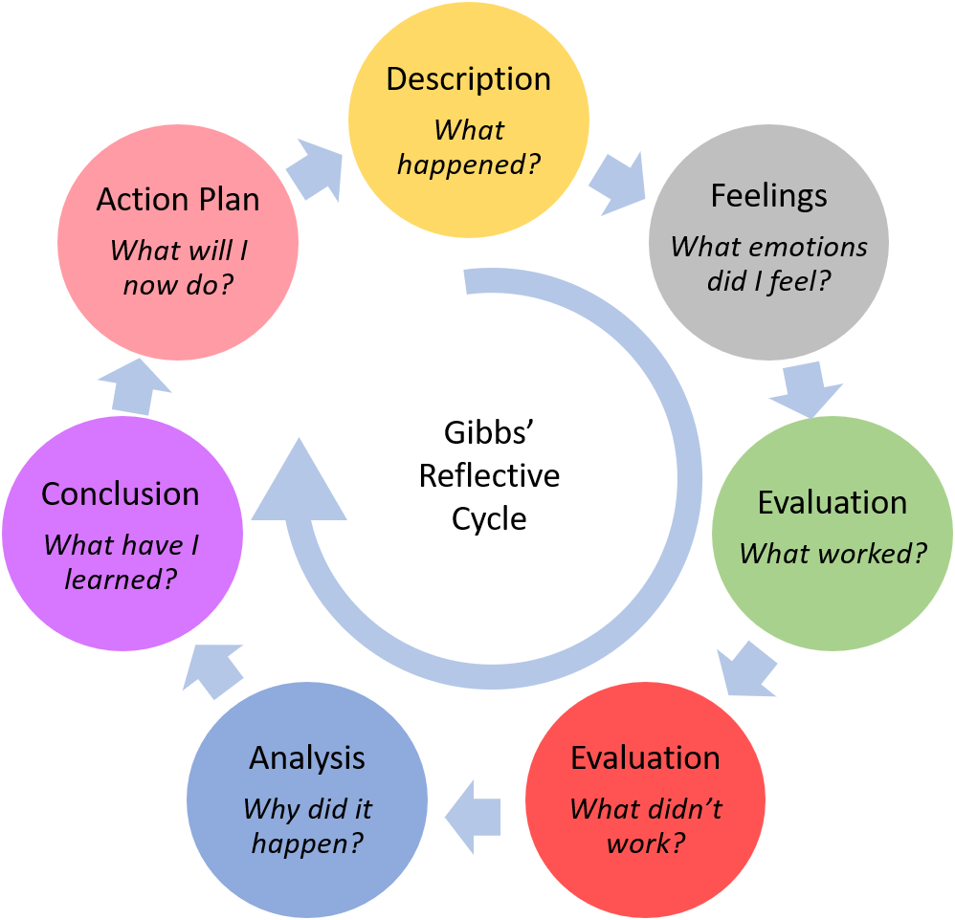
Figure 1: Gibb's reflective cycle
Source: (Potter, 2015).
During this experience, I felt excited while also carrying fear in the back of my mind. My understanding of hotel administration differed from what I expected because the workflow was quick, and frequent communication occurred between departments (Hayes et al., 2017). The multitasking requirements initially made me doubt my abilities, yet during the following weeks, I found assurance in my administrative duties management capabilities.
According to my evaluation process, some aspects of the placement experience proved satisfactory. The Back Office employees collaborated to handle guest needs and accommodate room assignments and special requirements. Back Office staff maintained excellent communication with Housekeeping personnel to have rooms ready by the guests' check-in times. The main issue that affected the hotel stemmed from having a single reception area to manage different hotel sections. The hotel experienced increased difficulties with guest management and coordination, which became harder due to the situation (Espino-Rodríguez & Gil-Padilla, 2015).
Observing at the Back Office taught me how excellent communication and teamwork combined with effective task handling help create an effective hotel operational flow. Departmental coordination enabled the hotel staff to fulfil guest demands even when the hotel reached maximum capacity. Without a designated reception area during peak hours, visitors needed to move to the main reception, causing operational interruptions (Martin, 2020).
The discovery through shadowing revealed to me how complicated it is to administer a hotel operation. I learnt better communication and coordination methods throughout my time at Reception and Guest Relations, yet I recognised issues with the guest flow process. Through this valuable experience, I gained important insights into how various departments jointly create the total guest experience and the necessity for smooth conversations between professionals.
Through my action plan, I will develop my task management and communication skills. During the placement, I aim to further my understanding of hotel back-end systems to enhance operational efficiency through streamlined processes. The placement experience taught me how essential it is to handle operational inefficiencies quickly, especially by optimising guest flow and space management (Benhadda et al., 2016).
Section 2: Critical Analysis of Work-Based Skills and Technical Knowledge
Work-based skills and technical knowledge serve as the basics for supervising everyday hotel operations in the Back Office department (Anuar et al., 2024). Proper communication is essential for an efficient and effective transfer of information, especially when working with guest services (Stone, 2017). I witnessed how the Back Office department coordinated seamlessly with the Reception staff by observing their collaboration to expedite guest requests involving room change requirements and extra amenity requests. Efficient communication enables the correct assignment of duties and the timely resolution of problems.
Observing my placement made me recognise teamwork as an essential competence. According to Huang and Baker (2021), back-office personnel collaborated on a daily basis with the Housekeeping and Reception divisions. During hotel operational capacity fills, the back office team managed room distributions, and Reception handled guest check-in procedures. The collaboration between staff involved problem-resolution activities in addition to their primary duties.
Hotel management significantly benefits from implementing appropriate task management techniques, as described in Lopez et al (2025). As part of my supervisory role observation, I witnessed that team members arranged their work based on critical needs and essential requirements. The operation staff in the Back Office immediately notified relevant departments about special requests from guests to provide timely satisfaction. The hotel management software system taught me to capture guest perspectives and handle guests' negative feedback and particular needs. The technical understanding acquired provides an essential foundation for operating efficiency and outstanding guest satisfaction.
My experience included acquiring professional skills regarding hotel system operations. According to Walker (2021), the PMS operated by the Back Office staff served as a vital tool for managing guest data reservation assignments and guest-specific preferences. People who support administration must master these systems since proper proficiency results in better operational performance through effective communication. The resource management software system taught me how to assist the Back Office in tracking hotel supplies and inventory and avoiding stockouts (Horner & Swarbrooke, 2004).
Section 3: Reflection on Organisational Issues
During my placement, I identified a meaningful organisational problem because the newly constructed area lacked its own dedicated reception area. According to Salleh (2010), long walking distances between the primary building and the new section caused difficulty at the hotel when studying its layout and size.
Due to this particular organisational challenge, hotel operations suffered various consequences. The hotel layout and reception design caused guest service problems since unfamiliar visitors became frustrated by the system. The guests' perplexity caused difficulties during check-in and check-out procedures, which diminished overall guest satisfaction, according to Martin (2020). Staff members in the main reception facing an elevated number of guests encountered problems that slowed their service provision.
Several operating solutions should be considered to resolve this problem. The hotel should provide better directional signs throughout its new construction area to simplify guest travel across the property (Hayes et al., 2017). Signs that are easy to read would guide visitors either to the main reception area or display a layout of the hotel route. A mobile check-in system which enables guests to do online check-in should become part of the hotel service. Implementing mobile check-in would minimise reception area queues to create an enhanced check-in process (Hagg, 2013). A temporary reception solution in the new hotel area will improve guest check-in activities and respond to their questions effectively.
Conclusion
This hotel administration placement experience equipped me with a critical understanding of back-office operations, including interactions between team members and effective assignment handling and communication systems. Through my experience, I learnt to operate technical systems for guest information management and resource distribution while understanding that efficient departmental communication leads to operational efficiency. Operational challenges that affect guest satisfaction become most apparent when no separate reception facilities exist in the new building.
I will dedicate myself to developing better communication skills and task management abilities at hotels as my profession advances. I aim to find training opportunities to build my hotel management system proficiency and research methods to enhance guest flow processes and service capabilities. The experience has shown me that hotel managers must understand operational and administrative functions simultaneously yet I will advance these skills throughout my career in the hospitality industry.

References
1. Anuar, J., Sumarjan, N., Patah, A., & Rashdi, M. O. (2024). Work-based Learning (WBL) hospitality graduates attachment: industry perspectives. Journal of Tourism, Hospitality and Culinary Arts, 16(1), 585-596.
2. Benhadda, L., Chibili, M. N., De Bruyn, S., Lashley, C., Penninga, S., & Rowson, B. (2016). Modern hotel operations management. Noordhoff Uitgevers.
3. Espino-Rodríguez, T. F., & Gil-Padilla, A. M. (2015). The structural and infrastructural decisions of operations management in the hotel sector and their impact on organizational performance. Tourism and Hospitality Research, 15(1), 3-18.
4. Fallon, M. & Rutherford, D. (2010) Hotel Management and Operations. London: Wiley.
5. Hagg, E. (2013) Internship Guide: Work Placements Step by Step. 5th Ed. The Hague: Eleven International Publishing
6. Hayes, D. K., Ninemeier, J. D., & Miller, A. A. (2017). Hotel operations management. Pearson.
7. Huang, A. & Baker, M., (2021). Exploring skill-based career transitions for entry-level hospitality and tourism workers. Journal of Hospitality and Tourism Management, 48, pp.368-373.
8. López, S. M. C., Guerra, I. R., & Barreal, J. (2025). Theoretical Framework and Preliminary Evaluation of a Model for Analysing the Qualified Personnel Needing’s in the Hotel Accommodation Sector. Tourism and Hospitality, 6(1), 21.
9. Martin, A. (2020) The Practical Guide to Understanding and Raising Hotel Profitability. Abingdon: Routledge.
10. Potter, C. (2015). Leadership development: an applied comparison of Gibbs’ Reflective Cycle and Scharmer’s Theory U. Industrial and Commercial Training, 47(6), 336-342.
11. Salleh, N. Z., Hamid, A. B. A., Hashim, N. H., & Omain, S. Z. (2010, November). Issues and challenges in Malaysian hotel operations. In 3rd Asia-Euro Tourism, Hospitality and Gastronomy Conference.
12. Walker, J.C. (2021) Introduction to Hospitality. 8th Ed. Harlow: Pearson Education Limited.

