Ilies Corneliu Laurean
2238974
EVIDENCE OF LEARNING
E portfolio
Learning in the Digital Era – BMPL4007

Task 1 – Preparing for Higher Education

Preparing for higher education is a crucial step in the academic journey of students, as it sets the foundation for future success. This summary explores key aspects of preparing for higher education, including academic readiness, selecting the right institution, financial planning, and building a well-rounded profile.
To ensure a smooth transition to higher education, students must develop essential skills. According to Smith (2020), a textbook on college readiness, students should focus on improving their critical thinking, time management, and study skills. These abilities will empower them to handle the rigorous demands of college-level coursework effectively.
Essential digital skills are the skills needed to use technology for work, learning and daily life. According to the UK government’s Essential Digital Skills Framework, there are five categories of essential digital skills for life and work:

- Communicating
- Handling information and content
- Transacting
- Problem solving
- Being safe and legal online

Some examples of essential digital skills include being able to use devices like a computer, tablet or mobile phone for simple, personal and work tasks; finding and using information on the internet; understanding how to be safe and responsible online; and communicating socially and professionally using email, messaging and social media¹.
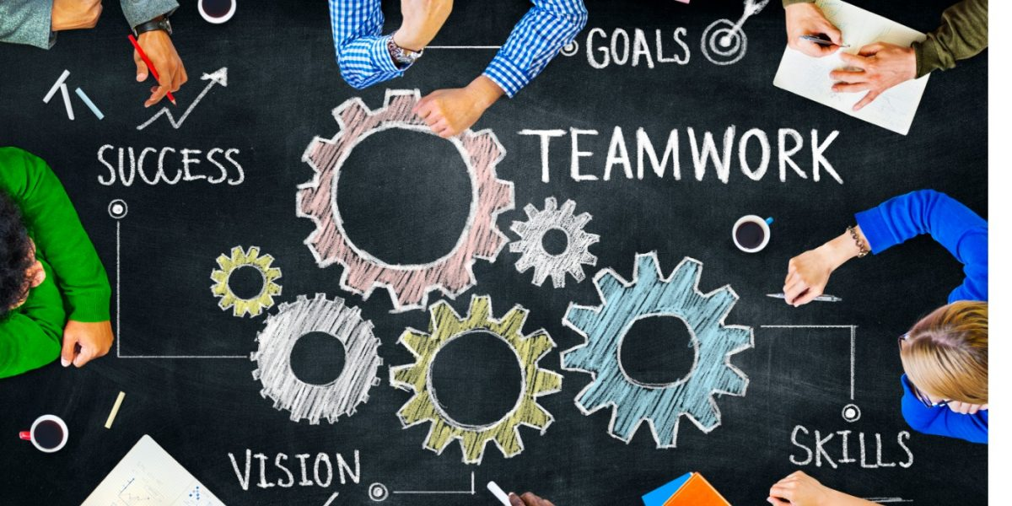
(ewdpulse, s.f.)

Selecting the right institution plays a pivotal role in shaping a student's higher education experience. An article by Johnson (2022) in The Chronicle of Higher Education emphasizes the significance of considering factors such as academic programs, campus culture, location, and extracurricular opportunities when making this decision. Prospective students should research institutions thoroughly and visit campuses to gain first-hand insights.
Higher education often comes with significant costs, making financial planning essential. Williams (2021), in a journal article titled "Navigating the Costs of Higher Education," highlights the importance of exploring financial aid options, scholarships, and grants. Additionally, students should create a budget, consider part-time employment, and explore student loan options cautiously to manage their financial obligations effectively.
Apart from academic achievements, higher education institutions often seek students with diverse interests and experiences. A newspaper article by Thompson (2023) in The New York Times suggests that students should engage in extracurricular activities, volunteer work, and internships to develop their skills and demonstrate a commitment to personal growth. These experiences help students stand out during the application process.
Preparing for higher education involves several essential steps that contribute to a successful transition. By focusing on academic readiness, selecting the right institution, financial planning, and building a well-rounded profile, students can maximize their potential for a fulfilling higher education experience. Proactive research, planning, and self-reflection will enable students to make informed decisions and embark on their higher education journey confidently.

Task 2- Mindmap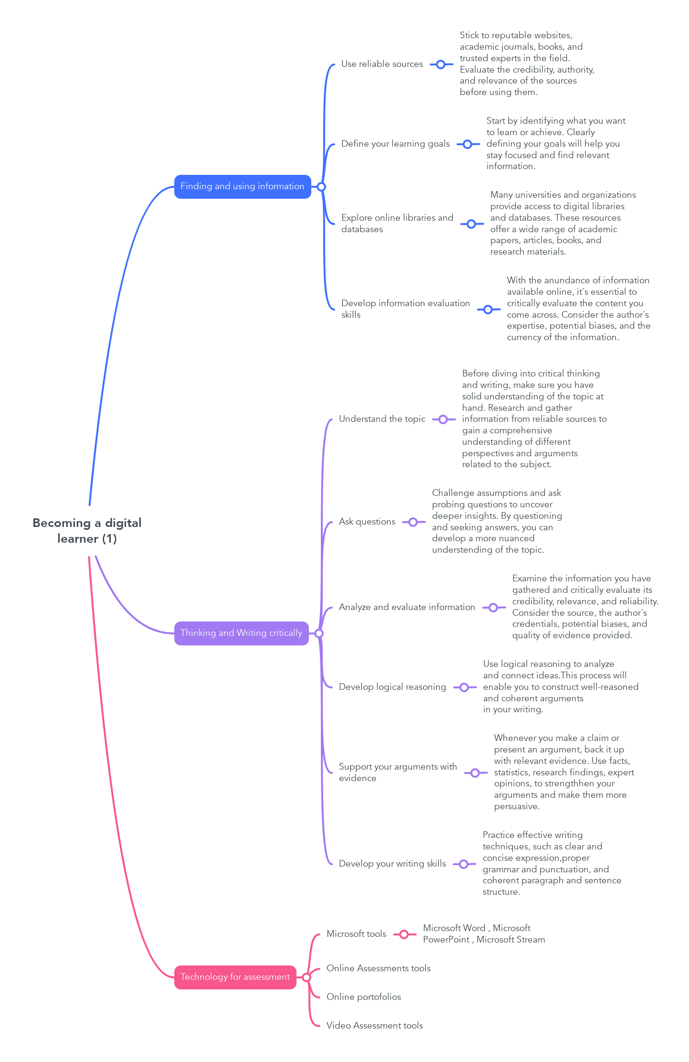

Task 3- Presentation Link (please email the link to your tutor also)

https://youtube.com/watch?v=OCfV5BHjVSE&feature=share

Task 4- Reflection

1. Description – I started university and had to get used to online learning and resources. I found it difficult to navigate the online platform and find the resources I needed. I also struggled with writing my first assignments.
2. Feelings – I felt overwhelmed and frustrated. I was worried that I wouldn’t be able to keep up with the work and that I wasn’t cut out for university.
3. Evaluation – The experience was both good and bad. It was good because it challenged me and helped me develop new skills. However, it was also bad because it was stressful and made me doubt myself.
4. Analysis – Looking back on the experience, I can see that I was struggling because I didn’t have enough support or guidance. I also didn’t have a clear understanding of what was expected of me.
5. Conclusion – If I could do it again, I would seek out more support and guidance from my professors and peers. I would also make sure that I had a clear understanding of what was expected of me before starting my assignments.
6. Action Plan – If I find myself in a similar situation in the future, I will make sure to seek out support and guidance early on. I will also make sure that I have a clear understanding of what is expected of me before starting any assignments.

Task 5- Personal Development Plan

Student Name |  | Student Number |  | Module |  | Code
ILIES CORNELIU LAUREAN |  | 2238974 |  | Learning in the Digital Era |  | BMPL4007  BMPS4009
What goals do I want to achieve? | How will I measure my progress? |  | What resources or support will I need? |  | How is the objective relevant to my personal aspirations? | What is the timeframe for the achievement of my goals?
Specific | Measurable |  | Achievable |  | Relevant | Timebound
Acquiring discipline-specific knowledge and research skills, developing communication, creative thinking, and problem-solving skills, planning your expenditure and managing my time effectively, prioritizing my mental well-being and surrounding myself with positive people, joining a sports team, volunteer project, or student organization, finding an internship in my desired industry and building a strong professional network, gaining additional certifications or educational credentials, striving to achieve the salary you want and work for a specific company or organization¹. | To measure progress include tracking my grades and academic performance, setting specific goals and objectives for each semester or academic year, monitoring my personal growth and development, and seeking feedback from professors and peers. |  | Academic advising, tutoring services, career services, mental health counselling, financial aid and scholarships, student organizations and clubs, and library resources. |  | More positive, confident, productive.  Improving personal skills in society and professionaly.  Building a better character for upgrading personal knowledge and be reliable. | Weekly work and study for the assignment making sure to upload it before the deadline.

(1) 10 Smart Goals for University Students - Best Assignment Writer. https://bestassignmentwriter.co.uk/blog/10-smart-goals-for-university-students/.

Task 6- Reference List
Improve your digital skills | National Careers Service. https://nationalcareers.service.gov.uk/careers-advice/build-foundation-digital-skills-to-help-your-career/
Johnson, A. (2022). Choosing the Right College: Key Factors to Consider. The Chronicle of Higher Education.
. Harvard Business Review - "High-Performing Teams Need Psychological Safety. Here's How to Create It": https://hbr.org/2020/03/high-performing-teams-need-psychological-safety-heres-how-to-create-it
National standards for essential digital skills – GOV.UK. https://www.gov.uk/government/publications/national-standards-for-essential-digital-skills
Smith, J. (2020). College Readiness: Developing Critical Thinking, Study Skills, and Time Management. ABC Publishing.
Thompson, L. (2023). Building a Well-Rounded Profile: The Importance of Extracurricular Activities and Internships. The New York Times.
Williams, R. (2021). Navigating the Costs of Higher Education: Strategies for Affording College. Journal of Student Financial Aid.

