Impact of the business environment of Revolut

Individual project report
LCBB4005_BIRM: GLOBAL BUSINESS MANAGEMENT (Level- 4)
Assignment component 1

Student Name: Carmen-Ioana Hodoroaba
Student Id: 2109656
Lecturer name: Arinze Ekwem

Table of contents
Introduction 3
1. Overview of the business 3
Main discussion 5
2. Major forces that shape the global business environment 5
2.1. PESTLE Analysis 6
2.2. Porter's five forces 10
2.2.1. Bargaining power of buyers 10
2.2.2. Bargaining power of suppliers 10
2.2.3. The threat of new entrants 10
2.2.4. The threat of substitutes 11
2.2.5. Industry rivals 11
2.3. Reasons why organisations engage in international trade 11
2.3.1 Expanding the sales 11
2.3.2 Maximising revenue 12
2.3.3 Acquiring resources and suppliers 12
2.4 Understanding micro and macroeconomic foundations 13
2.5 Major features of the current international economy 13
Conclusion 15
References 16

Introduction

This report is based on Global business management. Revolut is represented as a British financial technology corporation that provides banking services to customers. This report aims to analyse the impact of the business environment of Revolut which is operating in the services sector. This report will identify the major forces shaping the global business environment and will understand the change in the environment effectively.
This report will discuss the relevant business models (PESTLE, and Porter's Five Forces) within the international environmental analysis of Revolut. The work will critically evaluate the reasons for the organisations engaged in international trade and will understand the micro-economic and macro-economic foundations, varied market structure, and their influence on the business strategy and long-term & short-term changes including features of the current international economy.

Overview of the business
Revolut has represented a British financial technology corporate established in July 2015 by Nikolay Storonsky and Vlad Yatsenko. The company is headquartered in London, England, UK. The company currently offers a variety of services including featuring currency exchange, virtual cards, debit cards, Apple Pay, commission-free stock trading, interest-bearing vaults, crypto, stock trading, commodities, and other services. In 2018, Revolut acquired a banking license from the Bank of Lithuania and in 2019 the company initiated its first business expansion into Singapore and Australia (Revolut, 2022).
In 2020, the company expanded throughout Japan and USA, launched banking services in Lithuania and Poland and acquired a customer base of 15.4 million in 2020. Currently, the business had acquired 18 million personal users, and 500k business users, operating in more than 200+ countries and regions and maintaining 30+ in-app currencies (Revolut, 2022).

Main discussion

Major forces that shape the global business environment
Businesses in a global environment does not operate in a vacuum, they are influenced by several internal and external factors. These forces can make a huge difference between failure and success, especially in today’s changing business environment. The external forces can influence the business climate into the respective six categories including competitive, economic, legal, global, social, and technological (Hedman Nilsson and Skarin, 2022). A corporate operates in all of the above business environments concurrently, and factors in one environment can influence or complicate other environmental factors.
The factors that affect the global business environment includes supply chain reliability, labour supply, availability of raw material, customer demand, government regulations, workers' expectation, etc. A strong hold over the economic, legal, social, technological, political and global environment, helps a business to drive huge success in the competitive global market. These six forces help in understanding the changes in the global business environment in terms of changes in rules and regulations implemented by the government, changes in market trends, taste and preferences of the customers, changes in policies and procedures of business operations, changes in the environmental factors like attaining sustainability, a shift in supply and demand, economic factors, changes in technology, etc (Mani and Gunasekaran, 2018). Therefore, these six forces help in understanding the continuous changes in the business environment and businesses to implement those changes to operate effectively.

PESTLE Analysis
Factors | Detail
Political | The company is offering the customers effective services, where customers can transfer money easily and that is free of charge. This can be done through a wallet, which includes UAE dirhams, US dollars, and cryptocurrencies like Bitcoin and Ethereum (Bris, 2022).
Economic | The company acquired 19 of the total market in the UK when it comes to downloading the bank app. This shows that the contribution of the company in the UK is somehow effective (refer to figure 1) (Statista, 2022).
Social | In the business, there is a huge requirement to understand the condition of the customer. There was an incident that has come to light, where one of the employees stated that the company is providing too, must market for the new candidates, during their interview round, and there is no guarantee that the job will be allotted once the round will be completed. This can disrupt the reputation of the company (Wiredco.uk, 2021).
Technological | Recently, the company faced technical issues in their app, and this directly impacted the number of customers. The issue was related to the error in the amount, where the customers were not able to justify the amount which they have in their account. This issue can occur in business if the team of developers doesn’t work effectively. So, it is mandatory for the company to ensure that the technical issues need to be removed (BBC.com, 2022).
Environmental | The company is taking the initiative where they are targeting to reduce its carbon footprint. And in 2019, they have reduced their carbon footprint for business by 34%. Apart from that, for sustainability purpose, the company usually conduct donation campaigns, charity partnership with WWF, Rainforest Alliance, etc. as these are the platform where Revolut donate. In their products, they have removed the 21% of the carbon footprint, while from goods and services, they have removed 35% (refer to figure 2) (Revolut.com, 2022). These factors directly outline that, for businesses, it becomes crucial to enforce steps where they can ensure sustainability and achieve the trust of the customers.
Legal | Fintech company Revolut is facing issues and this has been stated by the employee that the high-speed growth of the business is connected with unpaid work, unachievable targets and high staff turnover. Moreover, the company is facing controversies, where they are connected with Russia and Kremlin (Bris, 2022).
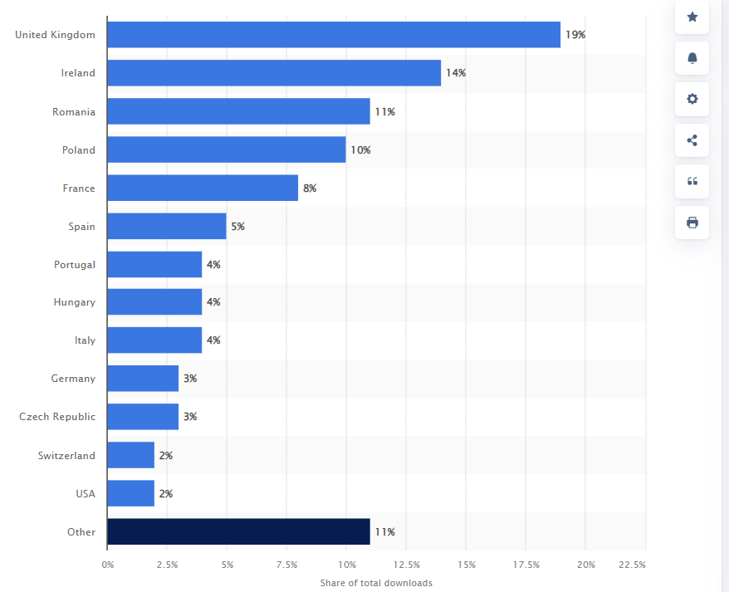
Figure 1: Market share of Revolut bank app downloads
Source: (Statista, 2022)

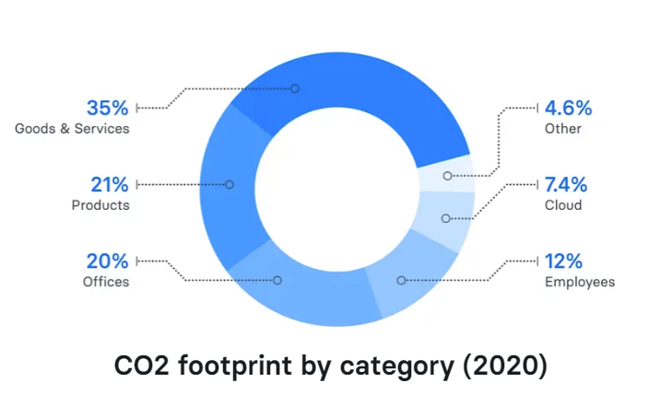
Figure 2: CO2 footprint by category (2020)
Source: (Revolut.com, 2022)

Porter's five forces
Porter’s five forces are represented as a business analysis tool that helps in determining or evaluating whether a strategy had the potential to survive or attain profit in the competitive business environment (Bruijl and Gerard, 2018). The five forces of this model include:
    - Bargaining power of buyers - The bargaining power of buyers is high because buyers are often demanding. They need the best services at an affordable price range. Since Revolut had been established in 2015, the company is serving the needs of the customers to develop a strong customer base. But due to large competition in the market, buyers can switch to those banking corporates, which provide quality baking services and fulfil all the banking needs including savings, checking, mortgage, etc at reasonable rates (Revolut, 2022).
    - Bargaining power of suppliers - The bargaining power of suppliers fluctuates from medium to high, as the power of suppliers is largely dependent on the market. Capital is the key resource needed by any financial technology company or institution. The key suppliers of these corporates involve loans from other institutions, customer deposits and mortgages and loans (Donnellan and Rutledge, 2019). By acquiring these resources, Revolut ensures that they meet the company and customer expectations effectively.
    - The threat of new entrants - The threat of new entrants is low to medium, as if a new entrant arrives in the market, existing market players emphasize earning fewer profits to reduce the threats. Apart from this, because this industry deals with other people's financial information and money, it is difficult for the new banks or financial technology corporate to initiate the business.
    - The threat of substitutes - The threat of substitutes is high for Revolut, as it is a newly established corporate that provides similar services provided by several other competitors in the market. Therefore, there is a high chance that buyers can find similar services at affordable prices (Bruijl and Gerard, 2018). The major threat is from non-financial corporates who offer several financial services to people at affordable ranges.
    - Industry rivals - There is high competition in the market, therefore businesses like Revolut face huge competition from their rivals including Starling Bank, N26, Qonto, Monese, etc. Because of this intense competition in the market, it is difficult for the existing forms to earn huge and sustainable profits (Barton, 2020). The banking competition often seems like a race to outline or recognise which bank or corporation offers the fastest and best quality services to its customer's, at affordable prices.

Reasons why organisations engage in international trade
Engagement in international trade help businesses explore the number of opportunities by which they can gain effective outcomes. This is the same strategy of the company, where they are gaining the trust of the customers. The reason behind the purpose of the company to engage in international trade is various, and these are:
    - Expanding the sales - The purpose of the company is to expand the business so that it can gain insight into the market and provide effective services to its customers. Since their expansion, they are able to attain the market where they are handling more than 500K business customers and handling more than 35 countries supported. The availability of the services is high; they are operating in more than 30 in-app currencies. While on the other side, they are handling 18 million customers (Revolut.com, 2022).
    - Maximising revenue - This is one of the reasons the company wants to explore a number of options, as they are continuously increasing the revenue. The revenue of the company is continuously growing (refer to table 1). This directly shows that their expansion of business at the international level, helped them to ensure the growth rate, along with sales.
Table 1: Revenue of Revolut
Year | Revenue (£mm)
2016 | 2.3
2017 | 13
2018 | 58
2019 | 166
2020 | 261

    - Acquiring resources and suppliers - Gaining a high level of annuitant revenue through a talent pool. This is because, there are a number of ways in which a company can gain revenue, but employees are the most important asset and resource. Apart from that, there is a huge demand for sustainable business, for which the company needs to ensure the involvement of sustainable suppliers.

Understanding micro and macroeconomic foundations
Market structure is defined based on the different industries, classification and on the degree of the competition level. The market structure can be described on the buyer’s structure, turnover, product differentiation, cost inputs, competition, and market share (Maghfuriyah, Azam, and Shukri, 2019).
The microeconomics of the business can be understood with individuals, resources, and decisions implemented by them (Hieu and Uyen, 2019). Such as the customer base of the company is high, but when it comes to employee satisfaction it somehow varies (as per employee) (Bris, 2022). But per the company, they also focus on the people of the company by putting their needs first (Polimac, 2020). While on the other side, macroeconomics can be defined by the study of the economy (Morales, 2019), and for that company effectively navigates the challenges of macroeconomics during the time of Covid. And to ensure their business downfall, they raise the fund of $80 million, so that they can perform effectively. The result of the issue is because of the restriction imposed by the government (Revolut, 2020).

Major features of the current international economy
There are some of the features of the global economy. These are: Options for production, Chances to create new markets, Expansion and Networking, even though companies have a number of options where they can explore the market and increase the demand for the business (Ahmad and Ribarsky, 2018). In 2019, they expanded the business in the US and other locations, which helped them. So there are other options available for them to ensure business growth, the same they used while exploring the option of the US market (Revolut.com, 2022).

Conclusion

After analysing the above report, it can be concluded that a business's internal and external environment, plays a crucial role in leading business development and success in the global market and business management. There are six external environmental forces including competitive, economic, legal, global, social and technological, that helps in analysing the changes in the business environment for leading high continuous changes as per the needs and requirement of the business. As per Porter's five forces analysis, it had been evaluated that Revolut has a high chance to attract a large customer base and provide tough competition to the existing market rivals at a global level. The business has effective environmental strategies that help them to reduce its carbon footprint to leading high sustainability and effectiveness. As per the PESTLE, it has been analysed, that the business faces issues with adopting technology advancement strategies which somewhere creates issues to offering quick customer services. Therefore, the Revolut company has huge opportunities to engage itself in several international trade activities to lead to high business effectiveness, profitability and growth.

References

Ahmad, N. and Ribarsky, J., 2018. Towards a framework for measuring the digital economy. In 16th Conference of the International Association of Official Statisticians (pp. 1-33). http://old.iariw.org/copenhagen/ribarsky.pdf
Barton, C., 2020. Revolut statistics - Finder UK. [online] Finder UK. Available at: <https://www.finder.com/uk/revolut-statistics> [Accessed 9 July 2022].
BBC.com. 2022. Revolut's banking app fixed after outages. Available at: <https://www.bbc.com/news/business-61711648> [Accessed 9 July 2022].
Bris. A., 2022. IE not supported. Available at: https://www.imd.org/research-knowledge/articles/revolut-could-allegations-of-russian-involvement-sidetrack-a-fintech-revolution/ (Accessed: 9 July 2022).
Bruijl, D. and Gerard, H.T., 2018. The relevance of Porter's five forces in today's innovative and changing business environment. Available at SSRN 3192207. https://www.researchgate.net/profile/Gerard Bruijl/publication/326026986_The_Relevance_of_Porter%27s_Five_Forces_in_Today%27s_Innovative_and_Changing_Business_Environment/links/5c14165c299bf139c7593f03/The-Relevance-of-Porters-Five-Forces-in-Todays-Innovative-and-Changing-Business-Environment.pdf
Donnellan, J. and Rutledge, W.L., 2019. A case for resource‐based view and competitive advantage in banking. Managerial and Decision Economics, 40(6), pp.728-737. https://www.researchgate.net/profile/John-Donnellan 2/publication/333976962_A_case_for_resource-based_view_and_competitive_advantage_in_banking/links/5d128311458515c11cf8891d/A-case-for-resource-based-view-and-competitive-advantage-in-banking.pdf
Hedman Nilsson, S. and Skarin, C., 2022. Disruptive external forces as a catalyst for service innovation: Influencing forces of facility service innovation processes due to changing customer behaviour. https://www.diva-portal.org/smash/get/diva2:1642762/FULLTEXT01.pdf
Hieu, B.T. and Uyen, B.T.K., 2019. Data-Driven Hint Generation in Intelligent Tutoring Systems for Learning Microeconomics. European Journal of Engineering and Technology Research, 4(9), pp.37-40. https://ej-eng.org/index.php/ejeng/article/download/1510/624
Maghfuriyah, A., Azam, S. and Shukri, S., 2019. Market structure and Islamic banking performance in Indonesia: An error correction model. Management Science Letters, 9(9), pp.1407-1418. http://growingscience.com/msl/Vol9/msl_2019_123.pdf
Mani, V. and Gunasekaran, A., 2018. Four forces of supply chain social sustainability adoption in emerging economies. International Journal of Production Economics, 199, pp.150-161.
https://www.researchgate.net/profile/VenkatesMani/publication/324068585_mani-four/data/5abc065a45851584fa6da3ce/mani-four.pdf
Morales, L.F., 2019. Interactions between Formal and Informal Labor Dynamics: Revealing Job Flows from Household Surveys. Borradores de Economía; No. 1090. https://repositorio.banrep.gov.co/bitstream/handle/20.500.12134/9739/be_1090.pdf?sequence=7
Polimac, S., 2020. 5 Ways to be Stronger Together. [online] Revolut. Available at: <https://blog.revolut.com/5-ways-to-be-stronger-together/> [Accessed 9 July 2022].
Revolut. 2020. Annual report. [PDF] UK: Revolut, pp.1-81. Available at: <https://assets.revolut.com/pdf/Revolut%20Ltd%20Annual%20Report%20YE%202020.pdf> [Accessed 9 July 2022].
Revolut. 2022. About us. [online] Available at: <https://www.revolut.com/our-culture> [Accessed 9 July 2022].
Revolut.com. 2022. All your money needs in one app. [online] Available at: <https://www.revolut.com/en-MT/about-revolut> [Accessed 9 July 2022].
Revolut.com. 2022. Sustainability at Revolut. [online] Available at: < https://www.revolut.com/en-PT/sustainability> [Accessed 9 July 2022].
Statista. 2022. Revolut bank: share of app downloads 2021. Available at: https://www.statista.com/statistics/1122372/global-share-of-app-downloads-revolut-bank-worldwide/ (Accessed: 9 July 2022).

