
Network and Cybersecurity Essentials
Module Name: Network and Cybersecurity Essentials
Module Code: ACCA 4024
Student Name: Dimitar Ivanov
Student ID: 2504573
Lecturer Name: Muhammad Azeem Abbas
Abstract 1
Introduction 2
Identification of Threats 2
Internal Threats 2
External Threats 2
Security Policies 2
Password Policy 2
Acceptable Use Policy 2
Email Security Policy 2
Backup Policy 2
Data Protection Policy 2

Abstract
This report analyses the challenges that SteelForm Manufacturing is facing is the cybersecurity sector. The small company uses smart technologies like mobile phones, tablets and cloud-based systems. It recognizes the main cybersecurity threats affecting the company and gives suitable and logical solutions and policies to reduce the risks. The report also monitors incident response plan and improves security awareness with training programme. The idea is for the company's cybersecurity sector to be strengthened and protect the data and business operations.

Introduction
With each day, cybersecurity becomes progressively important for businesses around the world since they all navigate them through technologies for everyday business operations, especially manufacturing companies since they use machinery connected with cloud services and everyday devices like phones, laptops and computers, which expands the risks. With larger risks, cyberattacks like phishing and unauthorised access can cause the company financial losses which ultimately result in damage to company's reputation[1].
This report's focus is on the manufacturing company SteelForm that has issues with different cybersecurity incidents. The report shows internal and external threats towards the organisation and recommends suitable policies and monitoring measures. It also analyses the incident response procedures and the acquired training that will strengthen the company's cybersecurity stance.

Identification of Threats
The cybersecurity problems can occur from both inside and outside source of the organisation. As the company only relies on cloud services, the devices and equipment, it could be vulnerable to security risks that can compromise operations and sensitive information which results in company loses. Acknowledging these threats is the main step towards effective and efficient cybersecurity strategy[2].

Internal Threats
One of the most basic and common internal threats and weaknesses are the passwords. Employees and Administrators using simple and reused passwords make it easier for hackers to gain access and compromise, sabotage and expose the company's sensitive information. The human error is another problem that companies must face since they accidentally could click on phishing emails and accidentally download virus or malware into company's network to steal login credentials, which also could occur from insider threats. Employees that aren't happy with their workplace could intentionally steal important and sensitive information and misuse it other companies[3].

External Threats
One of the most common threats are phishing attacks. Although cybercriminals only send emails or small messages to trick you, the more advanced criminals make these emails almost look harmless. With phishing attacks, the company's password, sensitive information and data could all be stolen since these attackers solely rely of social engineering. Malicious malware like viruses, spyware can infect any computer through the same links and attachment send on emails. Not only they can ask you to reveal information through phishing but also install programs and damage systems which ultimately damages the businesses productivity and harms the safety of their information and data. DDoS attacks are usually overlooked, but just as dangerous since attackers flood the servers with excessive traffic, forcing the servers to be unavailable for other users. This also stops productivity and stops employees accessing vital systems[4].

Security Policies
For all the security threats mentioned above, every company needs policies to protect the company's information, data, and employees from cyber-attacks. The policies provide simple rules and procedures that all the staff must follow to protect themselves from attacks, but also to reduce the risk of incidents. For SteelForm Manufacturing, enforcing those rules and policies will help protect their production network with cloud-based systems while guaranteeing employees are aware of their responsibilities.

Password Policy
One of the effective policies is strong password protection with authentication process to protect organisational and personal accounts. The company should demand every employee to create passwords with specific combinations like twelve characters with upper and lower cases along with numbers and special characters. The reusing of passwords should not be allowed as well as using passwords managers whenever appropriate. For stronger protection, MFA or multi-factor authentication should applied across all remote access and cloud services. The authentication reduces the risks of breaches because the attacker will need to possess more than your password and would get notified if someone is trying to gain access[5].

Acceptable Use Policy
The company should enforce an access control policy on (PoLP) which is Principle of Least Privilege. This principle gives employees only access to system, application and information they have permission so they can accomplish their work responsibilities. Giving employees restricted access to system minimises the threat of insider trying to damage the company's business and information. The Administrative privileges should only be given or authorised by IT department, while the permissions for employees should remain appropriate to their jurisdiction. Permissions should also be terminated in case of employee leaving the company, which further helps unauthorised access to be reduces

Email Security Policy
Phishing attacks are the most common way for attacks to gain access through email, the organisation must establish email security and use policy. Employees can only use company devices and email accounts for strictly only business matter and shouldn't download software from other websites. This policy requires employees to verify unwanted requests for important information, financial reports or even password resets before responding. For example, the anti-spam technology and scanning for attachments should also be enforced to reduce emails with viruses reaching the user. Regular briefs and reminders should also be implemented for safe online searching and behaviours which ultimately reduces phishing attacks.

Backup Policy
Thorough backup policy is needed for defending the company against malicious attacks, accidental deletion and system failures. Important business data should be backed automatically to cloud-based location to further minimise risks for company's loss and potential business loss. The manufacturing company must follow the backup rule 3-2-1, which advises companies to store three copies of important information, keep two different types of media, with one of them located off the company's site. Backup restoration should be tested to guarantee the systems could be recovered fast during an incident. The idea behind this policy is minimising downtime with supporting the businesses momentarily.

Data Protection Policy
Protecting everybody's data is essential for maintaining customer and employee's trust to keep the business running smooth. The manufacturing must classify data depending on the level of sensitivity and use appropriate security management for each category. Confidential data such as customers records, financial information, designs of the company must be encrypted when stored and when transferred across networks. That way the data cannot be stolen or accessed by unauthored individuals. Each employee must comply with General Data Protection Regulations also known as GDPR when using or handling personal information to reduce further legal and financial risks with data breaches.

Evaluation
When all employees follow these rules, the security policies give extra protection towards everyone working withing the company as well as the organisation itself. Instead of only relying on single security, the company embraces defence in depth by combining technical control, administrative methods and responsibilities to employees. The MFA protects the users and their sensitive information; permission control limits protect from insider's threats as well as encrypting sensitive information alongside backups with ultimately improves resilient against viruses and malware, it gives the company a chance for a safer and more secure working environment[6].

Mitigation Measures
Cybersecurity demands more than identifying threats to be efficient; organisations should enforce controls to reduce the possibility of potential impact after cyberattacks. For the manufacturing company, the measures for mitigation must combine technical guards with admin controls and physical security to form a strong defence strategy. This laminated approach makes sure if one of the security controls fails, the other two will step up and take additional control to protect the company.

Network Security
The company should utilize firewalls to track and filter any unwanted and incoming network traffic. These firewalls act as the first line of defence in case of any threats try to gain unauthorised access while leaving the business communication legitimate. Network segmentation must also be enforced to divide IT systems from Operational Technology (OT) systems operated in manufacturing. If one network is compromised, the other prevents attackers from easily, reducing the risks of disruption

Endpoint Protection
All IoT devices like computers, laptops and servers should be protected with an antivirus that's up to date and Endpoint Detection and Response (EDR) software which constantly checks for viruses. This security ensures constant monitoring of the devices for any suspicious activity and can instantly detect viruses before they inflict any damage. With software updates and patch management that are automatically downloaded, the devices will be ensured of security vulnerabilities which will be addressed promptly. A lot of cyberattacks manipulate software's that are outdated and lack security patches.

Data Encryption
Sensitive and confidential information must be encrypted while both stored on company systems even during transmission between networks. Encryption protects information by making it unreadable or not understandable without the decryption key, making the data less likely to be stolen or misused. The financial records, customer information and designs about the business also have encryption making it even less likely for attackers to steal it.

Backup and Business Continuity
With regular backup, the system remains even safer against ransomware and even property damages. Using the 3-2-1 backup strategy, the organisation prevents thieves and insider threat and makes the place safer since everyone's information and records are kept in another safe place. The company should develop Business Continuity Plan which recognises business functions and procedures for maintaining operations during incidents.

Physical Security
The physical security that the company needs are just as important as the digital. Server rooms being locked and only allowed to be accessed by authorised personnel using keys or even more modern technology like biometric card makes it harder to physically access control rooms. CCTV monitoring around areas with important rooms protects the place even more, while visitors must be supervised when entering authorised locations. This infrastructure reduces risks of sabotage, theft and ultimately makes it safer place for staff working with sensitive information.

Evaluation
Executing these measures creates multiple layers of security that reduces risks and vulnerabilities across the company. Mixing technical controls, securing the infrastructure and regularly maintaining improves the company's resilience against internal and external cyber threats.[7]

Monitoring and Incident Response
The company will always need to maintain constant monitoring since cybersecurity always advances and the ability to respond quickly when incidents occur is vital. Effective monitoring gives the organisation the ability to detect suspicious activity from an early stage, while a structured report plans to minimise damage to the business and have the normal operations running as quick as possible.

Network Monitoring
The company must continuously monitor the networks they are operating using Intrusion Detection System and Intrusion Prevention System which help the company identify unusual network behaviour and can block it automatically before it reaches the systems. Security Information and Event management softwares must be enforces to collect logs from firewalls to analyse the patterns of any suspicious activity that may signal as cyberattacks. Regular scanning and penetration testing should also be implemented to identify weaknesses before attackers can act on them[8].

Incident Response Plan
The company must create a formal incident plan that state clearly everyone's responsibility during a cybersecurity incident. Every incident response process should have preparation phase which is when everyone is aware that attack is being carried out, detection and analysis phase when the IT department detects where and who carried out the attack, containment phase is when keeping the attack under control without damaging any system, recovery phase is when the attack has already finished and the company now needs to access damage if any and the final phase which is observation phase where everyone reflect on the incident and learns how to not let it happen again.

Evaluation
Constant Monitoring with structured response gives the manufacturing company a chance to detect the threats quickly, minimise the downtime and build on future security with constant improvement and learning.

Employee Security Awareness and Training
Every organisation that's successful, the employees represent the most important component of the strategy when it comes to cybersecurity. Even though the most advanced security technologies can be provided, the human error remains as the leading causes of successful cyberattacks. Creating a strong security culture with education can help the company reduce those risks further. The manufacturing company must provide each employee with cybersecurity awareness training throughout the year with inductions about the topic. The training should be about employees recognising phishing emails, be more educated about password security and safe internet usage during work and the responsibility of data protection. Practical phishing simulations must be conducted for employees to check how literate they are about the dangers of cyberattacks. As well as that, employees should understand how to report such incidents without feeling scared. With awareness training, every employee on the premise will be not only be aware but prepared for incident like that[9].

Evaluation
Informed employees and workforce will always significantly make the operation work and organisational security stronger because staff become aware with possible threats and gets involved in reducing the risks and keeping the security within the organisation safe.

Conclusion
This report showcased the threats that could and are damaging the manufacturing company like phishing and malware. To manage the risks, we implemented policies withing the organization so the risks can be further minimised as well as that we mitigated preventions like encryption, segmentation, and firewalls. In total, these policies and preventions helped the manufacturing company strengthen their cybersecurity posture by improving and protecting the systems and the understanding of the threats from staff and employees[10].

Appendix
Slide 1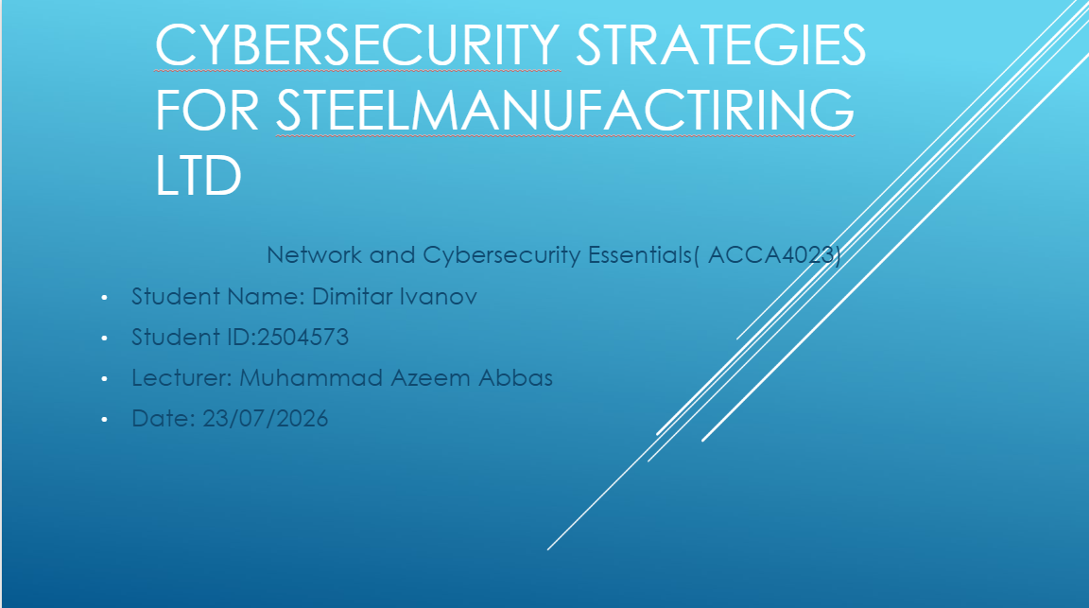:Slide2: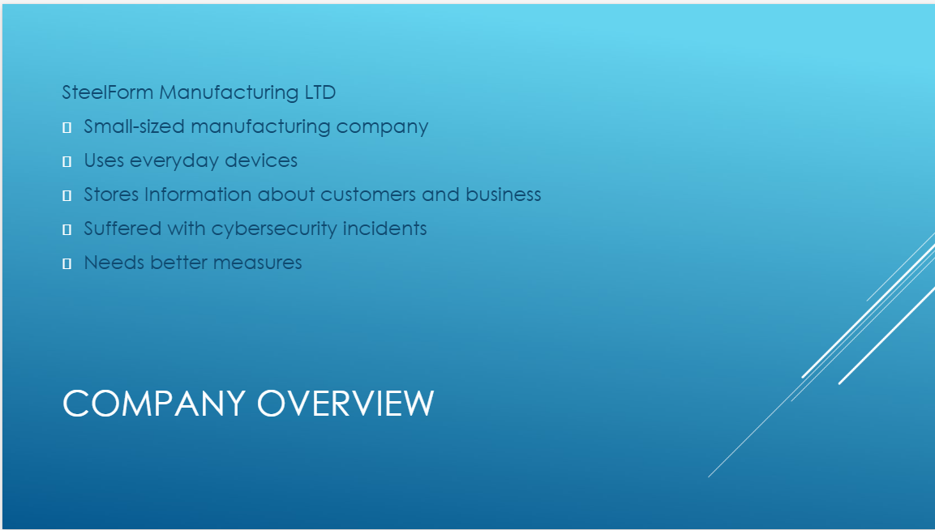Slide3: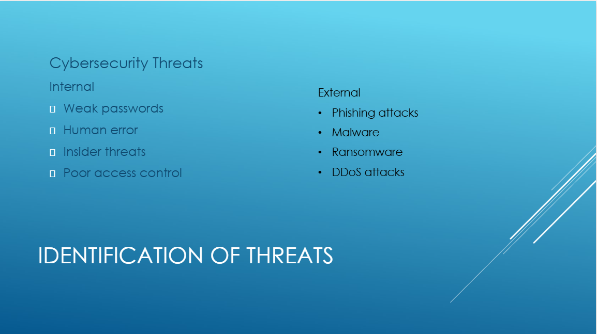Slide4: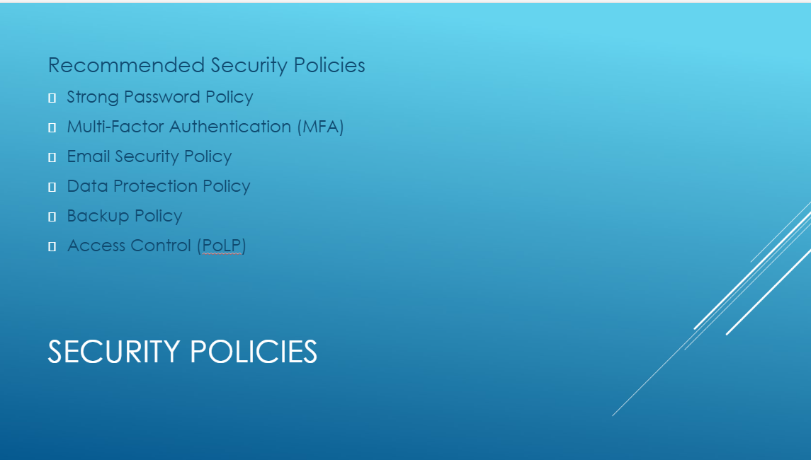Slide5: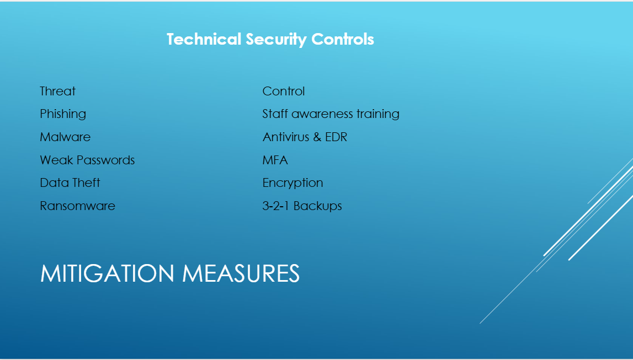Slide 6: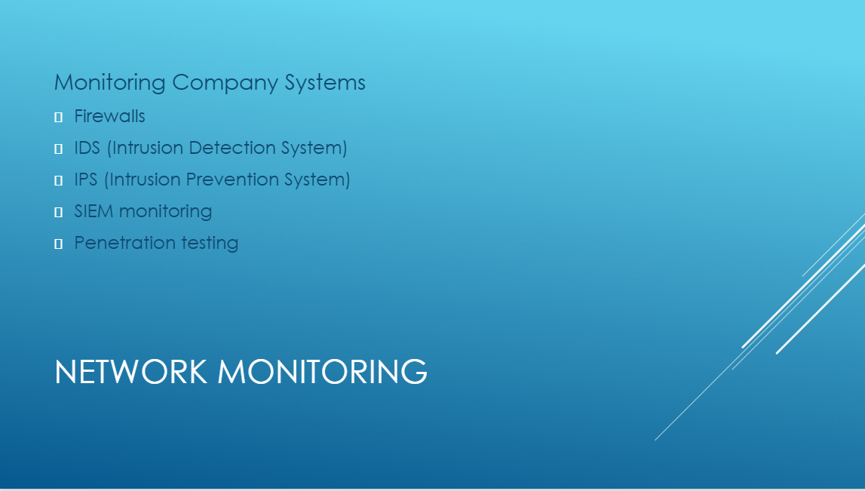Slide7: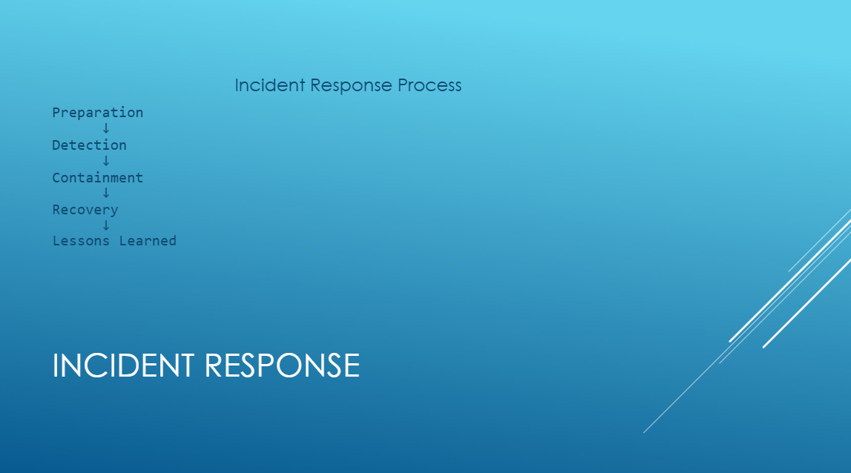Slide 8: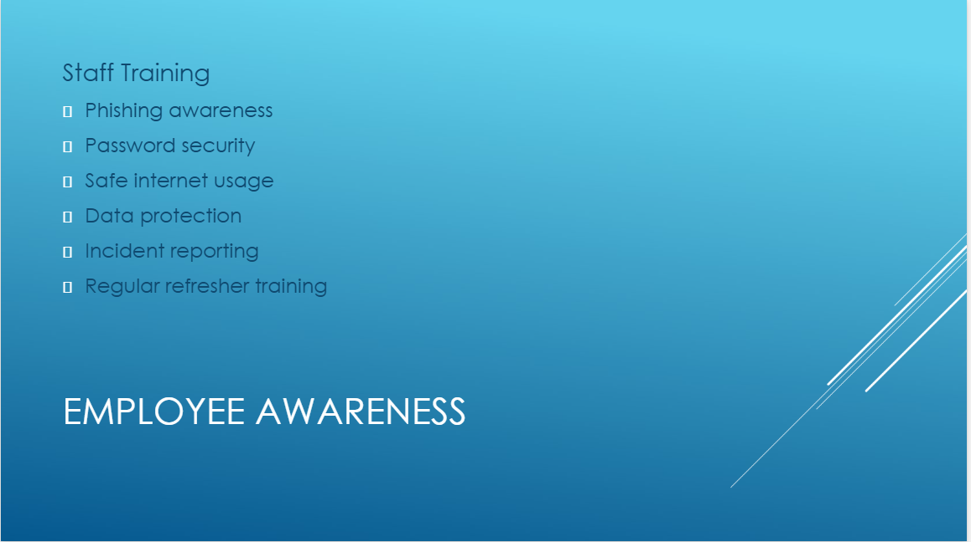Slide 9:
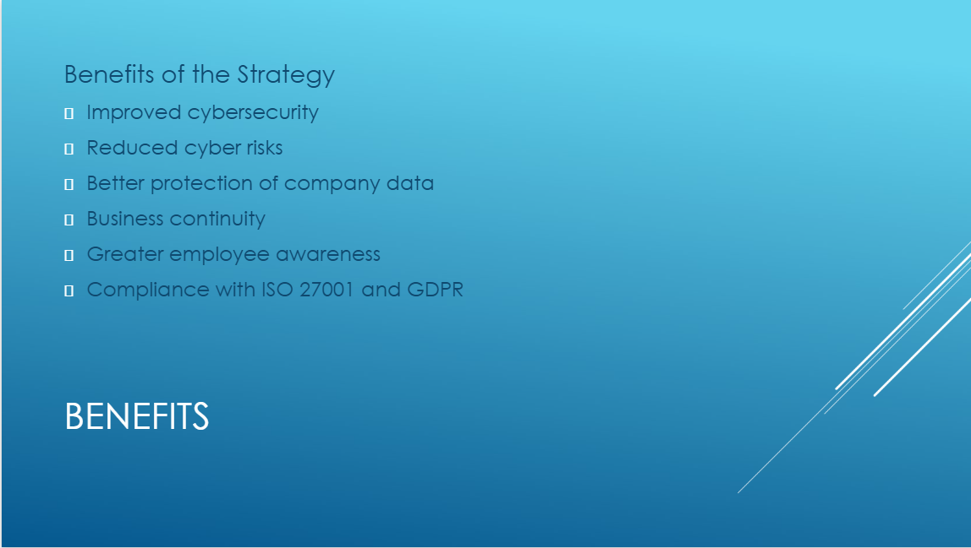Slide 10:
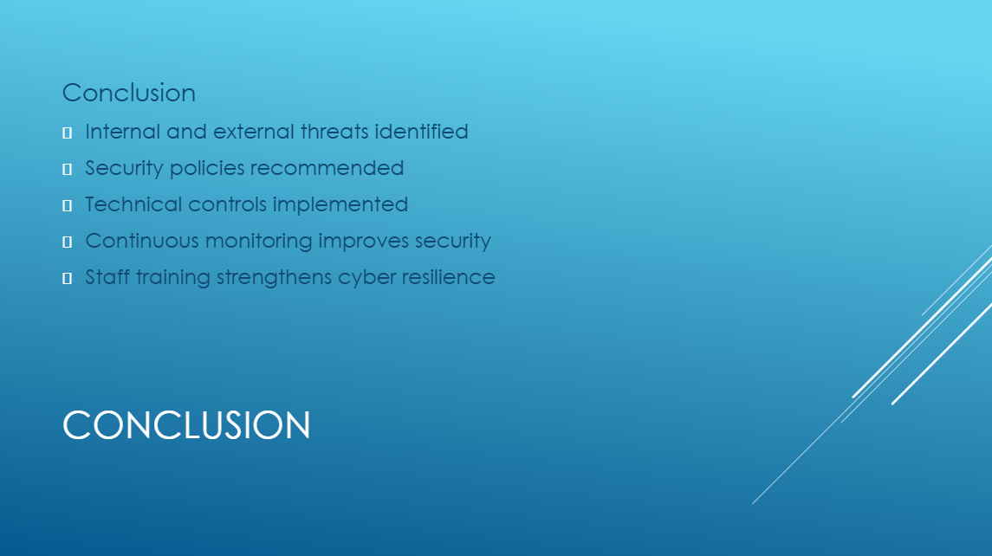

References
[1] "W. Stallings and L. Brown, Computer Security: Principles and Practice, 5th ed. Harlow, U.K.: Pearson, 2024."
[2] "M. E. Whitman and H. J. Mattord, Principles of Information Security, 7th ed. Boston, MA, USA: Cengage Learning, 2022."
[3] "National Cyber Security Centre, "Phishing attacks: Defending your organisation." [Online]. Available: https://www.ncsc.gov.uk/. [Accessed: 22-Jul-2026]."
[4] "National Institute of Standards and Technology, Cybersecurity Framework (CSF) 2.0. Gaithersburg, MD, USA: NIST, 2024."
[5] "National Cyber Security Centre, "Password guidance." [Online]. Available: https://www.ncsc.gov.uk/collection/passwords. [Accessed: 22-Jul-2026]."
[6] "International Organization for Standardization, ISO/IEC 27001:2022 Information Security, Cybersecurity and Privacy Protection – Information Security Management Systems – Requirements. Geneva, Switzerland: ISO, 2022."
[7] "UK Government, "UK General Data Protection Regulation (UK GDPR)." [Online]. Available: https://www.legislation.gov.uk/. [Accessed: 22-Jul-2026]."
[8] "National Institute of Standards and Technology, Guide to Industrial Control Systems (ICS) Security, NIST SP 800-82 Rev. 3. Gaithersburg, MD, USA: NIST, 2023."
[9] "International Organization for Standardization, ISO 22301:2019 Security and Resilience – Business Continuity Management Systems – Requirements. Geneva, Switzerland: ISO, 2019."
[10] "National Institute of Standards and Technology, Computer Security Incident Handling Guide, NIST SP 800-61 Rev. 2. Gaithersburg, MD, USA: NIST."

