ACMA 6001
William Holmes (2015755)
UWTSD
ACMA 6001
PLC control-developments & Functional specifications P1- P8
Modelling industrial control systems in MATLAB P9-P14

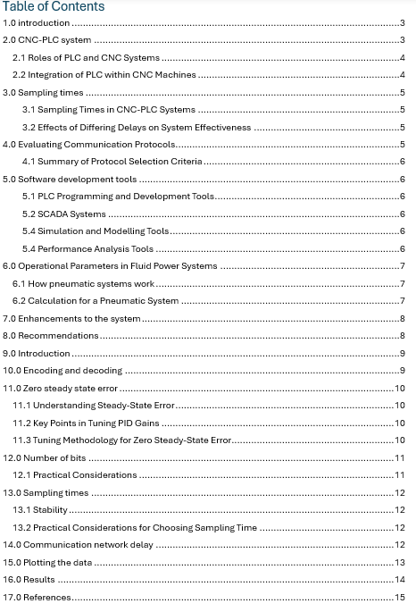

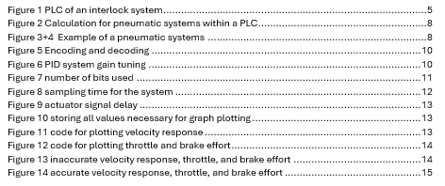

ACMA6001 Assignment 1

1.0 introduction
In the dynamic landscape of modern manufacturing, CNC (Computer Numerical Control) machines and PLC (Programmable Logic Controller) systems represent the pinnacle of precision and automation. These systems work synergistically to enhance productivity, accuracy, and efficiency in various industrial applications. CNC machines excel in executing detailed and complex machining tasks, driven by precise motion control and G-code instructions. In parallel, PLC systems handle the logic-based operations, ensuring smooth coordination of peripheral devices and overall system safety.
Central to the seamless operation of CNC-PLC systems are their diverse inputs and outputs, which include a wide array of sensors and actuators. These components gather crucial data and execute commands, maintaining the intricate balance required for optimal performance. At the heart of this sophisticated interplay lies the control algorithm, a meticulously designed sequence of operations that governs machine behaviour. By exploring the intricacies of these algorithms and the pivotal role of sensors and actuators, we gain a deeper understanding of how CNC-PLC systems achieve their remarkable capabilities, and how future advancements could further revolutionise the manufacturing industry.

2.0 CNC-PLC system
The PLC system example being used throughout this study, is the peripheral functions of CNC machines primarily interlock systems, although PLC systems aren’t ordinarily functioned together, the use of PLC systems has a large part to play within the operational systems and manufacturing systems of CNC machines. CNC systems are in most cases executed in combination with Programmable Logic Controllers (PLC). Whereas the CNC is responsible for the tool path generation, the PLC implements auxiliary functionality (mostly logical operations like activating lubrication at a certain time, interlock systems, and tool changing systems) having control over peripheral devices, as every piece of industrial machinery has to have interlock systems now by law which is enforced by HSE, this case study identifies revisions and improvements to current systems making them safer for operators, reducing maintenance and running costs, whilst working more effectively.

2.1 Roles of PLC and CNC Systems
CNC Systems, Precision Control: CNC systems are primarily responsible for controlling the movement and operation of machine tools with high precision. This includes tasks such as milling, turning, and grinding-Code Execution: CNC machines interpret and execute G-code, which is a language used to control automated machine tools. Motion Control: They control the movements of the machine along various axes (X, Y, Z, and sometimes others) using servo motors and feedback systems.
PLC Systems Logic Control: PLCs handle the logic-based control functions within a CNC machine, such as starting and stopping the machine, managing safety interlocks, and coordinating peripheral devices. Input/Output (I/O) Management: PLCs manage the input from sensors and switches and control the output to actuators, lights, and other devices. Automation of Ancillary Processes: They automate non-motion-related processes, such as coolant control, tool changes, and part handling systems.

2.2 Integration of PLC within CNC Machines
Interfacing: Communication Protocols: PLCs and CNC controllers communicate through various industrial protocols such as Ethernet/IP, Modbus, or proprietary interfaces. Synchronisation: The CNC controller sends commands to the PLC to perform specific actions at precise times during the machining process. Operational Coordination: Machine Startup and Shutdown: The PLC manages the overall startup and shutdown sequences of the CNC machine, ensuring all subsystems are activated or deactivated in the correct order. Safety Management: PLCs handle safety interlocks, emergency stop functions, and safety sensors, ensuring the machine operates within safe parameters. Tool and Part Handling: PLCs control automated tool changers and part handling systems, ensuring smooth transitions and positioning of tools and parts during the machining process. Real-time Monitoring and Control: Sensor Integration: PLCs collect data from various sensors (temperature, pressure, vibration) and provide real-time feedback to the CNC system or operators. Error Handling and Recovery: PLCs detect and respond to errors or faults, implementing predefined recovery procedures to minimize downtime. This researched is also quantified in "Automation, Production Systems, and Computer-Integrated Manufacturing" by Mikell P. Groover (1987). As it discusses the broader context of automation and manufacturing systems, including the integration of PLCs in CNC operations.
Figure 1 PLC of an interlock system
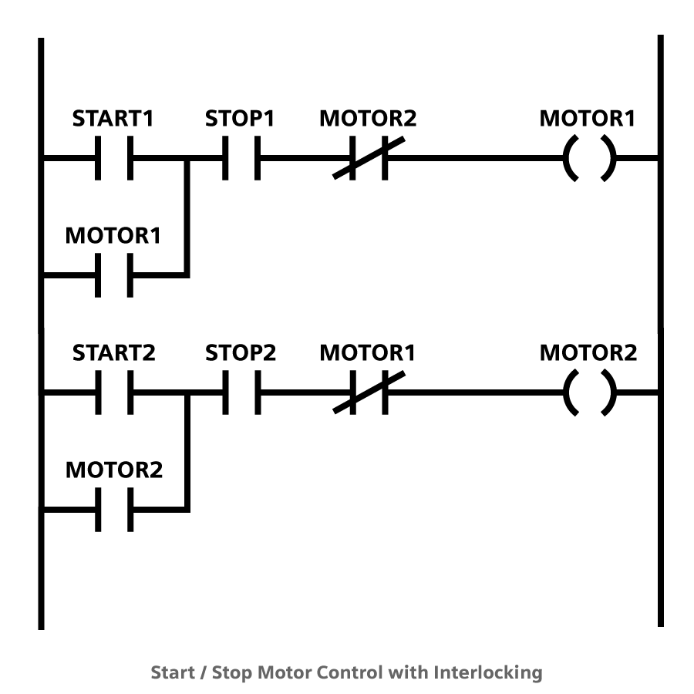

3.0 Sampling times

3.1 Sampling Times in CNC-PLC Systems
CNC Controllers: These typically operate at high frequencies, with sampling times in the range of microseconds to milliseconds n this instance a requirement of 2 msec to protect the modulator system from its damage dealing with the interlock, to handle precise and rapid movements of machine tools. PLC Systems: These often operate with sampling times from milliseconds to tens of milliseconds, as they handle a wide variety of inputs/outputs that may not need ultra-fast updates, using the Nyquist theorem from The Sampling Theorem" by H. Nyquist (1928)also utilised be IEEE standards(2024) is a function of time t contains no frequency components higher than f_{max} (Nyquist frequency), it is completely determined by sampling its value at time intervals Δ‎t = 1/(2f_{max}). Meaning samples are made at twice the highest frequency made by the system (60 hertz).

3.2 Effects of Differing Delays on System Effectiveness
Delays can arise from several sources, including network latency, processing time, and signal transmission time. These delays can affect various functions and components differently: Impact of Delays: Delays in detecting interlock conditions can lead to unsafe situations or unnecessary machine stoppages. For example, a delay in detecting an open safety door might result in the machine continuing to operate, posing a risk to operators. These mitigating delays are reinforced by L. Wang and P. Kumar (2024) through they’re paper on the effects of delays in industrial automation systems.
Strategies to Mitigate Delays:
- Optimising Sampling Rates
- Network Design
- Distributed Processing
- Buffering and Filtering
- Regular Maintenance
- Redundancy and Safety Checks

4.0 Evaluating Communication Protocols
Effective communication between sensors, controllers, and actuators is crucial for the efficiency and reliability of any automated or control system. Below are several communication protocols commonly used, evaluated based on factors such as reliability, speed, and compatibility as per thorough research and sources such as: Perry S. Marshall and John S. Rinaldi (2017), and Dick Caro (2004): Modbus - 115,200 BPS easy integration. Profibus – 12 Mbps Compatible with many industrial devices and controllers. CAN (Controller Area Network) – 1Mbps can FD extends to 8mbps, widely used in automotive and industrial applications. EtherCAT 100 Mbps supports cycle time of less than 100 µs. Often used in high-performance automation systems. Zigbee 250 Kbps used in home automation and industrial control systems.

4.1 Summary of Protocol Selection Criteria
- Reliability:
- All the protocols reviewed offer high reliability, with Modbus, Profibus, and CAN being particularly noted for robust error detection and correction mechanisms.
- Speed:
- EtherCAT offers the highest speed, making it ideal for real-time applications requiring low latency.
- Compatibility:
- Modbus and CAN are highly compatible with a wide range of devices and are commonly used in various industries

5.0 Software development tools
The development and analysis of industrial control systems (ICS) involve a range of activities including system design, programming, simulation, and performance analysis. Below is an exploration of various software tools available for these purposes, along with their key features and relevant use cases, below are examples of the development tools which are in-use or could be beneficial to the interlock CNC-PLC system being discussed within the report.

5.1 PLC Programming and Development Tools
Siemens TIA Portal
Rockwell Automation Studio 5000

5.2 SCADA Systems
Wonderware InTouch
Ignition by Inductive Automation

5.4 Simulation and Modelling Tools
MATLAB/Simulink
ANSYS Twin Builder

5.4 Performance Analysis Tools
OSIsoft PI System
GE Digital APM (Asset Performance Management)

6.0 Operational Parameters in Fluid Power Systems
Within CNC-PLC systems pneumatics act as a medium for the actuation and control of mechanical systems. For the application of an interlock plc system on a CNC machine both pneumatic and hydraulic systems are applicable. These operational parameters are widely discussed throughout Webb, J.W. and Reis, R.A., (2011) book on Programmable Logic Controllers, Principles and Applications.
Key parameters to analyse include Pressure (P): Force exerted by the fluid per unit area. Flow Rate (Q): Volume of fluid passing through a point per unit time. Velocity (v): Speed of the fluid flow. Force (F): Resultant force generated by the system. As CNC machines averagely require 200-400 PSI for all main and peripheral systems, pneumatic is more commonly used.

6.1 How pneumatic systems work
- Pressure: Generally lower pressures (e.g., 80-100 psi).
- Flow Rate: Higher flow rates can be achieved due to the compressibility of air.
- Force: Similarly calculated using F=P×AF = P \times AF=P×A, but lower force due to lower pressure.

6.2 Calculation for a Pneumatic System
With the operating parameters and calculations for the flow rate and force generated by a pneumatic cylinder with a piston diameter of 2 inches operating at 90 psi (average size for a interlock pneumatic system on CNC machines). The operational parameters can be calculated.
Calculation of the area and force within the CNC pneumatic system.

Figure 2 Calculation for pneumatic systems within a PLC
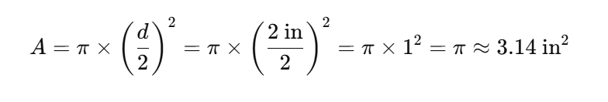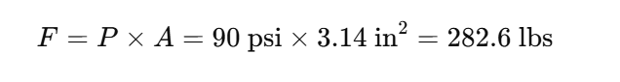
Figure 3+4 Example of a pneumatic systems
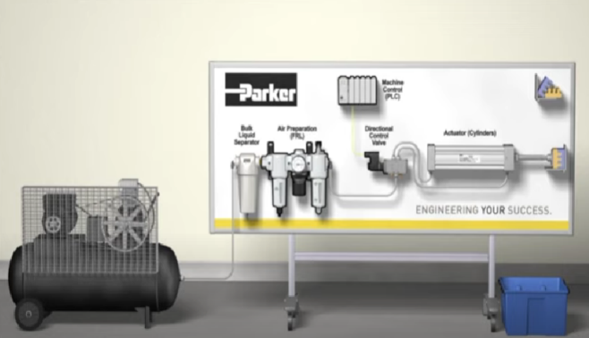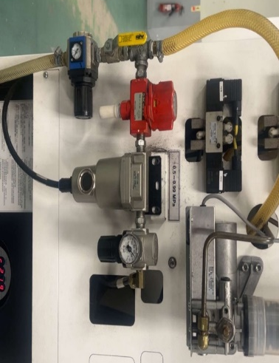

7.0 Enhancements to the system

1. Additional Actuators
Smart Actuators: Integrating smart actuators with built-in feedback capabilities can enhance control precision and allow for real-time adjustments based on sensor data.
2. Additional Sensors
Temperature Sensors: Installing additional temperature sensors at critical points can prevent overheating and ensure optimal operating conditions, thereby increasing machine longevity.
Vibration Sensors: Adding vibration sensors can help monitor the health of the machine and detect issues such as imbalances, misalignments, or wear and tear in real-time, allowing for predictive maintenance.
3. Software Upgrades
Enhanced HMI: Upgrading the Human-Machine Interface (HMI) to include more intuitive displays, real-time data visualization, and easier diagnostics can improve operator interaction and system monitoring.
4. Data Analytics and Monitoring
Condition Monitoring Systems: Implementing comprehensive condition monitoring systems that use data from multiple sensors to assess the overall health and performance of the machine can prevent downtime and extend equipment life.

8.0 Recommendations
With the data and research presented, it is recommended that the implementation of additional sensors paired with the addition of a smart actuator would refine the CNC-PLC system within this case study. With the added control of utilising temperature and vibration sensors, unplanned downtime could be significantly reduced, unpremeditated tool and machine degradation would be reduced due to the additional sensors and smart actuators allowing for real time adjustment, as the machines interlock would initiate mitigating or all damage.
With the other system enhancements listed above although they can provide better monitorisation, the above system has many of the monitorisation systems built into the operating system, therefore they wouldn’t be cost efficient or provide sufficient advantage to warrant the costs.

ACMA6001 Assignment 2

9.0 Introduction
In this study, we use MATLAB to model the control system, simulate its behaviour, and design a feedback controller that ensures zero steady-state error. This process includes encoding and decoding signals, investigating the trade-offs between velocity response and control effort, and examining how the number of bits used in the system affects closed-loop performance. Additionally, we explore the impact of different sampling times on system effectiveness and analyse network delays to determine the maximum delay that can be tolerated while maintaining satisfactory performance. Finally, we investigate whether adjusting controller gains can accommodate larger delays. By modelling the system and simulating various scenarios, a comprehensive understanding of the factors that influence the performance of digital control systems. highlight the complexities involved in optimising these systems for real-world applications.

10.0 Encoding and decoding
Figure 5 Encoding and decoding
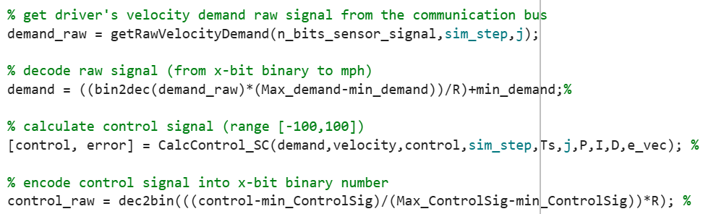

As shown in the code above the first line of code extracts the raw velocity from the communicating bus. Once this data is gathered, we can translate the binary code received into decimal numbers, using the newfound decimal data the control signal can be calculated giving us an output ranging from -100 to 100 which portrays full braking pressure to full throttle. To finish we can relay the signal back in binary so both sides of the system are communicating.

11.0 Zero steady state error
Figure 6 PID system gain tuning
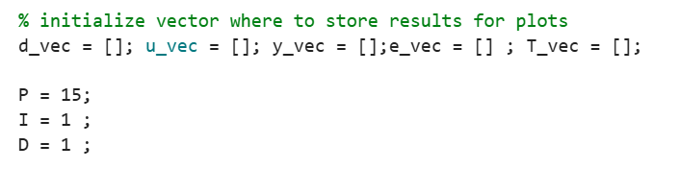
Achieving zero steady-state error in a PID (Proportional-Integral-Derivative) controller primarily relies on the integral term of the controller. Here's how tuning the PID gains can ensure zero steady-state error:

11.1 Understanding Steady-State Error
Steady-State Error: The difference between the desired setpoint and the actual output of the system when the system has settled and is no longer changing.
Integral Action: The integral term in a PID controller accumulates the error over time and adjusts the control output to eliminate this error.

11.2 Key Points in Tuning PID Gains
Proportional Gain: Reduces the overall error but cannot eliminate steady-state error alone.
Integral Gain: Eliminates steady-state error by accumulating past errors and applying necessary corrections.
Derivative Gain: Improves transient response and stability but does not directly affect steady-state error.

11.3 Tuning Methodology for Zero Steady-State Error
Here is a systematic approach to tuning the PID gains to ensure zero steady-state error, these approaches are corroborated by Webb, J.W. and Reis, R.A., 2011, and Stephenson, T.A. and Robotis, M.A., 2024 with their extensive research on PID systems and they’re responses.
Manual Tuning
Manual tuning is a straightforward method where gains are adjusted based on the system's response.
Ziegler-Nichols Method
The Ziegler-Nichols method is a more structured approach to tuning.
Software-Based Tuning
Tools like MATLAB's PID Tuner can automatically tune the gains for you.

12.0 Number of bits
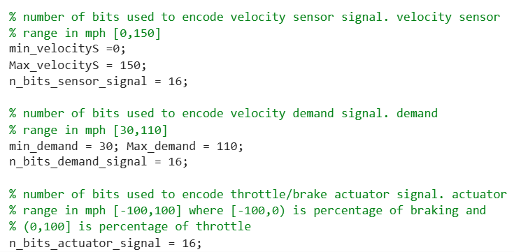
Figure 7 number of bits used

12.1 Practical Considerations
Hardware Constraints: The choice of bit resolution is often influenced by the hardware capabilities. For example, an 8-bit microcontroller may have limited resources compared to a 32-bit microcontroller or a digital signal processor (DSP).
Cost and Power Consumption: Higher resolution ADCs, DACs, and processors can be more expensive and consume more power. There is often a trade-off between desired performance and available budget or power constraints.
Application Requirements: High-precision applications, such as aerospace or medical devices, typically require higher bit resolution to ensure accurate and reliable control. Conversely, less critical applications may operate effectively with lower resolution.

13.0 Sampling times
Figure 8 sampling time for the system
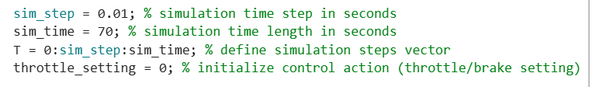

13.1 Stability
Too Long Sampling Time: If the sampling time is too long, the controller may respond too slowly to changes in the process variable. This can lead to instability, increased overshoot, and slower response times.
Too Short Sampling Time: If the sampling time is too short, the system may experience excessive noise and require more computational resources. This can also lead to instability due to the high-frequency response of the system.

13.2 Practical Considerations for Choosing Sampling Time
Nyquist Criterion: The sampling rate should be at least twice the highest frequency component of the process variable to avoid aliasing.
System Dynamics: The sampling time should be small enough to capture the dynamics of the system accurately but not so small that it leads to excessive computational load and noise sensitivity.
Controller Bandwidth: The sampling time should be chosen such that the controller can adequately perform the necessary computations within each sampling interval.

14.0 Communication network delay
Figure 9 actuator signal delay
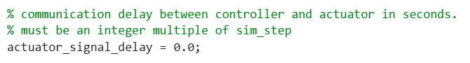
Short communication delays in PLC systems have minimal impact, maintaining real-time control and synchronisation. They ensure data accuracy and system efficiency. Long delays, however, degrade performance, compromise real-time control, cause synchronisation issues, and result in data staleness. These delays can lead to inefficiencies, increased error rates, and potential safety hazards. Proper network optimisation and system design are crucial to mitigate these effects.

15.0 Plotting the data
Figure 10 storing all values necessary for graph plotting
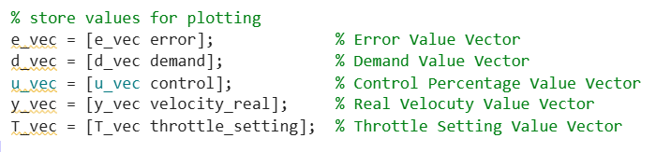

Figure 11 code for plotting velocity response
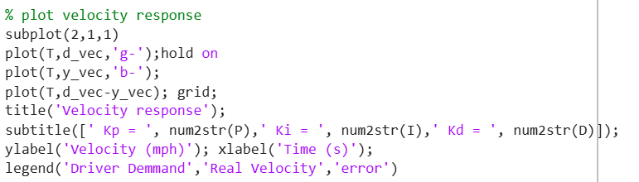

Figure 12 code for plotting throttle and brake effort
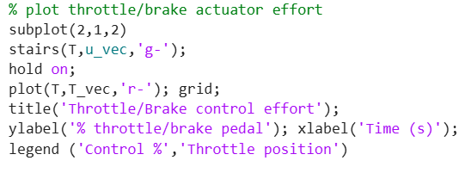

16.0 Results
Figure 13 inaccurate velocity response, throttle, and brake effort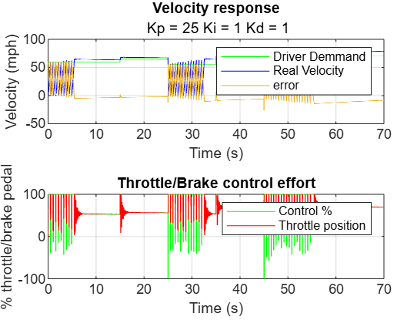
The above graphs show how a poor PID system responds with velocity response, and throttle/brake effort. As shown in the first graph the error and real velocity are highly unpredictable, overshooting and oscillating violently, this behaviour is also mirrored with throttle and brake effort having little control over throttle position.
In comparison the below results present accurate velocity response and equally accurate throttle and brake effort showing little signs of error and oscillation. These results were obtained utilising and exercising multiple programming strategies such as: Manual (trial and error), Ziegler-Nichols Method, and Software-Based Tuning (MATLAB SIMULINK).
Figure 14 accurate velocity response, throttle, and brake effort
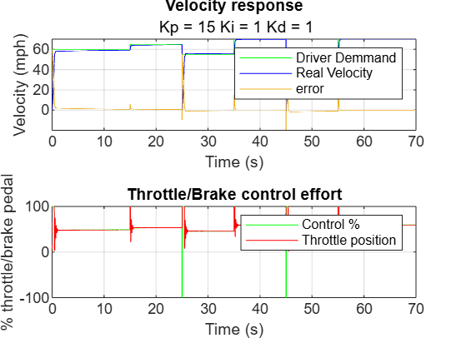

17.0 References


