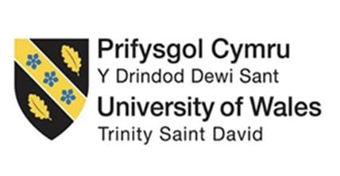

COURSE’S NAME: Leading and Implementing Change (LCLM6003_LON)
STUDENT’S NAME: Alba Bartolini
STUDENT’S ID: 2230835
LECTURE’S NAME: Nadeem Mirza

ASSIGNMENT TITLE:
A STRATEGIC CHANGE PLAN

DECLARATION OF AI

Use of Generative Artificial Intelligence in Assessment
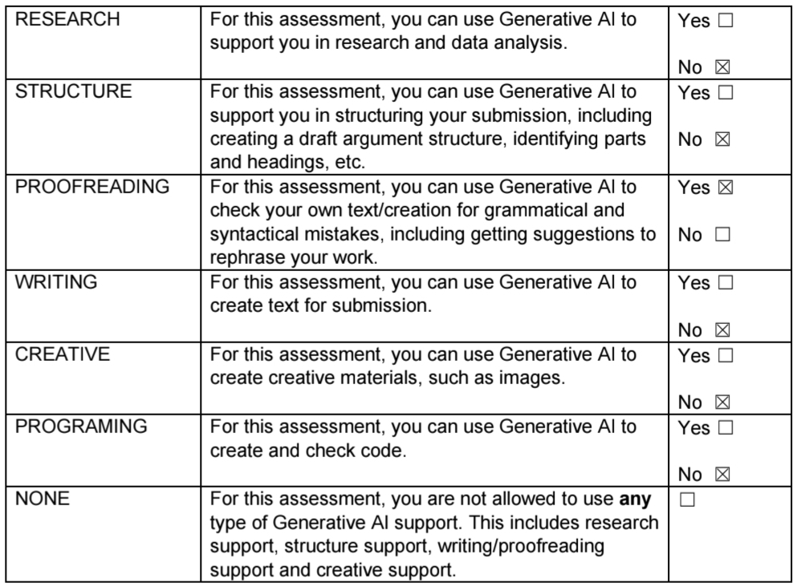

Table of Contents
Executive Summary 4
1. Introduction 5
1.1 Overview of The North Face 5
1.2 Contemporary Issues and Drivers for Change 5
1.3 Purpose and Structure of the Report 5
2. Organisational and Environmental Analysis 6
2.1 External Environment: PESTLE Analysis 6
2.2 Internal Environment: SWOT Analysis 7
2.3 Industry Structure: Porter’s Five Forces 8
2.4 Recent Organisational History and Strategic Context 9
2.5 Synthesis of Key Strategic Change Issues 9
2.5.1 Rationale for Strategic Change 10
3. Change Management Models and Strategic Change 10
3.1 Nature of Organisational Change at the North Face 10
3.2 Lewin’s Three-Step Change Model (1951) 11
3.3 Kotter’s 8-Step Change Model (1996) 11
3.4 ADKAR Model (Hiatt, 2006) applied to The North Face 12
3.5 Critical Evaluation of Change Management Models 13
4. Leadership and Organisational Culture 13
4.1 Role of Leadership in Managing Change 13
4.2 Transformational Leadership and Strategic Change 14
4.3 Edgar Schein’s model of organisational Culture Applied to The North Face 14
4.4 Impact of Organisational Culture on Change Outcomes 15
5. Proposed Change Management Plan for The North Face UK 15
5.1 Introduction to the Proposed Change 15
5.2 Description and Scope of the Proposed Change 16
5.3 Change Objectives 16
5.4 Financial Plan 17
5.5 Communication Plan 18
5.5.1 Stakeholders Analysis 18
5.6 Evaluation and Control Plan 19
5.6.1 Balanced Scorecard 19
5.6.2 Implementation Timeline Gantt Chart ok 20
6. Conclusion 21
7. References 22

Executive Summary
This report critically examines the strategic change challenges facing The North Face UK from the perspective of a Change Manager operating within a highly dynamic business environment. The outdoor apparel industry is subject to intensifying scrutiny over environmental impacts, rapid digital disruption, shifting consumer expectations, and increasingly stringent regulatory requirements. These pressures necessitate a structured and organisation-wide approach to managing change to safeguard long-term competitiveness and operational resilience.
The report analyses both internal and external drivers of change, including sustainability imperatives, technological innovation, the growth of e-commerce and digital transparency, and the introduction of Extended Producer Responsibility (EPR) legislation in the UK. Analytical frameworks such as PESTLE, SWOT, and Porter’s Five Forces are applied to assess The North Face UK’s strategic position and readiness for transformation. In addition, established change management models, Lewin’s Three-Step Model, Kotter’s Eight-Step Model, and the ADKAR Model, are critically evaluated to determine their suitability for supporting a sustainability-led organisational transformation.
The analysis highlights the pivotal role of leadership and organisational culture in enabling effective change, emphasising the importance of transformational leadership and cultural alignment in embedding sustainable practices. The report concludes by proposing a structured change management plan with clearly defined objectives, supported by financial, communication, and evaluation plans. Overall, the report demonstrates that sustainability-driven change is central to The North Face UK’s future competitiveness, risk management, and strategic viability.

1. Introduction
The contemporary business environment is shaped by rapid technological change, increasing regulatory pressure, and rising stakeholder expectations for sustainability. Within the apparel industry, digital disruption, online shopping, and the adoption of artificial intelligence (AI) are transforming competitive dynamics and organisational practices, making effective strategic change management a critical capability. These pressures also require organisations to prioritise and manage stakeholders strategically, particularly when responding to regulatory, environmental, and social demands (OECD, 2023).

1.1 Overview of The North Face
This report focuses on The North Face UK, a leading outdoor apparel brand operating in a highly competitive and sustainability-focused market. Despite having strong environmental credentials and a reputation for innovation, the growing digitalization, regulatory requirements, and changing consumer expectations necessitate further strategic change.

1.2 Contemporary Issues and Drivers for Change
The North Face UK is experiencing a range of contemporary issues that act as critical triggers for strategic change. Digital disruption, particularly the expansion of online shopping and the integration of artificial intelligence (AI) across supply chains and inventory management, has significantly altered consumer expectations regarding convenience, speed, and transparency. Simultaneously, sustainability has become a dominant strategic issue within the apparel sector, driven by tighter environmental regulation and growing pressure from consumers and other stakeholders for credible circular and low-carbon business practices. Research indicates that organisations that fail to respond strategically to these combined digital and sustainability pressures risk losing competitive relevance and stakeholder trust. Together, these technological, regulatory, and market-driven forces compel The North Face UK to undertake strategic change to maintain competitiveness, legitimacy, and long-term resilience (McKinsey & Company, 2023).

1.3 Purpose and Structure of the Report
The purpose of this report is to critically analyse how environmental change affects organisational capability at The North Face UK, evaluate leadership and change management approaches, and apply relevant change management models. The report concludes by proposing a strategic change plan to support long-term sustainability and competitiveness.

2. Organisational and Environmental Analysis

2.1 External Environment: PESTLE Analysis
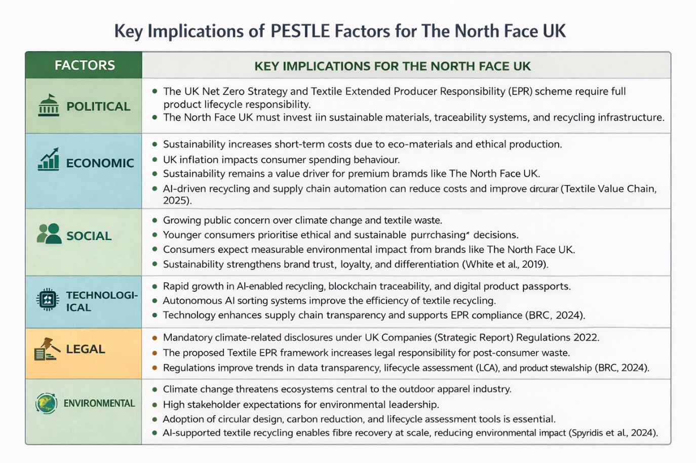
The figure shows the PESTLE analysis, highlighting that sustainability and regulation strongly shape The North Face UK’s operating environment. Politically and legally, the UK Net Zero Strategy and the proposed Textile Extended Producer Responsibility (EPR) framework require brands to manage full product lifecycles, increasing compliance, traceability, and reporting requirements (BRC, 2024). Economically, sustainability initiatives raise short-term costs due to eco-materials and ethical production, particularly amid inflationary pressures; however, AI-driven recycling and supply chain automation offer long-term cost reductions and improved circular efficiency (Textile Value Chain, 2025). Social factors further reinforce this shift, as younger consumers increasingly prioritise ethical purchasing and expect measurable environmental impact from brands. Technologically, advances such as AI-enabled textile sorting, blockchain traceability, and digital product passports enhance transparency, recycling efficiency, and EPR compliance (Spyridis et al., 2024). Environmentally, climate change threatens ecosystems central to outdoor apparel, intensifying stakeholder expectations for environmental leadership and accelerating the need for circular design, carbon reduction, and scalable fibre recovery solutions.

2.2 Internal Environment: SWOT Analysis
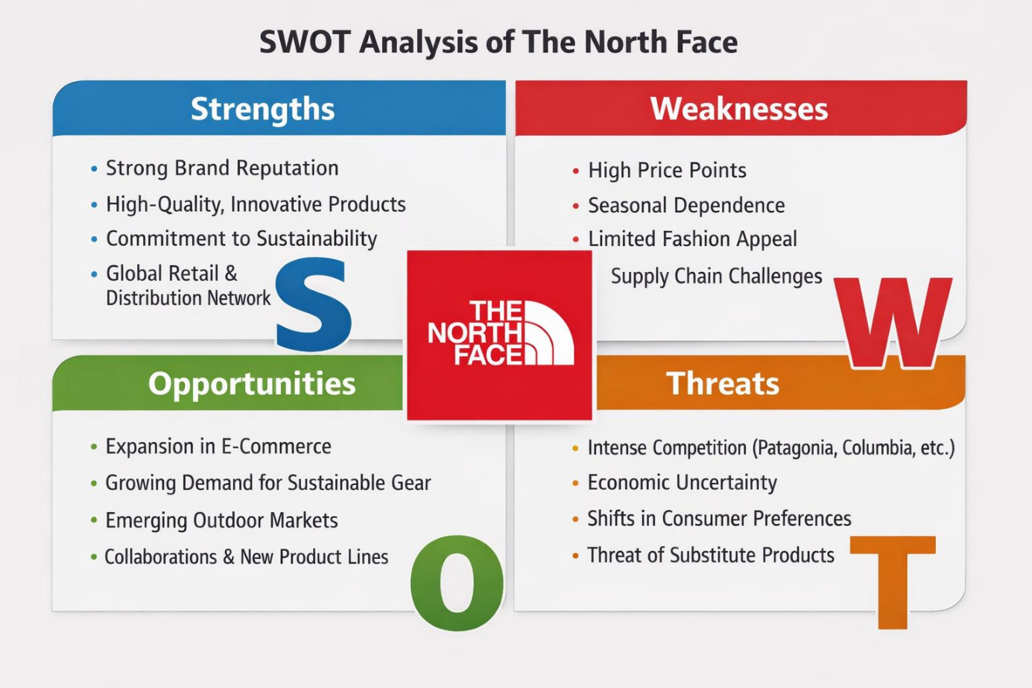
The figure shows the SWOT analysis, highlighting The North Face’s current strategic position within the global and UK outdoor apparel market. One of the brand’s key strengths is its strong global reputation for high-performance and innovative outdoor products, supported by a well-established distribution network and a growing direct-to-consumer presence. The company’s ongoing commitment to sustainability and product durability further strengthens brand loyalty and competitive advantage (Latterly, 2025).
However, the brand also faces weaknesses, including premium pricing and reliance on complex global supply chains, which can expose the organisation to operational challenges and reduce appeal among price-sensitive consumers. In terms of opportunities, the continued expansion of e-commerce, digital engagement, and circular business models provides significant potential for long-term growth. At the same time, notable threats remain, particularly intense competition from other outdoor apparel brands and ongoing economic uncertainty, which may limit consumer spending on non-essential products (Fern Fort University, 2025).
Overall, the SWOT analysis illustrates the need for The North Face to leverage its strengths and opportunities while carefully managing internal limitations and external risks.

2.3 Industry Structure: Porter’s Five Forces
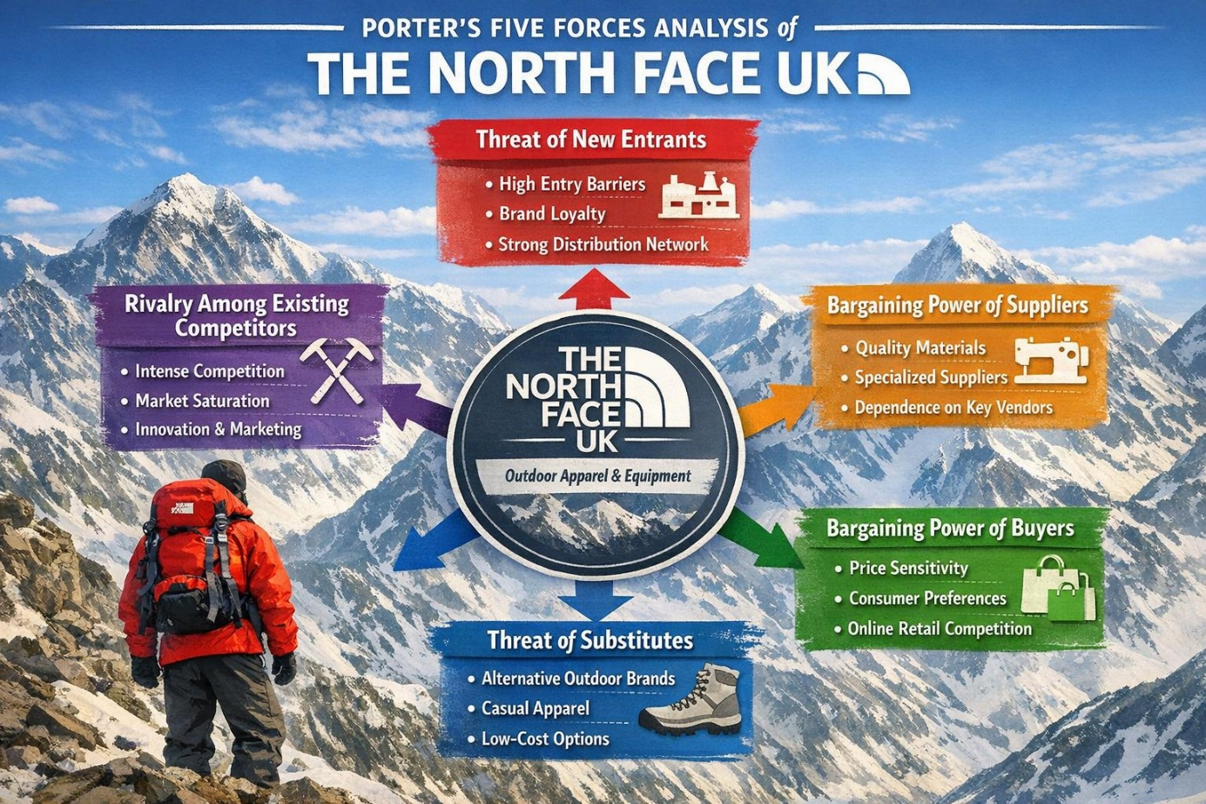
The figure applies Porter’s Five Forces framework to analyse the competitive environment of The North Face UK, clearly showing how external market forces influence the brand’s strategic position within the outdoor apparel industry. Competitive rivalry is high, as The North Face competes with well-established brands such as Patagonia, Columbia, and Arc’teryx. These rivals invest heavily in innovation, sustainability, and brand differentiation, increasing pressure to maintain market share. The threat of new entrants is relatively low because the industry has high barriers to entry, including strong brand loyalty, significant start-up costs, and the need for advanced technical expertise in product development.
Buyer power in the UK market is moderate to high, as consumers have access to numerous alternative outdoor brands and can easily compare prices and reviews online. This forces The North Face to remain competitive in both pricing and perceived value. Supplier power is moderate, as the brand relies on specialized, high-performance materials; however, its global scale and established supplier relationships help reduce its dependence on individual suppliers. The threat of substitutes is notable, as consumers may switch to lower-priced outdoor brands or casual fashion products that offer similar functionality for everyday use.
Overall, the visual illustrates how Porter’s Five Forces help explain the competitive pressures faced by The North Face UK and emphasizes the importance of differentiation, innovation, and brand strength in sustaining a competitive advantage (Britannica, 2025).

2.4 Recent Organisational History and Strategic Context
In recent years, The North Face UK has undergone a strategic shift driven by sustainability commitments, digital transformation, and changing consumer behaviour. As part of VF Corporation, the organisation has prioritised environmentally responsible practices, including increased use of recycled materials, circular product design, and repair-based services. These initiatives reflect a move away from purely volume-driven growth towards long-term value creation. However, this transition has occurred alongside intensifying competition from digitally native and sustainability-led brands, as well as rising expectations for omnichannel retail experiences. Combined with increasing regulatory scrutiny, these pressures have exposed limitations in existing operational models, indicating the need for more coordinated and organisation-wide strategic change.

2.5 Synthesis of Key Strategic Change Issues
The analysis of The North Face UK’s external environment, internal capabilities, and industry conditions highlights a set of interconnected strategic challenges. Digital disruption, sustainability regulation, and competitive intensity are increasing demands for transparency, efficiency, and circularity. While the organisation benefits from strong brand equity and established sustainability credentials, scaling these initiatives creates cost and operational complexities. This misalignment between environmental pressures and organisational capability suggests that incremental change is insufficient. Instead, a structured and integrated approach to strategic change is required to realign leadership practices, organisational culture, and operational systems. Research indicates that such alignment is essential for building resilience and sustaining performance in dynamic environments (Awad and Martín-Rojas, 2024).

2.5.1 Rationale for Strategic Change
The combined effects of regulation, technological advancement, and market expectations create a strong rationale for strategic change at The North Face UK. Evidence suggests that digital transformation supports sustainable business performance by strengthening organisational capabilities and enabling firms to respond more effectively to environmental and social pressures. Incremental improvements are therefore insufficient, as they risk compliance challenges and competitive disadvantage. Strategic, organisation-wide change is required to realign leadership practices, organisational culture, and operational systems with long-term sustainability and digital transformation objectives (Heliyon, 2024).

3. Change Management Models and Strategic Change

3.1 Nature of Organisational Change at the North Face
The change facing The North Face UK is best characterised as strategic and transformational, as it involves fundamental shifts in strategy, operations, and organisational culture. The organisation is responding to long-term environmental pressures such as digital disruption, sustainability regulation, and changing consumer expectations, which require more than incremental improvement. The transition towards a circular and low-carbon business model affects multiple organisational levels, including supply chain processes, employee capabilities, and leadership practices. Such organisation-wide change necessitates a structured change management approach to ensure alignment between strategy, people, and culture. Transformational change is particularly relevant where organisations must realign their capabilities to sustain competitive advantage in dynamic environments (Balogun and Hope Hailey, 2020).

3.2 Lewin’s Three-Step Change Model (1951)
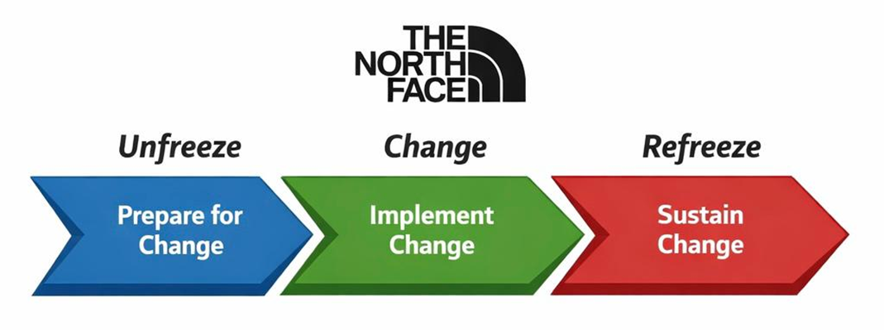
According to Burnes (2023), Lewin’s Three-Step Change Model explains organisational change as a process of unfreezing existing behaviours, implementing change, and refreezing new practices into organisational routines. Applied to The North Face UK, the unfreezing stage involves challenging traditional linear production models and raising awareness of the need for sustainability-led transformation. The change stage reflects the introduction of circular design practices, digital supply chain systems, and new operational processes. Refreezing then focuses on embedding these changes into organisational culture through training, performance management, and leadership reinforcement. While the model provides a clear and accessible framework, its assumption of organisational stability limits its effectiveness in continuously evolving industries. Nevertheless, it remains a useful tool for structuring early-stage strategic and cultural change.

3.3 Kotter’s 8-Step Change Model (1996)
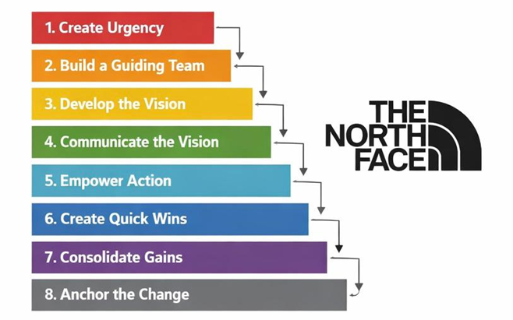
According to Kotter (2023), successful transformational change depends on strong leadership, clear communication, and sustained momentum. Kotter’s Eight-Step Change Model emphasises creating urgency, building guiding coalitions, and anchoring change within organisational culture. For The North Face UK, this approach supports the leadership alignment and employee engagement required to implement sustainability and digital transformation initiatives. The model’s focus on short-term wins helps maintain motivation and reduce resistance during large-scale change. However, critics argue that the model’s linear structure may oversimplify change in volatile environments. Despite this limitation, Kotter’s framework remains highly relevant for guiding leadership behaviour and reinforcing strategic commitment.

3.4 ADKAR Model (Hiatt, 2006) applied to The North Face
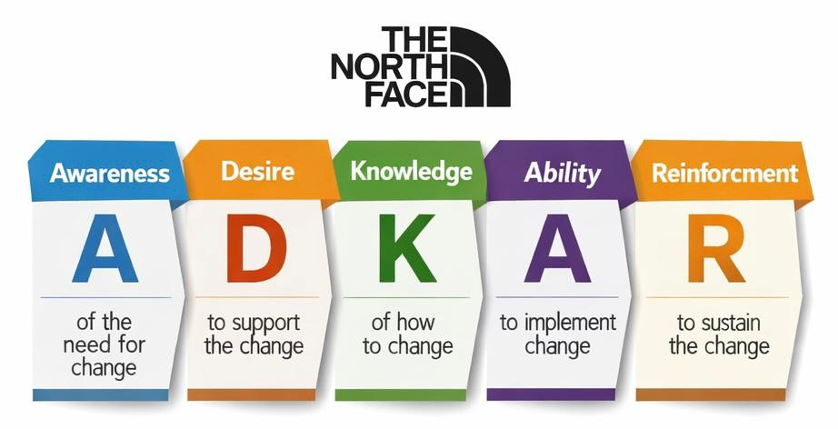
According to Prosci (2023), the ADKAR model focuses on managing change at the individual level through awareness, desire, knowledge, ability, and reinforcement. This approach is particularly relevant to The North Face UK, where employee engagement and skills development are essential for embedding sustainability and digital initiatives. ADKAR helps managers identify resistance points and tailor training and communication strategies to support behavioural change. By reinforcing new behaviours through feedback and rewards, the model supports long-term adoption of change. However, ADKAR does not explicitly address organisational structures or strategic alignment, limiting its effectiveness as a standalone framework. It is therefore most effective when combined with broader organisational change models.

3.5 Critical Evaluation of Change Management Models
While Lewin’s, Kotter’s, and the ADKAR models each offer valuable insights into the change process, their application to The North Face UK reveals important limitations. Lewin’s model provides a useful high-level framework but may oversimplify change in a fast-moving and digitally disrupted environment where continuous adaptation is required. Kotter’s model emphasises leadership and vision, aligning well with sustainability-led transformation, yet its top-down nature may risk limiting employee empowerment if not complemented by participatory approaches. The ADKAR model effectively addresses individual behaviour and resistance but lacks a strong strategic focus when applied in isolation. Consequently, this analysis supports the use of a blended approach that integrates structural, leadership, and behavioural perspectives. Combining these models enables The North Face UK to manage both the technical and human dimensions of strategic change more effectively (Gborogbosi & Amah, 2025).

4. Leadership and Organisational Culture

4.1 Role of Leadership in Managing Change
Leadership is a critical enabler of effective change management, particularly in organisations undergoing strategic and transformational change. Leaders are responsible for setting a clear vision, aligning organisational strategy with external environmental demands, and guiding employees through uncertainty. Research published in the IIMB Management Review (2023) emphasises that leadership effectiveness during change is closely linked to strategic coherence, communication, and the ability to foster organisational learning. Leaders who actively support change initiatives help reduce resistance and encourage employee engagement by reinforcing shared goals and long-term value creation.
In the context of The North Face UK, leadership plays a vital role in driving sustainability-led transformation, ensuring that strategic objectives such as environmental responsibility and digital innovation are embedded across organisational processes and behaviours. Effective leadership is therefore essential to coordinating change across multiple levels of the organisation and sustaining momentum throughout the change process.

4.2 Transformational Leadership and Strategic Change
Transformational leadership is particularly relevant in situations where organisations must implement large-scale strategic change. Transformational leaders inspire and motivate employees by articulating a compelling vision, encouraging innovation, and fostering commitment to organisational goals. Empirical research shows that transformational leadership supports organisational change by reducing resistance, enhancing psychological safety, and increasing engagement with change initiatives, which can lead to more effective strategic outcomes.
For The North Face UK, transformational leadership supports the successful implementation of strategic initiatives related to sustainability and cultural change. By modelling desired behaviours and reinforcing organisational values, leaders can shape employee attitudes and encourage alignment with the organisation’s long-term strategic direction. This leadership approach is especially important in embedding new practices and ensuring that change is sustained beyond initial implementation.

4.3 Edgar Schein’s model of organisational Culture Applied to The North Face
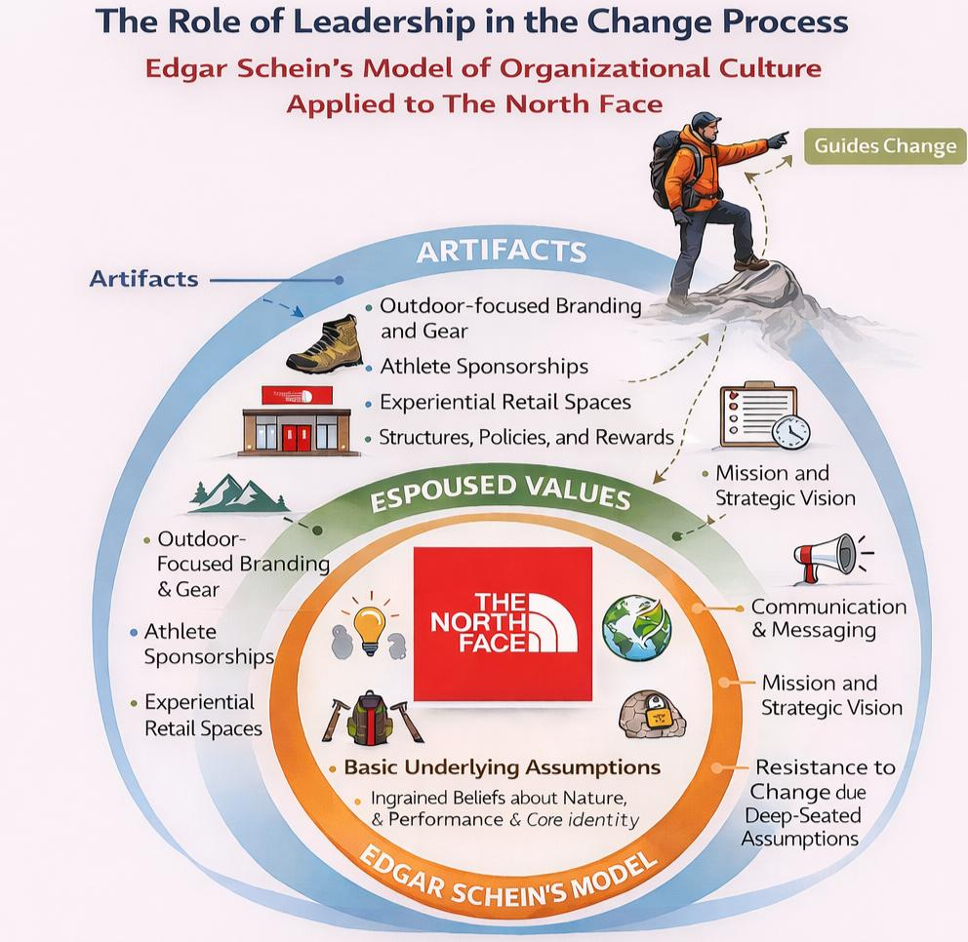
The figure illustrates Edgar Schein’s Model of organisational culture, explaining how leadership influences change at three interconnected levels: artefacts, espoused values, and basic underlying assumptions. Applied to The North Face, leaders use artefacts such as adventure-focused branding, athlete sponsorships, and experiential retail spaces to visibly communicate change and reinforce desired behaviours. Espoused values are reflected in the company’s mission, strategic vision, and emphasis on innovation and sustainability, which leaders actively promote to align employees with organisational goals. At the deepest level, basic underlying assumptions include beliefs about respect for nature, performance excellence, and long-term responsibility. Leadership is critical in challenging and reshaping these assumptions, as lasting organisational change occurs only when new values become embedded within the culture (ToolsHero, 2025).

4.4 Impact of Organisational Culture on Change Outcomes
Organisational culture plays a decisive role in determining the success or failure of change initiatives, as it shapes employee attitudes, behaviours, and responses to new strategic directions. A culture that supports openness, trust, and shared values can significantly enhance employee engagement and reduce resistance during periods of transformation. Nottingham Business School (2025) emphasises that organisations with strong, purpose-driven cultures are better positioned to implement sustainable change, as cultural alignment enables employees to internalise organisational goals and translate them into everyday practices.
In the case of The North Face UK, organisational culture is particularly important given the company’s emphasis on sustainability, ethical responsibility, and innovation. Embedding these values into the organisational culture can reinforce commitment to strategic change initiatives, such as the transition towards circular business models. Conversely, misalignment between stated values and actual behaviours may undermine change efforts. Therefore, cultivating a culture that consistently supports sustainability and adaptability is essential to achieving positive and enduring change outcomes.

5. Proposed Change Management Plan for The North Face UK

5.1 Introduction to the Proposed Change
The North Face UK is undertaking a strategic transition towards a circular and low-carbon business model, with a focus on sustainable materials, waste reduction, and repair-based services. This strategic shift responds to increasing consumer expectations and mounting environmental pressures within the outdoor apparel industry, where environmental credibility and brand authenticity are essential for maintaining competitiveness. Adopting circular practices such as repair, reuse, and emissions reduction is widely recognised as a critical pathway for fashion and apparel organisations seeking long-term sustainability and resilience (United Nations Environment Programme, 2023).

5.2 Description and Scope of the Proposed Change
The proposed change involves the implementation of three integrated sustainability initiatives that collectively affect product design, retail operations, and supply chain activities across The North Face UK:
Increasing the use of recycled and responsibly sourced materials across all UK product categories.
Expanding the “Clothes the Loop” repair and reuse programme across UK retail locations.
Reducing operational carbon emissions through energy-efficient retail stores, logistics improvements, and active supplier engagement.
Together, these initiatives represent an organisation-wide approach to embedding sustainability into core business operations.

5.3 Change Objectives
The proposed change is underpinned by clear and measurable objectives designed to guide implementation and evaluate performance:
To increase the use of recycled and low-impact materials to 40% of all materials used across product lines by 2027.
To reduce overall operational carbon emissions by 30% by 2028, compared with the 2024 baseline.
To expand the in-store repair programme by increasing customer participation by 50% within the next three years.
To strengthen organisational sustainability capability by ensuring that 100% of employees complete sustainability training within 12 months.
These objectives provide a structured foundation for aligning organisational resources, driving employee engagement, and supporting the long-term success of the proposed strategic change.

5.4 Financial Plan
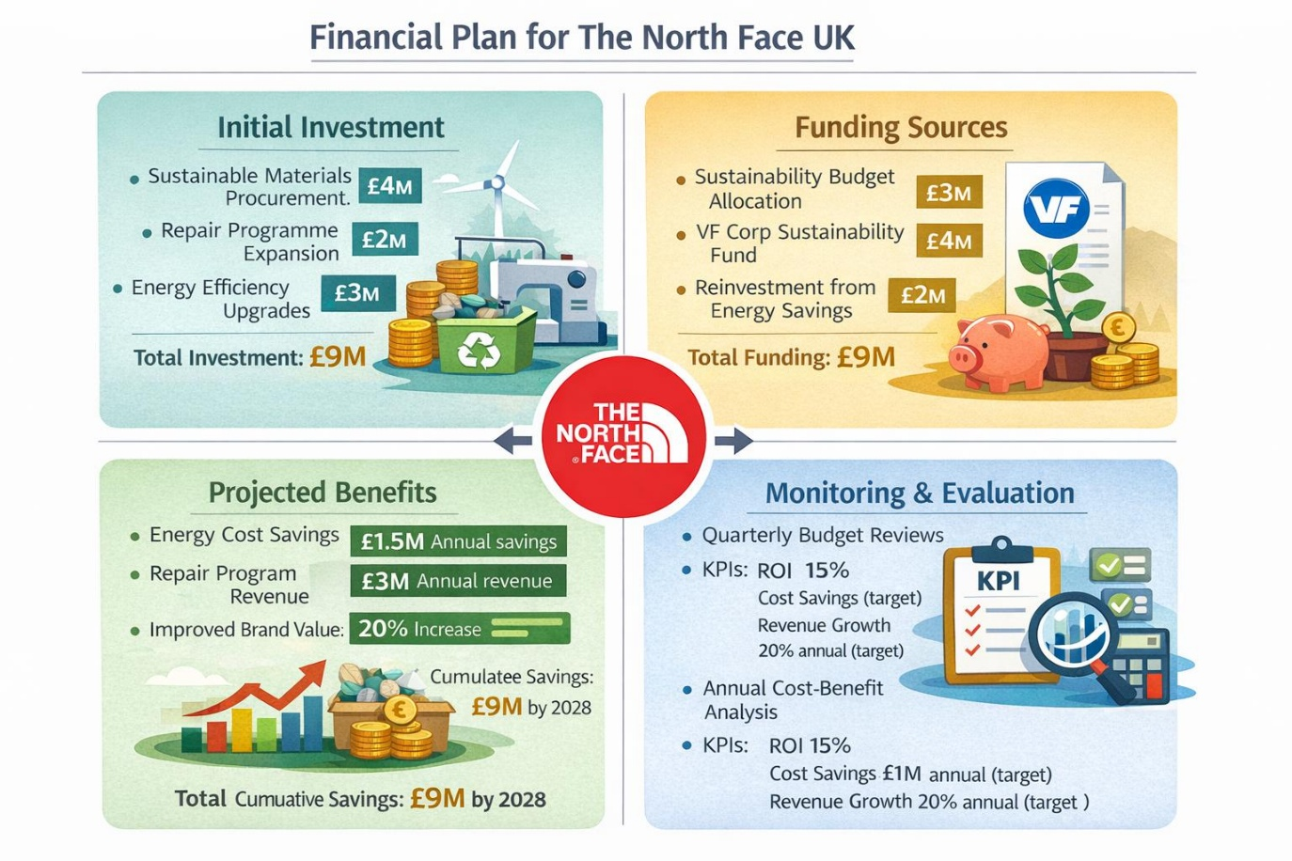
The figure shows a financial plan that supports the proposed strategic change at The North Face UK. The matrix demonstrates how a total investment of £9 million is allocated across three core initiatives: sustainable materials procurement (£4m), expansion of the repair and reuse programme (£2m), and energy efficiency upgrades (£3m). Funding is sourced from internal sustainability budgets, VF Corporation sustainability funding, and reinvestment of energy savings, ensuring financial feasibility without excessive external financing. The projected benefits highlight tangible financial returns, including £1.5m in annual energy cost savings, £3m annual revenue from repair services, and a 20% increase in brand value, resulting in cumulative savings of £9m by 2028. Ongoing monitoring through KPIs, ROI targets, and cost–benefit analysis ensures financial accountability and long-term value creation.

5.5 Communication Plan

5.5.1 Stakeholders Analysis
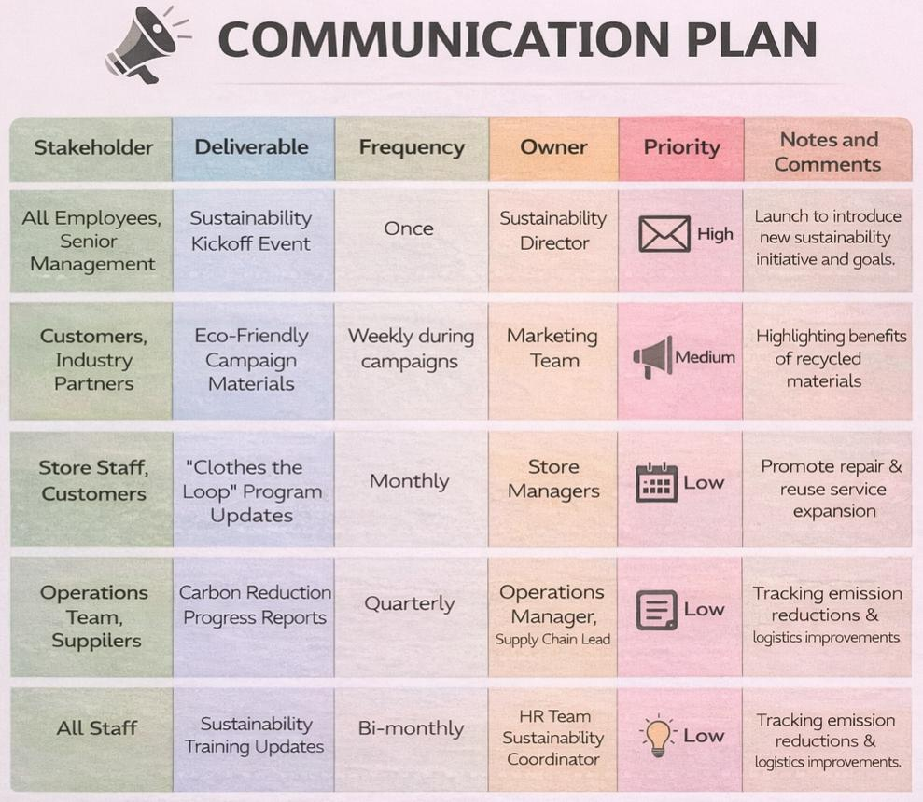
The communication plan outlines a structured and targeted approach to supporting the sustainability-led change programme at The North Face UK. It identifies key stakeholder groups and aligns tailored communication deliverables, frequencies, and ownership responsibilities to ensure consistent and effective information flow throughout the change process. High-priority communication is directed at senior management and employees through a sustainability kickoff event, reinforcing leadership commitment and strategic alignment. Customers and industry partners are engaged through regular eco-friendly marketing campaigns that emphasise the value of recycled materials and circular practices. Operational updates, such as carbon reduction progress reports, are communicated quarterly to relevant internal and supply chain stakeholders to support accountability and performance tracking. In addition, ongoing sustainability training updates for staff help embed long-term behavioural change and capability development. Overall, the plan supports transparency, stakeholder engagement, and alignment with the organisation’s sustainability and digital transformation objectives (CIPD, 2023).

5.6 Evaluation and Control Plan

5.6.1 Balanced Scorecard
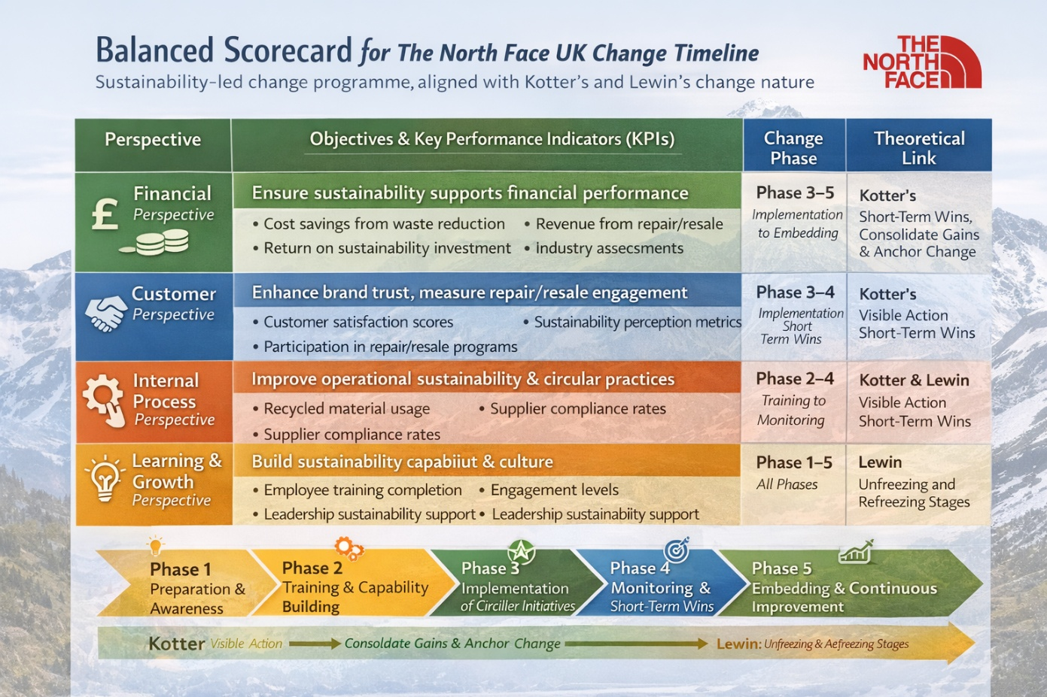

The figure shows how a Balanced Scorecard supports the sustainability-led change programme at The North Face UK by aligning strategic objectives with measurable outcomes across a phased change timeline. From a financial perspective, the scorecard assesses cost efficiencies from waste reduction and revenue generated through repair and resale services, ensuring that sustainability initiatives contribute to long-term value creation rather than short-term cost pressures. This supports Kotter’s stages of consolidating gains and anchoring change by demonstrating tangible business value (Martín-Gómez et al., 2024).
The customer perspective focuses on measuring brand trust, customer satisfaction, and engagement with circular services. These indicators are particularly important during the implementation and monitoring phases, as they provide evidence of progress and help create short-term wins. Communicating these successes reinforces stakeholder commitment and sustains momentum throughout the change process (Usman et al., 2023).
The internal process perspective evaluates operational performance through metrics such as recycled material usage, supplier sustainability compliance, and reductions in carbon emissions. Monitoring these measures supports structured implementation and strengthens accountability as new practices are embedded.
Finally, the learning and growth perspective underpins all stages of change by assessing employee training, engagement levels, and leadership commitment to sustainability. This supports Lewin’s unfreezing and refreezing stages by embedding new skills, behaviours, and values into organisational culture.

5.6.2 Implementation Timeline Gantt Chart
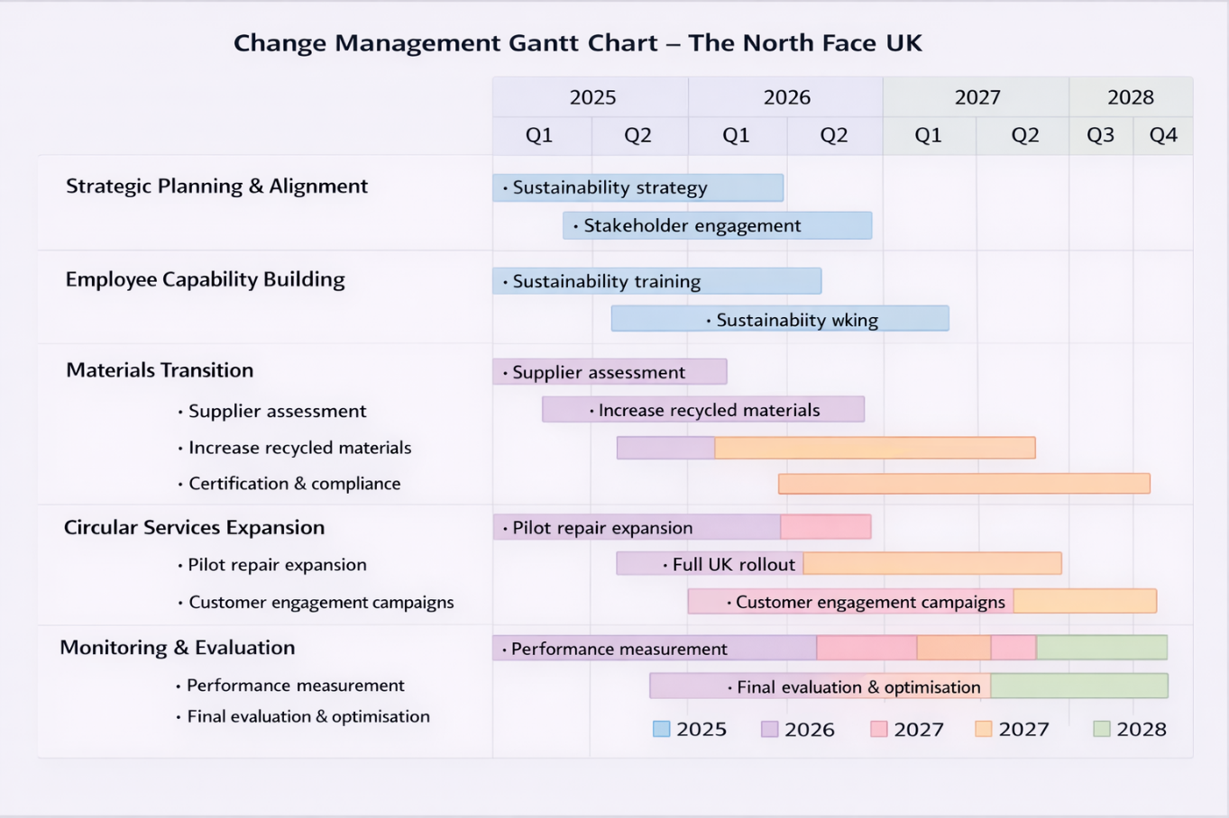
The Gantt chart illustrates a phased change management roadmap supporting The North Face UK’s transition to a circular and low-carbon business model between 2025 and 2028. The programme begins with a sustainability strategy to develop stakeholder alignment, ensuring leadership commitment and organisational readiness. Employee sustainability training is prioritised early to build internal capability and support behavioural change.
The materials transition phase focuses on supplier assessment and increased use of recycled and responsibly sourced materials, directly supporting the objective of achieving 40% low-impact materials by 2027. In parallel, the expansion of repair and reuse programmes and carbon reduction initiatives in stores and logistics is implemented and scaled across UK operations. Continuous monitoring and evaluation run throughout the programme to track progress against sustainability and performance targets. Overall, the timeline demonstrates logical sequencing, integration of objectives, and long-term commitment to measurable environmental and organisational change.

6. Conclusion
This report critically examined the need for strategic change at The North Face UK in response to contemporary business challenges, including digital disruption, evolving consumer expectations, and increasing sustainability regulation. The analysis demonstrated that environmental change directly influences organisational capability, requiring firms to adapt not only their operational processes but also their leadership approaches and organisational culture.
The Evaluation of change management models highlighted that no single framework is sufficient to manage complex strategic change in isolation. Instead, a combined application of Lewin’s, Kotter’s, and ADKAR models provides a more comprehensive understanding of both structural and behavioural aspects of change. Leadership was identified as a critical success factor, with transformational leadership playing a key role in shaping employee behaviour, reducing resistance, and embedding sustainability values. Edgar Schein’s model further reinforced the importance of organisational culture in determining whether change initiatives are sustained over time.
The proposed strategic change management plan offers a structured and realistic pathway for The North Face UK to strengthen its sustainability capabilities, enhance stakeholder engagement, and maintain long-term competitiveness. Ultimately, the success of the change programme will depend on consistent leadership commitment, effective communication, and the integration of sustainability into the organisation’s core cultural assumptions.

7. References
Awad, J.A.R. and Martín-Rojas, R., 2024. Digital transformation influence on organisational resilience through organisational learning and innovation. Journal of Innovation and Entrepreneurship, 13, article 69. Available at: https://innovation-entrepreneurship.springeropen.com/articles/10.1186/s13731-024-00405-4 (Accessed: 18 December 2025).
Balogun, J. and Hope Hailey, V. (2020) Exploring Strategic Change. 4th edn. Harlow: Pearson. Available at: https://www.pearson.com/en-gb/subject-catalog/p/exploring-strategic-change/P200000003536/9781292271781 (Accessed: 13 December 2025).
BRC (2024) ‘Governing principles for a UK textile Extended Producer Responsibility (EPR) scheme’, BRC Sustainability News, 12 February. Available at: https://brc.org.uk/news-and-events/news/sustainability/2024/brcs-governing-principles-for-a-uk-textile-epr/ (Accessed: 27 October 2025).
Britannica, 2025. Porter’s Five Forces. Available at: https://www.britannica.com/money/porters-five-forces-explained (Accessed: 17 December 2025).
Burnes, B. (2023) Managing Change. 8th edn. Harlow: Pearson. Available at: https://www.pearson.com/en-gb/subject-catalog/p/managing-change/P200000003851/9781292156088 (Accessed: 16 December 2025).
CIPD (2024) Employee communication: building an effective internal communication strategy. Available at: https://www.cipd.org/en/knowledge/factsheets/employee-communication/ (Accessed: 16 December 2025).
Fern Fort University, 2025. The North Face SWOT Analysis. Available at: https://fernfortuniversity.com/essay/swot1/north-face-466 (Accessed: 17 December 2025).
Gborogbosi, L.G. & Amah, E. (2025) The Effectiveness of Change Management Models in Different Industries. South Asian Research Journal of Business Management, 7(3), pp.333–343. Available at: https://sarpublication.com/media/articles/SARJBM_73_333-343.pdf (Accessed: 18 December 2025).
Heliyon, 2024. Digital transformation as the driving force for sustainable business performance: A moderated mediation model. Heliyon, 10(8), e29509. Available at: https://www.sciencedirect.com/science/article/pii/S2405844024055403 (Accessed: 18 December 2025).
IIMB Management Review (2023) Leadership and strategic change in dynamic environments.
Available at: https://www.sciencedirect.com/journal/iimb-management-review (Accessed: 13 December 2025).
Kotter International (2023) 8-Step Process for Leading Change. Available at: https://www.kotterinc.com/methodology/8-steps/ (Accessed: 27 October 2025).
Latterly, 2025. The North Face SWOT Analysis. Available at: https://www.latterly.org/the-north-face-swot-analysis/ (Accessed: 17 December 2025).
Martín-Gómez, A.M., Pineda-Ganfornina, M., Ávila-Gutiérrez, M.J., Agote-Garrido, A. and Lama-Ruiz, J.R. (2024) Balanced Scorecard for Circular Economy: A Methodology for Sustainable Organizational Transformation, Sustainability, 16(4), 1464. Available at: https://doi.org/10.3390/su16041464 (Accessed: 16 December 2025).
McKinsey & Company, 2023. The net-zero transition: What it would cost, what it could bring. Available at: https://www.mckinsey.com/capabilities/sustainability/our-insights/the-net-zero-transition-what-it-would-cost-what-it-could-bring (Accessed: 13 December 2025).
Nottingham Business School (2025) Responsible leadership, organisational culture and sustainable change. Available at: https://www.nottingham.ac.uk/business (Accessed: 13 December 2025).
OECD, 2023. Stakeholder engagement for sustainable development. Available at: https://www.oecd.org/dac/stakeholder-engagement.htm (Accessed: 18 December 2025).
Prosci (2023) What is the ADKAR Model?. Available at: https://www.prosci.com/methodology/adkar (Accessed: 16 December 2025).
Spyridis, Y., Argyriou, V., Sarigiannidis, A., Radoglou, P. and Sarigiannidis, P. (2024) ‘Autonomous AI-enabled industrial sorting pipeline for advanced textile recycling’, arXiv, 17 May. Available at: https://arxiv.org/abs/2405.10696 (Accessed: 27 October 2025).
Textile Value Chain (2025) ‘Circle-8 & NewRetex use AI to transform textile recycling in UK’, Textile Value Chain, 3 May. Available at: https://textilevaluechain.in/sustainability-waste-management-recycling-upcycling/circle-8-newretex-use-ai-to-transform-textile-recycling-in-uk (Accessed: 27 October 2025).
ToolsHero, 2025. Schein’s Model of Organizational Culture. Available at: https://www.toolshero.com/leadership/organizational-culture-model-schein/ (Accessed: 13 December 2025).
Transformational leadership and organisational change (n.d.) International Journal of Management. Available at: https://www.ijmanagement.co.uk/article/transformational-leadership-and-organizational-change-51/ (Accessed: 18 December 2025)
United Nations Environment Programme (2023) Sustainability and circularity in the fashion industry. Available at: https://www.unep.org/resources/report/sustainability-and-circularity-fashion-industry (Accessed: 13 December 2025).
Usman, A., Mediaty, N.A. Liwan, N. and Nindita, O. (2023) ‘A Systematic Literature Review: the Role of Balanced Scorecard in Performance Measurement for Corporate Sustainability’, Journal of Finance and Business Digital, 2(4), pp. 463–484. Available at: https://doi.org/10.55927/jfbd.v2i4.7253 (Accessed: 16 December 2025).
White, K., Habib, R. and Hardisty, D.J. (2019) ‘How to SHIFT Consumer Behaviors to Be More Sustainable: A Literature Review and Guiding Framework’, Journal of Marketing, 83(3), pp. 22–49.

