Business Plan
mANAGING ENTERPRISE (BMSW4011)
Piotr CZUBINSKI (2237463)

Contents
Executive Summary 2
Business Plan for a Private Investigation Office 3
2.1 REPORT REMIT 3
2.2 THE COMPANY 4
Company Name: Shadow Trace Investigations 4
2.3 MISSION STATEMENT 5
Unique Selling Points 5
2.4 RESOURCES 6
2.5 HUMAN RESOURCES 7
2.6 MARKET RESEARCH 7
SWOT Analysis 8
2.7 MARKETING ACTIVITY 8
REFLECTIVE REVIEW 10
REFERENCES. 12

Executive Summary
Shadow Trace Investigations is a private detective company that specialises in digital forensics, investigations of cheating spouses, and background checks. This report highlights a promising business opportunity that meets the rising demand for discreet and professional investigative services in the Swansea region.
Shadow Trace Investigations was started because of the founder's own experience of being betrayed and the fact that it was hard to find easy access to research help. Because of this personal and practical journey, a company was made to help other people who are going through similar things. The company's goal is to "provide honest, private, and professional investigative services to people seeking truth and peace of mind, using cutting-edge technology that is also reasonably priced and expert methods to find important evidence. Our market research shows that there aren't many well-known and visible private investigation companies in the Swansea area, especially online. This is despite the fact that most people are aware of these services. This gap is a big opportunity for the market to grow. As the number of cheating relationships and worries about personal safety rise, Shadow Trace Investigations will react with understanding, knowledge, and low-cost solutions. To build trust and get new customers, the business will use SEO, social media, and relationships with other local businesses.

Business Plan for a Private Investigation Office

2.1 REPORT REMIT

This report aims to make a business plan for a private detective company that focuses on digital forensics and cases of cheating on a spouse. Due to a lack of available support, the founder of this business had to gather proof on their own after suspecting cheating in their marriage. This is what inspired them to start the business. After a lot of study, tracking device purchases, and investigations, solid proof was found that proved the suspicions. This company knows that many others are going through the same problems without the right help, so they want to help people by offering professional, moral, and private investigation services. The results of our private survey in the Swansea area suggest that while individuals understand what a private investigator is, they are unaware of and have never heard of such a company in the region. The reason for this is that these types of companies are not visible online on social media, which is a significant gap that we can leverage to build our business.

2.2 THE COMPANY

Company Name: Shadow Trace Investigations

Shadow Trace Investigations is a private detective company focusing on digital investigations, cheating spouse cases, and background checks. The company's goal is to help people find the truth in a skilled and private way, based on the founder's own experience. At the time of his problems in marriage, the founder of the company did not even consider hiring a company because such companies do not advertise themselves, so people have no idea that they are available, that they can help how quickly, and that it is not that expensive, he noticed the lack of advertising of such companies, especially in social media. The facts speak for themselves: 75% of men and 68% of women who were in a partnership said they had cheated on their partner at some point (BBC,2019). This market is huge. The most important thing is to show ourselves to the customer so that he can reach us (Wuisan and Handra, 2023 ).
Concerns about personal and business security have led to a lot of growth in the private detective business in the UK (Statista, 2025). Shadow Trace Investigations uses cutting-edge technology and investigation methods to gather proof that is both reliable and legal. The company will be able to offer agents lower prices because of improvements in Chinese manufacturing that have recently made surveillance devices cheaper (Mordor Intelligence,2025). This will allow the company to offer competitive prices to its clients.

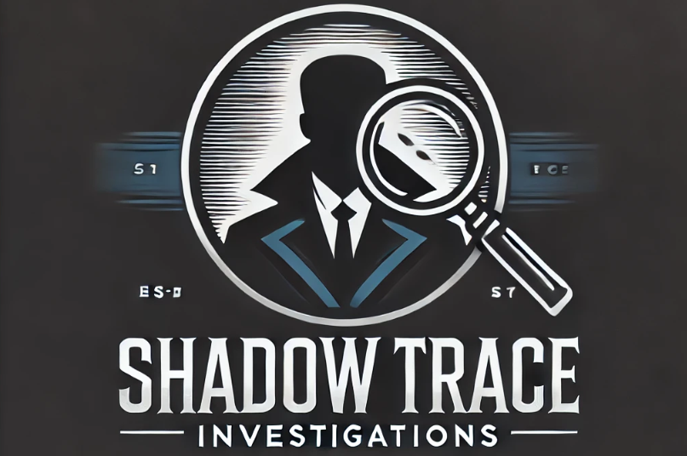

2.3 MISSION STATEMENT

A mission statement tells people what the purpose and direction of a business are, which helps them make decisions and run their business (CFI,2025)
"To provide ethical, confidential, and professional investigative services to individuals seeking truth and peace of mind, utilising advanced yet affordable technology and expert methodologies to uncover critical evidence."

Unique Selling Points
Founded by someone who knows how hard it is to deal with the mental effects of cheating, so they can relate to their clients. The company will be constantly present online on social media so that when customers have problems, their first thought will be to contact our company. The company specialises in using digital forensics and current surveillance methods to investigate cases of cheating. The services are professional and private, and all customers' information is kept secret. The company also gives different pricing packages to fit the budgets of its clients. These packages are now more affordable because technology costs have decreased. Being clear about prices helps customers believe you and makes it easier for them to make choices (Mohammadi et al., 2024).

2.4 RESOURCES

For private meetings with clients, the business needs an office space in Swansea that is out of sight and out of mind. Due to the nature of investigative work, the place is less important than being able to work quietly in different places. Surveillance tools like cameras and invigilation tools are essential resources that have become much cheaper thanks to progress in technology. The price of video gear has dropped by 40% in the last five years (Elvy,2024). This means that small businesses can now afford to buy this kind of technology. GPS trackers and audio recording devices are easier to get and cheaper, which has cut costs by a large amount (SourcifyChina,2023). The company will use these high-quality tools that do not cost a lot to speed up investigations. For covert activities, two unmarked vehicles will be used. As monitoring technology gets cheaper, the company can offer better prices while still upholding high standards for investigations. Online searches and legal referrals are the main ways people find private investigators. To make them more visible and trustworthy, a lot of money will be spent on search engine marketing, social media activity, and making sure their website is well-optimized.

2.5 HUMAN RESOURCES

2.6 MARKET RESEARCH

The need for private detective services has grown because more people think their partners are cheating on them, especially online (Leigh, 2025). According to recent data, cheating is very common in the UK. A World Population Review study from 2025 found that about 36% of people in the UK have admitted to cheating on their partners. Online cheating is becoming more common because more people are using relationship apps and social media (Hassan, 2024). This has increased the need for investigative services. Technology improvements that have made surveillance easier and more efficient have also helped the private investigation business. During the Swansea marketing research, we discovered three companies that have a website. After checking them out, it was discovered that they have poor online visibility and their websites are very simple and basic, lacking to attract the customer's eye and build trust. Plimsoll (2025) says that the private investigation business in the UK will grow each year. This is because more people are learning about the services that are offered, and research technology is getting better. This makes me think that we could use tiered price models to charge different amounts for different types of cases.

SWOT Analysis
Strengths | Weaknesses | Opportunities | Threats
Founded by someone with firsthand experience | Limited financial resources initially | Growing demand for private investigations | Competition from well-known agencies
Access to affordable surveillance technology | Small initial team size | Small online visibility of our competition | Legal challenges concerning data privacy
Empathetic client approach | Reliance on third-party specialists | Increased need for cyber and digital forensics | Regulations on monitoring are changing quickly.

2.7 MARKETING ACTIVITY
To contact possible customers in a discreet and useful manner and so create a strong market presence, Shadow Trace Investigations will concentrate on social media advertising on sites like Facebook, Instagram, and LinkedIn. According to a 2024 Statista analysis, 68% of UK citizens daily access social media. This makes advertising a quite effective approach. Content marketing will also be used by the company through blog and article writing on trust issues, cheating, and the need of background checks. This approach will enable the public to become more knowledgeable about the topic and establish Swansea Investigations as an official authority on it. Making contacts with surrounding therapists, solicitors and support organisations will increase your profile and help you attract more business.

REFLECTIVE REVIEW
For Shadow Trace Investigations, compiling this business report was a brand-new challenge for me; honestly, it felt a little challenging at times. This was the first time I had written anything approaching a business plan, so as a first-year business student, I often wondered if I was writing correctly. Whether I had covered what I was meant to made me anxious. Still, I'm glad I finished it as I know that's only the start of a protracted educational road. As I worked on the report, I learnt a lot. Until I began drafting my business plan, I had no idea how much goes into one. It's not only about having a brilliant idea you also must consider the objective of the business, who your target customers are, what differentiates your organisation, and how to support all of it with actual research. For me, the component of market research was particularly helpful. The fact that so many Swansea residents had not even heard of local private investigators intrigued me and allowed me to appreciate the need this company could provide. The writing style was one area in which I first found great difficulty. I usually write how I speak; academic writing does not come easily to me. Changing to a more formal tone then required some work. Still, I believe I improved by studying models and began to recognise an understandable structure. Divining it into pieces like the SWOT analysis and marketing plan enabled me to keep concentrated and avoid losing myself in my own ideas. I also came to see that, in terms of entrepreneurial thinking, I do have certain advantages. My biggest ability is most likely creativity; I like to consider fresh ideas and picture how they may be implemented in actual life. I believe this company concept has a stronger foundation as it came from a real, emotional situation. I also found I'm good at spotting openings or gaps, such as the lack of online visibility for this kind of company in the local area. Having said that, I most certainly have a few things I should work on. With this report, time management became a major challenge. I left much too many pieces till the very last minute, which caused great anxiety. I'm going to attempt to divide large jobs into smaller ones and give myself minor deadlines, as I know I can do better if I start ahead.
The process has taught me a lot, even if I'm not sure whether my report is "good enough." It helped me to see what the university expects and changed my perspective to more that of a businessman. It thrills me to keep becoming better.

REFERENCES.

BBC. (2019) Why we need to talk about cheating.
https://www.bbc.co.uk/future/article/20190625-why-we-need-to-talk-about-cheating

CFI. (2025). Mission Statement. https://corporatefinanceinstitute.com/resources/management/mission-statement/

Elvy, S.A., (2024). The Vehicle Monitoring and Collection Technology Era. Iowa L. Rev., 110, p.43

Hassan, N. (2024). Infidelity in the Digital Age: The Rise of Online Affairs and Cyber-Infidelity
https://insights.lifemanagementsciencelabs.com/online-affairs-and-cyber-infidelity/?

Infante, A. and Mardikaningsih, R., (2022). The Potential of Social Media as a Means of Online Business Promotion. Journal of Social Science Studies.
Mohammadi, H., Mohammadalipour, N., et al. (2024).
A Model for Implementing New FinTechs in the Banking Industry.
Mordor Intelligence. (2025). China Video Surveillance Market Size & Share Analysis - Growth Trends & Forecasts (2025 - 2030).
Source: https://www.mordorintelligence.com/industry-reports/china-video-surveillance-market

Leigh Ebony. (2025). I'm having an electronic affair, and I just can't stop. https://www.dailytelegraph.com.au/lifestyle/im-having-an-electronic-affair-and-i-just-cant-stop/news-story/96c36e3b0974bb30e4f6e5424c1f6ead

Plimsoll. (2025). UK Private Investigation and Intelligence Services Industry Overview. https://www.plimsoll.co.uk/market-reports/private-investigation-and-intelligence-services?

Rawtani, D. and Hussain, C.M., (2023). Modern forensic tools and devices: Trends in criminal investigation. John Wiley & Sons.

Sourcing from China (2023). Analysis of Manufacturing Expenses for GPS Tracker cost.
https://www.sourcifychina.com/gps-tracker-cost/

Statista. (2024). Social media usage in the United Kingdom (UK) - statistics & facts. https://www.statista.com/topics/3236/social-media-usage-in-the-uk/#topicOverview

Statista. (2025) Security services industry in the United Kingdom - statistics & facts. https://www.statista.com/topics/10034/security-services-industry-in-the-uk/

World Population Review. (2025). Infidelity Rates by Country 2025.
https://worldpopulationreview.com/country-rankings/infidelity-rates-by-country?

Wuisan, D.S. and Handra, T., (2023). Maximizing online marketing strategy with digital advertising. Startupreneur Business Digital (SABDA Journal)

