
Faculty of Business and Management
/Cyfadran Busnes a Rheolaeth
Swansea Business School
/Ysgol Fusnes Abertawe

An investigation into the management of male mental health in police officers

Bachelor of Science: Policing

Jasmin Amy Pugh - 1800635


Declaration
This work has not previously been accepted in substance for any degree and is not being concurrently submitted in candiature for any degree
Signed:
Date: 07/05/2021

Statement 1
This dissertation is being submitted in partial fulfillment of the requirements for the degree of BA

Signed:

Statement 2
This dissertation is the result of my own independent work/investigation except where otherwise stated. Other sources are acknowledged in the reference section
Signed:
Statement 3

I hereby give my consent for my dissertation, if accepted, to be available for photocopying and for interlibrary loan, and for the title and summary to be made available to outside organisations.
Signed:

Statement 4
I hereby give my consent for my dissertation, if accepted, to be available on the university’s IT system to those who have consent to use the system
Signed:

Table of Contents
- Title……………………………………………………………………………………………………………. Page 1
- Declaration……………………………………………………………………………..……….……….Page 2-3
- Impact of COVID 19……………………………………………….……………………………..………Page 6
- Introduction………………………………………………………….…………..………………...……Page 6-7
- Literature Review………………………………………………………………………………………Page 7-10
- What are the causes of mental health problems…………………...……......…Page 7-8
- What are the different types of mental health problems?………………..….Page 8-9
- Male mental health statistics…………………………………………………………….…..Page 9-10
- Treatments for mental health problems……………………………………….……….Page 10
- Mental health in police officers………………………………………………………….Page 10-12
- Types of strategies are in place to support police officer mental health..Page 12
- Charities and support groups in place for male mental health……….……….Page 12-17
- Movember…………………………………………………………………………………………Page 12-14
- MenHealth- “Time to listen”………………………………………………………………Page 14-15
- MIND…………………………………………………………………………………………………Page 15-16
- Police Care UK………………………………………………………………………..…………Page 16-17
- Methodology………………………………………………………………………………………….Page 18-23
- Philosophy…………………………………………………………………………….…………Page 18-19
- Inductive approach…………………………………………………………..…….……….Page 19
- Strategy……………………………………………….……………………….………………...Page 19
- Choice …………………………………………………………………………….……………...Page 19-20
- Time horizon……………………………………………………………………………………Page 20
- Limitations……………………………………………………………………………………….Page 20
- Design and ethical considerations…………………………………………………..Page 20-21
- Purpose of a questionnaire for data collection……………………………….Page 21-22
- Qualitative research………………………………………………………………………..Page 22
- Quantitative research……………………………………………………………………….Page 22-23
- Copy of questionnaire used for data collection……………………………………….Page 24-26
- Data analysis……………………………………………………………………………………………Page 27-38
- Recommendations……………………………….…………………………………………………Page 38
- Limitations…………………………………………………………………..…………… ………….Page 38-39
- Conclusion………………………………………………….………………………………………..Page 39-41
- References…………………………………………………………………………………………...Page 42-48

Impact of COVID-19
In light of the continuing impact of the global pandemic, it is important to include a statement at the start of my dissertation which outlines the effects that COVID-19 has had on the research that I have undertaken towards your undergraduate degree.
The University of Wales Trinity Saint David recognises that the COVID-19 pandemic, and consequent closures of our campus (18th March 2020) and national and international lockdowns, has directly or indirectly impacted the work of many of our undergraduate researchers. Although the campus had periods of re-opening in 2020 and 2021, some research will have been disrupted and some personal circumstances difficult to manage. Teaching was arranged via suitable meeting software and documents shared electronically. All research data collection was designed to utilise digital data collection.
The inclusion of this statement is to facilitate the reader’s awareness, both now and in the future, that the pandemic may have had an effect on the scope, direction and presentation of the research.
The academic standards and quality threshold for the award remains unchanged. I wish to reassure readers that this statement is not evidencing a lack of original research or quality.
Introduction
This research project aims to investigate how male police officers manage their mental health.
Firstly, a literature review will discuss previous research that has already been done on the topic of male mental health and comparisons will be made throughout the investigation, referring back to the literature review. The approach this investigation will use is an inductive approach, and therefore an inductive approach will be discussed, talking about the strategy, choice of questions, the time horizon, any limitations and any design and ethical considerations that will need to be taken into consideration. The method of research will then be discussed, discussing both qualitative and quantitative research methods. Next, a questionnaire will be created for the participants, who are male police officers, to complete in their own time.
Next, an analysis of this data received from the questionnaire will be created, using different charts to visually show the results, as well as discussing the results and comparing them to previous research that has been done.
Finally, a conclusion will bring together the project at the end, summarising the information that has been gathered and discussing whether it is similar or different to research that has previously been done.
Literature Review
This chapter of the dissertation will look at previous research that has already been done on the topic of male mental health. It will discuss aspects of mental health such as the causes of mental health problems, different types of mental health problems, male mental health statistics and treatments for mental health problems. It will then go on to discuss mental health in police officers, and any strategies in place to support their mental health. Finally, this chapter will discuss mental health charities and campaigns in place to support anyone with mental health problems.
What are the causes of mental health problems?
Life style factors such as diet, drugs, alcohol, work and lack of sleep can all have an effect on an individual’s mental health, however there are many other contributing factors that can also have an effect on an individual’s mental health, these can include;
- Drug and alcohol misuse
- Social isolation or loneliness
- Social disadvantage, poverty or debt
- Severe or long-term stress
- Being a long-term carer for someone
- Having a long-term physical health condition
- Childhood abuse, trauma, or neglect
- Experiencing discrimination and stigma
- Bereavement (losing someone close to you)
- Unemployment, losing your job or working in a stressful job e.g., police
- Homelessness or poor housing
- Domestic violence, bullying or other abuse as an adult
- Significant trauma as an adult, such as military combat, being involved in a serious incident in which you feared for your life, or being the victim of a violent crime
- Physical causes – for example, a head injury or a neurological condition such as epilepsy can have an impact on your behaviour and mood (Mind, 2021).
What are the different types of mental health problems?
- Anxiety
- Depression
- Post-traumatic stress disorder (PTSD)
- Bipolar Disorder
- Eating Disorders
- Obsessive compulsive disorder (OCD)
- Personality Disorders
- Psychosis
- Schizoaffective Disorder
- Schizophrenia
- Self-harm
- Suicidal Feelings
(Time to change, 2021)

Male mental health statistics
Although mental health problems can affect anyone and does not discriminate, statistics show that men are more likely to suffer with mental health problems, this is partially due to the stigma associated with male mental health.
According to statistics, just over 3 out of 4 suicide deaths (76%) are males and suicide is the biggest cause of death for men under 35 (ONS, 2021).
Furthermore, 87% of rough sleepers are men, which increases the likelihood of developing mental health problems (Crisis, 2021).
Men are also three times more likely to become dependent on alcohol than women, this would impact their life hugely and increases the likelihood of developing mental health problems (ONS, 2021).
On average, 191,000 men a year report that their stress, depression or anxiety is caused by their job, or that their job worsens their mental health (HSE, 2021).
Treatments for mental health problems
Treatments for mental health problems can be categorized into two categories; somatic and psychotherapeutic. Somatic treatments include medications, electroconvulsive therapy and other brain-stimulating therapies e.g., transcranial magnetic stimulation and vagus nerve stimulation.
Psychotherapeutic treatments include psychotherapy (individual, group, or family and marital), behaviour therapy techniques (such as relaxation training or exposure therapy), and hypnotherapy (First M.B, 2020).
There are also numerous natural everyday remedies that are proven to boost your mood, these can include; regular exercise, balanced diet, 8 or more hours sleep per night, meditation, good hygiene, clean environment to live in and talking about your feelings (MIND, 2021).
Mental health in police officers
Police officers are assumed to be at a higher risk of mental health problems, simply due to the nature of their work (Velden P.G et al). Police officer’s mental health is said to be a growing concern as officers are often exposed to many sights and crimes that the average person would not see usually. Officers are under a huge amount of pressure in their job role, increasing their likelihood to develop mental health problems (Edwards and Kotera, 2020). Research has identified the job role of policing as a stressful and dangerous occupation. The consequences of organisational stressors and the high-risk nature of frontline duty means that officers are at a higher risk of developing psychological illnesses e.g., post-traumatic stress disorder (PTSD), depression, anxiety and other stress-related conditions. Increasing exposure to numerous potentially traumatic situations is an unavoidable part of operational policing (Edwards and Kotera, 2020).
In 2020, a survey was taken of 434 police officers and it found that 12% had a lifetime mental health diagnosis and 26% reported current symptoms of mental illness. Out of the 434 officers, 17% had required mental health care services in the past 12 months. These findings indicated that routine mental health screening may be required in law enforcement agencies to thoroughly identify and refer officers to mental health care services (Jetelina et al, 2020). Furthermore, 42% of these respondents stated that they felt poorly or very poorly supported by the police service (Jetelina et al, 2020).
If left untreated, mental illnesses have the ability to unpleasantly affect workplace performance and future career prospects and therefore it is critical that the stigma associated with male mental health is broken, allowing males to speak freely about their feelings without feeling judged or scared to do so (Edwards and Kotera, 2020). The implications of stress-related illnesses include; reduce productivity, death and injury, premature retirement and sick leave (Edwards and Kotera, 2020).
As policing is often seen as a ‘tough’ or ‘strong’ role, research suggests that emergency services workers are less likely to seek help for their mental health as they want to fit the stereotype associated with their job role (Edwards and Kotera, 2020). Officers may resist talking about their mental ill health in fear of the stigma and negative reactions from their colleagues. Furthermore, they fear internal stigma in their job, this is where the police stigmatise each other because of mental health problems, this plays a huge role in the way a person responds to psychological distress and it has been noted as one of the most common and main reasons as to why officers avoid seeking help (Edwards and Kotera, 2020).
Given the vital role of policing roles, it is critical for people to understand the psychological strain and pressure this puts on police officers. A method in which to ease the psychological symptoms that occur from their occupation is to increase mental health awareness and educate at an organisational level. The experiences that officer’s face at any level, whether it be at an organisational level or operational level, plays a huge factor and role in determining their mental well-being (Edwards and Kotera, 2020).

Types of strategies in place to support police officer mental health
In September 2017, a nine-point stress plan template by the Police Federation in order to help forces better prioritise on officer wellbeing (Police Federation, 2021). It was released as a national template for all forces, to work in conjunction with Oscar Kilo and the Blue Light Wellbeing Framework, sorely focusing on improvements on officer welfare. This scheme was launched as it was stated that there was not enough being done to support the mental health of police officers, it is set out to encourage forces to give staff an awareness of the Health and Safety Executives, Stress Management Standards and their main causes of stress.
The nine-point stress plan also pledges an openness campaign, in attempt to tackle the stigma of stress, and to introduce effective measures to share sickness data. This plan came after figures released in February 2017, stated that 80 per cent of police officers report feelings of stress, anxiety, low mood or other mental health problems (Pritchard and Lewis, 2017).
Charities and support groups in place for male mental health
Movember
A very well-known and popular male mental health and suicide charity is ‘Movember’, who state that globally, on average a male dies every minute of every day from suicide. Movember is funded through donations and fundraising events, or through their partners Men’s Health and is also known for supporting men with prostate or testicular cancer. This is a charity that looks at mental health through a male lens, sorely focusing on prevention, early intervention and health promotion (Movember, 2021).
They have 6 steps in place in attempt to win the fight for male mental health;
- Education- Movember helps men and boys to stay mentally healthy, build strong social connections and take action early times get tough.
- Conversations that matter- Movember helps to get males talking and works towards males being comfortable having conversations about their mental health or things that may worry them
- Services that work for men- Movember have acknowledged the needs of men, and they are working to ensure that services are designed with their needs in mind.
- Bright minds, brought together- Movember are funding advanced projects and when they know that something works, their share their information globally in order to raise awareness to the rest of the world and share their knowledge.
- Community first- Movember ensure that there is access to support for all men in their own communities and making sure their comfortable with this, they have acknowledged there is no one-size-fits-all solution as everyone deals with problems differently.
- Advocating for all men- The Movember charity is forcing governments to understand and acknowledge the issues that men are facing, demanding action for them (Movember, 2021).
The main aim of this charity is to reduce the rate of male suicide by 25%. They state that they will get there by uniting experts in this field, funding bold new approaches and embracing fresh perspectives (Movember, 2021).
MenHealth- “Time to listen”
Another support strategy in place is the Man’s health “Time to listen” scheme. This funded through donations and fundraising and is created by ManHealth who have built a network of male peer support groups across the UK, in an attempt to help men to manage and prevent depression or other mental health conditions (ManHealth, 2021).
All of the MenHealth groups are facilitated by men with a lived experience of a mental health condition. This is an effective method of running this scheme as men may be more comfortable opening up to men who have previously struggled mentally, as they may feel they will be more understanding. These men who run this scheme are also living proof that things do get easier, and as they can speak from experience, males who need support, may feel more at ease when seeking help or support. ManHealth also provides a variety of training courses on health equalities affecting men, this educates them as well as supports them. The main aim of this scheme is to raise awareness about male mental health (ManHealth,2021).
MenHealth gave advice on lifestyle changes that may improve your mental health, these include;
- Exercise- This is an extremely powerful tool in fighting depression and one of the most important aspects when recovering with mental illness.
- Support Group- Men often isolate themselves when they are depressed or struggling, as they do not want to feel like a burden to others, however, these charities are in place to break down the male mental health stigma and encourage them to talk.
- Sleep- Sleep has a huge impact on your mood, and if you do not get enough sleep then depression symptoms can be significantly worse.
- Stress Reduction- Too much stress aggravates depression and puts you at risk for future depression.
- Sunlight- Sunlight can help improve your mood by boosting serotonin levels
- Eating habits- What you can eat can have a significant impact on your mood and not eating enough can result in lack of energy, also leading to inactivity and mental health problems (MenHealth, 2021).
MIND
Furthermore, a charity for mental health is MIND. MIND is made up of local mind support groups in an attempt to provide help and support directly to those who need it most. Across England and Wales there are around 125 local mind groups that offer specialised support and care based on the needs of the communities that they support.
MIND charity relies on funding from the public via merchandise and fundraising events (MIND, 2021). Similar to MenHealth, the charity MIND, state that there are 5 ways to wellbeing, these include;
- Connect- There is evidence that indicates that feeling close to, and valued by, other people is a fundamental human need and can boost your mood overall. Social relationships are crucial for promoting wellbeing and for acting as a cushion against mental health problems for any ages.
- Be active- Regularly taking physical exercise and activity is associated with lower rates of depression and anxiety and is vital for promoting well-being.
- Take notice- Reminding yourself to ‘take notice’ is said to strengthen and broaden awareness and promotes your well-being as it allows you so ‘embrace the moment’ and can boost motivation.
- Learn- Continued learning through life can boost your self esteem and motivation to try new things and go further, it also encourages social interaction and a more active life.
- Give- Participating in community and social life can make you feel rewarded for your efforts and therefore can boost your mood. Those who show a better and larger interest in helping others are more likely to rate themselves as happy as it can give them a sense of achievement (Mind, 2021).
Police Care UK
Additionally, in place to help police officers and staff is a charity called Police Care UK. This is a charity funded purely by donations and fundraising and they receive no money from the government. Police Care UK is in place to support police officers and staff, volunteers, and their families all who have suffered any physical or psychological harm as a result of policing (Police Care UK, 2019).
Police Care UK aims to;
- Ensure awareness is raised about the harm experienced in policing roles- They improve awareness as they help develop appropriate services to support those who need them, and they reduce the shame or embarrassment of physical or psychological injuries that police officers may feel, ensuring they can get the care they need, with dignity.
- Enable police and families to recover and rebuild their lives- They do this by providing a professional and confidential programme or plan of practical, emotional, and financial support, helping people to effectively recover and rebuild their lives.
- Engage with the police service to do all it can to reduce or prevent harm- Their role is to complement and add to this care, and to assist with identifying gaps through targeted services, projects and programmes. (Police Care UK, 2019).
Police Care UK has 5 values that makes them the charity that they are, these include;
- Caring- They have a caring approach as it is an approach that is built around understanding and respecting the difficult environment in which the police operate in. They demonstrate understanding, empathy and respect in everything they do.
- Independent- They manage to effectively support the police service whilst being outside of it.
- Open- They share their expertise, experience, and resources with others because they understand that collaboration is the only way they can help improve the lives of the individuals they are supporting.
- Responsible- They use their resources intelligently to provide the best support to individuals both now and in the future while upholding the maximum ethical and professional standards they possibly can.
- Innovative- They are continuously looking for new ways to improve and better their working practices, support programmes, and welfare options to support individuals to their highest ability (Police Care UK, 2019).

Methodology
This chapter aims to discuss a suitable research approach for this project and aims to use the research onion to structure and guide the research that will be written (Rafael, 2016).
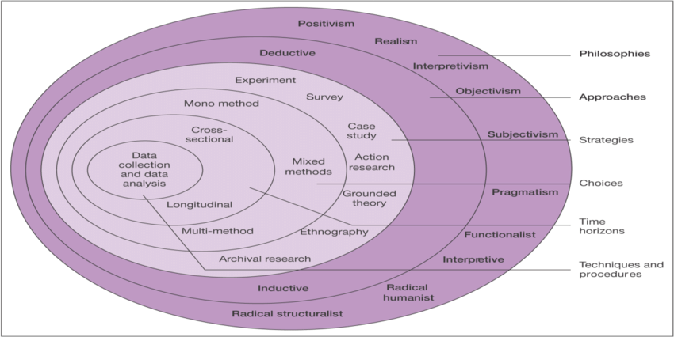
The research onion was created by Saunders and Lewis and its approach is to go from the inside of the structure, outwards (Rafael, 2016). The research onion outlines each that which a researcher must go through when developing an effective methodology (Crossley and Jansen, 2021).
Philosophy
Philosophy is a method of thinking about specific subjects such as ethics, thought, existence, time, meaning and value. That 'way of thinking' involved in philosophy is the 4 Rs: responsiveness, reflection, reason and re-evaluation (Sellars, 2021). The aim of philosophy is to create a more in depth understanding on the chosen subject. The hope is that by doing philosophy, individuals will learn to think better and to act more wisely, therefore helping to improve the quality of the way they live (Sellars, 2021). This research takes the metaphysics view which is a view to research that studies reality and the physical world (Pujanes, 2020). This project will also take a epistemology view of philosophy, which is also known as the theory of knowledge, meaning it focuses into the definition, scope, and parameters of knowledge based on the subject area (Pujanes, 2020).
Inductive Approach
An inductive approach will be taken when observing the data gathered in order to interpret and understand the theories and patterns that occur when analysing the data collected (Gabriel, 2013). Additionally, an inductive approach is a beneficial approach to take as it uses research questions to narrow the scope of study (Gabriel, 2013). An inductive approach is often associated with qualitative research, however there are no set instructions and an inductive approach can be used for qualitative and quantitative research (Azungah, 2018).
Strategy
A questionnaire was created on google forms and a link was then shared in order to get the questionnaire to the target audience. To check the link works correctly, it will be tested by sending it over to a sample responder for them to fill in and confirm that it all works how it should. Once filled in, google forms responses section will be checked to confirm that the sample responders’ answers have been received. Once it is confirmed that the questionnaire works as it should, the link will then be shared through social media platforms e.g., Facebook and Instagram, in order to reach its target audience. Social Media is an effective platform to ensure that the target audience of male police officers receive the questionnaire as it can be instantly shared, and reshared by friends and family. It is also beneficial as it is easily accessible and will reach people who it may not have reached if it was to be handed out to only known individuals (Dukart, 2018).
Choice
Data will be gathered through multimethod research, meaning it will not be collected by only qualitative or quantitative research, it will be gathered through a combination of both of these research methods (Rahman, 2015).
Time Horizon
Cross sectional study is the most appropriate method of study for this project as it is an observational study. Cross sectional study allows questions to be compared and contrasted, finding many different variables at the same time (Sedgwick, 2014). Cross sectional study is done over a short period of time, which is why it is more of suitable study than longitudinal as longitudinal study is performed over a longer period of time, sometimes even over years which is not possible for the timeframe for this project (Caruana et al, 2015).
Limitations
Due to the current COVID-19 pandemic, data collection methods are very limited to online methods of communication. With the current 2-meter social distancing rule, it is not appropriate to approach people in person and therefore can only really communicate with people via social media (UK Gov, 2020). It is also not appropriate to organise socially distanced interviews, as this would require travelling and all non-essential travel is currently banned (UK Gov, 2020).
Due to the questionnaire being online, participants may feel less inclined to open up than they would if they were in an interview setting and as they are not in a comfortable face-to-face setting, they may not expand on their answers as much as if they were face to face (Debois, 2019).
Designs and Ethical Considerations
Many considerations were looked at when developing a questionnaire to use to gather data for this project. As mental health is a significantly sensitive subject, caution was taken when creating questions to ask the participants. Consideration was taking when developing questions to ensure that it was a combination of open and closed questions, making the participant feel at ease and not under pressure to answer the questions in a specific way (Graham et al, 2007). The choice of words has to be considered in order to not cause offence to anyone, allowing them to feel comfortable when filling in the questionnaire (Graham et al, 2007).
Purpose of a questionnaire for data collection
For the purposes of this research, a questionnaire will be used to gather information based on how male police officers manage their mental health. A Questionnaire has been produced as a research method as they are a simple yet effective way to gather information anonymously, and given the current circumstances with the global pandemic and social distancing, interviews and face to face meetings would be extremely difficult to arrange (Debois, 2019).
The questionnaire produced is made up of a combination of qualitative and quantitative questions in order to get a variety of answers, making it easier to draw conclusions at the final stage and to get as much information and detail from the participants as possible (Guest, 2019). The questions asked in the questionnaire focus solely on the participants perceptions, opinions, attitudes, and experiences of mental health and mental health within their policing role. The questionnaire uses a combination of qualitative and quantitative questions as they both are research methods that come with different strengths as quantitative data gives you the facts, and qualitative data can highlight the story behind the numbers (Guest, 2019).
A questionnaire was produced as a research method as it is an easy and effective way of gathering information anonymously, and is easily accessible from an individual’s mobile phone or laptop/computer, meaning they can fill in and complete the questionnaire at any time and from any where (Jones et al, 2013).
Online questionnaires are also an effective method of gathering information because by not being face-to-face with the researcher, respondents and participants are more likely to feel anonymous and under less pressure, and are therefore are more likely to give the most honest answers (Tiley, 2017). Furthermore, online questionnaires are effective as they are easily comparable to one another, and the researcher can ask questions based on exactly what they want to know (Debois, 2019)
Qualitative Research
Qualitative research focuses in understanding a research query as a humanistic or idealistic approach (Aspers and Corte, 2019). The qualitative research method is used to understand the participants beliefs, experiences, attitudes, behaviours, and interactions and it produces non-numerical data (Pathak et al, 2013).
The qualitative research method allows participants to give the researcher a unique depth of understanding via the questions, which is extremely difficult to gain from a closed question survey (Tiley, 2017). Respondents are also able to freely disclose their experiences, thoughts and feelings easily without constraint, giving them the freedom to disclose however much information they would like, as some participants may not want to give too much detail in particular questions as mental health is a sensitive subject and could cause upset to them. Therefore, qualitative research methods may make participants feel at ease and more comfortable when answering the questions (Tiley, 2017).
Quantitative Research
A quantitative approach is said to be a more reliable research method as it is based upon numbers and methods that can be made accurately and spread by other researchers (Pathak et al, 2013). Quantitative research methods can be used in a variety of ways to be able to find patterns and averages, make predictions, test causal relationships, and generalize results to wider populations (Bhandari, 2020).
When investigating and concluding the results from the completed questionnaires, the results are summarised and they then are presented as statistics (Sheard, 2018).
Quantitative research methods are an effective way of gathering data as it can be used for descriptive, correlational or experimental research (Bhandari, 2020). Descriptive research consists of finding an overall conclusion of the study variables, in correlational research, the researcher investigates relationships between the study variables and in experimental research, the researcher can systematically examine whether there is a cause-and-effect relationship between variables (Bhandari, 2020).
Although quantitative research is good for capturing numerical data, it does make it more difficult to analyse when it comes to the interpretation of the results, and therefore it is important that a combination of quantitative and qualitative questions are used (Madrigal and McClain, 2012).

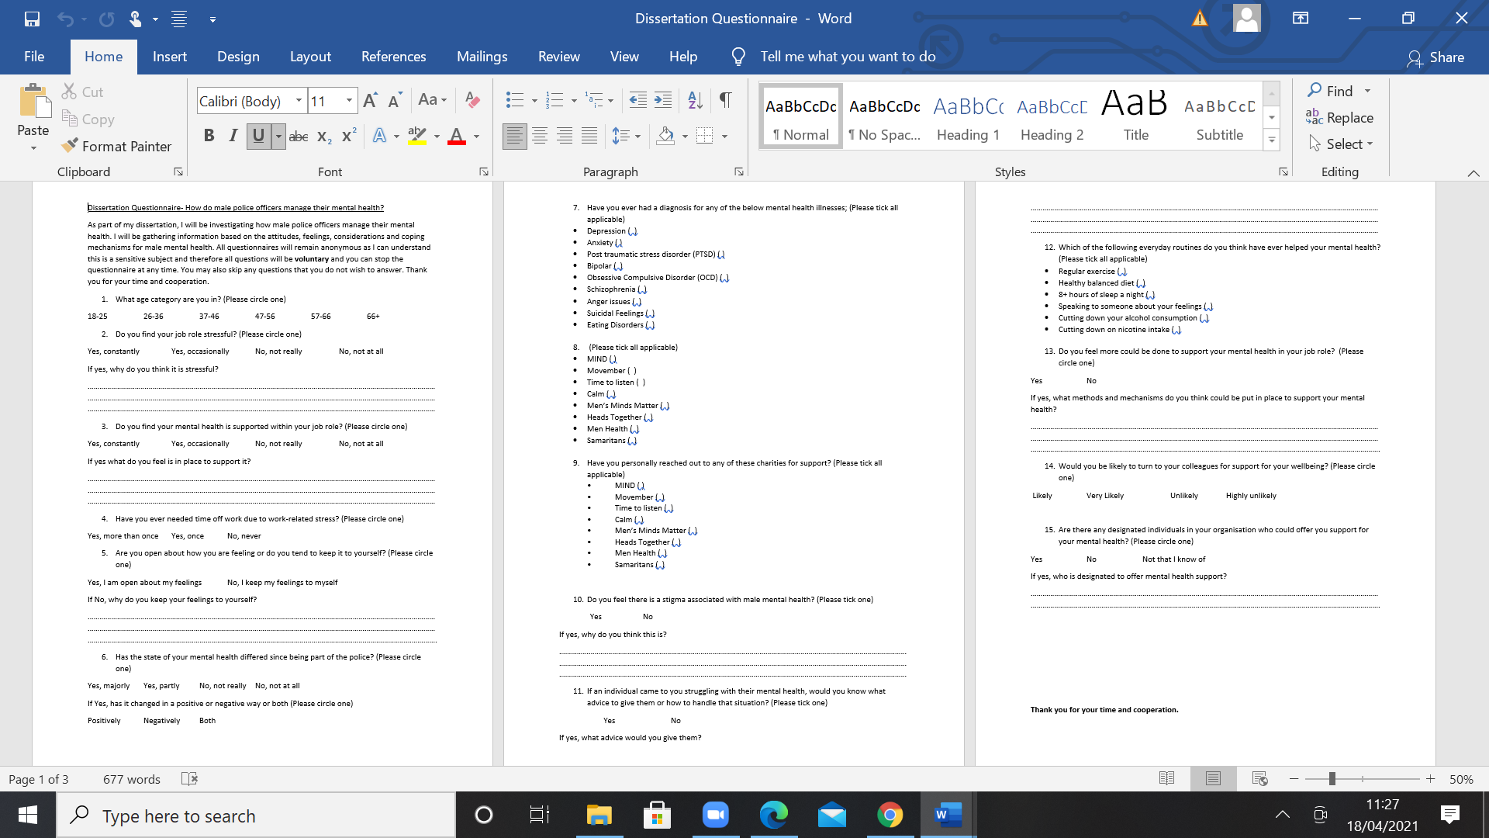
A copy of the questionnaire that will be used can be found below;

Data analysis
This chapter of the dissertation will analyse and conclude the data and information gathered from the questionnaire created for male police officers. An analysis will be done and comparisons will be made between the questionnaire results, and previous research that has already been done by others, to see if the outcome of the research is similar, different or whether any patterns between them can be identified.
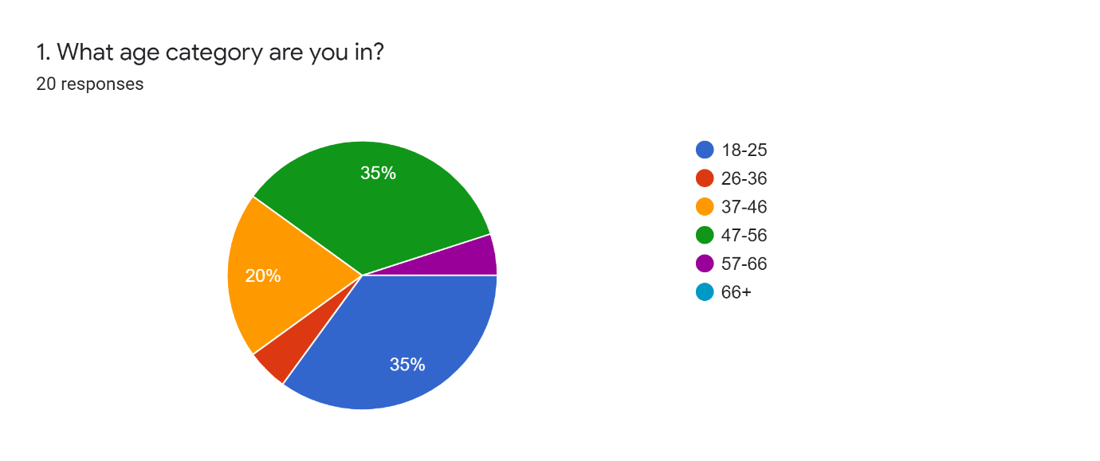

As shown in the pie chart above, the results from this questionnaire have come from a variety of different age groups, 7 people being 18-25, 1 person being 26-36, 4 people being 37-46, 7 people being 47-56 and 1 person being 57-66. This is a good selection of individuals with a wide range of age categories. This allows comparisons to be made between the aged groups.
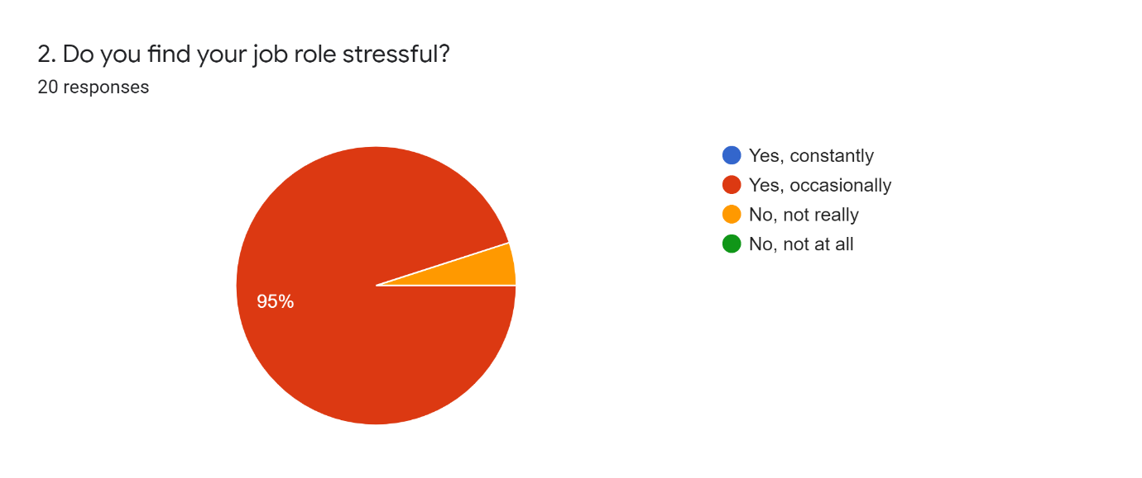

From all 20 responses, only one person in the age category 37-46 stated that they do not find their job role stressful. This is a contrast to the remaining results as the other 19 people stated that being in the police can occasionally be stressful. This result reinforces the findings found in an article in 2016, which states that policing is a highly stressful job role (Violanti et al, 2016).
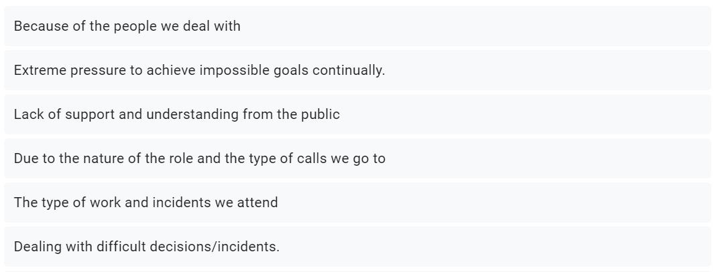
Following on from question 2, the participants were asked why they find their job role stressful, below are the results and different opinions that were given on why they think the role of policing is stressful.
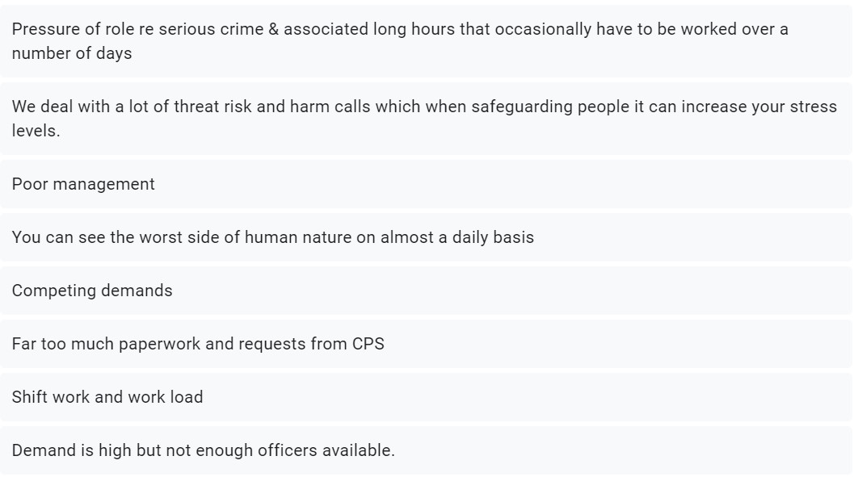
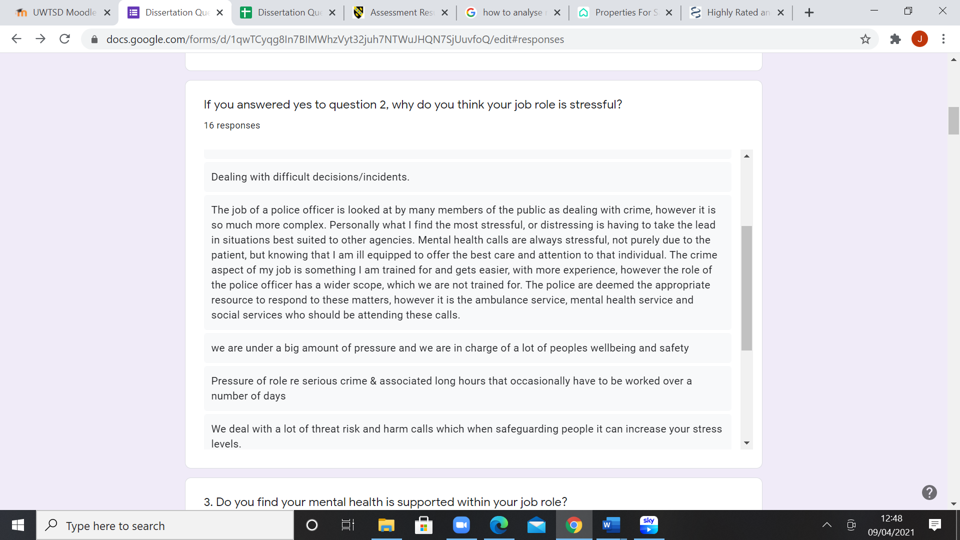
From reading these different opinions, a common occurrence for the cause of stress in the police is the pressure put on them through their work loads and staff cuts. This is a similar conclusion to an article written by the Greater Manchester Police Federation, which claims that the staff cuts and extra work loads are overwhelming, which results in backlogs of emergency jobs, causing the officers to not be able to protect the public to their full potential (Greater Manchester Police Federation, 2018).
Another common theme found as to why the police role is stressful is the people in the public that officers have to deal with, and their mental health incidents. They stated that they are not trained to deal with mental health calls and when they have to attend them, it adds major stress as they are not specialists in this area. This data is backed up by an article released in 2019, claiming that police are dealing with numerous mental health calls, and it states that if there is a mental health crisis in the community, it should be dealt with the NHS specialist staff and not be the responsibility of police officers (Jones, 2019).
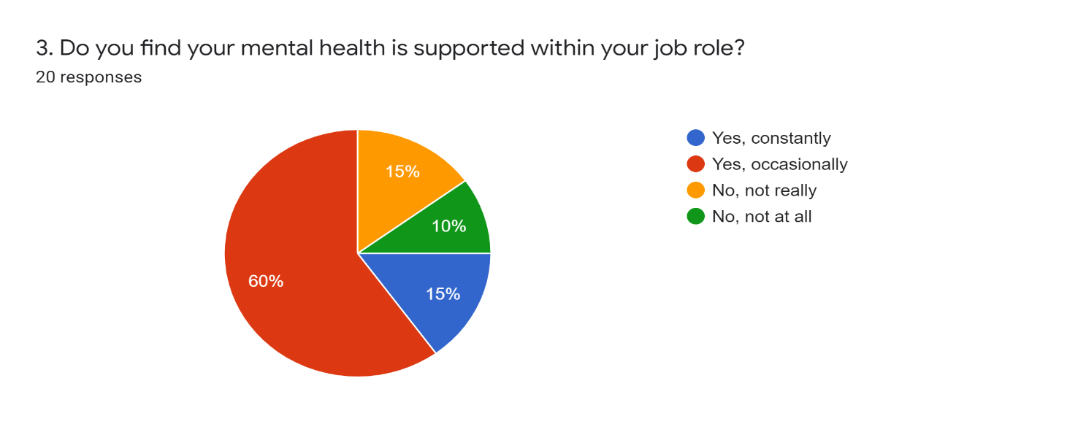Question 3 looked to investigate whether participants thought their mental health is supported within the police, 12 individuals said yes it is occasionally supported, 3 people said yes it is constantly supported, another 3 people said it is not really supported and 2 individuals stated that their mental health is not supported at all. Three of the individuals who stated that their mental health is not supported were in the age category 18-25, another one was in the age category 37-46 and another was age 47-56. Agreeing with the claim that their mental health is not supported, is an article written in 2019, that states that there is no complete strategy or plan to tackle the issue of mental health in policing, and that this is something that needs to change (Police Care UK, 2019).
However, contradicting this is the remaining 15 individuals who state that their mental health is supported in their job role. An article stating a support line in place for police officers was written in 2018, and it discusses the blue light information line, and it encourages police officers to use this and talk about how they are feeling (Hailstone, 2018). Another article discussing the support for police officer’s mental health was written in 2021 and it discusses the blue light programme and a nine point stress plan in place to relieve officer’s stress (Police Federation, 2021).
From these results, it is clear to see that neither answer is right nor wrong, it is more based on how the officers feel and whether they feel their own mental health is supported. The support they receive is also determined by whether they seek it, for example, if someone is struggling and finds it difficult to tell someone, they may feel like they are not supported, however if they told someone, then they could realise the support that is available to them.
When asked what do officers feel is in place for their mental health, there were a variety of different responses.
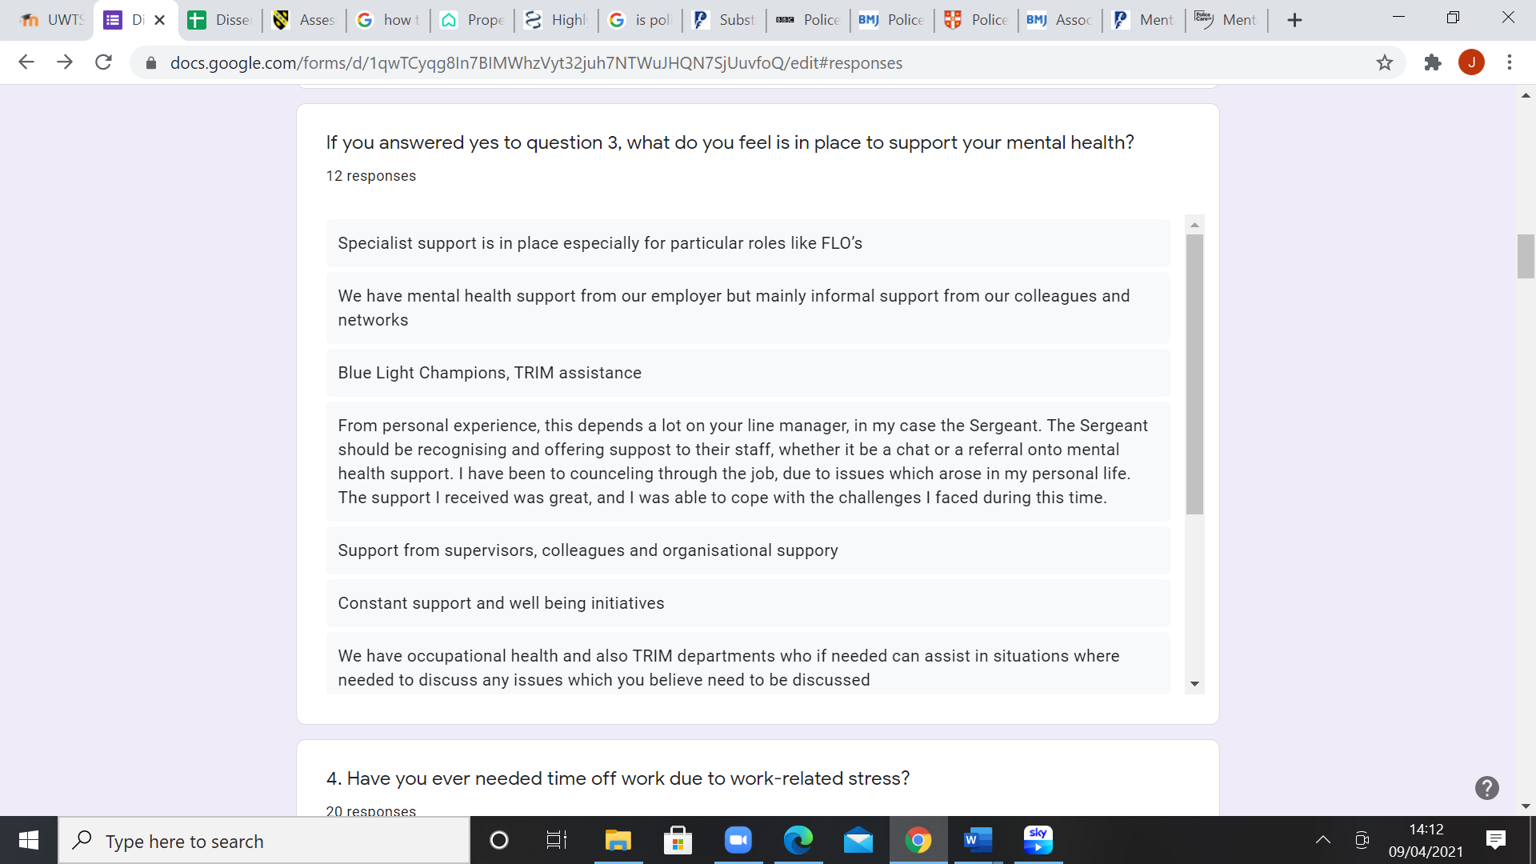

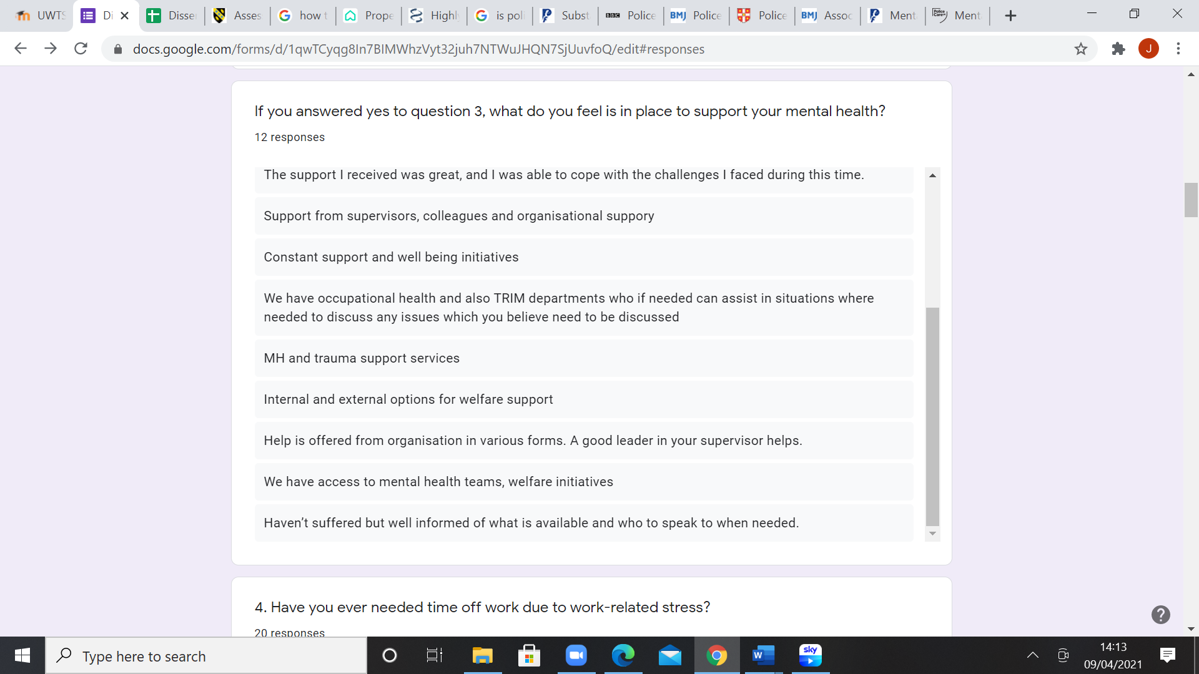
A common theme was trauma risk incident management (TRIM), which is a management strategy that aims to keep employees of organizations functioning after any traumatic events. TRIM provides support and education to individuals who need it and it is in place to help identify those with difficulties that require more specialist input (Kent Police, 2021).
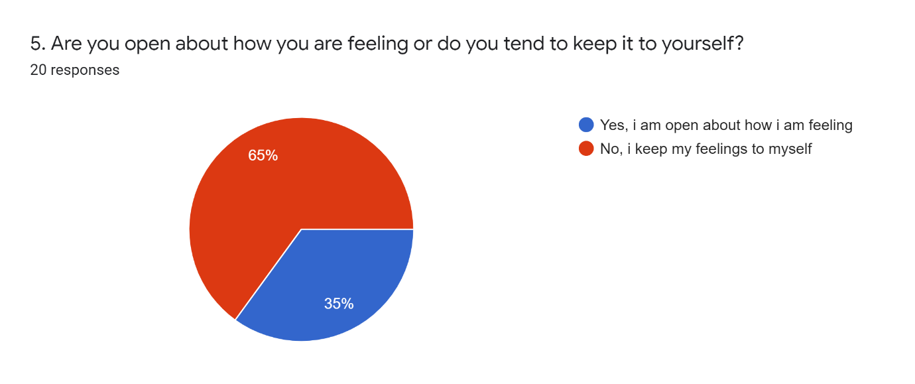
Question 5 discusses whether officers bottle up their feelings or if their able to talk about them. 13 people said they keep their feelings to themselves and 7 stated that they are open about how their feeling, out of these 7, 3 of them were aged 37-46, and the remaining 4 were aged 47-56. This suggests that higher age categories are more likely to talk about their feelings more than the younger ages. However, it is not just younger ages that struggle to discuss their feelings, mental health does not discriminate and can affect any one and cause them to struggle to discuss their feelings. A study undertaken in the UK found that 28% of men did not seek help for mental health issues (BMI Healthcare, 2021). This is significantly less than the questionnaire results found, as they found that 65% of male police officers said that they tend to keep their feelings to themselves.
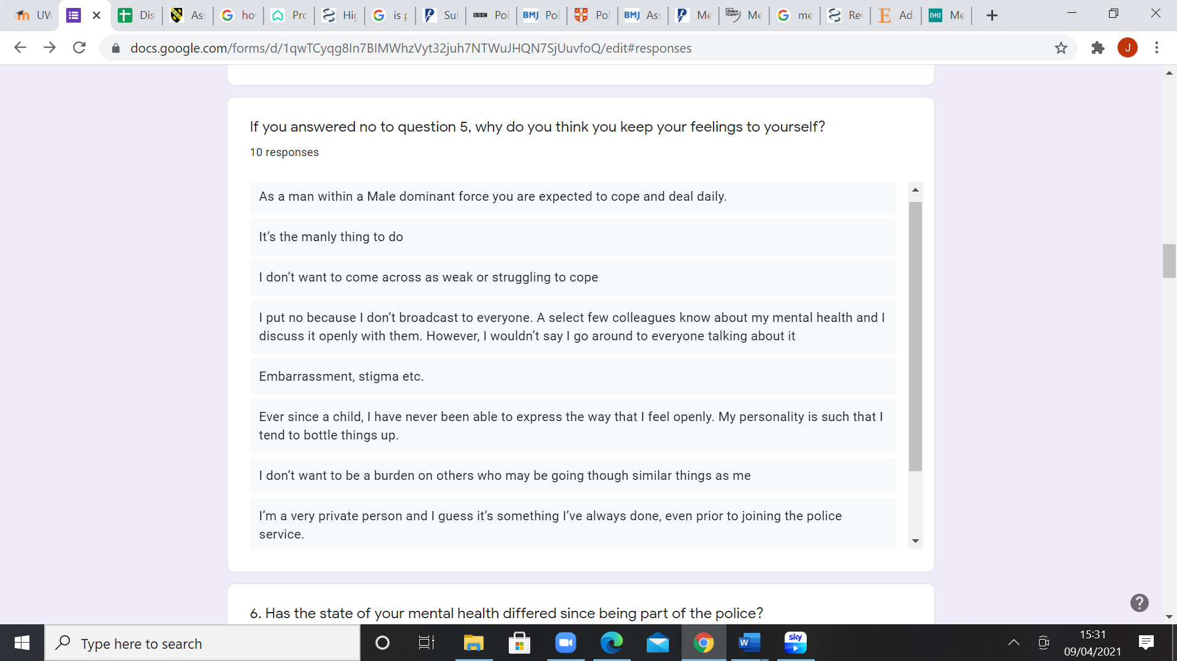

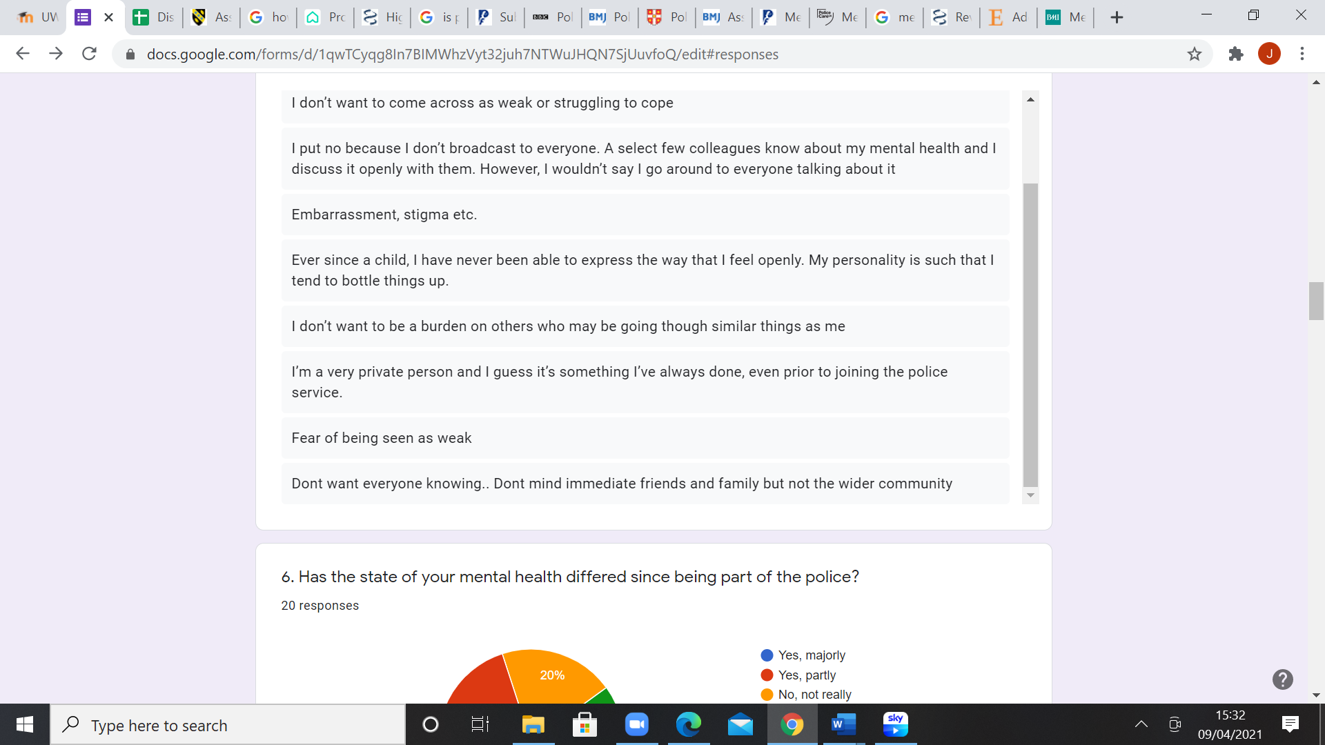

Above is the reasoning behind individuals not wanting to discuss their feelings. The main and overall problem here is the male mental health stigma that is evident across the UK. An article that backs up the idea of there being a stigma around male mental health was written in 2019 and claims that people are ignoring the stigma surrounding male mental health, which then stops many men from seeking help when they need it most — and it’s literally killing them (Campbell, 2019).
The results received from the questionnaire for the reasoning of men not talking about their feelings all stems from the same issue of men feeling like they have to be strong and ‘macho’ like and seeing ill mental health as a weakness. This image is portayed especially in the police as it is shown as a strong and resilient role and therefore they feel like if they discuss their feelings, they may be seen as weak. Furthermore, previous research that has been done on this topic found has similar results as it states that that toxic masculinity plays a huge role in the male mental health stigma as they tend to have been brought to be ‘strong’ and quiet about their feelings as they state they feel that depression is a sign of weakness (Salter, 2019).
As part of question 10, participants were asked why do they think there is a stigma associated with male mental health, giving similar results to question 5, many of the answers state that they do not want to be seen as weak.
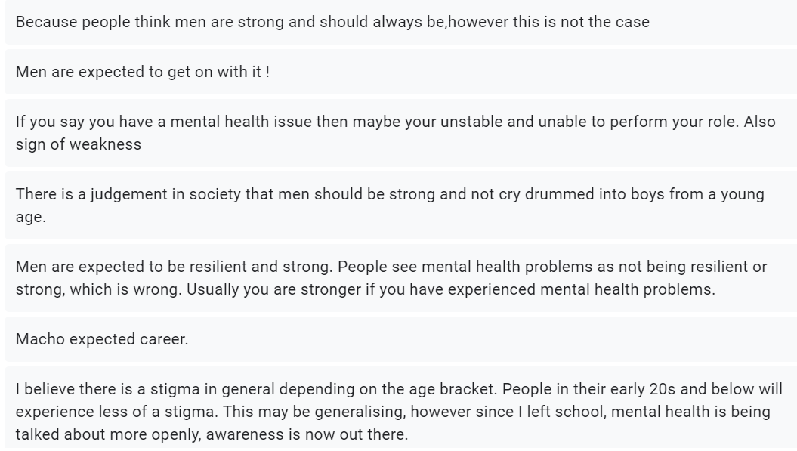

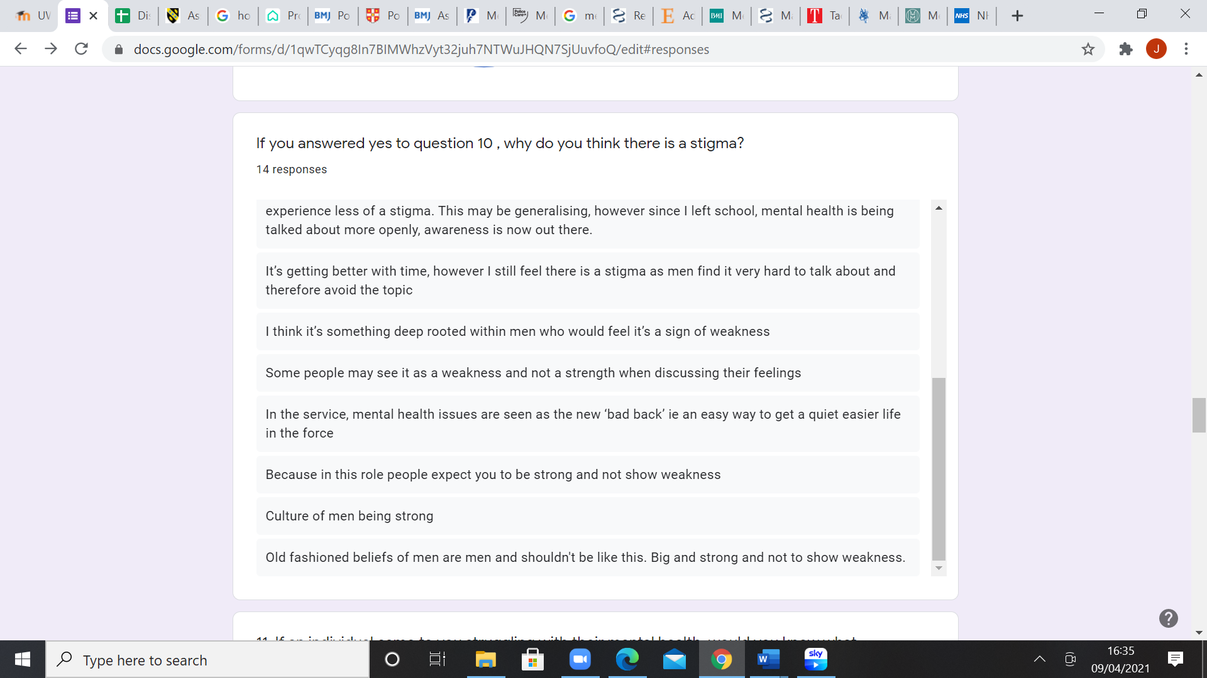

Above is the participants reasoning for why they think there is a stigma with male mental health. Again the general consensus is that males are afraid of looking weak and therefore do not talk about their feelings. This is similar to previous research done on the male mental health stigma, when an article written in 2019 states that males do not express their feelings as much as women as there is a cultural expectation for them to be strong and masculine (Mull, 2019).
Question 11 begins by asking the participants if they would know what to do if a colleague came to them for mental health advice, 3 said no and the remaining 17 said yes they would know how to handle that situation. All 3 of the individuals who said no were in the 18-25 category, so this could indicate a lack of education or experience with mental health as the older categories above 18-25 all stated that they would know what to do in that situation. This is similar to previous resarch, where an article written in 2020, indicates a lack of education on mental health to 18-25 year olds, as it states the health education in schools is inadequate (Broadwater, 2020).
Below is the advice and methods that participants stated they would give someone if they turned to them for help.
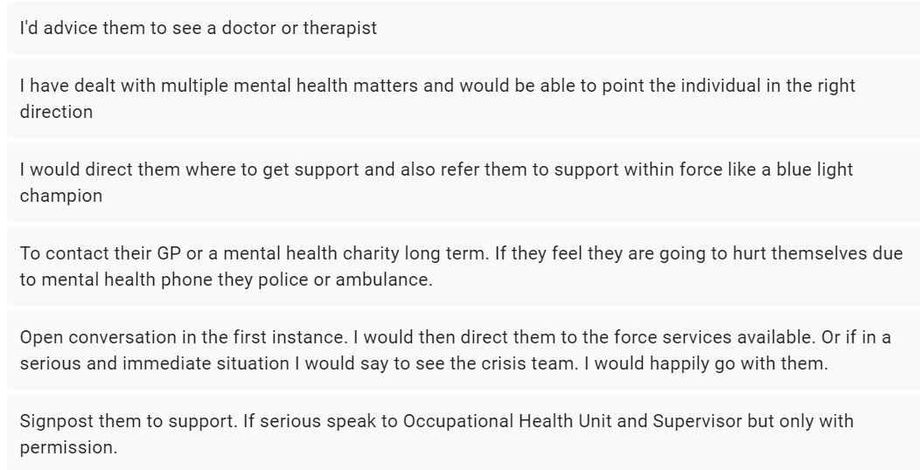

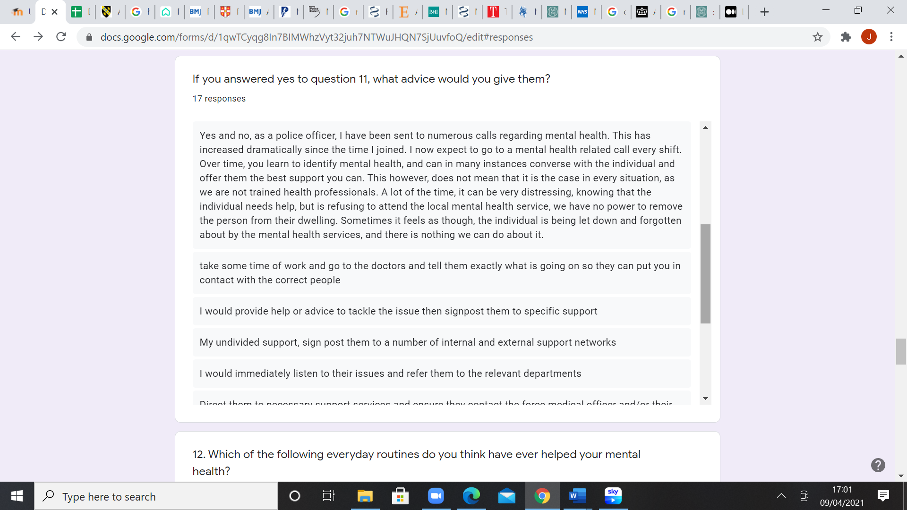

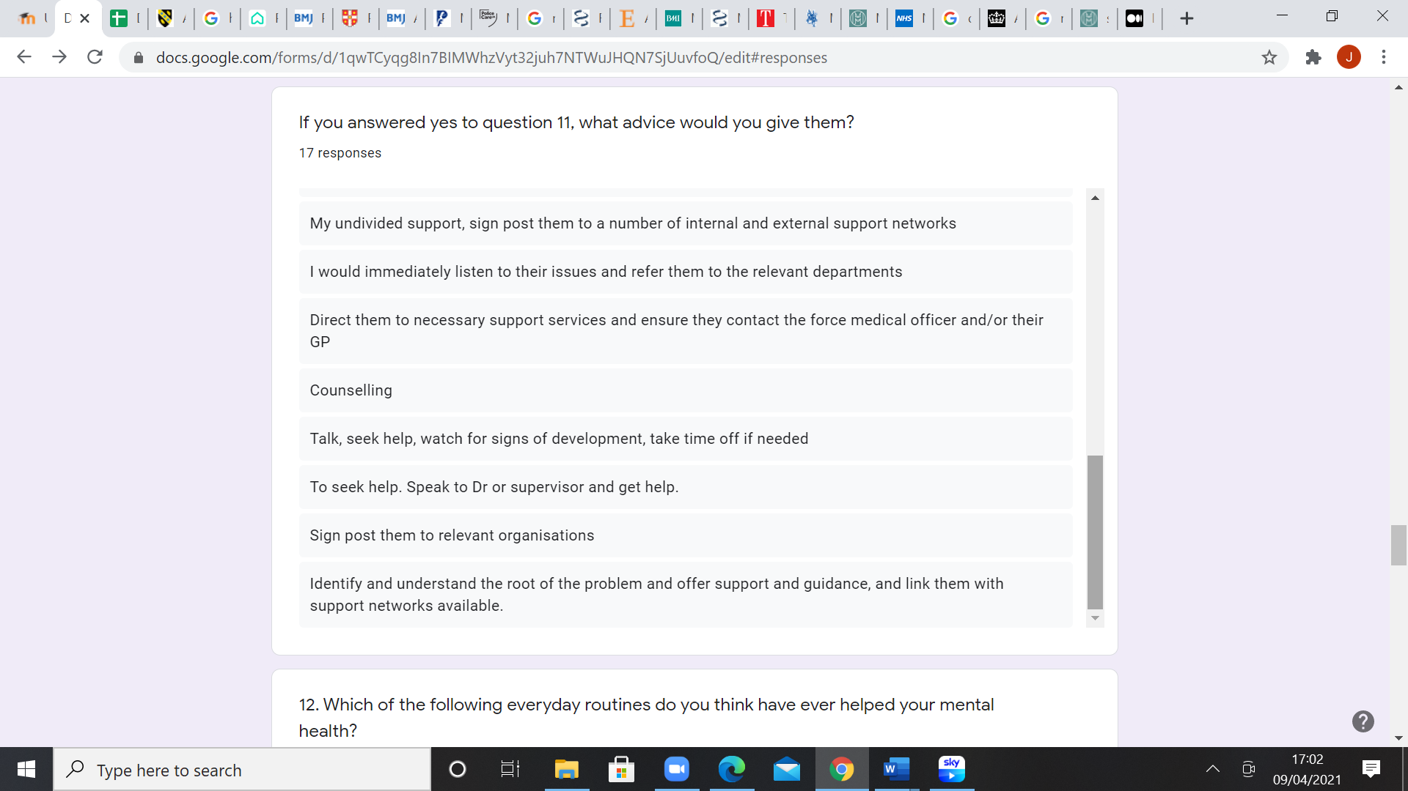

The general consensus of this advice is to seek help from individuals, to talk about feelings and to seek professional advice. This is a common response to a mental health crisis as the main stigma is people not talking about their feelings, encouraging this is crucial and it is said that tackling mental health is the lynchpin to suicide prevention (Bell, 2018). Another article that also backs up the findings found from the questionnaire is written by the NHS, encouraging individuals to seek help and advice if they feel they need it (NHS, 2018).
Furthermore, question 12 in the questionnaire asks participants of what lifestyle factors they have found to make a difference to their mental health.

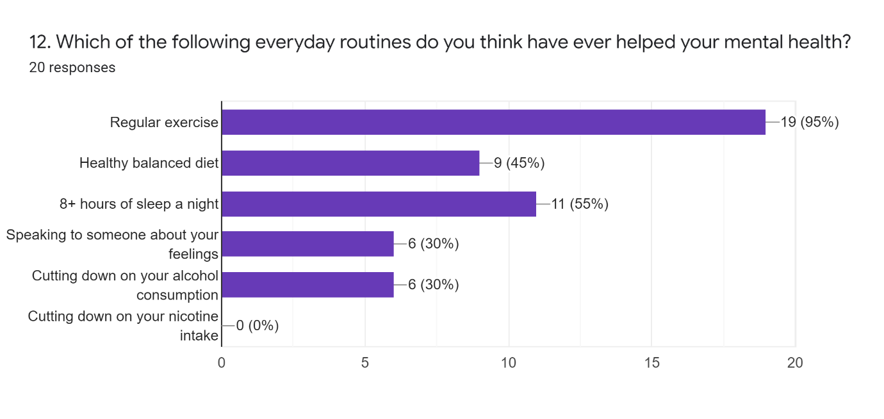Out of all 20 participants, 19 of them found that regularly exercising has helped improve their mental health. This evidence reinforces previous research that has been done, which states that exercise is vital for improving mental health as it reduces anxiety and depression and is known for improving self-esteem and cognitive function. It also explains that exercise can ease low self esteem and social withdrawal (Sharma et al, 2006).
Next, 9 participants stated that they find their mental health is also affected by their diet. This is also a life factor that is reinforced through previous research as it states that when an individual sticks a to diet of healthier foods, they tend to set themselves up for less mood fluctuations, and they have an overall happier outlook and their ability to focus improves. Previous studies have also shown that healthier diets can help with symptoms of anxiety and depression (Gomstyn, 2021).
Next, a lifestyle factor that 11 participants said has a positive affect on their mental health is getting 8+ hours of sleep per night. These results coincide with previous research that has been done as it states that sleep is as important to our health as eating, drinking and breathing (Mental Health Foundation, 2011). This is because it allows our bodies to repair themselves and it allows our brains to consolidate our memories and is essential for individuals to be able to process information. Research has also shown that a lack of sleep is linked to mental health problems such as depression and anxiety (Mental Health Foundation, 2011).
Recommendations
A common theme occuring througout the data anaylsis was a lack of education and therefore a recommendation to improve mental health and raising awareness for it would be for it to be taught in schools and colleges, this could allow more people to know how to handle situtations that involve mental health.
Furthermore, training on mental health should be compulsory when going into any type of job role, especially within the police. It would not necessarily mean full training, however even just learning how to sign post mental health. For example training on the traffic light system, which helps analyse the risk to the indiviual. Green being not urgent but when an individual does need to see a specialist, amber meaning a specialist is required that day, and red being a call made to 999 considering the safety and welfare of the Individual (Croucher and Williamson, 2013).
Limitations
Unfortunately, this investigation was significantly restricted due to the coronavirus pandemic that began in 2020. Had this not occurred, the research methods would have been different as it would have meant that face to face interviews could be done with the participants aswell as the questionnaires. Meaning more in depth questions could have been asked and more detail could have been taken from the participants, giving the project more information to analysis and conclude.
The COVID-19 pandemic has also restricted the amount of participants that the questionnaires reached as it was all done online as they could not be physically handed out to individuals which means if the pandemic did not occur, the number of participants would have been significantly higher and results may have varied more, meaning they would be more accurate to develop a better understanding on the topic of male mental health.
Another limitation in this investigation was the lack of resources available, this is again down to the COVID-19 pandemic as libraries were closed and therefore access to more resources was extremely limited. Had this not occurred, the literature review could have gone into more depth about the topic of male mental health, meaning more comparisons could have been made, and a bigger perspective of the management of mental health in male police officers could have been discussed.
Finally, the investigation focused just on England and Wales, whereas if it had been more widespread across the UK, comparisons could have been drawn between the different countries, maybe identifiying if it male mental health is worse or better in certain areas etc.
Conclusion
From the data received, it is clear to see that male mental health nowadays is very much similar to previous research that has been done. From receiving the questionnaire results it is also clear to see that there is still a huge stigma associated with male mental health which could be the reason why many males suffer in silence, as they do not want to be portrayed as ‘weak’ or ‘not manly’.
This investigation has highlighted that there are many support strategies in place for the mental health of male police officers such as counsellors, blue light champion, welfare officers etc. however, it does not matter how many support strategies are in place if there is still a stigma associated with male mental health as regardless of the support strategies, males will still be afraid to speak up or turn to these strategies, in fear of being seen as weak, especially in the police which is deemed as job role that requires strength and resilience. Therefore this project has shown that it is the stigma associated with male mental health which is the main problem.
Ways in which the stigma can be tackled is to make male mental health more publicised and allow males to talk freely about it if they wish. Potentially more campaigns should be created, encouraging males to speak up about their feelings and their mental health, just as they would with their physical health. This is not a responsibility for anyone in particular, but everyone has a role to play, by speaking to their male friends or family such as brothers, fathers, uncles, cousins, grandfathers etc. and encouraging them to speak about their feelings and seek help.
Having said that, the Government do have a big role to play as they are the people responsible for the support accessible to all individuals. Therefore, if this support is not accessible quick enough, then male mental health could deteroriate even further, leading to an increase in suicides and other individuals feeling like there is no point in seeking help as the waiting list is too long.
Furthermore, the police federation should take more responsibility as their employers are the ones in a job at a higher risk of mental health problems due to the nature of the job. This is similar to other emergency service jobs as they are aswell under a huge amount of pressure and witness traumatic events and the aftermath of them on a daily basis.
This project has investigated the management of mental health in male police officers. It has begun with a literature review which has discussed previous research that has already been carried out by other people, on the topic of male mental health and the mental health of police officers. An inductive approach has then been discussed as this was the approach used throughout the investigation, alongside discussion about the strategy, choice of questions, time horizon, any limitations that were faced and any design and ethical considerations that were taken into account whilst carrying out the investigation.
Next, the method of research was discussed, covering both qualitative and quantitative research methods. These were both discussed as the questionnaire used a combination of both of them, rather than just one, in order to get a variety of results.
A questionnaire was then created for the participants for them to complete in their own time. This was done online as the current COVID-19 pandemic prevented any other methods such as interviews and paper questionnaires from taking place.
The data received from these questionnaires were then analysed, using different charts to visually represent the results, as well as discussing and comparing the results to the previous research that has been done on this topic.
Finally, a conclusion has been created at the end in order to summarise the information and data that has been gathered, discussing whether it is similar or different to previous research that has been done.

References
Aspers P and Corte U, 2019, What is Qualitative in Qualitative Research, accessed at: https://link.springer.com/article/10.1007/s11133-019-9413-7 Accessed on: 23/02/2021
Azungah T, 2018, Qualitative research: deductive and inductive approaches to data analysis, accessed at: https://www.emerald.com/insight/content/doi/10.1108/QRJ-D-18-00035/full/html Accessed on: 25/02/2021
Bell P, 2018, Tackling men’s mental health is the lynchpin to suicide prevention, accessed at: https://www.england.nhs.uk/blog/tackling-mens-mental-health-is-the-lynchpin-to-suicide-prevention/ Accessed on: 09/04/2021
Bhandari P, 2020, An introduction to quantitative research, accessed at: https://www.scribbr.com/methodology/quantitative-research/ Accessed on: 24/02/2021
BMI Healthcare, 2021, Men and mental health: a damaging stigma, accessed at: https://www.bmihealthcare.co.uk/health-matters/mens-health/men-and-mental-health-a-damaging-stigma#gdpr-out Accessed on: 09/04/2021
Broadwater A, 2020, Mental Health Education in Schools is Far From Adequate — and Our Teens’ Lives Rely on that Adequacy, accessed at: https://medium.com/age-of-awareness/mental-health-education-in-schools-is-far-from-adequate-and-our-teens-lives-rely-on-that-3b4407c79c4f Accessed on: 09/04/2021
Campbell L, 2019, Why Many Men Have a Harder Time Seeking Treatment for Mental Illness, accessed at: https://www.healthline.com/health-news/how-can-we-reduce-mens-mental-health-stigma Accessed on: 09/04/2021
Caruana E.J, Roman M, Sanchez H.J and Solli P, 2015, Longitudinal studies, accessed at: https://www.ncbi.nlm.nih.gov/pmc/articles/PMC4669300/ Accessed on: 25/02/2021
Crisis, 2021, accessed at: https://www.crisis.org.uk/ending-homelessness/rough-sleeping/ Accessed on: 20/01/2021
Crossley J and Jansen D, 2021, Saunders’ Research Onion: Explained Simply, accessed at: https://gradcoach.com/saunders-research-onion/ Accessed on: 25/02/2021
Croucher S and Williamson G.R, Risk Assessment in Mental Health: Introducing a Traffic Light System in a Community Mental Health Team, accessed at: https://www.ncbi.nlm.nih.gov/pmc/articles/PMC3715756/ Accessed on: 15/04/2021
Debois S, 2019, 10 Advantages and Disadvantages of Questionnaires, accessed at: https://surveyanyplace.com/questionnaire-pros-and-cons/ Accessed on: 24/02/2021
Dukart B, 2018, 20 Important Benefits of Social Media Marketing Every Business Should Know, accessed at: https://coschedule.com/blog/benefits-of-social-media-marketing-for-business/ Accessed on: 25/02/2021
Edwards A.M. and Kotera Y, 2020, Mental Health in the UK Police Force: a Qualitative Investigation into the Stigma with Mental Illness, accessed at: https://link.springer.com/article/10.1007/s11469-019-00214-x Accessed on: 27/01/2021
First M.B, 2020, Treatment of Mental Illness, accessed at: https://www.msdmanuals.com/home/mental-health-disorders/overview-of-mental-health-care/treatment-of-mental-illness Accessed on: 20/01/2021
Gabriel D, 2013, Inductive and deductive approaches to research, accessed at: https://deborahgabriel.com/2013/03/17/inductive-and-deductive-approaches-to-research/ Accessed on: 24/02/2021
Gomstyn A, 2021, Food for your mood: How what you eat affects your mental health, accessed at: https://www.aetna.com/health-guide/food-affects-mental-health.html#:~:text=When%20you%20stick%20to%20a,symptoms%20of%20depression%20and%20anxiety Accessed on: 12/04/2021
Graham J, Grewal I and Lewis J, 2007, Ethics in Social Research: the views of research participants, accessed at: https://assets.publishing.service.gov.uk/government/uploads/system/uploads/attachment_data/file/497221/ethics_participants_tcm6-5783.pdf Accessed on: 25/02/2021
Greater Manchester Police Federation, 2018, Substantial cuts and extra workload demands are “overwhelming” police officers, accessed at: https://www.polfed.org/gmp/news/2018/substantial-cuts-and-extra-workload-demands-are-overwhelming-police-officers/ Accessed on: 09/04/2021
Guest C, 2019, Qualitative vs. Quantitative Research Methods, accessed at: https://www.cvent.com/en/blog/events/qualitative-vs-quantitative-research-methods Accessed on: 24/02/2021
Hailstone J, 2018, The Thin Blue Line – mental health in the police force, accessed at: https://www.shponline.co.uk/culture-and-behaviours/thin-blue-line-mental-health-police-force/ Accessed on: 09/04/2021
Health and Safety Executive (HSE), 2021, LFS - Labour Force Survey - Self-reported work-related ill health and workplace injuries: Index of LFS tables, accessed at: https://www.hse.gov.uk/Statistics/lfs/index.htm Accessed on: 20/01/2021
Jetelina K.K, Molsberry R.J and Gonzalez R.J, 2020, Prevalence of Mental Illness and Mental Health Care Use Among Police Officers, accessed at: https://jamanetwork.com/journals/jamanetworkopen/fullarticle/2771400 Accessed on: 26/01/2021
Jones L, 2019, Police 'dealing with more mental health incidents', accessed at: https://www.bbc.co.uk/news/uk-49317060 Accessed on: 09/04/2021
Jones TL, Baxter J and Khanduja V, 2013, A quick guide to survey research, accessed at: https://www.ncbi.nlm.nih.gov/pmc/articles/PMC3964639/ Accessed on: 23/02/2021
Kent Police, 2021, Trauma Risk Incident Management (TRIM) protocol (L11260), accessed at: https://www.kent.police.uk/foi-ai/kent-police/Policy/human-resources/trauma-risk-incident-management-trim-protocol-l11260/ Accessed on: 09/04/2021
Madrigal D and McClain B, 2012, Strengths and Weaknesses of Quantitative and Qualitative Research, accessed at: https://www.uxmatters.com/mt/archives/2012/09/strengths-and-weaknesses-of-quantitative-and-qualitative-research.php Accessed on: 24/02/2021
ManHealth, 2021, Peer support groups, accessed at: https://www.manhealth.org.uk/ Accessed on: 26/01/2021
Mental Health Foundation, 2011, Sleep Matters: The Impact Of Sleep On Health And Wellbeing, accessed at: https://www.mentalhealth.org.uk/publications/sleep-report Accessed on: 12/04/2021
Mind, 2020, Mental Health problems; What causes them? Accessed at: https://www.mind.org.uk/information-support/types-of-mental-health-problems/mental-health-problems-introduction/causes/ Accessed on: 20/01/2021
Movember, 2021, How were going to win the fight, accessed at: https://uk.movember.com/about/mental-health Accessed on: 26/01/2021
Mull A, 2019, Psychology Has a New Approach to Building Healthier Men, accessed at: https://www.theatlantic.com/health/archive/2019/01/traditional-masculinity-american-psychological-association/580006/ Accessed on: 09/04/2021
NHS, 2018, Get help from a mental health charity helpline, accessed at: https://www.nhs.uk/mental-health/nhs-voluntary-charity-services/charity-and-voluntary-services/get-help-from-mental-health-helplines/ Accessed on: 09/04/2021
Office for National Statistics (ONS) 2021, Suicides in Great Britain: 2016 registrations, accessed at: https://www.ons.gov.uk/peoplepopulationandcommunity/birthsdeathsandmarriages/deaths/bulletins/suicidesintheunitedkingdom/2016registration Accessed on: 20/01/2021
Pathak V, Jena B and Kalra J, 2013, Qualitative research, accessed at: https://www.ncbi.nlm.nih.gov/pmc/articles/PMC3757586/ Accessed on: 23/02/2021
Police Care UK, 2019, Police Care UK calls for a dedicated mental health strategy tackling trauma-related stress in UK policing, accessed at: https://www.policecare.org.uk/mental-health-strategy-for-policing-urgently-required/ Accessed on: 09/04/2021
Police Care UK, 2019, Welcome to Police Care UK, accessed at: https://policecare.org.uk/ Accessed on: 27/01/2021
Police Federation, 2021, Mental Health, accessed at: https://www.polfed.org/our-work/wellbeing/mental-health/ Accessed on: 22/01/2021
Police Federation, 2021, Mental Health, accessed at: https://www.polfed.org/our-work/wellbeing/mental-health/ Accessed on: 09/04/2021
Pritchard G and Lewis P, 2017, Stress plan launched as ‘not enough being done’ to support mental health, accessed at: https://www.policeprofessional.com/news/stress-plan-launched-as-%c2%91not-enough-being-done%c2%92-to-support-mental-health-2/ Accessed on: 26/01/2021
Pujanes K.M, 2020, Philosophy 101: The Six Branches of Philosophy, accessed at: https://thebadbread.com/2020/04/08/philosophy-101-the-six-branches-of-philosophy/ Accessed on: 25/02/2021
Rafael C, 2016, Understanding the research onion: an illustration, accessed at: https://nairaproject.com/blog/understanding-the-research-onion-methodology.html Accessed on: 24/02/2021
Rahman S.A, 2015, What is the difference between multimethod and mixed methods? Accessed at: https://www.researchgate.net/post/What-is-the-difference-between-multimethods-and-mixed-methods Accessed on: 25/02/2021
Salter M, 2019, The Problem With a Fight Against Toxic Masculinity, accessed at: https://www.theatlantic.com/health/archive/2019/02/toxic-masculinity-history/583411/ Accessed on: 09/04/2021
Sedgwick P, 2014, Cross sectional studies: advantages and disadvantages, accessed at: https://www.bmj.com/content/348/bmj.g2276 Accessed on: 25/02/2021
Sellars W, 2021, What is philosophy? Accessed at: https://www.philosophy-foundation.org/what-is-philosophy Accessed on: 25/02/2021
Sharma A, Madaan V, Petty F.D, 2006, Exercise for Mental Health, accessed at: https://www.ncbi.nlm.nih.gov/pmc/articles/PMC1470658/#:~:text=Exercise%20improves%20mental%20health%20by,self%2Desteem%20and%20cognitive%20function.&text=Exercise%20has%20also%20been%20found,self%2Desteem%20and%20social%20withdrawal Accessed on: 12/04/2021
Sheard J, 2018, Quantitative Research, accessed at: https://www.sciencedirect.com/topics/social-sciences/quantitative-research Accessed on: 24/02/2021
Tiley C, 2017, Qualitative research: what is it and why should you use it? Accessed at: https://www.onepoll.com/qualitative-research-what-is-it-and-why-should-you-use-it/ Accessed on: 24/02/2021
Time to change, 2021, Types of mental health problems, accessed at: https://www.time-to-change.org.uk/about-mental-health/types-problems Accessed on: 20/01/2021
UK Government, 2020, Review of two metre social distancing guidance, accessed at: https://www.gov.uk/government/publications/review-of-two-metre-social-distancing-guidance/review-of-two-metre-social-distancing-guidance Accessed on: 25/02/2021
Velden P.G et al, 2020, Police officers: a high-risk group for the development of mental health disturbances? A cohort study, accessed at: https://bmjopen.bmj.com/content/3/1/e001720 Accessed on: 22/01/2021
Violanti et al, 2016, Highly Rated and most Frequent Stressors among Police Officers: Gender Differences, accessed at: https://www.ncbi.nlm.nih.gov/pmc/articles/PMC5330309/ Accessed on: 09/04/2021

