

Component 2
Poster and Pitch

Submission date: 24th November 2025
Module: Change makers: Creativity & Value creation BMHP 5014
Lecturer: Alice Clayton
Student: Precious Lewis 2328179


- Records blood sugars
- Records food & Drink intake
- Monitors diabetes management
- Records medication consumption
- Easy to use
- Linked to GP surgery
- Tracks bad foods
- Encourages healthy lifestyle choices
- Reduces
Anxiety
- Proven to put type 2 diabetes into remission
- Signposting


new tracker app for
diabetes
mANAGEMENT

CHECK TRACK ACT
Fight back against Type 2 Diabetes
Diabetes Facts
- Diabetes affects roughly 12 million people in the UK.
- Type 2 Diabetes makes up 90% of cases, and type 1 only accounts for 8% (Diabetes UK, 2025)
NHS Tracker app
- Reduce GP and hospital Visits
- Reduce complications of diabetes
- Allow for better management of diabetes
- Meal planners and diet tracking
- Easy to use
- Self-help tools
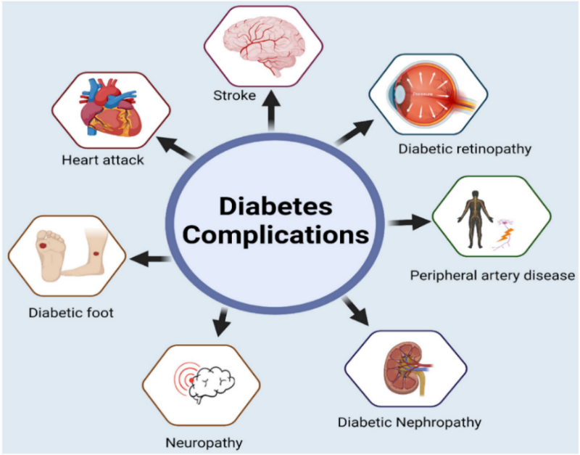 Avoid the complications with the ‘Trackapp’ Scan the QR code

(diabetes.org.uk, 2025)

Pitch for the Creation of Trackapp: A Digital Solution for Managing Type 2 Diabetes

The Issue
Type 2 diabetes is a chronic health condition characterized by elevated blood sugar levels resulting from the body’s inability to produce sufficient insulin or use it effectively. Although there is currently no cure, the condition can be managed—and in many cases, placed into remission—through consistent lifestyle changes, including a balanced diet, regular physical activity, and close monitoring of health indicators (NHS, 2023). Early detection and proactive management are essential to prevent serious complications such as cardiovascular disease, nerve damage, kidney failure, and vision problems.

Innovation
In response to the growing prevalence of type 2 diabetes, particularly among younger adults and children, we propose the development and rollout of Trackapp, a comprehensive digital health tool designed to support individuals in managing their condition effectively. Trackapp is not just another health app—it is a transformative platform that empowers users to take control of their diabetes through daily tracking, personalized insights, and direct access to healthcare support.
The app’s primary objective is to make diabetes management more accessible and efficient for both patients and healthcare professionals. By enabling users to monitor their food and fluid intake, blood sugar levels, medication usage, and physical activity, Trackapp provides a holistic view of their health (Diabetes, UK, 2023). This data-driven approach allows users to identify patterns, make informed decisions, and take timely action to prevent complications.

Key Features of Trackapp Include:
- Food and Drink Tracking: Users can log their meals and beverages, helping them identify foods that cause blood sugar spikes and make healthier choices.
- Blood Sugar Monitoring: The app allows users to input their blood glucose readings, track fluctuations, and receive alerts when levels are too high or too low.
- Medication Logging: Users can record their medication intake, ensuring adherence to prescribed treatment plans and reducing the risk of missed doses.
- Lifestyle Encouragement: Through motivational prompts and educational content, the app promotes healthy habits and supports users in making sustainable lifestyle changes.
- Direct GP Integration: Trackapp is linked to users’ GP surgeries, allowing for seamless communication and data sharing with healthcare providers.
- Symptom Reporting and Support Requests: A drop-down menu enables users to report worsening symptoms or concerns and request a GP call, appointment, or message their healthcare team directly.
- Self-Help Resources: The app includes meal plans, physical activity recommendations, and links to trusted organizations such as Diabetes UK for additional support.
- Multilingual Accessibility: To ensure inclusivity, Trackapp will be available in ten different languages and written in plain English, with intuitive navigation for users of all backgrounds.

Targeted Audience
The app is designed for adults of all ages and demographics who have been diagnosed with type 2 diabetes. The only requirements for use are a smartphone and internet access. Users can register using their NHS number and date of birth, after which they will be prompted to input daily health data. This includes information on meals, fluid intake, exercise, bowel and bladder function, and blood sugar readings. The app’s interface is user-friendly, with clear tabs and buttons to guide users through each section.

Implementation and pilot study
To validate the effectiveness of Trackapp, a six-month pilot trial was conducted involving a diverse group of volunteers. Participants were selected from various cultural backgrounds, age groups, and demographics, all of whom had been living with type 2 diabetes for several years. During the trial, users were asked to engage with the app daily and provide feedback on its usability, impact on their diabetes management, and overall experience.
The results of the pilot were overwhelmingly positive. Users reported that the app was intuitive and easy to navigate, even for those with limited digital literacy. Many participants experienced a significant reduction in the need for medical intervention due to improved self-management. Remarkably, 95% of users reported no episodes of hypoglycemia during the trial period, and 37% achieved remission of their type 2 diabetes. These outcomes highlight the app’s potential to reduce strain on NHS resources by minimizing unnecessary GP visits and hospital admissions.
Participants also praised the app’s community-building features, such as links to local support groups and charity organizations. These resources helped users feel less isolated and more empowered to manage their condition. The meal plans and signposting features were particularly well received, offering practical guidance and fostering a sense of connection among users.
One testimonial from a trial participant, Jane Silverton, aged 43, encapsulates the app’s impact:
“Using Trackapp changed my life. I have more energy, my diabetes has been stable, and I've not had any spikes or needed to see my GP since using it. This has given me peace of mind. I clicked the link for the Diabetes UK website and have attended a few coffee mornings. I would highly recommend Trackapp to anyone who has diabetes.”

Timeline and Development
To ensure widespread adoption, a comprehensive national marketing strategy has been developed. The app will first be launched in Central England and then gradually rolled out across the UK. Promotional efforts will include digital advertising on social media platforms, targeted campaigns on health-related websites, and printed materials such as leaflets and flyers distributed in GP practices, hospitals, and community centres.
Training will be provided to NHS frontline staff—including receptionists, pharmacists, and nurses—to equip them with the knowledge and tools to support patients in using the app effectively (NHS England, 2023). Workshops will be held in community centres, GP surgeries, libraries, and online for those with limited mobility. These sessions aim to maximize user engagement and ensure that patients can fully benefit from the app’s features.

Regulations
All data collected through Trackapp will be handled in accordance with the UK’s Data Protection Act (2018), ensuring that users’ health information is stored securely and shared responsibly. Special category data, such as medical records, will be protected through encryption and strict access controls.

Potential limitations
To address digital literacy challenges among older adults, tailored support and accessible training are essential (NHS Digital, 2023). There will be established dedicated spaces offering one-to-one support for downloading and using the app. These sessions aim to build confidence and improve engagement with digital tools. However, the current app design is not suitable for children under 16. To ensure inclusivity across age groups, it may be necessary to develop a child-friendly version with simplified navigation and age-appropriate features.

Conclusion
In conclusion, Trackapp represents a significant advancement in the digital management of type 2 diabetes. By combining user-friendly technology with evidence-based health strategies, the app empowers individuals to take control of their condition, reduce complications, and improve their overall well-being. The pilot trial has demonstrated its effectiveness, and with a strategic rollout and NHS integration, Trackapp is poised to become an essential tool in diabetes care. Its inclusive design, multilingual support, and community-focused features ensure that it meets the needs of diverse populations across the UK. Ultimately, Trackapp offers a scalable, cost-effective solution that aligns with public health goals—delivering personalized care, fostering healthier lifestyles, and minimizing the long-term impact of diabetes.

References

Bing (ND) Images of a mind map of diabetes complications. Available at: https://thumbs.dreamstime.com/z/diabetes-complications-affected-organs-affects-nerves-kidneys-eyes-vessels-heart-brain-skin-round-info-graphic-62541059.jpg (Accessed: 09 October 2025).

Diabetes UK (2023) Type 2 diabetes in children and young people. [online] Available at: https://www.diabetes.org.uk/diabetes-the-basics/type-2-diabetes/type-2-diabetes-in-children-and-young-people (Accessed 01 October 2025).

Diabetes.org.uk (2023) ‘Type 2 diabetes symptoms’ Diabetes UK. Available at: https://www.diabetes.org.uk/about-diabetes/type-2-diabetes/. (Accessed: 23 October 2025).

Ehtasham, A. et al. (2022) Type 2 diabetes. The Lancet, 400 pp.1803-1820. (Accessed: 9 October 2025).

Gov.uk (nd) Equality Act 2010 Available at: https://www.legislation.gov.uk/ukpga /2010/15/notes /division/3/11/1/1. (Accessed: 24 October 2025).

Gov.uk (nd) Data protection: The UK’s data protection legislation – GOV.UK. Available at: https://www.gov.uk/data-protection (Accessed: 23 October 2025).

Health Education England (2023) ‘Improving the digital literacy of the workforce’, NHS Digital Transformation. Available at: https://digital-transformation.hee.nhs.uk/building-a-digital-workforce/digital-literacy (Accessed: 28 October 2025).

NHS (2025) Type 2 Diabetes Prevention Week 2025 Toolkit Available at: https://www.campaignresources.dhsc.gov.uk/campaigns/healthier-you-nhs-diabetes-prevention-programme/type-2-diabetes-prevention-week-2025-toolkit/ (Accessed: 17 October 2025).

NHS Digital (2023) Digital inclusion for health and social care. [online] Available at: https://digital.nhs.uk/about-nhs-digital/our-work/digital-inclusion (Accessed: 29 October 2025).

NHS England (2023) Building a digitally enabled workforce. [online] Available at: https://www.england.nhs.uk/digitaltechnology/digital-workforce/ (Accessed 28 October 2025).

NHS (2023) Type 2 diabetes. [online] Available at: https://www.nhs.uk/conditions/type-2-diabetes/ (Accessed: 01 October 2025).

