Cover page
Component 1: E-portfolio - study skills
Module: ECP4018
Karen

Contents page:
- Cover page
- Contents page
- Summary of article – Bare Necessities of Stress, BPS
- Summary
- Infographic – motivation
- Essay plan – describe and discuss the psychological, social and physical benefits of engaging in a sporting activity
- Essay plan
- Essay plan
- Essay plan
- Library search
- Library search
- Summary of sources
- reference list
- AI acknowledgment

Task one:
Written summary (300 words)
Article: Bare necessities of stress, BPS

Within this article, the various ways in which the body reacts to stress are discussed and examined to identify and understand the short and long-term effects that contribute to health and wellbeing. It is made up of continuous investigation throughout, ensuring efficient and accurate results are conducted.

The article ‘analyses stress holistically, implying that it is the body’s natural response, both psychologically and physiologically to particular environments or challenges. It first becomes apparent in the brain, which then activates different body systems leading to different signals from each’ (Wetherell, M. (2022). Whilst this is a normal and healthy reaction, ‘prolonged stress can have significant and long-term consequences on both physical and mental health, including cardiovascular diseases, higher cortisol levels and elevated anxiety levels,’ making it more difficult to manage everyday life. (Wetherell, M. (2022)

Additionally, the article also addresses the connections between psychological, biological and social factors, all of which contribute to an individual’s experience and perception of stress. This was demonstrated through the study carried out on ‘parents and guardians of autistic children’ (Lovell & Wetherell, 2011), which provided a deeper understanding of the unique stressors someone may encounter, all within relation to the three components. This emphasised that subjective experiences could shape stress responses, referring to the fact that different people experience various issues that affect their stress levels as this is not the case for all, which in turn can lead to poorer outcomes.

Furthermore, this article also highlights the importance of social support and other strategies for managing stress including seeking professional support. Efficient data and analysis suggest that ‘stress can be caused by a variety of situations including relationships, therefore recommends that individuals recognise the signs and take necessary steps to improve their ability to adapt and cope with stressors’ (Wetherell, M. (2022)

To conclude, this article provides a comprehensive overview of stress that is supported by empirical evidence. It also emphasises the significance of how it may affect individuals and the different approaches to managing it effectively.

Task 2:
Infographic:

Task three:
Essay plan - Describe and discuss the psychological, social and physical benefits of engaging in a sporting activity:

Things to make sure I include:
- APA referencing format
- Critical thinking/analysis
- Make sure it flows
- Outline key points
- Provide empirical evidence/data

Essay title: relate it to the question

Introduction:
- start with a brief description of what I will be discussing, specifically focusing on the key points I will be talking about and how I will do this
- Include a statistic from a reliable source, which will help to engage the reader from the start and justify my points
- Keep it short but be concise and clear to ensure it stays within the 10% range of the word count/ around 3 sentences

Main body:
Paragraph 1: include subheadings
- Provide a comprehensive overview of what psychological benefits entail, covering a wide range of different contexts to ensure that the reader has a good understanding before moving onto the specific psychological benefits of engaging in a sporting activity.
- Include empirical evidence such as results from surveys and questionnaires to emphasise the importance and benefits, which will ultimately enhance the effectiveness of the essay.
Psychological benefits to discuss:
- Improved mental health
- Cognitive benefits: improved memory and concentration
- Increase in Self-esteem and confidence: I will paraphrase the information from the section that discusses the psychological benefits from the article ‘The Social Impact of Participative Sporting Events: A Cluster Analysis of Marathon Participants Based on Perceived Benefits’. This article discusses qualitative research that is based on personal experiences and motivations, which will provide more insight and depth to my essay. (Hautbois et al., 2019)

All 3 aspects of the psychological benefits are essential and will contribute to an individual’s overall health and wellbeing, implying that they will each improve someone’s quality of life.

Paragraph 2: include subheadings
- Give a general description of what social interaction means, making sure to include the different aspects of what it can look like including verbal, non verbal and informal. This will make sure that the reader has a clear definition of what social interaction implies before being more specific to the social side of it.
- Back it up with scientific evidence such as facts and stats that have been conducted about the social benefits of engaging in a sporting activity. I will also include qualitative research such as interviews that have taken place to support the benefits.
Social benefits to discuss:
- Building relationships & making new friends
- Sense of belonging/community
- Teamwork and communication skills

Paragraph 3: include subheadings
Provide a clear explanation of what physical activity is to make sure that the reader gains a good understanding of how it relates to the physical benefits of engaging in a sporting activity that I will then go on to discuss.
Include a quote from reliable source to introduce the physical benefits more specifically. This will help the essay flow and more importantly increase objectivity.

Physical benefits to discuss:
- Improved performance/fitness
- Health benefits – paraphrase the quote from the ‘physical activity communication: A scooping review of the literature’ article - ‘Engaging in regular physical activity can help prevent chronic disease and enhance quality of life’ which will contribute to the essay being persuasive and encouraging. (Bergeron et al., 2019)
- Fine and motor skills

Conclusion:
- Summarise and reinforce the main points and objectives of the essay
- Highlight the importance of engaging in a sporting activity for the final time
- End on a question or compelling statement to encourage further thoughts and self reflection, which will inevitably allow for good impressions and engagement
- Stay in the 10% range of the word count and keep in succinct to avoid anything that does not reinforce the main point

library search:
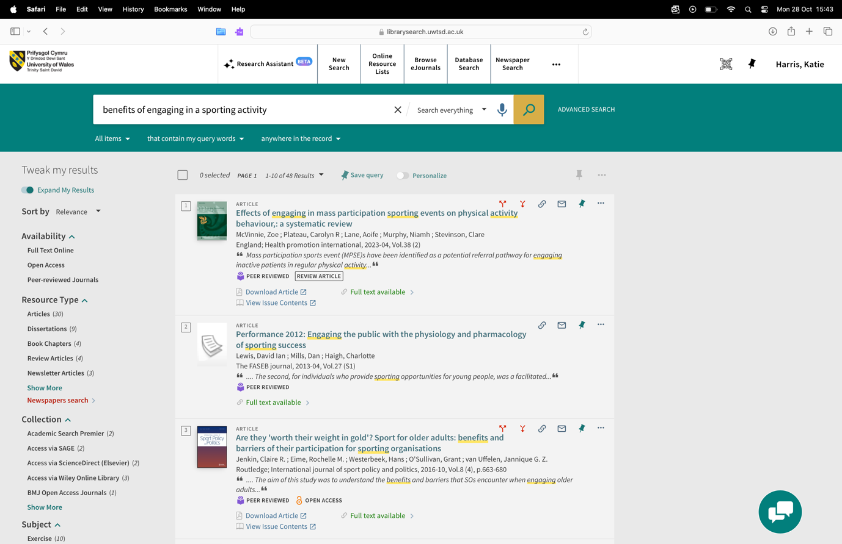
I will use this article to provide empirical evidence about physical activity to support my key points within that paragraph. More specifically, I will paraphrase how engaging in a sporting activity can help fitness performance and weight loss. This will not only show my understanding of this specific topic but will also help present my key points in a scientific manor.

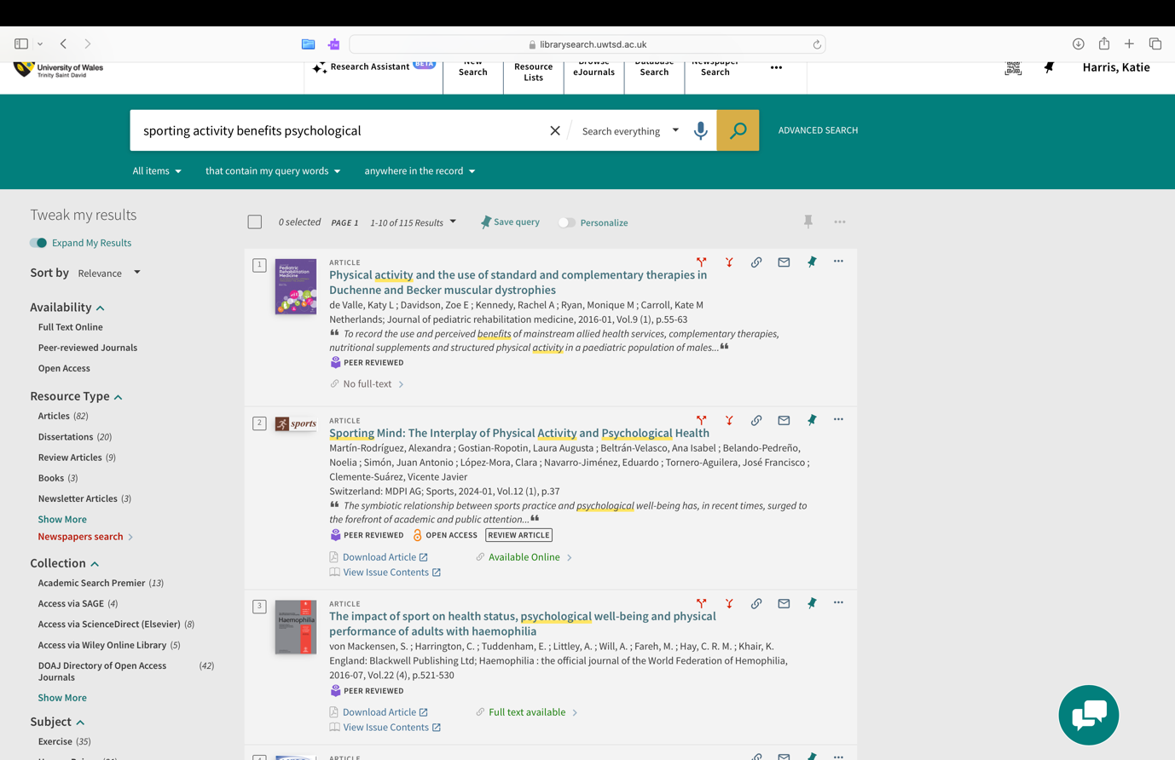
I will use this article to emphasise the importance of the psychological benefits from engaging in a sporting activity which will allow me to organise my essay logically. In particular, I will use this evidence to encourage the reader to further acknowledge and understand the significance of participating in a sporting activity. By using this article, it will also ensure credibility and support my key points on the psychological benefits.

Summary of sources:
I will decide what sources to use by considering various different factors including whether the source is credible, reliable and trustworthy, as well as up to date and relevant to my chosen topic. I will use a range of sources including books, journal articles and peer reviewed articles.

Reference list:
Bergeron, C. D., Tanner, A. H., Friedman, D. B., Zheng, Y., Schrock, C. S., Bornstein, D. B., Segar, M., & Swift, N. (2019). Physical Activity Communication: A Scoping Review of the Literature. Health Promotion Practice, 20(3), 344–353. https://doi.org/10.1177/1524839919834272

Cottrell, S. (2019). The Study Skills Handbook (5th ed.). Bloomsbury Publishing.

Hautbois, C., Djaballah, M., & Desbordes, M. (2019). The social impact of participative sporting events: a cluster analysis of marathon participants based on perceived benefits. Sport in Society, 23(2), 335–353. https://doi.org/10.1080/17430437.2019.1673371

Lovell, B., Moss, M., Wetherell, M.A. (2011). The psychosocial, endocrine and immune consequences of caring for a child with autism or ADHD. Psychoneuroendocrinology, 37, 534-542

Motivation Boosters. (2024). https://cms.bps.org.uk/sites/default/files/2024-08/Teachers%20Toolkit%20-%20Motivation%20Boosters.pdf

‌ Motivation Science. (2023). Oxford University https://doi.org/10.1093/oso/9780197662359.001.0001

Wetherell, M. (2022). The bear necessities of stress. Psychologist,
35(10), 42-45.https://www.bps.org.uk/psychologist/bear-necessities-stress

Yang, J., Ju, F.-Y., & Tian, Z.-G. (2022). Sports and Social Interaction: Sports Experiences and Attitudes of the Urban Running Community. International Journal of Environmental Research and Public Health, 19(21), 14412-. https://doi.org/10.3390/ijerph192114412

Acknowledgment of AI:

I confirm that I have not used any form of AI in my work and that all work presented is my own.

‌

