
Programme Name: Master of Business Administration
Module: LCMB7003 Strategic Management
Assignment Title: Strategic Management Analysis of Apple Inc.
Student Name: Chetnaben Anilbhai Fadke
Student ID: 2430959
Word Count: 5477

Table of Contents
Section 1: Report 2
1.0 Introduction 2
2.0 Organisational Context and Overview 2
2.1 Organisational overview: Apple Inc 2
2.2 Industrial Overview: Technology Industry 4
3.0 External and Internal Environment Analysis 5
3.1 External Environment Analysis using PESTLE 5
3.2 Critical Success Factors and Challenges for Apple 7
3.3 Value Chain Analysis for Internal Environment Assessment of Apple 8
3.4 VRIO Analysis for Strategic Capabilities 9
3.5 Linking internal strengths to competitive advantages 10
4.0 CSR and Sustainability objectives 11
4.1 Apple's CSR strategy 11
4.2 Alignment with business objectives 12
5.0 Comprehensive and holistic view of the organisation 13
6.0 Strategic Choices and Implementation 15
6.1 Business level 15
6.2 Corporate level 16
6.3 Recommending an appropriate choice to Apple 17
6.4 Change management and impact on strategic implementation 17
7.0 Strategic Evaluation and Recommendations 18
7.1 Strategic evaluation: SWOT 18
7.2 Strategy improvement and competitive enhancement: Ansoff’s Matrix 19
8.0 Conclusion 22
Section 2: Reflective Account 23
2.1 Kolb’s Cycle of Reflective Practice 23
2.2 Concrete Experience 23
2.3 Reflective Observation 24
2.4 Abstract Conceptualisation 25
2.5 Active Experimentation 26
References 27

Section 1: Report

1.0 Introduction
The context of strategic management involves processes concerning planning, monitoring, analysing, and assessing towards the attainment of desired organisational goals and objectives. In this context, the purpose of the present report is inclined towards the strategic management practices of the multinational organisation, Apple Inc. The report will offer a comprehensive insight into the chosen organisation, the external and internal environment of operation and the CSR strategy and sustainability objectives of the venture. Including operational performance measures, strategic choices of the firm and recommendation in the enhancement of the current organisational strategy.

2.0 Organisational Context and Overview

2.1 Organisational overview: Apple Inc
The multinational technology company Apple Inc was founded in the year 1976 as Apple Computer Company by Steve Jobs, Steve Wozniak and Ronald Wayne, with its official headquarters in California, United States (Apple, 2026). The period of 200 marks a greater transformation in the development of Apple's venture, where its success is driven by the release of the iPhone, dominating legacy and establishing a new design, particularly within the smartphone market (Reed, 2024). Since then, the mission of Apple is to "bring the best user experience to customers through innovative hardware, software, and services”, and its vision is driven by a process to “create products that empower people and enrich their lives with an emphasis on design leadership, privacy, and sustainability” (Rowland, 2025). The business model of the venture is built around product design, vertical integration, and innovation, based on which consistency towards the creation of a unique and desirable brand is ensured (Apple, 2026). Through this business model, Apple is able to deliver groundbreaking products and a seamless experience to customers, thereby being the most valuable and influential brand globally.

Figure 1: Apple brand logo
(Source: Apple, 2026)
In the Initial phase, Apple is known for designing, manufacturing and marketing products, such as smartphones, tablets, personal computers, and wearable devices. Its core brand portfolio comprises iPhone, iPad, Mac, iPod, Apple Watch, and Apple TV. The global operation of Apple includes the Americas, Europe, the Middle East, Africa, and Asia-Pacific (Global Data, 2024).
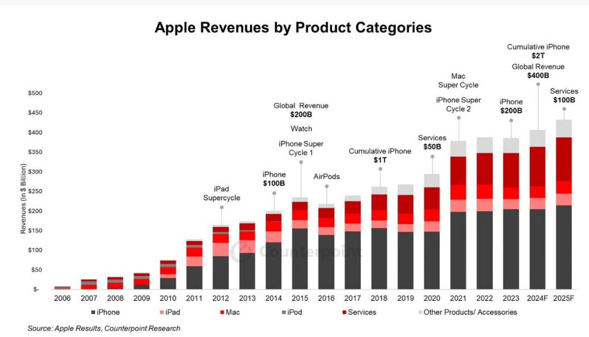
Figure 2: Apple revenue
(Source: Quiller Media, 2025)
The above statistical representation highlights that in the financial year of 2024 the annual revenue of Apple exceeded $400 billion in response to products, such as the iPhone. Additionally, the company has exceeded the growth of $100 billion in revenue in the financial year of 2025, contributing to the core aspects of its global net profit (Quiller Media, 2025). This showcases the effort of Apple to fulfil market commitments, leveraging on unique inventions, thereby enhancing its market capitalisation.

2.2 Industrial Overview: Technology Industry
The global technology industry is witnessing a growth of $6.31 trillion in 2026, and it's further expected to rise to $48.39 trillion by 2031. The growth in this regard is found to be driven by the Compound Annual Growth Rate (CAGR) 5.85% during this specific period (Mordor Intelligence, 2026).
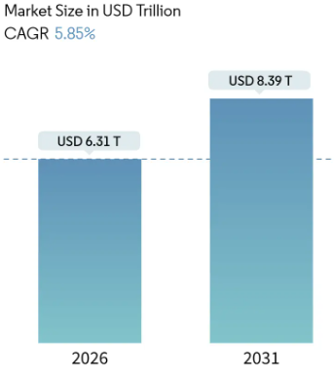
Figure 3: Technology industry growth
(Source: Mordor Intelligence, 2026)
Based on this, the technology industry where Apple operates highlights the presence of intense competition. Apple faces a major rivalry from tech giants such as Samsung, Microsoft, Google, and Amazon, including Huawei, Lenovo and Sony across consumer electronics, software, and online services sectors (FranZoom, 2024). Amidst the competitive threats, Apple was able to secure a market value of $3 trillion in 2023 (Reuters, 2023).
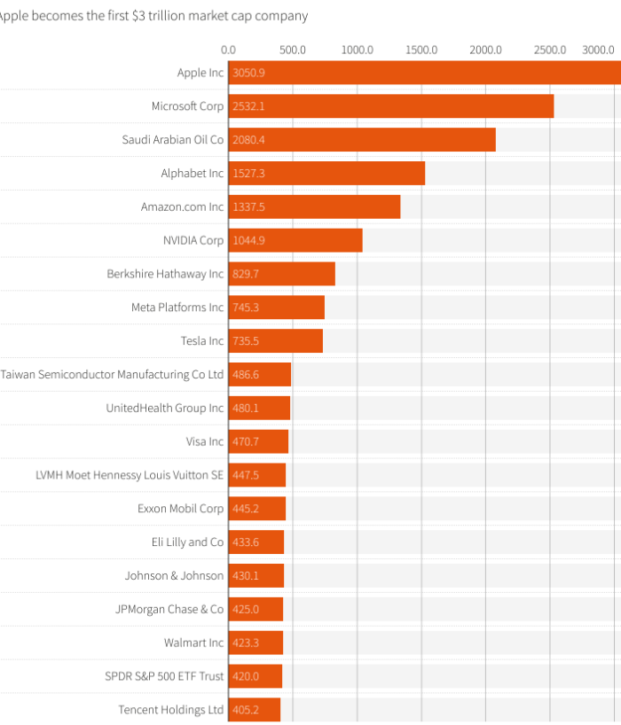
Figure 4: Apple market position
(Source: Reuters, 2023)

3.0 External and Internal Environment Analysis

3.1 External Environment Analysis using PESTLE
PESTLE | United States
Political | - As of 2024, the USA has a political stability index of -0.10 on a scale of 2.5 (strong) to -2.5 (weak) (The Global Economy, 2024).  - This shows an unstable political condition in the US. (Unfavourable)
Economic | - The economic growth rate in the US has declined from 2.89% in 2023 to 2.80% in 2024 (The Global Economy, 2024a).  - Inflation in the US is at 2.9% as of 2024, which is higher than the economic growth rate (The Global Economy, 2024b). (Unfavourable)
Social | - With 322 million internet users, 94% of the American population is avid users of the internet (Statista, 2025).  - The USA has a 317 million-strong smartphone user base (Statista, 2025a). (Favourable)
Technological | - The US government has made a decision to invest $600 billion by 2028 towards the expansion of AI technology, workforce and related infrastructure (White House, 2026).  - The US is one of the largest tech-advanced countries in the US. (Favourable)
Legal | - The Rule of Law Index of 0.96 on a scale of -2.5 to 2.5 shows that the US is a moderately law-compliant society (The Global Economy, 2024c).  - Several legal factors in the US effectively regulate technological development (Favourable)
Environmental | - The US has officially stepped away from its environmental sustainability commitments, cutting funding for several environmental action initiatives (Climate Action Tracker, 2025).  - This is beneficial for businesses to focus on business growth and financial development (Favourable)
Table 1: PESTLE Analysis
(Source: Self-Developed)
From Table 1 above, it can be seen that the Political and Economic environment in the US is unfavourable for Apple Inc., mainly because the political instability can lead to protests, strikes and riots, which can contribute severely to the disruption of organisational workflow. Furthermore, the higher inflation rate than economic growth, shows reduced purchasing power of consumers in the US, which is also unfavourable for Apple Inc. However, the Social, Technological, Legal and Environmental domains of the US show favourable conditions for business growth of Apple Inc. The high smartphone user count, alongside the governmental push for AI expansion, the law-compliant nature of the citizens, and the lax environmental commitments support business activities at Apple Inc. while minimising expenses for the firm towards litigations and environmental initiatives.

3.2 Critical Success Factors and Challenges for Apple
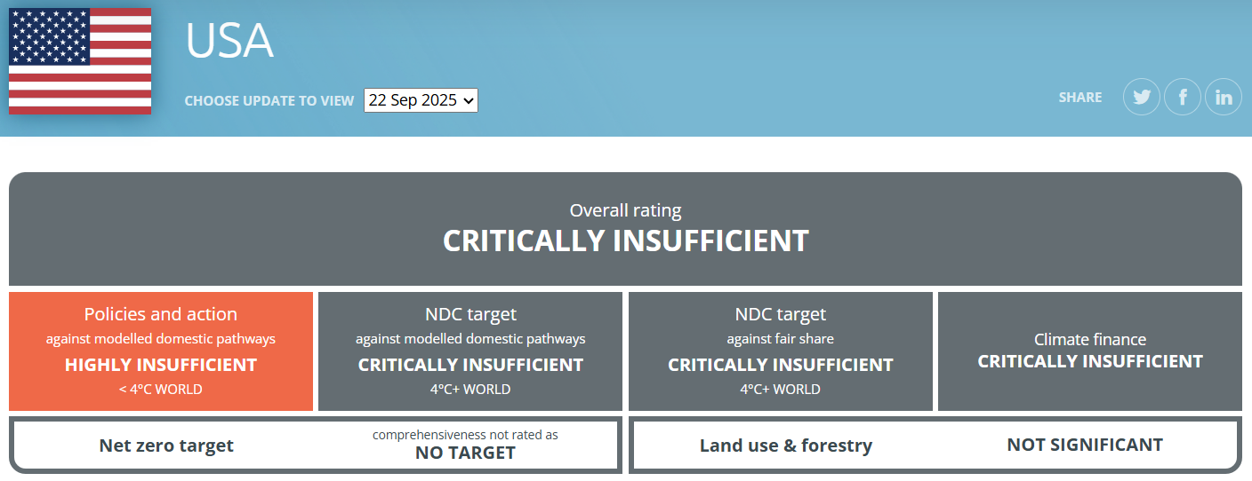
Figure 5: Climate Action of the USA
(Source: Climate Action Tracker, 2025)
As seen in Figure 5 and from the PESTLE Analysis, the USA has officially withdrawn its funding for climate action and has also stepped back on the country’s environmental sustainability projects ( Climate Action Tracker, 2025). This, in particular, is a critical success factor for Apple Inc., as this will reduce the firm's spending towards environmental sustainability initiatives, enabling the firm to reallocate the funds for R&D and business development. Moreover, the USA has a large base of smartphone and internet users, accounting for 317 million users and 322 million users, respectively, alongside government funding of $600 billion to improve AI infrastructure and skilled workforce within the country (Statista, 2025; White House, 2026; Statista, 2025a). This also provides a favourable success factor for the proliferation of Apple Inc. Similarly, the legal environment in the US presents the country as a law-abiding society, which in turn shows that the chances of Apple Inc. being forced to pay legal fines due to controversies and non-compliance with legislation are slim. These present the critical success factors which externally support the business growth of Apple Inc. On the other hand, as seen from the PESTLE analysis, there is an inflation of 2.9% against an economic growth rate of 2.8% in the US, which increases product price and reduces the purchasing power of customers. Kharpal (2025) supports this, stating that the smartphone prices are set to rise by 6.9% in 2026, especially due to AI-powered chip shortages.85% of Americans, according to Pew Research, have considered that the politically motivated violence is on a significant rise in the USA (Copeland and Kiley, 2025). This further validates the challenge of workflow disruption for Apple Inc., resulting from the unstable political environment in the country.

3.3 Value Chain Analysis for Internal Environment Assessment of Apple
Primary Activities
Inbound Logistics | 3M, Alpha and Omega Semiconductors, Amphenol Corporation, ams-OSRAM AG, and Broadcom Limited, among 98 supplier firms, are engaged in providing components and raw materials for production (Apple Inc, 2022).
Operations | Apple has its production and manufacturing facilities across Arizona, Pennsylvania, Colorado, Kentucky, Texas, Oregon, Indiana and Utah (Apple Newsroom, 2025).
Outbound Logistics | Apple has its warehouses for distribution in Elk Grove and Fremont, California, as well as Harrisburg, Pennsylvania. It also uses FedEx and other distribution partners for national and international distribution. Omoth (2020) reported that Apple also aims to use its 271 retail stores for distribution.
Sales and Marketing | Apple engages in Sales and Marketing through its significant global brand image and brand loyalty derived from creative and innovative use of marketing content (Greg, 2020).
After-sales Support | Apple provides a toll-free customer care helpline, while also providing after-sales support through emails and website booking options (Apple Inc, 2026).
Secondary (Supporting) Activities
Firm Infrastructure | Apple has invested $500 billion across 50 US States for increasing its manufacturing spaces, television production studios, data centres and corporate facilities (GCR, 2025).
HR Management | Diongson (2026) reported that Apple has around 80,000 employees under its direct payroll in the US, with nearly 450,000 more employees working for its suppliers.
Technology | Sherman (2025) reported that Apple committed a $500 billion investment in the US, while creating 20,000 new jobs, and developing a tech-advanced 250,000 sq ft. manufacturing facility in Houston, Texas.
Procurement | Apple focuses on the ethical procurement of electronic parts and chips, as well as other raw materials, from its large list of suppliers.
Table 2: Value Chain Analysis for Assessing Internal Environment
(Source: Self-Developed)
Table 2 presents the strategic capabilities of Apple in its internal environment, including its massive workforce, significant brand loyalty, diversified supplier base, and innovative and widespread distribution network. Moreover, the firm also sports a strong and ever-expanding infrastructure and technological development, which also acts as a major strategic capability for the firm. These strategic capabilities and resources provide Apple with the internal capabilities for business development and also allow it to be resilient in the face of external threats from the political and economic domains.

3.4 VRIO Analysis for Strategic Capabilities
Capabilities | Valuable | Rare | Inimitable | Organised | Competitive Advantage
Massive Workforce | Yes | Yes | No | No | Temporary Competitive Advantage
Significant Brand Loyalty | Yes | Yes | Yes | No | Unused Competitive Advantage
Diversified Supplier Base | Yes | Yes | Yes | Yes | Sustainable Competitive Advantage
Innovative and Widespread Distribution Network | Yes | Yes | No | No | Temporary Competitive Advantage
Ever-expanding Infrastructure | Yes | No | No | No | Competitive Parity
Technological Development | Yes | Yes | Yes | Yes | Unused Competitive Advantage
Table 3: VRIO Analysis
(Source: Self-Developed)
Based on the internal strategic resources and capabilities identified in Apple Inc., Table 3 conducted a VRIO Analysis, which shows that the expanding infrastructure of Apple, as seen from its recent investments of $500 billion in developing more manufacturing facilities, production studios, and corporate facilities, is a competitive parity, as it is valuable but not rare, provided any established firm can achieve this. Similarly, it was found that Apple aimed to innovate its distribution by starting direct shipment of orders from its 271 retail stores in the US, while it also owns a massive workforce of over 80000 employees within the country. These were found to provide the firm with temporary competitive advantages, as these are valuable and rare, yet easily imitable. In this regard, strategic capabilities of Apple, which were found to be valuable, rare and inimitable yet clearly unused or unorganised for leverage, include the firm’s brand loyalty and its technological developments. Finally, Apple, as of 2022, had 98 suppliers globally, wherein multiple suppliers provided components and raw materials to the US market, showcasing the sustainable competitive advantage resulting from a valuable, rare, inimitable and organised, diversified supplier base.

3.5 Linking internal strengths to competitive advantages
Pratono (2024) explained in their research that diversification of the supplier base can reduce the risk of supply chain disruptions due to the presence of alternate supply channels and reduced dependence on a particular supplier. Therefore, the presence of 98 suppliers in Apple, as seen from the VRIO framework, is a source of competitive advantage for Apple (Apple Inc, 2022). Mandung et al. (2025) also identified that technological innovations can become an excellent source of competitive advantage for a firm. In this regard, the technological developments in Apple, as seen from the Value Chain Analysis, and a workforce of 80,000 employees supporting such tech innovation within the US market of Apple, can also be considered as a significant source of competitive advantage for the firm (Diongson, 2026). The firm’s internal capabilities, such as its outbound logistics and brand presence, as well as its financial capability to finance large-scale infrastructure development in the US, are also major sources of competitive advantages for Apple, as seen from the VRIO Analysis conducted in Table 3. Atanasovski and Veselinova (2024) further supported this, stating that branding towards the development of a strong corporate brand image of a firm can become an excellent source of sustainable competitive advantage for a firm. This shows that the internal capabilities of Apple are linked to its sources of competitive advantages.

4.0 CSR and Sustainability objectives

4.1 Apple's CSR strategy
The Corporate Social Responsibility (CSR) strategy of Apple is influenced by aspects of environmental responsibility, social impact, and ethical practices. The company focuses on the reduction of carbon footprint under the plan of 2030, and till date it has met the reduction of global greenhouse gas emissions by 60%. It has further achieved environmental goals by using 99% of recycled rare earth elements and recycled cobalt in terms of designing batteries (Giorgi, 2025). Apple emphasises the continuous use of recycled and renewable materials, without compromising the quality of its products or its brand performance, thereby showing its effort towards the reduction of its carbon footprint. The Zero Waste program of Apple evidence the approximate reduction of 600,000 metric tons of waste from landfills, ensuring the credible participation of suppliers in the acceleration of further progress as a part of sustainable responsibility (Giorgi, 2025).
Additionally, in the social context, Apple is investing on Racial Equity and Justice Initiative programme. Through this strategy, the venture is providing support towards minority businesses and addressing systemic barriers, including the reformation in education, economic empowerment, and criminal justice segments. The company has surpassed $200 million in investments across five global nations since 2020 (Apple, 2023).
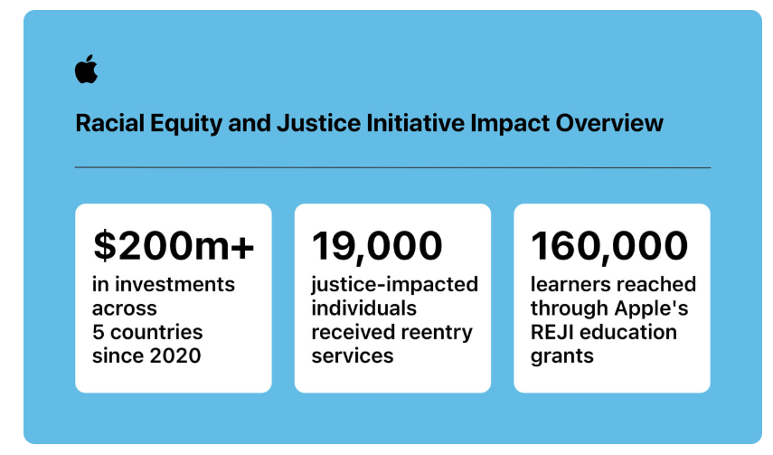
Figure 6: Apple Racial Equity and Justice Initiative programme
(Source: Apple, 2023)

4.2 Alignment with business objectives
The enforcement of a significant CSR strategy by Apple has supported its objectives concerning the enhancement of brand reputation and business growth by developing products that appeal to environmentally conscious consumers (Apple, 2025). This has supported Apple to become a recognisable and influential brand globally, with the generation of $416 billion in profit in 2025, approximately an increase by 6.5%. The responsible commitment fulfilled by Apple has also helped boost sales of its major products, such as the iPhone, by 50%, contributing to its growth by $209 billion (Curry, 2025).
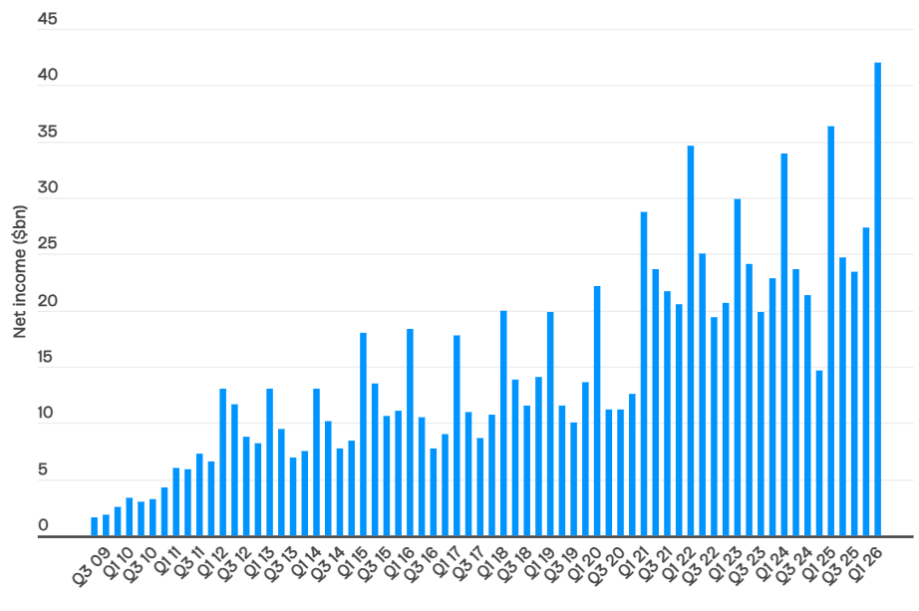
Figure 7: Growth in Apple's net income
(Source: Curry, 2025)

5.0 Comprehensive and holistic view of the organisation
Perspectives | Objectives | KPI | Targets | Initiatives
Financial | To sustain long-term financial growth using the Product and Service Ecosystem. | Annual Revenue  Net Profit Generation | Achieve revenue above $480 billion and improve profitability by 15%. | Apple is investing in Apple TV+, developing new original content, and securing broadcasting rights for sports events (Markman, 2026).
Customer | To improve customer loyalty, using enhanced customer experience based on ecosystem integration. | Net Promoter Score, Customer Satisfaction Score  Customer Retention Rate | Achieve 30% improvement in customer satisfaction and retain 40% customers from the previous fiscal year. | Mathur (2023) reported that Apple utilises seamless ecosystem integration, a unique brand store experience, reliable customer-centric support, and product quality to achieve customer satisfaction and 90%+ customer retention.
Internal Business Processes | To improve sustainability and operational efficiency across the company's supply chain. | Carbon Emission Reduction  Product Development Time | Make clear progress towards reducing Carbon Emission by 75% within the next 2 years.  Reduce product development time by 30% | Materials recycling, low-carbon transportation and renewable energy are used by Apple to achieve reduced carbon emission (Apple Inc., 2026a). Apple is aiming for investments in AI and engaging in Product Innovations for product diversification to improve operational efficiency (Smith, 2025).
Learning and Growth | To enhance innovation capability at Apple by conducting organisation-wide skill development. | Employee Participation in Upskilling  Employee Productivity | Achieve 60% improvement in employee innovativeness and productivity. | Apple not only offer Training for its employees using different programs but has also launched Supplier Employee Development Program to support the employees working for the firm’s suppliers.
Table 4: Balanced Scorecard Analysis for Apple’s Mission and Strategy
(Source: Self-Developed)
The above Table presents the balanced scorecard analysis for Apple based on the firm’s current mission and strategy. In this regard, it can be identified that from a financial perspective, towards improving revenue generation and profit maximisation, Apple has engaged in expanding its service offerings, especially regarding Apple TV+, based on new original content production and sports broadcast rights. Furthermore, from the customers' perspectives, towards achieving improved customer satisfaction and retention, Apple uses its product quality, alongside brand store experience, customer-centric support and Apple ecosystem. Furthermore, from the perspective of Internal business processes, the firm, towards achieving improved operational efficiency, engages in AI integration and product innovation, while sustainability is achieved by the firm, using low-carbon transportation, recycling of materials and renewable energy usage. Finally, the firm uses multiple employee training programs and the Supplier Employee Development program to improve Learning and Growth perspectives and achieve improved employee productivity across the firm and its value chain.

6.0 Strategic Choices and Implementation

6.1 Business level
In the evolving technology marketplace, Apple has ensured a differentiation strategy with the design and development of innovative, high-end products and services. Towards the pursuit of a loyal customer base, the company has ensured product differentiation through a premium pricing strategy in terms of staying ahead of its competitors. The focus of the company is to acknowledge that customer purchasing capacity has allowed it to succeed in terms of meeting the demands of products, amidst the higher competitive environment (Nielson, 2020). Besides, Apple also prioritises a focus strategy in terms of targeting the premium customer segment by meeting their specific needs concerning the development of high-quality products and services. The development of products, such as Apple Fitness+, evidences the venture's strategic focus in aligning with the needs of a specific customer segment, especially fitness enthusiasts and tech-savvy individuals (Apple, 2020).
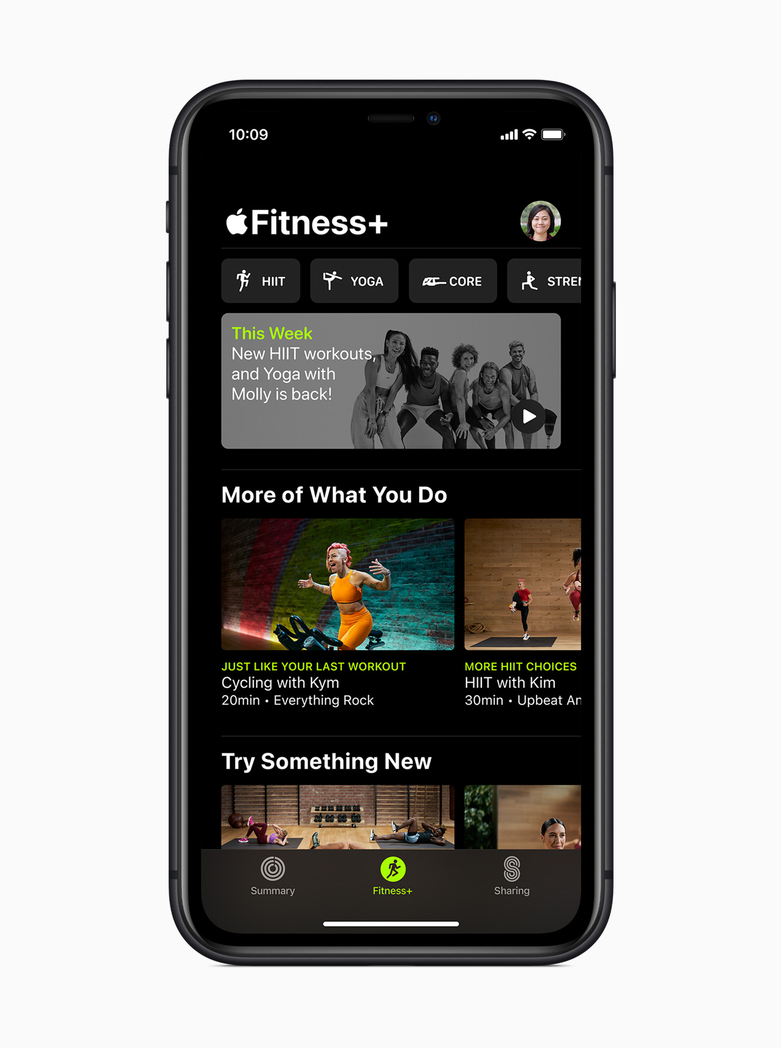
Figure 8: Apple Fitness+
(Source: Apple, 2020)

6.2 Corporate level
In this aspect, Apple highlights a focus towards diversified product segments by expanding its concentration from the development of personal computers to the smartphone range, in addition to wearables and services. The diversification of Apple's service segment in response to the digital context includes services such as iCloud storage, Apple Music, the App Store, Apple Arcade, Apple TV+, and AppleCare, which is emerging as a significant driver in the support of company growth with an emphasis on evolving trends, concerning subscription-based models and digital content consumption, thereby enabling Apple to reduce dependency on iPhone for revenue generation (Song, 2024). Simultaneously, Apple is securing a strong global presence and can gain significant share in the competitive landscape of the international technology marketplace. For example, Apple's effort concerning international expansion in the global marketplace, such as China, has supported the venture to secure 80% of its manufacturing footprint (Bloomberg, 2023). Moreover, the success of Apple in China is driven by its emphasis to develop localised products and services, such as partnering with Alibaba to roll out artificial intelligence features as per Chinese customer needs (Reuters, 2025).

6.3 Recommending an appropriate choice to Apple
Apple is recommended to focus on corporate-level strategic choices in response to the expansion of its service segment. Li et al. (2021) suggested that the enhancement of corporate strategy and enterprise innovation is highly crucial in terms of scaling benefits pertaining to sales and higher returns. For Apple, this means relying on existing strengths, particularly growing the corporate ecosystem and enhancing customer loyalty, toward the expansion of its product portfolio. For example, the venture can concentrate on the development of a new service portfolio, such as augmented reality experiences in supporting the feasibility of services, including Apple Pay and financial services.

6.4 Change management and impact on strategic implementation
The transition of Apple from Intel processors to Apple silicon in Mac computers highlights its ability in terms of creating product differentiation. This strategic implementation has impacted the position and brand impact of the company in terms of delivering industry-leading performance and the development of new powerful technologies (Apple, 2020). Besides, the shift of Apple from hardware sales to services, such as Apple TV, Apple Music, and Apple News, has been remarkable in the support of global expansion and growth. This has redefined the brand image of the company, as it is able to offer an enriching experience to users (850 million weekly), showing its commitment towards the introduction of new innovations and intelligent enhancements (Apple, 2026).
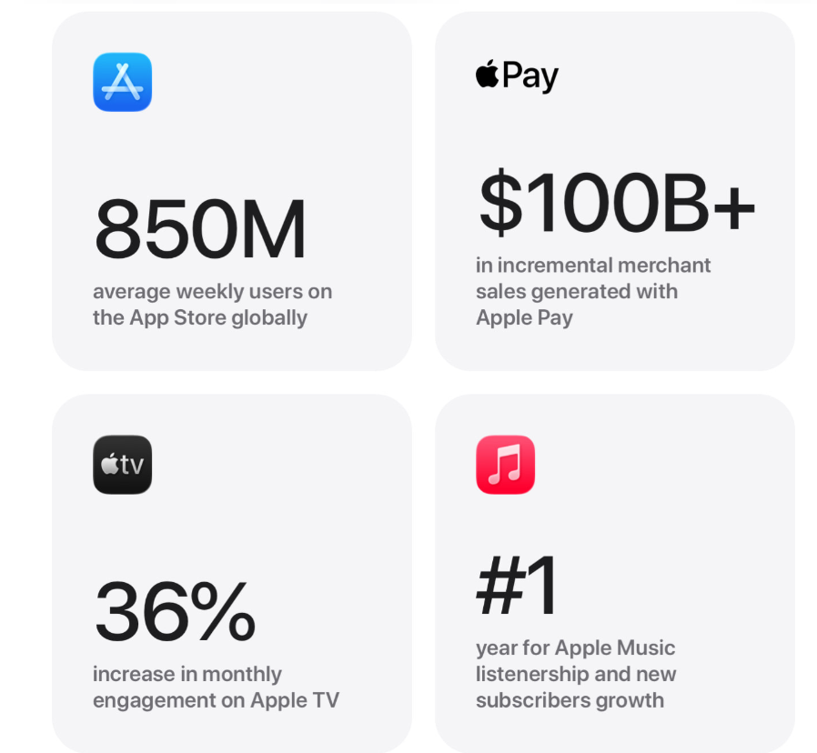
Figure 9: Users' growth in Apple service
(Source: Apple, 2026)

7.0 Strategic Evaluation and Recommendations

7.1 Strategic evaluation: SWOT
Strengths | Weaknesses
- Loyal customer base and premium brand image (Apple, 2026)  - An integrated ecosystem supported by hardware, software, and services for driving customer loyalty and engagement (Krause, 2024) | - Higher dependence on sales of specific products, such as the iPhone (Bary, 2024)  - A premium pricing strategy can hinder market share expansion in price sensitive region (Wang, 2025)
Opportunities | Threats
- Growing demand for streaming content (Ganguly, 2026)  - Roll out within the financial service market in response to the growing payment ecosystem (Modrich, 2022) | - Significant antitrust issues in the United States and the European Union (Redaktion, 2026)  - Intense rivalry pressure from tech giants, such as Samsung, Microsoft, Google, and Amazon (FranZoom, 2024)
Table 5: Strategic evaluation of Apple
(Source: Self-developed)

7.2 Strategy improvement and competitive enhancement: Ansoff’s Matrix
Market Penetration:
In terms of attracting price-sensitive customers, Apple can focus on a competitive pricing strategy. This will enable Apple to offer discounts for products, such as iPhones, particularly in emerging markets. For example, in a price-sensitive market, such as the Indian market, Apple will have to offer convenient pricing options. The recent survey report has highlighted that 70% of Indian consumers prioritise price during the process of making buying decisions (Vaishanav, 2024). Additionally, Apple is suggested to focus on targeted marketing campaigns to increase brand awareness and drive sales (Nyange, 2024). Apple can take evidence from other companies, such as Samsung, in terms of offering promotions and discounts on its flagship smartphones through campaigns such as Samsung Fab Grab Fest (Shrivastava, 2025).
Market Development:
Apple can focus on the enhancement of geographic expansion, particularly in the emerging Southeast Asia market. The market report shows that the smartphone market size of Southeast Asia is expected to grow by 90.5 million Units by 2033, at a growth rate of 5.63% (IMARC Group, 2025). The growth in this regard is driven by rising demand towards wireless communication technologies and the development of relevant app stores (IMARC Group, 2025). Acknowledging this growth in the region, Apple can focus on product localisation to target a new customer segment by leveraging partnerships with local companies to boost market presence. The Chinese smart manufacturing company Xiaomi has sought an aggressive market expansion in emerging market segments, such as Africa and Southeast Asia (Xiaomi, 2024).
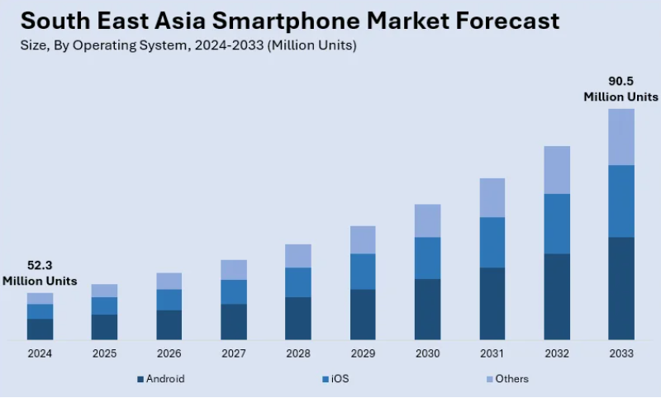
Figure 10: Southeast Asia smartphone market size
(Source: IMARC Group, 2025)
Product Development:
Apple can improve its existing innovative product portfolio with the integration of new features leveraging augmented reality towards the development of wearables for enhancing the experience of the health-focused customer segment. In this regard, Apple can improve its existing products, such as Apple Fitness+, with the introduction of new health monitoring features, driven by augmented reality. From the report, it can be evidenced that the AR fitness service market requires a valuation of $2,902.3 million in 2025 and is expected to reach $1,750.4 million in 2035 at 15.0% growth rate (Pandita, 2025). The growth can be leveraged by Apple towards the introduction of AR headsets, connected fitness mirrors, and corporate wellness platforms for dominating the market in response to immersive workout experiences.
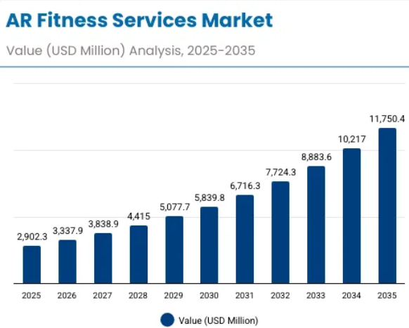
Figure 11: AR Fitness Services Market
(Source: Pandita, 2025)
Diversification:
Apple can diversify its expertise into new product segments, such as smart home devices. The growth possibility for Apple in this regard can be highlighted with the increasing market size of global smart home devices from $179.73 billion in 2026 to $278.32 billion by 2034, at a growth rate of 5.62% (Fortune Business, 2025). In this regard, Apple can consider the example of Amazon in diversifying its product segments into cloud computing (AWS) and streaming services (Prime Video) segments (Kumar et al., 2024).
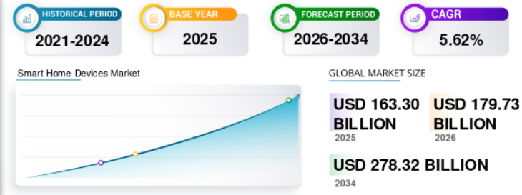
Figure 12: Global smart home device market
(Source: Fortune Business, 2025)

8.0 Conclusion
Based on the above discussion, it can be identified that a strategically managed firm like Apple Inc. can achieve a sustainable global leadership using ecosystem integration, product innovation and a significant brand position. In this regard, it was found that Apple initially transformed from a computer manufacturer to a diversified technology product provider offering premium products and services. Similarly, the external environment of Apple showed a favourable social, technological, legal and environmental condition while also showcasing political instability and economic tension. Moreover, the value chain analysis and VRIO analysis showed that a diversified supplier base, brand presence, technological prowess and the strengthening infrastructure are the key strategic resources and capabilities providing competitive advantage to Apple. Moreover, Apple was found to be committed to recycling, social equity and carbon neutrality regarding its CSR initiative. It was also found by SWOT and Ansoff’s Matrix that expansion of business into emerging markets, and investments in AR/VR, as well as smart home technologies, are opportunities that Apple Inc. can leverage for strategic growth. Thus, it can be concluded that Apple Inc.’s strategic success on the global market can be attributed to its innovation capabilities, integrated ecosystem, and ability to align itself with the technological and market evolutions in the external environment.

Section 2: Reflective Account

2.1 Kolb’s Cycle of Reflective Practice
Egan et al. (2023) explained that Kolb’s Cycle of Reflective Practice, also known as Kolb’s Learning Cycle, includes four different phases, carried out cyclically, starting with Concrete Experience, which details the open involvement of oneself in an experience. The second stage in this cycle is Reflective Observation, which involves reflecting on the experience from multiple perspectives, followed by the third stage, Abstract Conceptualisation, which involves the development of actionable theories from the reflections previously conducted (Egan et al., 2023). The final stage of this cycle is Active Experimentation, which involves testing the theories and altering pre-existing notions, beliefs and practices accordingly, before going through another experience (Egan et al., 2023). This reflective piece will also focus on conducting such a reflective process.

2.2 Concrete Experience
The task I had was to provide a critically analytical report on the strategic management practices of an organisation of my choice. As part of this report, I had to analyse and evaluate the internal and external environments of the organisation, its competitive position, resource competencies, as well as its approach for achieving sustainable competitive advantages. In this regard, I chose Apple Inc. as the organisation I was interested in discussing and reporting on. This was mainly because I have been following Apple for quite some time, and I realised that the firm had held onto its IOS model as a distinctive feature, turning it into a competitive advantage using its products and services ecosystem, against its competitors who have all been relying on Android OS.
This piqued my interest, and choosing Apple, I went on to investigate recent news articles, recent years' annual reports and company press releases, alongside some moderately older sources of secondary literature, which included news articles published as old as 2017. These information, alongside the theoretical knowledge regarding management concepts gained from the module and personal research, further helped me map the current external environment faced by Apple in the US, alongside the firm’s internal strategic resources and capabilities.
This also helped me to further evaluate Apple’s Sustainability Strategies, while analysing the firm’s strategies on a business and corporate level. Moreover, this also helped me use the Balanced Scorecard to better justify the firm’s recent initiatives across the financial, consumer, internal business process, and learning and growth perspectives. Finally, based on the insights across all these strategic analyses, a comprehensive strategic evaluation of Apple Inc. was also conducted, where I used SWOT to detail the current strengths, weaknesses, opportunities, and threats of the firm. This further revealed to me Apple’s main sources of competitive advantages, alongside the firm’s positive aspects, which have allowed it to sustain global success for a long-time.

2.3 Reflective Observation
In the process of writing this report, I reflected critically on the role of strategic management frameworks in interpreting the real-world decisions of MNCs like Apple Inc. During the research process, I found that Apple’s long-term success cannot simply be attributed to technological innovation, but also to the firm’s actions to carefully integrate a curated product and services ecosystem, alongside long-term R&D investments and brand positioning. Herein, while using strategic frameworks like PESTLE, Value Chain Analysis and VRIO analysis, I also realised that external environmental conditions and internal competencies of a firm have ways to exert their influence towards shaping the organisational competitiveness of the firm. While writing the report, I noticed that the ability of Apple to maintain an excellent customer loyalty and retention rate using a seamless integration between its hardware and software ecosystem has significantly influenced the firm’s overall competitive strategy. This further led me to realise that differentiated business strategies can generate strong competitive forces for a firm. Moreover, the way in which Apple utilises its CSR initiatives helped me realise the importance of balancing financial success with CSR for a firm. However, this process also highlighted my significantly high reliance on secondary sources and publicly accessible reports, which relied on a high level of logical reasoning and inferences to make sense of internal strategic decisions of the firm. While this allowed me to exercise my theoretical knowledge and apply it to understand real-world decisions, I believe the addition of primary research data would have improved the accuracy and credibility of my inferences.

2.4 Abstract Conceptualisation
Based on the analysis conducted during the reporting process, the reflective observations have allowed me to conceptualise abstract theoretical insights in relation to competitive advantages and strategic management of Apple Inc. Firstly, through the reflection I reaffirmed my understanding of the resource-based view theory, which posits that sustainable competitive advantage can be derived from strategic integration of resources, capabilities and systems which are valuable, rare, inimitable and organised. I found this clearly reflected in the case of Apple Inc., which led me to my first main abstract conceptualisation. I realised that Apple’s ability to compete in the global market largely comes from its strategically curated integration of product and services ecosystem, despite the presence of its flagship products like iPhone and MacBook. For instance, the user experience of iPhone is not shaped solely by the product quality but by the array of applications available solely on Apple Store, and the array of original and borrowed content available on Apple TV+. I also realised in this regard that differentiation strategy in a firm-setting plays a critical role in shaping the brand position of a business. For instance, in the case of Apple, I found that Apple can afford to have a premium price, and yet a strong brand loyalty, by increasing the switching costs through the differentiation brought by the IOS interface. This further allowed the firm to maintain a 92% customer retention rate despite premium pricing. Furthermore, I also observed in retrospect that Apple Inc.’s CSR approach reflects the global need to balance financial gains with CSR, simply for the strategic development of firms.

2.5 Active Experimentation
Based on the above insights gained from this reflection, I aim to apply this strategic management framework more critically in future organisational analysis reports, especially including primary and secondary data if possible. I would also consider integrating strategic management models like Balanced Scorecard, VRIO and PESTLE in a more appropriately structured logical sequence of the reports. In the future, I would also like to compile a report based on primary data from Apple, towards testing my Apple-specific hypothesis. Moreover, I would experiment further, through comparative reports between multiple organisations within the same industry and country, across different lenses, like a cross-cultural lens or a lens of varied leadership styles. I believe this would improve my analytical capabilities and position me better for a business consultancy career or a strategic management career.

References
Apple (2020). Apple announces Mac transition to Apple silicon. [online] Apple Newsroom. Available at: https://www.apple.com/newsroom/2020/06/apple-announces-mac-transition-to-apple-silicon/.
Apple (2020). Apple Fitness+: A personalised fitness experience comes to life with Apple Watch. [online] Apple Newsroom (India). Available at: https://www.apple.com/in/newsroom/2020/09/apple-fitness-plus-a-personalized-fitness-experience-comes-to-life-with-apple-watch/.
Apple (2023). Apple’s Racial Equity and Justice Initiative surpasses $200m in investments. [online] Apple Newsroom. Available at: https://www.apple.com/newsroom/2023/06/apples-racial-equity-and-justice-initiative-surpasses-200m-usd-in-investments/.
Apple (2025). Annual Report on Corporate Social Responsibility (CSR) Activities FY24/25. [online] Available at: https://www.apple.com/in/legal/more-resources/docs/Apple-India-CSR.pdf.
Apple (2026). 2025 marked a record‑breaking year for Apple services. [online] Apple Newsroom . Available at: https://www.apple.com/newsroom/2026/01/2025-marked-a-record-breaking-year-for-apple-services/.
Apple (2026). Apple. [online] Apple. Available at: https://www.apple.com/.
Apple Inc, 2022. USA: Apple Supplier List FY22. Available at: https://www.apple.com/tw/supplier-responsibility/pdf/Apple-Supplier-List.pdf [Accessed 12 March 2026]
Apple Inc, 2026. Contact Apple Support. Available at:https://support.apple.com/en-us/106932?choose-your-country-or-region=united-states [Accessed 12 March 2026]
Apple Inc., 2026a. Environment. Available at:https://www.apple.com/in/environment/ [Accessed 12 March 2026]
Apple Newsroom, 2025. Apple will spend more than $500 billion in the U.S. over the next four years. Available at: https://www.apple.com/newsroom/2025/02/apple-will-spend-more-than-500-billion-usd-in-the-us-over-the-next-four-years [Accessed 12 March 2026]
Atanasovski, V. and Veselinova, E., 2024. Creating a strategic competitive advantage through branding. Journal of Economics, 9(2), pp.30-41.https://js.ugd.edu.mk/index.php/JE/article/download/7007/5546
Bary, E. (2024). Apple’s business is way more dependent on the iPhone than you might think. [online] MarketWatch. Available at: https://www.marketwatch.com/story/heres-just-how-much-apples-business-is-dependent-on-the-iphone-d2f0e75b.
Bloomberg (2023). Apple’s iPhone Supply Chain Splinters under US-China Tensions. Bloomberg.com. [online] Available at: https://www.bloomberg.com/graphics/2023-apple-supply-chain-shift-beyond-china/.
Climate Action Tracker, 2025. USA. Available at:https://climateactiontracker.org/countries/usa/ [Accessed 12 March 2026]
Copeland, J., and Kiley, J., 2025. Americans say politically motivated violence is increasing, and they see many reasons why. Available at: https://www.pewresearch.org/short-reads/2025/10/23/americans-say-politically-motivated-violence-is-increasing-and-they-see-many-reasons-why/ [Accessed 12 March 2026]
Curry, D. (2025). Apple Statistics (2025). [online] Business of Apps. Available at: https://www.businessofapps.com/data/apple-statistics/.
Diongson, D., 2026. How many employees does Apple have? A deeper look at the tech giant’s workforce. Available at:https://www.thestreet.com/technology/how-many-apple-employees [Accessed 12 March 2026]
Egan, J.D., Tolman, S., McBrayer, J.S. and Ballesteros, E., 2023. Reconceptualizing Kolb's Learning Cycle as Episodic & Lifelong. Experiential Learning and Teaching in Higher Education, 6(1), pp.24-33.https://files.eric.ed.gov/fulltext/EJ1422266.pdf
Fortune Business (2025). Smart Home Devices Market Size, Share, Analysis, Report, 2032. [online] Fortunebusinessinsights.com. Available at: https://www.fortunebusinessinsights.com/smart-home-devices-market-112792.
FranZoom (2024). Battle of the Titans: Apple vs. Its Biggest Competitors. [online] FranZoom: Online Franchise Document Services: FDD, Operations Manual, Franchising Guide & More. Available at: https://www.franzoom.com/business-strategies/apple-vs-its-biggest-competitors/.
Ganguly, A. (2026). Apple’s Services Growth Ride on Strong Content & Games: What’s Ahead? [online] Nasdaq.com. Available at: https://www.nasdaq.com/articles/apples-services-growth-ride-strong-content-games-whats-ahead.
GCR, 2025. Apple to spend $500bn on factories and more across the US. Available at: https://www.globalconstructionreview.com/apple-to-spend-500bn-on-factories-and-more-across-us [Accessed 12 March 2026]
Giorgi, M. (2025). Apple has exceeded a 60% reduction in its global greenhouse gas emissions - Strategic Energy Europe. [online] Strategic Energy Europe. Available at: https://strategicenergy.eu/apple-exceeding-60-reduction-in-its-global-greenhouse-gas-emissions/.
Global Data (2024). Apple Inc: Overview. [online] www.globaldata.com. Available at: https://www.globaldata.com/company-profile/apple-inc/.
Greg, R., 2020. Strategic Review on Apple Inc Marketing in the United States of America. Journal of Marketing and Communication, 3(2), pp.47-61.https://stratfordjournalpublishers.org/journals/index.php/journal-of-marketing/article/download/725/847
IMARC Group (2025). South East Asia Smartphone Market Size, Share, 2033. [online] Imarcgroup.com. Available at: https://www.imarcgroup.com/south-east-asia-smartphone-market.
Kharpal, A., 2025. The AI-fueled chip shortage could raise smartphone prices — new research spells out by how much. Available at:https://www.cnbc.com/2025/12/16/smartphone-prices-to-rise-in-2026-due-to-ai-fueled-chip-shortage.html [Accessed 12 March 2026]
Krause, C. (2024). Apple’s Ecosystem Strategy - Building Loyalty and Revenue Through Integration and Innovation. [online] The CDO TIMES. Available at: https://cdotimes.com/2024/11/21/case-study-apples-ecosystem-strategy-building-loyalty-and-revenue-through-integration-and-innovation/.
Kumar, T., Sharma, P., Tanwar, J., Alsghier, H., Bhushan, S., Alhumyani, H., Sharma, V. and Alutaibi, A.I. (2024). Cloud‐based video streaming services: Trends, challenges, and opportunities. CAAI Transactions on Intelligence Technology, 9(2). doi:https://doi.org/10.1049/cit2.12299.
Li, R., Cui, Y. and Zheng, Y. (2021). The Impact of Corporate Strategy on Enterprise Innovation Based on the Mediating Effect of Corporate Risk-Taking. Sustainability, [online] 13(3), p.1023. doi:https://doi.org/10.3390/su13031023.
Mandung, F., Sahari, S. and Amra, W., 2025. Understanding how companies utilize technological innovation for competitive advantage: a qualitative inquiry. Golden Ratio of Data in Summary, 5(1), pp.144-154.https://goldenratio.id/index.php/grdis/article/download/1069/659
Markman, J., 2026. Apple’s Desperate Pivot From Glass To Dopamine. Available at: https://www.forbes.com/sites/jonmarkman/2026/01/13/apples-desperate-pivot-from-glass-to-dopamine/ [Accessed on 12 March 2026]
Mathur, N., 2023. The Extraordinary Power of Apple's Customer Loyalty. Available at: https://www.nector.io/blog/power-of-apple-customer-loyalty [Accessed on 12 March 2026]
Modrich, S. (2022). Tracking Apple’s growing fintech ambitions. [online] Available at: https://www.spglobal.com/market-intelligence/en/news-insights/articles/2022/11/tracking-apple-s-growing-fintech-ambitions-72910844.
Mordor Intelligence (2026). Information And Communications Technology (ICT) Market Size & Share Analysis - Industry Research Report - Growth Trends. [online] Mordorintelligence.com. Available at: https://www.mordorintelligence.com/industry-reports/information-and-communications-technology-market.
Nielson, S. (2020). Apple’s premium pricing strategy and product differentiation - Market Realist. [online] Market Realist. Available at: https://marketrealist.com/2014/02/apples-premium-pricing-strategy-product-differentiation/.
Nyange, E.F. (2024). The Impacts of Digital Marketing on Brand Awareness: Consumers Perspectives . International Journal of Management, Accounting and Economics, [online] 11(8), pp.1004–1025. doi:https://doi.org/10.5281/zenodo.13323374.
Omoth, T., 2020. Apple will ship iPhones and other devices from retail stores. Available at: https://www.itpro.com/business-operations/logistics/357398/apple-will-ship-new-iphones-and-other-devices-from [Accessed 12 March 2026]
Pandita, R. (2025). AR Fitness Services Market Analysis - Size and Share Forecast Outlook 2025 to 2035. [online] Futuremarketinsights.com. Available at: https://www.futuremarketinsights.com/reports/ar-fitness-services-market.
Pratono, A.H., 2024. Multiple flexible suppliers and competitive advantage during market turbulence: the role of digital capabilities. Journal of Enterprise Information Management, 37(2), pp.437-455.https://www.emerald.com/jeim/article-pdf/37/2/437/9610851/jeim-09-2022-0339.pdf
Quiller Media (2025). iPhone 16 will lead Apple to record high $400 billion revenues in 2024 - iPhone Discussions on AppleInsider Forums. [online] AppleInsider Forums. Available at: https://forums.appleinsider.com/discussion/237422/iphone-16-will-lead-apple-to-record-high-400-billion-revenues-in-2024 [Accessed 12 Mar. 2026].
Redaktion (2026). Apple Prepares for a Week of Product Reveals Amid Regulatory Scrutiny. [online] Apple Prepares for a Week of Product Reveals Amid Regulatory Scrutiny. Available at: https://www.ad-hoc-news.de/boerse/ueberblick/apple-prepares-for-a-week-of-product-reveals-amid-regulatory-scrutiny/68619771 [Accessed 12 Mar. 2026].
Reed, E. (2024). History of Apple: Company and Stock. [online] Yahoo Finance. Available at: https://finance.yahoo.com/news/history-apple-company-stock-142145068.html.
Reuters (2023). Apple makes history as first $3 trillion company amid tech stock surge. Reuters. [online] 3 Jul. Available at: https://www.reuters.com/technology/global-markets-apple-2023-07-03/.
Reuters (2025). Apple teams up with Alibaba to bring AI features for iPhones in China, The Information reports. Reuters. [online] 11 Feb. Available at: https://www.reuters.com/technology/apple-partners-with-alibaba-develop-ai-features-iphone-china-information-reports-2025-02-11/.
Rowland, C. (2025). Apple Inc.’s Mission Statement and Vision Statement (An Analysis). [online] Panmore Institute. Available at: https://panmore.com/apple-mission-statement-vision-statement.
Sherman, N., 2025. Apple commits to $500bn US investment. Available at: https://www.bbc.com/news/articles/ce980m2xv30o [Accessed 12 March 2026]
Shrivastava, A.K. (2025). Samsung Fab Grab fest begins: Discounts, offer details, availability, more. [online] @bsindia. Available at: https://www.business-standard.com/technology/tech-news/samsung-fab-grab-fest-price-discounts-offers-availability-125092300273_1.html [Accessed 12 Mar. 2026].
Smith, D., 2025. Apple won’t be the same in 2026. Meet the company’s next generation of leaders and rising stars after its biggest executive exodus in years. Available at: https://fortune.com/2025/12/08/apple-executive-exodus-2026-new-leadership-team-rising-stars-tim-cook-successor/ [Accessed on 12 March 2026]
Song, J. (2024). A Company Analysis of Apple Inc. Based on its Internal and External Environment. [online] ResearchGate. Available at: https://www.researchgate.net/publication/383713124_A_Company_Analysis_of_Apple_Inc_Based_on_its_Internal_and_External_Environment.
Statista, 2025. Internet usage in the United States - statistics & facts. Available at: https://www.statista.com/topics/2237/internet-usage-in-the-united-states/ [Accessed 12 March 2026]
Statista, 2025a. Smartphones in the U.S. - statistics & facts. Available at:https://www.statista.com/topics/2711/us-smartphone-market/ [Accessed 12 March 2026]
The Global Economy, 2024. USA: Political stability. Available at: https://www.theglobaleconomy.com/USA/wb_political_stability/ [Accessed 12 March 2026]
The Global Economy, 2024a. USA: Economic growth. Available at: https://www.theglobaleconomy.com/USA/Economic_growth/ [Accessed 12 March 2026]
The Global Economy, 2024b. USA: Inflation. Available at: https://www.theglobaleconomy.com/USA/Inflation/ [Accessed 12 March 2026]
The Global Economy, 2024c. USA: Rule of law. Available at:https://www.theglobaleconomy.com/USA/wb_ruleoflaw/ [Accessed 12 March 2026]
Vaishanav, N. (2024). India’s Economic Growth and Price-Sensitive Consumer Market. [online] Zero Gravity Communications. Available at: https://zerogravitycommunications.com/changing-consumer-behavior-in-india-price-meets-digital/.
Wang, F. (2025). Apple swot analysis: Stock Outlook Amid AI Push and Global Challenges. [online] Markets.com. Available at: https://www.markets.com/education-centre/apple-swot-analysis-stock-outlook-amid-ai-push-and-global-challenges.
White House, 2026. TRUMP EFFECT: A Running List of New U.S. Investments in President Trump’s Second Term. Available at:https://www.whitehouse.gov/articles/2026/03/trump-effect-a-running-list-of-new-u-s-investment-in-president-trumps-second-term/ [Accessed 12 March 2026]
Xiaomi (2024). Xiaomi Global Home. [online] Xiaomi. Available at: https://www.mi.com/global/discover/article?id=3341.

