

Strategic Management (ACCA7002)

Abertawe Arts Centre Reservation System’s Report

Submitted by:
Yinan Yan
Student ID: 2006532

Content

1. Introduction 1
2. The debate of SQL and NoSQL database 1
2.1 SQL database 1
2.1.1 Concept 2
2.1.2 Advantage 2
2.1.3 Bottleneck 2
2.2 NoSQL database 3
2.2.1 Concept 3
2.2.2 Classification 3
2.2.3 Advantage 3
2.2.4 Disadvantage 4
2.3 Comparision of sql and nosql 4
2.4 The SQL in the case of Abertawe Arts Centre 6
3. Description of performance Tuning 7
4. Solution of Task 1,item 4 8
5. Distributed database solution 9
5.1 Summarize of DDBS 9
5.2 Classification of DDBS 10
5.3 Fragmentation strategy 10
5.3.1 Types 10
5.3.2 Rules 10
5.4 Solution 11
6. Conclusion 15
Reference 16

Abertawe Arts Centre Reservation System’s Report

Abstract: In this report, based on the actual situation of the Abertawe Arts Centre, the SQL database is used to construct a suitable reservation system. The system’s performance is optimized and enhanced to a certain extent, and a suitable solution is proposed.
- Introduction
The Abertawe Arts Centre a new theatre complex in Swansea is near completion and due to open early in the next year. As a result of a cash injection from the local council they now have 3, newly refurbished, theatre spaces with this new construction. The Abertawe Arts company hopes to become successful in providing a venue for professional and amateur performing arts organization to show live bands, plays, musicals, pantomimes and all other entertainment productions. And after the venue is booked, the Abertawe Arts company will provide the service of tickets booking and advertisement of artistic performance.
For the smooth implementation of the functions of venue reservation and customers’ tickets booking of art performances, the Abertawe Arts company hopes to build a relatively suitable database. This database should have the function of storing and calling information, which are art performance, company, customer, etc. Therefore, in the construction of the database, some information that needs to be used in the whole process should be considered.
- The debate of SQL and NoSQL database
  - SQL database

2.1.1 Concept
SQL database is a database built on the basis of a relational model. It uses mathematical concepts and methods such as geometric algebra to process data in the database. Frankly speaking, the SQL database uses mathematical methods such as selection, projection, connection, union, intersection, difference, division, addition, deletion, and modification to implement the storage and query of data. You can use SQL statements to do very complex data queries between a table and multiple tables [2].

2.1.2 Advantage
(1) the structure of the two-dimensional table is very close to the real world, and the two-dimensional table is easy to understand.
(2) General SQL statement makes operating the SQL database very convenient
(3) Easy to maintain, the ACID attribute of the database greatly reduces the probability of data redundancy and data inconsistency.

2.1.3 Bottleneck
(1)The efficiency of reading and writing massive data. For websites with high concurrency, often reaching tens of thousands of requests per second, hard disk I/O is a big challenge for traditional SQL databases.
(2) High scalability and availability.In the web-based structure, the database is the most difficult to expand horizontally. When the number of users and visits of an application system is increasing day by day, the database cannot be as simple as web Server by adding more hardware and service nodes to expand performance and load capacity[1].
  - NoSQL database

2.2.1 Concept
The NoSQL database is based on the correspondence between key-value pairs and does not need to be parsed by the SQL layer, so the performance is very high. But it is not suitable for multi-table joint query and some more complex queries. NoSQL is used for the storage of very large-scale data [2]. NoSQL databases mainly refer to data storage systems that are non-relational, distributed, and generally do not guarantee ACID [1].

2.2.2 Classification
Most of the NoSQL databases are open source, and the implementation is relatively simple, and most of them appear for application requirements of some characteristics. According to different structured methods and application scenarios, it is divided into the following categories [1].
(1) Key-value database for high-performance concurrent reading and writing. The main feature is extremely high concurrent read and write performance.
(2) Document-oriented database for mass data access. The feature is that it can quickly query data in massive databases.
(3) For scalable distributed database. The main problem to be solved is the flaws in the scalability of traditional databases.

2.2.3 Advantage
(1) Performance: NoSQL is based on key-value pairs, which can be imagined as the corresponding relationship between the primary key and value in the table, and does not need to be parsed by the SQL layer, so the performance is very high.
(2) Scalability: Because NoSQL database based on key-value pairs, there is no coupling between data, so it is very easy to scale horizontally.
(3) Cost: NoSQL databases are simple and easy to deploy. They are basically open source software, and do not need to spend a lot of money to buy and use. Compared with relational databases, they are cheaper.
(4) Query speed: NoSQL databases store data in the cache, and SQL databases store data in the hard disk. Naturally, the query speed is far less than that of nosql databases.
(5) The format of the stored data: NoSQL storage formats are key-value, document, image, etc., so it can store basic types and various formats such as objects or collections, while databases only support basic types.

2.2.4 Disadvantage
(1) The tools and data to maintain are limited, because NoSQL is a new technology and cannot be compared with the technology of SQL databases which have existed for more than 10 years.
(2) Do not provide the support for SQL. If industry standards such as SQL are not supported, a certain amount of user learning and use costs will be incurred.
(3) Does not provide SQL database processing [3].
  - Comparision of sql and nosql
(1) Storage:SQL database is usually stored in the form of a database table, such as storing user information. If an external relationship is added to SQL, a foreign key needs to be added to the original table to associate the external data table.NoSQL uses key-value storage
(2) Transaction:In SQL database, if multiple tables need to be updated in the same batch, and one of the tables fails with the new update, the other tables will not be updated successfully. This scenario can be controlled by transactions, and the transaction can be submitted uniformly after all commands are completed. There is no concept of transaction in Nosql, and every data set is atomic.
(3) Data table and Data set:The SQL database is tabular and stored in the rows and columns of the data table. Related to each other, easy to extract. The NoSQL database is stored together in bulk.
(4) Pre-defined structure and Dynamic structure: In SQL database, you must define the location and table structure before you add data, such as defining the primary key, index, and foreign key of the table. The table structure can be updated after the definition, but if there are major structural changes, it will become more complicated.
In NoSQL database, data can be added at any time and anywhere. No need to pre-define.
(5) Storage standards and Storage code: For the sake of standardization, relational databases allocate data into the smallest logical tables to store them to avoid duplication and obtain streamlined space utilization. But the relationship between multiple tables is limited, and multi-table management is a bit complicated.Of course, streamlined storage can save valuable data storage, but now with the development of society, the price paid on disks is insignificant.
The NoSQL database is a flat data collection. The data can often be repeated. A single database is rarely separated, but is stored as a whole. This kind of block reading data is more efficient.
(6) Vertical expansion and Horizontal expansion: In order to support more concurrency, the SQL database adopts vertical expansion to improve processing capacity, and increase processing capacity by improving computer performance.
The NoSql database adopts expands horizontal to improve processing capacity, and the NoSQL databases are naturally distributed, so load balancing can be achieved through clusters.
(7) Other aspects: For example: the SQL database is a structured query language, the NoSql database uses a simpler and more accurate data access method; Most of the SQl databases are more expensive, and most of the NoSql databases is open source.
  - The SQL in the case of Abertawe Arts Centre
Through the discussion of the characteristics and performance of the SQL databases and the NoSQL databases, we know the application scenarios of different types of databases, as shown in Figure 1 [4]
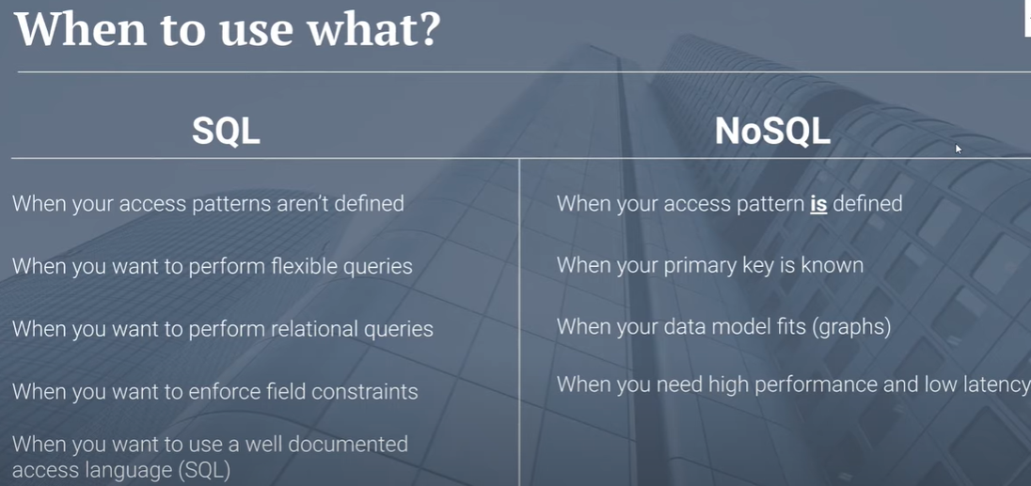
Figure 1 Application scenarios
Through the comprehensive analysis and consideration of the actual needs and scenarios of Abertawe Arts Centre, using the SQL databases in the Abertawe Arts Centre case will be a more appropriate choice.
- Description of performance Tuning
In order to solve the problems raised in the assignment, in addition to the primary key index, we also need to add multiple secondary indexes. This can solve the problems raised in the assignment and improve the data query performance.
For the ten tables in the constructed database, Table theaterOrders and Table customerOrders have many attributes.When it comes to query for the two tables, the performance would be relatively poor, so secondary indexes should be established for the corresponding attributes in these two tables.
I added secondary indexes on companyID and customerID to the Table theaterOrders and Table customerOrders respectively.As the Figure 2 and Figure 3 show.
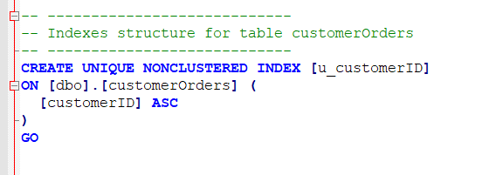
Figure 2 Secondary index-customerID
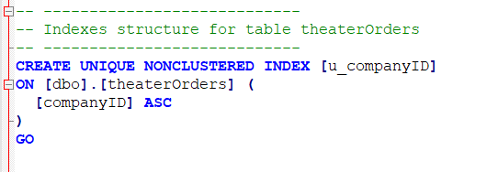
Figure 3 Secondary index-companyID
With the addition of secondary indexes, relatively speaking, the performance of the database has been strengthened to a certain extent.
- Solution of Task 1,item 4
For the problems raised by Task1, item 4, we need to use the Transaction to solve this problem.
Transaction is a logical unit of work in SQL Server, which will be processed as a whole. The transaction guarantees that multiple consecutive operations must be executed successfully, otherwise it must immediately return to the state without performing any operation, that is, the result of executing the transaction will either complete the operation to be performed by the data or not modify all the data [9] .
For the Abertawe Arts Centre’s problem, using transaction to solve the problem, the code is shown in the Figure 4
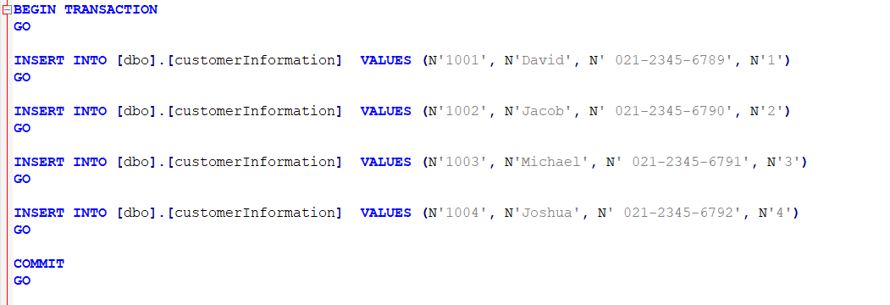
Figure 4 Transaction code
- Distributed database solution
  - Summarize of DDBS
The distributed database technology is a combination of database technology and distributed technology. Specifically, it refers to a database technology that combines the various database nodes that are geographically dispersed, but in the computer system logic, it is a database technology that combines data belonging to the same system. There is not only the coordination between databases but also the distribution of data. This system does not pay attention to the centralized control of the system, but the autonomy of each database node. In addition, in order to allow programmers to reduce the workload and the possibility of system errors when writing programs, they generally do not consider data at all. The distribution situation, as a result, the distribution situation of the system data has been kept transparent [5].
The concept of data independence is a very important part of a distributed database management system, and the distributed data management system also adds a new concept called distributed transparency. The function of this new concept is to make the correctness of the program unaffected when the data is transferred, just as the data is not distributed when the program is written. In a distributed database, data redundancy is a required feature, which is different from the general centralized database system. The first point is to replicate data in those database nodes that are needed to improve local applicability. The second point is that if a system error occurs on a database node, before the repair is done, the system can continue to be used by operating the copied data in other database nodes to improve the effectiveness of the system.
  - Classification of DDBS
(1) Isomorphic and homogeneous DDBS: All sites use the same type of data model, and are the same type of DBMS.
(2) Isomorphic and heterogeneous DDBS: All sites uses the same type of data model, but the model of DBMS is different.
(3) Heterogeneous DDBS: The data model of each site has different models, and even types [6].

5.3 Fragmentation strategy

5.3.1 Types
The types of Fragmentation strategy is as follows[6]:
(1) In the case of horizontal fragmentation, identify the set of predicates (where conditions) that will be used to form the fragments.
(2) In the case of vertical fragmentation, the attributes (columns) making up the fragments.
(3) In the case of mixed fragmentation, identify the combination of vertical and horizontal fragments.
(4) In the case of derived fragmentation, identify the child fragments to be derived from which parent fragment.

5.3.2 Rules
The rules of Fragmentation strategy is as follows [7]:
(1) completenness condition- All the data of the global relation must be mapper into the fragments.
(2) Reconstruction condition-It must alwaysbe possible to reconstruct each global relation from its fragments.
(3) Disjointness-Fragments be disjoint, sothat the replication of data can be controlled explicity at allocation level

5.4 Solution
The basic architecture of a distributed database is shown in the Figure 5.

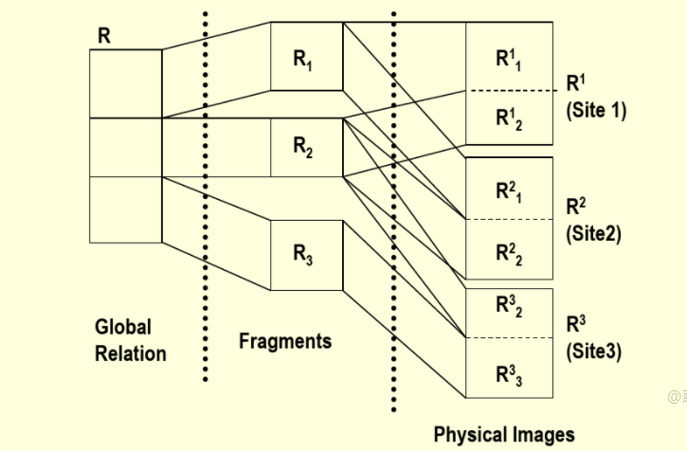
Figure 5 Architecture
In the database construction case of the Abertawe Arts Centre Reservation System,we have constructed 10 tables, which are companyInformation, customerInformation,customerOrders, customerTypes, levels, performanceTypes, seatInformation, theaterOrders, theaterScopes and theatreInformation.
Due to the various factors such a prompt and friendly service, the Abertawe Arts company is gaining an ever-increasing customer base from those wishing to book space to host shows and those wishing to purchase tickets to come and see a show.
Considering the possible prosperity of the theater in the future, more and more performance companies will perform in the theater, and more and more customers want to watch the performance in the theater. This will make the database that has been created overwhelmed, so in this case, you can use a distributed database to solve this solution. To solve the storage and recall of massive data, to ensure the normal operation of the theater ticket booking system.
For data stored in tables with fewer attributes, when the amount of data reaches a huge amount, we adopt a horizontal fragmentation strategy. such as Table companyInformation and Table customerInformation.
For the data stored in tables with more attributes, when the amount of data reaches a huge amount, we adopt the vertical fragmentation strategy. If the amount of data reaches another order of magnitude, we should adopt the mixed fragmentation strategy at this time, such as Table seatInformation,theaterOrders and customerOrders.
In general, the general architecture diagram is shown in the figure 6 [8].
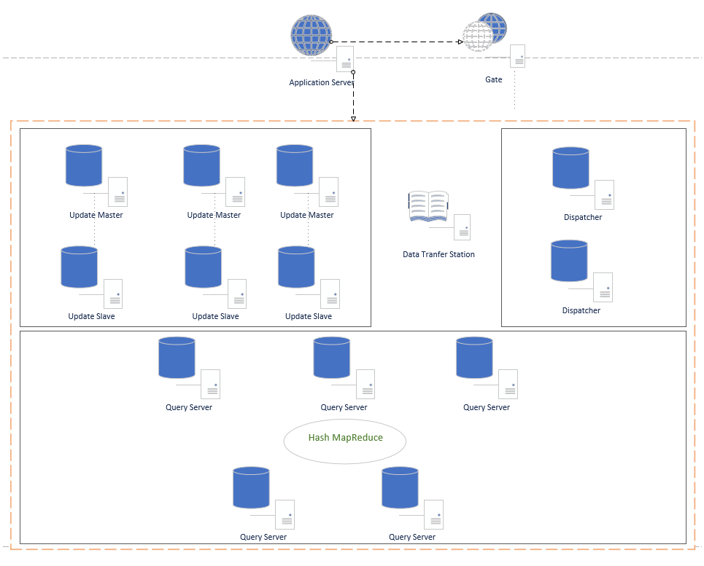
Figure 6 Architecture model
Function of node is as follow [8].
(1) Application Server：Only one is drawn here. In the actual production environment, there may be hundreds or thousands of Host services, mainly business services;
(2) Gate: The Gate maintains the status information of each functional node in the data center.
(3) Update Master: Update Master is responsible for the update operation of the database. This node does not save all the data, but when it needs to be updated, it obtains the required data from the corresponding query database, and then performs the transaction update on the local machine. After completion, it is also submitted to Native.
(4) Update Slave: Standby Update server, which automatically becomes the Master instead of Update Master when the Master expands. The daemon monitors the status of Master in real time
(5) Data Transfer Station: it is a data transfer center, which is responsible for collecting changed data and backing up the store in case it needs to be tracked or restored.
(6) Dispatcher: the distributor obtains the data from the Data Transfer Station, and obtains the idle Query Server that has not synchronized the data from the Gate, and marks the Query Server as synchronized data, and then synchronizes the data. After the synchronization is completed, the synchronization log records are returned to the Data Transfer Station, and then the next Query Server is synchronized until all synchronization is completed. After completion, Data Transfer Station marks the data as all nodes synchronized (Query Server can still provide query services during synchronization)；
(7) Query Server: it is responsible for external data query.
The query data request flowchart is shown in Figure 7 [8].
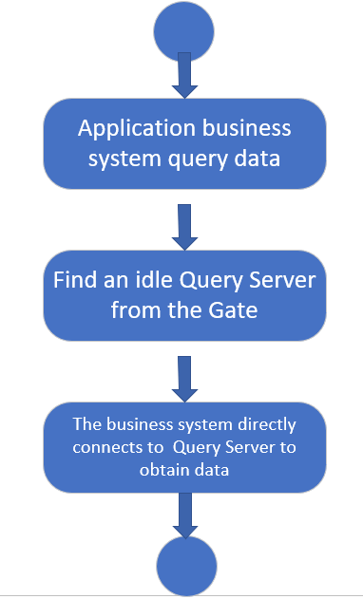
Figure 7 Query data request flowchart
The update data request flowchart is shown in Figure 8 [8].
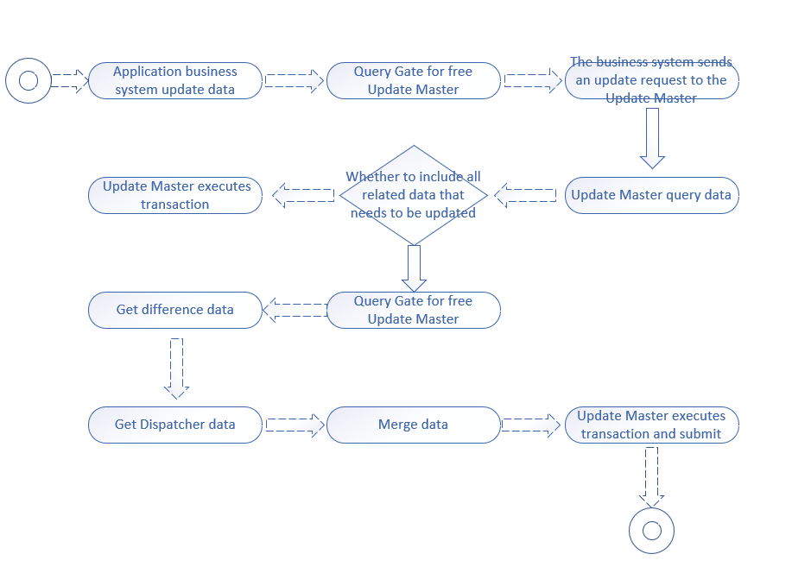
Figure 8 Update data request flowchart

- Conclusion
For the Abertawe Arts Centre case, we successfully constructed a suitable database system, implemented the required functions, and strengthened the functions of this system. Although the construction of this database is not the best, but in database construction process I have studied and consolidated the relevant knowledge of the database, and also gave myself a new understanding of the database, which made me full of confidence in the subsequent self-study of the database.

Reference
[1]https://zhuanlan.zhihu.com/p/78619241(Accessed:January 10, 2021).
[2]https://blog.csdn.net/u014590757/article/details/79900497?ops_request_misc=%25257B%252522request%25255Fid%252522%25253A%252522161070204416780274144581%252522%25252C%252522scm%252522%25253A%25252220140713.130102334..%252522%25257D&request_id=161070204416780274144581&biz_id=0&utm_medium=distribute.pc_search_result.none-task-blog-2~all~baidu_landing_v2~default-9-79900497.first_rank_v2_pc_rank_v29&utm_term=%E5%85%B3%E7%B3%BB%E5%9E%8B%E6%95%B0%E6%8D%AE%E5%BA%93%E4%B8%8E%E9%9D%9E%E5%85%B3%E7%B3%BB%E5%9E%8B%E6%95%B0%E6%8D%AE%E5%BA%93(Accessed:January10,2021)
[3]https://blog.csdn.net/clover_lily/article/details/79991300?ops_request_misc=%25257B%252522request%25255Fid%252522%25253A%252522161070204416780274144581%252522%25252C%252522scm%252522%25253A%25252220140713.130102334..%252522%25257D&request_id=161070204416780274144581&biz_id=0&utm_medium=distribute.pc_search_result.none-task-blog-2~all~baidu_landing_v2~default-7-79991300.first_rank_v2_pc_rank_v29&utm_term=%E5%85%B3%E7%B3%BB%E5%9E%8B%E6%95%B0%E6%8D%AE%E5%BA%93%E4%B8%8E%E9%9D%9E%E5%85%B3%E7%B3%BB%E5%9E%8B%E6%95%B0%E6%8D%AE%E5%BA%93(Accessed:January 10, 2021).
[4]https://www.youtube.com/watch?v=ruz-vK8IesE (Accessed: January 10, 2021). [5]https://blog.csdn.net/m0_47575110/article/details/111303394?ops_request_misc=&request_id=&biz_id=102&utm_term=%25E4%25BB%2580%25E4%25B9%2588%25E6%2598%25AF%25E5%2588%2586%25E5%25B8%2583%25E5%25BC%258F%25E6%2595%25B0%25E6%258D%25AE%25E5%25BA%2593&utm_medium=distribute.pc_search_result.none-task-blog-2~all~sobaiduweb~default-3-111303394.first_rank_v2_pc_rank_v29(Accessed:January 8, 2021).
[6]https://blog.csdn.net/enmotech/article/details/91685842?ops_request_misc=%25257B%252522request%25255Fid%252522%25253A%252522161070831116780299089555%252522%25252C%252522scm%252522%25253A%25252220140713.130102334..%252522%25257D&request_id=161070831116780299089555&biz_id=0&utm_medium=distribute.pc_search_result.none-task-blog-2~all~top_click~default-1-91685842.first_rank_v2_pc_rank_v29&utm_term=%E5%88%86%E5%B8%83%E5%BC%8F%E6%95%B0%E6%8D%AE%E5%BA%93(Accessed:January 10, 2021).
[7] https://wenku.baidu.com/view/4ce7276727d3240c8447ef90.html(Accessed:January 10, 2021).
[8]https://blog.csdn.net/weixin_30815469/article/details/96001260?ops_request_misc=&request_id=&biz_id=102&utm_term=%25E5%2588%2586%25E5%25B8%2583%25E5%25BC%258F%25E6%2595%25B0%25E6%258D%25AE%25E5%25BA%2593%25E8%25A7%25A3%25E5%2586%25B3%25E6%2596%25B9%25E6%25A1%2588&utm_medium=distribute.pc_search_result.none-task-blog-2~all~sobaiduweb~default-3-96001260.first_rank_v2_pc_rank_v29(Accessed:January12,2021). [9]https://blog.csdn.net/sanermm/article/details/1851383?ops_request_misc=%25257B%252522request%25255Fid%252522%25253A%252522161072880216780266213150%252522%25252C%252522scm%252522%25253A%25252220140713.130102334..%252522%25257D&request_id=161072880216780266213150&biz_id=0&utm_medium=distribute.pc_search_result.none-task-blog-2~all~sobaiduend~default-3-1851383.first_rank_v2_pc_rank_v29&utm_term=%E6%95%B0%E6%8D%AE%E5%BA%93%E4%B8%AD%E7%9A%84%E4%BA%8B%E5%8A%A1%E5%A4%84%E7%90%86(Accessed:January 13, 2021).

