University of Wales Trinity Saint David

Wales Institute of Science & Art



Tensile Test
Engineering science 1

Ieuan Jones
2503192
June 2026

Table of Contents
Introduction 4
Aim 4
Objectives 4
Experimental procedure 5
Results 7
Analysis 10
Aluminum 10
Duralumin 10
Steel 12
PVC 12
Comparison of Results 13
Conclusion 14
References 15

Figure 1 - Tensile tester 5
Figure 2 - broken specimens 9
Figure 3 - Aluminium Stress-Strain Graph 10
Figure 4 - duralumin Stress-strain graph 11
Figure 5 - Stress-strain graph for steel 12
Figure 6 - stress strain graph for PVC 13

Table 1 - result table template 6
Table 2- Aluminum tensile test results 7
Table 3 - Steel tensile test results 7
Table 4 - duralluium tensile test results 8
Table 5 - PVC tensile test results 9

Introduction
Tensile testing is one of the most used methods for determining the mechanical properties of a material. The test involves gradually applying an increasing tensile load to a specimen until it fails. During the test, measurements of load and extension are recorded, allowing the engineer to calculate strain, stress, Young’s module and percentage of elongation. These properties are fundamental for selecting new materials, as they provide an indication of a materials strength, stiffness and ductility (Ashby, 2025).

Aim
The aim of this experiment was to investigate the tensile behaviour of four different materials using the ES6 Tensile Tester (TecQuipment, n.d.) and to produce stress-strain graphs for each material.

Objectives

- Carry out tensile test on four different materials using ES6 tensile tester
- Record and document all data collected during the testing
- Calculate stress, strain and percentage of elongation of each specimen
- Produce stress-strain graphs for each material
- Compare the properties and behaviors of the materials tested

Experimental procedure

The experiment was carried out using the TecQuipment ES6 Tensile Tester. 4 different specimens were tested: aluminium, duralumin, steel and PVC. Before testing began, both the equipment and test specimens were inspected to ensure they had no damage which would cause an unexpected failure and to confirm that the tooling is ready for use. Safety glasses were worn.

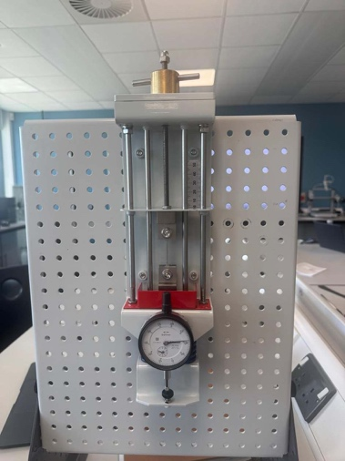
Figure 1 - Tensile tester

Before testing, each specimen was measured using a Vernia caliper and recorded. The specimen was then secured between the upper and lower clamps of the tensile tester. The slack was removed using the load adjuster and the dial indicator was set to zero. A tensile load was applied by rotating the load nut in increments 0.2 turns. At each increment the dial indicator reading was recorded in the results table.

From the data, the extension is then calculated using equation 1

Equation 1 - Equation 1 - Extension (mm) = Number of turns - Dial indicator
The applied force was calculated using dial indicator reading as show in equation 2

Equation 2 - Force(N) = Dial indicator reading x 100
Loading continued until the specimen failed, all readings were recorded in a results table for later analysis. The table is show below in Table 1.
Table 1 - result table template
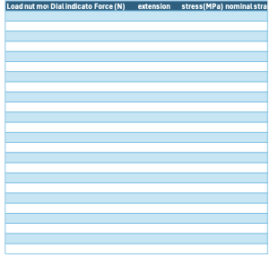

Following failure, the specimen was removed and replaced with the next material specimen. The testing procedure was repeated for each of the remaining materials using the same equipment, loading increments and test conditions.
After testing, the broken specimens were reassembled to measure their final length and width. These measurements, with the original specimen dimensions, were used to calculate stress and strain using Equations 3 and 4.

Equation 3 - Stress (MPa) = Force/ Cross sectional area
Equation 4 - Strain = Extension/Original gauge length

Stress strain graphs were then produced for each material to determine their mechanical behaviour.

Results

Tensile tests were completed on four materials: aluminium, duralumin, steel and PVC. During each test, the dial indicator reading was recorded at 0.2-turn increments until failure. After the specimen failed, the final length and width were measured to determine the percentage elongation and calculate stress and strain.
The raw experimental data collected during testing are presented in Tables 2–5.
Table 2- Aluminum tensile test results
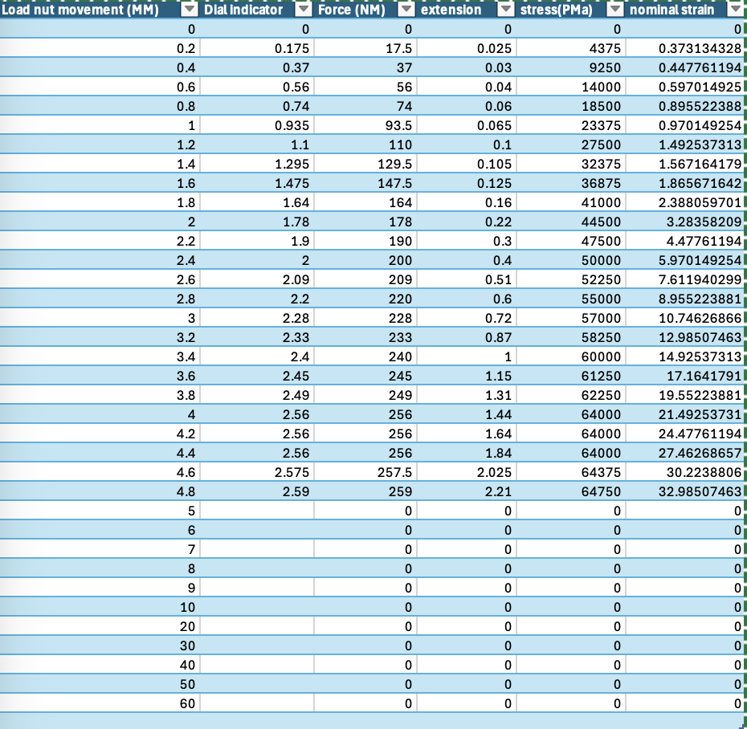

Table 3 - Steel tensile test results
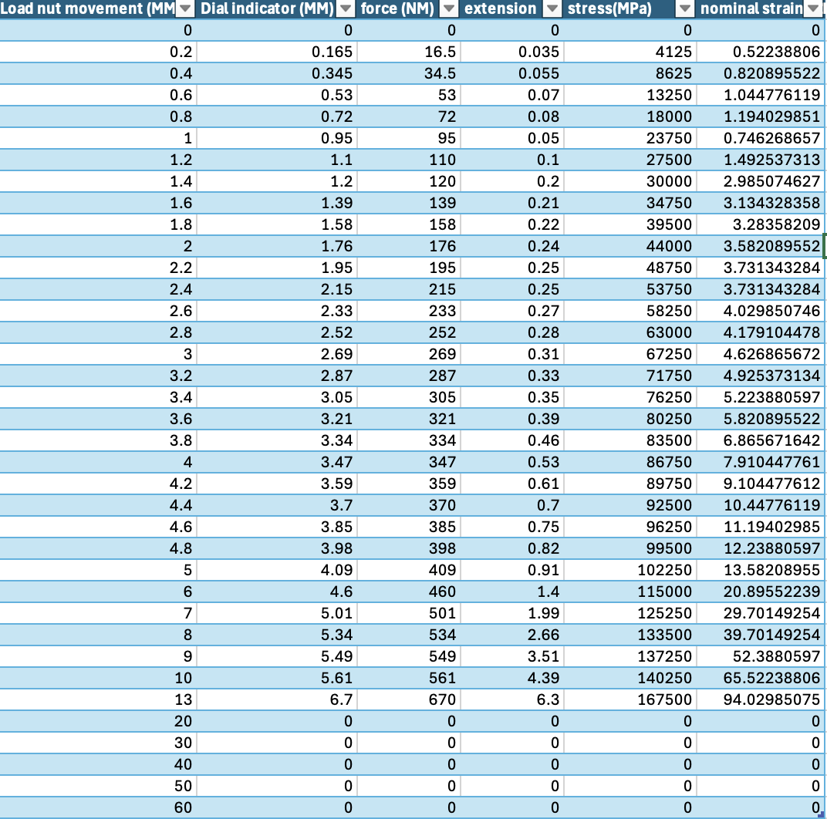

Table 4 - duralluium tensile test results
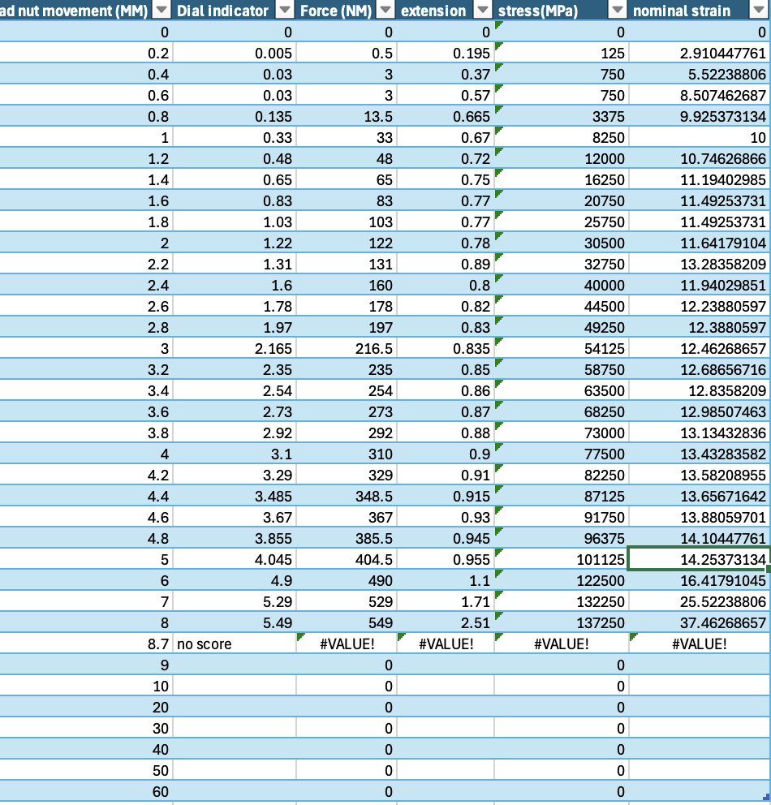
Table 5 - PVC tensile test results
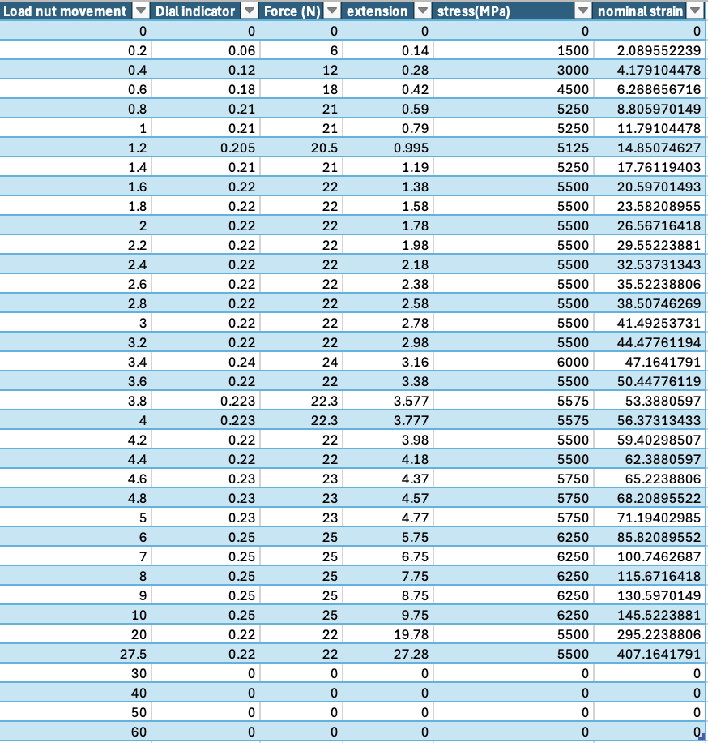
The percentage of elongation is show in table 6
Material | Elongation (as %)
Steel | 6.20%
Aluminium | 9.60%
Duralumin | 6.40%
PVC | 35.80%

Table 6 - percentage of elongation
Figure 2 shows the fractured specimens following tensile testing. The steel specimen showed relatively little elongation before fracture, whereas the aluminium and duralumin specimens showed greater deformation prior to failure. The PVC specimen showed the greatest extension before fracture. These observations are in line with the expected tensile behaviour of these materials reported in engineering literature (MatWeb, 2024).
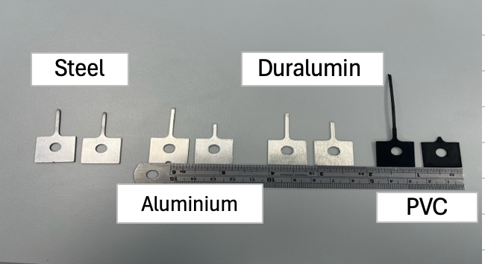
Figure 2 - broken specimens
The raw data presented in table 2-5 was then used to calculate stress and strain, then these values were used to produce stress-strain graphs.

Analysis

Aluminium

Figure 3 - Aluminium Stress-Strain Graph
Figure 3 shows the stress-strain curve obtained for the aluminium specimen. The graph initially displays a linear relationship between stress and strain, indicating elastic deformation. As the applied load increased, the gradient of the curve reduced as the specimen entered the plastic region, before eventually reaching its max tensile strength and fracturing. Compared with the other metal specimens, aluminium exhibited a relatively large amount of plastic deformation before failure. The relatively large strain recorded before failure demonstrates the good ductility of aluminium, making it suitable for applications where lightweight materials with good formability are needed (Ashby, 2025).

Duralumin
Figure 4 shows the stress-strain curve for duralumin

Figure 4 - duralumin Stress-strain graph
The stress-strain curve for the duralumin specimen gave an initial linear relationship in the elastic region, where stress increased proportionally with strain. As the load increased, the material reached its yield point and entered the plastic deformation region before ultimately failing. Compared with the aluminium specimen, duralumin withstood a higher applied stress before failure while exhibiting a smaller amount of plastic deformation. This indicates that duralumin has more strength but lower ductility than aluminium.
The higher strength of duralumin is a result of alloying aluminium with elements such as copper and magnesium (AZO Materials, 2013), which increase its resistance to plastic deformation. This allows the material to withstand greater tensile loads while maintaining a relatively low density. Although the increased strength reduces its ductility compared with pure aluminium, the material still exhibits sufficient plastic deformation before fracture, preventing sudden failure from being too hard and brittle

Steel
Figure 5 shows the stress-strain curve for steel
Figure 5 - Stress-strain graph for steel
The steel specimen has the steepest initial curve on the graph, this indicating the highest stiffness and Young's Modulus. During the initial stage of loading, the relationship between stress and strain stayed linear, demonstrating the elastic region is in line with Hooke's Law (Augustyn, 2017). Once the yield point was reached, the specimen entered the plastic deformation region before reaching to the max tensile strength and snapping.
Compared with aluminium, duralumin and PVC, steel required the greatest applied force to produce the same amount of strain and had the highest ultimate tensile strength before failure (ECONSTEEL, 2025). Although plastic deformation occurred after yielding, the total elongation (22.5%) before failure was lower than that of aluminium and PVC, indicating that steel has greater strength but reduced ductility. This combination of high stiffness and strength makes steel well suited to structural applications where resistance to deformation is critical.

PVC
Figure 6 shows the stress-strain curve for PVC

Figure 6 - stress strain graph for PVC
The PVC specimen exhibited significantly different mechanical behaviour compared with the metal specimens. The initial gradient of the stress-strain curve was much shallower, indicating a lower Young's Modulus and therefore lower stiffness. As the tensile load increased, the specimen experienced considerably greater strain before fracture, demonstrating a high level of ductility and flexibility. Unlike the metal specimens, PVC was able to take substantial deformation before failure while carrying relatively low tensile stresses. (Belshof, 2025)
The tensile strength for PVC is in a much lower than the metals tested, it provides excellent flexibility and energy absorption, making PVC suitable for applications where resistance to deformation is less important than durability and toughness.

Comparison of Results
The stress-strain curves produced during this experiment demonstrated the differences in the mechanical behaviour of aluminium, duralumin, steel and PVC. Each material responded differently to the applied tensile load, reflecting the influence of its composition and internal structure on its mechanical properties.

Steel exhibited the highest stiffness and ultimate tensile strength, whereas PVC showed the greatest elongation before fracture and the lowest stiffness. Duralumin provides a balance between strength and weight, while aluminum demonstrated good ductility and moderate strength. These differences demonstrate why engineers select materials according to the mechanical demands of a particular application rather than relying on a single material property.

Conclusion

The aim of this investigation was to examine the tensile behaviour of four engineering materials using the TecQuipment ES6 Tensile Tester and to produce stress-strain graphs from the experimental data. This aim was successfully achieved, with all four specimens tested to fracture and the required calculations completed to determine stress, strain and percentage elongation.
The results demonstrated clear differences in the mechanical behaviour of each material. Steel showed the greatest stiffness and ultimate tensile strength, making it the most suitable material for applications requiring high strength and resistance to deformation. Duralumin provided a good balance between strength and weight, while aluminium displayed lower tensile strength but greater ductility, allowing it to undergo greater plastic deformation before fracture. In comparison, PVC exhibited the lowest stiffness and tensile strength but the greatest elongation before failure, demonstrating its flexibility and ability to absorb deformation.
The stress-strain curves produced during the investigation clearly identified the elastic and plastic regions of each material and gave a direct comparison of their mechanical properties. Minor experimental errors may have influenced the accuracy of the results, the overall trends were consistent with the expected behaviour of the materials reported in engineering literature.
Overall, the investigation demonstrated the value of tensile testing as a method for evaluating the mechanical properties of engineering materials. The results highlight how differences in stiffness, strength and ductility influence material selection and reinforce the importance of selecting materials based on the mechanical requirements of their intended engineering application.

References

Ashby, M.F. (2025). Materials Selection in Mechanical Design. Elsevier.
Augustyn, A. (2017). Hooke’s Law. In: Encyclopædia Britannica. [online] Available at: https://www.britannica.com/science/Hookes-law.
AZO Materials (2013). Duralumin - Chemical Composition, Mechanical Properties and Common Applications. [online] AZoM.com. Available at: https://www.azom.com/article.aspx?ArticleID=8073.
Belshof, N. (2025). PVC Material and Properties. [online] Rollepaal.com. Available at: https://rollepaal.com/knowledge/pvc-material-and-properties.
ECONSTEEL (2025). Tensile Strength of Steel. [online] Econsteel.com. Available at: https://www.econsteel.com/blog/tensile-strength-of-steel.
MatWeb (2024). tensile test - material properties. [online] www.matweb.com. Available at: https://www.matweb.com/search/DataSheet.aspx?MatGUID=b8d536e0b9b54bd7b69e4124d8f1d20a&ckck=1.
TecQuipment (n.d.). TENSILE TESTER KIT. [online] TecQuipment. Available at: https://www.tecquipment.com/tensile-tester-kit [Accessed 28 Jun. 2026].

