Report for Community Engagement – Assignment 2
Problem Solving for Marginalised Individuals working within Cyfle I Dyfu -



APRIL 2018

MODULE NAME: Community engagement m4x00799
Project Name: cyfle i dyfu
Name: jacky robson
Student Number: 1704545

Table of Contents

1. eXECUTIVE sUMMARY 1
2. Introduction 2
2.1 Report Remit 2
2.2 Brief background the organisation 2
2.3 The problem 2
3. Problem solving techniques 3
3.1 Solving the problem 3
3.2 Problem solving implementation 3
4. Conclusion 4
5. References 5

List of Figures
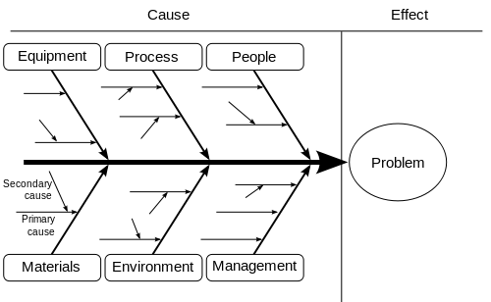
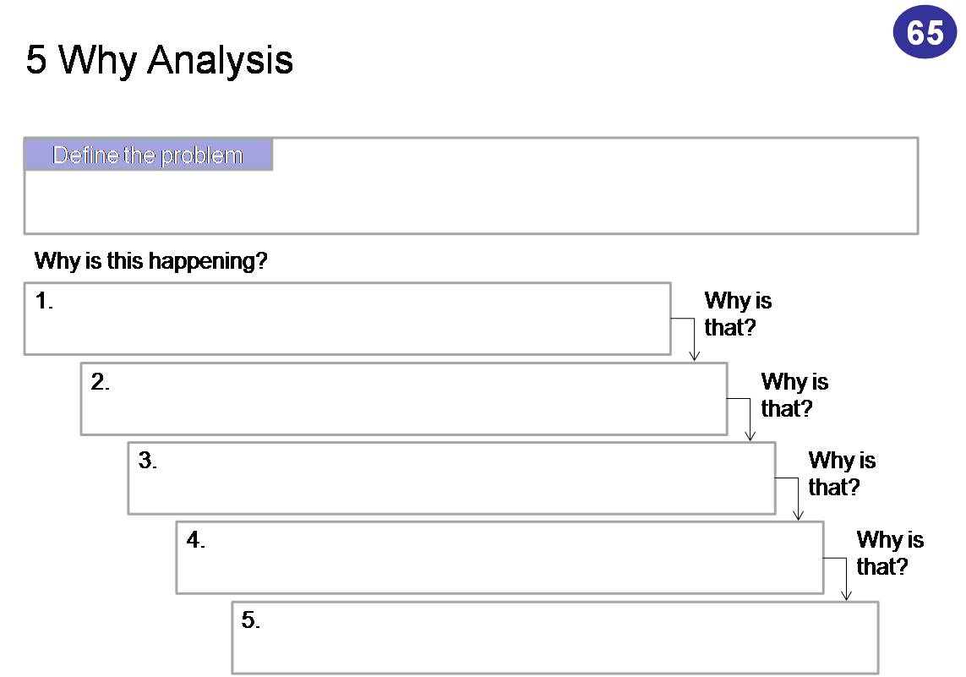

eXECUTIVE sUMMARY

Introduction

Report Remit

Within this report the topic will cover problem solving for marginalised individuals and the problems they encounter entering the workplace or re adjusting into a working environment with certain difficulties. The report will also include why the majority of ex – criminals reoffend, and why ex mis substance users reuse, and the difficulties that people have with learning difficulties and what effect this has on them getting a job.
This report will look at how the possibility of changing certain aspects and coming up with problem solving techniques for these individuals and what positive impact it may have on them.
Recently a team of students worked alongside and assessed a charity named Cyfle I Dyfu, this organisation is a non-profitable organisation, that teaches marginalised individuals a trade of carpentry skills that may help them to gain the skills for them to gain employment and to ultimately turn their lives around in a positive manner. Andrew who is the founder of the organisation specifically helps individuals that are ex – criminals, he works with individuals who have learning difficulties and his organisation also includes individuals who have had substance mis use issues in the past. Andrews philosophy is that in helping these individuals they will not be left to seek employment with no qualifications and therefore not have much better opportunities, that will help them to achieve a trade and long-term employment that will have a positive impact on their future.
This report will cover how to problem solve with these individuals and what the impact will be if this was achieved.

Brief background the organisation

Andrew is the founder of the organisation named Cyfle I Dyfu, who founded the company in 2007. The organisation builds all different types of wood furniture and bespoke wood pieces. He had previous experience within the carpentry industry and had also worked with people who had difficulties with substance misuse and ex criminals. Andrew was given the opportunity of a redundancy pay-out, and this is when he decided to help people who had suffered previous issues that put a stop to them gaining employment. He wanted to give back to the community and help people who were in need of some guidance and help. He currently has 11 people who is teaching and has previously helped over 100 individuals gain employment. Andrew has faced a few problems over the years but is now running a successful organisation and will continue to do all that he can to help more people in the future.

THE PROBLEMS THAT MARGANILISED INDIVIDUALS FACE GAINING RE EMPLOYMNET, THE PROBLEMS OF SUBSTANCE MISUSE AND RE OFFENDING CRIMINALS AND THE PROBLEMS THAT ARE INCURRED WHEN PEOPLE HAVE LEARNING DIFFICULTIES.

The specific problems that marginalised individuals face is they are not able to gain employment and therefore they are not able to achieve or gain a positive outcome for their future. Therefor this leads to more crime and a bigger problem with substance misuse, and it also will affect people that have learning difficulties, with an outcome of them relying on members of their family to support them instead of learning to fend for themselves and therefore all of these combined will affect the crisis with unemployment issues, that the country currently faces.
The organisation itself is currently running very well and achieving a positive impact on the majority of the individuals they help and train, although there are problems that they have to attend to, for example, some individuals will initially want to change, Cyfle I Dyfu will take them into the organisation and willingly help these people, but there is only so much they can do to help and some of the individuals will not always adhere to the rules and regulations set out in Cyfle I Dyfu and therefor Andrew will not keep them on and will not be able to help them anymore. Another problem that challenges Cyfle I Dyfu is that they are limited to how many individuals they are able to take on for apprenticeships. Therefore, this affects the majority of individuals who would be willing and keen to learn new skills and gain employment.

Problem solving techniques

In this section of the report there will be problem solving techniques that an individual could try to use to aid the organisation and possibly that could be investigated further for the future, to help individuals achieve better results gaining employment, for the individuals to prevent reoffending, reusing and to help with learning difficulties.
Two of the techniques that may be of assistance is the:
Ishikawa and 5 whys.
The Ishikawa model will reflect with scoping out the cause and effect of a problem. The way in which to use the Ishikawa model is to find the problem and then break it down into more depth you can have as many or as few headings for the diagram, within this you will hopefully find the problem finally unravels through this effect. The best and simplest way to describe this is as follows, it can be used to structure a brainstorming session. It immediately sorts ideas into useful categories. The Ishikawa model was designed by a gentleman named Kaoru Ishikawa he wanted to change the way people think about problem solving and came up with this concept.
The 5 whys model will work in a similar way but perhaps not in as much depth as the Ishikawa model. The 5 whys will be more of a basic way of starting with the problem, and the working through why that problem started and then following through the whys of why that problem occurred. “I listened to a Podcast by Personality Hackers with Sir John Hargrave and he mentioned using the 5 whys technique to solve problems or make decisions. I investigated and thought this is worth sharing. By repeating the question why (5 times) after every previous answer you should get to the root cause/defect of the problem. It is like peeling an onion you start with your problem and first why.” (unknown, 2015). The key is to avoid assumptions and instead trace the problem through layers of concepts and preoccupation. Don’t stop at the first answer keep questioning until you reach the end result, and this is usually done within the 5 whys.

Solving the problem

Problem solving implementation

Conclusion

References
(unknown, 2015)

