Academic and Employability Skills

Andreea Luciana Gingirov
Student no.: 1910083
Module code: BMSW4001
Lecturer name: Anita Nan

Contents
Introduction 2
Academic skills 3
Paraphrasing 3
Summarising 3
Critical thinking 3
Research skills 4
Employability skills 4
Communication 4
Time-management 4
Problem solving 5
Teamworking 5
Conclusion 6
Appendix 7
References 9

Introduction
The purpose of this report is to explain what academic and employability skills means, describe some of them and explain the techniques that helps people to make the best use of them, and the methods that can be used to improve them. As academic skills, this report explains paraphrasing, summarising, critical thinking and research. As employability skills there are going to be found communication skills, time-management, problem-solving and teamworking.

Academic skills

This type of skills, such as paraphrasing, critical thinking, time management or summarising, are used in academic writing, helping students to excel with their assignments.

Paraphrasing
Paraphrasing is an academic skill through which students are avoiding plagiarising other writings that they are using in their work, by writing in they own words what they had read, using few important techniques. The length of the initial paragraph has to be kept the same, while changing vocabulary, changing words class and words order are used for a good paraphrasing. This skill helps students to understand better what they had read, and in the same time to reformulate all the information with their own vocabulary. Paraphrasing skill and its techniques are used mainly by students, for their assignments or exams, to reach a higher degree, and eventually for their diploma.
Even though paraphrasing is a useful skill, I need to improve it, because at the moment it is difficult for me to find and use my own words, to describe the information read. This technique can be improved by working often with it, reading more and develop my vocabulary.

Summarising
Summarising is the academic skill through which the student gives his own understanding about the information read. The difference between summarising and paraphrasing consists in the length of the text. If the paraphrasing has to be of the same length with the text read, the summarising has to be shorter, containing only the main ideas of the text. The other techniques used to give a good summarising are the same that are used for paraphrasing, like changing vocabulary, words class and words order. People are always using summarising technique, even though they do not realise, when they are telling a story, when they are telling others about what was the movie that they saw, or about events to which they took part of.
I need to improve this skill, because most of the times my summaries are much shorter than should be. I am forgetting some of the main ideas that should be included in my summary, because I am always rushing to finish the tasks that I have. This skill can be improved by allowing enough time understanding the text, extracting correctly the main ideas, and focusing on arranging them in order to make sense.

Critical thinking
Critical thinking is about taking a ‘step back’ to analyse, in a logical and careful way, what it had been seen, read or heard. Is about questioning the new ideas, if they are accurate or not, if the source is credible or not. This skill could be also something that people do, by their nature, in their day-by-day life. They are listening, or reading the information, but in the same time they are thinking if there are any evidence behind those ideas (Aveyard, et al., 2011). According to Kallet, M.(2014) the tools and techniques used for critical thinking are given by a framework, that has as components the clarity, conclusions and decisions.
Clarity is the component that allows people to define which is the real problem or purpose of the situation presented. Conclusion comes after the issue has been discovered, as a ‘to-do’ list. Once a conclusion has been set, a decision has to be made, and to be done (Kallet, 2014).
Being an important skill for academic writing, I think I need to improve my critical thinking, because there are always ideas and situations that have to be analysed, and not taken for granted, as universal truth. This technique can be improved with help from day-by-day life situations, that can make people to be more critical in the way of thinking, also doing a lot of research.

Research skills
In student life, most of the time lecturers are expecting students to do their own research about a specific topic, rather than giving all the information to be learnt by heart. Even if students know or not something about the topic, there are three basic techniques: finding the information, recording it and after exploiting it. Individuals can make researches for their topic in libraries, or online, on internet, or they can use questionnaires (Wallace, 2004).
Being an important skill for writing an assignment, I think I need to improve it, because I do not know yet very well where to search for reliable sources. Also, on the internet I do not find always exactly the information that I am looking for, a library being hard to access due to the lack of free time. This skill can be improved by practicing always, searching for good and reliable sources, questioning if the information found it is accurate or not.

Employability skills

Employability skills are those skills and behaviours that make an individual employable, also to be in competition with other people to gain the desired job or position. People’s different behaviour and personalities make the difference on a variety of skills, make them to be stronger or less strong, and that time certain skills need to be worked on them.

Communication
Communication besides that is an art of transmitting thoughts between individuals, is also an extremely important employability skill, that helps employees to have a good work relation, effective team working and a possible improvement of the business.
Communication refers to the ability to listen and understand what an individual is transmitting, and depending of the job, means to transmit a clear meaning of what it is wanted as an achievement. Non-verbal communication is included too in this skill, people being able to transmit their actual feelings through gestures (n.a., 2019).
With a long experience in hospitality, I think I still need to improve my communication skills, because to work with human beings is the hardest job, as it is said. Sometimes people can push you to the limits, and if you cannot control yourself enough, you just let your emotions and anger be heard. This skill can be improved by starting to control your emotions, thoughts and gestures, making researches on the topic, and the most important, learning to listen first. Can be a long process, but the results definitely will appear.

Time-management
Time management skills are representing the ability to organize the time in such way to meet the deadlines and to be able to prioritise different tasks, in order to be effective at workplace. Being a skill that is in high demand, employers are looking for people that possess it, to increase the effectiveness of a department, or organisation. Employees who are able to manage their time are more likely to be more productive, efficient and they have a bigger chance to finish their tasks in time. This type of employability skill can be efficient following a few steps like prioritizing, scheduling, keeping a to-do list, resting and delegating (n.a., 2019).
I think I need to improve this skill, because I am always behind with the tasks that I have, never setting any rules to manage my time. This skill can be improved by prioritising the tasks that should be done, with a to-do list, setting deadlines for each task.

Problem solving
Being a vital skill for both personal and professional life, problem solving skill can be defined as the process of finding solutions to different problems that occurs. For an effective problem-solving, employees must be as clear and specific as possible when are trying to find the issue, starting with finding the most important elements of the problem. There are certain things to avoid in this process, as blaming others or trying to find an excuse, assuming that everything is known, or taking decision without spending time thinking for the best solution (Trought, 2017).
I think I have to improve this skill, because I am always either rushing in taking decisions or panicking. This skill can be improved by allowing the necessary amount of time to pick up the best solution, without rushing things, for an effective running of the business.

Teamworking
Teamworking is an extremely important skill for employability sector and refers to the ability of a group of people to get along with each other, where they put their abilities and skills together to achieve the desired purpose. People are always somehow forced to be part of a team, starting with their families, after in school and later on at workplace. But in some cases, are individuals that cannot fit in any of the teams. A good way to help them could be to trust them, encourage them that they can do a great job. Is everything about good communication skills among the group, respect and friendship.
I think that I have good teamworking skills, because I like to be always there where I am needed, to help the people I work with, and to be efficient in everything I do. But as it is said, there is always space for some improvement. This skill can be improved by paying more attention to what is surrounding us, trying to integrate everyone, communicate with everyone, giving all our best to achieve our goals, knowing that is this way the others will be tempted to do the same. And the most important things: respect and listen to each other, this is the key to success.

Conclusion
This report explained several skills, paraphrasing, summarising, critical thinking and research as academic skills and communication, time-management, problem-solving and teamworking as employability skills. For all these skills are given definitions and several techniques that can be helpful using them in an efficient way, and also methods that can be used to improve them.

Appendix

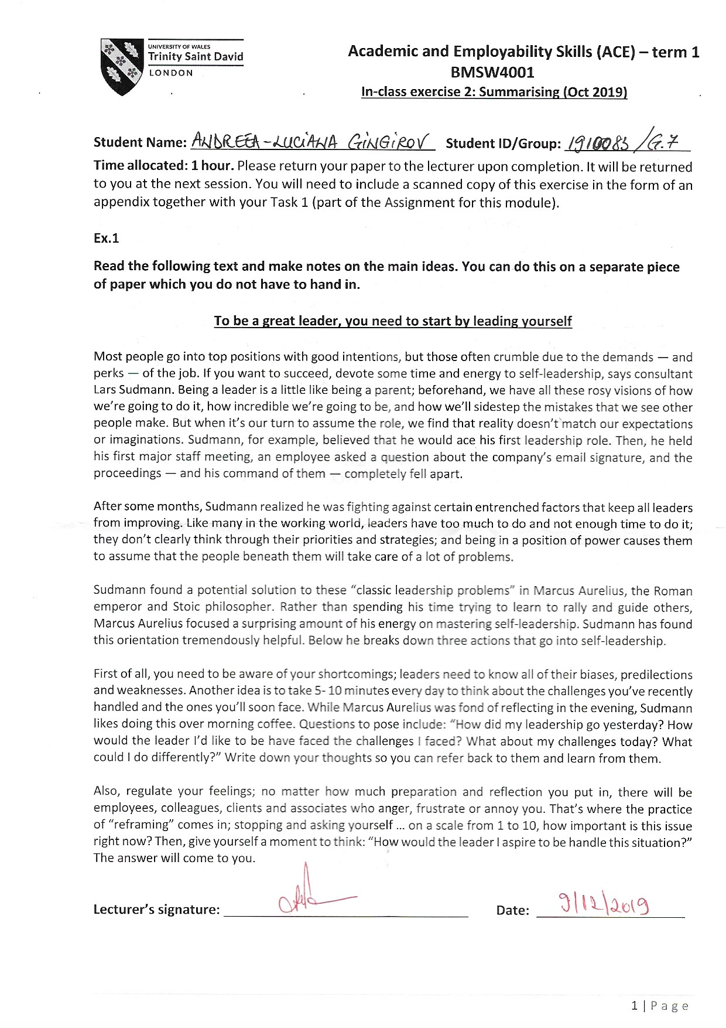

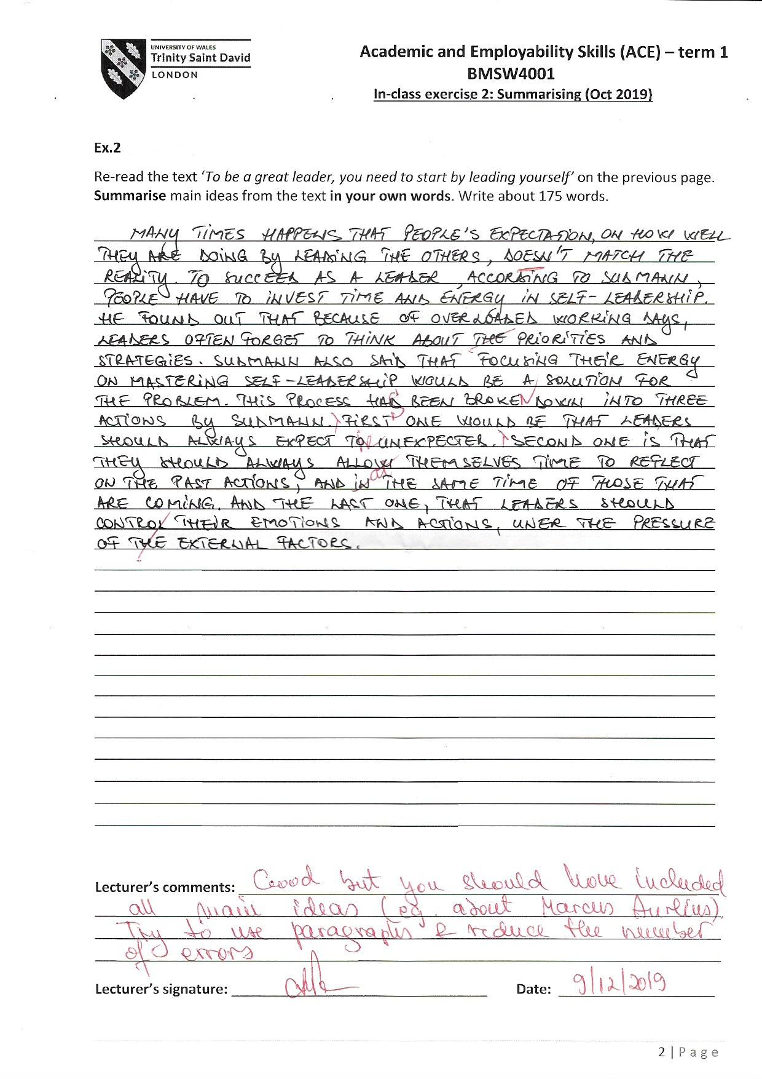

References
Aveyard, H., Sharp, P. & Woolliams, M., 2011. A Begginer's Guide to Critical Thinking and Writing in Health and Social Health. Berkshire: Open University Press.
Kallet, M., 2014. Critical Thinking to Improve Problem-Solving and Decision-Making Skills. New Jersey: John Wiley & Sons.
n.a., 2019. 8 job skills you should have. [Online]
Available at: https://www.youthcentral.vic.gov.au/jobs-and-careers/plan-your-career/8-job-skills-you-should-have
n.a., 2019. Important Time Management Skills For Workplace Success. [Online]
Available at: https://www.thebalancecareers.com/time-management-skills-2063776
Trought, F., 2017. Brilliant Employability Skills. London: Pearson UK.
Wallace, M. J., 2004. Study Skills in English. 2nd ed. Cambridge: Cambridge University Press.

