Module Code: M4X01508
Student Name: Fathi Sharif, 1701105
Module Lecturer Name: Gaynor Thomas

Title: Lottery number generation and management

Contents page:
Introduction | 2
Requirements (Must, Should, May) | 3 & 4
Flowchart
Why use a loop? | 4
Testing | 5, 6 & 7
User documentation | 7, 8 , 9 , 10 & 11
Technical documentation (this doubles as a Code Listing) | 11
Flowchart | 12
Conclusion | 13
Bibliography | 14

Introduction

In this assignment, I’m going to write a program and is about lottery game, this game generates 6 different lottery numbers in the range of 1 to 59. Then the program asks a user to input 6 random numbers, all random numbers are stored in variables and then the random numbers sorted from lowest numbers to highest.
the input numbers from the users are then compared to random the numbers by using (if statement) to see if the numbers match. when the random numbers match the guess numbers the program will output whether the users won or lost a lottery.
I’m also going to create a flowchart using Microsoft Visio so can use a diagram that representing my program. The flowchart shows all the process steps that I’m program is going to through, I’m going to use specific shapes and then connect those steps together with connecting arrows.
I will describe the importance of a loop in programming and how I can use in my programming, why do I need to use it.

The requirements must have:
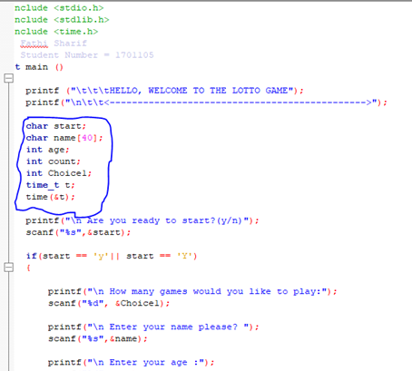
The requirements that my program must have is things like variables. Variables play a big role in computer programming because it allows the program to be flexible and is something that is used in programming because when I want to keep track of a value is easy to find and it can be changed but the operations on the variable remain the same. I found this article (Bolton, 2017) saying that variable is a space that the computer sets aside in memory with a name where I can store a value. there are different types of variables, each variable has a name, they all hold different data type and for example the (int variables store integers).

I found out that (Rouse, 2005) Loops are programming element that is very useful in computer programming and the way it works is that the loop repeats a command of coded continually until a certain condition is reached.
using loops allow me to shorten what can be hundreds of lines of code to just a few. Loops will make my program more manageable and organised as I learn more about c programming and writing complex programs, loops will be an important element to use for my program.
To generate the lottery numbers, the program must have (rand function). I’m using this function because it generates random numbers and random numbers are a big deal in this lottery game.
The program must have if statement because is conditional that the computer makes, you give a test and if the test is true to perform a function or display information but if fails then it doesn’t do anything at all. according to (Allain, n.d.) the way it works is, if one is less than other 2 using less than sings, one is greater than 2 using the greater than sing or if they if they are exactly equal using double equal signs and there are other tests but I’m going to using the basics.
Switch statement is pretty much alternative to the if statement, but switch statement is easier because is useful when you have several options and for each choice must perform a differently.

The requirements should have:
I should have used arrays in my program, this function is an import but does not have to be added because the program still works without (arrays). This function allows to store multiple values in a single variable and it saves time for you.

The importance of loops:
There are three different kinds of loops in c, the first one is while loop, the second one is a do-while loop and the third one is for loop. Loops are important in c and loop repeats a statement a certain number of times and this allows the program to keep execute the actions as many times as needed and each different loop structure has its own format.
As you can see, I’m using (for loop) because it allows the users to control over exactly how many times the player wants to play.

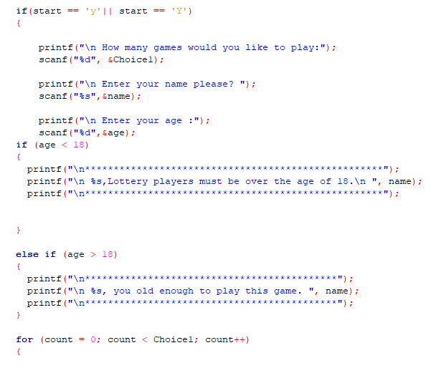

Testing:
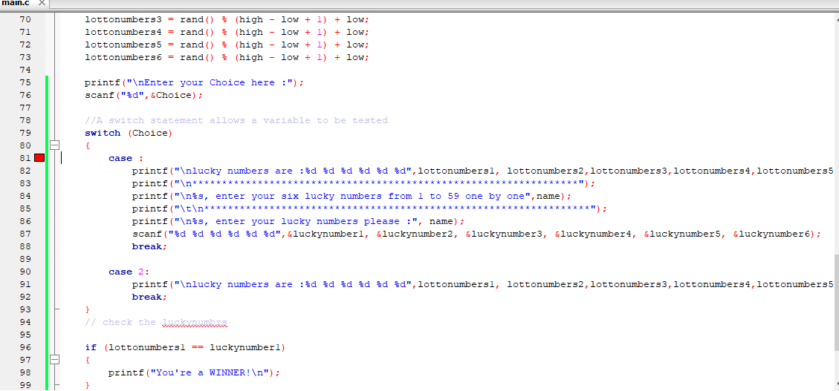
Using the switch statement for the (menu) section was useful, but I keep forgetting to type the value option and add a colon. The switch statement takes a number from the user and it test that number. as you can see the screenshot, the user entered a number one and the program displayed whatever that equals to one.

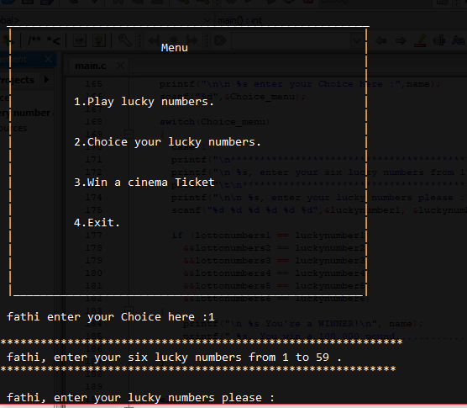
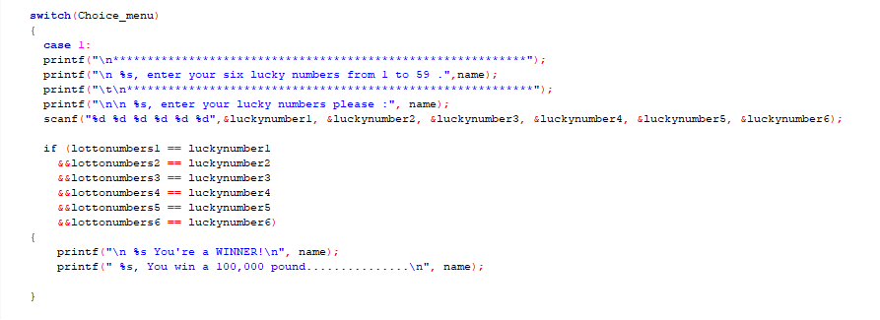

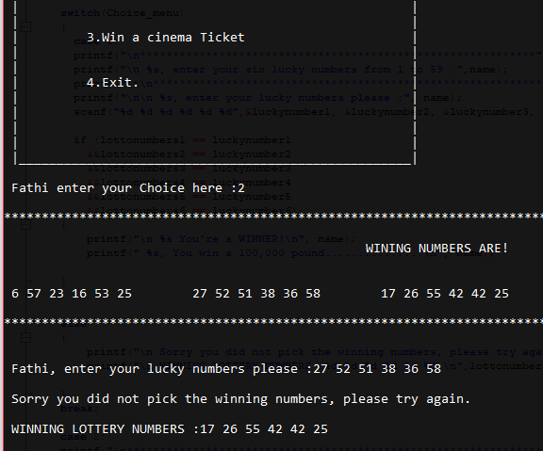
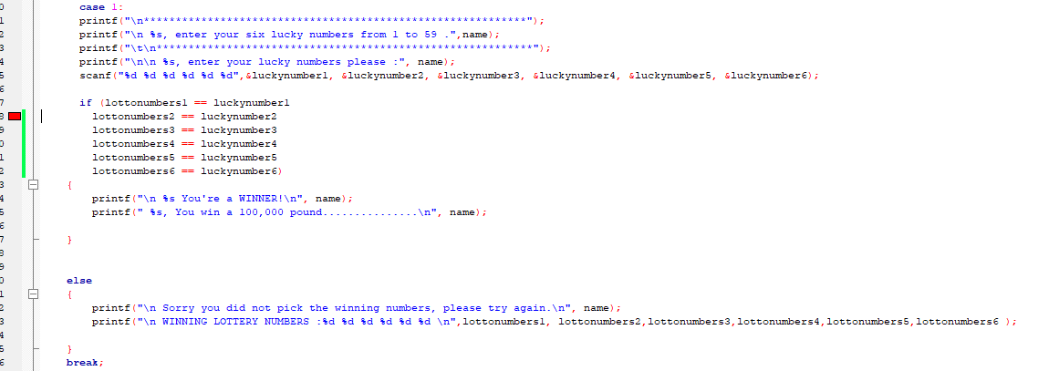
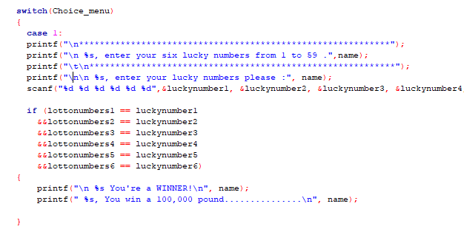
When the user enters the six numbers, they will be stored in different variables and test using if statement. But it wasn’t testing condition because I didn’t use logical AND (&&) and it becomes true only when all six conditions are true.

I wanted some feedback from my assessor so, I asked her to check my work to see if I was on the right track. After analysing my work, she stated that if two random numbers where the same in my code that would be invalid due to the fact duplicate. She also recommended that I ought to use a loop. The loop would intercept only if two numbers were the same and would generate until those numbers are not identical to each other.
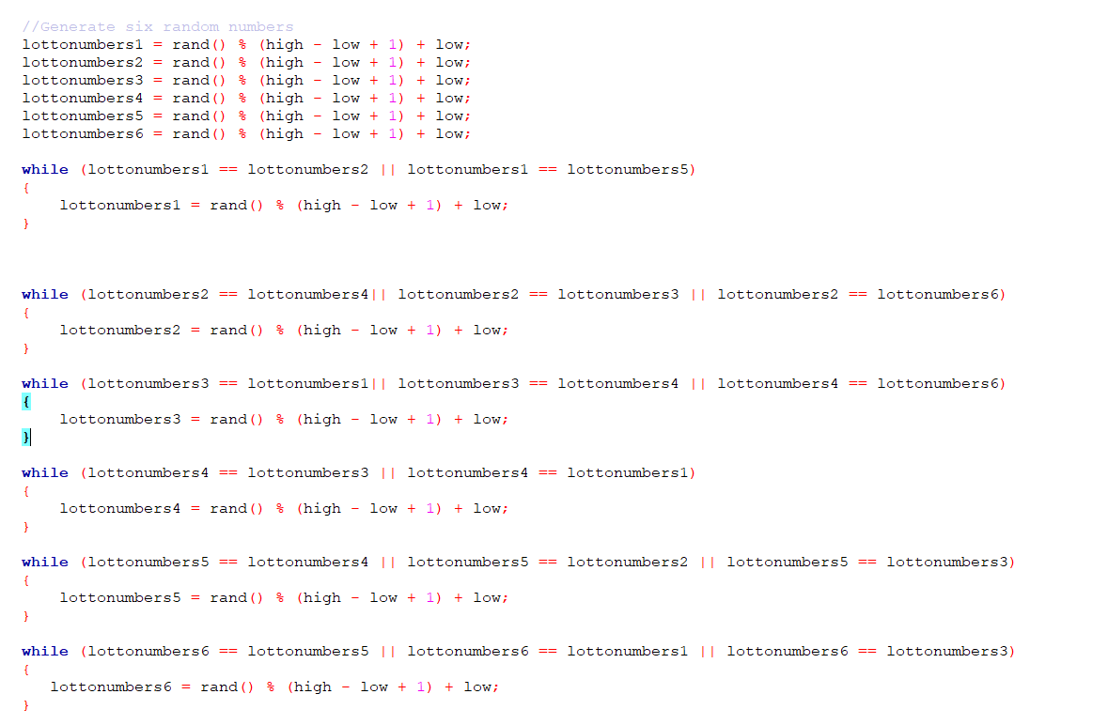
User documentation:
hello, if you are experiencing technical problems, please read this support guide.
user I have create this new game which is lovely as you see at top of the page it welcomes you and this game is very simple to play. The first question is (Are you read to start) and you should use y / yes or n/ no, and you need to enter the program how many games you would play by using numbers. The program will ask you a view questions about yourself like your name and age.
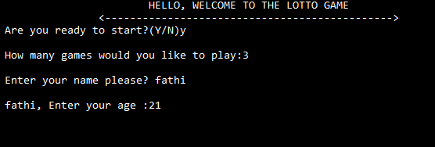
To start the game, enter (y).
Enter how many times would play the game using numbers. Enter your name here.
Enter age here please.

The menu is a set of four options presented to the user because is easy to follow and it helps the user to find information and the users can choose their options.
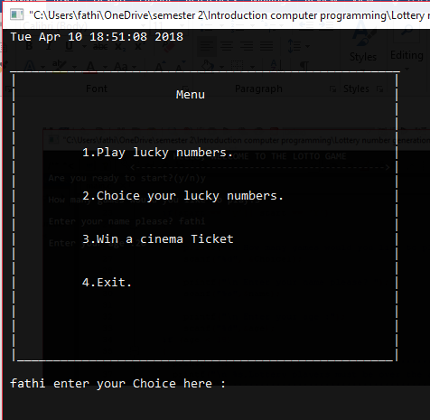

To choose from the menu, you need to enter those numbers 1, 2, 3, 4 and hit the enter bottom. The program will allow you to enter 6 numbers, range 1 - 59 and the program will compare your chosen lottery numbers to the generated numbers.

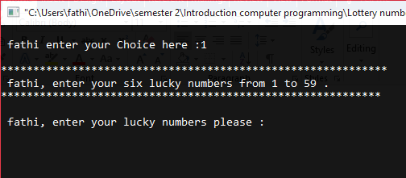

Enter the lottery numbers here.

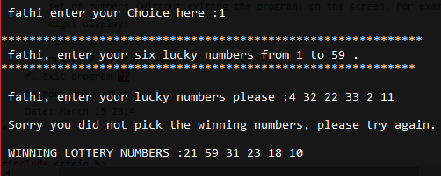
The user must enter the guessing numbers just like this.

The user needs to choose those numbers and choosing the correct numbers makes the difference between losing or winning.
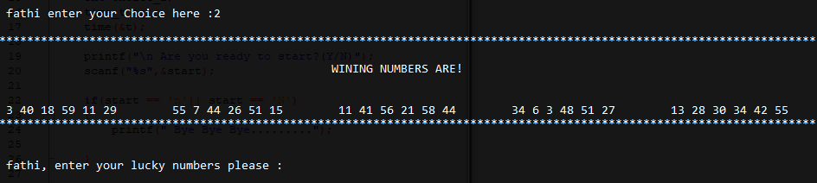

as you can see the screenshot, this is what happens if the user chooses the wrong numbers.
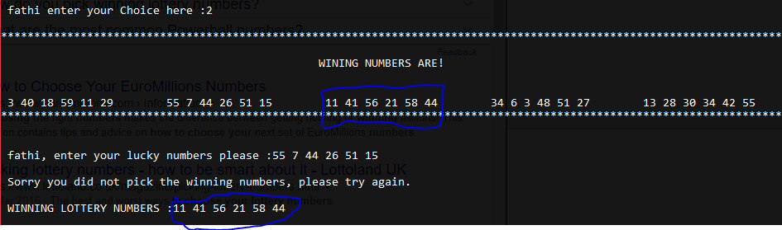

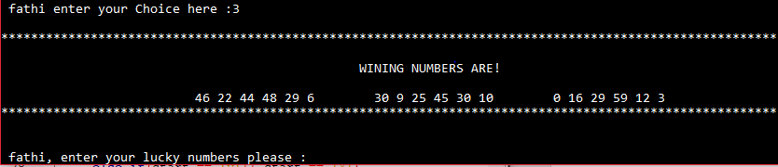

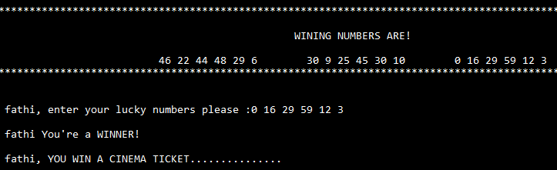

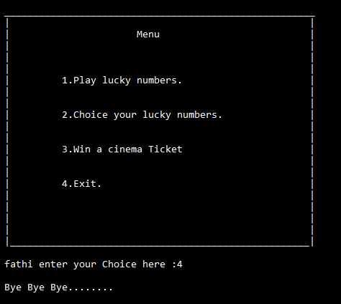

if you like to stop the game enter (4).

Technical documentation:
This game doesn’t have code comments and I believe is a region that I get confounded about. There were times that I didn’t how to put code comments into my code because I didn’t know when to use and when shouldn’t use. when I first started computer programming, I felt that great code was code that had loads of comments because is making the code a lot easier for a programmer to understand. But I discovered that I could accomplish a similar impact of clarifying what something does by making the names of the variables more elucidating and not using comments.
You will find that there aren't a lot of comments in my program, however, you will find that easy to understand my code because my variables are telling the story.
I was having an issue using arrays, so I decide not to use it but if you like to add arrays to the program. I think is a good idea because it allows you to store hundreds of numbers in one variable name.

Flowchart

Advantages of the program:
- There are a few advantages, first one is easy to use and understand.
- I present to the user actions and other options.
- Is easy for the user to use and the users can end the game when they want.

disadvantages of the program:
- using arrays would organise the code.
- there is some error that can be implemented on the menu.

Conclusion:
I have learned a lot through this assignment. this project has improved my coding skills. I learned a lot about variables, loop and if statement.
At the start of the game, my aim was to add more features in the game such as multiple players and more graphics. But doing all the designing of the lottery game became too complex.
This project also tested my technical skills and there were times that I almost lost hope, but I recovered through endless concentration and hard work.

Bibliography
Allain, A. (n.d.). Lesson 2: If statements in C. Retrieved from Cprogramming.com: https://www.cprogramming.com/tutorial/c/lesson2.html
Bolton, D. (2017, March 17). Definition of Variable. Retrieved from ThoughtCo.: https://www.thoughtco.com/definition-of-variable-958320
GookIn, D. (n.d.). HOW TO GENERATE RANDOM NUMBERS IN C PROGRAMMING. Retrieved from dummies A Wiley Brand: http://www.dummies.com/programming/c/how-to-generate-random-numbers-in-c-programming
Rouse, M. (2005, Sep). loop. Retrieved from Whatls.com: https://whatis.techtarget.com/definition/loop

