CONTENTS:

- Executive Summary-----------------------------------------------------------------
- Trend analysis-------------------------------------------------------------------------
- Advantages and disadvantages of using Excel---------------------------------
- Conclusion------------------------------------------------------------------------------
- References------------------------------------------------------------------------------

Introduction:

I am asked to analyse the data of kwikee mart to find areas where the profitability is low or negative. In order to do so, I shall use the Microsoft Excel Pivot Table and charts to identify the area from raw data provided by kwikee mart. In order to extract qualitative data from raw data to locate the areas needed to be addressed to increase profitability of kwikee mart, these tools shall be proved very useful. My approach to extract qualitative data from the raw data will be clustering. Basically, clustering is the task of grouping a set of objects in such a way that objects in the same group (called a cluster) are more similar (in some sense) to each other than to those in other groups (clusters). It is a main task of exploratory data mining, and a common technique for statistical data analysis, used in many fields, including machine learning, pattern recognition, image analysis, information retrieval, bioinformatics, data compression, and computer graphics. Cluster analysis was originated in anthropology by Driver and Kroeber in 1932 and introduced to psychology by Joseph Zubin in 1938 and Robert Tryon in 1939and famously used by Cattell beginning in 1943^{[4]} for trait theory classification in personality psychology.

Pivot Table:

Basically, A pivot table is a automated technique of clustering data in a meaningful way using Microsoft Excel Sheet. This is a table of statistics that summarizes the data of a more extensive table (such as from a database, spreadsheet, or business intelligence program). This summary might include sums, averages, or other statistics.

For example, in this task, the raw data looked like following:

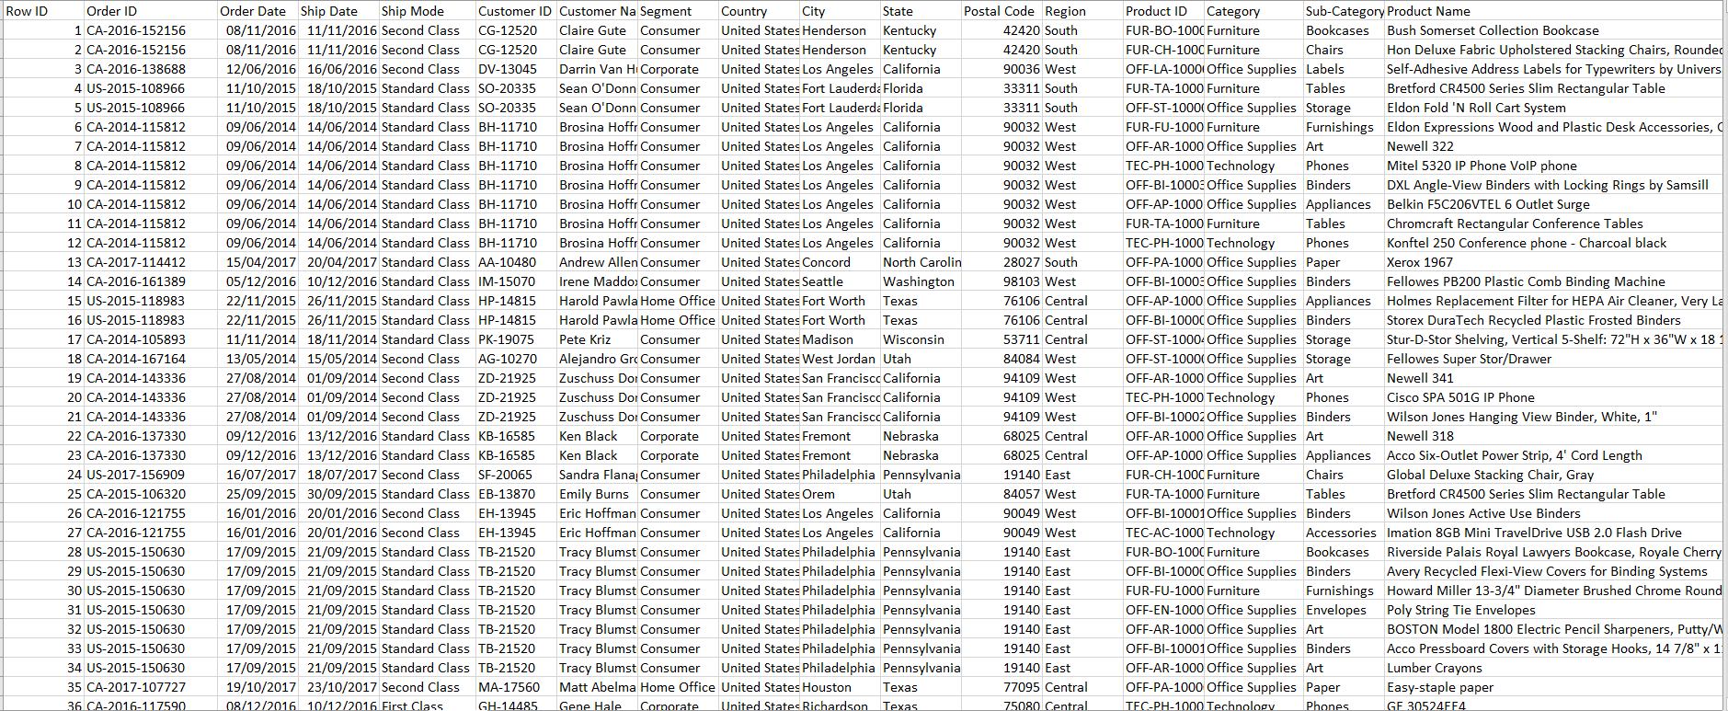

After using Pivot Table, We found some meaningful clustering of data which will guide us to identify the areas where the profitability is low or negative.

categorisation of quanity of goods sold, number of sales and discount:

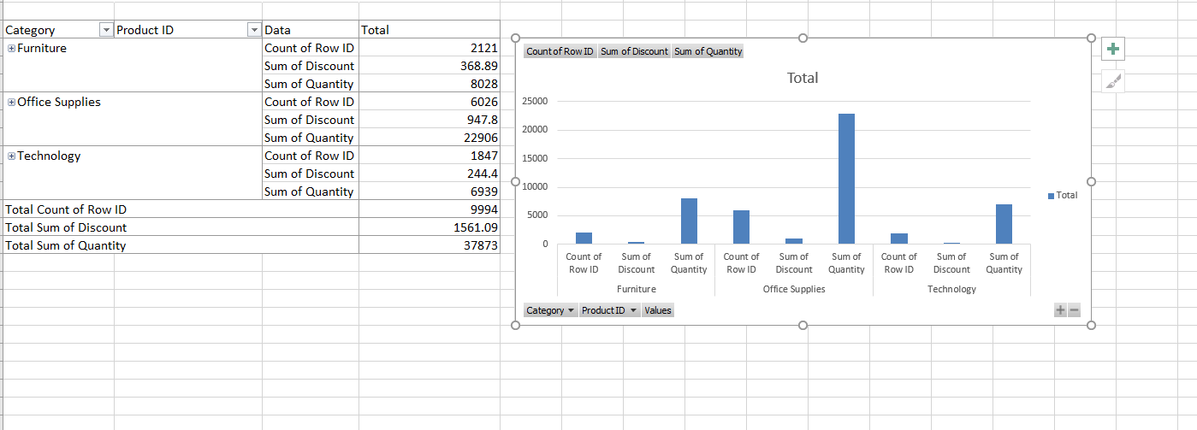

It can be observed that in terms of relation between number of sales, volume of sales and discount, Office supplies topped the list in all three and and technological goods is down the line. It can be said basing on this finding that there is a direct relation in between discount offered and sale volume. If larger sum of discount is offered, then number of sale will usually rocket up.

sum of discount by types of consumer:

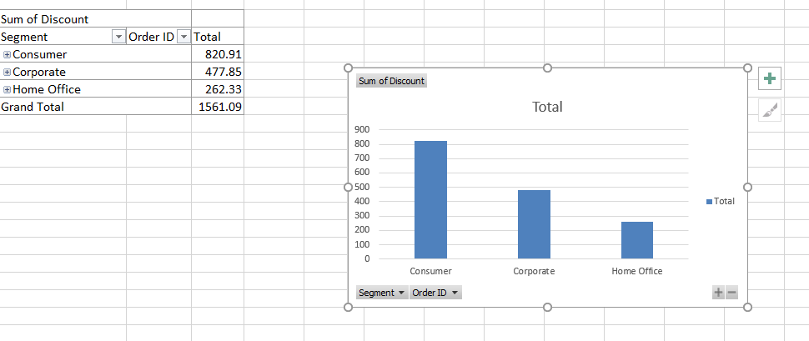

sum of quantity by geographical region:

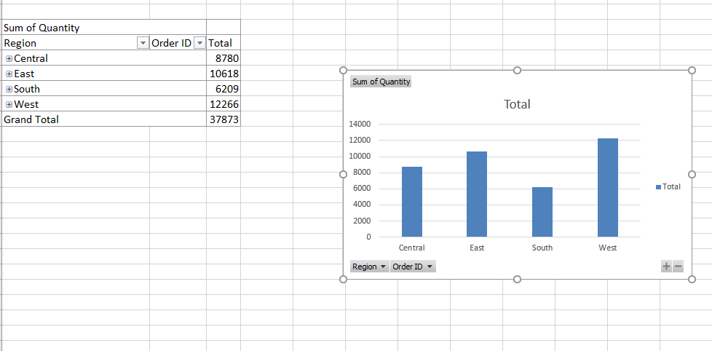

Basing on this pivot table, Easter and Western region has a higher sale count where as Central is just behind them, but southern region is at the bottom. Since from the earlier table, we observed that discount increase sale volume, it can be casually advised that introducing a discount for southern states may help in achieving the sale target in south. However, a discount will also decrease the profit margin. So, before deciding, we should look at the profitability sums.

sum of profit by geographical region

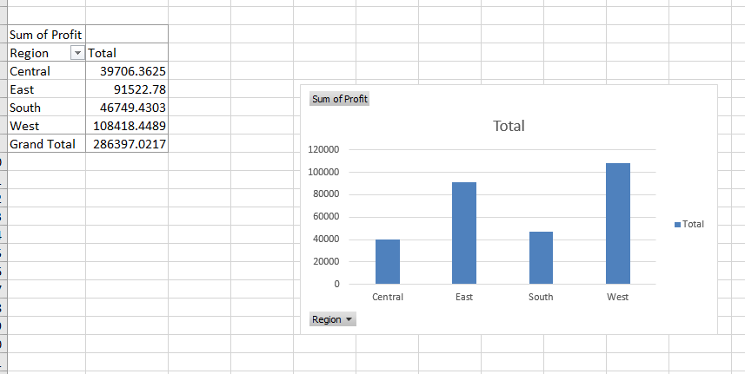

Contrasting with the data extracted in earlier table, though quantity or volume of sale in south was lower than central, but in regard of profitability central region is at the bottom. It should be prioritised to increase the sale in central. Probably, marketing campaign or promotional offer will help.

sum of profit by class of delivery:

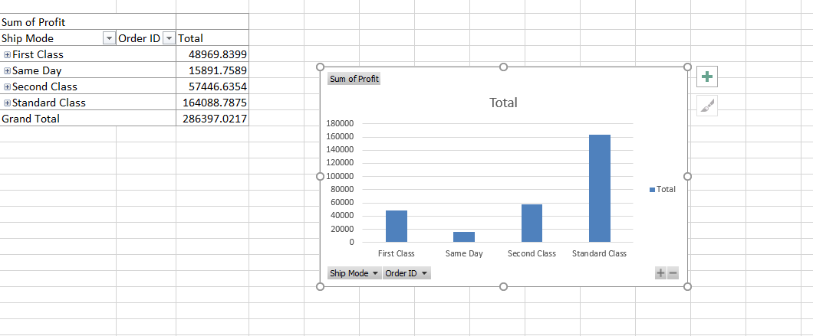

Last but not the least, an analysis of profitability on delivery method shows us that standard class of delivery, which is the cheapest class of delivery, earned highest amount of profit, then second class, first class and same day delivery. It is evident that, same day delivery is bringing significantly lower profit than the other classes. This situation can probably be addressed in one of three way. A conservative approach would be curtailing same day delivery for a while or allowing same day delivery only in the products where profit margin is high and delivery cost is lower. Alternatively, an approach could be taken enabling promotional offer in using other classes of delivery method so that customer will tend to avoid the same day. Thus, increasing the profitability.

Excelsheet is attached with the report separately.

There are some advantages of using excelsheet for data analysis and some disadvantages as well.

Advantages:
- Data Organisation
One of the biggest benefits of Excel is the core function of excel. The core ability of Excel is to organize large amount of data into orderly, logical spreadsheets and charts. It is understandable that when the data is organized, it is indeed, a lot easier to analyse and digest, especially when used to create graphs and other visual data representations.

Formula and calculation
Excel crunches numbers almost instantly, making batch calculations lot easier and smoother than working things out by yourself using a calculator. The formulae and equations make it very easy to compute both simple and complex equations processing large amounts of data.

Support from third party
Excel is essentially considered the standard for spreadsheet software and as such enable taking help and support from a considerably large amount of platform. Excel can be easily used in smartphones or tablets.

Office Integration
Excel can be used easily in conjunction with other Microsoft office tools such as Microsoft word and powerpoint. Excel spreadsheets can be easily added to Word documents and PowerPoint presentations to create more visually dynamic reports or presentations.

Disadvantages of Using excel in data analytics.

Learning Curve
While just about anyone can pick up Excel and start filling in tables, getting the full benefit of its features takes a lot of practice. Unfortunately, any User not familiar with Excel syntax may also find entering calculations and calling up other functions a bit difficult until they get a solid understanding.

Calculation Errors
While Excel's automatic calculation functions make most large-scale batch calculations easy, it isn't foolproof. In simple, Excel has no means of checking for human error during data entry, which indicates that wrong information entered by human flaw can skew all the results, often disastrously. As Tim Worstall of Forbes reports, JP Morgan lost billions of dollars due to an equation error in Excel introduced by users copying and pasting data on an excel sheet..

Time Consuming
Excel requires manual entry of data. For obvious reasons, Manually entering data into Excel takes substantial time, especially in cases, when you have a lot of data to enter. Lior Weinstein of Cogniview points out, can lead to boredom, which has potential to lead to inattentiveness which may turn into a very expensive loss.

Conclusion:

Excel spreadsheet proved to be a very useful tool for over three decades. In data analysis, it will always remain an useful tool.

References:

Books:
- Driver and Kroeber (1932). "Quantitative Expression of Cultural Relationships". University of California Publications in American Archaeology and Ethnology. Quantitative Expression of Cultural Relationships: 211–256
- Zubin, Joseph (1938). "A technique for measuring like-mindedness". The Journal of Abnormal and Social Psychology. 33(4): 508–516
- Tryon, Robert C. (1939). Cluster Analysis: Correlation Profile and Orthometric (factor) Analysis for the Isolation of Unities in Mind and Personality. Edwards Brothers.
- Data Analysis and Business Modeling with Excel 2013 by David Roja
- Guerrilla Data Analysis Using Microsoft Excel: 2nd Edition Covering Excel 2010/2013 by Oz du Soleil, Bill Jelen
- Excel Data Analysis: Modeling and Simulation by Hector Guerrero
- Decision Analytics: Microsoft Excel by Conrad Carlberg
- Marketing Analytics: Data-Driven Techniques with Microsoft Excel by Wayne L. Winston
- Basic Marketing Research: Using Microsoft Excel Data Analysis, 3rd Edition by Alvin C. Burns, Ronald F. Bush
- Hidden Secrets of Data Analysis in Excel: How to Use Microsoft® Excel Differently to Gain a Productive Edge by Jason Khoo
- Microsoft Office Excel 2007 Data Analysis: Your Visual Blueprint for Creating and Analyzing Data, Charts, and PivotTables by Denise Etheridge

Websites:

- www.efinancemanagement.com
- www.Investopedia.com

Driver and Kroeber (1932). "Quantitative Expression of Cultural Relationships". University of California Publications in American Archaeology and Ethnology. Quantitative Expression of Cultural Relationships: 211–256
Zubin, Joseph (1938). "A technique for measuring like-mindedness". The Journal of Abnormal and Social Psychology. 33(4): 508–516
Tryon, Robert C. (1939). Cluster Analysis: Correlation Profile and Orthometric (factor) Analysis for the Isolation of Unities in Mind and Personality. Edwards Brothers

