Name: Helal Uddin Khan
Student Number: 2434776
Module Code: LCHS4003
Module Title: Introduction to Health and Social Care
Lecturer: Mohammed Aliyu
Assignment Title: Healthcare Services Poster and NHS Essay

Task 1 – Poster (Ambulance Services)
Understanding the Ambulance Service in the United Kingdom
Introduction and Explanation
The ambulance service gives urgent help when someone is very ill or badly injured. People call 999 or 112 and emergency medical help comes to the place. Ambulance staff include paramedics, emergency medical technicians, ambulance care assistants and call handlers. These workers assess patients, give immediate treatment, provide life support when needed, and arrange safe transport to hospital or other care. In many cases paramedics treat people at home so patients do not need hospital admission. Ambulance services also give telephone advice, coordinate with community services, and take part in public health tasks such as vaccination clinics.
A Brief History
The ambulance service in the UK began as several local and charitable efforts in the late nineteenth century. Early services moved sick people, sometimes in horse-drawn carriages, and were often linked to workhouses or public boards. Motorised ambulances became common in the early twentieth century and made faster response possible. During the Second World War emergency medical arrangements showed that a national system could be organised. When the NHS started in 1948 ambulance services were integrated into public health provision and funded by the state. Through the 1970s and 1980s the focus moved from transport to clinical care as paramedic training improved and new equipment such as defibrillators and advanced airway tools became standard. Today the ambulance service is a clinical, highly skilled part of health care.
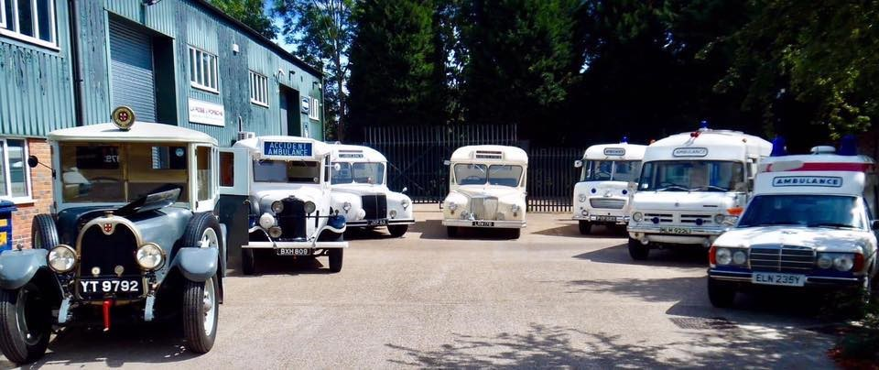
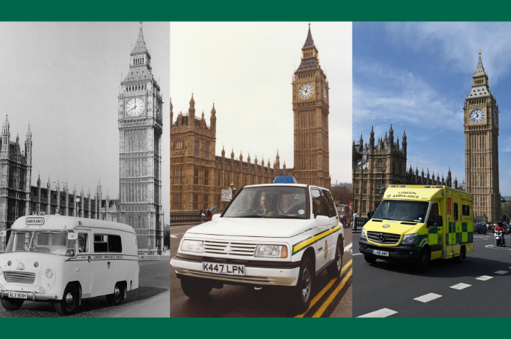
Current Functioning
Modern ambulance services operate 24 hours a day and perform several roles. The emergency response uses a telephone triage system to decide priority of calls; life-threatening situations are fast-tracked. Ambulances carry equipment for advanced life support, including cardiac monitors, medicines, oxygen and immobilisation devices. Clinical telephone triage and advice allow some callers to receive care without an ambulance or be referred to GP or urgent treatment centres. Non-emergency patient transport supports planned hospital visits for people with mobility needs. Ambulance services work closely with hospitals, mental health crisis teams, social care and other emergency services. Technology such as GPS navigation, electronic patient records and real-time communication helps faster and safer care.

Two Key Challenges
Challenge 1 — Rising demand and delays: Demand for ambulance care has grown because of an ageing population and more long-term conditions. As hospitals become busier, ambulances sometimes wait outside emergency departments before they can hand over patients. This ‘ambulance handover delay’ reduces the number of vehicles available for new calls and increases response times for other people in urgent need.
Challenge 2 — Workforce, retention and well-being: Ambulance work is physically and emotionally demanding. Paramedics and crews face long shifts, difficult scenes and sometimes violence or verbal abuse. Recruitment and retention are difficult; many skilled staff leave for better pay or less stress. Staff shortages worsen waiting times and increase pressure on remaining employees, risking burnout and sickness absence.

Conclusion
Ambulance services have moved from basic transport to skilled clinical care over many decades. They remain vital to public health and emergency response but face real pressures from demand and workforce challenges. These issues need system-level action such as better hospital flow, workforce planning and staff support so ambulance services can continue to save lives.

Task 2 – Essay: Origins and Structure of the NHS
Origins and structure of the National Health Service (NHS)
Origins and Historical Context
The NHS began on 5 July 1948. Before NHS, health care in Britain was patchwork: private doctors, charity hospitals and limited insurance schemes. Many poor people could not get treatment. The experience of the Second World War, with national planning and shared services, showed how health services could be organised for all people. After the war there was a political will to rebuild society and reduce inequality. Aneurin Bevan, as Minister of Health, led creation of the NHS based on three clear ideas: universal access, care free at the point of use, and funding through taxation. These principles responded to social need and desire for fairness.
Key Principles and Early Impact
The founding principles were simple: every person should get healthcare when they need it, without payment at the time, and the system should be paid by public taxation. The change increased access quickly, especially for families and older people who previously avoided treatment because of cost. The NHS became symbol of collective responsibility for health and social welfare.
Current Structure and Functioning
Over time the NHS has grown complex and seen many reforms. In England the Department of Health and Social Care makes policy and NHS England sets national priorities and allocates budgets. Local services are planned through Integrated Care Systems (ICSs), which bring together hospitals, general practice, community health, mental health, local councils and the voluntary sector to plan and deliver care according to local needs. Hospitals are organised as NHS Trusts or Foundation Trusts that run services and manage budgets. General practitioners usually work as independent contractors but are central to patient access and long-term care. Social care remains separate in funding and organisation, which creates difficulties in joining health and social care services.
Challenges and Critical View
Today the NHS faces rising demand from older people and more chronic illness, workforce shortages in nursing and medical staff, and constrained funding which affects capacity. Waiting lists for routine surgery and specialist appointments have increased. Integration with social care is incomplete, causing gaps in care for frail older people who need both health and social support. There is also tension between national targets and local priorities. To maintain the founding promise, the NHS needs sustained investment, better workforce planning, and stronger partnership with social care and community services.
Conclusion
The NHS was created from a clear moral idea: healthcare for all. Its core values remain important but the system must adapt to modern challenges. Improved funding, workforce support and local integration are essential if the NHS will continue to deliver universal care in future.

References
Bevan, A. (1952) In Place of Fear. London: Victor Gollancz.
Timmins, N. (2018) The Five Giants: A Biography of the Welfare State. London: HarperCollins.
NHS England (2022) Integrated care systems: design framework. Available at: https://www.england.nhs.uk/ (Accessed: 16 November 2025).
NHS (2023) About the NHS. Available at: https://www.nhs.uk/ (Accessed: 16 November 2025).
Rivett, G. (1998) From Cradle to Grave: Fifty Years of the NHS. London: King’s Fund.

