

TITLE PAGE:
Engineering Academic Discipline
Motorsport Engineering HND
----------------------------------------------------------
TITLE OF REPORT: MODULE NAME AND CODE:
Electronic Circuits Testing Electrical Control Systems
And Applications ACHA4010
----------------------------------------------------------STUDENT NAME: RYAN WILLIAMS
STUDENT NUMBER: 2409909
DATE: 06/04/2025
----------------------------------------------------------

Content Page:
TITLE PAGE: 1
Content Page: 2
Task 3 2
Scope Time Division Calculations (3) 2
Function Generator output square wave (3) 2
Capacitor charge and discharge wave marked at correct points. (3) 2
Basic Capacitor Calculations (3) 2
Capacitor discharge table (2) 2
Plot log(V) Gradient (2) 2
Gradient Calculations and Compare(4) 2
Gradient Calculations 2
Comparison table 2
Capacitor Uses (5) 2
Inaccuracies Question (4) 2
References 2
Table of Figures:
Figure 1 Square Waveform 3
Figure 2 Capacitor Charge and Discharge 4
Figure 3 Voltage Vs Time 5

Scope Time Division Calculations:

𝑓=1𝑃𝑒𝑟𝑖𝑜𝑑 (𝜏) & 𝑃𝑒𝑟𝑖𝑜𝑑(𝜏)=1𝑓 & 𝐷𝑖𝑣𝑁𝑢𝑚𝑏𝑒𝑟𝑇𝑖𝑚𝑒=10
$$T= \frac{1}{250}=\frac{0.004}{10}=0.0004$$Further information on scope time division calculations was taken form a website which increased understanding of time scope divisions calculations. (oscilloscope)

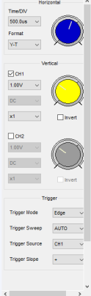
Function Generator output square wave:
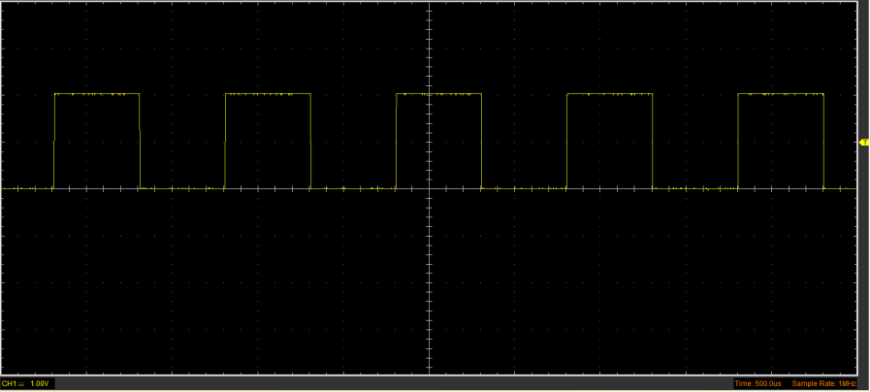
Figure 1 Square Waveform

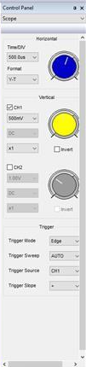
Capacitor charge and discharge wave marked at correct points:

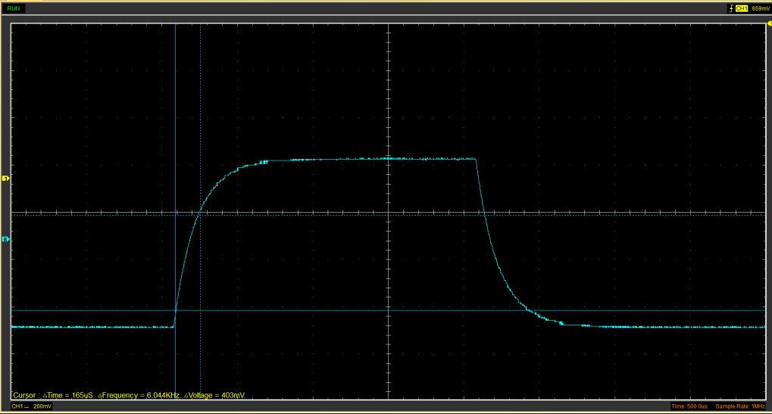
Figure 2 Capacitor Charge and Discharge

Basic Capacitor Calculations:

$$(Peak\left(V\right)-Start\left(V\right)×63.2\%+Start\left(V\right)=V Top Cursor$$
$$0.639×0.630=0.403$$

C=time contents/resistance (100)
$$\frac{0.403}{100}=0.00403$$

Capacitor discharge table:
Time (s) | Voltage (V) | ln (V) | dy = y2 – y1  dy = ln(V)2-ln(V)1 | dx = x2- x1  dx = Time2 – Time1 | dy/dx
0.00437 | 0.8282 | -0.1885 | x | x | x
0.004381 | 0.6525 | -0.42694 | -0.23844 | 1.10E-05 | -21676.7
0.004393 | 0.4392 | -0.8228 | -0.39586 | 1.20E-05 | -32988
0.004405 | 0.32 | -1.13943 | -0.31663 | 1.20E-05 | -26386.2
0.004416 | 0.2447 | -1.40772 | -0.26829 | 1.10E-05 | -24389.8
0.004428 | 0.2071 | -1.57455 | -0.16683 | 1.20E-05 | -13902.6
0.00444 | 0.1694 | -1.77549 | -0.20094 | 1.20E-05 | -16744.9
0.004451 | 0.1506 | -1.89313 | -0.11764 | 1.10E-05 | -10694.1
0.004463 | 0.138 | -1.9805 | -0.08737 | 1.20E-05 | -7281.14
0.004475 | 0.1192 | -2.12695 | -0.14645 | 1.20E-05 | -12204.2

Plot log(V) Gradient:
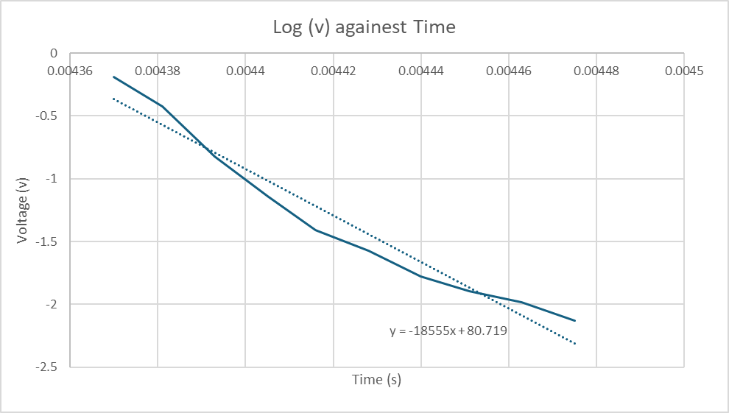
Figure 3 Voltage Vs Time
.

Gradient Calculations:

$$Gradient= \frac{d(in\left(V\right))}{dt}=-\frac{1}{RC}$$

$$dy=-0.42694-\left(-0.1885\right)=-0.23844 \\ dx=0.004381-0.00437=0.000011 s \\ Gradient=0.000011-0.23844​≈-21676.4​$$

$$dy=-0.8228-\left(-0.42694\right)=-0.39586 \\ dx=0.004393-0.004381=0.000012 \\ Gradient=0.000012-0.39586​≈-32988.3$$

(Storr, 2013a)

Comparison table:

$$Capacitor Discharge Formual: \\ V\left(t\right)=V0_{e}-^{\frac{t}{RC}}$$

$$Capacitance Formual:$$
$$C=-\frac{1}{R.Gradient}$$
$$-\frac{1}{100×32988.3}=3.03177792×10^-7$$
$$-\frac{1}{100×-21676.4}=4.613312174×10^-8$$

 | Capacitance | Delta | Percentage difference
Actual | 1 µF | x | X
Marker Calculation
Gradient Calculation | -18555+80.719

Capacitor Uses:
A capacitor has a use in just about every single field worth of engineering, this can range from motorsport engineering all the way to electrical engineering itself.

One of the many uses for a capacitor uses within the automotive industry more to do electric vehicles with the break energy regeneration. Capacitors play a key role in this system, when a vehicle is breaking it would recapture the kinetic energy and then turn it into electricity and there it will be stored in the capacitor for a certain period. (Powers, 2015)

An additional use of a capacitor in relation to the automotive industry is to do with vehicle car audio system, according to (Kötz and Carlen (2000) once the car battery has been disconnected it will be backup for a few days. (Kötz and Carlen, 2000)

A use of a capacitor within motorsports and the automotive industry would be enhancements towards ignition systems. The capacitors can hold energy and then rapidly discharge allowing a strong and consistent spark to be created for efficient combustion. (Role of Capacitors in Automotive Ignition, Power Supply & Radio Tuning, 2009)
Moreover, a capacitor can be used for active suspensions systems, which are used within motorsports as well as automotive. The capacitor can deliver rapid energy to allow the suspension height as well as the overall damping of the vehicle. (Shepard, 2016)

In terms of motorcycles, a capacitor can be used for voltage stabilizer. In short it can ensure that any voltage fluctuations are smoothen out. This will assist in the electrical performance of electrical components. (Sayed, 2020)

Another use when it comes to motorcycles and any automotive vehicle in general would be a noise filtering application. In short, the capacitors are there to filter out electrical noise and assist in the suppression of voltage spikes. (Motorcycle Capacitors | Electronics Forum Circuits, Projects and Microcontrollers)

Capacitors can be used in respects for rectifier support, the capacitor can assist in stabilizing DC voltage output from a rectifier/regulator and motorbikes which don’t have a battery. (“Battery Eliminator / Capacitor,” 2020)

If a vehicle was to lose power, a capacitor could be used to help support important parts of the car such as the ECU which is needed to run the vehicle effectively. The capacitor could act as a backup power source for keeping the memory function of the ECU in check if the main battery is disconnected. (“The Role of Capacitor Films in the Automotive Sector,” 2023)

An automotive capacitor can be used for assisting sensor, this can include tire pressure sensors, drivetrain monitoring and more importantly battery management. (“Automotive Capacitors - Automotive Applications - Holy Stone,”)

A new feature in modern day vehicle is a stop start system, and to allow this to work effectively a capacitor can be used to sort power to assist in turning the engine back on after its been off when stopped in traffic. (“Automotive Applications For Supercapacitors & Ultracapacitors )

Inaccuracies Question (4)
The measurements taken could have had many factors could have impacted the overall accuracy of the results. One of factors could a been human error as humans can still make errors no matter how much time is taken to try to mitigate any source of errors. (Storr, 2013b)

Additionally, the environmental factors such as temperature can impact the capacitors performance meaning that the data could have been incorrected due to that.

Moreover, the breadboard and other connecting leads would have had there own resistance which if high enough will add up therefore leading to our results having many inaccuracies due to them factors although all connections were checked for the test to ensure the resistance was known.

Overall, it is very hard to have full control over this type of test due to the number of factors that are involved in it. The most important thing to consider is that the temperature will affect the data therefore it must be taken with a bit of slat.

References:
Automotive Applications For Supercapacitors & Ultracapacitors | CAP-XX, n.d. . CAP-XX Des. Manuf. Thinnest High. Power Density Supercapacitors Ultracapacitors. URL https://www.cap-xx.com/applications/auto/ (accessed 3.27.25).
Automotive Capacitors - Automotive Applications - Holy Stone, n.d. . Holy Stone Capacit. URL https://www.holystonecaps.com/automotive/ (accessed 3.27.25).
Battery Eliminator / Capacitor [WWW Document], 2020. . Hughs Hand Built. URL https://www.hughshandbuilt.com/product/battery-eliminator-capacitor/ (accessed 3.27.25).
Kötz, R., Carlen, M., 2000. Principles and applications of electrochemical capacitors. Electrochimica Acta 45, 2483–2498. https://doi.org/10.1016/S0013-4686(00)00354-6
Motorcycle Capacitors | Electronics Forum (Circuits, Projects and Microcontrollers) [WWW Document], n.d. URL https://www.electro-tech-online.com/threads/motorcycle-capacitors.5505/?utm_source=chatgpt.com (accessed 3.27.25).
oscilloscope [WWW Document], n.d. URL https://www2.hawaii.edu/~jmcfatri/labs/notes3.html (accessed 3.27.25).
Powers, N., 2015. Capacitor Powered Cars: Capacitors in Automotive Applications [WWW Document]. Arrow.com. URL https://www.arrow.com/en/research-and-events/articles/capacitors-in-automotive-applications (accessed 3.27.25).
Role of Capacitors in Automotive Ignition, Power Supply & Radio Tuning [WWW Document], 2009. . Phys. Forums Sci. Discuss. Homework Help Artic. URL https://www.physicsforums.com/threads/role-of-capacitors-in-automotive-ignition-power-supply-radio-tuning.330883/ (accessed 3.27.25).
Sayed, M.A., 2020. (PDF) Energy Regeneration System for Electric Vehicles Using DC-DC Converter with Super-capacitors, in: ResearchGate. https://doi.org/10.23919/ICEMS50442.2020.9291140
Shepard, J., 2016. Electromagnetic Active Automotive Suspension System - News [WWW Document]. URL https://eepower.com/news/electromagnetic-active-automotive-suspension-system/ (accessed 3.27.25).
Storr, W., 2013a. RC Discharging Circuit Tutorial & RC Time Constant. Basic Electron. Tutor. URL https://www.electronics-tutorials.ws/rc/rc_2.html (accessed 4.5.25).
Storr, W., 2013b. RC Discharging Circuit Tutorial & RC Time Constant. Basic Electron. Tutor. URL https://www.electronics-tutorials.ws/rc/rc_2.html (accessed 4.6.25).
The Role of Capacitor Films in the Automotive Sector [WWW Document], n.d. . Cosmo Films. URL https://www.cosmofilms.com (accessed 3.27.25).

