
Student Name: Susan Jacqueline Henry
Student Number: 2517542
Module: Network and Cybersecurity Essentials
Module Code: ACCA4024
Date: --/08/2026

Lecturer’s Name: Dr Kwame Assa-Agyei


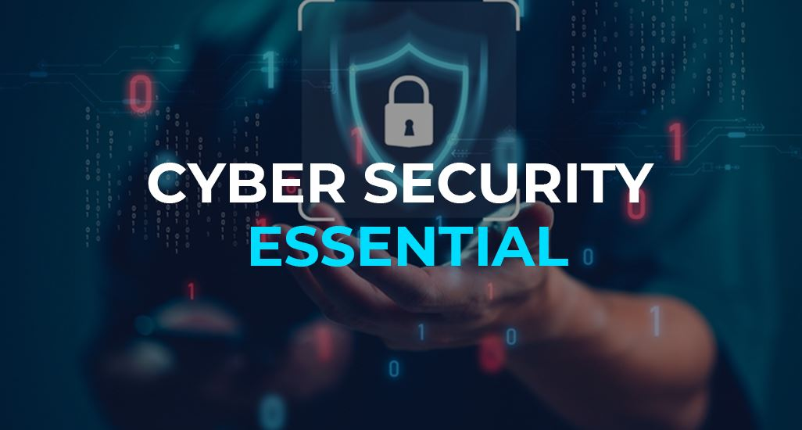
Table of Contents
Cybersecurity Policy Development for SteelForm Manufacturing Ltd 1
Abstract 1
Introduction 2
Identification of Modern Threats 3
External Threats 3
Internal Threats 3
Modern Security Policies 4
Policy Framework Structure 4
Modern Security Policies cont. 5
Acceptable Use Policy 5
Access Control and Identity Policy 5
Network Segmentation Policy 5
Data Classification and Governance Policy 5
Supplier Patch Management Policy 5
Technical Mitigation Measures 6
Proactive Monitoring and Incident Response 7
Continuous Monitoring Framework 8
Response Times 8
Induction Training 8
Ongoing Awareness Programme 8
Accountability 8
Conclusion 9
References 10
Appendix A: Screenshot of the Board of Directors PowerPoint presentation 11
Appendix B: Screenshot of Security Badge 16

Cybersecurity Policy Development for SteelForm Manufacturing Ltd

Abstract
The adoption of Industry 4.0 technologies, including Internet of Things (IoT) sensors, automated operational technology, and cloud-based management systems, has transformed manufacturing operations but instantaneously expanded the cyber-attack surface. This report identifies the full scale of internal and external threats that SteelForm Manufacturing Ltd (SFM), establishes a comprehensive set of security policies aligned with international standards [1] [2], proposes targeted technical and procedural mitigation measures; outlines a proactive monitoring framework and incident response system, and delivers a staff and awareness training programme. The recommendations are designed to protect critical operational infrastructure, intellectual property (IP); and sensitive data, ensuring business continuity, compliance regulations, and secure digital transformation [3].

Introduction
The shift toward Industry 4.0 has significantly increased the risks for manufacturing companies, creating new opportunities for cyber criminals to exploit interconnected operational technology and traditional IT environments [4]. SFM is now exposed to a range of cyber threats that target both smart manufacturing machinery as corporate information systems. Understanding these threats is essential for developing a robust, effective cybersecurity and data governance policy [2].
Modern manufacturing environments rely on smart machinery, remote monitoring and are connected to supply chains which expose sensitive data, proprietary design and production systems to threats [5]. The recent ransomware attacks against industrial control systems and supply chain data breaches have demonstrated how cyber incidents can bring production to a standstill, affecting the company’s reputation and cause substantial financial loss [6] [7]. Following these recent security breaches, malware viruses, phishing attacks, and attempts on unauthorised access, this report provides a systematic policy framework to reinforce SFM’s security and protect the companies’ key assets [2].

Identification of Modern Threats

External Threats
Modern manufacturing organisations face an array of external threats, many of which specifically target the industrial environments [4]:
Malware and Ransomware Attackers encrypt production systems, enterprise resource planning (ERP) platforms and design files demanding financial payment for restoration [6]. This poses a catastrophic risk to manufacturing operations, where downtime directly impacts revenue and customer requirements [5].
Phishing and Social Engineering: Target deceptive communications commonly carried out via emails, directed at procurement and staff. Cyber criminals seek to steal credentials to initiate fraudulent payments or deploy malware [7]. These attacks exploit human trust, not technical vulnerabilities [6].
Supply chain and Third-Part Attacks: Suppliers, logistics partners, and cloud service providers are open to attacks via pathways to the network. A compromise at any trusted partner can be used as a gateway to attack SFM systems [5].
Industrial Espionage: Competitors or state-aligned actors may target IP, manufacturing process and aerospace/automative specifications representing loss of competitive advantage and potential contract breaches [8].
IoT and Operational Technology Exploitation: Many smart devices and sensors operated with default configurations, unencrypted communications, and unpatched firmware, providing attackers with easy access to the production network [9].

Internal Threats
Accidental Human Error: Misconfiguration, lost devices, sending sensitive data to incorrect recipients [3].
Privilege Misuse and Insider Risk: Authorised personnel accessing data outside their scope; malicious insiders stealing data or sabotaging systems [3].
Weak Access Governance: Shared account, exercise permissions, and failure to withdraw access prior to exit [2].

Modern Security Policies

Policy Framework Structure

ISO 27001/NIST ALIGNED
POLICY FRAMEWORK

Supplier & Acceptable Use Policies
Classification
Encryption
Back Rules
Retention
Data Governance & Policies
IT/OT Separate
Firewall Rules
Guest Isolated
Patch Policy
Network & Infrastructure Policies
Least Priv. MFA Enforced Password Std Offboarding
Access & Identity & Policies

Modern Security Policies cont.

Aligned with ISO/IEC27001 and the NIST Cybersecurity Framework [2], the following policies establish mandatory security requirements:

Acceptable Use Policy

All IT and operational assets are for authorised business purposes only. Personal devices, external USB storage, and unapproved software must not be connected or installed. Remote access requires encrypted VPN and multi-factor authentication [4].

Access Control and Identity Policy

Principle of Least Privilege: uses only receive minimum permissions. MFA is mandatory for all remote access accounts, and cloud portals [4]. Passwords: 12 characters, and rotation quarterly. Access rights reviewed monthly; withdrawn immediately after termination [2].

Network Segmentation Policy

IT and OT networks are logically separated by firewalls. Machinery, sensors and industrial control systems must not reside on the dame LAN as general business workstations [9]. Guest wireless isolated fully from corporate and production [4].

Data Classification and Governance Policy

Restricted: proprietary designs, contracts, financial data are encrypted at rest and in transit
Internal Use only: operational reports, maintenance logs
Public: marketing and general information

All restricted data is encrypted in accordance with industry standards [3], [4].

Supplier Patch Management Policy
Vendors must demonstrate equivalent security standards. Critical vulnerabilities patched within 72 hours; high severity within 14 days [2].

Technical Mitigation Measures

Technical mitigation measures provide the essential controls need to protect interconnected systems, IoT devices and cloud-based platforms [4]. These measures are vital to reducing exposure to malware, unauthorised access, and industrial espionage across both information Technology and Operational Technology networks [9].

Layer 1 Physical & Perimeter
Firewalls – VPN – DMZ – External Filtering

Layer 2 Network & Segmentation
IT VLAN | OT VLAN | Management | Guest |Isolated

Layer 3 Endpoint & Access
EDR/Antivirus – MFA – Strong Authentication – Least Privilege

Layer 4 Data & Backups
Encryption – Access Logs – 3-2-1 Backup Strategy

Measure | Implementation | Threats Addressed
Network Segmentation & Firewalls | Separate VLAN’s default deny traffic rules [4] | Lateral malware spread; OT access
Endpoint Detection & response | Enterprise protection across all devices [7] | Malware, ransomware execution
Multi-factor Authentication | Enforced VPN, email, cloud, admin accounts [4] | Credential theft, phishing success
Data Encryption | AES-256 at rest. TLS 1.3 in transit [4] | Data theft, eavesdropping
Vulnerability Scanning & Patching | Weekly scans, 72hr critical patch target [2] | Known exploit attacks
3-2-1 Backup Strategy | 3 copies, 2 media types, 1 offsite backup [6] | Ransomware recovery

Proactive Monitoring and Incident Response
Alert Received

Validate Alert

False Positive
Contain Isolate
Close OK

Assess Impact

Notify Stakeholders

Notify IT Board Legal/Regulator

Remove Threat
Restore Systems

Post-Incident
Review & Learn

Close Ticket

Continuous Monitoring Framework
Security Information and Event Management (SIEM) centralises logs from firewalls, servers, authentication systems, and cloud platforms [4]. Automated alerts trigger on, repeated failed logins, unusual outbound data transfers, after hours OT access and encryption indicators [7]. Critical alerts routed to IT Security Manager immediately; reports to the Board [2].

Response Times
Critical (production/OT impact} Respond within 1 hour: 24/7
High severity – Respond within 4 hours
Routine/policy violations – Address within 3 Working days

Induction Training
All new employees receive mandatory training covering, acceptable use policies, identifying phishing indicators, password security, and physical security including screen lock and clear desk policies [6], [7].

Ongoing Awareness Programme
Monthly newsletter: current threats and real-world examples relevant to manufacturing [7].
Quarterly phishing simulations: controlled testing; no penalties for honest mistakes [6].
Role specific training: Procurement/Finance – payment fraud, Engineering – OT security and USB risks [5].

Accountability
Security awareness and compliance form part of annual performance reviews. A quarterly “Security Champion” programme recognises positive contributions, repeated violations addressed through management and disciplinary procedures [3].

Security Culture Foundation
Policies – Passwords – phishing
(all new staff – Induction)

Ongoing Awareness Programme
Monthly Newsletter – Quarterly Testing
(All staff)

Role-Specific Training
IT/Admin
Privileges & Access
General
Compliance Standards
Procurement
Fraud & Email

Conclusion
The integration of smart manufacturing technologies offers SFM significant operational advantages but introduces commensurate cybersecurity risks from ransomware and supply chain compromise to internal error and data leakage [5], [6]. By systematically identifying threats, adopting standards aligned security policies [2], implementing layered technical defences [4] as illustrated in the defence in depth model, establishing proactive monitoring and incident response capabilities [7], and fostering an informed security culture through continuous training [3], SFM can manage risk effectively. This framework provides a repeatable, auditable foundation that protects critical assets, ensures compliance, builds stakeholder confidence, and enables secure digital transformation without compromising business growth.

References
[1] H. Taherdoost, “Understanding cybersecurity frameworks and information security standards — A review and comprehensive overview,” vol. 11, no. 14, p. 2181, 2022.

[2] W. Stallings, Network Security Essentials: Applications and Standards, 6th ed., Global ed. Harlow, England: Pearson, 2017, p. 463.

[3] M. Christen, The Ethics of Cybersecurity, 1st ed. Cham: Springer Nature, 2020, p. 384, doi: 10.1007/978-3-030-29053-5.

[4] W. Stallings, Data and Computer Communications, 10th ed. Boston: Pearson, 2014, p. 914.

[5] G. Kumar, D. K. Saini, and N. H. H. Cuong, Eds., Cyber Defence Mechanisms: Security, Privacy, and Challenges. London; New York, 2021, p. 231.

[6] J. Steinberg, Cybersecurity For Dummies, 3rd ed. Hoboken, NJ: For Dummies, 2025, p. 432.

[7] Cisco Academy, “Cybersecurity Essentials.” [Online]. Available: https://www.netacad.com/courses/cybersecurity

[8] Association for Computing Machinery. [Online]. Available: https://www.acm.org/

Appendix A: Screenshot of the Board of Directors PowerPoint presentation
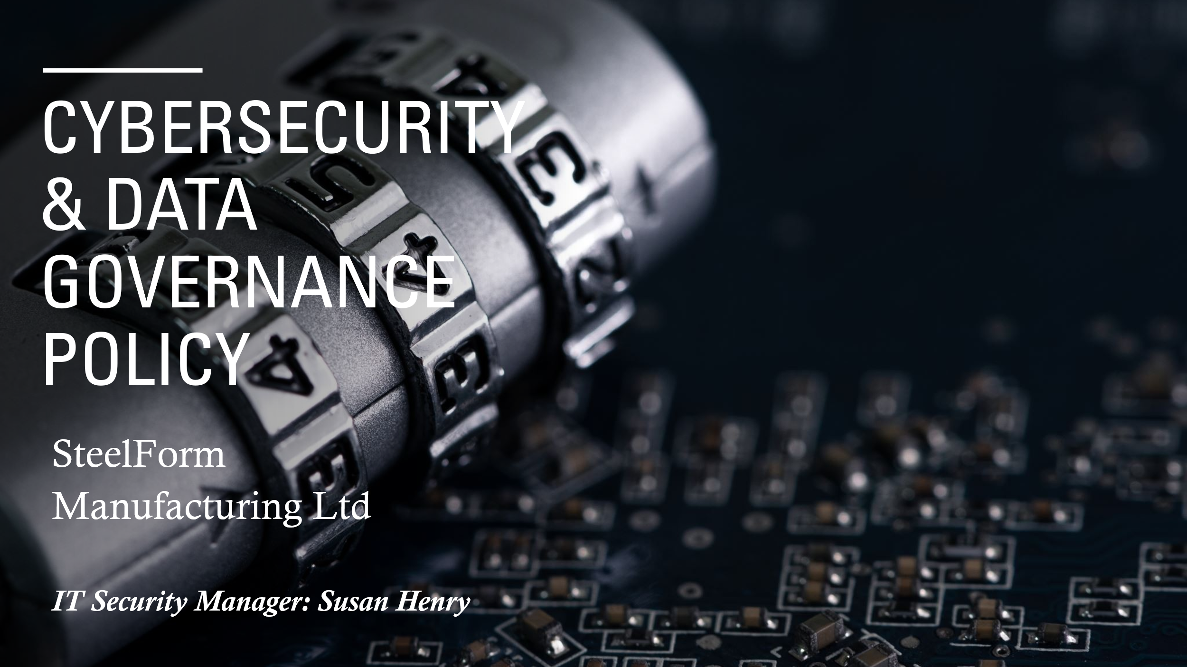
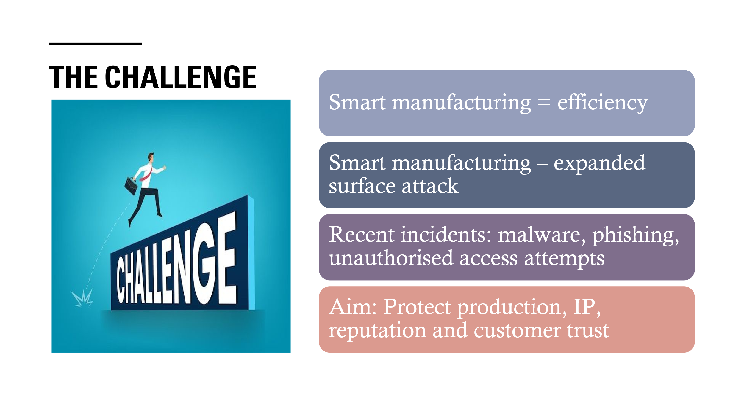
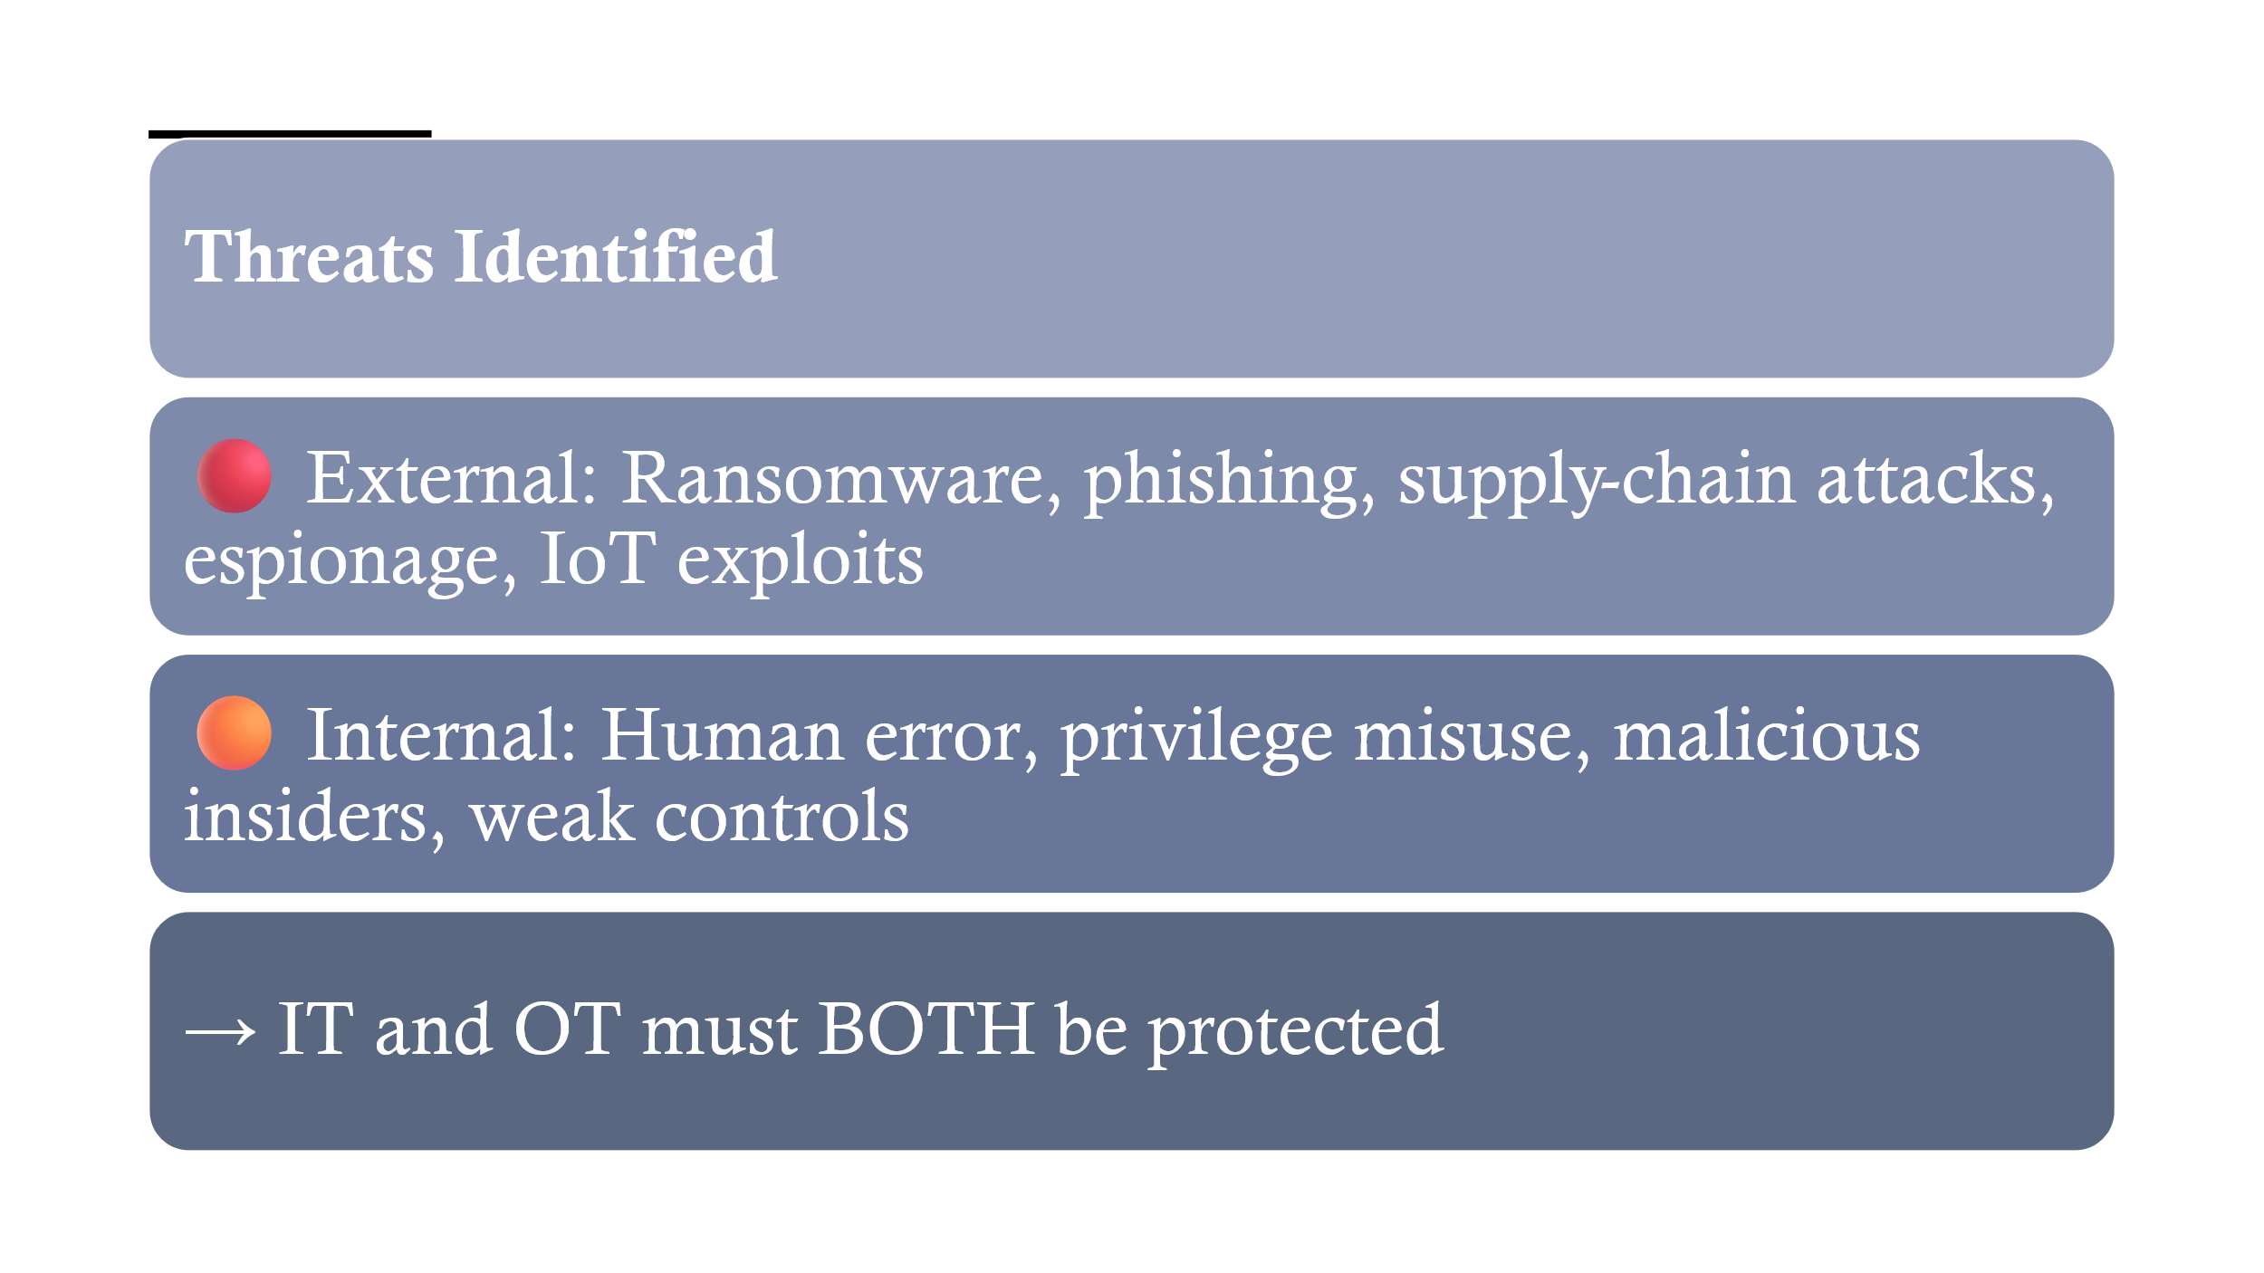
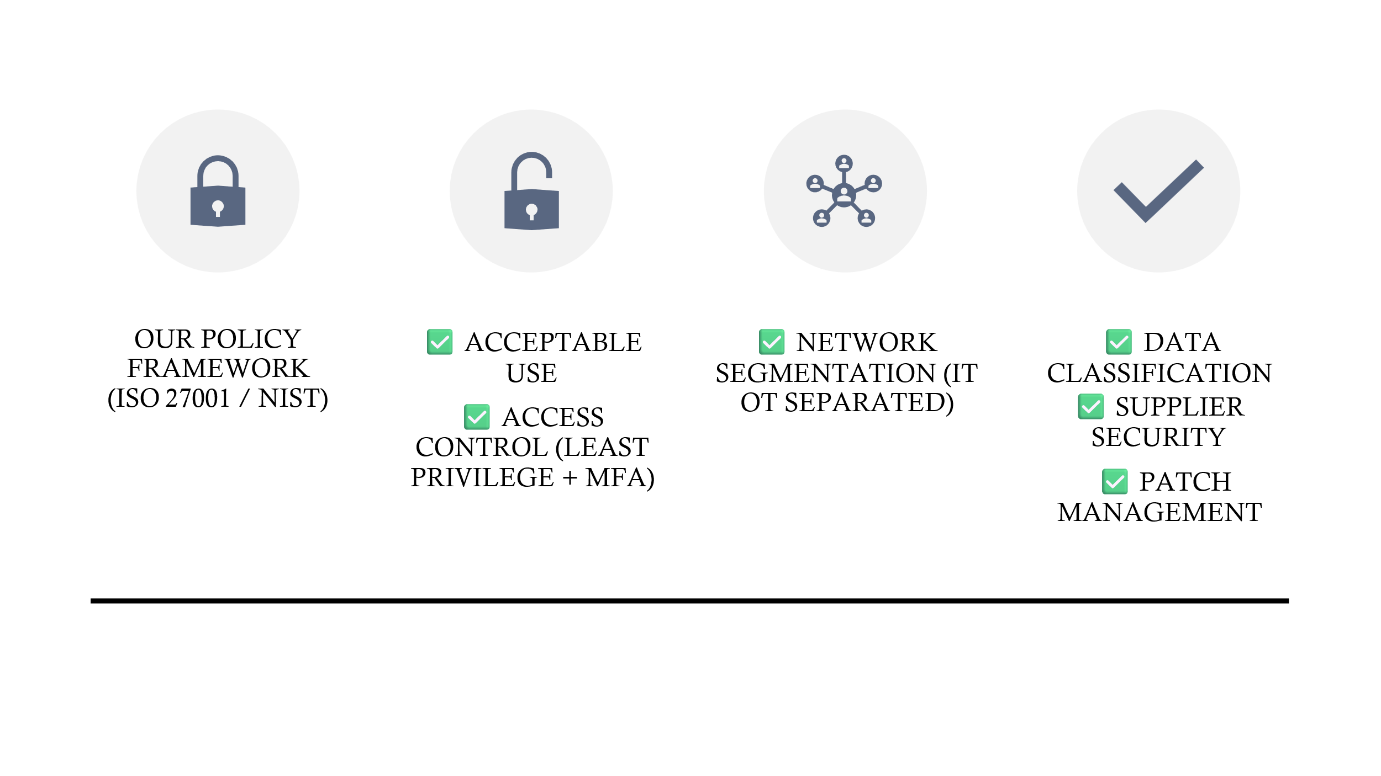
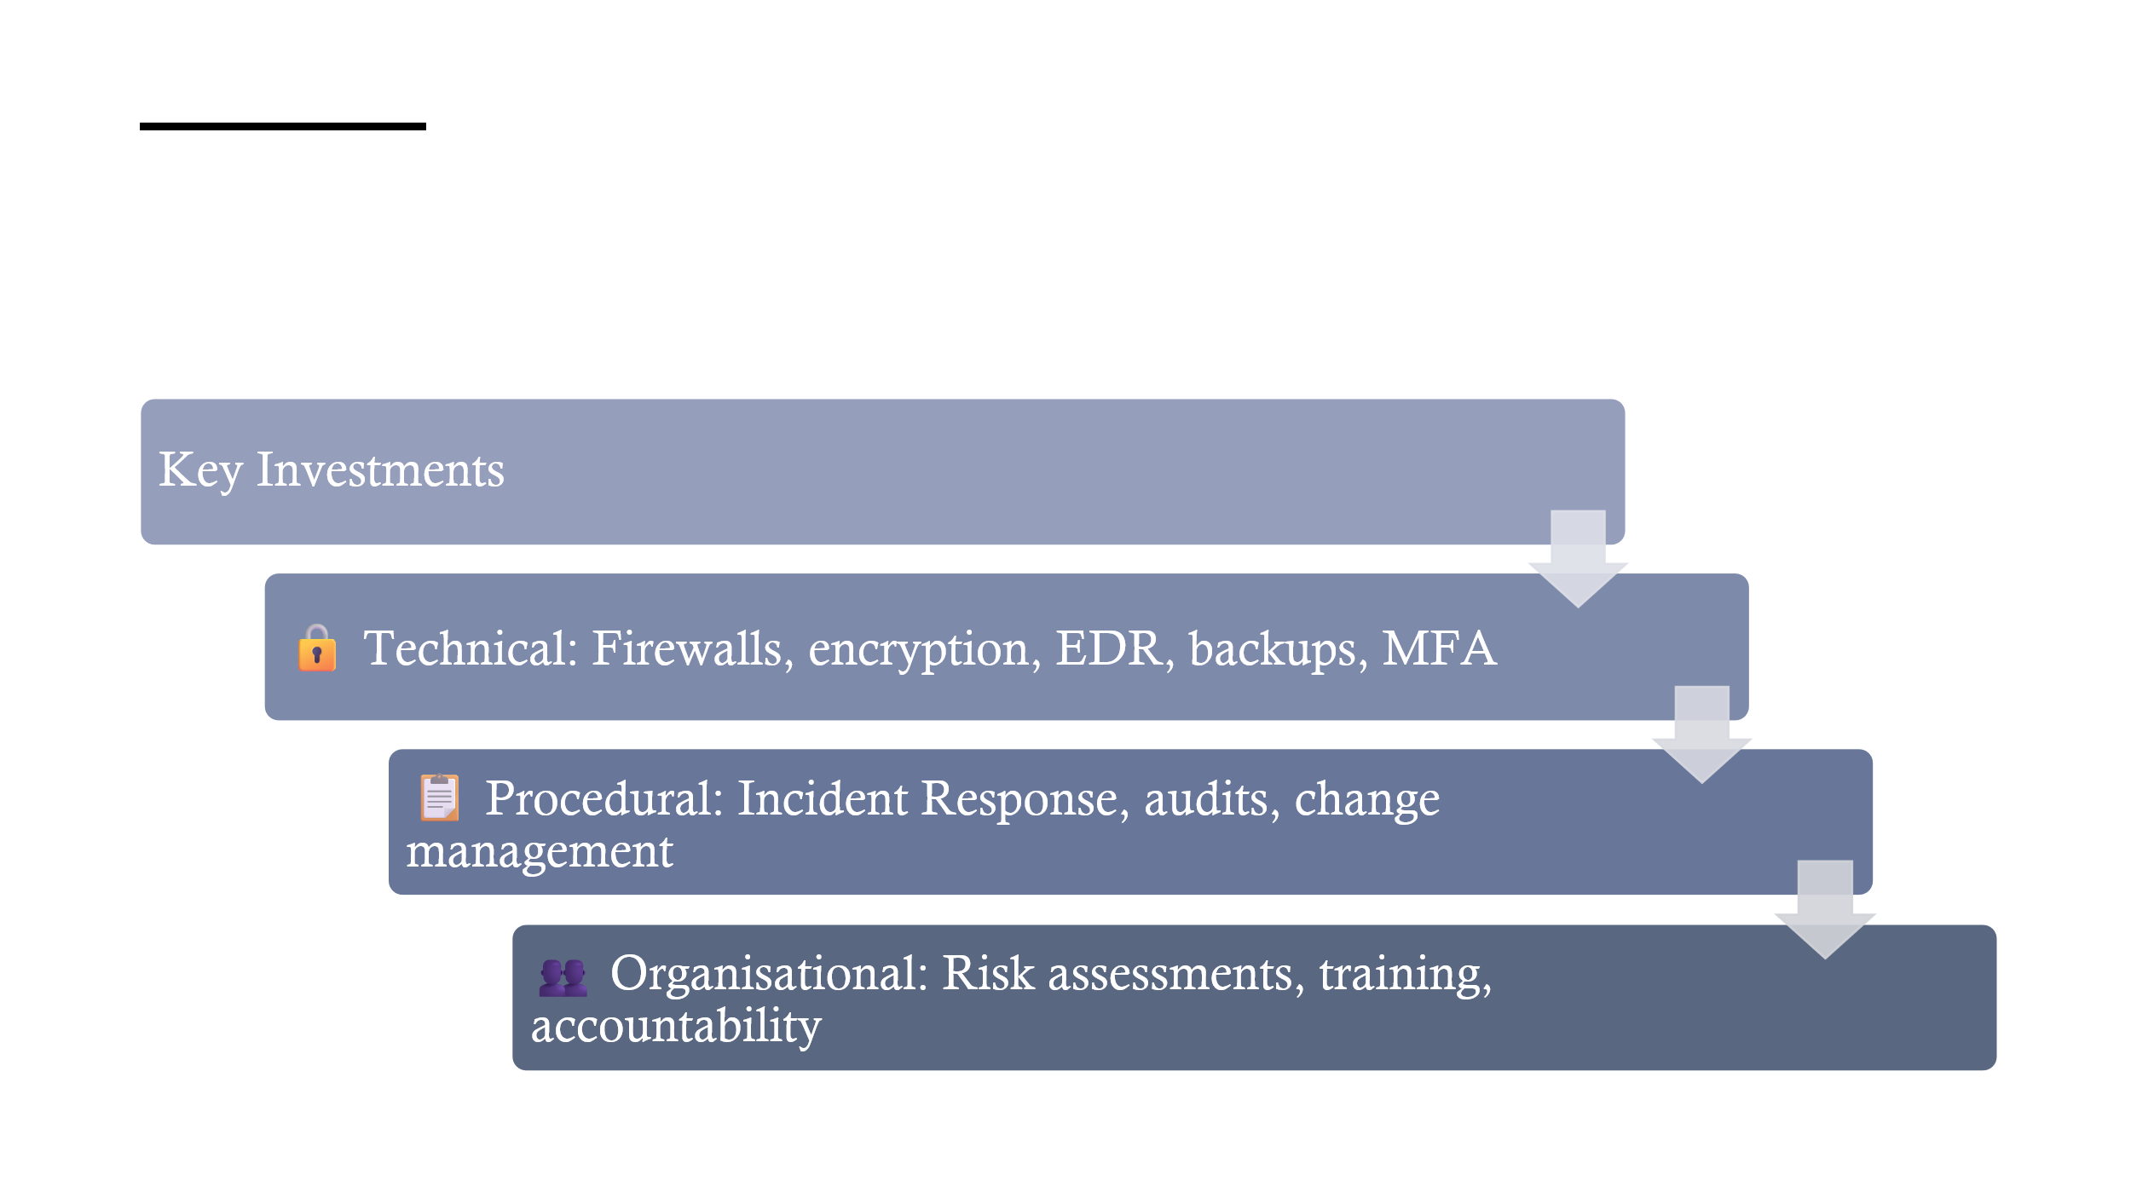
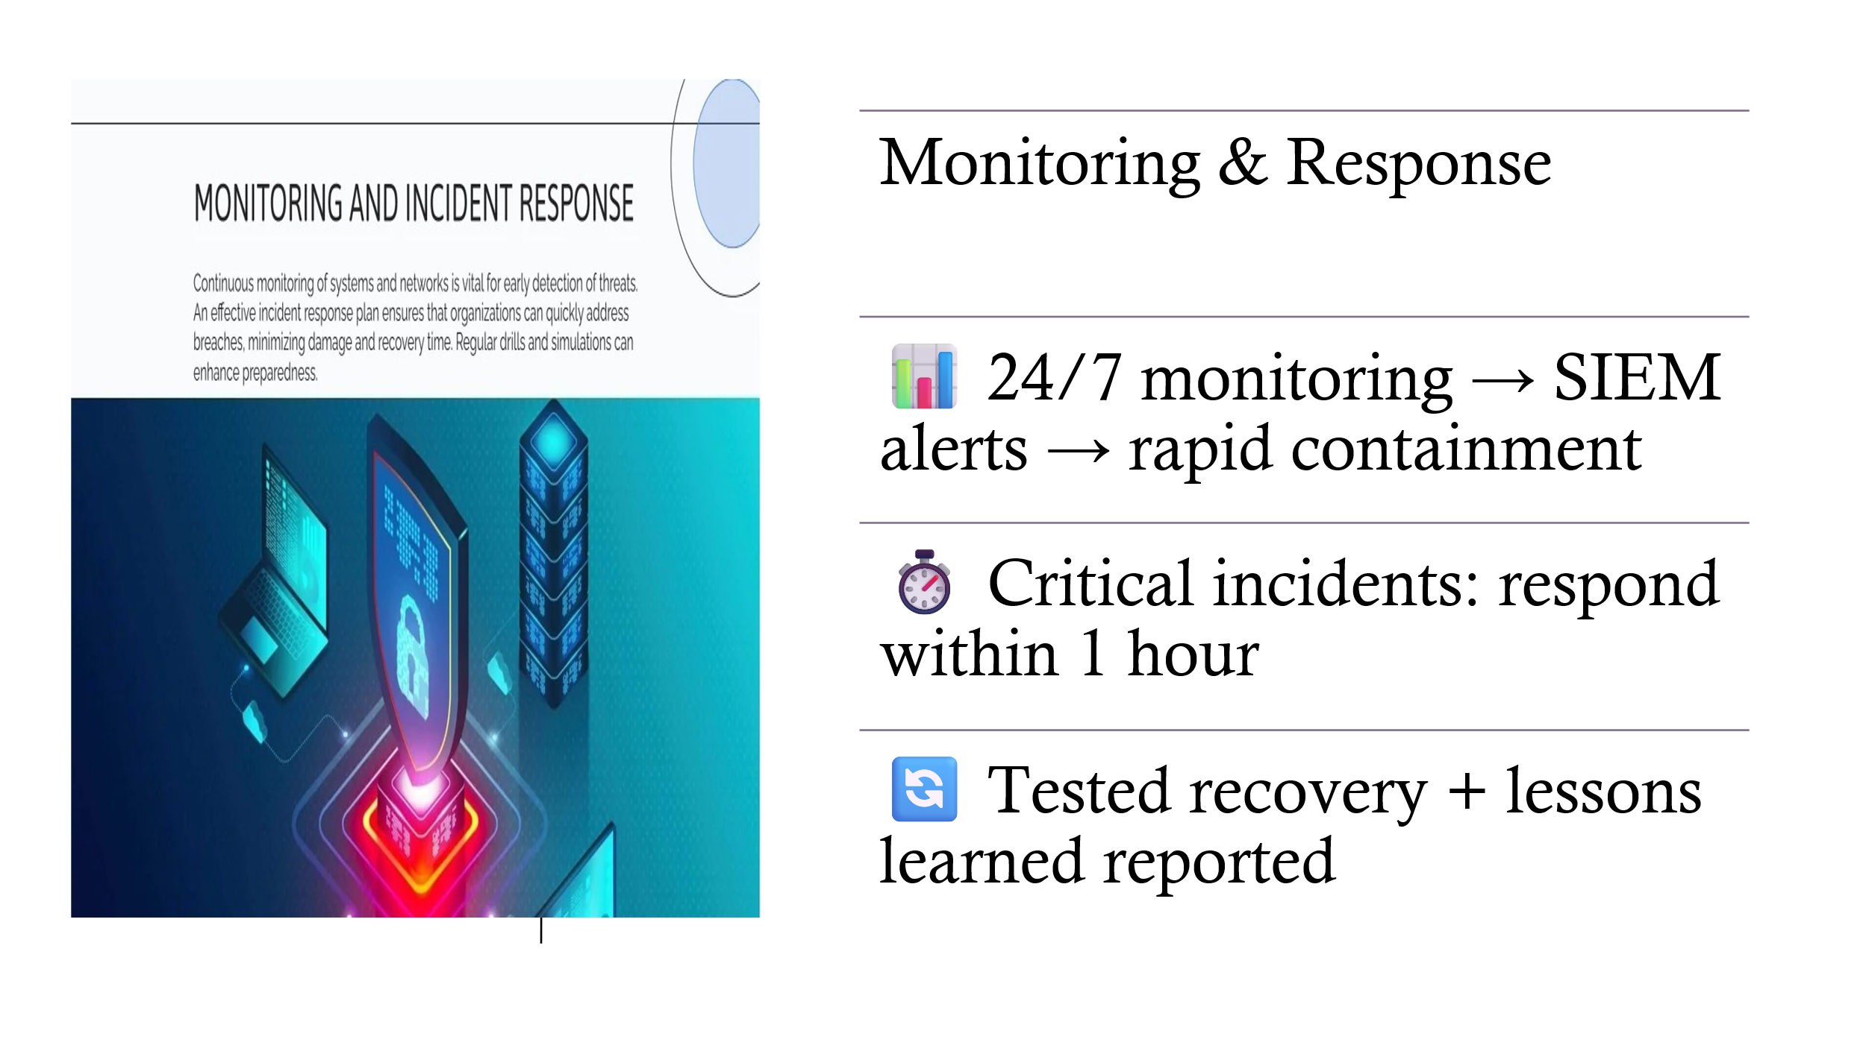
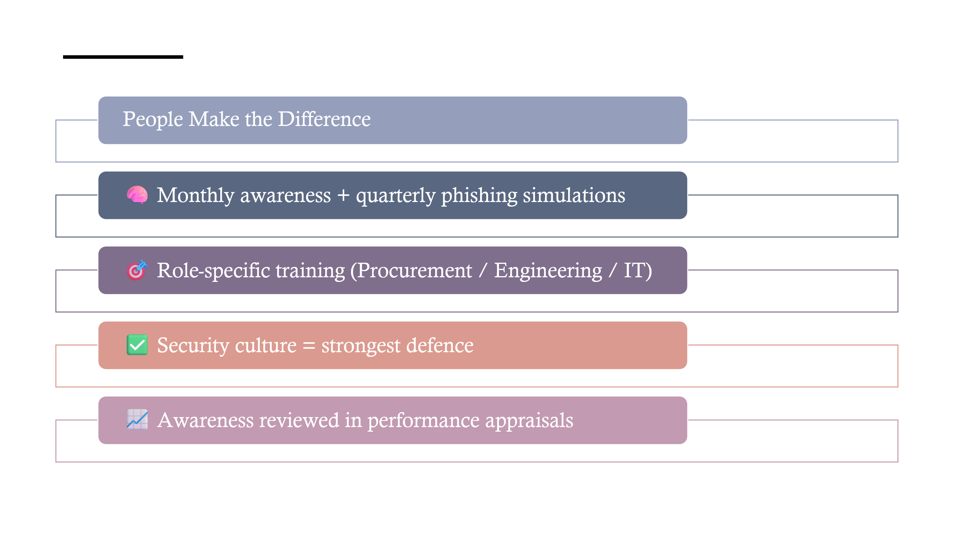
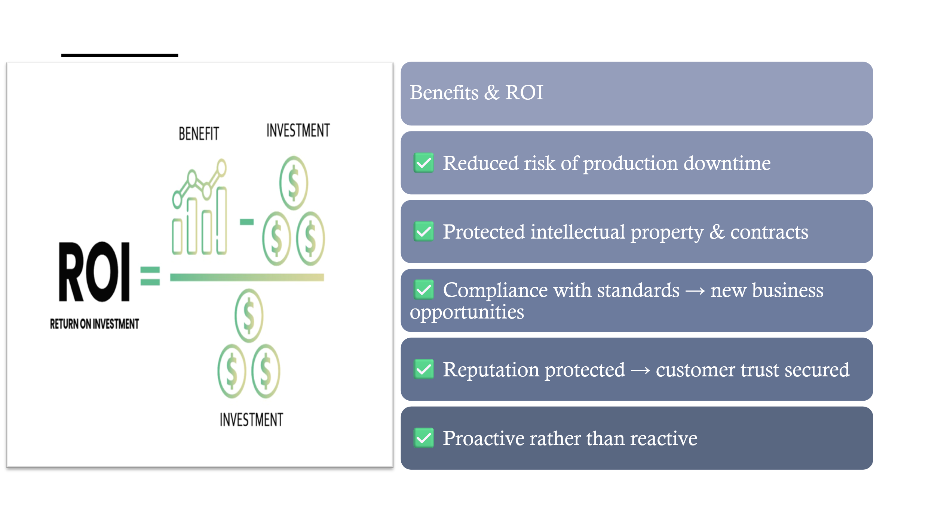
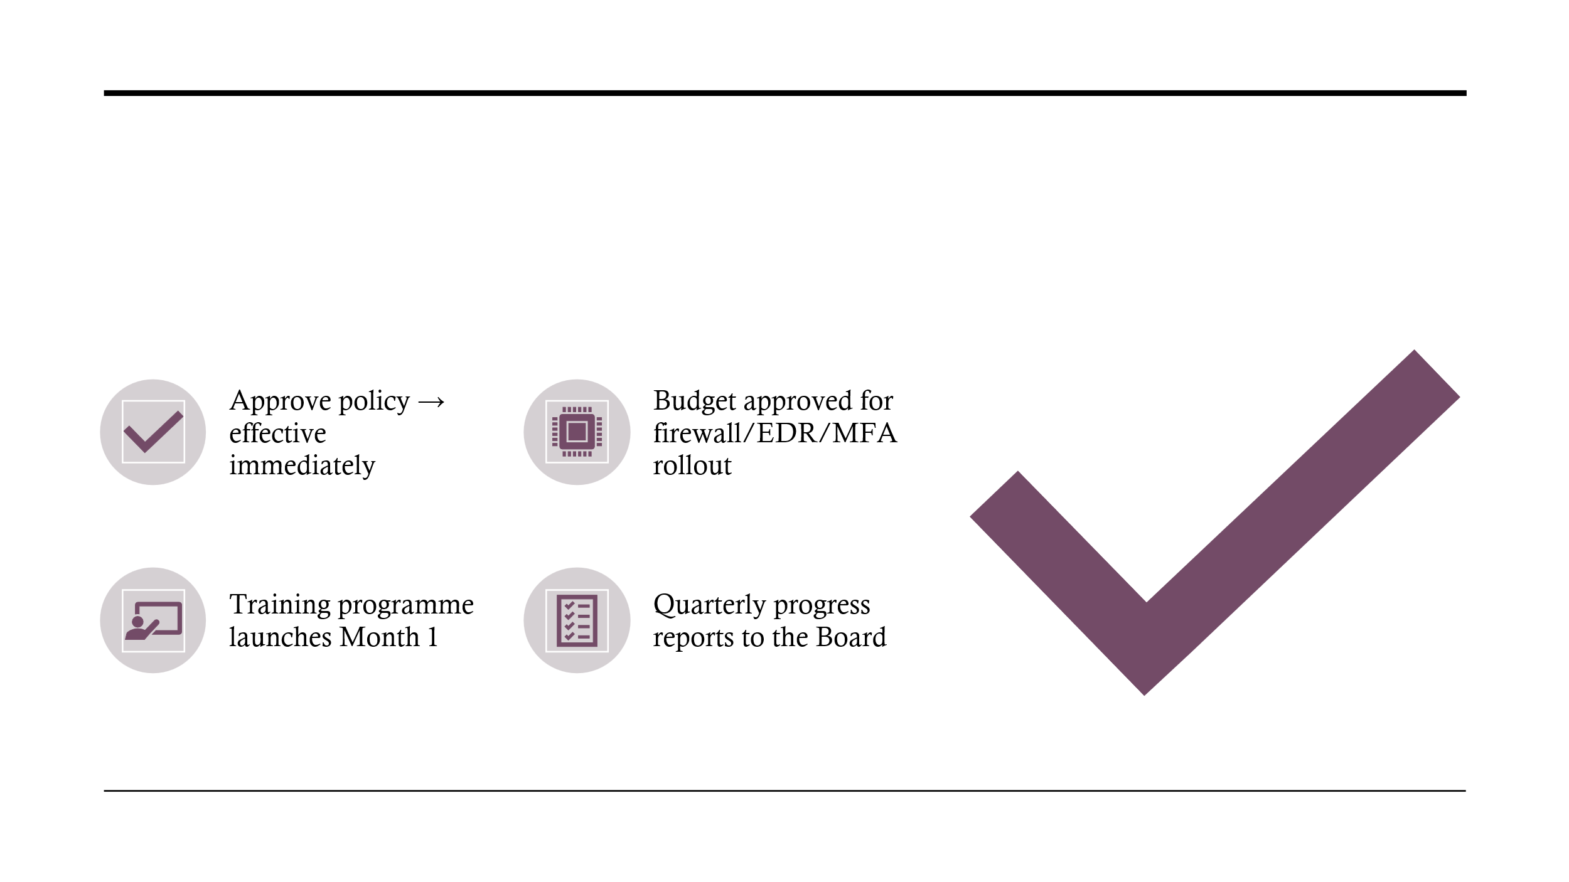

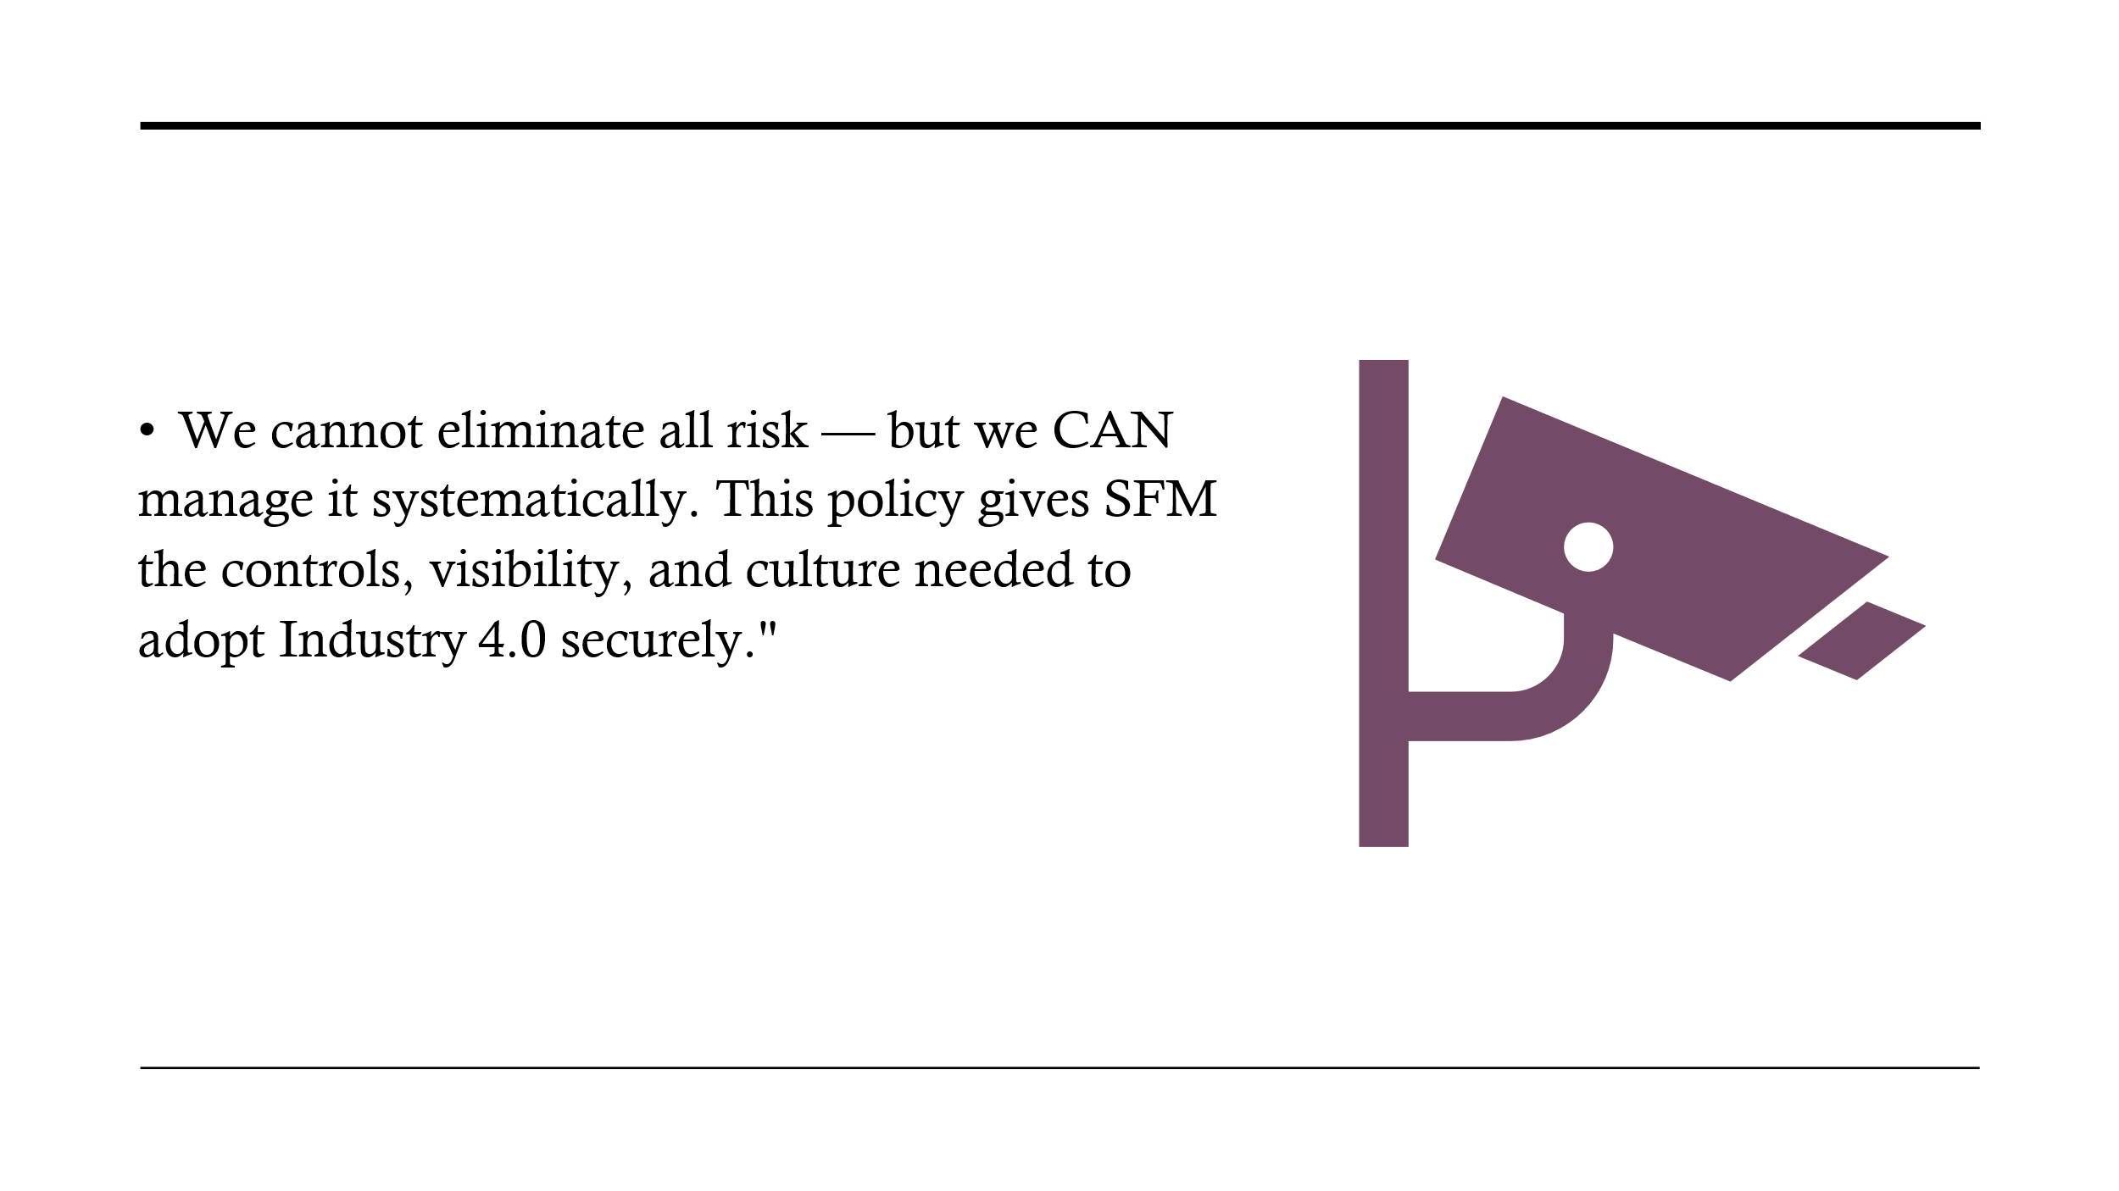

Appendix B: Screenshot of Security Badge



