NAME:
Sentiljano Kacokaj

STUDENT NUMBER:
2313169

MODULE CODE:
ACCb6017

MODULE TITLE:
Usability Engineering

Subject Specialist NAME:
Dr Osman Elgawi

ASSIGNMENT TITLE:
Component 1: User Requirements and Prototype

I. RESEARCH METHODS 2
II. Designing for Usability 3
III. Personas 5
IV. Storyboards 6
V. PROTOTYPE FEEDBACK 7
VI. PEER EVALUATION 8
VII. References 9
VIII. APPENDIX 10
A. User and Experience Requirements (MoSCoW) 10
B. Storyboards 12
C. User Research Questionnaire 17
D. Personas 21
E. Prototype Feedback 25
F. Peer Heuristic Evaluation 27

RESEARCH METHODS

The personas in this report were built from primary research. To ground the design in what potential players wanted, a structured questionnaire was used as the single research instrument (Appendix C). Google Forms was used to collect the responses.

A questionnaire was better than interviews or focus groups for this project stage. Early design study benefits more from a broad range of attitudes and behaviours from multiple people than from a few interviews [1]. A self-completed survey also avoids the social dynamics of a focus group, where more confident participants can steer the discussion and quieter views go unheard [2]. Sixteen questions were asked, mixing closed items that could be counted with open ones that captured the reasoning behind a preference. They covered who the respondent was, including age, relationship to the university, how they attend, and any accessibility needs; how they play, including frequency, preferred genres, session length, and multiplayer habits; how the concept landed, in terms of appeal and tone; and what would make or break it for them, through priority features, frustrations, and what might draw them to campus.

Ten people completed the questionnaire, and the responses gave the variation the personas needed. Accessibility was the clearest case. Three participants reported a need that affects how they use phone apps, one cognitive, one related to vision and one motor, and each fed directly into Mara, Priya and Gareth rather than added after the design was created [3]. Three participants played regularly and four never played on a phone, which mattered because most respondents had never played Pandemic and only one had played it several times. Five of the ten respondents chose a teach-as-you-play tutorial mode as the most important feature, proving that unfamiliarity made it a must. Six of ten participants liked 15-minute sessions, just two picked playing online with strangers, and eight to two favoured balanced play, with no one choosing the tense end. The concept proposal of the game was moderately popular, averaging 3.3 on a five-point scale, which helps avoid overstating enthusiasm. Appendix A contains all user and experience needs from these responses, grouped by MoSCoW.

The sample is limited because half of the participants have no university affiliation, so they are not the game's intended audience. This illustrates ease and self-selection sampling, the practicality of a brief project dispersed through personal networks, and a well-documented drawback of survey work recruited this way [1]. Since accessibility demands, session preferences, and mobile multiplayer issues are not exclusive to UWTSD students, the personas are valuable as chosen archetypes instead of a statistically representative university portrait.

Designing for Usability

Since the survey described an audience that was not confident gamers, usability was built into the first wireframe instead of tested at the end. Four participants never played on a phone, and most were new with Pandemic, so the interface needed to guide and support users. The storyboards were designed around a few established principles, each aimed at solving a specific issue visible on the screens.

The clearest of these risks is cognitive overload at the start of a game, which matters most for Mara, whose ADHD makes a dense rules screen a likely point of abandonment. Storyboard A explains the rules with a contextual coach mark on the board (Figure 1) and a "suggested" move in the action menu (Appendix B1, Frame 4). Both rely on recognition instead of recall, one of Nielsen's heuristics, by keeping the relevant option in view at the moment it is needed instead of asking the player to hold it in memory [4]. The same reason was applied for sparse screens which is presenting only what the current step required reduces unnecessary burden for all users, not just those who stated a requirement.

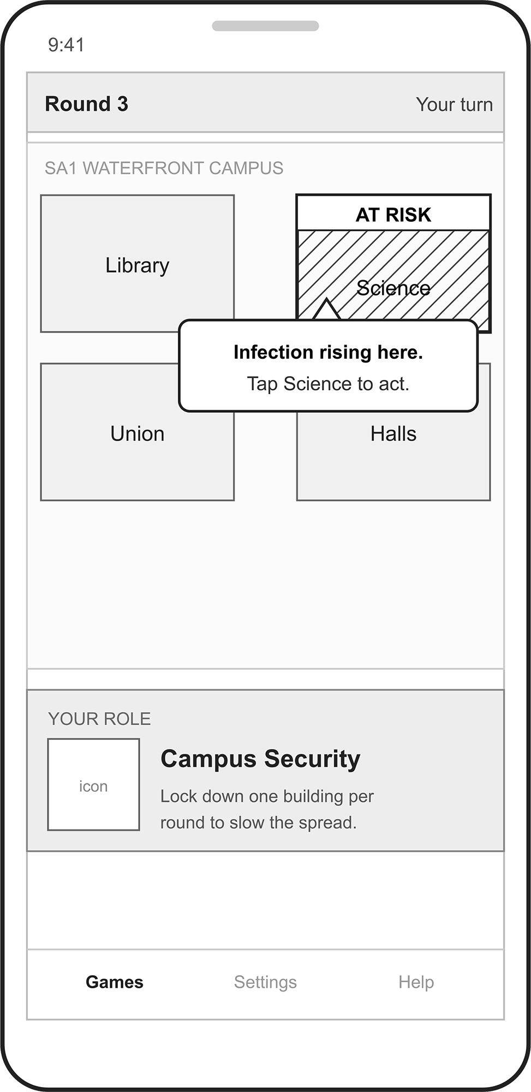
Figure 1. Asynchronous board with a contextual tutorial coach mark

Feedback was the second priority. Norman makes the point that a system has to reveal the outcome of each action, or the user is left unsure whether anything happened at all [5]. Every storyboard ends with a simple "Infection reduced" after a treatment (Appendix B1, Frame 5), a saved and notified confirmation after a turn (Appendix B1, Frame 6), and a brief "Aled moved" update during the live match. None of these messages depend on colour.

That restriction is applied to every mode, not just Priya's, though her colour-vision deficiency makes the reason clearest, since a red-means-danger convention would be useless to her. Figure 2 shows a hatch pattern and an explicit "AT RISK" label to communicate the game condition, meeting the WCAG guideline that colour should never be the exclusive source of communication [6]. The same rule applies to Gareth's offline screens (Appendix B4). The controls are made larger and the clock is removed, both because the guidance calls for big enough tap targets and because the time pressure would be unfair given his motor need.

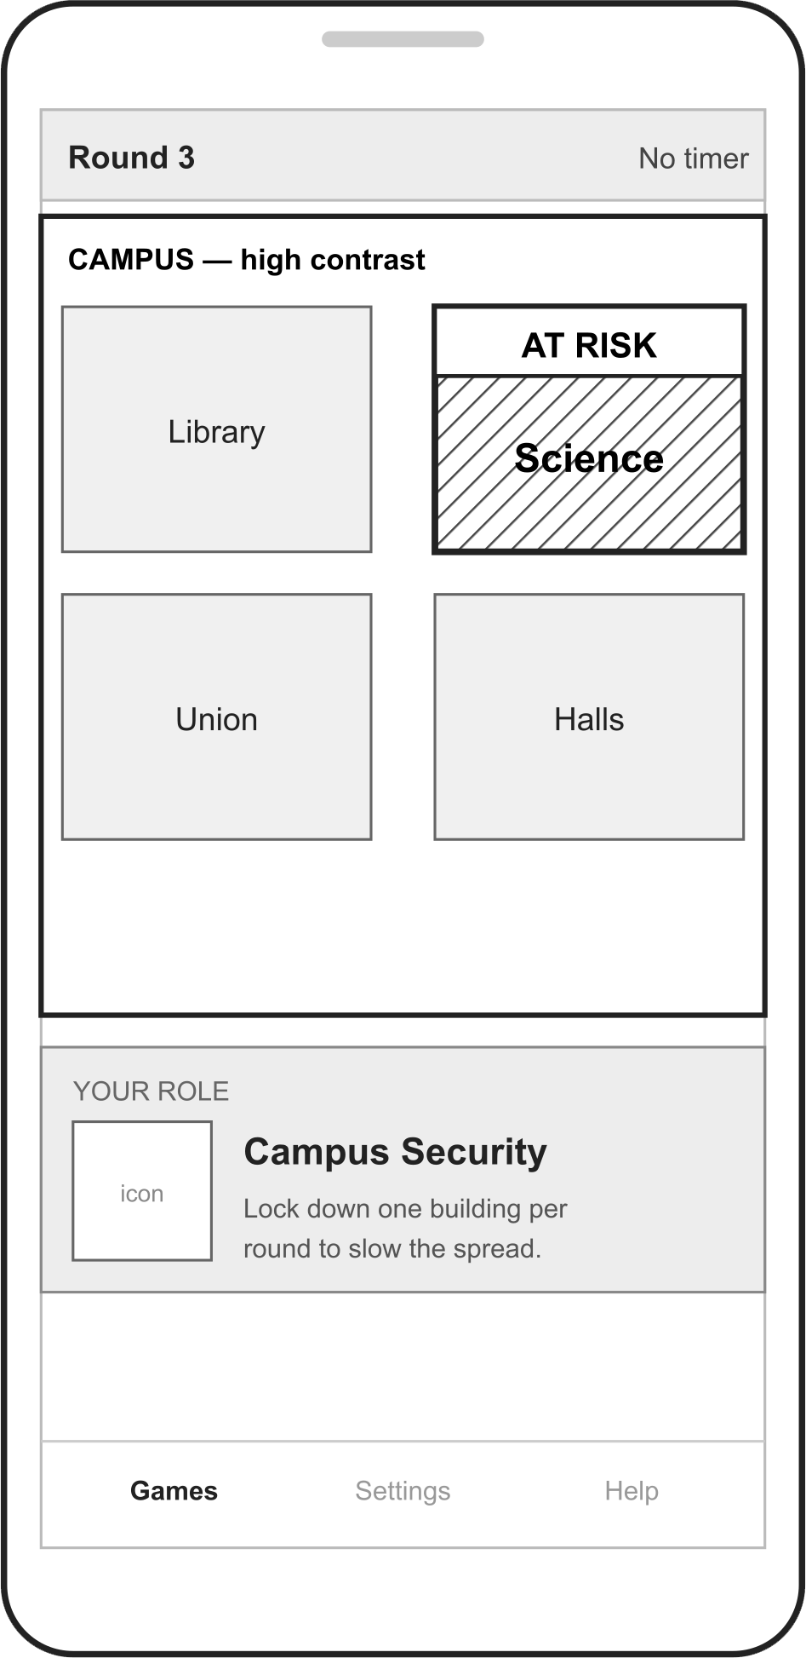
Figure 2. Accessible board: state shown by hatch pattern and label, with enlarged high-contrast text

Consistency ties the four storyboards together. The board, role card and action menu stay the same in every mode, so once a player learns the first one, the others come easily. This follows the heuristic of consistency and standards [4]. An early draft showed the opposite failing: a navigation tab and a list heading both labelled "games," corrected once it was clear that duplicated labels work against that consistency.

The final factor is emotional instead of functional. Replacing punitive missed-turn penalties with a forgiving AI mode was decided to lower the anxiety implied by the survey's clear preference for balanced play, on the understanding that how an interface makes someone feel is part of its usability instead of a separate concern [5].

Personas
The survey told us what players wanted, but raw figures are difficult to design from. It is hard to picture a screen for "60% of respondents." Personas solve this by turning the repeating patterns to a few representative players, each one built from needs that appeared several times across the ten responses [3]. They are archetypes built from the data instead of portraits of any single participant. A persona earns its place only by representing a real pattern in the research [3].

Four were synthesised, spanning the age range, all four attendance modes, and the three accessibility needs that surfaced in Q4. Each pulls the design in a particular direction. Aled is the embedded daily player who expects genuine tactical depth and wants to play with coursemates instead of strangers, so he is the reason for balanced difficulty and private group creation. Mara plays in short bursts around a commute and has ADHD, which makes asynchronous turns with persistent state and a teach-as-you-play tutorial the difference between her staying or leaving at the first screen. Priya has low vision and a colour-vision deficiency, so she forces the rule that game state must read through text and shape, instead of colour alone. Gareth is a staff member who barely games and has a dexterity condition, which justifies the offline practice mode as low-stakes onboarding, along with the large, forgiving touch targets that go with it.

Between them they cover the range the prototype later has to satisfy. The full profiles, scenarios and requirement lists can be found in Appendix D.

Storyboards
Every mode in Campus Outbreak returns to the same home screen, so that is where the discussion starts. Figure 3 shows it working as a hub. The three ways to play sit at the top as clear entry points, and below them an Active games list lets the player resume a game in progress. The list only shows asynchronous games, deliberately because synchronous matches do not survive once they end, and an offline practice round is over in one sitting, so listing either would suggest a continuity the system never keeps. Each row shows its own status, "Your turn" or "Waiting on Aled", so the player can see where a game stands before opening it. The bottom navigation keeps the same three destinations everywhere in the app, giving the returning player a fixed frame to move from [2].

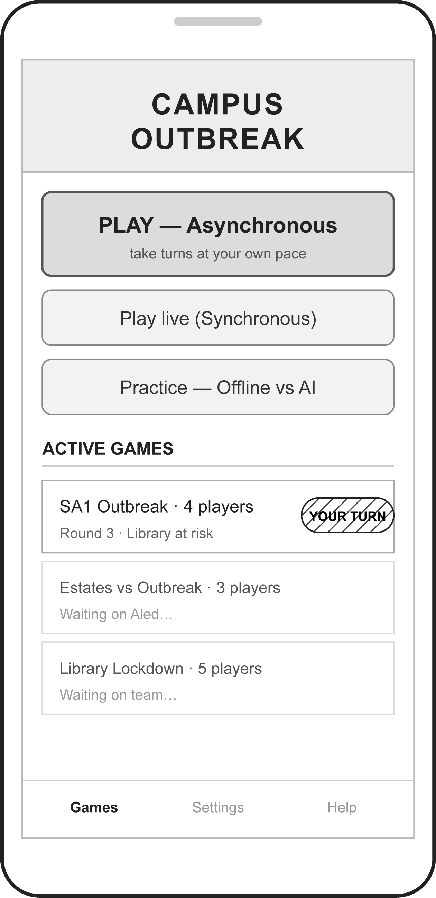
Figure 3. Home screen: the three game modes and the asynchronous Active games list

The asynchronous flow is the main mode, so Mara's path through it (Appendix B1) is covered in the most detail. When she opens a game, the board first introduces her department role, so she starts by learning what she actually controls. The tutorial then teaches in context. A prompt appears against the building that is actually at risk, instead of front-loading a block of rules, which suits both her ADHD and the finding that most participants had never played Pandemic. She picks an action, sees a plain confirmation of what it will do, commits it, and the screen acknowledges the turn before she can go back to her day. The persistent state means the half-finished game waits exactly as she left it, which is what makes the mode usable in snatched minutes.

Aled's synchronous flow in Appendix B2 is built as a contrast. He sets up a private group instead of being matched with strangers, waits in a lobby until his coursemates join, then plays on a live board with a timer counting down each turn. Quick actions and a toast when a teammate moves keep all the players engaged in the live game. The match ends on a result screen with a rematch option, perfect for his short competitive bouts between lectures. Most of the async board's components are used on the screens, but the timer and live turn-passing add pressure.

Priya's and Gareth's storyboards are variations on these core screens, so only the parts that change are covered here. Priya's path in Appendix B3 reuses the home and board screens, but she opens an accessibility screen first from the Settings tab in the bottom navigation. There she raises the text size and turns on high contrast, and the board carries both, so the screen is easier for her to read. Gareth's offline path (Appendix B4) starts solo against AI as a no-stakes way to learn, with enlarged, well-spaced controls and no timing pressure, before passing into a relaxed asynchronous game with colleagues once he is comfortable.

The navigation map in Appendix B5 shows where the modes branch from the home hub, loop, and incorporate Gareth's offline practice into asynchronous social play. The storyboards show the same small set of screens rearranged to match four distinct game modes.

PROTOTYPE FEEDBACK

Structured walkthroughs provided wireframe storyboard feedback. Paper prototypes are easier to understand when a researcher guides participants down a set path and asks what each screen is for, what they would tap, and where they expect to land [2]. Emotional response was captured separately using a set of reaction cards adapted from the Microsoft product reaction method, which lets participants pick words that describe how a design made them feel without having to articulate it unprompted [7]. Four testers were recruited so the session covered the full persona range: a heavy strategy gamer matched to Aled, a short burst commuter matched to Mara, an off campus infrequent player matched to Priya, and a non gaming person matched to Gareth. Recruiting one tester per persona meant the prototype was read from each end of the confidence and accessibility spectrum, so it wasn't only judged by people who already think like gamers. The full session records are in Appendix E.

Usability findings focused on a few points. Every tester, even the most experienced, noted the lack of an undo, suggesting this was about confidence to act instead of a newbie safety net. That broad response means an interface should provide quick action reversal so users can explore without fear of making a mistake [8]. Turn visibility worked for Aled but got weaker further down the experience scale. Mara said the indicator was small, Priya had to hunt for it, and Gareth missed it until prompted. This is the classic problem of keeping system status visible [4]. Several testers also wanted to know what an action would do before committing to it, and Gareth's description of tapping and hoping captured a feedback gap that Norman's account of clear and immediate system response speaks to directly [5].

Emotional response tracked experience level more closely than expected. Measuring how the prototype felt apart from whether it worked reflects a familiar split in the user experience literature, between how well a product does its job and how satisfying it is to use [9], and the reaction cards showed that split clearly.

Aled's cards were all confident: Engaging, Strategic and Clear. Gareth went for Intimidating, Confusing and Hard to use. Priya landed between them, pairing Inviting and Helpful with Overwhelming. Some of this split was expected, since the survey had already shown most potential players had never heard of Pandemic, but how strongly the novices reacted confirmed that the real risk sits in onboarding, not in the mechanics themselves. It backed up the decision to treat the teach-as-you-play tutorial as a Must.

PEER EVALUATION

A coursemate was asked to check the Campus Outbreak storyboards against Nielsen's Ten Usability Heuristics [4], and the same form was applied to their submission in return. Rating the severity of their issues consistently proved harder than expected, since the same problem could read as cosmetic or serious depending on which persona was imagined hitting it. The finished evaluation is in Appendix F. This kind of inspection works well next to the walkthrough, since testers only see the screens the moderator leads them through, while a separate evaluator can double-check what the testing found and catch problems the sessions never touched.

The clearest overlap was around user control. The missing undo on a committed action got one of the two highest severity ratings on the form, which matched every tester, even the most experienced, asking for a way to reverse a move [8]. That pattern was expected after four walkthroughs; the inspection missing it would have been more surprising.

The least expected finding was one the testing could not catch. Testers only walked a working path, so no failed sync or dropped connection ever appeared, and the storyboards show no error state. A campus game played asynchronously will run into exactly those situations, so the gap is structural, not cosmetic.

The review was not all negative. The suggested-move guide was flagged as a strength for helping players recognise options instead of recalling them, though the inspection noted that once the coach marks are dismissed the rules aren't easy to get back to mid-game. Four changes follow from this. Undo stays available until a turn is submitted, confirmation dialogs say what an action does and not just that it commits, the asynchronous flow gains explicit offline and retry states so a failed sync is accounted for, and the Help tab in the bottom navigation is set to hold the rules so they stay reachable after the tutorial closes.

References
[1] J. Lazar, J. H. Feng and H. Hochheiser, Research methods in human-computer interaction, Cambridge, MA: Morgan Kaufmann Publishers, 2017.
[2] H. Sharp, J. Preece and Y. Rogers, Interaction Design: Beyond Human-Computer Interaction, 5th Ed. Wiley, 2019.
[3] J. Pruitt and T. Adlin, The Persona Lifecycle, Morgan Kaufmann, 2006.
[4] J. Nielsen, "Enhancing the explanatory power of usability heuristics," in Proc. SIGCHI Conf. Human Factors in Computing Systems (CHI '94), Boston, MA, USA, 1994, pp. 152–158. doi: 10.1145/191666.191729.
[5] D. A. Norman, The design of everyday things, New York, New York: Basic Books, 2013.
[6] World Wide Web Consortium (W3C). "Web Content Accessibility Guidelines (WCAG) 2.2." World Wide Web Consortium. Accessed: 25 June 2026. [Online]. Available: https://www.w3.org/TR/WCAG22/
[7] J. Benedek and T. Miner, "Measuring Desirability: New Methods for Evaluating Desirability in a Usability Lab Setting", in Usability Professionals' Association Conference, Orlando, FL, USA, 2002.
[8] B. Shneiderman, C. Plaisant, M. S. Cohen, S. Jacobs, N. Elmqvist and N. Diakopoulos, Designing the User Interface: Strategies for Effective Human-Computer Interaction, 6th Ed. Pearson, 2016.
[9] M. Hassenzahl and N. Tractinsky, "User experience - a research agenda," in Behaviour & Information Technology, vol. 25, no. 2, pp.91–97, 2006, doi: 10.1080/01449290500330331.

APPENDIX

- User and Experience Requirements (MoSCoW)
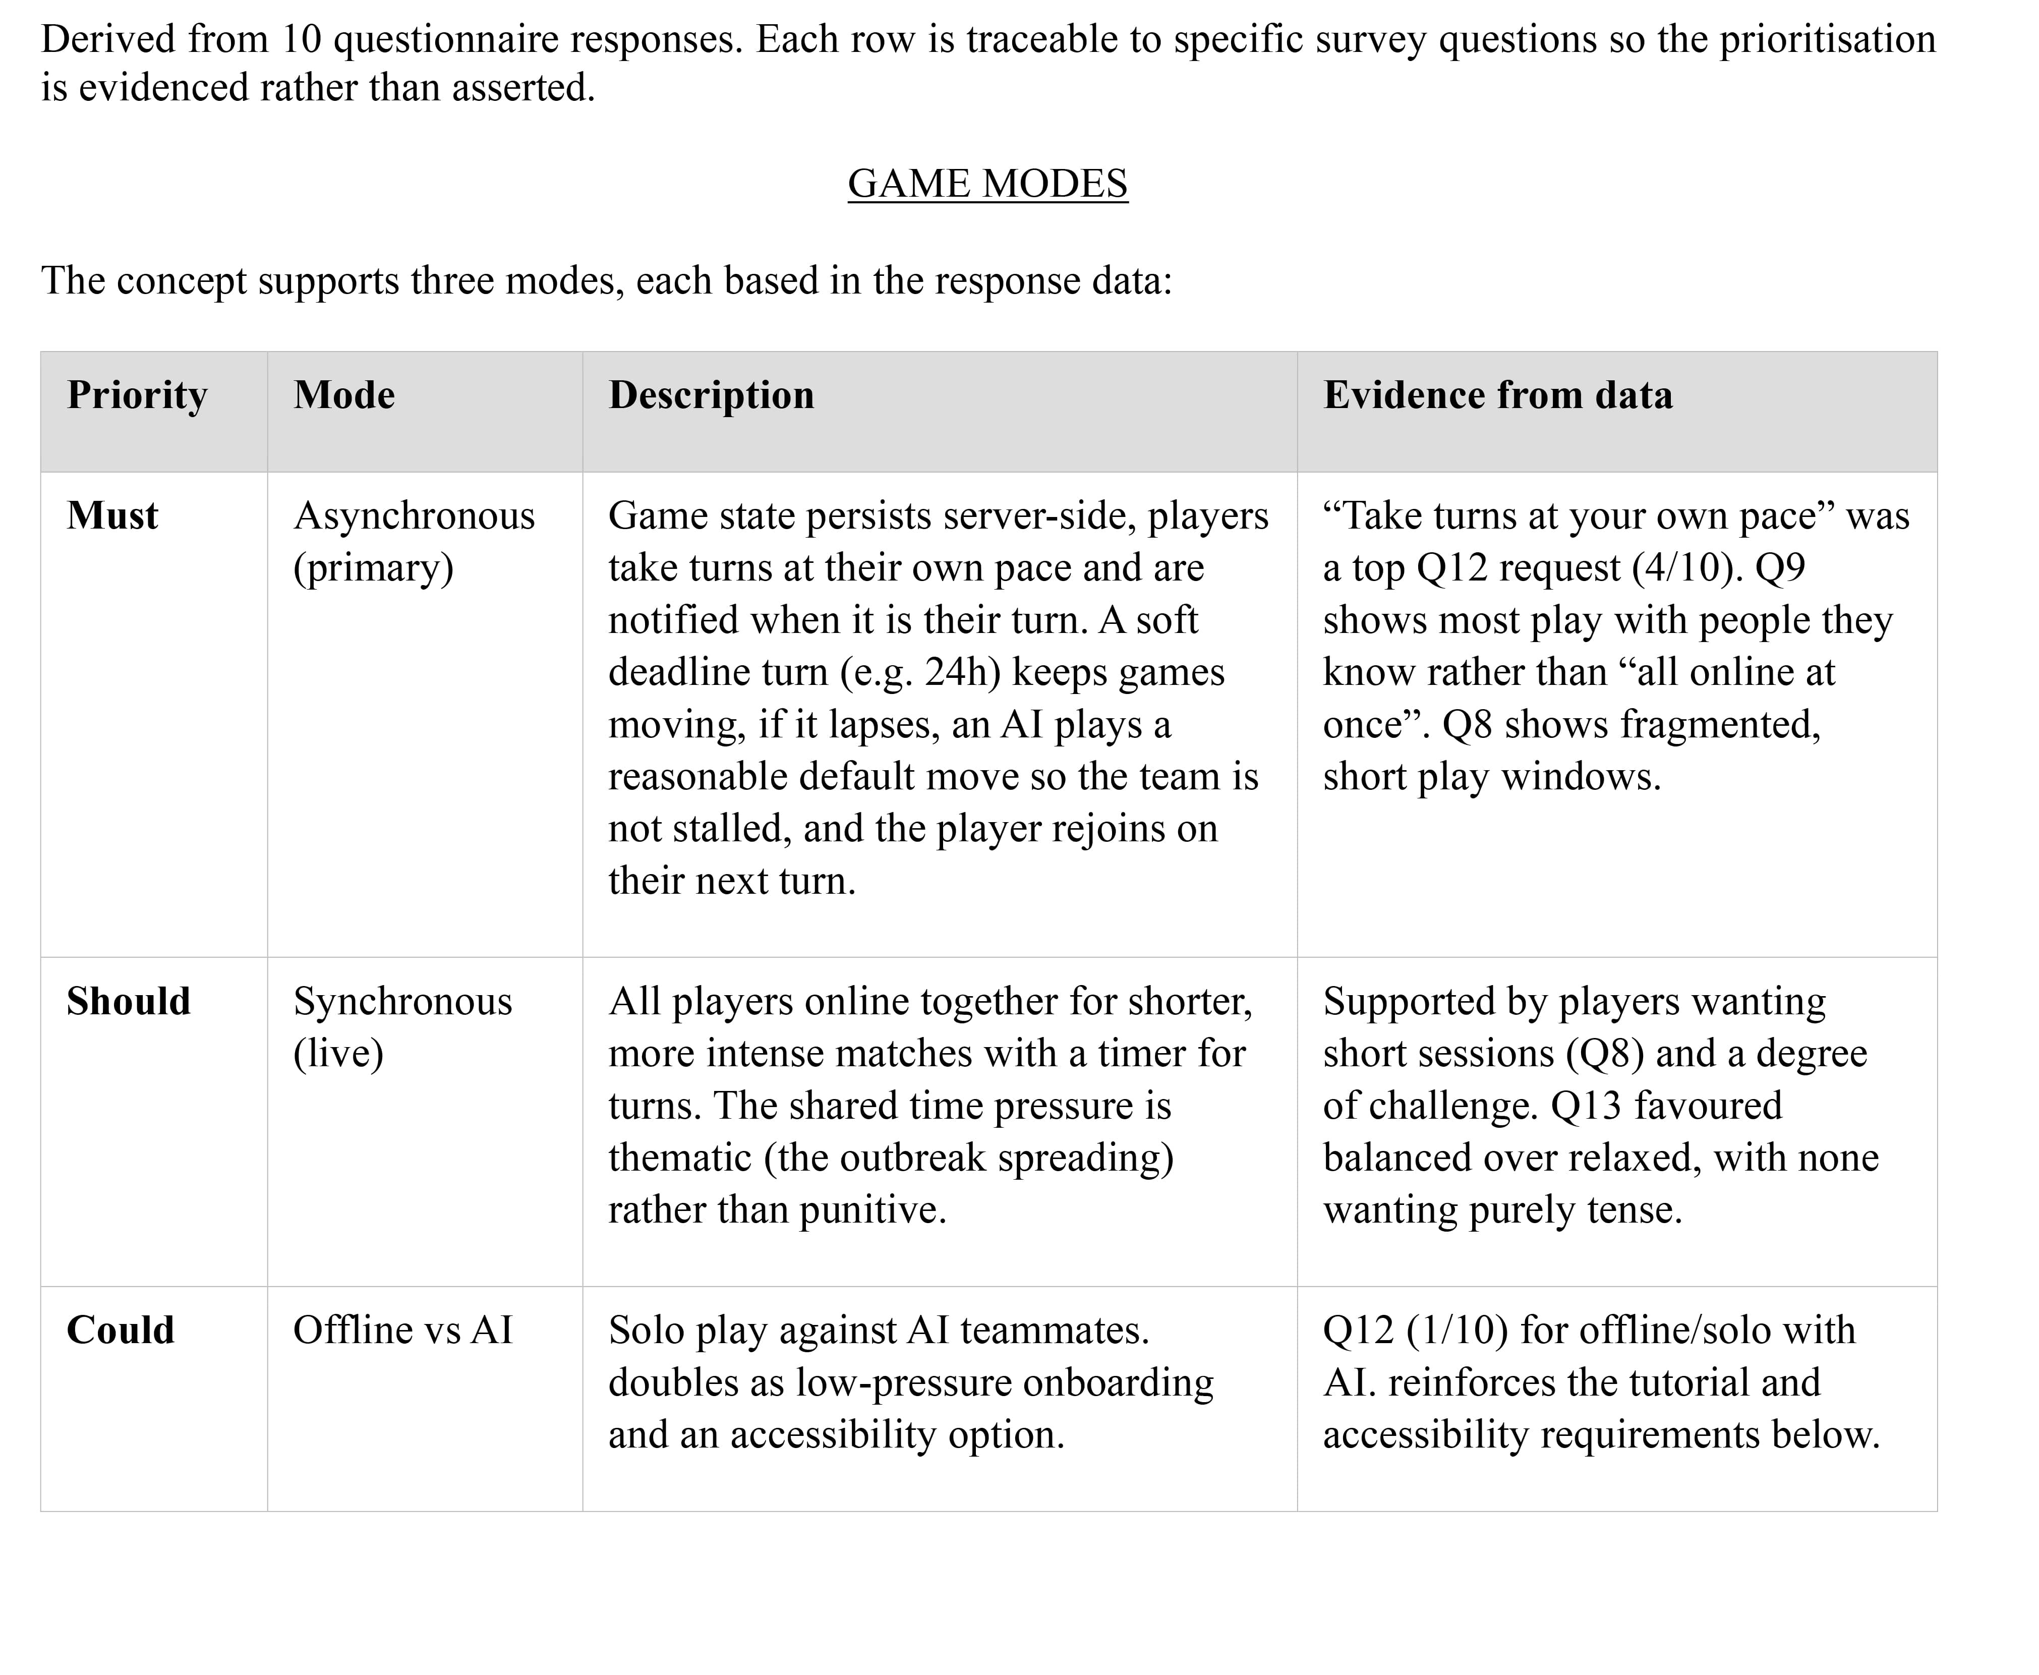

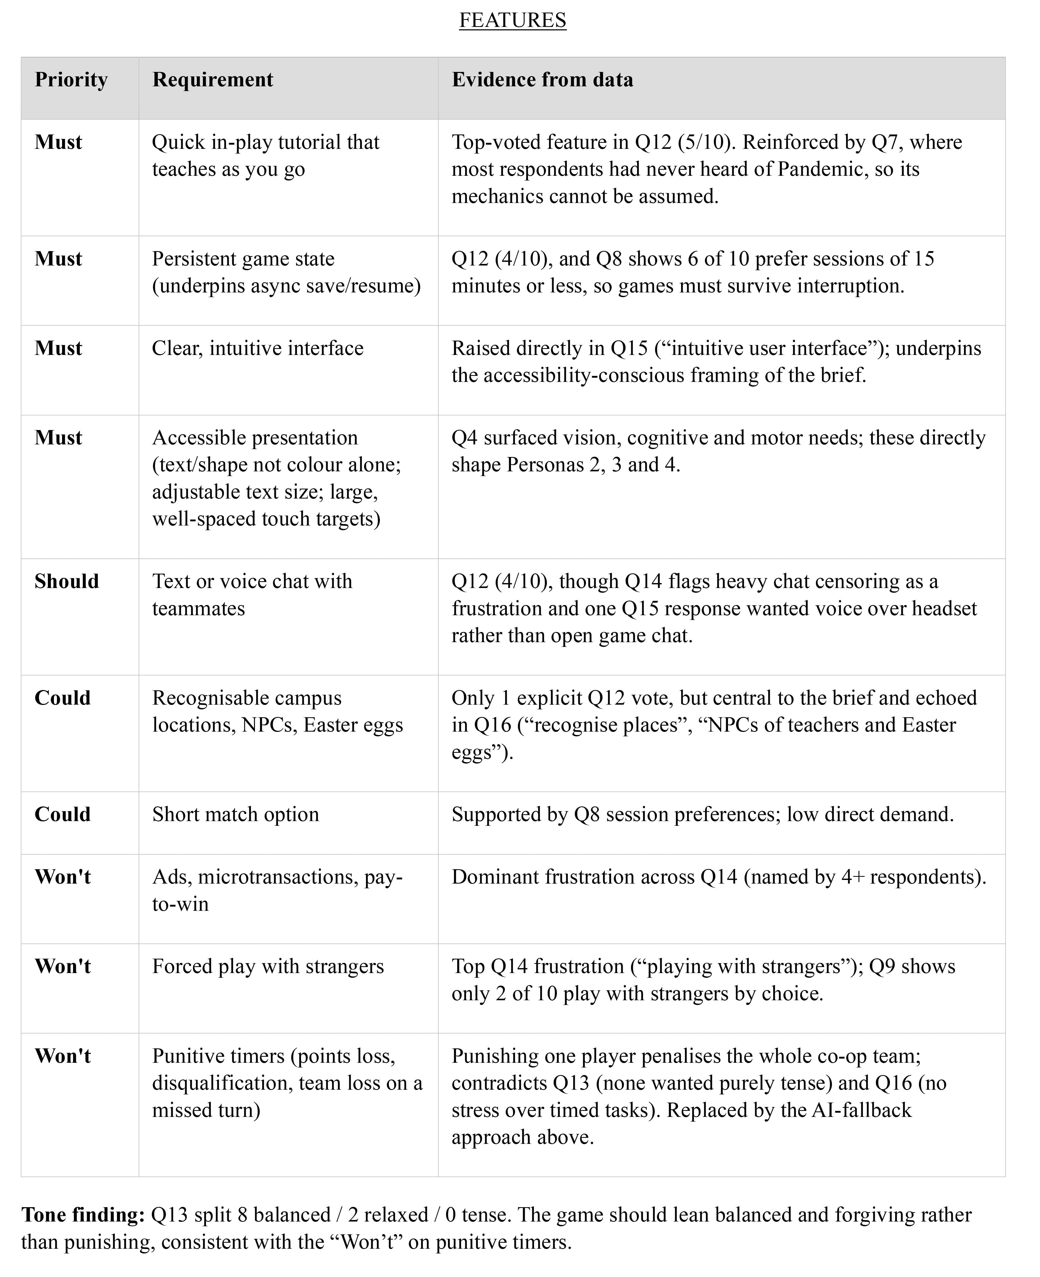

- Storyboards

Asynchronous flow (Mara)
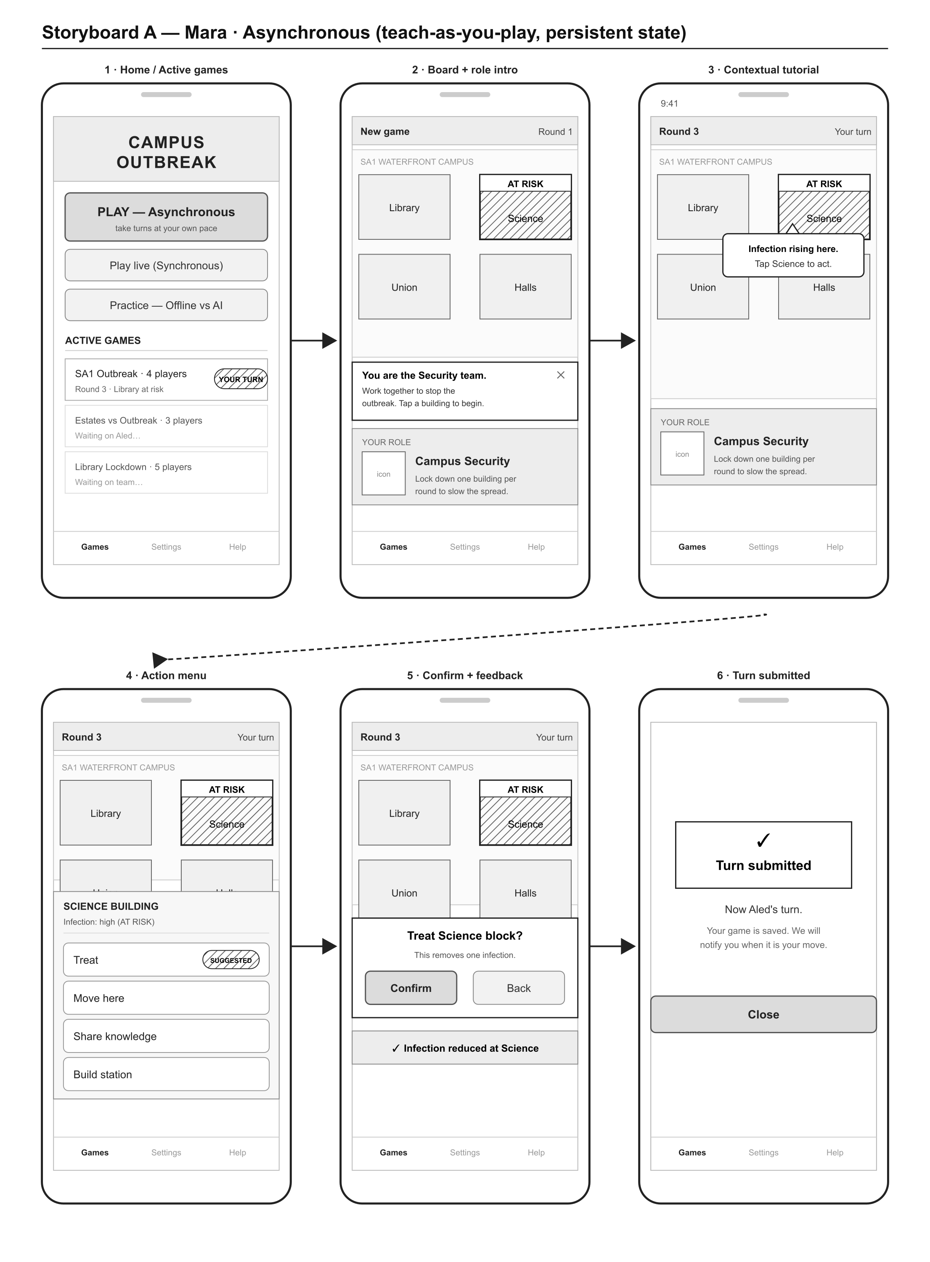

Synchronous flow (Aled)
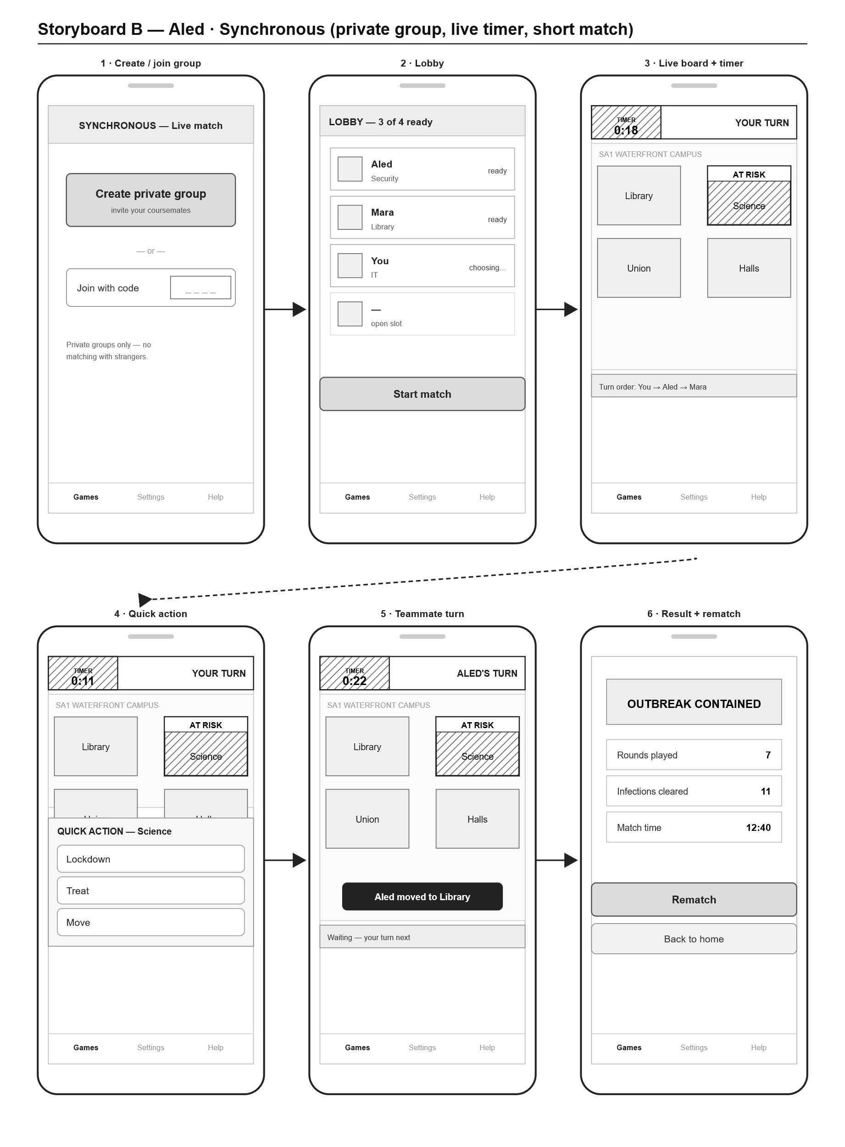

Accessible asynchronous flow (Priya)
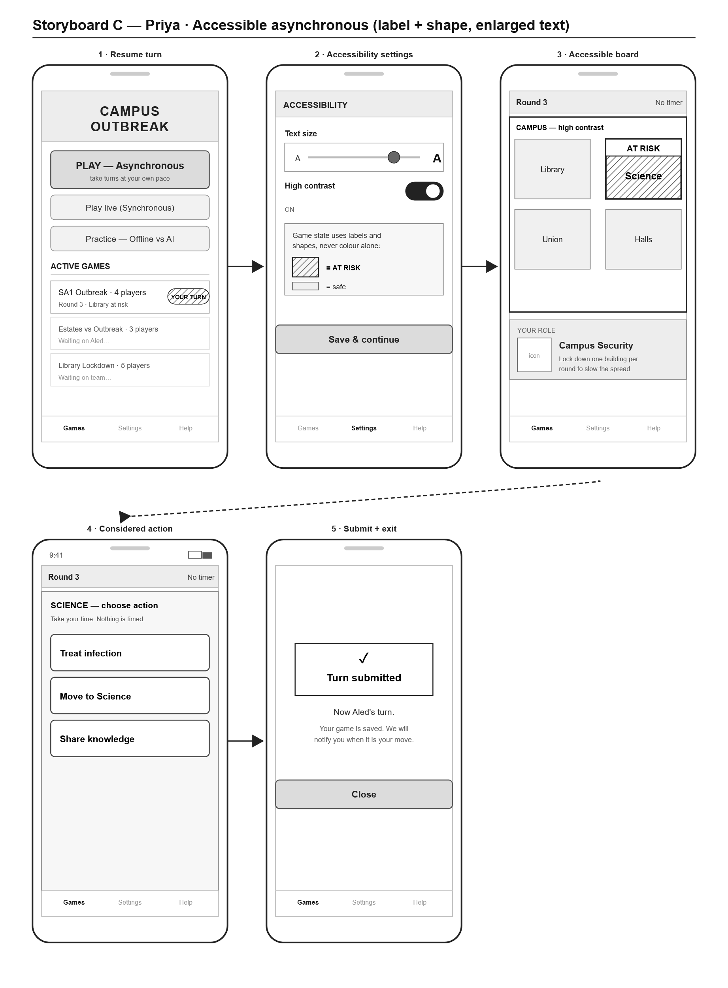

Offline vs AI flow (Gareth)
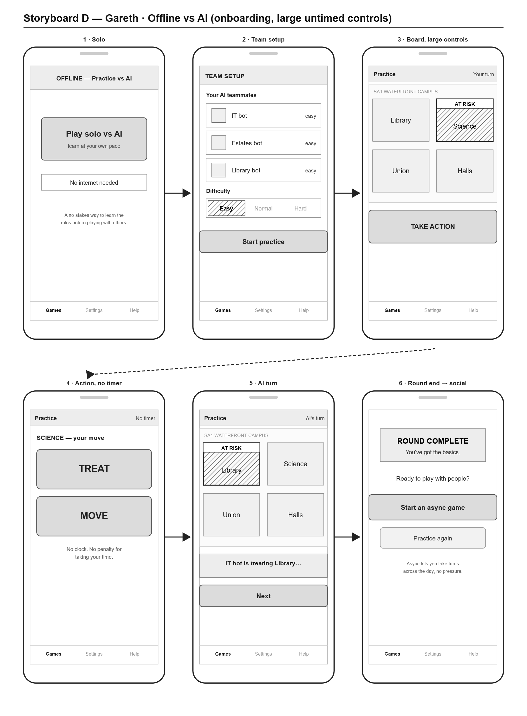

Navigation map
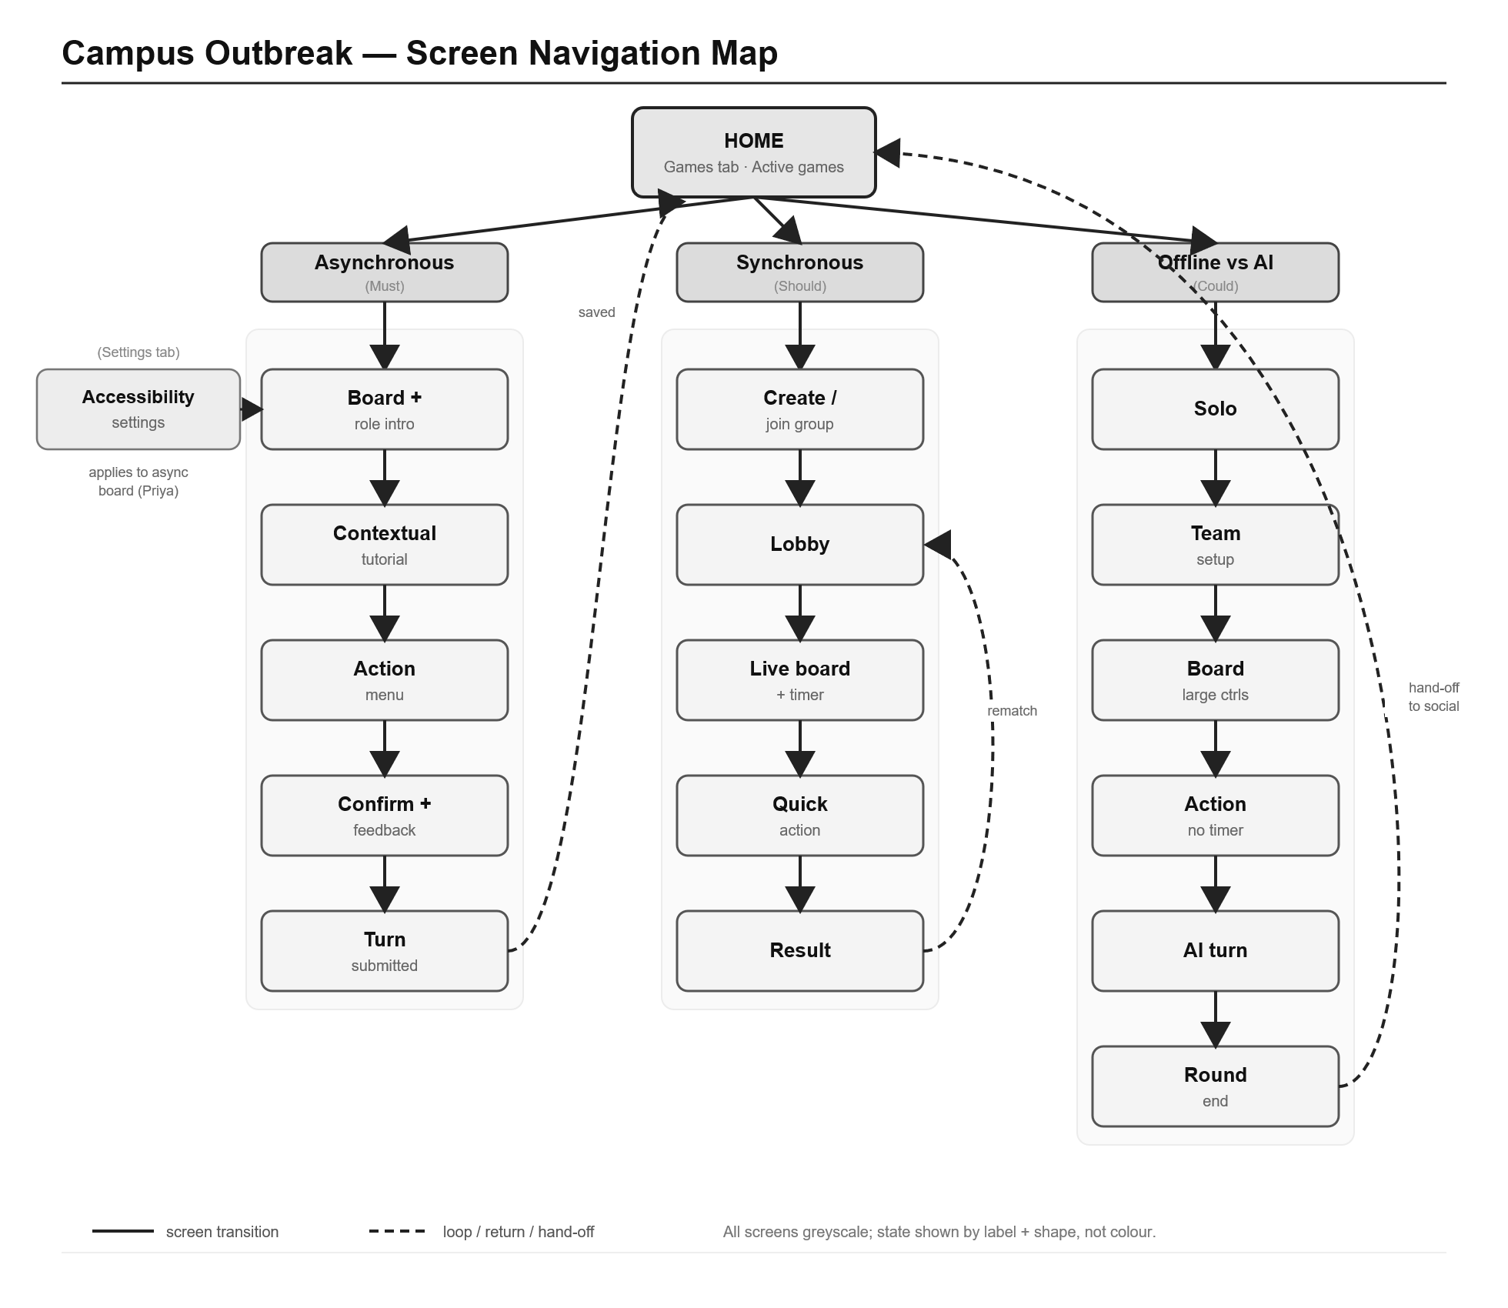

- User Research Questionnaire
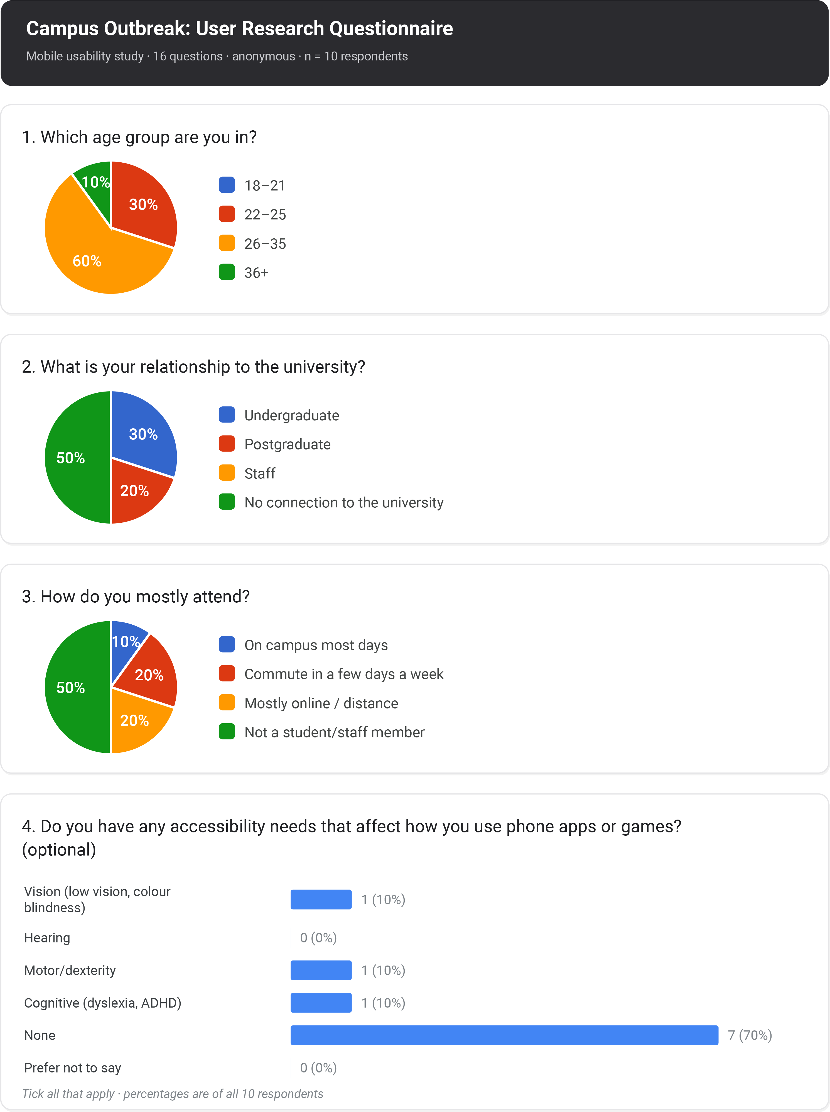

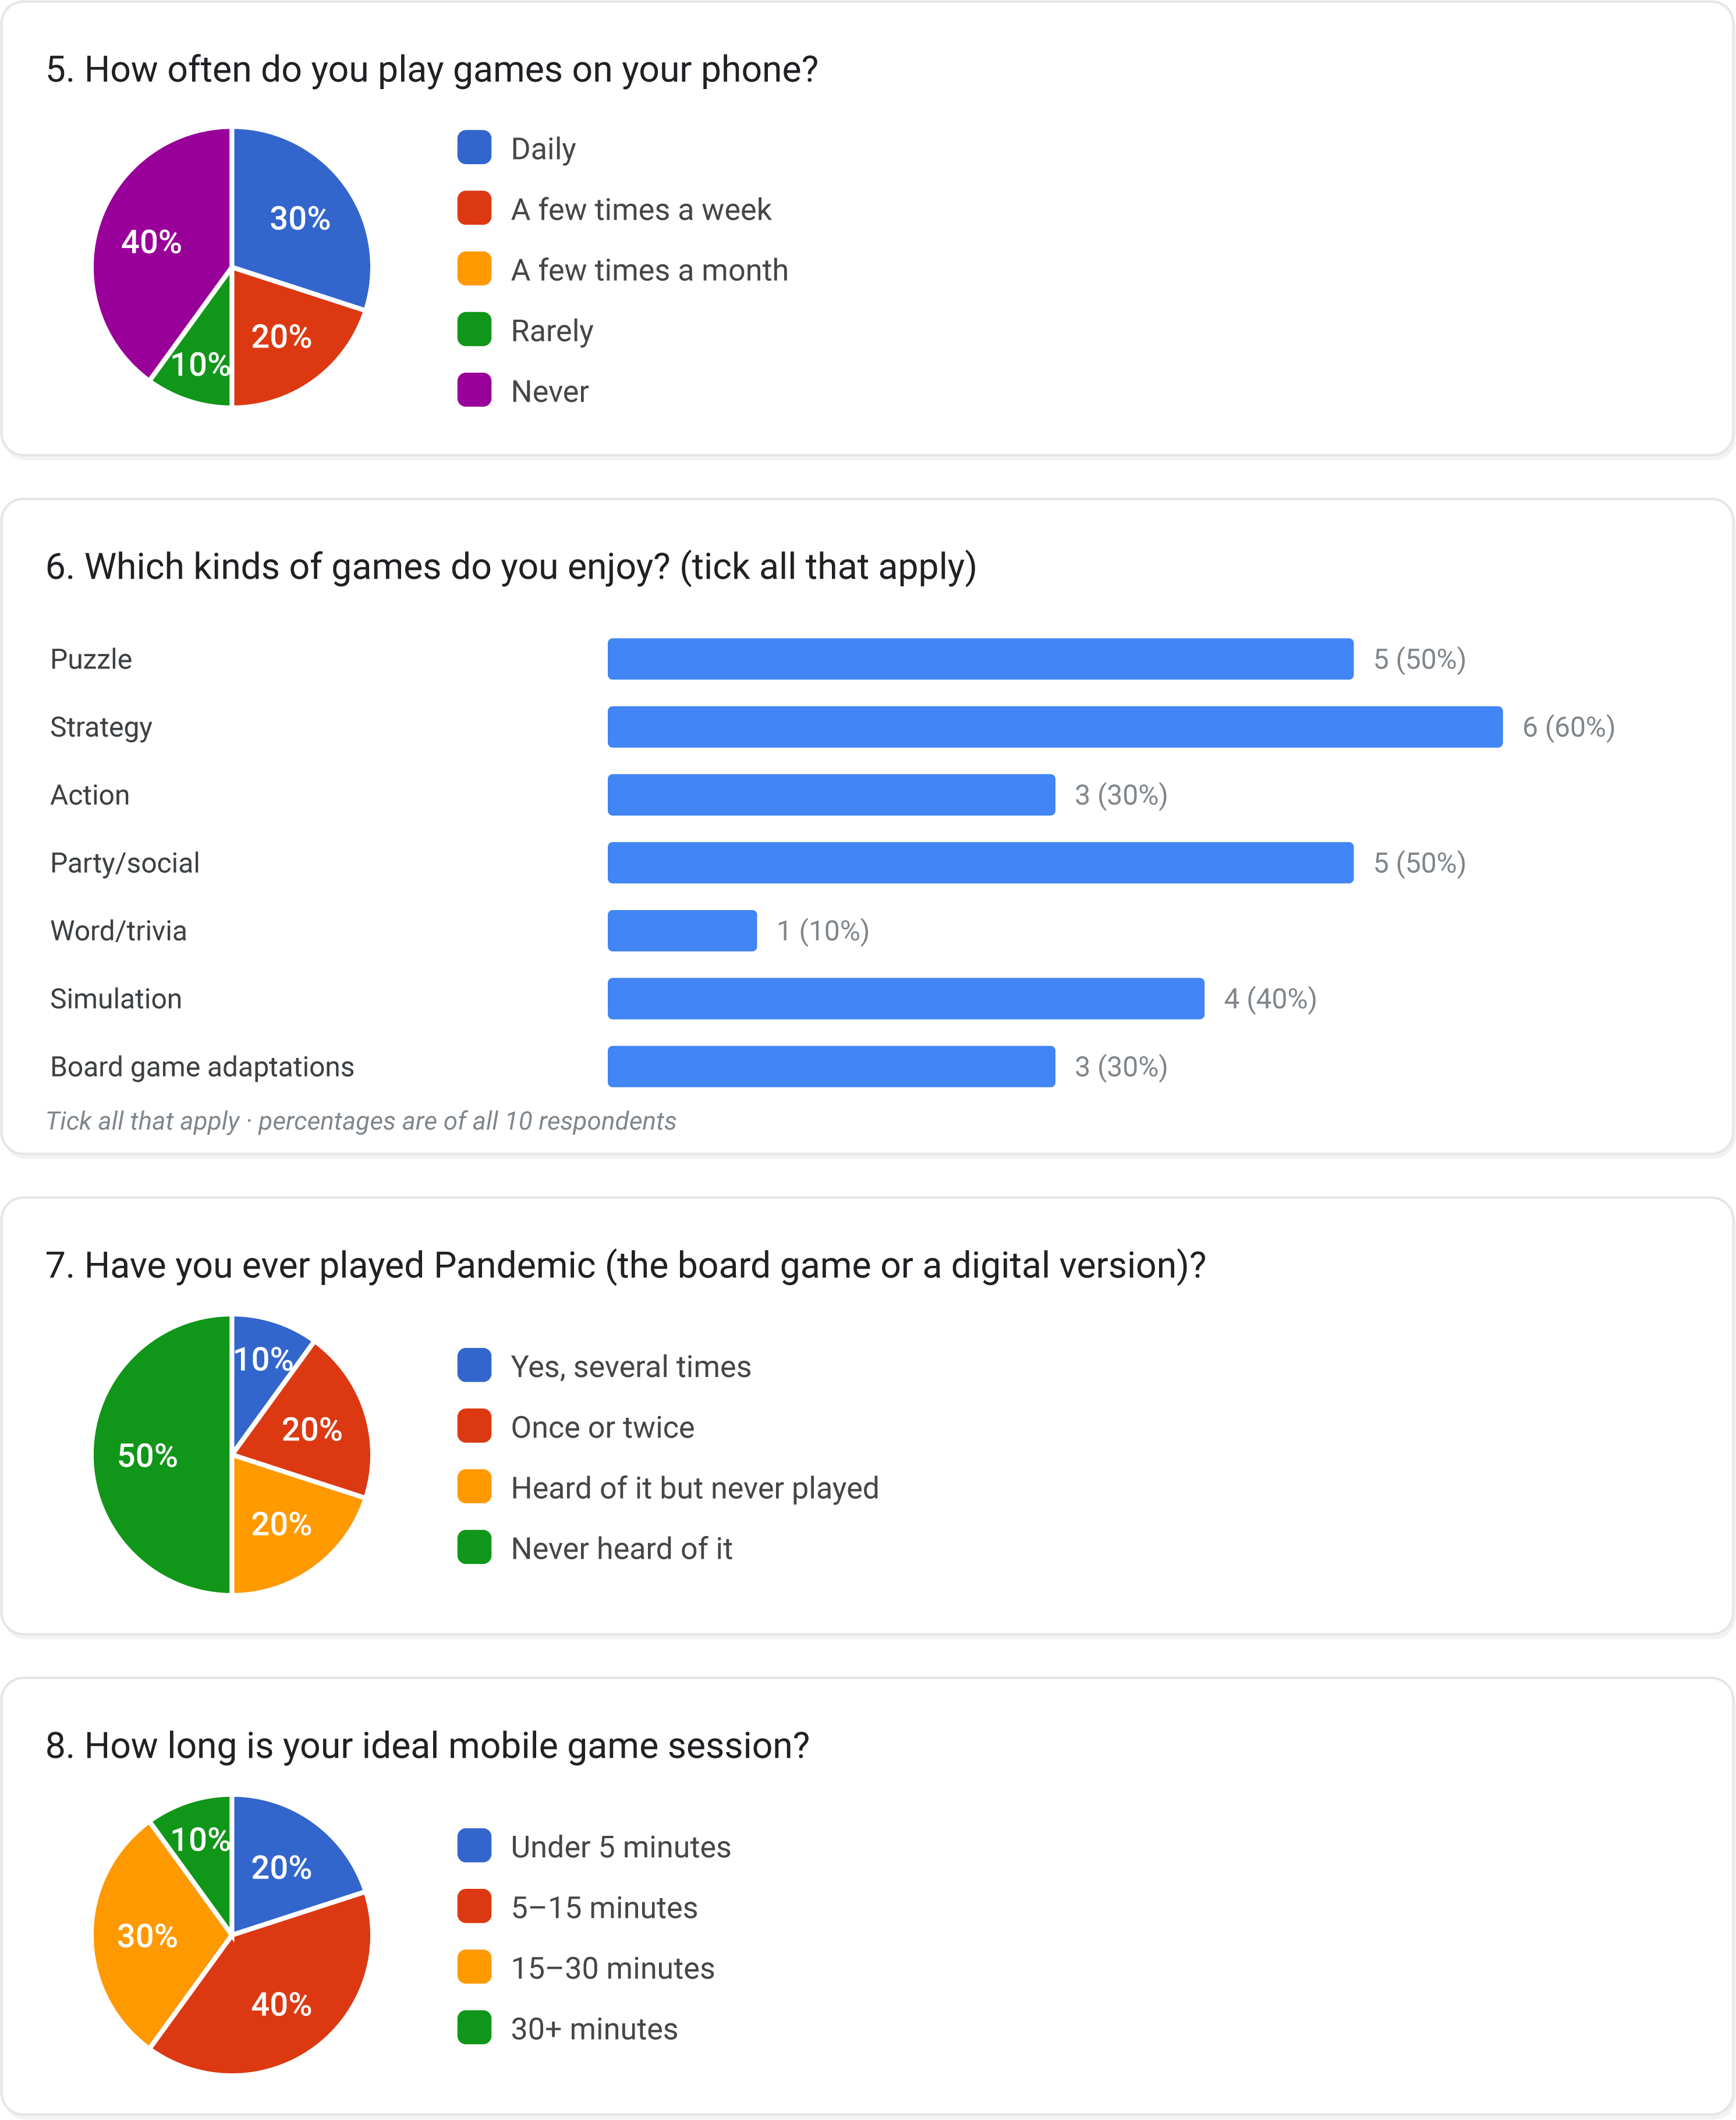

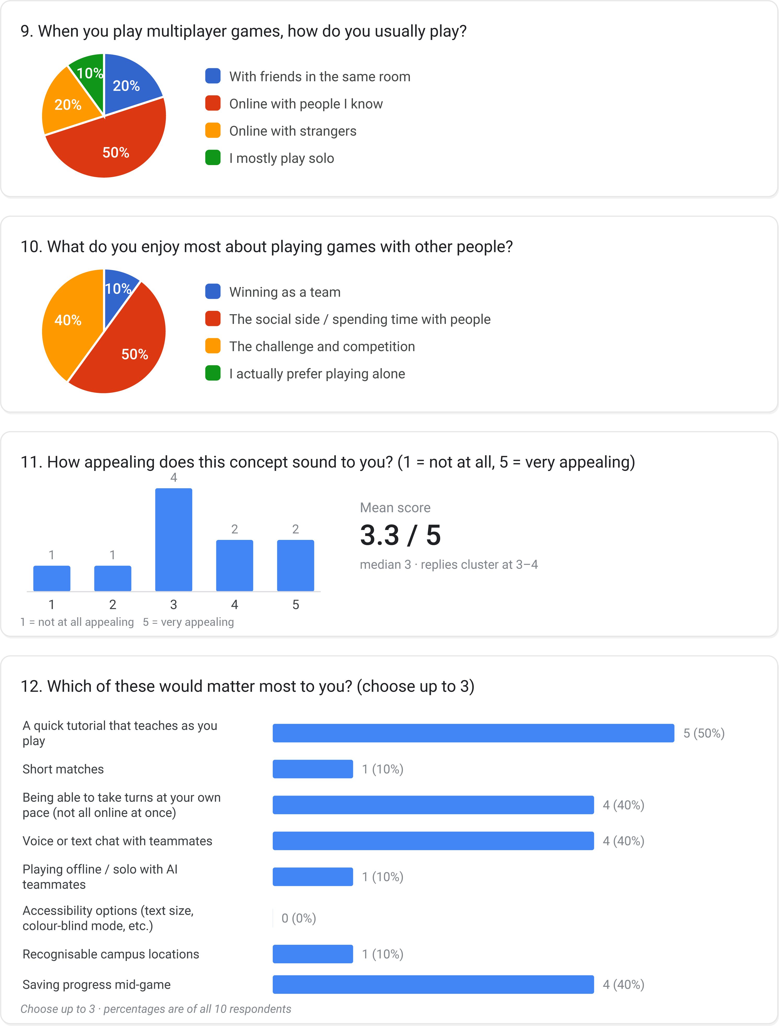

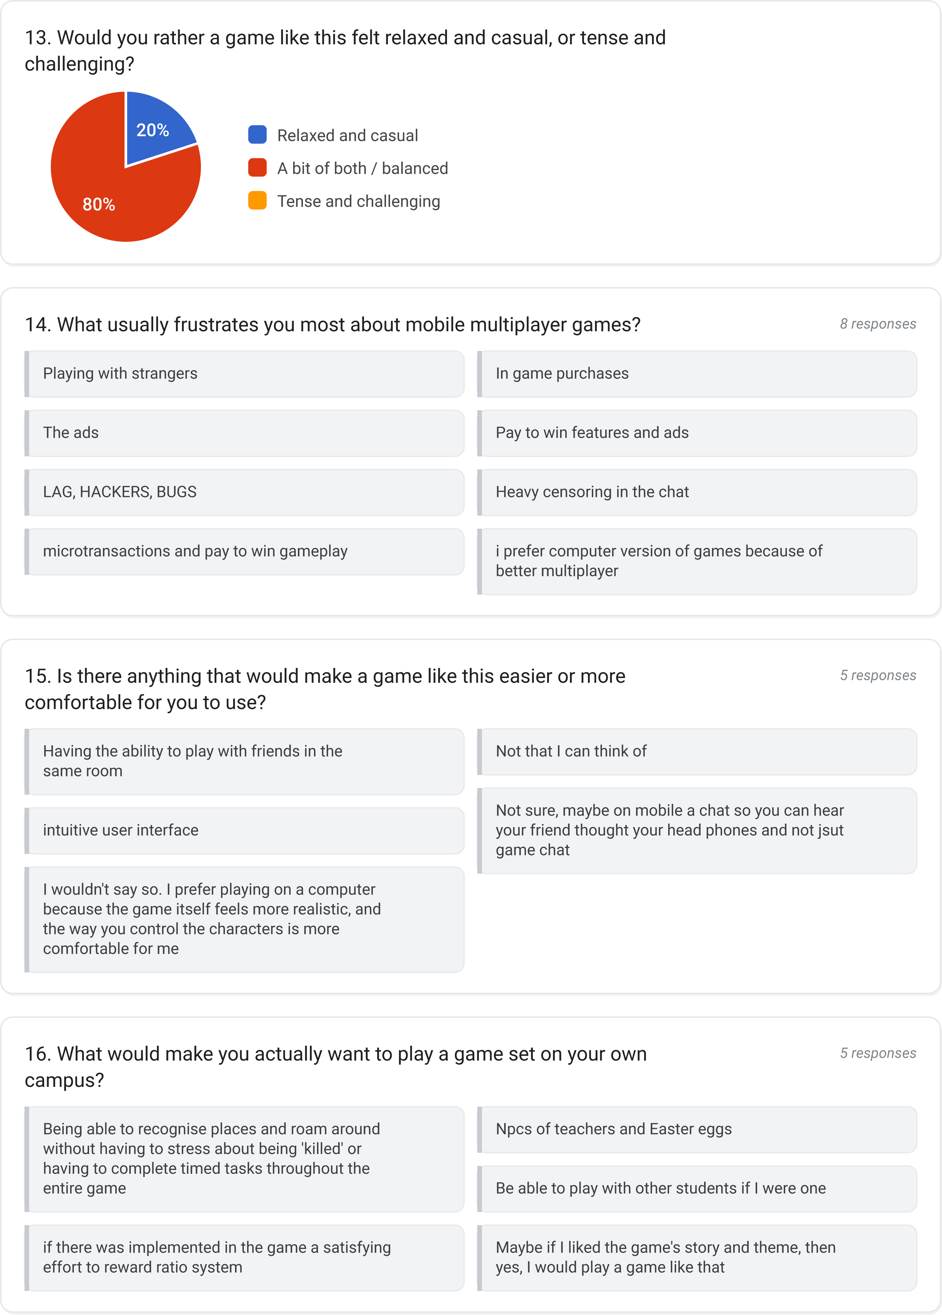

- Personas
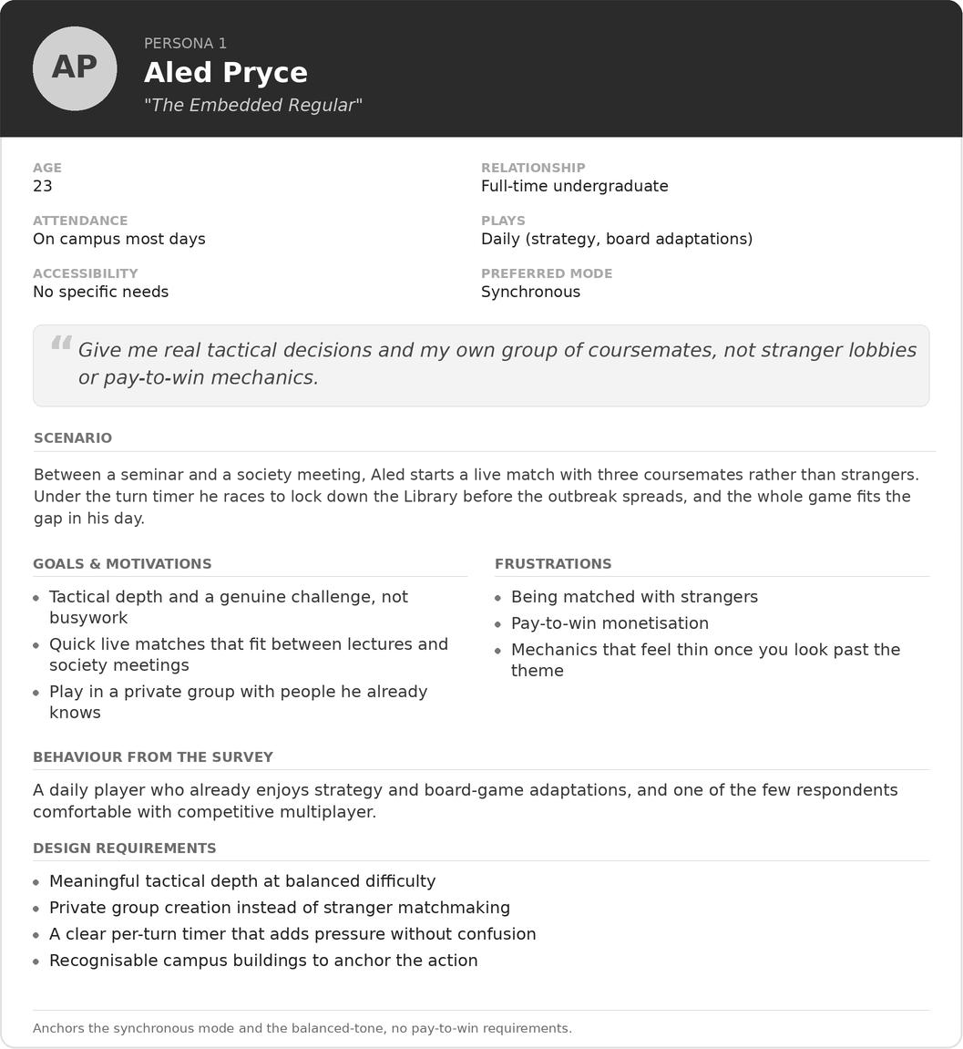

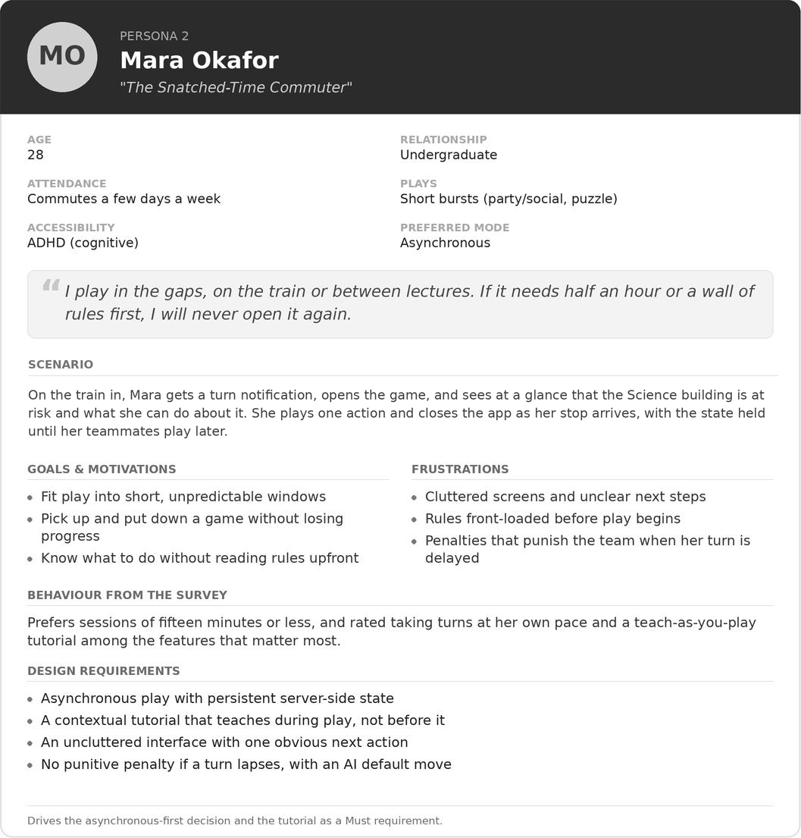

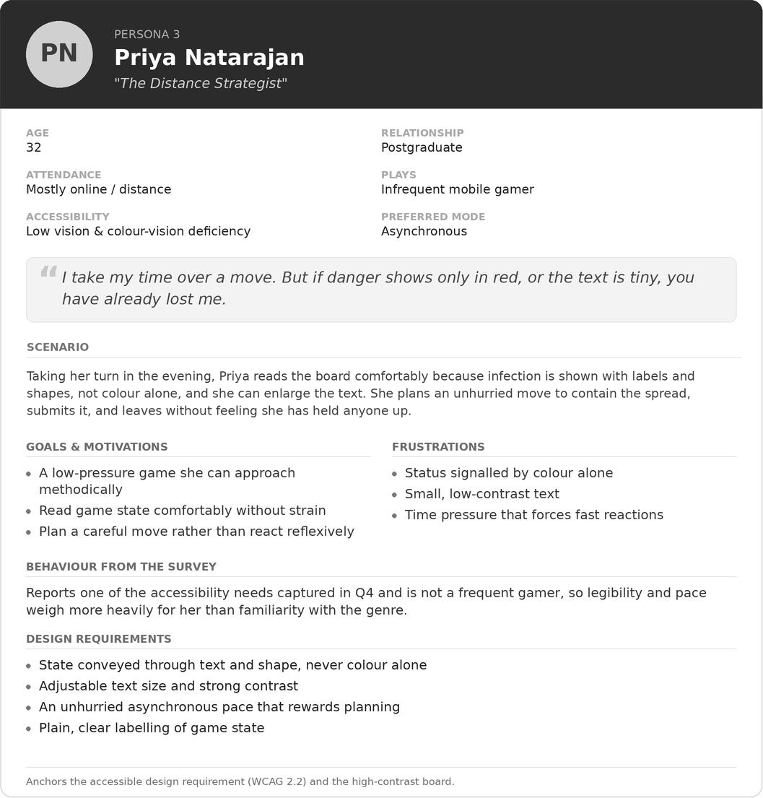

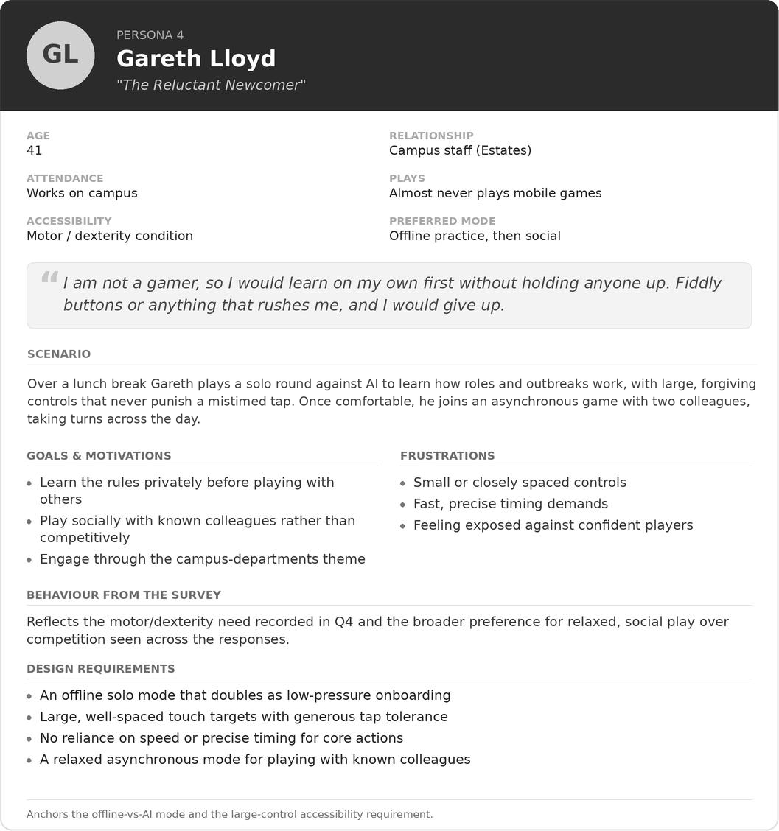

- Prototype Feedback
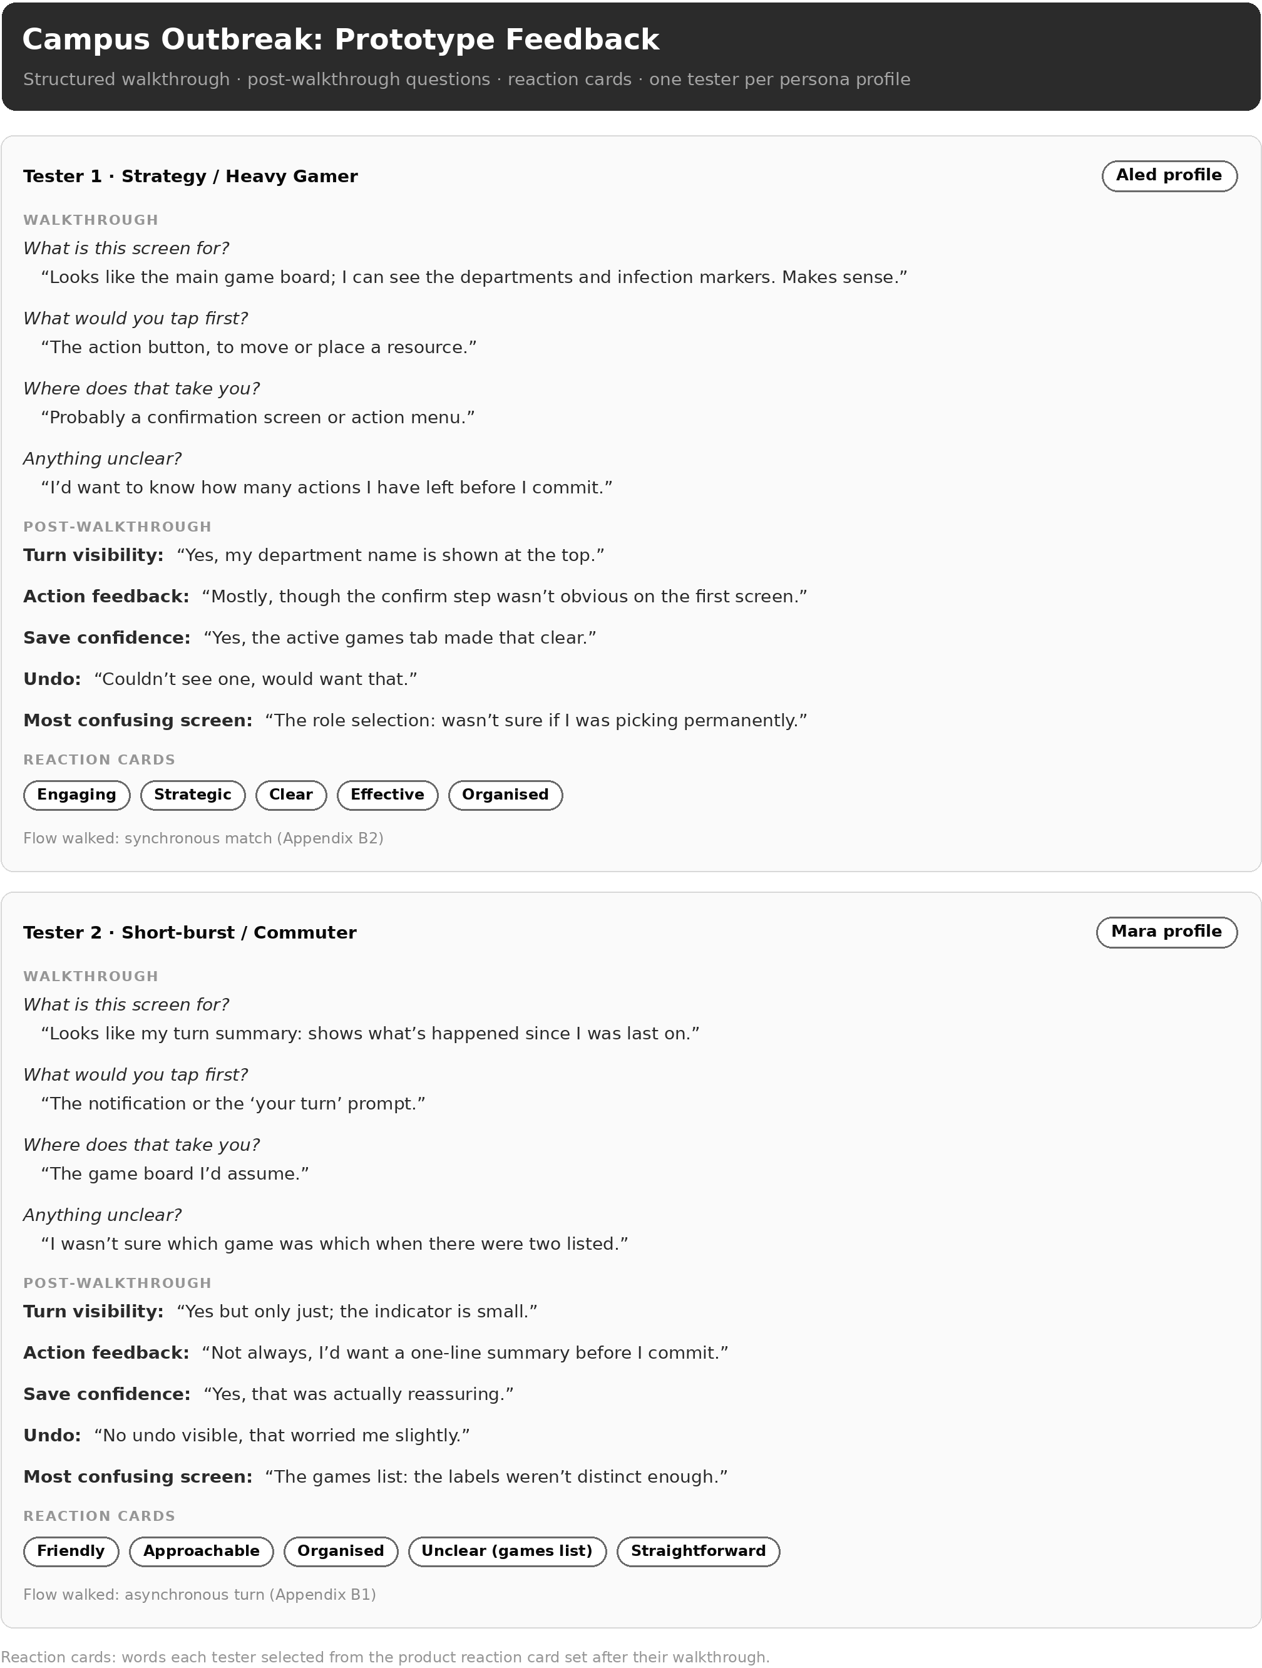
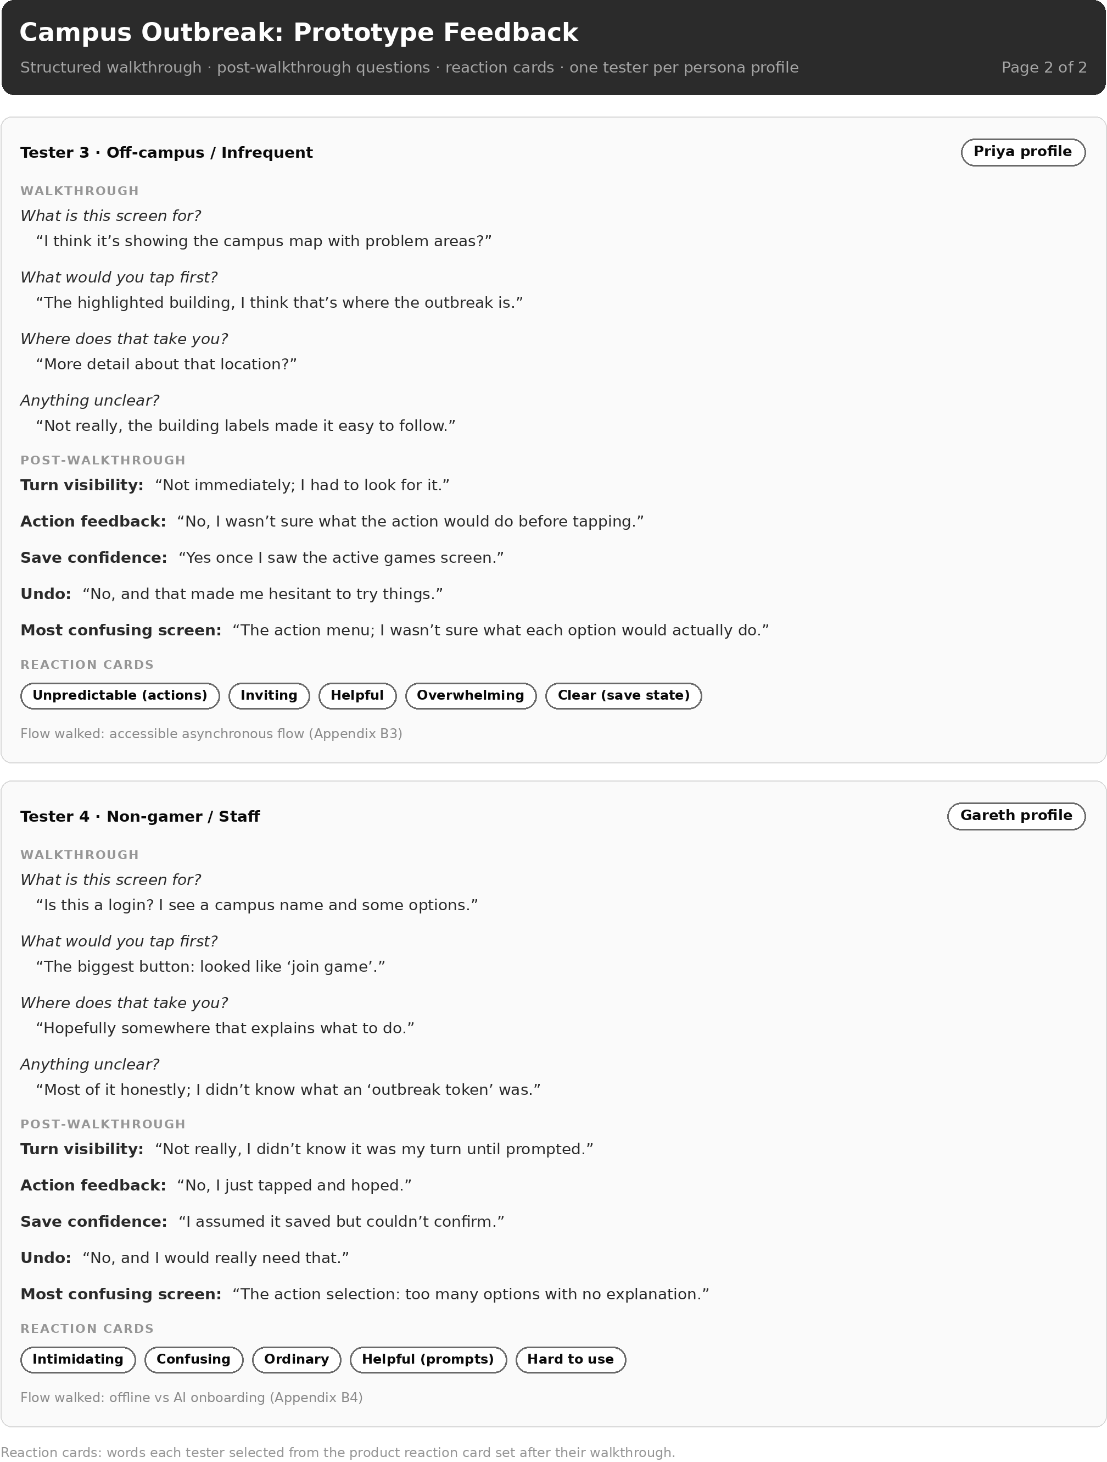
- Peer Heuristic Evaluation


