Software Development
Author: Cameron Brown (2004688)
ACCB4017
School of Applied Computing
Wales Institute of Science and Art

Variables 2
If/else statements 2
Loops 3
Exercise 1: 3
Exercise 2: 5
Exercise 3: 6
Exercise 4: 8

Variables
A variable is a value that you can assign a name to. A variable can be created easily by assigning a value to a name, such as “houseNumber = 5”. This small bit of code means that “houseNumber” has the number 5 attached to it, so whenever houseNumber is reused in the code, it would be the exact same as using the number 5. Variables are useful for many reasons, one of which being that you can attach a user input to a variable and then reuse that input later on in the code. For example, I could put in the code “userAge = int(input())” and then use that input later on in a math equation to work something out.

Another reason why variables are important is that they can make a program look a lot more understandable, especially when given an appropriate name. For example, if I were going to ask for the users age, I would call the variable “userAge”. This is very helpful as I can look back on the code and understand exactly what this variable is meant to contain.

If/else statements
An if statement is where you state that if a variable relates in another way to another variable, then you can state the code to perform something else. For example,
“if a = b:
print(“congratulations! a equals b!”)”
What this means is that if the “a” variable is equal to the “b” variable, then it prints the text “congratulations! a equals b!” onto the screen.

An else statement is an extension of an if statement that can be used to perform another action if the if statement is not met. For example, if we take the previous example code and add an else statement to it, such as:
“if a = b:
print(“congratulations! a equals b!”)
else:
print(“a does not equal b! sad!”)”

What this means is that if the 2 variables do not equal each other, then the else statement comes into play and prints the text “a does not equal b! Sad!” onto the screen.

Loops
Python has 2 loop commands, a for “loop” and a “while” loop. Loops are very important as they can repeat statements as long as the condition is met. With “for” loops, the statement is repeated in iterations. For example, with the code;
“for x in range(5):
print(x)”

The code will print the numbers from 0 up until the specified number of loops, which in this case is the “(5)”.

With “while” loops, the code will loop for as long as a statement is met. For example,
“while a > b:
print(a)”

This means that if a > b then it prints the value of “a” for as long as that statement is true. If a does not equal b, then the loop stops.

Exercise 1:
print("Enter the car make:")
carMake = input() # User enters the brand of the car

print("Enter the car model:")
carModel = input() # User enters the model of the car

print("Enter the mileage:")
carMileage = int(input()) # User enters the mileage of the car

print("Enter the number of doors:")
carDoors = int(input()) # User enters the number of doors on the car

print("Your car make is:", carMake)

print("Your car model is:", carModel)

print("Your mileage is:", carMileage)

print("Your number of doors is:", carDoors)

Issues:
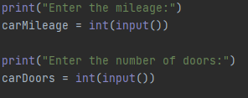
At the start I had forgotten how to restrict what would be allowed into a user input, but after a small bit of research I had ended up with the correct code. Other than this, there were no issues with this program.

Testing:
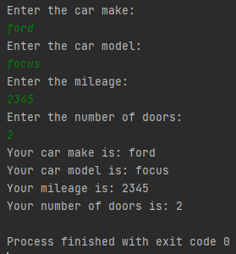
The program correctly accepts and displays all of the entered information.

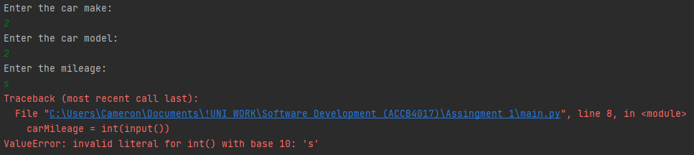
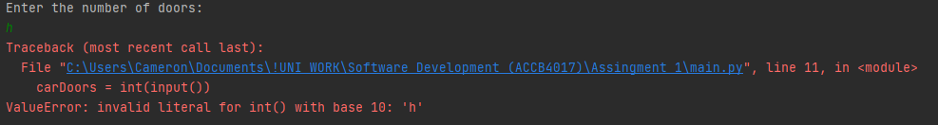
The program allows integers in the car make and car model as it’s realistically possible, but the program does not allow anything but an integer in the car mileage or car door fields as they would only be integers.

Exercise 2:
print("Enter the first required vegetable bed dimension in cm :")
bedSize1 = int(input()) # User enters the first dimension

print("Enter the second required vegetable bed dimension in cm :")
bedSize2 = int(input()) # User enters the second dimension

carrotPatch = 64

totalSize = bedSize1 * bedSize2 # Multiplies both dimensions to get the total size

print("You can fit in", totalSize // carrotPatch, "number of carrots")

Issues:
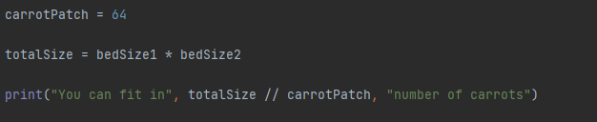
The only issues I had with this program was figuring out the maths which I believe that I have done correctly. Other than that there were no issues with the rest of the code.

Testing:
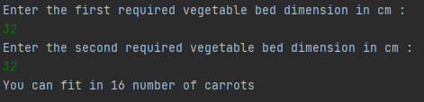
The program correctly displays the number of carrots that can fit into the entered dimensions.
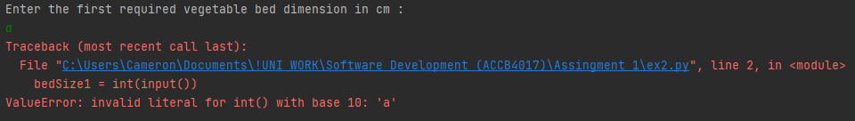
The program also fails to work if the user enters an input that isn’t an integer as the measurement cannot be displayed with anything but an integer.

Exercise 3:
print("Enter product 1:")
product1 = input()
print("Enter price 1:")
price1 = float(input())

print("Enter product 2:")
product2 = input()
print("Enter price 2:")
price2 = float(input())

print("Enter product 3:")
product3 = input()
print("Enter price 3:")
price3 = float(input())

print("Enter product 4:")
product4 = input()
print("Enter price 4:")
price4 = float(input())

print("Enter product 5:")
product5 = input()
print("Enter price 5:")
price5 = float(input()) # User enters 5 different products and their prices

print("Products entered:")
items = [product1, product2, product3, product4, product5]
price = [price1, price2, price3, price4, price5] # All of the information into lists

for x in range(5):
print(items[x], price[x]) # Loops the lists to display all the entered information

print("Total price is: £", sum(price)) # Adds up all the prices and displays it
priceDiff = sum(price) * 0.15
totalPrice = sum(price) - priceDiff # Maths for the discount

print("Total with staff discount is: £", round(totalPrice, 2)) # Displays discount

Issues:
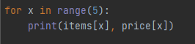
The only issues I had with this program was the “for loops”. I had completely forgotten how they worked, which meant that I had to go do a bit of research to reteach myself about them. Other than that, there were no issues with this.

Testing:
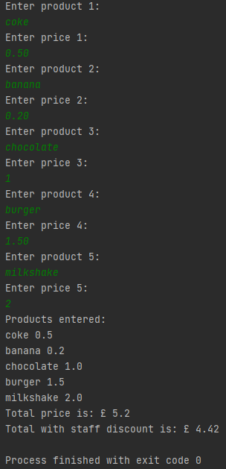
The program correctly lists all products and the prices, adds all of the prices up correctly and adds on the staff discount correctly.

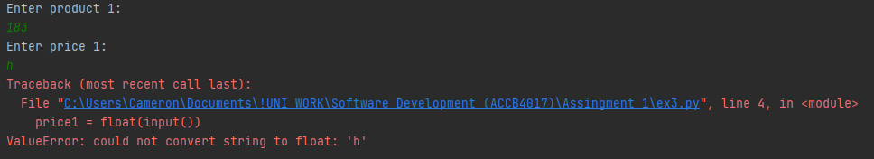
The program stops working when the user enters anything but an integer into the price field. I have allowed the use of anything into the product field as a product can realistically contain anything in its name.

Exercise 4:
import random

gameBoard = [0, 0, 0, 0, 0, 0, 0, 0, 0, 0, 0, 0, 0, 0, 0, 0] # List for the board
counter = 0
randomPosition = random.randint(0, 15) # Random number generator

def game(counter):
print("Choose position: (0-15)")
chosenPosition = int(input()) # User guesses the position
counter += 1 # Counts the number of times the user has guessed
outcome(chosenPosition, randomPosition, gameBoard, counter)

def outcome(chosenPosition, randomPosition, gameBoard, counter):
if chosenPosition == randomPosition: # Displays if the user has won
print("Win! Well done. You took", counter, "turns")
else:
print("Miss! Unlucky")
gameBoard[chosenPosition - 1] = "X" # Marks the board with an “X” if wrong
print(gameBoard[0], gameBoard[1], gameBoard[2], gameBoard[3])
print(gameBoard[4], gameBoard[5], gameBoard[6], gameBoard[7])
print(gameBoard[8], gameBoard[9], gameBoard[10], gameBoard[11])
print(gameBoard[12], gameBoard[13], gameBoard[14], gameBoard[15])
game(counter)

game(counter)

Issues:
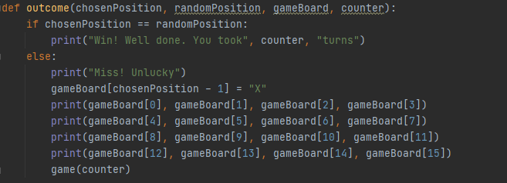
I encountered some issues when trying to get the 0’s to be replaced by X’s as it would always in the wrong spot. After some trial and error, I had found out that it puts the X one spot ahead of where it should be. I had fixed this issue by adding a “- 1” to the code which places the X one spot behind which is also where it should be.

Another issue I had in the screenshot was formatting the gameboard to be displayed as a 4x4. I had placed the prints there as a placeholder with the intention to clean it up at the end, but I could not figure out how to make it look more clean. So I had decided to give up and leave it since it works fine.

Testing:
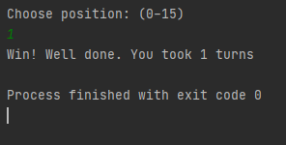
The program ends and displays a winning message if the number was guessed correctly.

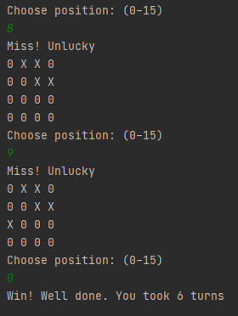
The program correctly displays if the user has guessed incorrectly and places an “X” on the correct spot. The number of turns the user has taken is also displayed correctly.

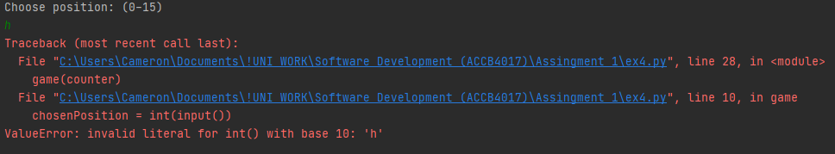
The program fails to continue if the user enters anything but an integer.

