MINODORA-VIOLETA DULUMAN
STUDENT NUMBER: 1919047
PROGRAMME: BA BUSINESS MANAGEMENT LEVEL 4
MOODLE: THE GLOBAL BUSINESS ENVIRONMENT- ASSIGNMENT 1
LECTURER: MALANI GUNARATNAM

MARKETING FUNDAMENTALS – ASSIGNMENT 1, ZARA BLOG

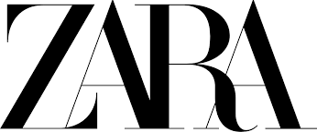
BLOG ON ZARA
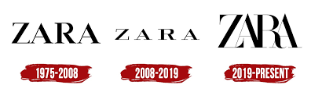

History of Zara
Zara Sa Is also known for Zara. Zara was founded in 1975. It is a Spanish retailer based on Arteixo which was situated in Galicia. The company Zara was specialized in many different fashion products Like clothing, accessories, shoes, swimming wear, beauty, And special perfumes. It is also known as the largest company in the Inditex group. In the year 2017 Zara is known as the world's largest retailer in which it manages more than 20 clothing collections in a year. The first Zara store was open by Amancio Ortega in 1975 which was located in central A Coruna. Zorba is known for the hit film in an industry where Ortega names the store Zorba. After analyzing there was the same name two blocks away and then rearrange the letter and sign to Zara. The first store was open at low price Because of being popular and clothing fashion. In Spain Ortega open many additional stores. 1980 many changes have been taking place like design manufacturing and distribution process that was done by Ortega To reduce the lead time an introduction of a new trend which is called instant fashion. This is done due to the use of new information technologies and a group of designers. Zara launches an online shopping product for its customers in September 2010. In 2015 Zara was known for interbrands's among the all brands and best brand world wild. In 2019 Zara updated its logo. Zara is known for its eco-friendly company(Hansen.2012).

Marketing Mix

Marketing mix:
The Greek word marketing mix is the foundation of model business and history that tells about the product, price, place, and promotion is also known as 4ps. The marketing mix also tells about the various tool of a firm that the company used in the target market does marketing mix also has the four-layer or level of marketing mix product, price, place, and promotion. This marketing makes tell about the various framework of marketing decisions. These tools Tell about the development of strength and identifying the various weakness of a business. Hence Zara also uses these types of the various marketing mix for development and the growth of the business. These all marketing mix strategies are used by Zara to achieve their goals in the target market so that they can compete with their competitors(Caro et al,. 2010).
Marketing mix of Zara as in product strategy:
Zara is known as one of the famous leading brands worldwide. Zara production in many brands like men women and children. Zara deals in many products like jeans, trousers, tops, skirts, nightwear, T-shirts, shoes, bag, and accessories. The marketing mix consists of all this type of product strategy of Zara. It is known for the top brand leading where customers want to buy formals or casuals. There are a variety of product that Zara produce in which one individual can choose any different style of product. Around 10,000 new products, Zara produces in a year. Zara's product is known for the highly fashionable as well as a new use of technology. The company analyzes the product in the target market which helps them to cheque the taste and preferences of the customer. Zara also works with local producers to provide the best fashion trend in the market. Zara believes to produce production waste with the help of sustainable development. Zara also recycles their tags hence Zara introduce paper or biodegradable plastic bags to sell the product in these bags. Zara uses premium quality fabric like organic cotton for the production of their item. These all are the product strategy that Zara follows in the marketing mix to achieve their target and goals which help them to compete with their competitors in the target market. Zara maintains its good relationship with the customer or clients so that they achieve the target in the market. More satisfy customer leads to an increase in the sale of goods and services. Zara is known for coca-cola fashion. The main important role of the company is to respond very quickly and take immediate action toward the customer need and want. The company is not doing the outsourcing with another manufacturing company. the achievement. The achievement of the company is products are available to the store within two weeks(Lee et al,. 2014).


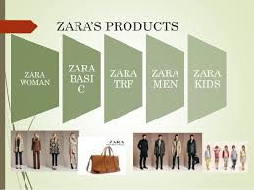



Zara pricing strategy

Pricing strategy
Marketing mix of Zara as in price strategy
Zara is known for the high product fashion market at a low price. Zara manufactures the latest fashion brands at a lower price in all over the international stores as compared to another competitor in the international brand. Zara’s means strategy is to follow a low price product. Zara may not spend more amount of money on their advertisement and raw material.
Compared to their competitor they have a low-priced product as their countries specific price(Gamboa and Gonçalves. 2014). Their tagging on clothes is done by local production marketers. Zara fixes the market price strategy in which customer influence to purchase the product effectively and efficiently. According to the target price, the market budget production takes place. Zara fixes the profit margin in their production to earn on daily basis. Lower the price of the product may attract the customer more for the increase in their sale. Effective price attracts the customer most which help in the purchasing power of the customer(Kim and Park. 2013).

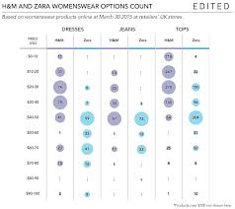
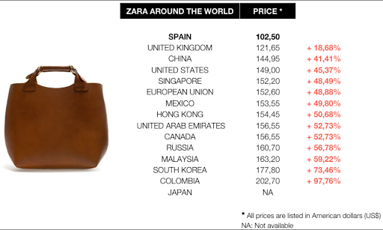
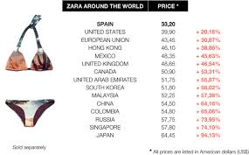
Zara Place Strategy

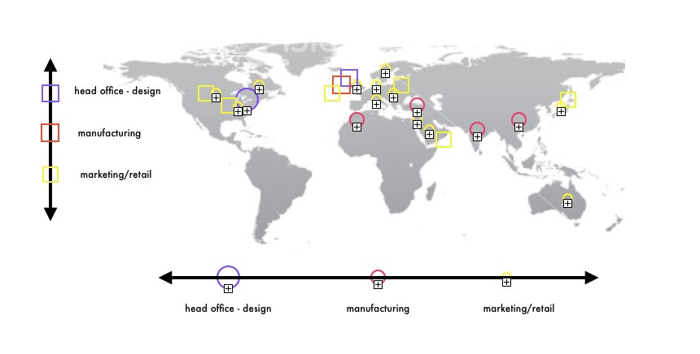

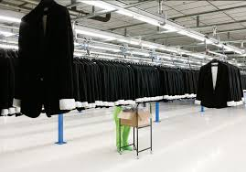

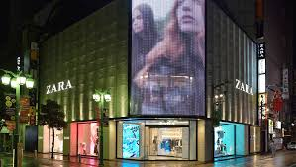
Marketing mix of Zara as an in-place strategy
Zara total reaches out with 88 countries having a store with more than 6500 outlets. Many of Zara's are items sold online. Zara involves the various type of channels for the brand like marketing mix place and distribution strategy. It analyzed the unique business model to introduce the new product and fashion in the market for a short time. Twice a week store manager gives the orders of the product to the headquarters of Zara based on the sales and shoppers' preferences(HR and Aithal. 2020). The commercial team accepts all the orders from the headquarters of Zara and then is sent to the manufacturing hub.
The commercial team analyze and discuss with their coordinator’s about the design of a product and to find the new trend and development of the new product in the market as per to satisfy the customer need and want in the target market. Without taking franchisees most of the Zara stores are owned by the company. Many of these stores are allocated in premium locations, with high standards a modern in look, and excellent lightning. Zara provides training to their salesperson so that they help in communicating with the customer or client softly which helps in increasing sales and attracts the customer most. The good place attracts the customer most for the purchasing power of the product(Nam et al,. 2015).

ZARA Promotion Strategy

Marketing mix of Zara as in promotion strategy
Promotion strategy plays an important role in business organizations. Zara very rear spends money on advertisement. It is shy for being famous. Even the owner of a company never gives any press interview. Sara does not organize Or join any campaigns. This is the main reason Zara not able to adopt any advertisement that is shown on television. Zara's selling proportion is a short time as it includes a large variety of fashion Houses with reasonable rates. Rather than using other expensive marketing tools it main believes in mouth promotion and social media.
Zara is famous on social media. Zara has 15 million followers on Instagram as well as 2.5 million on Facebook globally. The main interesting part of Zara is that company is not put its logo on any products that are sold in the market. Zara more prefers to spend money on the opening of new stores. Zara spends money on real estate for its stores and to maintain decor. Zara thinks show window is more sufficient for advertisement and they do not need anything else to sell their product. This shows the promotion strategy of Zara(Abril and Rodriguez,. 2016).

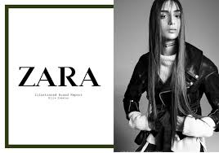

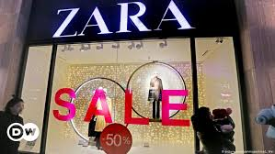



Conclusion
Above summary, the conclusion is a report of the Zara company. It tells about the history of Zara. When the company started what new achievement the company has made with their new technologies with their new production line And some difficulties they may suffer too. The company opens the world's largest fashion products for men women and children. The company was eco friendly and maintained their relationship with their customers or clients for their satisfaction. Hence the company's various marketing mix strategies for their production of goods and services tell about whether the good upper news is good quality or low quality. Marketing mix also tells about Various marketing tools. There are a total of four marketing mix strategies product, price, place, and promotion. Product strategy tells about the quality of the product that has to be manufactured. It analyses the customer taste and preferences that occur in the market. It ensures the superior quality of the product should be produced to satisfy the customer need and want. Price strategy tells about the price-quality of the product. The lesser the price more the increase in the sale of the product. Customers are willing to buy products at reasonable prices so that they may help increase more purchases. Place strategy is one of the most important roles in Zara company. Good place attract the customer for the purchasing power of the product. Premium location leads to an increase in sales. Promotion strategy is also plays important role in a business organization. The company may not spend more money on advertisement rather it has a mouth to mouth promotion. It is shy for being famous. Zara company has more followers on Instagram and Facebook so this is more sufficient for them rather advertise on television.

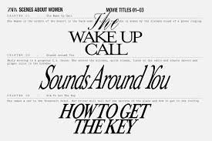

References

Reference
Abril, C. and Rodriguez-Cánovas, B., 2016. Marketing mix effects on private labels brand equity. European Journal of Management and Business Economics, 25(3), pp.168-175.
Caro, F., Gallien, J., Díaz, M., García, J., Corredoira, J.M., Montes, M., Ramos, J.A. and Correa, J., 2010. Zara uses operations research to reengineer its global distribution process. Interfaces, 40(1), pp.71-84.
Gamboa, A.M. and Gonçalves, H.M., 2014. Customer loyalty through social networks: Lessons from Zara on Facebook. Business horizons, 57(6), pp.709-717.
Hansen, S., 2012. How Zara grew into the world’s largest fashion retailer. The New York Times, 9.
HR, G. and Aithal, P.S., 2020. Establishing True Lifestyle Brand in India: An Integrated Marketing Mix Framework. International Journal of Management, Technology, and Social Sciences (IJMTS),(June 2020), 5(1), pp.261-284.
Kim, E.Y. and Park, K., 2013. Marketing mix elements influencing brand attitude strength: Global vs. domestic SPA brands. Journal of Global Scholars of Marketing Science, 23(3), pp.263-281.
Lee, C.H., Ko, E., Tikkanen, H., Phan, M.C.T., Aiello, G., Donvito, R. and Raithel, S., 2014. Marketing mix and customer equity of SPA brands: Cross-cultural perspectives. Journal of Business Research, 67(10), pp.2155-2163.
Nam, H., Son, H. and Lee, Y., 2015. Effect of SPA brand consumers' emotional consumption value orientation and assessment of marketing mix attributes on brand loyalty. Journal of the Korean Society of Costume, 65(4), pp.45-60.

