BMIH5004:
Management & Organisational Behaviour
By
Aleksandar Mitkov Mitev
Student number 2014129

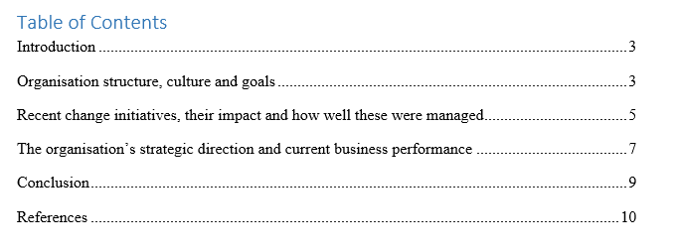

Introduction
In the pandemic time, every hospitality organization has to change in structure and design system. Every hospitality organization wants to bring changes to gain competitive advantage. Like other hotels, the management of the Hilton hotel company implements various unique ideas to boost client numbers, productivity, and growth rates (Nwali, 2018). Customers will benefit from a clean and healthy atmosphere as a result of this improvement. A healthy atmosphere contributes to the hotel's improved brand value and reputation. Due to these evolving challenges, this hotel will gain a competitive edge and be able to readily compete with both domestic and foreign consumers (Smadi, 2022). In this report describes structure of Hilton hotel, culture of Hilton hotel, goals of this hotel, and some changes with its impact. In this report also describes this hotel’s strategic direction system, current business performance of this hotel, conclusion and references.

Organisation structure, culture and goals
Organisational structure:
Organisational structure means an organisation's reporting and direction system. Organisational structure helps to achieve the goals and objectives of the hospitality organisation. Organisational structure includes the rules and regulations of the organisation, the responsibility and role of employees and so on (Omar, 2019). Every hospitality organisation has its own organisational structure. Like other hotels, Hilton hotel group also has an effective organisation structure. This organisational structure helps this hotel to understand the direction or reporting system. In this structure, president is seen as the top position in this hotel group. Under President, two vice Presidents are properly noticed. One vice president overlooks the financial activities and other vice President overlooks the corporate service (Smadi, 2022). Under the finance vice president, this hotels general manager, corporate controller l, corporate finance director are seen. Under the corporate service vice-president, sales and marketing's corporate director, technology's corporate director, revenue management's corporate director and human resource management corporate director are properly noticed. Then under the corporate controller, regional accountant are seen, under sales and marketing's corporate director regional sales and marketing's manager are seen, Under Technology's corporate director, executive assistant and administrative assistants are seen, Under corporate revenue director, corporate revenue management analyst is seen and Under HRM director, HRM assistant is properly noticed (Lacroux, 2021). Then in the bottom line it is seen that Hotel's controllers, HRM manager, hotel's font office manager, information technology analyst and sales manager are noticed. By that this hotel's organizational structure is developed.
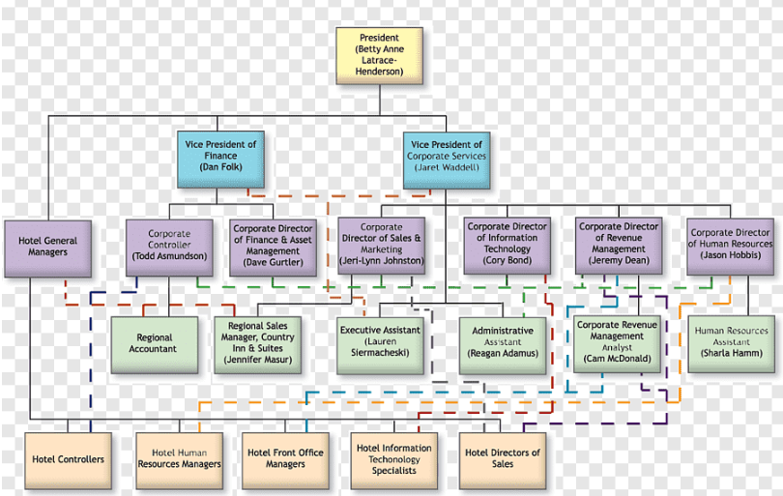
Figure: Organisational structure of Hilton hotel
Source: (Nuckcheddy, 2018)
Organizational culture:
The organizational culture consists of an organization's structure system, symbol, ritual and controlling system. Hilton hotel group provides service to more than 114 countries. This hotel has more than 6500 properties. This hotel also maintains effective culture to develop the operation system. The power distance system of this hotel is low because the management maintains democratic Leadership system to run this hotel (Omar, 2019). In this hotel employees have equal rights and management provides equal opportunities to all employees. The uncertainty avoidance of this hotel is low and for that reason employees do not feel stressed and uncomfortable to run the operation. That helps this hotel's productivity and efficiency level. This hotel's management and employees maintain collectivist culture (Nwali, 2018). For taking decisions, the management consults with every employee and creates meetings. Management provides empowerment opportunities to all employees and that helps employees to express their opinion in the meeting. The present controls all employees in this hotel (Smadi, 2022). The management also provides participative leadership style in this hotel. The management maintains Hierarchy culture and by following that method builds up a top to bottom approach in this hotel. By that, a proper chain of command is developed in this hotel.
Goals:
The management of Hilton Hotel Group develops some corporate goals and objectives. These corporate goals and objectives of Hilton hotel group is listed below.
- To increase the repeated guest number around 10 to 15% in every year.
- Has to reduce the time of check in as well as check out around three minutes.
- To increase the market growth and share around 8% in every year.
- To open more new brunches and increase the average occupancy level of the hotel by 4%.
- To increase the sales rate and sales volume around 7% in every year.
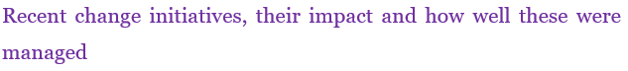Change initiatives:
To increase the customer’s number, productivity and rate of growth in Hilton hotel group, the management takes some changing initiatives. In the pandemic time, management brings some changes. First change that in noticed the management of Hilton hotel group is change in hotel design. The management changes the infrastructure of the hotel and hotel lobby. The management has developed social distance maintaining rule and regulations (Smadi, 2022). For that reason management creates circle in floor and the guests have to maintain this circle for maintaining the social distance. Management brings Covid-19 protective equipment like gloves, sanitizers and hats for the customers. Management also increases the room number for decreasing the affection rate. Management of this hotel group pays more concern on cleanliness issue. The management tells the staffs to clean the hotel floor, rooms of the hotel and so on. That helps to develop health environment in this hotel (Lacroux, 2021). Cleanliness issue play the important part to reduce the rate of Covid-19 and ensure safety issue for the customers or guests. The management also brings innovation and creativity in service process. The management brings digital equipment for developing the service process of this hotel. Management brings advanced service to increase the customer name, grab the market and develop the productivity of this hotel. Management increases the restaurant service in this pandemic time so that customers do not have to go outside for taking foods. Management develops clean kitchen and to that clean kitchen chef creates fresh food for the customers (Wood, 2019). More loyalty programs are arranged by the management of Hilton hotel group foe bring the change. Management increases the more training equipment for the staffs and employees. These train equipment easily develop employee’s career. That help employees to provide creative and innovative service to the guests. These types of changes are noticed in this hotel group.
Impact:
These change help to create positive impact in this hotel. Due to bringing this change, customers are going to get clean and healthy environment. Healthy environment helps this hotel to increase the brand image and brand value of this hotel. These type of changes help to increase the profit percentage of this hotel. Vision and objectives are going to be achieved due to creating these changes (Smadi, 2022). The Covid-19 affection rate is going to be decreased as a result of bringing these changes. Customers become satisfied and customers become loyal for this hotel. As a result, this hotel's sales are going to be increased and enhanced. Customers are going to provide more positive words of mouths due to bringing these changes. That helps this hotel to get a lot of customers and increase the growth rate and market share of this hotel. Both employees and customer’s requirements are fulfilled due to bring these changes (Wood, 2019). This hotel is going to obtain competitive advantage and easily compete with the domestic and international customers due to these changing issues. Customers are going to get on time service for bring these changes. Some negative impact are going to be created due to bringing these changes. To implement these changes, management has to arrange and spend a lot of money. That time the profit of this hotel is going to decrease (Smadi, 2022). The management has to spend a lot of time to bring these changes and for that reason, this hotel's productivity is going to be decreased.
Manage changes:
For managing the changes, the management of Hilton hotel group has to arrange the resources and materials in time and has to manage those resources properly. The management has to hire talented and skilled people for managing these changes. To manage change, the management has to pay more concern on developing the meeting system (Lacroux, 2021). To the meeting, the employees are discussed with each other for bringing the new changes in easy way. The management has to develop risk management system to minimize those risks that are going to see for bringing these changes. The management has to create proper budget for managing these changes (Wood, 2019). To manage changes, the management is required to develop for forecasting system. Proper forecasting reduce the rate of surplus or shortage products (Mickan, 2018). The management has to control inventory and cost to manage these changes. These things are going to manage these changes in easy and effective way.
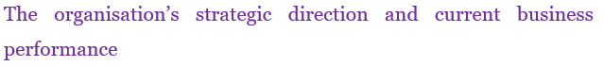Strategic direction:
Vision of Hilton hotel is to reach the global market and fulfill the requirements of the global customers.
Mission statement:
The mission of Hilton hotel is the improve lives, develop the communities, create positive opportunities for team members and because the most hospitable international hotel.
Core values:
Core values of this hotel are leadership, teamwork, passion, proper direction, provide proper service, integrity, and focus on mission and vision and so on.
HRM plan:
To develop the strategic direction, the Hilton hotel's management will develop a proper HRM plan. For making it, the management is going to select professional and advanced candidates to bring innovation in service (Omar, 2019). The management will as develop training session for developing employee’s career and providing right time customer’s service. The HRM manager will also create performance management system and motivational system to develop employee’s performance level and engagement level. That is going to increase the productivity of this hotel.
Operation plan:
To develop the strategic direction, the Hilton hotel's management will develop a proper operation plan (Smadi, 2022). The management is going to pay more concern on developing quality management plan, inventory management system, forecasting system, logistics system, procurement system, supply chain management activities and so on. It is going to create proper operation system in this hotel.
Marketing plan:
To develop the strategic direction, the Hilton hotel's management will develop a proper marketing plan. In order to developing the marketing plan, management of Hilton hotel is going to use proper promotional strategy. For promoting service, the management is going to offer discounts to the customers in different seasons (Lacroux, 2021). The management is going to charge the premium price from the customers and is going to use the hotel website to upload the service detail of this hotel. The management is going to use differentiation strategy to develop the marketing plan. The management is also going to develop digital marketing system and social media marketing system to create the attractive marketing strategy. That is going to help this hotel to achieve the vision.
Accounting plan:
To develop the strategic direction, the Hilton hotel's management will develop a proper accounting and finance plan. The management is going to analyse the ratio to understand this hotel's financial condition (Smadi, 2022). The management is going to develop some important financial statements like profit and loss account, cash flow statement and balance sheet to understand Hilton hotel's financial situation.
Current performance of Hilton hotel:
The current performance of Hilton hotel is not very good due to the global pandemic issue. International customers do not feel safe to visit Hilton hotel in this time and for that reason, the number of customers number of this hotel decreases. That creates negative impact in the profit and revenue of this hotel (Lacroux, 2021). The management has to increase the room service in this pandemic time. But the customer’s number of this hotel decreased. That increases the operational cost of this hotel. For that reason this hotel faces loss. In the pandemic time, management has to arrange pandemic protective equipment and that also increases the operational cost of this hotel (Smadi, 2022). Revenue, growth rate and market share of this hotel is decreased as a result of it.

Conclusion
Management makes various modifications throughout the epidemic. The Hilton hotel group's management first create change in hotel design. The hotel's infrastructure, including the lobby, is changed by the management. The management has created a social distance maintaining law (Omar, 2019). Because of this, the management makes a circle on the floor, which the visitors must keep in order to preserve their social distance. For the benefit of the clients, management provides Covid-19 protection gear like as gloves, hand sanitizer, and caps. The Hilton hotel group's management has set up more loyalty schemes to bring about change. A healthy atmosphere is created due to these changes and that contributes to the hotel's improved brand value and reputation. These kinds of adjustments assist in raising the hotel's profit margin. By implementing these modifications, the vision and objectives will be met (BelschakJacobs, 2018). The implementation of these adjustments will result in a drop in the Covid-19 affection rate. Customers who are happy with the hotel stay there again. The sales of this hotel will thus rise and improve as a result.

References
Nuckcheddy, A., 2018. The effect of personality on motivation and organisational behaviour. Psychology and Behavioral Science International Journal, 9(2), pp.1-5.
Wood, J., Zeffane, R., Fromholtz, M., Wiesner, R., Morrison, R.R., Factor, A. and McKeown, T., 2019. Organisational behaviour: Core concepts and applications. John Wiley & Sons Australia, Ltd..
Nwali, A.C., 2018. Influence of organisational behaviour variables on the management of employees in hospitality organization. Journal of Education and Entrepreneurship, 5(2), pp.47-68.
Omar, S., Jayasingam, S. and Bakar, R.A., 2019. Does positive organisational behaviour and career commitment lead to work happiness?. International Journal of Business Excellence, 19(1), pp.44-64.
Mickan, S. and Boyce, R.A., 2018. Organisational behaviour: understanding people in hospitality organisations. In Key Topics in Healthcare Management (pp. 164-179). CRC Press.
Smadi, S., 2022. Principles of Organisational Behaviour.
Khaola, P. and Rambe, P., 2020. The effects of transformational leadership on organisational citizenship behaviour: The role of organisational justice and affective commitment. Management Research Review.
Nani, D.A. and Safitri, V.A.D., 2021. Exploring the relationship between formal management control systems, organisational performance and innovation: The role of leadership characteristics. Asian Journal of Business and Accounting, 14(1), pp.207-224.
Aslam, H., Azeem, M.U., Bajwa, S.U., Ramish, A. and Saeed, A., 2021. Developing organisational citizenship behaviour for the environment: the contingency role of environmental management practices. Management Decision.
Belschak-Jacobs, G., 2018. Organisational Behaviour and Culture.
Lacroux, A., 2021. Gaussian graphical models: contributions for exploratory data analysis in organisational behaviour. Revue internationale de psychosociologie et de gestion des comportements organisationnels, (70), pp.51-82.
Sallos, M.P., Garcia-Perez, A., Bedford, D. and Orlando, B., 2019. Strategy and organisational cybersecurity: a knowledge-problem perspective. Journal of Intellectual Capital.

