

Programme: Master of Business Administration
Module: Marketing Management
Module code: LCMB7024
Assignment Title: Marketing Environment Analysis
Marketing Environmental Analysis for Pioneers and Followers
Student Name : Manupati Priyanka
Student I’d : 2431447
Word’s Count : 2542
Submission Date : 23-10-2025

Table of Contents
Task 1 3
1.1 Overview 3
1.2 Economic Actors 3
1.3 Political Actors 4
1.4 Comparative Analysis: Pioneers vs. Followers 6
Task 2 6
2.1 Overview 6
2.2 Strategic Responses to Economic Actors 7
2.3 Strategic Responses to Political Actors 9
2.4 Marketing Strategies Supporting Competitive Response 10
References 12

Task 1

1.1 Overview
The macro marketing environment requires strategic marketing management whereby organizations need to understand the environment to stay competitive and changes that are external to the organization. Macro environment refers to the external actors that are beyond control that affect the marketing decisions made by a company, which are the opportunities and threats in the market. These factors may have different impacts on pioneers (first movers) and followers (later entrants) of organizations competing in the same industry and demand different strategic responses (Covin, Slevin and Heeley, 2020). In the pioneers company Tesla is the first electric vehicle (EV) company that was established in 2003 by Elon Musk and pioneered sustainable transportation by means of innovation, technology, and clean energy solutions. Lucid Motors, founded in 2007, as a follower, came into the market with the emphasis on the luxury electric sedans and innovative engineering.

1.2 Economic Actors
Some of the economic variables are economic growth, inflation rates, interest rates, unemployment rates, disposable income and exchange rates. These influence the consumer spending, investment in businesses and consumer demand in the market. Changes in the economic conditions have the potential of a firm in the same industry to offer some opportunities, as well as threats, which may affect strategic decisions differently to pioneers and followers.
Opportunities for Pioneers
Organizational pioneering can be used to exploit the good economic situations to achieve competitive advantage. Economic boom raises consumer expenditure and readiness to embrace new products. For Example, Tesla, being a market leader in the electric vehicle (EV) sector, enjoyed the advantages of growing income levels and environmental consciousness among people across the globe (Hopkins and Lazonick, 2024). At the time of economic boom Tesla is able to invest a lot in the production capacity and innovation which strengthens its first mover advantage.
Opportunities for Followers
In Lucid Motors, being a follower in the electric vehicle market, took the opportunity of the global economy revival and the increased demand of EVs generated by Tesla. Lucid aimed at a luxury market paying relatively little attention to competition, where high-performance electric sedans were sold at competitive prices, which helped the company to take advantage of consumer readiness to spend on premium, but sustainable cars. Entering when Tesla already proved the market, Lucid did not have to spend significant amounts of research and used the fact that consumers already trusted EV technology. Economic stability, thus, allows followers to scale their operations, access investment capital and position themselves strategically in emerging markets with minimal financial risks (Dai and Zhang, 2022).
Threats for Pioneers
Early movers such as Tesla are at risk of serious economic consequences since they are highly dependent on innovations and massive investment. The recessions, inflation, or the increase of interest rates may decrease consumer buying power, and this fact will directly affect the sales of the high-end electric cars. When financial instability occurs, the cost of R&D and production is very high, which increases the vulnerability further. To illustrate, in the case of the 2008 financial crisis, many tech innovators, including early EV pioneers, had to cope with lower sales since consumers began to reduce their spending, which casts the sustainability and growth of the innovations in perspective (Arribas-Ibar, Nylund and Brem, 2021).
Threats for Followers
To the followers such as Lucid Motors, economic instability has threats which include constrained accessibility to capital, tough competition and sluggish market uptake. Being a newcomer, Lucid is already reliant on the financial support of investors and the level of consumer trust, which decreases during recessions (Cornell, 2022). The costs of production can be affected by inflation and disruption of supply chains leading to low profit margins.

1.3 Political Actors
Among the political actors, there are government policies, regulations and trade agreements, tax policies and political stability. These factors have influence on accessibility of the market, cost of operation and regulatory environment. Political changes usually have an impact on the regulations, trade policies, taxation, and government incentives, which can redefine market dynamics. As an example, once the governments start providing green energy subsidies or tax breaks on electric cars, such companies as Tesla and Lucid Motors will be able to capitalize on these chances and produce more products and gain a larger market share.
Opportunities for Pioneers
Innovation, investment, and expansion of markets are supported by favorable political environments to pioneers. The market penetration and adoption of new technology can be increased faster by government subsidies, tax incentives, or friendly regulations (Covin, Slevin and Heeley, 2020). These benefits can be used by pioneers to influence the industry standards and gain competitive power in the long term. For Example, U.S. and European EV subsidies gave Tesla an advantage as it encouraged people to adopt them and enabled the company to grow fast and strengthen its leadership (Hopkins and Lazonick, 2024).
Opportunities for Followers
Political support enables followers to exploit markets with well-established regulations and not as risky. They are able to monitor compliance strategies of pioneers and make adjustments to their products or services (Hahn, Hyun and Pyun, 2021). Positive political environment enables the followers to obtain access to the market and distinguish themselves in an effective manner. Lucid Motors have entered North American and European EV markets by appealing to regional regulations encouraging clean energy, with little risk of regulation, and competitive to Tesla (Wen, 2022).
Threats for Pioneers
Pioneers are sensitive to political instability, changes in political regulations or reversed changes in policy, as it depends on massive investments and long-term market development. The unpredictable changes can raise the operational costs, supply chains, or the demand of innovative products in the markets. For Example, Tesla had difficulties in China when the policies in the country were changing, which meant that the company had to change its operations and investment approaches to get in line with new regulations (Dai and Zhang, 2022).
Threats for Followers
Exporters such as Lucid Motors have massive political risks when they venture into markets that have changing or uncertain regulatory systems. The cost of operation may rise as a result of sudden alterations in government policies, importation tariffs, or environmental regulations, which will slow down market growth. Lucid unlike pioneers like Tesla does not have great political leverage and established compliance systems which complicate adaptation. Also, EV subsidies or tax incentives can be cut, which will decrease consumer demand, preventing newer players in the market who may be attempting to enter competitive markets in the world (Vainio, 2024).

1.4 Comparative Analysis: Pioneers vs. Followers
Economic Actors
Economic factors such as Tesla's pioneering investor respond by putting high investments on innovation, increased production and exploiting economic growth to gain early market leadership. They leverage their powerful financial capabilities to survive in the market and stay on top of technology. Unlike this, other followers like Lucid Motors employ cost-effective measures, and they venture into the market after the demand is established. They concentrate on niche markets and ensure efficiency in pricing and production to reduce financial risks amid economic uncertainties.
Political Actors
Responding to the political aspect, Tesla provides active interaction with governments to control the policy of clean energy, using incentives and establishing regulatory norms. Its aggressive political loyalty enhances its competitiveness in the world. In the meantime, Lucid Motors is reactive in its strategy and modifies itself to fit the predetermined laws and leverages the policy in favor of electric mobility. Nonetheless, the weak lobbying capabilities of Lucid expose it to changing policies, and flexibility and compliance-based policies need to be employed to keep the market stable.

Task 2

2.1 Overview
In the analysis of the macro environment, it is obvious that economic and political players play a significant role in the functioning of innovative and adhering companies in the same business. Organizations should ensure that they adopt strategic responses which are consistent with these external factors to stay competitive. Tesla is an innovational organization that created the norms of the industry in the electric vehicle (EV) sector and Lucid Motors is a follower, entering the market only after it is proven to be valid by the market. This part assesses critically the way the two companies are reacting strategically to the economic and political forces through the marketing strategies, which are market segmentation, positioning, product differentiation, pricing and promotion innovation.

2.2 Strategic Responses to Economic Actors
Pioneers’ Strategic Responses (Tesla)
Being a pioneer, Tesla takes advantage of the opportunities in the economy by basing its marketing plans on the economic activities such as the economic booms and recessions and consumer needs regarding the sustainability of the technologies.
Investment in Product Innovation: Tesla has a marketing strategy based on technological excellence. The company spends a lot of money on battery development, autonomous driving, and charging infrastructure during the positive economic cycles, which supports its image of a high-end EV manufacturer (Hu et al., 2023). This is constant innovation which enables Tesla to set a premium price and have a stable consumer base even through economic cycles.
Premium Pricing and Brand Positioning: Tesla operates on the basis of the value-based pricing strategy, positioning its products as the luxury and high-performance vehicles. This high-end strategy corresponds to the readiness of consumers to spend more in the periods of economic prosperity (Sai Dhiresh Kilari, 2025). Tesla has a very strong brand equity that enables it to sustain a profit in even weaker economies by promoting itself as perceived value and head of innovation.
Diversification and Cost Effectiveness: In order to mitigate the economic uncertainties, Tesla has diversified in markets as it introduces new models such as Model 3 and Model Y to attract middle-income buyers. This market segmentation plan expands its customer base and will not be affected by one segment of the market hence giving it financial stability when economic markets are sluggish.
Example: In the period of the world economy recovery following the pandemic, Tesla launched two plants in Germany and China and coordinated its marketing and production policies with the increasing demand of EVs in these countries (Siew, Hui and Rebecca, 2024).
Followers’ Strategic Responses (Lucid Motors)
Being a follower, Lucid Motors fits in the economic conditions by offering flexible, customer-oriented, and cost-conscious marketing approaches minimizing the financial risk.
Targeted Market Segmentation: Lucid is targeted at niche, affluent, luxury and innovation oriented consumers (Sypko, 2022). Having saturated the premium segment instead of competing directly with the mass-market models offered by Tesla, Lucid positions itself strategically as a brand with a differentiation strategy, but maximizes profit by appealing to the mass-market.
Value and Competitive Pricing: Lucid uses the differentiation approach founded on a high battery range, design, and interior comfort. It positions its cars as more cost effective than other luxury Tesla models (Sharma, Ud Din and Ogunleye, 2024).
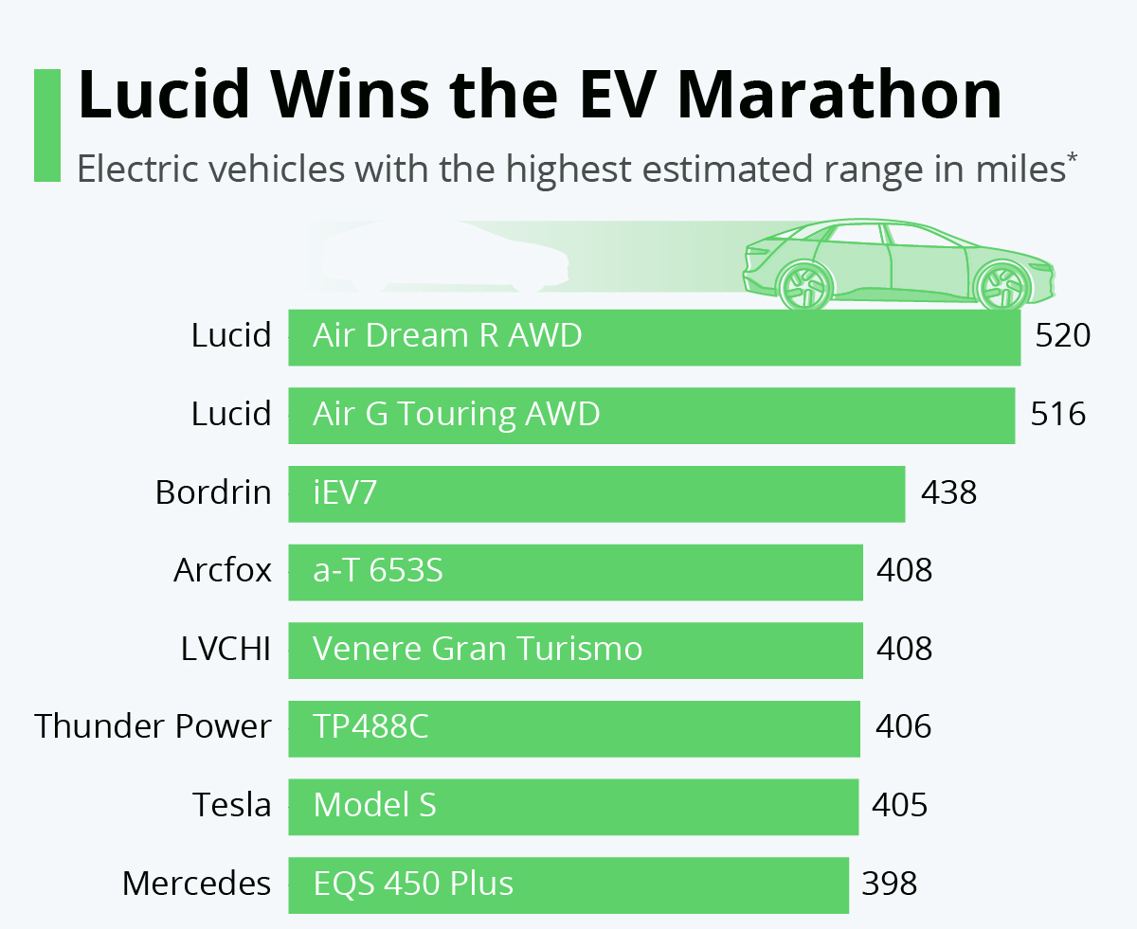
Figure 1: Lucid Wins the EV Marathon
Source: (Zandt, 2022)
The electric vehicles that have the largest range of 520 miles are the Lucid Air Dream R AWD and Air G Touring AWD, respectively. Bordrin iEV7 and Tesla Model S are also among the top EVs at the moment.
Cost Optimization with Efficient Production: Lucid does not aim at massive global growth, but rather, it prioritizes efficient centralized production. Such managed expansion reduces the operational expenses and capital risks in unpredictable economic times.
Example: In 2023-2024, Lucid was marketing the Lucid Air with a focus on better performance at an affordable cost, attracting buyers who want Tesla-like innovation, with luxurious style (Liu, Boothman and Graham, 2025).

2.3 Strategic Responses to Political Actors
Pioneers’ Strategic Responses (Tesla)
Tesla has been successful due to political environments. Strategic marketing and policy engagement helps the company to align with the goals of the government and impact industry policies.
Lobbying and Policy Advocacy: Tesla lobbying and policy advocacy Tesla is an active participant in lobbying the policymakers in support of renewable energy incentives and EV-friendly policies. This proactive strategy aids the brand to influence the political environment to its favor, making the electric mobility supported in the long term (Sai Dhiresh Kilari, 2025).
Global Expansion Aligned with Political Incentives: Tesla is an investor in areas that have subsidies and trade conducive policies. According to Tesla, how it presents its vehicles as remedies to environmental and energy problems means that it makes its image consistent with political agendas centered on sustainability.
Corporate Social Responsibility (CSR) and Image Building: Tesla marketing incorporates the idea of CSR, with the focus on sustainability, carbon neutrality, and clean energy. This alignment makes it stronger in the eyes of government and consumers making it to be a leader in responsible innovation.
Example: Tesla had strategically opened its Gigafactories in Germany and China to enjoy government subsidies, tax incentives and domestic EV policies, which supported its production effectiveness as well as corporate branding (Reuters, 2024).
Followers’ Strategic Responses (Lucid Motors)
Lucid Motors being a follower is the one that reacts to the political element by organizing themselves to abide by the regular rules and use the government policies to facilitate the penetration of the market and brand recognition.
Compliance and Regulatory Alignment: Lucid will ensure complete adherence to environmental and safety rules and regulations which it will use as a marketing strategy to earn consumer confidence (Sypko, 2022). It is not bound to regulatory threats because it is practicing best practices that have been adopted by innovators such as Tesla.
Leveraging Policy-Driven Market Demand: Lucid also enters markets with existing positive regulatory policies and incentives on EVs, which reduces the uncertainty in politics. It takes advantage of the current policies without having to spend money lobbying by promoting its cars as compliant and environmentally friendly.
Building Government Partnerships: The firm is aiming at collaborating with state and federal governments to facilitate the adoption of EVs (Simon, 2019). The clean transport programs also improve brand awareness and reliability by the consumers and policymakers when there are partnerships.
Example: Lucid leveraged federal tax credits to EV buyers in the United States and state-based sustainability incentives to align its product introductions with positive political environments to push consumers to adopt it (Garsten, 2025).

2.4 Marketing Strategies Supporting Competitive Response
Product Strategy
Innovation-based product marketing is applied to Tesla, as it constantly improves battery performance, software updates and autonomous features to be at the head. The variousiation marketing used by Lucid Motors is based on luxury design, interior, and superior driving range (Qadir et al., 2024). Through its product refinement through the market experience of pioneers, Lucid establishes the market appeal to a premium niche market.
Pricing Strategy
Tesla uses the pricing strategy of value based because of its brand prestige and innovation in technology (Hu et al., 2023). Lucid uses competitive pricing where its luxury cars cost a little more than the top models of Tesla.
Promotional Strategy
Tesla incorporates direct marketing and online interaction based on social media, brand promotion, and the strength of the CEO (the persona of Elon Musk) to create organic marketing without advertising. Lucid Motors concentrates on experience marketing by arranging special test drives, web builders, and digital advertisements to emphasize on performance and craftsmanship (Sharma, Ud Din and Ogunleye, 2024).
Distribution and Market Expansion Strategy
The internationalization approach of Tesla will involve company-operated showrooms and e-commerce sales designs to promote brand control and standard customer experience. Lucid chooses a selective distribution model with a concentration in flagship stores in the large cities to increase the exclusivity.
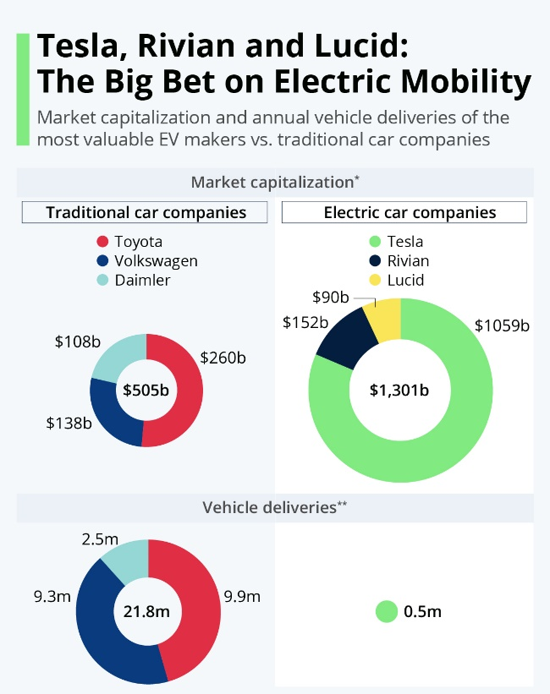
Figure 2: Tesla and Lucid: The Big Bet on Electric Mobility
Source: (Richter, 2021)
By November 16, 2021, the market capitalization of traditional automakers Toyota, Volkswagen and Daimler was 505 billion delivering 21.8 million vehicles. Conversely, Tesla, Rivian, and Lucid are EV manufacturers with a larger market cap of over 1,301 billion, yet sold only 0.5 million vehicles, which shows how much the market values them compared to scale of production

References
Arribas-Ibar, M., Nylund, P. and Brem, A. (2021). The Risk of Dissolution of Sustainable Innovation Ecosystems in Times of Crisis: The Electric Vehicle during the COVID-19 Pandemic. Sustainability, 13(3), p.1319. doi:https://doi.org/10.3390/su13031319.
Cornell (2022). Big Market Delusion–Electric Vehicles. [online] Available at: https://papers.ssrn.com/sol3/papers.cfm?abstract_id=3801052.
Covin, J.G., Slevin, D.P. and Heeley, M.B. (2020). Pioneers and followers. Journal of Business Venturing, 15(2), pp.175–210. doi:https://doi.org/10.1016/s0883-9026(98)00015-9.
Dai, X. and Zhang, H. (2022). The Opportunities and Challenges of Tesla’s Entry into Chinese Market. [online] www.atlantis-press.com. doi:https://doi.org/10.2991/aebmr.k.220405.138.
Garsten, E. (2025). Lucid Motors Bolsters Post-EV Tax Credit Strategy, Launches SUV Abroad. Forbes. [online] 7 Sep. Available at: https://www.forbes.com/sites/edgarsten/2025/09/07/lucid-motors-bolsters-post-ev-tax-credit-strategy-launches-suv-abroad/.
Hahn, C., Hyun, J. and Pyun, J. (2021). Export Market Survival of Pioneers and Followers. [online] Available at: https://www.eria.org/uploads/media/discussion-papers/FY21/Export-Market-Survival-of-Pioneers-and-Followers.pdf [Accessed 17 Oct. 2025].
Hopkins, M. and Lazonick, W. (2024). Tesla as a Global Competitor: Strategic Control in the EV Transition. [online] Ssrn.com. Available at: https://papers.ssrn.com/sol3/papers.cfm?abstract_id=4973602.
Hu, J., Coleman, K., Zhang, D., Lee, E.B., Humam Kadara, Wang, L. and Li, M. (2023). Deciphering tumor ecosystems at super resolution from spatial transcriptomics with TESLA. Cell systems, 14(5), pp.404-417.e4. doi:https://doi.org/10.1016/j.cels.2023.03.008.
Liu, C.C., Boothman, S.G. and Graham, J.D. (2025). The Rise and Recent Decline of Tesla’s Share of the U.S. Electric Vehicle Market. World Electric Vehicle Journal, [online] 16(2), pp.90–90. doi:https://doi.org/10.3390/wevj16020090.
Qadir, S.A., Ahmad, F., Al-Wahedi, A.M.A.B., Iqbal, A. and Ali, A. (2024). Navigating the Complex Realities of Electric Vehicle adoption: a Comprehensive Study of Government strategies, policies, and Incentives. Energy Strategy Reviews, [online] 53(53), pp.101379–101379. Available at: https://www.sciencedirect.com/science/article/pii/S2211467X24000865.
Reuters (2024). Tesla gets green light from German authorities for first stage of plant expansion. [online] Reuters. Available at: https://www.reuters.com/business/autos-transportation/tesla-gets-green-light-german-authorities-first-stage-plant-expansion-2024-10-15/.
Richter, F. (2021). Infographic: Tesla, Rivian and Lucid: The Big Bet on Electric Mobility. [online] Statista Daily Data. Available at: https://www.statista.com/chart/26205/market-cap-and-deliveries-of-electric-car-makers-vs-traditional-auto-companies/?srsltid=AfmBOorUPqnuKUjPSa5LCE2fEb-dEPK0MdXeSRjFhumz0-pfRtVL-Bj5 [Accessed 22 Oct. 2025].
Sai Dhiresh Kilari (2025). The Impact of Advanced Manufacturing on the Efficiency and Scalability of Electric Vehicle Production. The Impact of Advanced Manufacturing on the Efficiency and Scalability of Electric Vehicle Production. [online] doi:https://doi.org/10.2139/ssrn.5162007.
Sharma, H., Ud Din, F. and Ogunleye, B. (2024). Electric Vehicle Sentiment Analysis Using Large Language Models. Analytics, 3(4), pp.425–438. doi:https://doi.org/10.3390/analytics3040023.
Siew, T., Hui, N. and Rebecca, Y. (2024). A Study of the Emerging Electric Vehicle (EV) Supply Chain in Malaysia. [online] Available at: https://www.iseas.edu.sg/wp-content/uploads/2024/04/ISEAS_Perspective_2024_33.pdf.
Simon, K.B. (2019). Lucid Motors secures US$ 1 Bn Investment . [online] Available at: https://www.researchgate.net/publication/328214483_Lucid_Motors_secures_US_1_Bn_Investment_from_Saudi_Arabia.
Sypko, D. (2022). Time-Based Competition in Tesla´s Supply Chain in the Era of Industry 4.0. Theseus.fi. [online] Available at: https://www.theseus.fi/handle/10024/752197.
Vainio, M. (2024). DIFFERENCES IN ELECTRIC VEHICLE START-UP COMPANY FUNDING MODELS AND ITS EFFECT TO LOCATION OF COMPANY ESTABLISHMENT. [online] Available at: https://lutpub.lut.fi/bitstream/handle/10024/167917/diplomityo_vainio_mikko.pdf?sequence=1.
Wen, J. (2022). Is Rivian the Next Tesla? [online] www.atlantis-press.com. doi:https://doi.org/10.2991/aebmr.k.220307.453.
Wurzel, R.K.W., Liefferink, D. and Torney, D. (2019). Pioneers, leaders and followers in multilevel and polycentric climate governance. Environmental Politics, 28(1), pp.1–21. doi:https://doi.org/10.1080/09644016.2019.1522033.
Zandt, F. (2022). Infographic: Lucid Wins the EV Marathon. [online] Statista Daily Data. Available at: https://www.statista.com/chart/27112/electric-vehicles-with-the-highest-estimated-range-in-miles/?srsltid=AfmBOorBWHFwFnQVaDA9_fdWQ-jg6CnQTYaAsZ7Vk0C6roeIbEl28BhB [Accessed 22 Oct. 2025].

