

Student Name: Mohammed Shahin
Student IDNo: 1605776
ModuleName: Employability
LecturerName: Mary March

Introduction
The term employability refers to the capability of finding and retaining employment. Employability development aims at making someone employable having skills, knowledge, abilities and also the experience that an employers want the employees to have(Henry, 2012). This assignment is based on employability. It will be developed with the three different tasks. The first task will have purpose of a job description and a person specification within recruitment and selection process while the second task with be developed with a CV that will demonstrate the understanding of importance of skills and knowledge for working effectively. And the last task will contain statement on problem solving and decision making competencies.
Task 1
Explain the purpose of a job description and a person specification within recruitment and selection process
The term recruitment refers to the process of searching for and obtaining potential candidates for a job with desired knowledge, skills and experiences that allow an organization to select the appropriate candidates from a range of candidates for specific a job to fill the vacancies(Henry, 2012). And the selection refers to the process of choosing the right people for the right job who can fill the required requirements of the job to fill the vacancy(Taylor, 2010). Within the recruitment and selection processes, there are several purposes of a job description and a person specification as the following.
Purposes of Job Description
A job description is considered to be the informative documentation that contains the tasks, scope, duties, responsibilities and also the working conditions which are related to the available job listing of an organization through job analysis process (Storey, 2007). Job description possesses several purposes within the recruitment and selection process.
- The job descriptions are essential for the recruitment and selection process that helps the employers and the employees to understand the roles of the job.
- It is considered to be necessary for all the people in their workplace as it helps the in defining the roles and accountabilities of persons on their workplace.
- An organization can improve its stability by using job description as the job descriptions are used to clarify the expectations of the employers from the employees.
- It also provides the basis for the measurement of job performance
- It clarifies the roles of the job in order that the candidates can know about it.
- It helps the organization to structure the pay and the grading systems in more fair and logic ways.
- If there is any possibility of dispute of employer and employees then it provides the reference guides to them along with providing the reference guide for the issues related to the disciplines within the organization.
- It also provides the guideline for the training and the development of the employees after their recruitment.
- It also helps the organization in respect of performance review, counseling and appraisals after the recruitment and selection of employees are completed.
Purposes of person specification
The person specification refers to the description of skills, experience, qualifications, knowledge and also other attributes that a candidate for a specific job must have to perform duties of their jobs. It is important toolbox for the recruiters and it allows them to contract with the exact traits they gets desirable in the ideal candidates (Boxall and Purcell, 2011). This toolbox is used for several purposes within recruitment and selection processes.
- It helps in making the interview process easier and more refined.
- The candidates can assess themselves before they apply for the job
- They can understand how they can be fit with the job roles.
- It helps the employers to clarify essential and desirable personal qualifications and helps be explicit in what they want and the candidates match the requirements.
- It allows communicating with the equal opportunities policies within the recruitment and selection culture of an organization.
- It ensures that their assessment on the candidates is done based on their abilities which are related to the role of the specific job.
- In addition, it helps in testing the candidates from the lists of the candidates set out in advance because it helps in removing the prejudice, bias and also personal interest that can be seen problematic at the time of recruiting and selecting candidates for the job.
Thus, a job description and person specifications help in recruitment and selection process to get the right candidate for the right posts.
Task 02
Prepare a CV for a specific job role. Within the CV, you should demonstrate an understanding of the importance of skills and knowledge for working effectively.
From a CV, an overall idea including qualifications can be attained. Now a CV has been prepared in the following for the post of Cafe Manager of the following job.
Top of Form

Bottom of Form

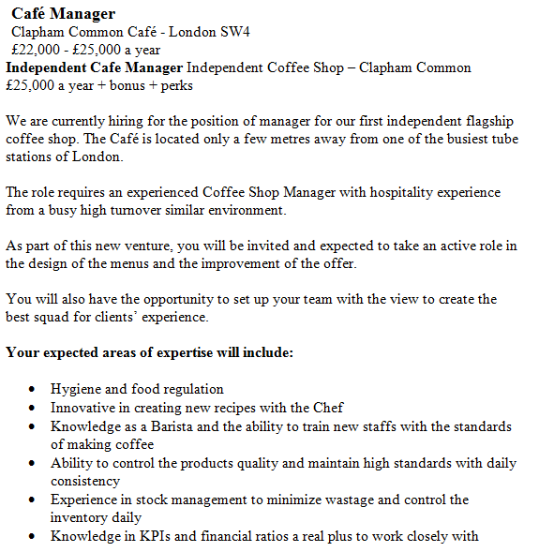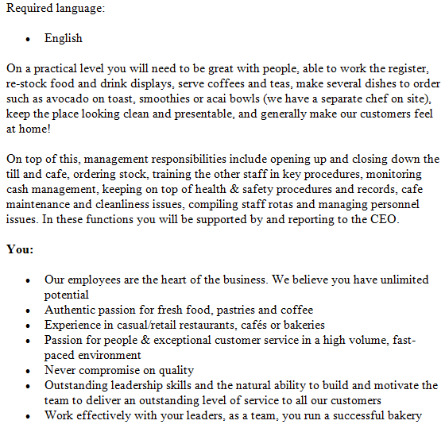

CURRICULUM VITAE
MR ZIAUL HAQUE SHAHIN

Professional Summery
Dedicated Cafe Manager experienced with skillfully working in fast-paced environments while ensuring customer satisfaction. Have profound knowledge in foods items, supply ordering and staff motivation and supervision. Have expertise in efficient hiring procedures and customer appealing food menu creation. Focus on identifying and resolving the issues.
Core Qualifications
- Pricing and ordering procedures of foods
- Hiring, training and motivating staffs
- Setting beverage equipment
- Point of sale system
- Processing payroll
- Communicating at the highly efficient level
Experience
Cafe Manager
April, 2013- Present
Quick Stop Cafe
New Cityland, CA
Duties
- Staffing new employees and training them
- Authorizing and developing promotions and offering weekly discounts
- Arranging of maintenance of in-store machines
- Placing monthly supply orders and processing invoices
- Responding to customer complaints quickly and courteously
Cafe Manager
September, 2011- March, 2013
Dinner’s Delight Café and Deli
New Cityland, CA
Duties
- Preparing orders of purchase and ensuring payment of suppliers
- Arranging staff meeting at the weekend for identifying potential issues
- Ensuring conformant of food with the health codes
- Ensuring the staffs of uniforms and clothing
- Implementing the updated cash control procedures
Educational qualifications
2011, Certification, Food Service Management, Sinclair School of Business, New Cityland, CA
2008, Customer Services and Care, National Vocational Qualification EDEXCEL Level 2
2003, G.C.S.E English and Mathematics, Southend Adult Community College, Southend-on-Sea
1999, R.S.A. Literacy and Information Technology, South East Essex College, Southend-on-Sea
Interest
Football and Customer Service
Reference
Available upon request

Task 03
Writing a statement for problem solving and decision making competencies from personal experience and applying the STAR model
The acronym STAR stands for Situation, Task, Action and Result. I will write a statement for problem solving and decision making competencies from my personal experience and applying the STAR model.
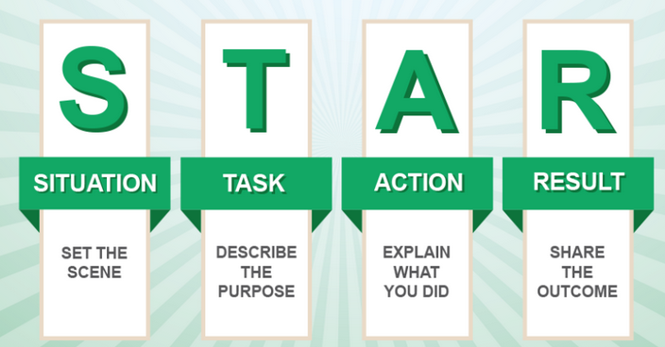
Figure: STAR Model
Source:(Gruman and Saks, 2011)

When I used to work in Dinner’s Delight Café and Deli, Once noticed a problem. It was noticed that the number of customers was decreasing and I solved this problem efficiently.

Situation: During working in the café, I was manager of the café and I fell in a problem that the number of customers was decreasing day by day. I found that it happened because of negligence of employees in the café. They were not providing enough services to customers coming to the cafe.
Task:in that situation, I was supposed to back the previous situation in which the customers were much interested to the cafe and used to come to cafe regularly. I thought how it can be done. I though the staffs are to be motivated.
Action: to solve this problem, I took some steps. I arranged a staff meeting to find out the problems analyzed the problems with them. I tried to motivate them. I provided training to them on care services, rewards based on their performance, extra bonus for higher performance, gave them opportunities for advancement.
Result: after taking these steps, I had been able to make the staff more confident and interested to offer services to the customers as before. Then, the customers started to come to the cafe as before. Mostly, they were satisfied to have services from the cafe. Thus the productivity of the organization rebuilt.

Decision Making
At the time working in the Quick Stop Cafe, I had to made several decisions. Most of them were very much effective. Once some of the employees were performing well despite giving them proper training and so it decided to fire them off from the organization. And so I had to decide on this and it was very much effective.
Situation: some of the employees in the cafe were not performing well in the cafe and though they were given training but they were not able to contribute to the cafe as expected. In this situation, I had to decide fire them off the job.
Task: the main purpose was to replace the worse performing employees with the best performing employees and recover the level of productivity of the organization.
Action: I provided notice to the employees who are to be fired off formally and they resigned the post. Then the post became vacant and I gave advertisement employees online and Newspapers mentioning the required qualities. The eligible candidates applied for the post. An interview was called for the short listed candidates who were seemed to be eligible. Through the interview, the right people for the right post were selected. After that they were given proper training on the responsibilities they should perform.
Result: with this decision, newer employees were so much creative and contributed to the cafe a lot. They could adapt training provided to them easily. So this decision was very much effective.
Conclusion
So the right people for the right post are selected through the recruitment and selection process. Within the recruitment and selection process, the purposes of the job description and person specification are so much important as the job requirements are mentioned in job description and the qualifications of person are mentioned in person specification. Both of these help in finding the right candidate for the right job. Also the CV is so much important because the recruiter can get the overall idea of the candidates having a look over the CV of a candidate. In addition, the candidates must have skills in problem solving and decision making because employee is to sometimes face problem and provide and proper solution and make decisions in several times in the organization.

Bibliography
Aguinis, H., 2009. Performance Management. NJ: Pearson Prentice Hall
Boxall, P. and Purcell, J., 2011. Strategy and Human Resource Management. 3rd ed. Palgrave MacMillan. ISBN: 978-0-230-57935-4
Gruman, J. A. and Saks, A. M., 2011. Performance Management and Employee Engagement. Journal of Human Resource Management Review. Vol. 21(2). Pp. 123-136. Elsevier
Henry, C., 2012. Human Resource Management. London and New York: Routledge. ISBN: 0 7506 0996 X
Kehoe, B. R., 2009. Recruitment and Selection. Journal of the Companion to Strategic Human Resource Management. Taylor & Francis
Storey, J., 2007. Human Resource Management: A critical context. Cengage Learning EMEA
Taylor, S., 2010. Resourcing and Talent Management. 5th ed. London: Charted Institute of Personnel and Development
Taylor, S., 2014. Recruitment and Selection. Journal of Strategic Human Resource Management. Vol. 10(6). Pp. 139-144. Sage

