

LCHS7009
Population Health and Digital Health Promotion
Component 1
2 Blogs

Student Name: Mahir Al Asif Masrur
Student ID: 2436075

Blog 1: Beyond the Prescription Pad: How Mobile Health Apps Are Rewriting the Rules of Type 2 Diabetes Care
The Growing Crisis of Type 2 Diabetes

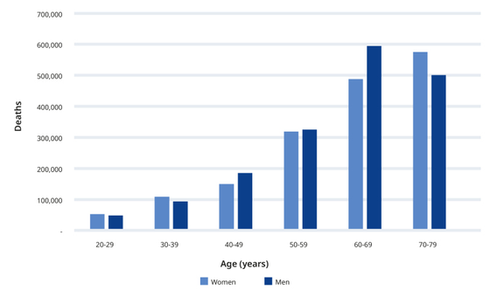

Figure 1: Projected mortality figures attributable to diabetes among people (ages 20–79), categorized by age and gender in 2024 (Magliano, Boyko and Atlas, 2025).
- Diabetes mellitus type 2 (T2DM) is a worldwide epidemic threat to the population. International Diabetes Federation (IDF) estimates that there are 589 million adults with diabetes, which represents approximately 11.1% of the world population, further projected to be 853 million by 2050 (Genitsaridi et al., 2025).
- In 2024, over 3.4 million people succumbed to diabetes-related causes surpassing cumulative expenditure of one trillion US dollars (Magliano, Boyko and Atlas, 2025).
These shocking numbers highlight the need to respond urgently with digital health promotion to T2DM.
Mobile Health Apps in Diabetes Promotion

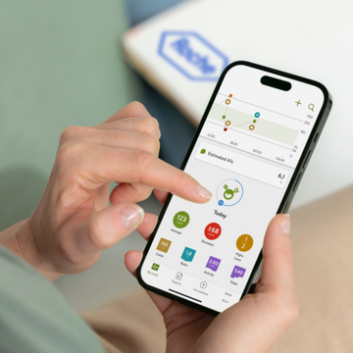

Figure 2: mySugr app (mySugr, 2017).
- Mobile health (mHealth) applications are a popular online type of technology that has been used to manage T2DM self-management. Applications, like mySugr, allow recording blood glucose measurements, food tracking, drug alerts, and feedback. These assist change in behaviour by self-monitoring, goal setting and customised education-strategies that are core in health promotion (Fleming et al., 2019).
- The NHS Digital Diabetes Prevention Programme is also focused on providing behaviour change coaching through apps to people who are at excessive risks of developing T2DM (Miles, Hawkes and French, 2023).
Evidence of Effectiveness
In a systematic review by Gu, Jimma and Mihretie (2025), mHealth intervention resulted in significant HbA1c improvements in fifteen (out of nineteen) studies. Xiao et al. (2025) verified the improvement in the parameters of HbA1c, fasting blood glucose and BMI in home-based patients. NHS Digital DPP recorded a mean weight loss of 4.76 kg with digital completers as compared to face to face of 3.04 kg (Barron et al., 2022).
Advantages and Shortfalls
According to Maharaj et al. (2020), mHealth applications allow scalability, economic viability, and ubiquitous capability without regard to geographic location giving the patient full control with real-time feedback. The level of engagement, however is low, with one trial indicating median use of only 4-6.5 days of the two weeks. Further, there is a low level of electronic health literacy among older adults and with low incomes, which results in their access discrepancies (Nagori et al., 2024). Ethical barrier is also seen through privacy and data security.
Addressing the Shortfalls
- When developing the next apps, gamification, behaviour change strategies and involvement of healthcare professionals should be incorporated in order to maintain engagement (Fleming et al., 2019).
- Multilingual simplified interfaces with cultural sensitivity must be provided to leverage digital inequality among the aged (Kim, Kim and Park, 2024).
- Regulatory frameworks need to advance to make sure that there is clinical validity and protection of data (Alaslawi et al., 2022).

References
Alaslawi, H., Berrou, I., Al Hamid, A., Alhuwail, D. and Aslanpour, Z. (2022). Diabetes Self-management Apps: Systematic Review of Adoption Determinants and Future Research Agenda. JMIR Diabetes, 7(3), p.e28153. doi:https://doi.org/10.2196/28153.
Barron, E., Bradley, D., Safazadeh, S., McGough, B., Bakhai, C., Young, B., Khunti, K., Murray, E., Wareham, N., Jebb, S. and Valabhji, J. (2022). Effectiveness of digital and remote provision of the Healthier You: NHS Diabetes Prevention Programme during the COVID ‐19 pandemic. Diabetic Medicine, 40(5). doi:https://doi.org/10.1111/dme.15028.
Fleming, G.A., Petrie, J.R., Bergenstal, R.M., Holl, R.W., Peters, A.L. and Heinemann, L. (2019). Diabetes digital app technology: Benefits, challenges, and recommendations. A consensus report by the european association for the study of diabetes (EASD) and the american diabetes association (ADA) diabetes technology working group. Diabetes Care, [online] 43(1), pp.250–260. doi:https://doi.org/10.2337/dci19-0062.
Gu, L., Jimma, B.L. and Mihretie, T.B. (2025). The effects of mobile health on self-management of patients with diabetes: A systematic review. PubMed, [online] 11, p.20552076251382049-20552076251382049. doi:https://doi.org/10.1177/20552076251382049.
Irini Genitsaridi, Paraskevi Salpea, Salim, A., Seyedeh Forough Sajjadi, Tomic, D., James, S., Sathish Thirunavukkarasu, Ayuba Issaka, Chen, L., Basit, A., Andrea, Ma, R.C.W., Mbanya, J.C., Ramachandran, A., Wild, S., Duncan, B.B., Boyko, E.J. and Magliano, D.J. (2025). Idf Diabetes Atlas: Global, Regional and National Diabetes Prevalence Estimates for 2024 and Projections for 2050. [online] doi:https://doi.org/10.2139/ssrn.5327047.
Kim, M., Kim, B. and Park, S. (2024). Social Support, eHealth Literacy, and mHealth Use in Older Adults With Diabetes: Moderated Mediating Effect of the Perceived Importance of App Design. Computers, informatics, nursing: CIN, [online] 42(2), pp.136–143. doi:https://doi.org/10.1097/CIN.0000000000001081.
Magliano, D.J., Boyko, E.J. and Atlas, D. (2025). 3. The global picture of diabetes. [online] Nih.gov. Available at: https://www.ncbi.nlm.nih.gov/books/NBK618744/.
Maharaj, A., Lim, D., Murphy, R. and Serlachius, A. (2020). The Challenges of Engaging Users with Diabetes Apps: A Randomised Controlled Feasibility Study Comparing two Commercially Available Diabetes Apps (Preprint). JMIR Formative Research, 5(6). doi:https://doi.org/10.2196/25151.
Miles, L.M., Hawkes, R.E. and French, D.P. (2023). Description of the nationally implemented National Health Service digital diabetes prevention programme and rationale for its development: mixed methods study. BMC Health Services Research, 23(1). doi:https://doi.org/10.1186/s12913-023-09210-3.
mySugr (2017). Welcome to mySugr - simplifying life with diabetes. [online] Mysugr.com. Available at: https://www.mysugr.com/en/home.
Nagori, A., Keshvani, N., Patel, L., Dhruve, R. and Sumarsono, A. (2024). Electronic health Literacy gaps among adults with diabetes in the United States: Role of socioeconomic and demographic factors. Preventive Medicine Reports, [online] 47, p.102895. doi:https://doi.org/10.1016/j.pmedr.2024.102895.
Xiao, Y., Wang, Z., Zhang, L., Xie, N., Chen, F., Song, Z. and Zhao, S. (2024). Effectiveness of digital diabetes management technology on blood glucose in patients with type 2 diabetes at home: Meta-Analysis (Preprint). Journal of Medical Internet Research. doi:https://doi.org/10.2196/66441.

Blog 2: GlucoCoach AI: Your 24/7 Digital Companion in the Fight Against Type 2 Diabetes
The Persistent Burden of Type 2 Diabetes

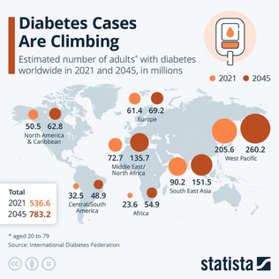

Figure 3: Diabetes statistics worldwide (Statista, 2026).
- Type 2 diabetes mellitus (T2DM) has a significant impact on the human population: It is estimated to have prevalence of 589 million adults, and the number is expected to rise to 853 million by 2050 (Irini Genitsaridi et al., 2025).
- 75% of the victims reside in low- and middle-income countries in which self-strengthening resources are minimal (UW Medicine, 2025).
- Continuous health literacy disparities and lack of cultural responsiveness of current digital resources should be addressed by innovative approaches (Nagori et al., 2024).
Introducing GlucoCoach AI

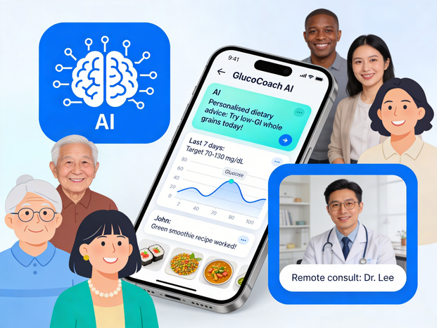

Figure 4: GlucoCoach AI (Self-made).
GlucoCoach AI is a proposed mobile application, which combines artificial intelligence and culturally-focused health promotion of T2DM self-management. Overcoming flaws of existing apps, it includes a personalised dietary and exercise coaching AI chatbot, culturally customized meal plans with regional food databases, automated motivation nudges based on the Transtheoretical Model, and a peer-support community which is moderated by professionals.
How GlucoCoach AI Promotes Health
The app provides health promotion by offering real-time personalised feedback on blood glucose patterns, which makes it possible to engage in self-monitoring- the most common behaviour change technique used in digital interventions. The AI algorithms detect the readiness of the user to change and customize its content, which reflects TTM-based strategies, which have proved effective in web-based health interventions. Here elevated-intensity human interaction yields better results is addressed through integrated professional coaching (Duong et al., 2025). The social motivation reinforced by peer-support features is in line with Ottawa Charter concepts of community action.
Advantages and Shortfalls
GlucoCoach is a personalised AI that makes it more relevant than generic apps, multilingual that minimises digital inequalities, and integrating adopted by professionals, which makes it more clinical credible (Alaslawi et al., 2022). Nevertheless, AI recommendations must undergo serious clinical testing in order to avoid inaccuracies (Guan et al., 2023). However, Kim, Kim and Park (2024) suggest digital divide is an obstacle with the aged possibly having problem with adoption. Both of the algorithmic transparency and the data privacy require cautious governance (Fleming et al., 2019).
Addressing the Shortfalls
- The co-designing process of GlucoCoach AI should involve older adults and various communities. Prior to implementation, randomised controlled trials are indispensable (Murray et al., 2016).
- The collaboration with the national health systems, following the example of the NHS Digital DDP, may guarantee equal access (Miles, Hawkes and French, 2023).
- Clear AI governance structures should be put in place to ensure there is trust and adherence.

References
Alaslawi, H., Berrou, I., Al Hamid, A., Alhuwail, D. and Aslanpour, Z. (2022). Diabetes Self-management Apps: Systematic Review of Adoption Determinants and Future Research Agenda. JMIR Diabetes, 7(3), p.e28153. doi:https://doi.org/10.2196/28153.
Duong, T., Olsen, Q., Menon, A., Woods, L., Wang, W., Marlien Varnfield, Jiang, L. and Sullivan, C. (2025). Digital Health Interventions to Prevent Type 2 Diabetes Mellitus: Systematic Review. Journal of Medical Internet Research, 27, pp.e67507–e67507. doi:https://doi.org/10.2196/67507.
Fleming, G.A., Petrie, J.R., Bergenstal, R.M., Holl, R.W., Peters, A.L. and Heinemann, L. (2019). Diabetes digital app technology: Benefits, challenges, and recommendations. A consensus report by the european association for the study of diabetes (EASD) and the american diabetes association (ADA) diabetes technology working group. Diabetes Care, [online] 43(1), pp.250–260. doi:https://doi.org/10.2337/dci19-0062.
Guan, Z., Li, H., Liu, R., Cai, C., Liu, Y., Li, J., Wang, X., Huang, S., Wu, L., Liú, D., Yu, S., Wang, Z., Jia, S., Hou, X., Yang, X., Jia, W. and Sheng, B. (2023). Artificial intelligence in diabetes management: Advancements, opportunities, and challenges. Cell Reports Medicine, 4(10), pp.101213–101213. doi:https://doi.org/10.1016/j.xcrm.2023.101213.
Irini Genitsaridi, Paraskevi Salpea, Salim, A., Seyedeh Forough Sajjadi, Tomic, D., James, S., Sathish Thirunavukkarasu, Ayuba Issaka, Chen, L., Basit, A., Andrea, Ma, R.C.W., Mbanya, J.C., Ramachandran, A., Wild, S., Duncan, B.B., Boyko, E.J. and Magliano, D.J. (2025). Idf Diabetes Atlas: Global, Regional and National Diabetes Prevalence Estimates for 2024 and Projections for 2050. [online] doi:https://doi.org/10.2139/ssrn.5327047.
Kim, M., Kim, B. and Park, S. (2024). Social Support, eHealth Literacy, and mHealth Use in Older Adults With Diabetes: Moderated Mediating Effect of the Perceived Importance of App Design. Computers, informatics, nursing: CIN, [online] 42(2), pp.136–143. doi:https://doi.org/10.1097/CIN.0000000000001081.
Miles, L.M., Hawkes, R.E. and French, D.P. (2023). Description of the nationally implemented National Health Service digital diabetes prevention programme and rationale for its development: mixed methods study. BMC Health Services Research, 23(1). doi:https://doi.org/10.1186/s12913-023-09210-3.
Murray, E., Hekler, E.B., Andersson, G., Collins, L.M., Doherty, A., Hollis, C., Rivera, D.E., West, R. and Wyatt, J.C. (2016). Evaluating digital health interventions: key questions and approaches. American journal of preventive medicine, [online] 51(5), pp.843–851. doi:https://doi.org/10.1016/j.amepre.2016.06.008.
Nagori, A., Keshvani, N., Patel, L., Dhruve, R. and Sumarsono, A. (2024). Electronic health Literacy gaps among adults with diabetes in the United States: Role of socioeconomic and demographic factors. Preventive Medicine Reports, [online] 47, p.102895. doi:https://doi.org/10.1016/j.pmedr.2024.102895.
Statista (2026). Diabetes Cases Are Climbing Estimated number of adults’ with diabetes worldwide in 2021 and 2045, in millions. [online] Facebook.com. Available at: https://www.facebook.com/Statista.Inc/posts/according-to-the-international-diabetes-federation-537-million-people-between-th/888723156798388/.
UW Medicine (2025). Over 250 million people worldwide unaware they have diabetes | Department of Medicine News. [online] Uw.edu. Available at: https://mednews.uw.edu/news/2025-IDF-diabetes-atlas.

