BMIH4002

Assignment 2

Student ID: 2225725
Student Name: Ribon Khan
Lecturer Jaliya De Silva
Word Count 355

Part 1: Restaurant Concept

Restaurant concept: Fine dining is a high-end restaurant concept recognized for its excellent service, fresh ingredients, and innovative recipes. Hotel Trinity's new restaurant concept is fine dining because of its target population and goal to offer a luxury dining experience. This paper discusses fine dining's appeal, target audience, and menu selections (Walker, 2021).
Why Fine Dining: The Hotel Trinity restaurant concept chose fine dining for various reasons. First, a 4-star hotel like Hotel Trinity attracts guests seeking high-quality food and service. This audience enjoys fine dining's luxury and unforgettable experience. Fine dining's attention to detail and high-quality ingredients match Hotel Trinity's brand and reputation (Gheribi, 2017).
Target Audience: Hotel Trinity's new fine dining restaurant concept targets rich people prepared to pay more for great food and service. Business travelers, tourists, and residents seeking high-end eating are examples. The restaurant will offer refined service and a luxurious atmosphere (Lepkowska-White, 2017).
Menu options: The new fine dining restaurant at Hotel Trinity will feature modern European cuisine made with local and seasonal ingredients. The menu will feature classic and unique cuisine for a wonderful meal (Walker, 2021).
Appetizers: Seared foie grass with brioche and fig jam and scallop ceviche with citrus and avocado are appetizers. These gorgeous, tasty dishes will set the tone for the meal.
Entrees include roasted venison with blackberry reduction and seared halibut with beurre blanc and caviar. These classic and contemporary cuisines use high-quality ingredients to produce rich, savory dinners.
Desserts: The dessert menu includes chocolate truffle cake with raspberry sorbet and vanilla panna cotta with mixed fruit compote. These gorgeous, tasty sweets use fresh, seasonal ingredients.
Hotel Trinity's new restaurant concept is fine dining to give its target demographic a luxury dining experience. The menu will highlight modern European cuisine using locally sourced and seasonal ingredients to produce gorgeous and delectable dishes. The restaurant will offer refined service and a luxurious atmosphere.
Our target demographic, upmarket business and leisure visitors, enjoys great dining on our menu. The restaurant serves modern French cuisine on its menu (Bradshaw, 2015). To satisfy a variety of tastes, we serve starters, mains, and desserts.

Part 2: Menu Design
Our menu prices are competitive and reflect our high-end dining experience. Vegetarian and gluten-free choices are available. To follow health and wellness trends, we also considered the dishes' nutritional composition.
Food and beverage selection:
The fine dining restaurant serves high-quality, visually beautiful cuisine produced with fresh, locally sourced ingredients. For a great meal, the foods are meticulously prepared and presented (Zou, 2023).
The restaurant's seared scallops, beetroot carpaccio, and foie grass parfait starters showcase its high-quality ingredients and complex flavors. Lamb rump and venison loin are perfectly cooked and served with complementary sides for a complete feast. The restaurant's lemon tart and chocolate fondant are delicious and beautiful, displaying its quality and attention to detail (Kim & Eves, 2016).
The restaurant's drinks match its concept. Wines from around the world are selected to complement the dish. The cocktail menu features classic and new cocktails to give clients a wonderful drinking experience.
The fine dining restaurant's menu emphasizes quality, refinement, and detail, creating a remarkable dining experience.
Pricing strategy:
The menu pricing plan was based on ingredients, expected food cost percentage, and competitor pricing. We also assessed the restaurant's target audience's willingness to pay for excellent dining.
Our menu prices reflect the fact that our target demographic values quality, elegance, and a great dining experience. We had to make sure our products were affordable for most of our target demographic (Marlowe, 2019).
Thus, we set our prices competitively with other fine dining restaurants in the vicinity while making the menu accessible to a wide spectrum of clients. This pricing strategy balances high quality and affordability for our target demographic (Koval & et. al., 2021)
Nutrition and special dietary considerations:
We included options for vegetarian, gluten-free, and lactose-free customers when preparing the menu. Current health and wellness trends include people adopting special diets for allergies, intolerance, or ethical reasons.
Wild Mushroom Risotto with truffle oil and parmesan cheese is a popular vegetarian dish that is healthful and nourishing. Vegetarians can enjoy a fresh and healthy Beetroot Carpaccio with goat cheese, honey, and walnuts.
We offered low-carb, gluten-free Pan-Seared Salmon with cauliflower puree and roasted veggies. Almond flour with coconut oil crust Lemon and Lime Tarts are gluten-free desserts (Jennings & Sloan, 2018).
Grilled Sirloin Steak with sautéed spinach and roasted sweet potato is a protein-packed, tasty lactose-free choice. A coconut milk-based Dark Chocolate Mousse is lactose-free (The Staff of Entrepreneur Media, 2023).
In conclusion, by including specific dietary requirements in our menu, we hope to appeal to a wider audience and make dining at our restaurant enjoyable for everyone. We also want to attract health-conscious diners and keep our fine dining status by following health and wellness trends (Mathews & Stokes, 2021).

Starters
Trinity Restaurant
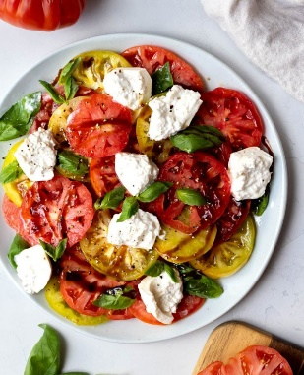
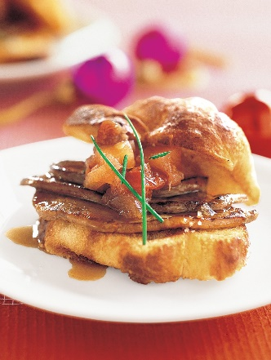
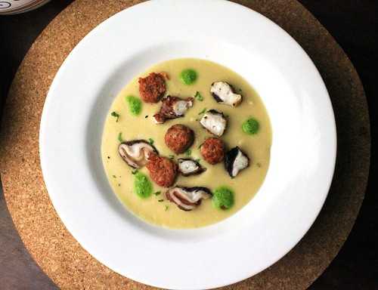
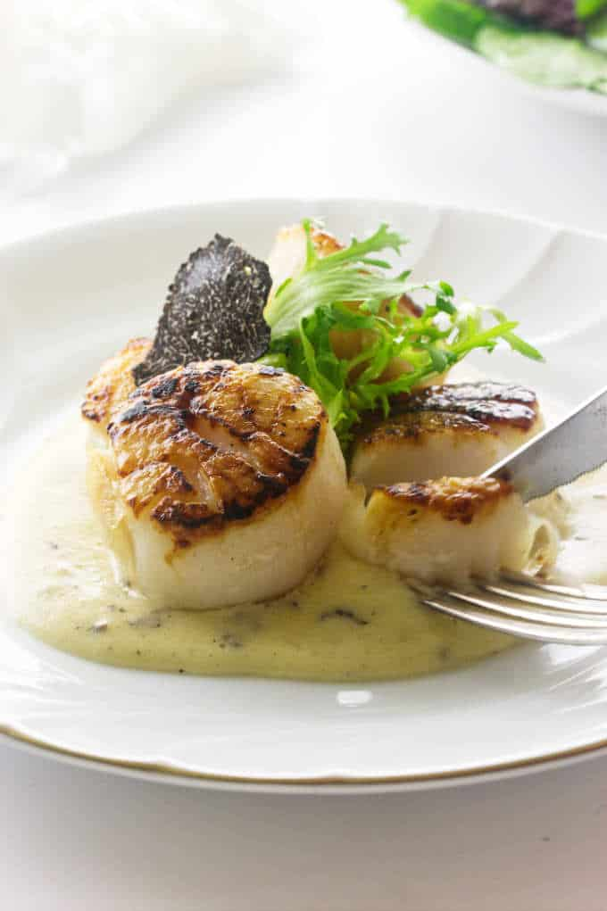
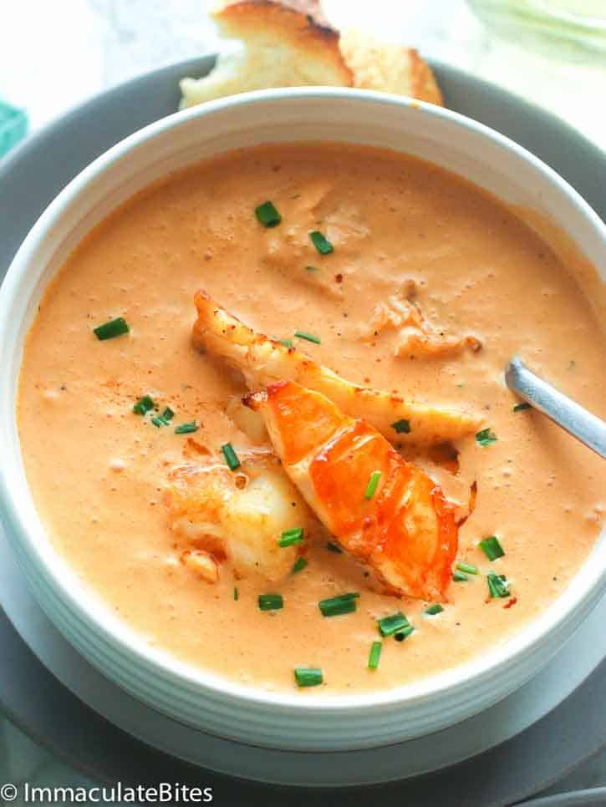
Foie Gras Torchon made with the finest duck liver, accompanied by a spiced apple chutney featuring a medley of aromatic spices,
Seared Scallops with Black Truffle Sauce, £16.00
Lobster bisque prepared with succulent lobster meat, enriched with the warm notes of cognac, and garnished with a dollop of tangy crème fraiche.
Tender scallops seared with garlic butter and herbs, served with a rich black truffle sauce infused with Alba truffles and aged balsamic vinegar.
Seared Scallops with Black Truffle Sauce, £16.00
Seared Scallops with Black Truffle Sauce, £16.00

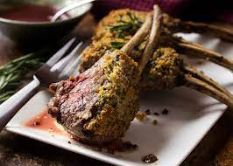
Grilled Octopus with Chorizo and Chickpea Purée - £15.00
Herb-Crusted Rack of Lamb with Rosemary Jus- £34.00
Burrata with Heirloom Tomatoes and Basil Pesto-£13.00

Creamy burrito cheese accompanied by ripe heirloom tomatoes and a fragrant basil pesto. The burrito is made with fresh cow's milk, while the heirloom tomatoes showcase their unique varieties and flavors.
Tender rack of lamb coated with a savory herb crust and served with a flavorful rosemary jus. The herb crust is prepared using a blend of fresh herbs such as rosemary, thyme, and parsley, combined with breadcrumbs
Grilled octopus accompanied by chorizo, a flavorful sausage infused with paprika, garlic, and other aromatic spices.

Desserts
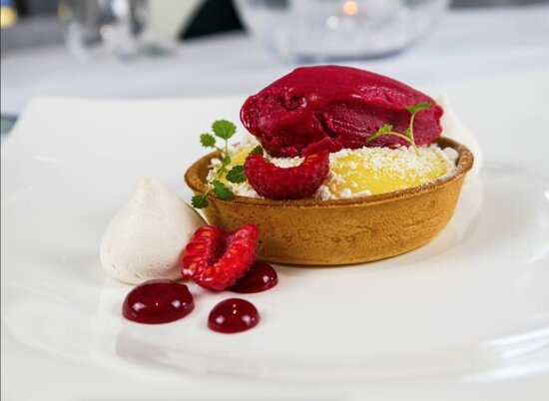
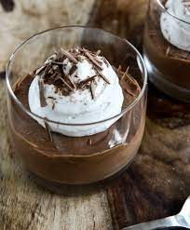
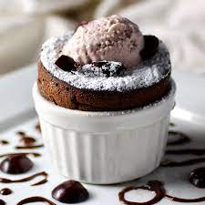

Dark Chocolate Mousse made with coconut milk- £15.00

The mousse is created by melting dark chocolate and combining it with coconut milk, allowing it to set into a smooth and velvety texture.

Chocolate soufflé accompanied by a luscious vanilla cream. The chocolate soufflé is made using dark chocolate, eggs, sugar, and a touch of butter.
Chocolate Soufflé with Vanilla Cream -£12.00

Lemon Tart with Raspberry Sorbet - £11.00

Lemon tart served with refreshing raspberry sorbet. The lemon tart is crafted with a buttery pastry crust and a tangy lemon filling made from fresh lemon juice, eggs, and sugar.
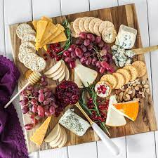

Cheese Board with Quince Paste and Artisan Crackers - £15.00
A curated selection of cheeses accompanied by quince paste and artisan crackers. The cheese board features a variety of artisanal cheeses, which can include options such as Brie, Camembert, Gouda, or blue cheese. Quince paste, made from quince fruit and sugar, adds a sweet and slightly tart element. Artisan crackers provide a crispy and neutral base to enjoy the cheese and quince paste.
Crème brulée garnished with fresh berries. The crème brulée consists of a creamy custard base made from egg yolks, cream, sugar, and vanilla extract. It is then baked and chilled until set. The fresh berries, such as strawberries, raspberries, or blueberries, are served alongside as a vibrant and juicy accompaniment.
Crème Brulé with Fresh Berries - £10.00

Beverages

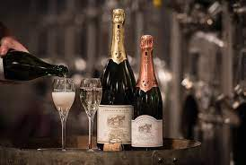
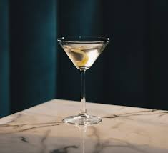


The exquisite Hotel Trinity Signature Cocktail is a tantalizing blend of fine spirits and carefully selected ingredients. This sophisticated libation combines the smoothness of premium vodka with the brightness of freshly squeezed citrus juices. A touch of elderflower liqueur adds a delicate floral note, while a hint of bitters provides a subtle complexity.
French Champagne - £60.00
Hotel Trinity Signature Cocktail - £12.00

French Champagne is a sparkling wine that originates from the Champagne region in France. It is typically made using a blend of Chardonnay, Pinot Noir, and Pinot Meunier grapes. The specific ingredients may vary depending on the Champagne producer and the particular cuvée.

References
Bradshaw, A. (2015). The modern French menu: adapting to today's customers. Restaurant Business, 114(9), 54-59.
Davis, B., Lockwood, A., Pantelidis, I. and Alcott, P., 2013. Food and beverage management. Routledge.
Gheribi, E., 2017. Innovation strategies in restaurant business. Econ. Organ. Enterp, 11, pp.125-135.
Jennings, L., & Sloan, S. (2018). Health and wellness trends: what you need to know. Restaurant Business, 117(6), 76-80.
Kim, Y. K., & Eves, A. (2016). The influence of menu design on customers' perceptions of a restaurant. International Journal of Hospitality Management, 52, 131-138.
Koval, L., Turski, I., Kolomiiets, O., Komarnitskyi, I. and Chaika, T., 2021. New Opportunities for Restaurant Business Development Based on Computer Modeling of Consumer Preferences. Studies of Applied Economics, 39(3).
Lepkowska-White, E., 2017. Exploring the challenges of incorporating social media marketing strategies in the restaurant business. Journal of Internet Commerce, 16(3), pp.323-342.
Marlowe, S. (2019). Menu pricing strategies for restaurants. Retrieved from https://www.thebalancesmb.com/menu-pricing-strategies-for-restaurants-2888747.
Mathews, A., Patten, E.V. and Stokes, N., 2021. Foodservice management educators’ perspectives on nutrition and menu planning in student-operated restaurants. Journal of Nutrition Education and Behavior, 53(3), pp.223-231.
The Staff of Entrepreneur Media, Inc. (2023) How to open a restaurant step by Step (2023), Entrepreneur. Available at: https://www.entrepreneur.com/starting-a-business/how-to-start-a-restaurant/73384 (Accessed: 03 June 2023).
Walker, J.R., 2021. The restaurant: from concept to operation. John Wiley & Sons.
Zou, N. (2023) Do’s and don’ts for your restaurant’s grand opening, TouchBistro. Available at: https://www.touchbistro.com/blog/dos-and-donts-for-your-restaurant-s-grand-opening/ (Accessed: 05 June 2023).

