
Module Name: Academic Skills in the Digital Era
Module Code: BMSW4013
Assessment 1: E-Portfolio
Student Name: Hibah Harb
Student Number:2511464
Lecturer: Scott James
Deadline: Friday 21st November 23:59PM

AI Acknowledgement
Examples of statements If you have not used AI.
I confirm that I have not presented any AI generated materials as my own work.
I confirm that I have copies of my drafts, notes, and other resources I used, which I may be asked to provide in evidence.
Examples of AI statements if you have used AI.
Example 1:
I acknowledge the use of Grammarly and Quillbot (https://www.grammarly.com/) (Paraphrasing Tool - QuillBot AI) on Date to check my work using the prompt(s):
1. Please check the following text for readability, grammar, and syntax.
I confirm that I have not presented any AI generated text as my own work. I confirm that I have copies of my drafts, notes, and other resources I used before, and after the use of AI tools which I may be asked to provide in evidence.
Example 2:
I acknowledge the use of SciSpace (https://typeset.io/) on 7 March 2024 to support my research using the prompt(s):
1. Please provide me with materials on Dadang Mulyana (2023) called “Educational Management Innovation:
2. Please provide me with materials of Challenges and Opportunities in the Digital Era,” published in Jurnal Info Sains: Informatika dan Sains.

I confirm that I have presented some AI generated text for referencing and also I confirm that I have copies of my drafts, notes, and other resources I used before, and after the use of AI tools which I may be asked to provide in evidence.
Example 3:
I acknowledge the use of ChatGPT (https://chatgpt.com/) on 04 November 2025 to write my notes into submission format using the prompt(s):
1. Please write up these bullet points as an essay paragraph at university level.
I confirm that I have not presented any AI generated text as my own work. I confirm that I have copies of my drafts, notes, and other resources I used before, and after the use of AI tools which I may be asked to provide in evidence.
*You must provide an AI statement
Screenshot of proof and also have my own draft

Contents
Component 1 – Research and Planning Template 4
Source Exploration 4
Key Challenge for Students 4
Key Opportunity for Students 4
Planning Your Report 4
Timeline for Component 2 4
Component 2 – Answering the Question 5
Introduction 5
Challenges Students Face 5
Opportunities Digital Tools Provide 5
How Students Can Adapt 5
Conclusion 5
Component 3 – Reflective Presentation 6
Slide 1 (Overview) 6
Slide 2 (Research) 6
Slide 3 (Planning & Writing) 6
Slide 4 (Challenges) 6
Slide 5 (Successes) 6
Reference List 7

Component 1 – Research and Planning Template

Source Exploration
Choose one source and answer the following.
The selected source is an article by Dadang Mulyana (2023) called “Educational Management Innovation: Challenges and Opportunities in the Digital Era,” published in Jurnal Info Sains: Informatika dan Sains.
In this source, the author explores how digital technologies are reshaping educational management and emphasizes the need for both students and educators to adapt to these shifts. The article sheds light on the role of digital tools like Learning Management Systems (LMS), online collaboration platforms, and gamified learning environments in enhancing modern education.
The author has chosen this source because it’s up-to-date, trustworthy, and closely tied to my research question regarding the challenges and opportunities that students encounter in the digital age. Mulyana points out the hurdles students face, such as unequal access to technology and varying levels of digital literacy, while also highlighting the potential for greater learning engagement and the development of digital skills.

Key Challenge for Students
One of the biggest advantages that digital tools bring to students is the chance to tap into a vast array of learning resources whenever and wherever they want. As Mulyana (2023) points out, technologies like online learning platforms, virtual libraries, and Learning Management Systems (LMS) empower students to study on their own and dive deeper into various subjects.
These tools offer a level of flexibility that allows learners to go over materials at their own speed and revisit lessons whenever they feel the need. Plus, this access fosters collaboration through online discussions and group projects, enabling students to exchange knowledge and hone their communication skills. I really appreciate this opportunity because it promotes self-directed learning and cultivates lifelong learning habits—skills that are crucial in our fast-paced world today.
Digital tools give students the power to take charge of their education and gear up for future careers that require adaptability and tech-savviness.

Key Opportunity for Students
Flexible access to educational resources at any time and from any location is one of the main advantages that digital tools provide to students, students can study at their own speed and review material as needed thanks to digital resources including learning management system, online libraries, and video tutorials.
Mulyana (2023) believes that this flexibility fosters self-organised learning and aids pupils in engaging in ownership of their own development.
For instance, instead of waiting for the next lesson, student can access the online tutorials or watch class recordings if they are confused about a subject. This is a wonderful opportunity because it lets me learn in a way that works for my schedule and learning preferences. I may revisit whatever I missed in class online. this helps me to develop abilities like self-management and academic confidence whiles making learning feel more accessible and less stressful.

Planning Your Report
I will be giving both challenges and opportunities equal attention; this is because comprehending difficulties clarifies the need for digital modification. opportunities also demonstrate the benefits of digital learning. A fair and comprehensive conversation will result from balancing both perspectives. it also lends support to my primary query of how pupils might thrive and adapt.
Yes, I will use instances from Mulyana's paper from 2023. For example, I will discuss Learning Management Systems (LMS) such as Moodle or Google Classroom. Additionally, I will discuss online collaboration tools like Zoom and Microsoft Teams. These resources demonstrate how students communicate and obtain information online. I might also talk about my personal use of these resources in the classroom.

I will begin with an introduction outlining my primary query. After that, I will write a section on the main difficulties that pupils encounter in the digital age. I will then go over a significant opportunity that digital tools offer. I will then offer tips on how kids can adjust and thrive. I will conclude by outlining my key points.

Timeline for Component 2
Task | Date/ Deadline
Finish research | 14/10/2025
Draft first section | 1/11/2025
Complete first draft | 11/11/2025
Final editing | 21/11/2025

Component 2 – Answering the Question

Introduction
Technology is now a crucial component of education in the digital age. These days, students study through digital tools, virtual collaboration, and online platforms. Although these tools can increase the flexibility and interactivity of learning, they also present students with recent problems and expectations. This study examines the potential and difficulties that students have when using digital learning resources. Knowing these elements is crucial because it demonstrates how students may adjust and acquire the abilities required to thrive in a contemporary, technologically advanced learning environment.

Challenges Students Face
When using digital tools for learning, students encounter a number of difficulties. One significant issue is that certain students find it more difficult to fully participate due to unequal access to dependable gadgets and the internet. Developing digital literacy abilities, such as managing digital tasks and navigating online sites, is another difficulty. Strong self-discipline and time management are also necessary for online study, which many students find difficult. If assistance is not given, these difficulties may lead to stress and make learning more challenging.

Opportunities Digital Tools Provide
Although there are obstacles, digital tools also give pupils worthwhile chances. They give pupils access to a variety of educational resources that they can review at any time and from any location. By enabling students to collaborate online and exchange ideas, digital platforms facilitate communication. Additionally, students can learn at their own speed using personalised digital learning. Learning may become more adaptable, interesting, and skill-focused with these options.

How Students Can Adapt
By acquiring essential digital and self-management skills, students can adjust to digital learning. To start, kids might constantly practise using online platforms to get more proficiency using digital technologies. To maintain organisation and prevent distractions, students might also make study schedules. Seeking assistance from instructors, fellow students, or online guides can also enhance comprehension. Students can overcome obstacles and fully utilise digital learning opportunities by developing certain habits.

Conclusion
In summary, our study has shown that adopting digital tools for learning presents both substantial obstacles and worthwhile potential for students in the digital age. The difficulties include disparities in digital literacy abilities, unequal access to devices and reliable internet, and the problem of staying motivated and organized in online learning environments. If these difficulties are not acknowledged and assisted, they may become obstacles to achievement. But there are also a lot of opportunities in the digital age. Students may collaborate more effectively with classmates and teachers online, access a greater variety of learning resources, and learn at their own speed. With the use of digital tools, students can acquire critical skills that will be useful for their future education and careers.

Students can take concrete actions to successfully adjust. By investigating platforms, posing queries, and practicing frequently, individuals can first actively engage on enhancing their digital skills. Second, to stay focused and control distractions, students can make a basic study timetable or habit. Third, when they face difficulties, they can turn to support systems including classmates, professors, and internet resources. Because technology will continue to change and influence how work and learning are conducted, it is critical to be well-adapted to digital tools.
In conclusion, I believe that mastering digital tools is a life skill that will help students develop, communicate, and prosper in the future. It is not just about academic accomplishment.

Component 3 – Reflective Presentation
**Copy and paste your PowerPoint slides below. Start with Slide 1 under the heading ‘Slide 1’. Then do the same for each slide, using the correct slide number as the heading
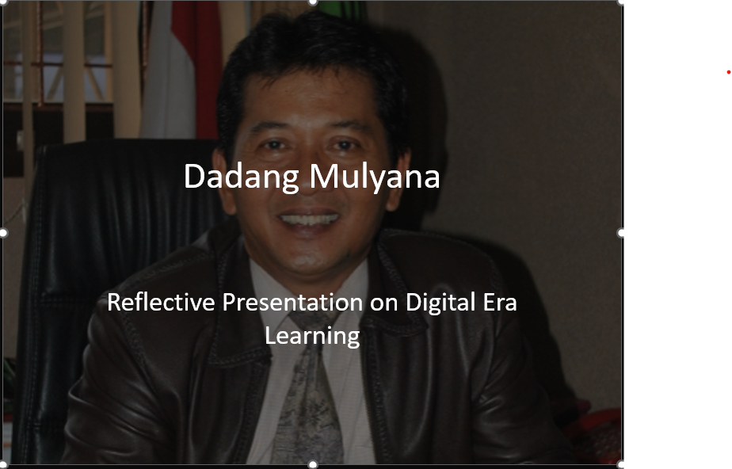
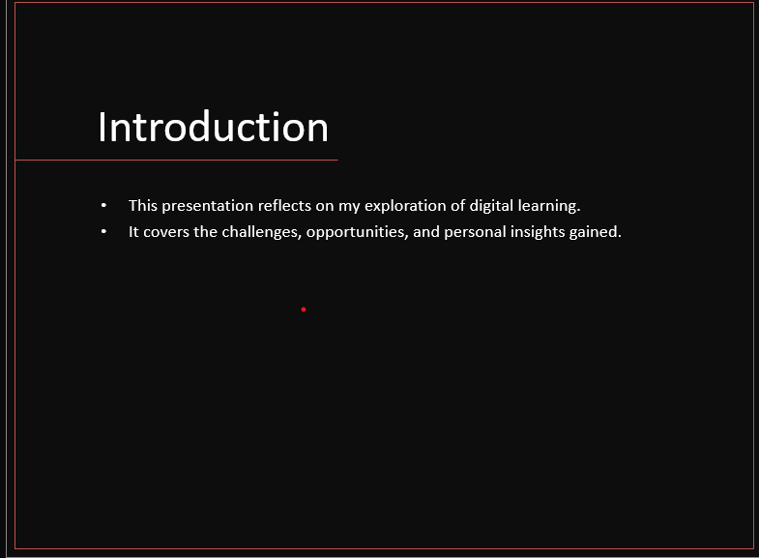
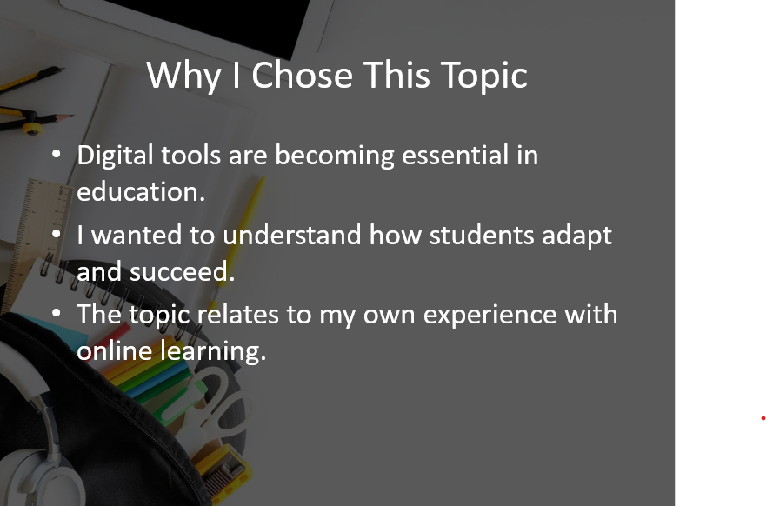
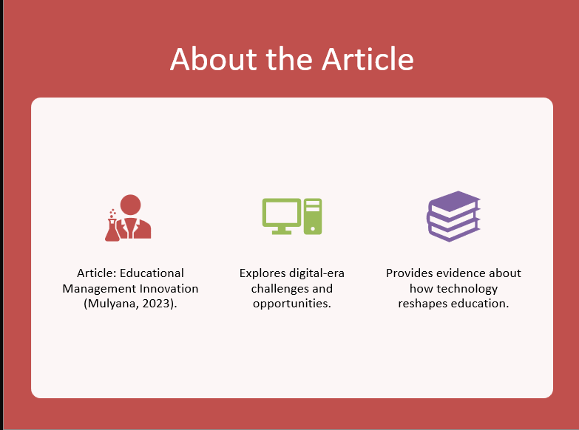

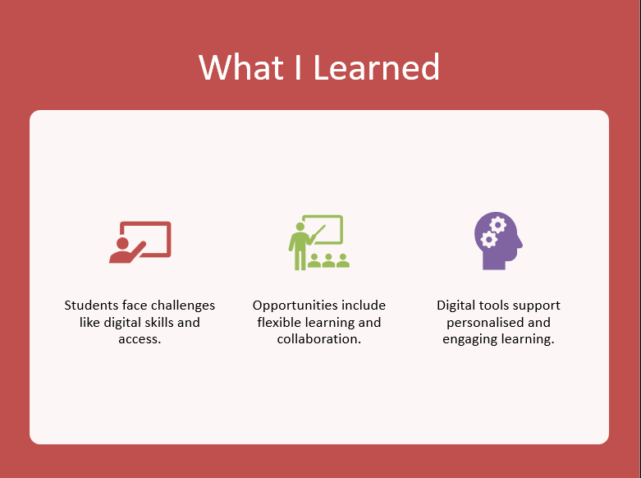
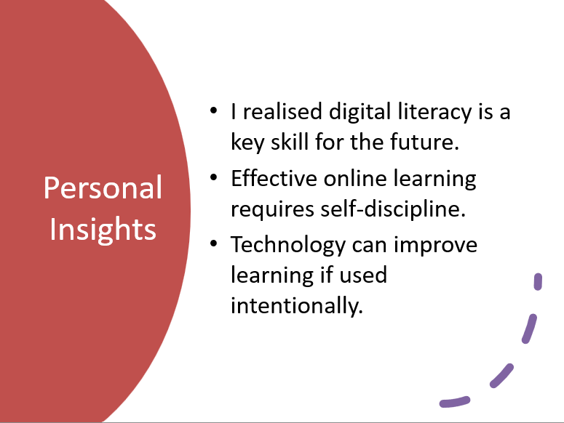
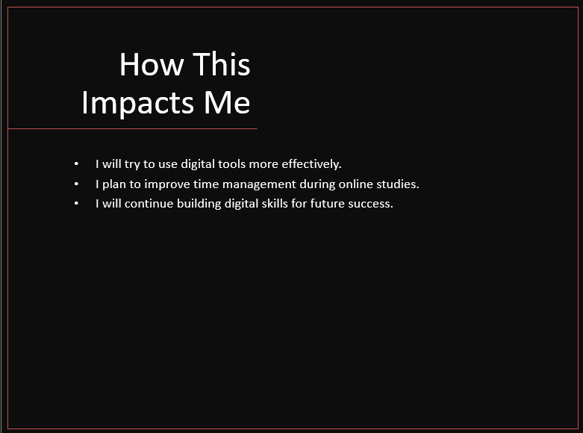
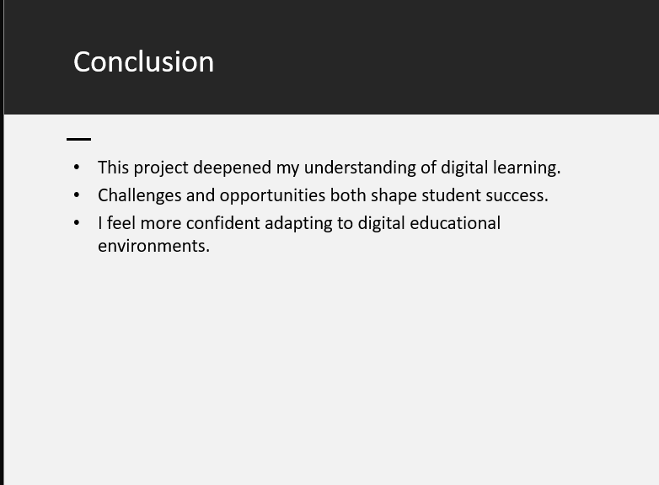

Reference List
**Include ten references, formatted in the Harvard Referencing style. List the references in alphabetical order.

Mulyana, D, (2023), educational management innovation: challenges and opportunities in the digital era. Jurnal Info Sains: informatika dan sains ,13(3),1201-1207: https://ejournal.seaninstitute.or.id/index.php/InfoSains/article/view/4082
https://www.grammarly.com/
Paraphrasing Tool - QuillBot AI
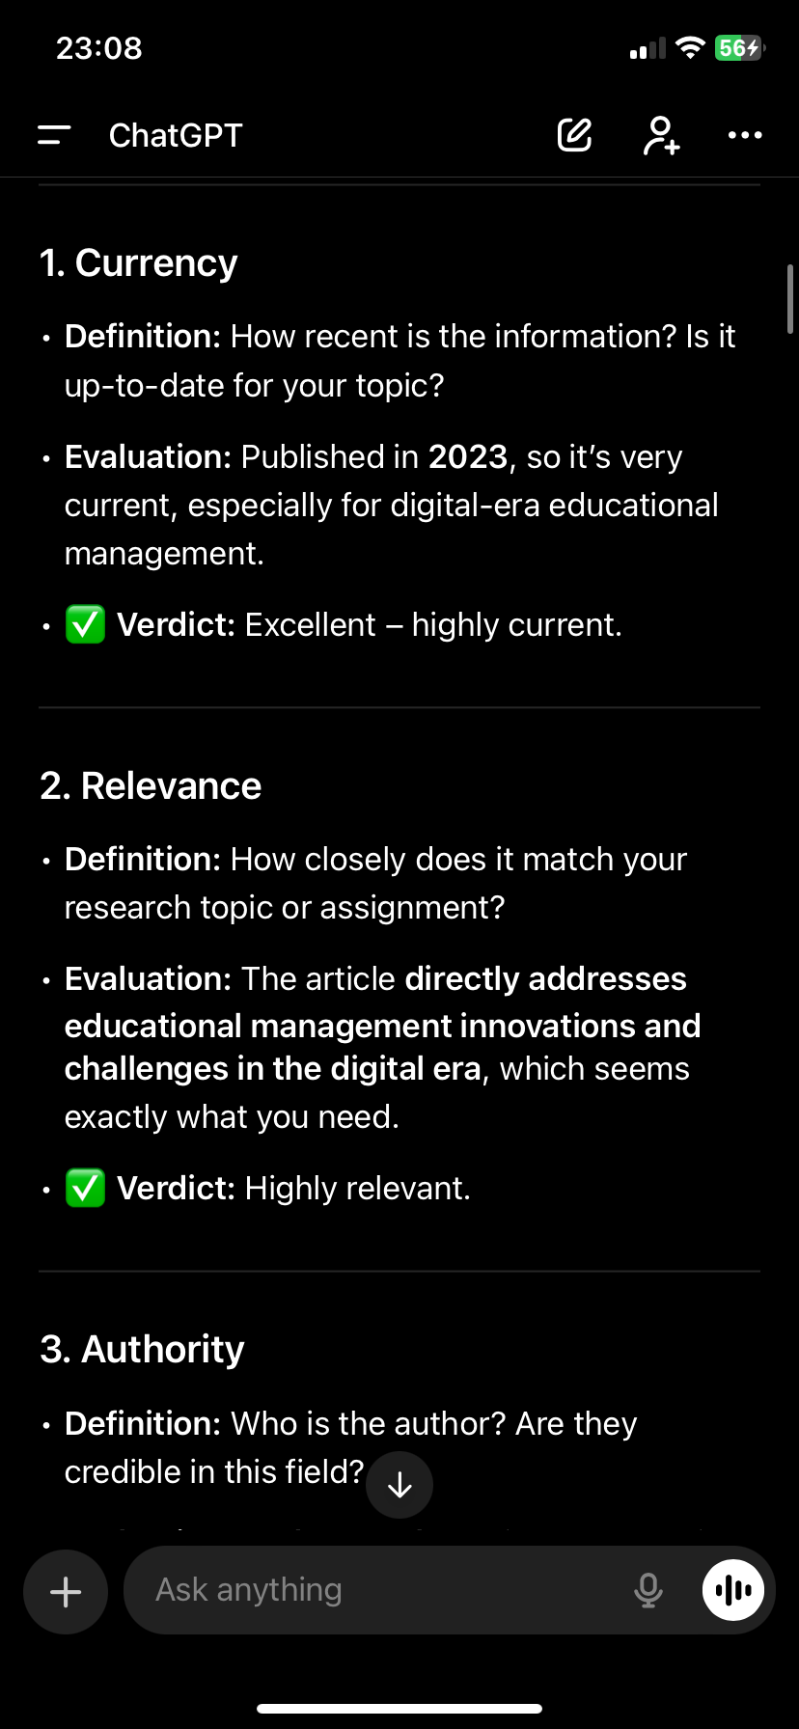
https://chatgpt



