




Reflective portfolio
Reflective portfolio
Module: Professional Career Development
Module code: BMSW4005_BIRM
Student Name: Manuela Ruzic
Student ID: 1911513
Lecturer: Olubukola Adegbite
TABLE OF CONTENT:
INTRODUCTION: 2
1. PERSONAL DEVELOPMENT PLAN FOR FUTURE CAREER: 3
1.1 Future career and its requirement: 3
1.2 Definition of PDP: 4
1.3 My Personal Development Plan: 5
1.4 My skills vs. skill required for chosen career: 6
2. LEARNING STYLES: 7
2.1 What does learning style mean? 8
2.2 Kolb’s learning style: 9
2.3 Honey & Mumford learning style: 11
2.4 VARK learning style: 12
2.5 Choose style for the learning and development of the new hires: 15
3. PERSONAL REFLECTION: 16
3.1 What is self-awareness? 16
3.2. Level of consciousness 16
3.3 Johari window: 17
3.4 Final thoughts: 18
4. REFERENCES: 19

INTRODUCTION:
As final assessment of this module, Personal Career Development, we ware asked to prepare a reflective portfolio and cover these 3 main topics:
1. Create a PDP, evaluate our current skills and compare them with the skills required for the career or job that we would like to apply for.
2. impersonate the role of an Assistant Manager for a company and evaluate the best method that can be used to help new hires to understand what is required from them.
3. reflect about the experience gained during this course explaining the differences that we see in ourselves before and after this module.



1. PERSONAL DEVELOPMENT PLAN FOR FUTURE CAREER:

1.1 Future career and its requirement:
In 2016 I’ve started to work in Amazon as a picker and this year, after almost 4 years, I got a promotion as Team Lead.
My dream would be to progress in my career and become an Area Manager.
After making some researches about the skills and competences needed to become an Area Manager, this are my findings:
An Area Manager is responsible of leading a team (from 80 to 120 associates), and for the team's recruitment and integration, encouragement, and empowerment to drive changes.
He/she works to ensure the wellbeing of the team, being responsible for the health and safety policies inside the company and leading the team to resolve operational issues and observes teams’ progress through a broad range of metrics that will include inventory, efficiency and defect supplied in real time.
The basic qualification required for an area manager are:
Degree in logistic, business administration or related field and previous experience in leading a team, problem solving, critical thinking and communication skills.



1.2 Definition of PDP:
After researching about the requirements needed to become an area manager, the next step is to create my own Personal Development Plan in order to understand what I need to do to be able to achieve my goal.
A PDP is a tool used by high achievers from all walks of life (BridgewaterUK, 2016).
The key idea for a PDP is to strengthen people's abilities to grasp what they are learning, to evaluate, train and take accountability about their own performance.
Personal Development Planning is an organized and managed process carried out by a person that reflects on his/her own learning, performance and/or achievement and that helps to prepare for a personal and professional growth.
This tool can help to understand:
- What are the priorities.
- Why these goals are important in the short or long term.
- The current situation a person is in.
- The abilities, experience or expertise required to move to the next level.
- Training and requirements needed to fulfil these criteria.



1.3 My Personal Development Plan:

CAREER GOAL:
To become an Area Manager in Amazon.

Which goals need to happen first?  Skills gaps? | Timeframe | What obstacles may get in my way? | How to overcome obstacles and keep focused?
Degree in business & management. | 2 years. | - Not getting level 4 in Skills for the Workplace.  - Not having enough time to study. | - Finish and upload my assignments in time.  - Use the time management skills learned at university to prepare an action plan.
Become a PROXY manager at work. | 6 months. | - Not talking to my manager about my plan.  - Not showing interest and initiative at work. | - Ask my manager to help and support me.  - Ask for more responsibilities, prepare and present projects.
Improve IT skills. | 3 months. | - Not finding online course to do.  - Not having enough energy to do it. | - Ask lecturers and colleagues at work for any suggestion and keep looking online.  - Don’t spend time on social media and delegate tasks to family and friends.
Source: High Speed Training, 2020

1.4 My skills vs. skill required for chosen career:
After all my researches about needed skills for the career that I would like to pursued as an Amazon Area Manager and my current skills, I realized that, in order to be successful, the PDP that I’ve prepared will help me by remembering and showing me what I need to do and when I will need to achieve it.
Firs of all, I will need to carry on with my studies and get a degree in Business and Management and to realize this I will need to prepare a time table with my tasks, the one that I will need to delay and the one that I will need to delegate.
Being a Team Lead will help me to understand better the environment in which I am working and to develop my current problem solving and team management skills and I think that talking with my manager and explaining him my plan, will help me to become a proxy manager because I am a person who wants to learn and to take upon myself more responsibilities.
As in regard of the lack of enough IT skills, I will try to find an online course and get a certificate once completed it.
It will not be easy to carry on with my studies and working at the same time, especially because as a Team Lead I have longer schedule and it can be stressful sometimes, but I want to progress in my career and if this means that I will need to make some sacrifices (less time for myself or less time spent with friends and less fun), I am willing to do them because, as Koyenikan (2016), said: “There is no progress or accomplishment without sacrifice”.



2. LEARNING STYLES:
The second part of this assignment consist in explaining the various learning methods and choose the most appropriate for the learning and development of the new hires of a company in which I have to impersonate myself as an Assistant Manager.
I think that, first of all, it is necessary to enlighten what a learning style is and after that categorize and explain the different learning styles and as last part of this section of the assignment, select one of the styles and clarify why I think is the most appropriate for the learning and development of the new hires in the company.


2.1 What does learning style mean?
Learning style is the person’s nature or behavior of collecting and retrieving information during the learning process.
Basically, everybody learns in a different way.
According to Newton (2015), 3 principles influence the perception of a learning style:
1. Human beings will claim that they tend to learn in a certain way: individual opinion based on previous experiences.
2. Everybody is different in how good they can differentiate between various forms of information.
3. Coaching individuals in their ideal/particular learning style can contribute to better learning.



As said before, everybody learns in a different way and understanding the way that each individual learns it is important in order to be successful and avoid to have difficulties during the learning process of something new, as it can be a job or during school life.
There are 3 main learning styles and here below I will try to explain them and after that I will choose the appropriate one for the required task of this section of the assignment.

2.2 Kolb’s learning style:
In 1984, the psychologist David Kolb defined his theory, the Kolb’s learning style, which has become one of the best-known and commonly used theories of learning styles.
Kolb believed that because of our biology, life experiences, and the requirements of our current environment, our individual learning styles occur.
In his philosophy of knowledge, learning is presented as a loop of four phases:
1. As a foundation for observation, there is the experience of the individual.
2. On these assumptions, the individual reflects and starts to develop a general concept of what this knowledge may mean.
3. Centered on his/her theory, the learner forms logical theories and generalizations.
4. The individual measures the results of these principles when in front of new situations.

Kolb’s learning style is defined by two main dimensions:
- Active/reflective.
- Abstract/concrete.
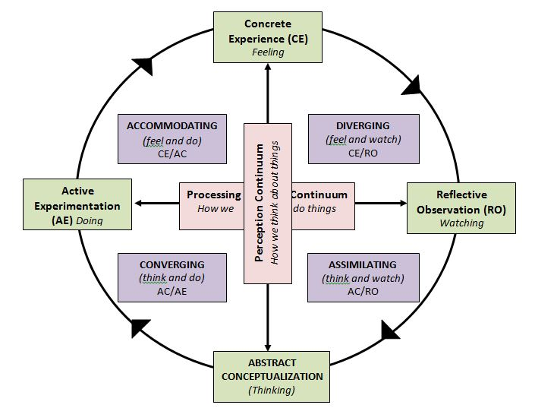

Source: Kolb’s learning theory
CONVERGENT: Individuals with this learning style are very accomplished in the applied use of ideas and they seem to do very well in situations where there is a single correct answer to the problem.
DIVERGENT: Individuals are excellent at seeing the "wider picture" and arranging a coherent whole from little pieces of info. Usually emotional, creative and innovative people.
ASSIMILATOR: One of their biggest strengths is understanding and constructing computational models. They appear to be more comfortable in philosophical concepts than in humans, but the practical applications of theories do not worry them greatly.
ACCOMODATOR: Individuals who love to take risks and are able to change their plans in response to the necessity.
They usually use a trial-and-error approach when meeting problems.

2.3 Honey & Mumford learning style:
This learning style was developed in 1896 by Peter Honey and Alan Mumford, who took the idea from Kolb’s learning style and updated it.
This learning style can be divided in four common learning styles or preferences: activist, theorist, pragmatist and reflector.
ACTIVIST: Individual who invest himself in new interactions completely, without prejudice, he/she learn by doing and tend to act without thinking to the consequences of his/her actions.
THEORIST: Person who examinate the root cause of the problem, using logic and observation.
A theorist is detached and rational rather than subjective and ambiguous.
PRAGMATIST: Individual who positively look out for new methods and ideas and who likes to experiment.
A pragmatist loves to act quickly and takes opportunities and problems as challenges.
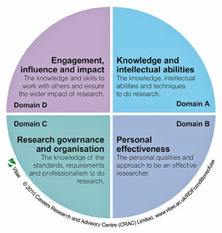
REFLECTOR: Person who prefers to observe before acting, collects information from others and from previous experiences and who is never in the center of the attention.

Source: Honey and Mumford - University of Leicester, 2020

2.4 VARK learning style:
In 1987, Neal Flaming designed the VARK learning style.
Flaming believed that each individual learns in a different way and that these ways can be categorized in four different styles of learning: visual, auditory, reading/writing and kinesthetic.

VISUAL: a visual person will learn by watching and illustrations, charts and videos are the best tools for this category of individuals to assimilate knowledge and information.


AUDITORY: an auditory (or aural) person learns by hearing and listening and have a really good memory.


READING/WRITING: this group of people learn by reading the information and taking notes of the important points.


KINESTHETIC: kinesthetic individuals learn by doing instead of just watching or taking notes.


2.5 Choose style for the learning and development of the new hires:
After researching and evaluating the different learning styles that I’ve described above, I think that the most suitable of them for the learning and development of the new hires of a company is the VARK learning style.
For an Assistant Manager it is important that the learning and development team finds a way in which all the employees, who can be visual, aural, reding/writing or kinesthetic learner, will be able to understand what they need to do.
Flaming’s learning style is conceived with the idea that each individual is different and that he/she learns in a different way and, in a group of new hires not all of them will have the same learning methods so that using this learning style will allow to all of them to understand the requirements for the job that they are about to start.
A few years ago, before becoming a Team Lead, I was an instructor in Amazon and I saw that most of the time, the associates that I had to teach, were understanding in different ways and that is why the methods that I was using to instruct them on what to do, had all four the basics present in the VARK learning style:
- visual: show to the associates the workplace environment and the process that they were supposed to do.
- aural/auditory: explain the process and the steps needed.
- reading/writing: give to the new hires’ papers document with instructions and important info.
- kinesthetic: after showing and explaining, ask individuals to show what they have understood by doing the process.

3. PERSONAL REFLECTION:
During this module, Professional Career Development, I’ve learned a few things and helped me to open my mind about some topics that were not so clear before starting it.
I hate to admit that some of the topics that we’ve talked about, like exploring employment opportunities and how to create a CV for the job that I want to apply for, were not new as I’ve learned about them by myself while preparing for a job interview that I had a few months.
Looking back at this module now, I think that the second week, when we talked about “improving self-awareness” was the most interesting for me because it opened my mind and made me realize that in order to be successful in my life, I have first of all, to start knowing myself, my weaknesses and my strengths.

3.1 What is self-awareness?
Self-awareness is the nature of a person, with his/her strengths, weakness, manners, spiritual faith, feeling, values and believes.
To be able to understand others, it is important, first of all, to know and understand yourself and managing to do this will allow you to have better relationships, not only in business, but in personal life as well.

3.2. Level of consciousness:

Unconsciousness Unable to react on oneself and the world.

Consciousness Paying attention to the environment around.
Self-awareness Focusing on yourself and collecting information about you from others

Meta-self awareness Knowing that you are self-aware.

Various models have been established over the years that can assist with an individual's level of self-awareness.
The most used of these models is the Johari window analysis model.

3.3 Johari window:
The Johari window is a model of self-awareness that was developed by Joe Luft and Harry Ingham.
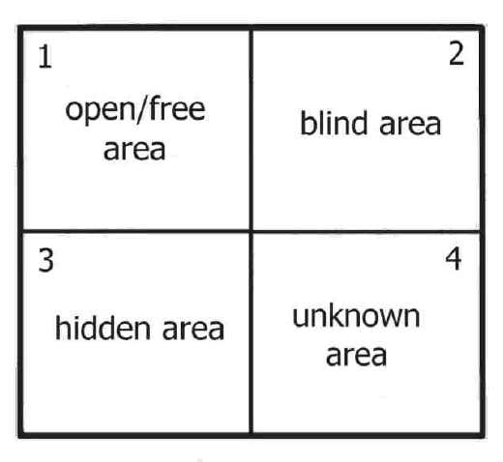
The name of the model was obtained by combining their names: Joe + Harry = Johari.

Source: Johari model (Berg & Feij, 2003)

As it can be seen from the figure above, the Johari window model is divided in 4 windows or sections:
- Open/free area: this area represents the things about us that we and the people around us know about ourselves, our personality and our life.
- Bind area: represents the thing that we do not know about ourselves but that people near to us may know or think to know about us.
- Hidden area: this area includes all those things that we know about ourselves but nobody else does.
- Unknown area: this is the area that nobody knows about us, including ourselves.

3.4 Final thoughts:
I can say that I am self-aware of myself, but I am pretty sure that there still are thing and areas of my personality and behaviors that I still do not know and maybe, will never know.
I think that the Johari window is a really useful tool that can help everybody to understand better himself and that can help to become successful in the personal life and in the career.
About this course, as I said at the start of this section, I’ve learned new things that I did not know about and I’ve refreshed my memory about some other topics.
As an overall, this year of University helped me to develop some very important skills, not only for my career but for myself, as well.

4. REFERENCES:
amazon.jobs. 2020. Area/Shift Manager. [online] Available at: <https://jobs.amazon.co.uk/en-gb/jobs/1349139/area-shift-manager> [Accessed 16 November 2020].
Berg and Feij, 2003. Complex relationship among personality traits, job characteristics, and work behaviors. International Journal of Selection and Assessment.
Cherry, K., 2019. Are You A Visual, Auditory, Reading/Writing, Or Tactile Learner?. [online] Verywell Mind. Available at: <https://www.verywellmind.com/vark-learning-styles-2795156#:~:text=The%20VARK%20model%20of%20learning%20styles%20suggests%20that,grew%20in%20popularity%20in%20the%201970s%20and%201980s.> [Accessed 24 November 2020].
Curly, M., 2012. PDP | Professional Development | Personal Development. [online] Scribd. Available at: <https://www.scribd.com/document/98207944/PDP> [Accessed 16 November 2020].
Definitions.net. 2020. What Does Learning Styles Mean?. [online] Available at: <https://www.definitions.net/definition/learning%20styles#:~:text=Learning%20styles.%20Learning%20style%20is%20an%20individual%27s%20natural,of%20acquiring%20and%20processing%20information%20in%20learning%20situations.> [Accessed 24 November 2020].
Highspeedtraining.co.uk. 2020. [online] Available at: <https://www.highspeedtraining.co.uk/hub/wp-content/uploads/2016/08/personal_development_plan_template.pdf> [Accessed 16 November 2020].
Koyenikan, I., 2016. Wealth For All: Living A Life Of Success At The Edge Of Your Ability. Grandeur Touch, LLC.
Kolb, D., 2015. Experiential Learning: Experience As The Source Of Learning And Development. 2nd ed. Pearson FT Press.
Newton, P., 2015. What Are Learning Styles?. [online] Psychology Today. Available at: <https://www.psychologytoday.com/us/blog/mouse-man/201504/what-are-learning-styles> [Accessed 24 November 2020].
Perera, P., 2017. Self-Awareness And Self Development | Self Awareness | Personal Development. [online] Scribd. Available at: <https://www.scribd.com/document/363428137/Self-Awareness-and-Self-Development> [Accessed 30 November 2020].
Rahman, M., 2016. Learning Styles - Definition And Types Of Learning Styles - Howandwhat. [online] howandwhat. Available at: <https://howandwhat.net/learning-styles-definition-and-types-of-learning-styles/> [Accessed 24 November 2020].
Spruce, H., 2020. Free Personal Development Plan (PDP) Example Template PDF. [online] The Hub | High Speed Training. Available at: <https://www.highspeedtraining.co.uk/hub/personal-development-plan-template/#:~:text=%20Writing%20a%20Personal%20Development%20Plan%20%201,could%20be%20external%20things%20or%20an...%20More%20> [Accessed 16 November 2020].
Www2.le.ac.uk. 2020. Honey And Mumford — University Of Leicester. [online] Available at: <https://www2.le.ac.uk/departments/doctoralcollege/training/eresources/teaching/theories/honey-mumford> [Accessed 24 November 2020].

