Software Development

Sean garrington gar19847608
Table of Contents
1. PART A 3
2. PART B 5
TASK 1 7
TASK 2 10
TASK 3 15
TASK 4 19
Appendices 26

PART A

A1. A variable is a way to store information that can be used in a computer program. They can be given descriptive names depending on what data is assigned to them. This is important because it can store for example, user inputs to be referenced later for a calculation in the program. In C#, there are static variables and dynamic variables, static variables can only be referenced where they are declared. Dynamic variables can be called throughout the whole program. Constant variables cannot be altered throughout the programs runtime, this is useful when using something like a price for an item any other item that should not change through the programs runtime.

A2. An if/else statement is a statement that triggers if a certain variable is true. The else part of the statement triggers if the main part of the if statement is false. An example of when to use an if statement would be as follows

If (userInput<50){
Console.Writeline(“Input is more than 50”)
}else{
Console.WriteLine(“Input is less than 50”)
}

There are many uses for if/else statements from checking the data inputs from the user are correct to putting test results into grade boundaries.
A3. Loops are needed in a program when code is repeated multiple times in a program. This is when a loop is useful because it reduces what could be hundreds of lines of code to just a few lines. One type of loop, a for loop keeps running until the condition of the for loop is met, this is usually a set value for example the number of objects in an array. A while loop on the other hand continues running while for example a certain variable = true.
For loop example
For (int i = 0; i = 8; i++){
Console.WriteLine(“The loop has iterated” + i + “ times.”)
}
This loop iterates 8 times and tells the user whenever it iterates it.
While loop example
While (input <= 0 && >= 5){
Console.WriteLine(“Please enter a number between 0 and 5”)
}

This while loop keeps iterating until the user inputs a valid input, being a number between 0 and 5.

PART B

To see the code for each program, please see the appendix.

TASK 1

(a)
The purpose of this program was to illustrate how different variables can contain types of values. In the program, the user is asked for three different inputs: name, age, and height. Upon successful input of the values, they are output back to the user on-screen.

(b)
Below is a flowchart for the program:
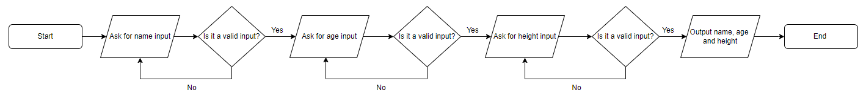

(c)
Test Num. | Details | Data | Expected Outcome | Outcome
1.a | Check typical name input | “Sean” | Accepted – Output asking for the user’s age | 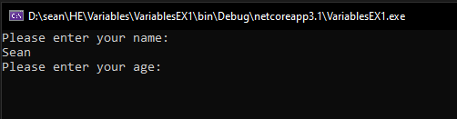  Outcome expected
1.b | Check blank name input | “ ” | Rejected, ask for input again | 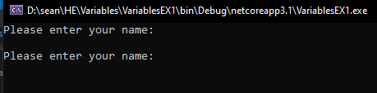  Outcome expected
2.a | Check typical age input | “17” | Accepted – Output asking for the user’s height | 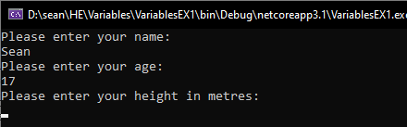  Outcome expected
2.b | Check blank age input | “ ” | Rejected, ask for input again | 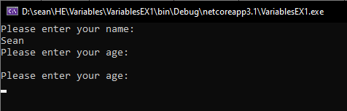  Outcome expected
3.a | Check typical heigh input | “1.6” | Accepted – Outputs all details | 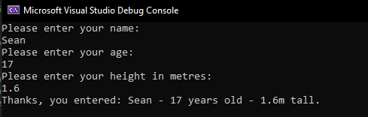  Outcome expected
3.b | Check blank height input | “ ” | Rejected, ask for input again | 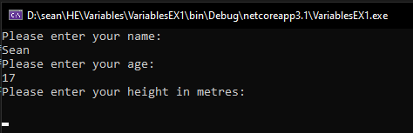  Outcome expected

TASK 2

(a)
The purpose of this program is to calculate the area of a circle, with a square shape and a rectangle shapes area removed from the area of the circle and outputting it back to the user. The inputs taken for this program are, radius the circle, side of the square, and the width and length of the rectangle. Once the inputs are taken in. Some calculations need to be done to complete the program; these are:
For area of circle: Pi * radius^2
For area of square: side * side
For area of rectangle: width * length
For area of the circle with the square and rectangle:
area of circle – area of square – area of rectangle

Once the calculations are complete, the output is given back to the user rounded to one decimal place.

(b)
Below is pseudocode for the program:
radius = 0

output "input circle radius"
if input = number
input = radius
else output "invalid input"

output "input side of square"
if input = number && >radius
input = side
else output "invalid input"

output "input width of rectangle"
if input = number && >radius
input = width
else output "invalid input"

output "input length of rectangle"
if input = number && >radius
input = length
else output "invalid input"

AoS = side * side AoR = length * width
AoC = pi * (radius^2)

area = AoC - AoR - AoS
output "shaded area is " area 1 d.p. " cm."

(c)
Test Num. | Details | Data | Expected Outcome | Outcome
1.a | Normal completion of the program | 10, 3, 4, 2 | Shaded area = 297.2 | 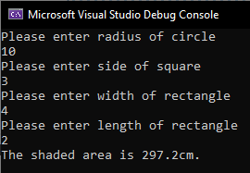  Expected outcome.
1.b | Side of square greater than radius of circle | 10, 21 | Invalid input. Ask for the side of square again. | 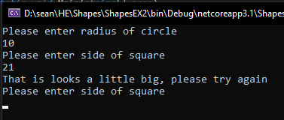  Outcome expected.
1.c | Rectangle width greater than radius of circle | 10, 10, 21 | Invalid input. Ask for the width of rectangle again. | 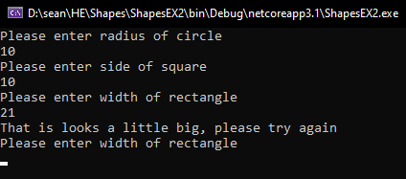  Outcome expected.
1.d | Rectangle length greater than radius of circle | 5, 5, 5, 50 | Invalid input. Ask for the length of rectangle again. | 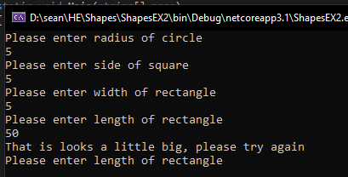  Outcome expected.
2.a | Erroneous inputs | a | Invalid input. Ask for the side of square again. | 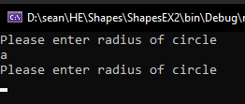  Outcome expected
2.b | Erroneous inputs | -1 | Invalid input. Ask for the side of square again. | 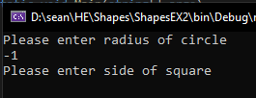  Outcome not expected – Need to add validation for numbers below 0

TASK 3

(a)
The purpose of this program is to track the weekly amount of fuel consumed and then calculate the cost of the petrol for the week using a fixed petrol price. The program takes inputs for fuel for each day of the week, totals it and outputs it back to the user, then calculates the cost of the petrol for the week. The formulae used in this program is:
Total mileage = mileage for each day added to each other
Cost of petrol = mileage/miles to litre * petrol price.
Miles to litre being 11.2 and petrol price being 1.35.

(b)
Below is pseudocode for the program:

array daysOfWeek (Monday, Tuesday, Wednesday, Thursday, Friday, Saturday, Sunday)
petrolPrice = 1.35
milesToLitre = 11.2
mileage = 0
input = 0

for i = daysOfWeek amount

while input = 0

output "enter miles for " i
take user input

if isNumber
add input to mileage
else output "not a valid output, please try again"

input = 0

output "total mileage for the week is " mileage

output "cost of petrol " mileage/milesToLitre * petrolPrice

(c)
Test Num. | Details | Data | Expected Outcome | Outcome
1.a | Successful completion of the program | 45.2, 67, 180.2, 140.6, 110.3, 30, 45 | Mileage = 618.3  Petrol cost = 74.53 | 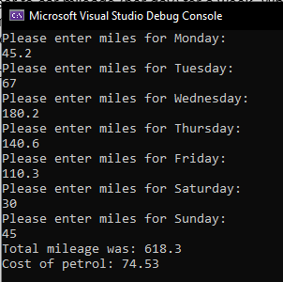  Expected outcome.
1.b | Inputting an erroneous input | a | Ask for the mileage again. | 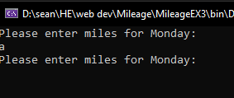  Expected outcome
1.c | Inputting number less than 0 | -50 | Asks for the mileage again. | 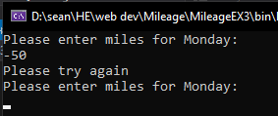  Expected outcome.

TASK 4

(a)
This program is a game of Pairs. The aim of this game is the match up pairs of animals using guess work and memory as you only can only see numbers of each object until you try to match it with another. There are six pairs to match up and these are shown at the start of the program with the numbers 0 to 11 printed at the top and the letters “?”s printed below them to show if they have been matched or not. When the user inputs two numbers that are not the same animal, the program tells the user what animal each guess was making it easier for them to finish the game. When a matching pair is found, when the numbers and the “?”s are printed again, the “?”s below the matched pair will change to “X”s showing the user this is the pair they have found. The program also tells them how many turns they are on. The program only takes two inputs, one for their first guess and one for their second.

(b)

Below is pseudocode for the program:
program class

array animals Cat, Dog, Giraffe, Monkey, Hippo, Helicopter
array num ?,?,?,?,?,?,?,?,?,?,?,?

shuffle board
fillboard(animals)

output "welcome to the pairs game! there are 6 paris to find, here is the board"

matched = 0
turns = 1

while matched < 6

guess1 = 0;
guess2 = 0;

output board

while guess1 and guess2 = 0

ouput "please enter guess 1"
if between 0 and 11 input = guess1
output "please enter guess 2"
if between 0 and 11 input = guess2
guess1A = board getname(guess1)
guess2A = board getname(guess2)

if guess1A = guess2A

output "pair found"
matched++
num(guess1) = X
num(guess2) = X

else guess1A != guess2A

output "not a match position " guess 1 " was " guess1A " and position " guess2 " was " guess2A

output "you've had " turns " turns so far"
if matched <6 turns++

if matched = 6 output "well done, all pairs found in " turns " turns!
board class

arraylist board

method addcard parameter p

board add p
entries ++
board add p
entries ++

method shuffle

var random

for i < 0 i < board length i++

swapIndex = random next within entries
temp = board(swapIndex)
board(swapIndex) = board(i)
board(i) = temp

method fillboard parameter animal

for i = 0 i < animal length i++

addcard animal(i)

(c)
Test Num. | Details | Data | Expected Outcome | Outcome
1.a | Normal completion of the game | Integers between 0-11 until game is complete | Correct number of turns for the amount of turns taken to complete, all pairs found. | 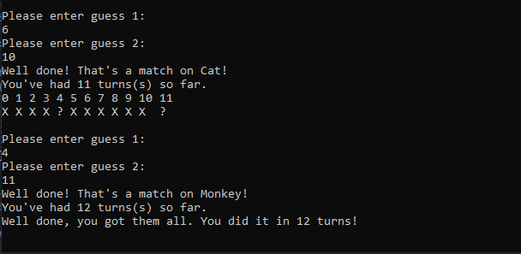  Expected outcome.
1.b | Testing numbers outside of usual inputs | 12 and 13 | Invalid inputs, asks for guesses again. | 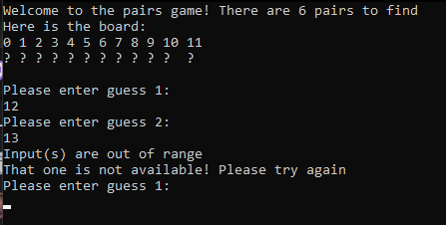  Expected outcome.
1.c | Re-entering a previously matched pair | After finding the first pair 3 and 4 | Inputs already revealed, not available, asks for guesses again. | 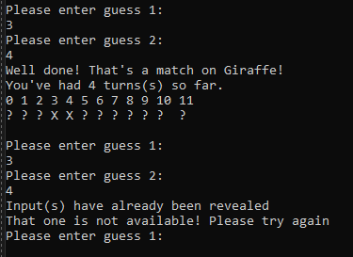  Expected outcome.
1.d | Re-entering one matched number with an unmatched number | 3 and 5 | Input already revealed, not available, asks for guesses again. | 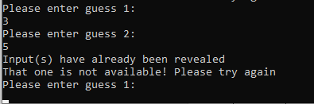  Expected outcome.
1.e | Entering negative numbers | -1 and -2 | Invalid inputs, ask for guesses again. | 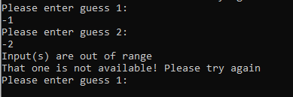  Expected outcome.
2.a | Entering letters | a and b | Invalid inputs, ask for guesses again. | 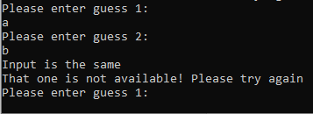  Outcome not expected. Inputs are not the same.
2.b | Blank inputs | Just hitting enter twice | Invalid inputs, ask for guesses again. | 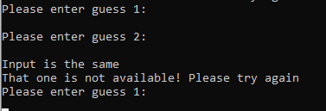  Outcome not expected. Inputs are not the same
2.c | When pair is matched the corresponding “?” characters change to “X”s | 2 and 6 | The 2nd and 6th characters change to “X”s. | 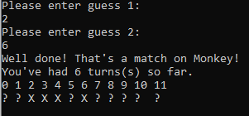  Expected outcome.

Appendices

Exercise 1:
class Program
{
// SEAN GARRINGTON TASK 1

static void Main(string[] args)
{

// valid input for name
string name = "";
while (name == "")
{
Console.WriteLine("Please enter your name:");
name = Console.ReadLine();
}

// Gets valid input for age
bool checkAge = true;
int age = 0;
while (age == 0)
{
Console.WriteLine("Please enter your age:");
checkAge = int.TryParse(Console.ReadLine(), out age);
}

// Gets valid input for height
double height = 0;
while (height == 0)
{
Console.WriteLine("Please enter your height in metres:");
height = double.Parse(Console.ReadLine());
}

// Output
Console.WriteLine($"Thanks, you entered: {name} - {age} years old - {height}m tall.");
}

}
}

Exercise 2:
class Program
{
// Task 2 Sean Garrington
public static double radius = 0;
static void Main(string[] args)
{

// Circle
radius = Input("radius", "circle");

// Square
double side = Input("side", "square");

// Rectangle
double width = Input("width", "rectangle");

double length = Input("length", "rectangle");

// Area circle calculation
double areaCircle = Math.PI * (radius * radius);

// Area rectangle calculation
double areaRectangle = width * length;

// Area square calculation
double areaSquare = side * side;
double shadedArea = areaCircle;

shadedArea = shadedArea - areaRectangle - areaSquare;

Console.WriteLine("The shaded area is " + Math.Round(shadedArea, 1) + "cm.");
}

public static double Input(string name, string shape) // Method that asks for user input and checks that the subsequent inputs for rectangle and square are within the circle's radius.
{
double input = 0;

while (input == 0)
{
Console.WriteLine("Please enter " + name + " of " + shape);
double.TryParse(Console.ReadLine(), out input);

if (name != "radius" && input > radius * 2)
{
Console.WriteLine("That is looks a little big, please try again");
input = 0;
}
}
return input;
}
}

Exercise 3:
class Program
{
// Task 3 Sean Garrington
// Declaring constant variables and array
public static readonly string[] Days = new string[] { "Monday", "Tuesday", "Wednesday", "Thursday", "Friday", "Saturday", "Sunday" };
public const double petrolPrice = 1.35;
public const double milesToLitre = 11.2;

static void Main(string[] args)
{
double mileage = 0;
double input = 0;

for (int i = 0; i < Days.Length; i++)
{
while (input == 0)
{
Console.WriteLine("Please enter miles for " + Days[i] + ":");

if (double.TryParse(Console.ReadLine(), out input))
{
if (input < 0)
{
Console.WriteLine("Please try again");
input = 0;
}
else
{
mileage += input;
}

}
}
input = 0;
}
Console.WriteLine("Total mileage was: " + Math.Round(mileage, 1) );

// Cost of petrol

Console.WriteLine("Cost of petrol: " + Math.Round(mileage / milesToLitre * petrolPrice, 2));
}
}

Exercise 4:

class Program
{
// Task 4 Sean Garrington
public static Board board = new Board();
public static string[] animals = { "Cat", "Dog", "Giraffe", "Monkey", "Hippo", "Helicopter" };
public static char[] num = { '?', '?', '?', '?', '?', '?', '?', '?', '?', '?', '?', '?' };
static void Main(string[] args)
{
board.FillBoard(animals);
board.Shuffle();

Console.WriteLine("Welcome to the pairs game! There are 6 pairs to find \nHere is the board:");

int matched = 0;
int turns = 1;

while (matched < 6) // Game will continue until all 6 pairs are found
{
int guess1 = -1;
int guess2 = -1;
Console.WriteLine(board.ToString(num)); // Prints the board

while (guess1 == -1 && guess2 == -1) // Validation checks
{
Console.WriteLine("Please enter guess 1: ");
int.TryParse(Console.ReadLine(), out guess1);
Console.WriteLine("Please enter guess 2: ");
int.TryParse(Console.ReadLine(), out guess2);

if (Validation(guess1, guess2))
{
Console.WriteLine("That one is not available! Please try again");
guess1 = -1; guess2 = -1;
}
}
// Gets the card name and assigns it to a variable
string guess1Animal = board.GetName(guess1);
string guess2Animal = board.GetName(guess2);

if (guess1Animal == guess2Animal) // Match is found
{
Console.WriteLine("Well done! That's a match on " + guess1Animal + "!");
matched++;
num[guess1] = 'X';
num[guess2] = 'X';
}
else if (guess1Animal != guess2Animal) // Match is not found
{
Console.WriteLine("Not a match. Position " + guess1 + " was " + guess1Animal + " and Position " + guess2 + " was a " + guess2Animal);
}
Console.WriteLine("You've had " + turns + " turns(s) so far.");
if (matched < 6) turns++;
}
Console.WriteLine("Well done, you got them all. You did it in " + turns + " turns!"); // All matches are found
}

private static bool Validation(int guess1, int guess2) // Validating user inputs
{
// Inputs are the same
if (guess1 == guess2)
{
Console.WriteLine("Input is the same");
return true;
}
// Checks inputs are not out of range
else if (guess1 >= 12 || guess1 < 0 || guess2 >= 12 || guess2 < 0)
{
Console.WriteLine("Input(s) are out of range");
return true;
}
// Checks guessses have no been revealed
else if (num[guess1] == 'X' || num[guess2] == 'X')
{
Console.WriteLine("Input(s) have already been revealed");
return true;
}
return false;
}
}

class Board
{
ArrayList board;
int numberOfEntries = 0;

public Board() // Instansiates the board Arraylist
{
board = new ArrayList();
}

private void AddCard(string c) // Adds object to the board arraylist
{
board.Add(c);
numberOfEntries ++;
board.Add(c);
numberOfEntries ++;
}

public void Shuffle() // Shuffles the board
{
Random rand = new Random();

for (int i = 0; i < board.Count; i++)
{
int randomIndexToSwap = rand.Next(numberOfEntries);
string temp = (string)board[randomIndexToSwap];
board[randomIndexToSwap] = board[i];
board[i] = temp;
}
}

public void FillBoard(string[] animal) // Fills the board with objects using the AddCard method
{
for (int i = 0; i < animal.Length; i++)
{
AddCard(animal[i]);
}
}

public string GetName(int input) // Outputs name of the object in the index corresponding to user input
{
return (string)board[input];
}

public string ToString(char[] array) // Outputs the board
{
string boardAsString = "";
for (int i = 0; i < array.Length; i++)
{
boardAsString += i + " ";
}
boardAsString += "\n";
for (int i = 0; i < array.Length; i++)
{
string result = "";
result += array[i] + " ";
if (i > 9) result += " ";
boardAsString += result;
}
return boardAsString + "\n";
}
}

