Hilton Hotel Group. Case study

Module Name: Management and Organisational Behaviour Resit
Module Code: BMIH5004
Student Name: Marina Georgiana Hogea
Student Id: 2131351
Lecturer: Daniel Payne

Executive Summary
The hospitality tourism sector is wide and encompasses avoid range of competitors who are competing for the best place as the hospitality organisation while providing exclusive customer service to maintain a unique approach. The report has delved into understanding the Hilton Hotel Group while analysing the organisation's management and behaviour in leadership and innovation contests. The report has shown the company's strong global presence with a diverse range of portfolios. The customer-centric approach and brand acquisition initiatives of the business have been highlighted in the report to focus on organisational change management initiatives. However, recommendations for focusing on empowering teams for selling, learning, organisation, environment and embracing containment security have been provided for the organisation to access success while creating a competitive age in the dynamic hospitality market.
Table of Contents
Introduction 4
Overview of the Organisation 5
Relationship between the Organisational culture, structure and goals of Hilton Hotel Group 6
Organisational culture 6
Organisational Structure 7
Recent change initiatives of the Organisation 9
Recent changes in Hilton 9
Change management strategies 9
Strategic direction 11
Vision and Mission Analysis 11
Competitive positioning and market strategies 11
Hilton's Long-Term Strategic Goals 12
Recommendations 14
Conclusion 15
References 16

Introduction
Management and organisational behaviour is the study of how individuals, groups and organisations interact and influence each other. This concept plays a vital role for any organisation in any sector helping them to understand their goals while aligning their initiatives with their objectives. The tourism sector encompasses many competitors within which Hilton Hotel Group serves a vital role. The report will delve into discussing the case study on the Hotel while conducting an organisational analysis and highlighting the enterprise’s leadership and innovation (Bashor et al., 2022). Hilton’s approach an innovation and adaptability to management and leadership shows accountability and serves as a benchmark for effective management practices. The report will aim to discuss its management excellence while highlighting the relationship of its culture, structure and goals for better understanding. Mullins said: “the goals of an organisations are the reason for its existence” (Mullins, 2008). A thorough strategic direction and comparative analysis will be conducted while leveraging critical theories of management to justify the recommendation.

Overview of the Organisation
Hilton Worldwide Holdings Inc (HWHI) or Hilton Hotel Group is a global hospitality company which manages and franchises hotels, resorts and timeshare properties. The company was founded in the year 1919 by its founder Conrad Hilton and headquartered in Tysons Virginia. The organisation has operations in more than 126 countries and territories including Latin America, Europe, The Caribbean, the Middle East, Africa, and the United States (Hilton, 2024). Their global portfolio contains more than 7500 properties within 22 brands with a room number of over 1.2 million, showing their industrial presence. Their services of luxury and full-service hotels and resorts, extended-stay suits and services hotels are under the 22 brands like Hilton, Conrad, Embassy Suites, Hampton Inn, Doubletree and Homewood Suites. The organisation has nearly 178,000 employees employed in their organisations under the leadership of its CEO Christopher J. Nassetta. This helps the organisation to generate a revenue of 1,020 crores USD according to the year 2023 (Rockett, 2023).

Relationship between the Organisational culture, structure and goals of Hilton Hotel Group
The relationship between organisational culture, structure and goals within the well-reputed Hotel groups of Hilton Hotel, plays a vital role in shaping organisational operations. The Hilton Hotel Group is renowned globally for its excellent hospitality services and has exhibited a robust interplay between its cultural structure and goals. The organisation aims to create a positive impact on society and its culture and promotes collaboration and equity in creating livelihood and lives better for people.

Organisational culture
Hilton’s organisational culture has represented the organisation's deeply rooted beliefs and visions to provide exceptional hospitality services. Their organisational culture encompasses integrity, respect, relentless pursuit and teamwork which provide exceptional guest satisfaction. They focus on innovation and continued improvement to help them enhance tier guest experience and drive operational efficiency while staying competitive and achieving their guest-centric approach (Dal Corso et al., 2022).
Edgar Schein's model
Edgar Schein's model encompasses the idea of organisational culture which is a management theory that describes the Hilton Hotel groups’ behaviour and culture of their corporations. This also defines how their behaviour affects their actions and helps in navigating complexities while achieving success. This theory can analyse the organisation’s behaviour through artifacts which are the service standards, employee uniforms and other physical presence of Hilton. The exposed value of the luxury hospitality brand can be recognised through their Hilton Honors loyalty program while the assumptions are their guest-generic mindset and customer-centric approach (Hilton et al., 2023).

Organisational Structure
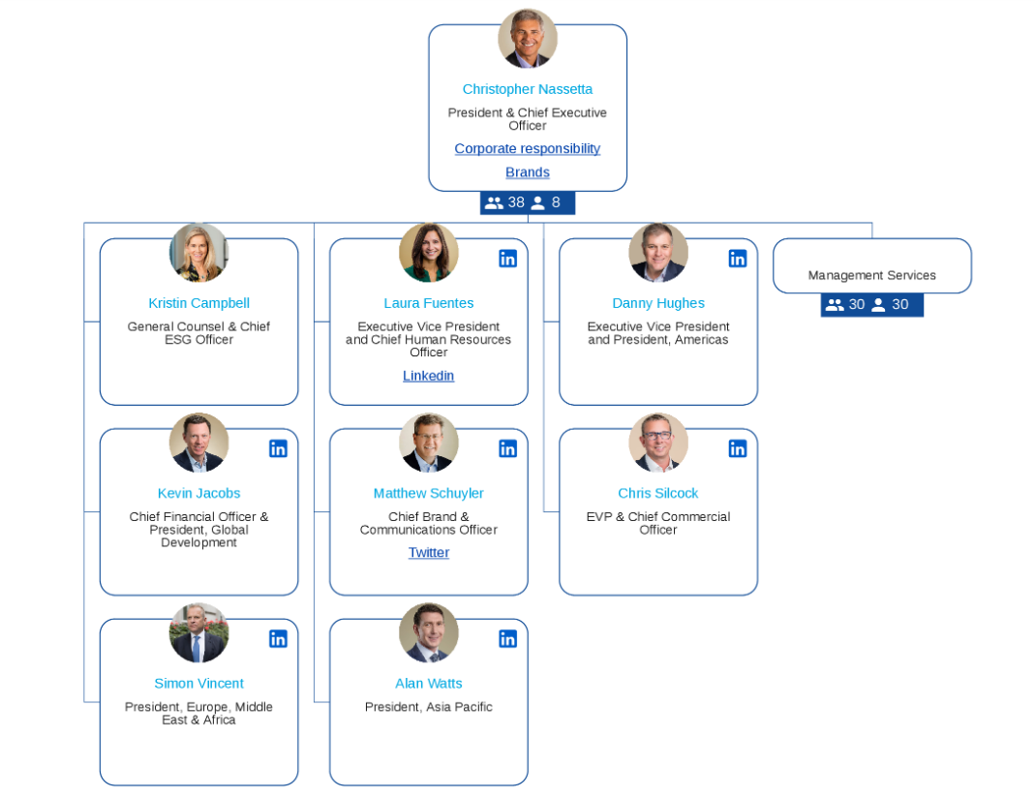
Source: (Nakano et al., 2021)
Figure 1: Hilton’s Organisational chart
Hilton’s organisational structure encompasses a hierarchal nature aligned with their global and diverse operations. This employs a clear line of reporting and authority for the organisation as a multinational hospitality organisation. Their structure also combines the elements of functional departments like marketing, finance, operations and customer service. The executive team overshares various functional and geographical divisions while the business has been divided into ownership management and timeshare in the organisation.
Henry Mintzberg's configurations
According to the theory of Henry Mintzberg's configurations, Hilton’s structure resembles a hybrid form of combining elements creating a proper functional department. These include their marketing, finance, operations and sales departments. They also have tier geographical divisions including America, Europe and Asia Pacific. Their hierarchical structure allows them to arrange appropriate decision-making, efficient resource allocation and standardised processes across the organisation. This hybrid structural combination of Hilton allows them to leverage the best efficiency in customer service, geographical segmentation and operations. Their organisational structure promotes innovation by providing channels for idea generation, and cross-functional collaboration which aligns with their growth objectives (Nakano et al., 2021).

Recent change initiatives of the Organisation

Recent changes in Hilton
The Hilton group has recently undergone significant changes in its operation which has created a significant impact on the organisation in enhancing their business strategies and models. Their adoption has made a critical opportunity for the organisation.
Digital check-in/check-out: The organisation has invested in its technological infrastructure. They have implemented a new digital check-in system which helped to make the user interface more autonomous and less complex for the customers (Zeng, 2021).
Brand acquisition: Expansion into a new market is the other step Hilton has taken in recent changes. Their acquisition of NoMad Hotels has helped them to expand their luxury portfolio. This has helped the organisation improve guest loyalty
Loyalty Program and Revamp: they have revamped their loyalty programs while restructuring the issues. Their loyalty programs can cover a wide range of customer bases and several competitive benefits (Matteucci, 2020).

Change management strategies
Change management process: Hilton’s change management strategies have created a significant impact on the organisation’s operations by navigating complexities smoothly. They have built up clear communication channels which helped the organisation to effectively improve their operations (Rockett, 2023).
Training and incentives: The organisation has provided a proper training program with a consistent communication opportunity. Hilton has established effective feedback mechanisms to help their authority's concerns and challenges faced by employees. They have introduced incentives for encouraging their employees to early digital-check-in employees (Matteucci, 2020).

Strategic direction

Vision and Mission Analysis
Vision: The vision of Hilton Hotel Groups in their operations is to provide light and warmth of hospitality services to fill the earth with exceptional customer service and affiliation. This is for their every, hotel, every guest and every operational location in every situation. Their visionary statement makes it clear that the organisation commits to making hospitality service positive and exclusive for their guests. while promoting sustainability through their actions in all their operational locations by supporting communities (Hilton, 2024).
Mission: The mission of Hilton Hotel Group as a renowned hospitality organisation is to be the best global hospitality enterprise with excellent customer service and other accommodations and amenities. Their mission is to become the first choice of the travellers, guests and their team members. Their mission strategy highlights their aim to be the leading hospitality organisation worldwide preferred by the guests as their first choice (Hilton, 2024).

Competitive positioning and market strategies
Strengths: Hilton has a diverse range of well-recognised brands in their portfolio and luxury brand presence. They also have a global presence with footprints in over 100 countries (Zientara et al., 2020). The enterprise encompasses loyalty programs and exclusive services by its skilled workforce across different locations. The organisation has collaboration with well-known travel companies, credit card providers and airlines which attracts customers through co-branded promotions (Byrne et al., 2020). The organisation has an effective opportunity to emerge their business in the growing tourism sector. However, they can aim to cater to particular travel segments to attract a new customer base. Although their global presence and loyalty programs also effectively work as the company’s strengths.

Competitive landscapes: The organisation encompasses a competitive plan, which includes its luxurious segments. companies like Ritz-Carlton, Four Seasons and Marriott International are some luxury bands with whom Hilton's high-end offerings usually compete. Mitskel brands like Courtyard by Marriott and Hyatt, offer competition with Hilton. Lastly, Hilton Group Hotel have to compete with organisations like ISG Holiday Inn Express, Fairfield Inn and other brands due to their budget-friendly presence.
Market strategies of the organisation: Hilton's effective marketing strategies have helped the organisation to create its overall brand presence. Their specific customer segmentation through their brand portfolio has effectively ensured to creation of tailored experiences for different needs and budgets. On the other hand, the continuous technological investment and innovations have helped them to create mobile room keys, stream and streamline in 9 guest experiences. Partnerships with organisations like Livemenation and Amazon have enhanced the opportunity for Hilton to improve their guest experiences and the effectiveness of their brand loyalty. For example, Hilton has started to honour their members and regular customers with points towards Amazon purchases (Zientara et al., 2020).

Hilton's Long-Term Strategic Goals
Sustainable leadership: Hilton's science-based emission reduction process targets to reduce their ecological footprints responsibly, while potentially attracting eco-conscious travellers. They are committed to their sustainability leadership process, where they have quantifiable goals like a 40% reduction in carbon emission, showcasing data-driven transparency. However, in this context LightStay, which is their ESG measurement platform, allows them to create a presence of leader in sustainability practise in the hostility sector (Byrne et al., 2020).
Social impact and integration: Organisations' sustainability goals are prominent. However, they are required to create appropriate social impact integration. Social impact goals like labour practice and implementing community engagement can help them to create more social strategies. The organisation's long-term aim is to create franchises in network consistency and effective social impact.
Long-term financial consideration: By implementing effective sustainable actions and different factors? organisational aims to create costs. Potential factors like reduced energy and consumption are aimed to be achieved by the organisation to create a more comprehensive evaluation (Byrne et al., 2020).

Recommendations
Empower local teams: The organisation can implement better autonomy for their local regional teams. This can help them adapt service offerings and marketing strategies according to customer preferences. In this process, they can invest bitterly in developing leadership skills and fostering open communication and employee engagement without avoiding brand standards (Scanlon, 2023). Marriott International has its Serve 365 initiative, which focuses on community engagement and local team empowerment. Which helped them to attract sufficiently conscious travellers (Gregersen and Black, 2020).
Knowledge sharing pair platform: This kind of initiative can help Hilton Hotel groups to implement a better learning environment inside their organisation. creating a platform for learning can help facilitate knowledge sharing between different departments colleagues including regions and brand teams. This can also help to break down information and encourage collaboration among the organisations.
Emphasising Long-term financial benefits: The organisation can implement public focus on their long-term gossiping associations. They can reduce their eligibility and invest in seeking environmental concerns companies. Just like Unilever. The organisation also can adopt a sustainability, focused business model, which can help them to get environmental and stakeholder benefits (Bashor et al., 2022).
Enhance Franchisee sustainability: IKEA's franchising model helps them to achieve special beauty throughout their supply chain. These allow them to provide training and resources to promote consistent practices across every location. Pull shop. This model can be implemented and promoted by Hilton through their training programs and financial initiatives to encourage their franchises and workplaces (Al-Zghool, 2020).

Conclusion
Hilton Hotel Group simply highlights its strong organisational culture, which aligns with its goals while demonstrating continuous innovation and effective leadership processes. The organisation's effective organisational structure which simply highlights hierarchy and combination of matrix structure the ability to create change resistance. However, Hilton's strategic initiative, such as digital transformation and brand acquisition has showcased their adaptability and resilience in the context of organisational changes. The organisation has taken several initiatives to improve its change management processes, competitive market industry and competition-evolving market can harm their businesses. The organisation can empower their local teams, and foster knowledge, environment, and supportive organisational culture while applying contingency theory to create initiative according to the situation, which can help Hilton to achieve a competitive edge.

References
Al-Zghool, M., (2020) An evaluation of IKEA’s global position and marketing standing.
Bashor, C.J. et al, (2022) Engineering the next generation of cell-based therapeutics. Nature Reviews Drug Discovery, 21(9), pp.655-675.
Byrne, J., et al, (2020) 12th Congress WFITN-9th to 14th November 2013-Hotel Hilton-Buenos Aires-Argentina. Interventional Neuroradiology: Journal of Peritherapeutic Neuroradiology, Surgical Procedures and Related Neurosciences, 19(Suppl 1), pp.178-179.
Dal Corso, J. et al, (2022) Environmental crises at the Permian–Triassic mass extinction. Nature Reviews Earth & Environment, 3(3), pp.197-214.
Enachi, F., Suleri, J. and Tarus, E., (2024) Retention of graduate trainee programmes: a case study of Hilton’s Elevator fast-track to general manager graduate programme. Research in Hospitality Management, 13(3), pp.143-151.
Esg.hilton, (2022) Our Reporting. Travel with Purpose. Hilton ESG. Available online at: https://esg.hilton.com/our-reporting/#Reports-and-Downloads. [Accessed 23 April 2024].
Fachada, B.C., (2023) Business adaptive strategies in crisis: the case of Hilton Hotels Worldwide (Doctoral dissertation).
Gregersen, H.B. and Black, J.S., (2020) JW Marriott, Jr., on growing the legacy. Academy of Management Perspectives, 16(2), pp.33-39.
Hilton, (2024) The Story of Hilton. Available online at: https://stories.hilton.com/history [Accessed 2 March 2024].
Hilton, C. et al, (2023) Iron, glucose and fat metabolism and obesity: an intertwined relationship. International Journal of Obesity, 47(7), pp.554-563.
Jia, Y., Curpad, S., Diller, C. and Gentry, R., (2022) Serving Hotel Customers in a Postpandemic World: How Can Hilton Worldwide Recover and Change?. SAGE Publications: SAGE Business Cases Originals.
Matteucci, V., (2020) How can the hospitality industry increase corporate value aligned with sustainable development goals? Case examples from Hilton, Meliá and Sun. Worldwide Hospitality and Tourism Themes, 12(5), pp.509-523.
Mullins, L.J., (2008) Essentials of organisational behaviour. Pp. 352. Pearson Education.
Nakano, R. et al (2021) Webgpt: Browser-assisted question-answering with human feedback. arXiv preprint arXiv:2112.09332.
Rockett, G., (2023) History/overview of Hilton. The Routledge Handbook of Diversity, Equity, and Inclusion Management in the Hospitality Industry.
Scanlon, N.L., (2023) Communicating Sustainability to Guests: Leading question: How should sustainability be communicated to guests?. In Critical Questions in Sustainability and Hospitality (pp. 255-263). Routledge.
Stories.hilton, (2020) In a Year Like No Other, Grows to Milestone 1 Million Rooms and Responds to Pandemic with Innovations for Guests, Positive Impact for Communities. Available online at: https://stories.hilton.com/releases/hilton-successfully-navigates-year-like-no-other. [Accessed 23 April 2024].
Stories.hilton, (2024) 2024 Trend Report: What Millennials, Gen Z, Gen X and Baby Boomers Tell Us About Travel in the Year Ahead. Available online at: https://stories.hilton.com/2024trends#summary. [Accessed 23 April 2-24].
Zeng, L., (2021) Analysis of Hilton Worldwide Hotel Group’s Transnational Operation Strategy. Academic Journal of Business & Management, 3(11), pp.20-27.
Zientara, P., Bohdanowicz-Godfrey, P., Whitely, C. and Maciejewski, G., (2020) A case study of LightStay (2010–2017)—Hilton’s corporate responsibility management system. Energies, 13(9), p.2303.

