7/31/2026
Data Warehousing


Student Name: Eric Marinho Nazare
Student ID: 2223750

Module NaMe: Data Warehousing & Data Mining
Module Code: ACCA6026
Lecturer: Dr. Rajeev Nath
Trinity saint david University of Wales (London Campus)

Table of Contents
Introduction 2
Task 1 3
1.1 OLTP vs. Data Warehouse 3
1.2 Architecture and ETL Process 3
1.3 Data Marts for Decision Making 5
1.4. Dimensional Modelling (Star Schema) 6
Task 2 7
2.1: Source System Identification 7
2.2: Star Schema Design 8
2.3: Data Marts and Schema 11
2.4: ETL Plan 11
2.5: Data Quality & Governance 13
Conclusion 14
References 15

Introduction
Every day, NHS England generates large volumes of clinical, operational, workforce, and financial data as it oversees one of the biggest and most intricate healthcare systems in the world. Even though operational systems like financial systems, workforce management systems, Electronic Patient Records (EPR), and Patient Administration Systems (PAS) efficiently support daily healthcare operations, they only offer a partial picture of organisational performance because they function independently.
A data warehousing solution that unifies data from these various systems into a single repository for strategic analysis and decision-making is suggested in this paper. The article defines data marts for various management groups, offers dimensional modelling using star schemas, contrasts Online Transaction Processing (OLTP) systems with data warehouses, and explains the suggested architecture and ETL methodology. To guarantee that NHS England can make well-informed, evidence-based decisions while enhancing patient care, operational effectiveness, and financial sustainability, it concludes by identifying the necessary source systems, suggesting an implementation strategy, and going over data quality and governance issues.

Task 1

1.1 OLTP vs. Data Warehouse
Currently, the great majority of NHS England's operations rely on Online Transaction Processing (OLTP) technologies. Clinical notes, therapies, and patient diagnoses are all kept in the EPR. Waiting lists, bed management, admissions, and discharges are all handled by the PAS. Workforce platforms monitor agency bookings, staff hours, and sick leave. Financial systems handle NHS tariff payments, administer budgets, and process invoices. These systems are made to run quickly; they can handle thousands of little transactions per day without collapsing [1].
All of that is OK for day-to-day operations, but it is useless when attempting to identify patterns or make strategic choices. Because every OLTP system was created separately, the data is organised in a way that makes sense for that specific system but not for anyone attempting to look across the entire organisation. Let's say the CEO wants to determine if longer waiting lines in London trusts are associated with increased agency spending. They would have to extract data independently from the PAS, the workforce system and the financial system before attempting to manually match everything. It is slow, prone to mistakes, and impractical [2].
A data warehouse is specifically made to handle this kind of issue. It is geared for reading and processing vast amounts of historical data from several sources at once rather than for quick transactions [3]. It gathers, cleans, and saves data from the OLTP systems in a format that simplifies complicated queries. In contrast to weeks, the CEO may receive the waiting-list versus agency-spending response in a matter of seconds.
For NHS England, this would entail being able to monitor Referral-to-Treatment (RTT) performance against the 18-week target nationally, pinpoint which trusts are having trouble with bed occupancy before winter arrives and ascertain whether increased spending on treatments truly improves patient outcomes. In a nutshell: OLTP keeps the NHS operating daily. The NHS can use the data warehouse to learn from its past actions [4].

1.2 Architecture and ETL Process
A data warehouse is most easily visualised as a central library. Currently, NHS England's data is dispersed over multiple file cabinets (the OLTP systems), each of which is arranged in a unique manner. The data warehouse gathers all pertinent data into one place, organises it, and makes it accessible to those who have the right authorisation.
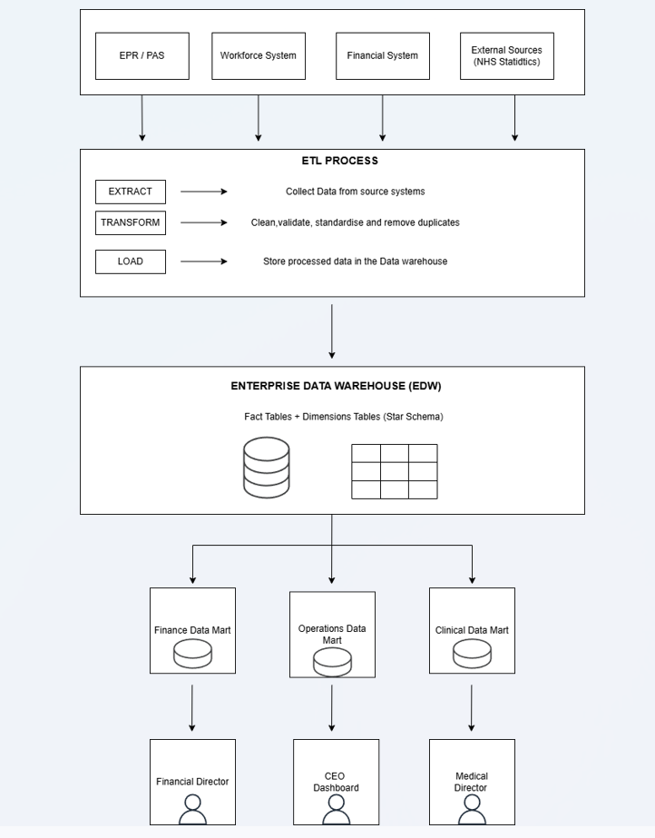
Figure 1: The suggested architecture for the NHS England data warehouse
There are four primary layers in the architecture that is suggested here. At the bottom are the workforce platforms, FMS, EPR, PAS, and external sources, such as ONS deprivation figures. Raw data is briefly stored in a staging area above that. The ETL engine, which cleans and transforms the data, comes next. Lastly, there is the enterprise data warehouse itself, which feeds into department-specific smaller data marts [5].
Extract, Transform, Load, or ETL, is the process that powers the entire enterprise.
To extract data is to take it out of the original systems. This takes place overnight, between 2:00 and 5:00, when clinical activity is at its lowest. Because read-only snapshots are used, there is no chance that live systems will be disrupted. The actual graft takes place in transform. It is rare for data from many systems to line up precisely. The ETL process standardises names, verifies codes like ICD-10 and OPCS-4 against official dictionaries, eliminates duplicate patient data, and, when feasible, fills in missing values. For example, one system may record a hospital as "St. Thomas Hospital" while other labels it "St. Thomas." Simply put, load refers to entering the cleaned data into the warehouse [6].
The board needs to be crystal clear about one thing: the ETL procedure never writes back to the source systems. It can only read. Thus, there is no chance that the EPR or PAS will be inadvertently corrupted. It will not even be noticed by frontline clinical workers.

1.3 Data Marts for Decision Making
The whole picture is not necessary for every member of NHS England. In essence, a data mart is a filtered portion of the data warehouse intended for a particular user base [7]. Consider it this way: the data marts are the individual store shelves, each supplied with just what that specific consumer needs, and the data warehouse is the overall supermarket warehouse.
As seen in Figure 1, three data marts are suggested:
a) Chief Executive Officer of Operations Data Mart
The big picture is necessary for the CEO. High-level performance scorecards for organisational benchmarking, RTT waiting list numbers and breach rates by trust, bed occupancy rates in all regions, trends in admissions and discharges to identify seasonal pressure points, and aggregate workforce data like agency spend and total headcount would all be included in this mart. The CEO can identify which trusts are lagging behind, where resources should be reallocated, and whether the organisation is on track to fulfil national goals using a single dashboard that is updated every day.
b) Finance Director at Finance Data Mart
Money must be connected to therapeutic activities by the Finance Director. No system in use today achieves this correctly. Income reconciliation including contract performance and tariff payments; budget versus actual spend by department and care pathway; cost per patient episode broken down by speciality, trust, and treatment type; and cross-referenced data connecting worker absence rates to agency and overtime costs are all displayed in this mart. Additionally, it would monitor procurement patterns, such as if pharmaceutical prices are increasing more quickly in some areas than others [8].
c) Medical Director at Clinical Data Mart
Safety and results are the Medical Director's priorities. Infection control metrics like MRSA and C. difficile incidence, 30-day readmission rates (which can indicate quality issues), mortality and complication rates by procedure, consultant, and trust, compliance rates with NICE clinical pathways, and categorised patient safety incident data by severity and type would all be monitored by this mart. The Medical Director can identify issues early and prove conformity to authorities like the CQC without having to go through several systems when everything is in one location [9].

1.4. Dimensional Modelling (Star Schema)
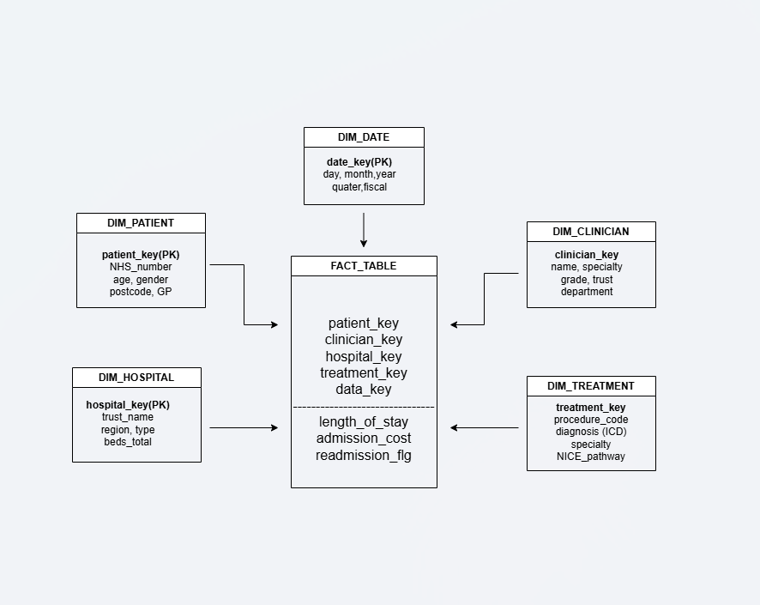
Figure 2: FACT_TABLE with core dimensions in a simplified conceptual star structure
Examining how each system arranges data will help you understand why OLTP systems and data warehouses require distinct structures.
OLTP systems make use of normalisation. To prevent storing the same data twice, this entails dividing data into multiple small, linked tables [10]. Patient, Address, Admission, Ward, and Clinician tables may all include information about a single patient. When updating a single record at a time, that is totally acceptable, but for analytics, it is a headache. It may be necessary to combine six or seven tables and scan millions of rows to obtain the average length of stay by speciality during the previous two years. The live system is hammered by its slowness.
Instead, dimensional modelling is used in data warehouses, and the star schema is the most used method [11]. The fact table, in this example FACT_TABLE, which holds the quantifiable events (admissions, treatments, and discharges), is the focal point of a star schema. Every row denotes a single episode. Context-giving dimension tables encircle the fact table:
The patient's identity (DIM_PATIENT), treatment location (DIM_HOSPITAL), date of treatment (DIM_DATE), kind of treatment (DIM_TREATMENT), and clinician (DIM_CLINICIAN).
The dimensions are denormalised, which is why this works so effectively. The hospital's name, region, bed capacity, and CQC rating are all located in one location, saving you from having to search through three different tables for information. So, a query such as "What is the average length of stay for hip replacement patients in the South East, by quarter, over the past two years?"
Only three tables need to be touched: the date dimension, the hospital dimension, and the fact table.
It operates in seconds instead of minutes [12].
For data warehousing in the healthcare business and almost every other major area, star schemas are the industry standard because of this [13].

Task 2

2.1: Source System Identification
Both internal and external sources must be utilised by the data warehouse.
internal sources:
EPR: clinical notes, discharge summaries, procedures (OPCS-4 codes), diagnoses (ICD-10 codes), and patient demographics.
PAS: Outpatient activities, bed management, appointments, waiting list entries, and referrals.
Workforce system: Payment data, agency usage, contractual hours, staff records, rotas, and absence information.
Financial Management System (FMS): NHS tariff income, purchase orders, supplier contracts, budgetary allocations, and actual spending.
External resources:
NHS England National Datasets: RTT statistics, public benchmarking data, and national performance indicators [14].
Office for National Statistics (ONS): Demand forecasting uses deprivation indexes and population demographics [15].

2.2: Star Schema Design
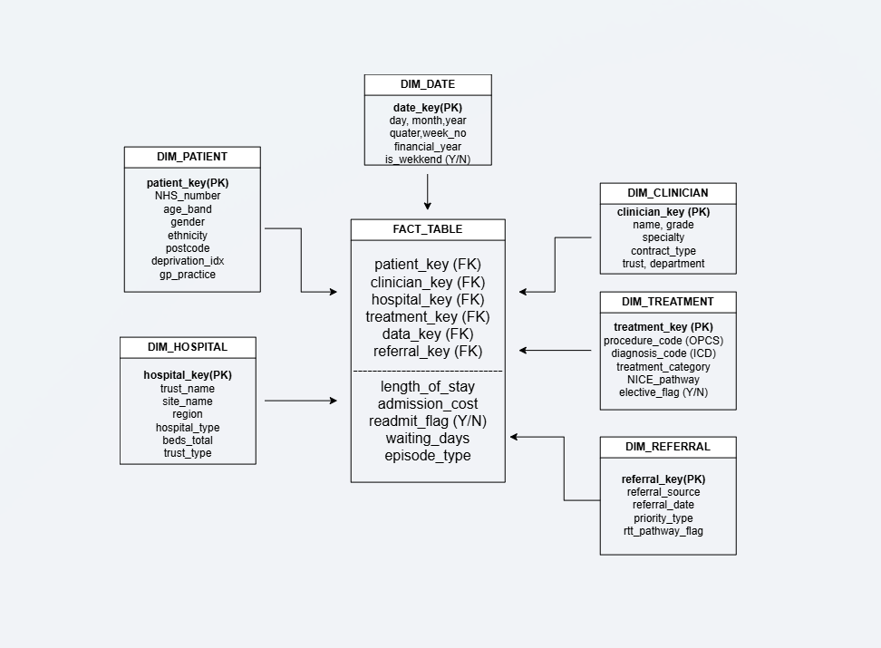

Figure 3: NHS Patient Activity's detailed star schema (FACT_TABLE with full dimensions)

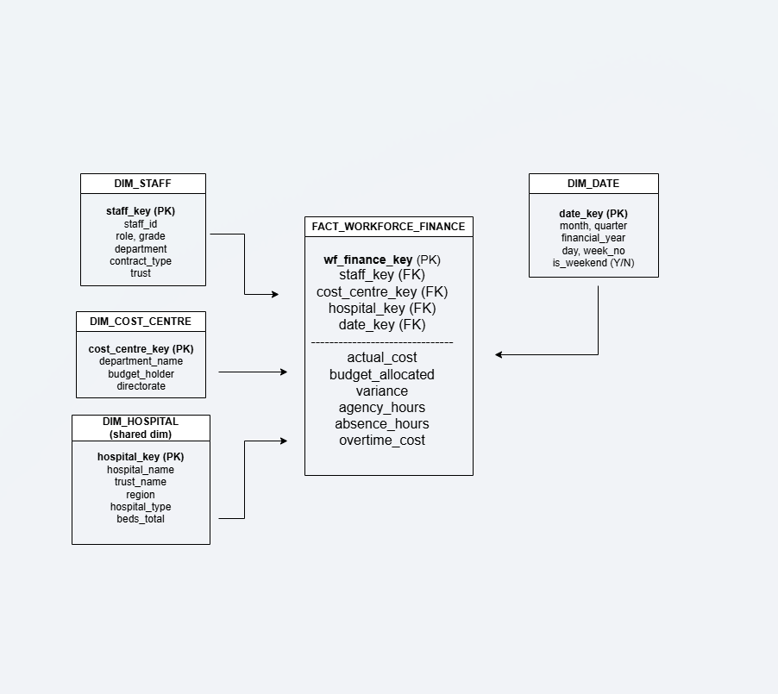
Figure 4: Shared dimensions of the Finance and Workforce Star Schema (FACT_WORKFORCE_FINANCE)
The warehouse is built on two star schemas of comparable scope. This is significant because it enables enquiries that span both financial and clinical data [17].
Schema 1: Activity Star Schema for Patients
As seen in Figure 3, the FACT_TABLE fact table is the core of this architecture. One patient episode, such as an inpatient admission, an outpatient visit, an A&E visit, or a mental health interaction, is represented by each row. Length_of_stay (days from admission to discharge), waiting_days (days from referral to treatment), admission_cost (the cost of that episode, derived from FMS tariff data), readmit_flag (a straightforward Y/N indicating whether the patient returned within 30 days for a related condition), and episode_type (to differentiate emergency, elective, outpatient, and mental health episodes) are the exact metrics stored here that you want to analyse.
The following dimensions apply to this fact table:
DIM_PATIENT: the patient's master data, mostly identified by their NHS number. This dimension provides a single, consistent view by deduplicating records because the same patient may be recorded slightly differently in different trusts. Data from the ONS lookup's deprivation index is also included [18].
DIM_HOSPITAL: information on the trust and location, such as ODS codes, trust name, site name, area, hospital type, number of beds, and A&E type. As seen in Figure 4, this dimension is shared with Schema 2 since it is conformed.
DIM_DATE is another conformed dimension that has been pre-populated with day, month, year, quarter, week number, financial year, and a weekend flag (Y/N) for a ten-year range.
DIM_TREATMENT maps therapy category, NICE route flag, speciality, procedure codes (OPCS-4), diagnosis codes (ICD-10), and an elective flag (Y/N). This metadata makes it possible to classify episodes according to the type of care.
DIM_CLINICIAN—staff IDs with name, grade, speciality, contract type, trust, and department that are connected to the workforce system.
DIM_REFERRAL: RTT pathway flag, referral date, referral source types, and priority type.
When needed by management dashboards and reports, performance indicators like readmission rates and average duration of stay can be computed straight from the FACT_TABLE [19].
Schema 2: Workforce and Finance Star Schema
The FACT_WORKFORCE_FINANCE fact table, as seen in Figure 4, is the focal point of this design.
Actual cost, budget allocated, variance, agency hours, absence hours, and overtime cost are some of its metrics.
DIM_STAFF (staff ID, role, grade, department, contract type, trust), DIM_COST_CENTRE (cost center key, department name, budget holder, directorate), and the two conformed dimensions shared with Schema 1 are DIM_HOSPITAL and DIM_DATE. Because these dimensions are consistent, queries that link the two fact tables can be performed, such as determining if trusts with greater agency nursing costs also have shorter patient wait times [20].
The FACT_WORKFORCE_FINANCE data can be used directly for budget variation and agency spend analysis.

2.3: Data Marts and Schema
The two star schemas directly support each of the three suggested data marts, each of which caters to a distinct management audience [21].
Schema 2 (Workforce & Finance) is the main source of inspiration for the Finance Data Mart. The Finance Director can access budget variance reports using FACT_WORKFORCE_FINANCE's budget_allocated versus actual_cost; agency spend analysis using agency_hours and overtime_cost filtered by DIM_DATE.financial_year; and FACT_TABLE.admission_cost joined with DIM_TREATMENT and DIM_HOSPITAL to obtain cost per episode. "Which specialities are operating over budget this financial year?" is one of the queries this store responds to.
Schema 1 is the source for the Operations Data Mart. Waiting list volumes, trust-level performance scorecards that compare RTT compliance, admission costs, and episode volumes across all hospitals, bed occupancy rates calculated from length_of_stay in combination with DIM_DATE and DIM_HOSPITAL and waiting_days can all be viewed by the Chief Executive using DIM_REFERRAL.
Schema 1 is used by the Clinical Data Mart to choose clinical measures. The readmission rates derived from FACT_TABLE are available to the Medical Director. readmit_flag sorted by DIM_TREATMENT.procedure_code; patient safety indicators like 30-day mortality obtained from aggregations on episode_type and DIM_DATE; and treatment outcomes cross-referenced with NICE pathway compliance via DIM_TREATMENT.nice_pathway.

2.4: ETL Plan
The table below lists the ETL transformations required for each key table [5]:
Table | Source System |  | Key transformations
DIM_PATIENT | EPR/PAS |  | Deduplicate by NHS number, standardise name format; map postcodes to deprivation index (ONS lookup); validate gender/ethnicity code against NHS data dictionary
DIM_CLINICIAN | Workforce System |  | Match staff_id across systems; standardise grade and specialty codes; flags leavers as inactive (SCD Type2)
DIM_STAFF | Workforce System |  | Extract staff master data (role, grade, department, contract type, trust); standardise codes; apply SCD type 2 for historical tracking
DIM_HOSPITAL | PAS/FMS |  | Standardise trust names (e.g., “St Thomas” to “St Thomas Hospital NHS FT”); validate ODS codes against NHS ODS portal
DIM_TREATMENT | EPR |  | Map ICD-10 diagnosis codes; map OPCS-4 procedure code; assign NICE pathway classifications
DIM_REFERRAL | PAS / EPR |  | Extract referral source, priority type and RTT pathway flag; standardise referral source codes; derive pathway start date
DIM_DATE | Generated |  | Pre-populate all dates for 10-year range; calculate financial year, quarters and week numbers
DIM_COST_CENTRE | FMS |  | Extract cost centre hierarchy (department, directorate, budget holder); standardise naming conventions
FACT_TABLE |  | EPR+PAS+FMS | Join patient, admission and cost records by NHS number; calculate waiting_days from referral to admission date; calculate admission_cost from FMS tariff tables; set readmit_flag if readmission within 30 days
FACT_WORKFORCE_FINANCE |  | Workforce+FMS | Join staff records to cost centres; calculate variance (budget minus actual); convert agency hours to cost using rate card; aggregate overtime and absence hours

2.5: Data Quality & Governance
Maintaining strong governance and excellent data quality is crucial for the NHS England data warehouse, because choices have a direct impact on patient care and public accountability [22].
Accuracy and completeness: During ETL, automated validation procedures will reject or flag records that have missing NHS numbers, invalid ICD codes, or date sequences that are illogical (e.g., a discharge date preceding an admission date)
Consistency: By ensuring that the same item is represented consistently across all data marts, conformed dimensions (DIM_PATIENT, DIM_HOSPITAL) help to avoid giving the Finance Director and Medical Director different numbers for the same trust.
Privacy and legal compliance: When managing patient data, NHS Data Security Standards, the Data Protection Act of 2018, and the UK GDPR must all be followed. Only authorised clinical roles will have access to complete identifiers; personally identifiable information (PII) will be pseudonymised within the warehouse [23].
Access control: Finance professionals cannot access clinical quality data, and vice versa. Each data mart will be restricted to its intended users thanks to role-based access control (RBAC).
Ongoing governance: To evaluate data quality indicators, approve schema changes, and guarantee ongoing compliance, a Data Governance Board made up of the Chief Data Officer, clinical informatics leads, and information governance representatives should meet regularly.

Conclusion
This report has shown how a data warehouse might give NHS England a uniform, scalable, and reliable platform for healthcare analytics. Decision-makers can receive timely and consistent information without disrupting everyday clinical operations by integrating data from operational systems such as EPR, PAS, personnel management, finance systems, and external healthcare databases.
The suggested architecture, ETL process, star schemas, and departmental data marts allow senior management to evaluate patient activity, workforce performance, financial expenditure, and clinical outcomes from a single source of truth. The Operations Data Mart provides the Chief Executive with strategic dashboards that display RTT compliance and bed occupancy.
The Finance Data Mart provides the Finance Director with cost-per-episode analysis connected to labour expenditures. Using the Clinical Data Mart, the Medical Director keeps an eye on patient safety and quality parameters in real time. Additionally, all three can be confident that they are examining the same hospitals, dates, and patients because the dimensions are consistent.
Data quality problems including duplicates, invalid codes, and mismatched formats are handled by the ETL plan before the data ever gets to the warehouse. Pseudonymization, RBAC, and quarterly review boards are examples of governance mechanisms that ensure the system complies with UK GDPR and NHS data security regulations.
All things considered, the suggested strategy would optimise resource allocation, increase operational performance, support evidence-based decision-making, and ultimately improve patient outcomes across NHS England.

References
[1] R. Elmasri, Fundamentals of database systems, Pearson Education India, 2008. [Online]. Available: Fundamentals of Database Systems - Ramez Elmasri - Google Books
[2] T. M. Connolly and C. E. Begg,Database systems: a practical approach to design, implementation, and management, Pearson Education, 2005. [Online]. Available: Database Systems: A Practical Approach to Design, Implementation, and Management - Thomas M. Connolly, Carolyn E. Begg - Google Books
[3] A. Vaisman and E. Zimányi, "Data warehouse systems," vol. 9, pp.2014, 2014, [Online]. Available: Data Warehouse Systems: Design and Implementation | Springer Nature Link
[4] W. H. Inmon, D. Linstedt and M. Levins,Data Architecture: A Primer for the Data Scientist, Elsevier, 2019. [Online]. Available: Data Architecture | ScienceDirect
[5] P. Vassiliadis, "A survey of extract–transform–load technology," vol. 5, no. 3, pp.1–27, 2009, [Online]. Available: A Survey of Extract–Transform–Load Technology: Computer Science & IT Journal Article | IGI Global Scientific Publishing
[6] M. Golfarelli, S. Rizzi and C. Pagliarani,Data warehouse design, McGraw-Hill Education, 2009. [Online]. Available: 12376239.pdf
[7] R. Kimball and M. Ross,The data warehouse toolkit: The definitive guide to dimensional modeling, John Wiley & Sons, 2013. [Online]. Available: The Data Warehouse Toolkit: The Definitive Guide to Dimensional Modeling - Ralph Kimball, Margy Ross - Google Books
[8] Y. Wang, L. Kung and T. A. Byrd, "Big data analytics: Understanding its capabilities and potential benefits for healthcare organizations," vol. 126, pp.3–13, 2018, [Online]. Available: Big data analytics: Understanding its capabilities and potential benefits for healthcare organizations - ScienceDirect
[9] A. Donabedian, "Evaluating the quality of medical care," Milbank Mem.Fund Q., vol. 44, no. 3, pp.166–206, 1966, [Online]. Available: Evaluating the Quality of Medical Care | JSTOR
[10] M. Golfarelli, D. Maio and S. Rizzi, "The dimensional fact model: A conceptual model for data warehouses," vol. 7, no. 02n03, pp.215–247, 1998, [Online]. Available: THE DIMENSIONAL FACT MODEL: A CONCEPTUAL MODEL FOR DATA WAREHOUSES | International Journal of Cooperative Information Systems
[11] R. Kimball, M. Ross, W. Thornthwaite, J. Mundy and B. Becker,The data warehouse lifecycle toolkit, John Wiley & Sons, 2008. [Online]. Available: The Data Warehouse Lifecycle Toolkit - Ralph Kimball, Margy Ross, Warren Thornthwaite, Joy Mundy, Bob Becker - Google Books
[12] J. Han, J. Pei and H. Tong,Data mining: concepts and techniques, Morgan kaufmann, 2022. [Online]. Available: Data Mining: Concepts and Techniques - Jiawei Han, Jian Pei, Hanghang Tong - Google Books
[13] S. Chaudhuri and U. Dayal, "An overview of data warehousing and OLAP technology," vol. 26, no. 1, pp.65–74, 1997, [Online]. Available: An overview of data warehousing and OLAP technology | ACM SIGMOD Record
[14] H. J. Watson and B. H. Wixom, "The current state of business intelligence," vol. 40, no. 9, pp.96–99, 2007, [Online]. Available: The Current State of Business Intelligence | IEEE Journals & Magazine | IEEE Xplore
[15] F. Tyrer, R. Morriss, R. Kiani, S. K. Gangadharan and M. J. Rutherford, "Mortality disparities and deprivation among people with intellectual disabilities in England: 2000–2019," J.Epidemiol.Community Health, 2021, [Online]. Available: Mortality disparities and deprivation among people with intellectual disabilities in England: 2000–2019 | Journal of Epidemiology & Community Health
[16] R. Payne et al., , "Challenges to quality in contemporary, hybrid general practice: a multi-site longitudinal case study," 2024, [Online]. Available: What are the challenges to quality in modern, hybrid general practice? A multi-site longitudinal study
[17] J. Declerck, D. Kalra, R. Vander Stichele and P. Coorevits, "Frameworks, dimensions, definitions of aspects, and assessment methods for the appraisal of quality of health data for secondary use: comprehensive overview of reviews," vol. 12, no. 1, pp.e51560, 2024, [Online]. Available: JMIR Medical Informatics - Frameworks, Dimensions, Definitions of Aspects, and Assessment Methods for the Appraisal of Quality of Health Data for Secondary Use: Comprehensive Overview of Reviews
[18] D. Loshin, Master data management, Morgan Kaufmann, 2010. [Online]. Available: Master Data Management - David Loshin - Google Books
[19] A. Abelló, J. Samos and F. Saltor, "A framework for the classification and description of multidimensional data models", in International Conference on Database and Expert Systems Applications, pp. 668–677. [Online]. Available: A Framework for the Classification and Description of Multidimensional Data Models | Springer Nature Link
[20] C. Adamson, Star Schema: The Complete Reference, McGraw-Hill, 2010. [Online]. Available: technicamente.it
[21] L. Corr and J. Stagnitto,Agile data warehouse design: Collaborative dimensional modeling, from whiteboard to star schema, DecisionOne Consulting, 2011.
[Online]. Available: Agile Data Warehouse Design: Collaborative Dimensional Modeling, from ... - Lawrence Corr, Jim Stagnitto - Google Books

[22] D. M. Strong, Y. W. Lee and R. Y. Wang, "Data quality in context," Commun ACM, vol. 40, no. 5, pp.103–110, 1997, [Online]. Available: Data quality in context | Communications of the ACM
[23] A. Da Veiga, R. Vorster, F. Li, N. Clarke and S. M. Furnell, "Comparing the protection and use of online personal information in South Africa and the United Kingdom in line with data protection requirements," vol. 28, no. 3, pp.399–422, 2020, [Online]. Available: Comparing the protection and use of online personal information in South Africa and the United Kingdom in line with data protection requirements | Information and Computer Security | Emerald Publishing

