Your name: Corina Teodora Cucos
Student ID number: 2245697
The module title: Marketing Essentials BMIH4005
Lecturer’s name: Scott James
[Word Count: 1500]

Table of Contents
1 Introduction 3
2 Main Body 3
3 Conclusion 5
4 References 6
5 Appendices 6

Introduction
The key theme behind the essay is to compare the marketing methods and strategies of two international brands, for which the brand selected, are Six Senses and Holiday Inn. To compare both hotels, the report will present situational analysis along with the use of SWOT and PESTLE analysis framework. Marketing essentials are important in the evaluation of the methods of the hotel, for which there will be a further discussion on the marketing mix of the selected hotel brands. In addition, the report will shed light on the target market of both hotels with the help of the STP framework.

Main Body
The story of Six Senses Hotel began in the year 1995. Six Senses is renowned as a five-star hotel that offer unique, sustainable, and authentic style services. The key strength of Six Senses Hotel is its unique location and luxurious services. The passion of Six Senses is to promote wellness, sustainable design, as well as a healthy community. The strength of Six Senses is to explore and reconnect with people and flourish their physical, spiritual, and mental health (Six Senses, 2023). The essay presents a comparison of the marketing methods of two multinational hotels. The hotel is categorized in the luxury and lifestyle collection of the company IHG Hotel and Resorts. On the other hand, Holiday Inn is categorized in the essential collection category. Holiday Inn operates in around 3,000 locations all across the world (Holiday Inn, 2023). The hotel is best known for the delivery of enjoyable and affordable hotel services. Despite this, Six Senses show weakness in the pricing area, as the premium pricing strategy is just fit for the elite class customers. While for Holiday Inn, the key weakness is its limited portfolio and options. For hotels, expansion, technological advancement, and association with luxury brands are considerable opportunities. When talking about threats, it is true that the economic downturn and increased competition in the hotel industry are the key threats for both Six Senses and Holiday Inn.
To conduct an external analysis of the hotel industry, PESTLE analysis is used in the essay. It has been analysed that the political stability of the UK is quite strong, which makes it easy for hotel brands to operate efficiently (Wang et al., 2021). Yes, Brexit is considered the main concern for the entire hotel industry as it impacts economic conditions as well as supply chain operations. The economic growth rate in the UK is increased by 4.1% in the year 2022 and 1.8% in the year 2023 (Statista, 2023). The downfall in the growth rate is because of the high inflation rate and low consumer spending (Figure 1 in the appendix). The country experienced a considerable inflation rate in the previous year mainly because of the pandemic, as it was 10.4% in 2022 and reached 11.1% in 2023 (Statista, 2023 a) (Figure 2 in appendix). Considering social factors, changing preferences and demands of customers, safety issues, and cultural aspects mainly impact the operations of the hotel industry. Involvement in research and development and other technologies like artificial intelligence, AR, data analytics etc., are important factors for hotel brands (Iranmanesh et al., 2022). Concerning legal factors, staffing hospitality legislation and related requirements imposed by the British government must be followed in the hotel industry. In the hotel industry, environmental factors are also important (Buhalis and Cheng, 2020). Hotels are focusing on General Health and Safety Laws in the UK. It is important for hotel brands to focus on eco-friendly practices and sustainability.
In order to analyse the differences in products or services of both hotels, the framework of the marketing mix is used in the essay. Within the aspect of products, it is evaluated that the product or service portfolio range of Six Senses Hotel includes wellness and spa, villas and luxurious suits, well-designed dining facilities and many more. The hotel is famous for its exceptional amenities, including; spacious and comfortable rooms, flourishing kitchen gardens, and different event services as well (Six Senses, 2023 a). On the other hand, Holiday Inn offers budget-friendly and affordable services like; food services, conventions, lodging, meetings, fitness centres, and business workspaces for customers (Holiday Inn, 2023 a). When considering pricing, it is noted that Six Senses adopt a premium pricing strategy as it is categorized among the luxury hotel brand portfolio. Contradict to this, Holiday Inn focuses on adjusting its price according to the area where it operates. Both hotels adopt different strategies for pricing, as Holiday Inn targets middle-class customers. Meanwhile, Six Senses targets high-class and elite-class customers. Related to place, the diversified location creates a competitive advantage for Six Senses. The hotel covers mainly luxurious locations all across the world, i.e. Thimphu, Gangtey, Bumthang, and many more (Six Senses, 2023 a). When considering Holiday Inn, the hotel operates within busy places where tourists can visit easily and affordably. The critical element of the marketing mix is promotion, which is also important in the comparison of both hotels. For Six Senses, the hotel offers different packages and deals to customers, such as romantic spa vacation deals, early booking discounts, seasonal complementary packages, wedding events discounts and so on. The hotel uses different social media platforms to communicate with customers and attract them. The hotel manages its official website efficiently and adds different analytics to it to make it attractive. Similarly, Holiday Inn offers work on different social media campaigns such as “We are there”, “Be the readiest”, and “Guest how you guest” (IHG Hotels & Resorts, 2023). The promotional strategies used by Holiday Inn are somehow compatible with the strategy of Six Senses. In addition to this, Holiday Inn focuses on training professionals and ensures that the criteria of customer satisfaction meet. Moreover, both hotels invest heavily in social media promotions and digital media advancement because of the increasing demand of customers towards digitalization and personalization (IHG Hotels & Resorts, 2023). Despite this, Six Senses and Holiday Inn offer early booking facilities and other services that help customers in collecting new experiences along with each gateway.
The section discusses the segmentation, targeting, and positioning of the two hotels. Six Senses serve a luxurious market for which it targets high-class segments that intend to use unique and luxurious facilities and services. From the analysis of similar web results, it is indicated that the gender distribution between Holiday Inn and Six Senses is 49.19% among males and 53.48% among females (Appendix). In particular, it is evident that the total age group of consumers of Six Senses Hotel is 35% from the age limit of 25 to 54. On the other hand, almost 20% of consumers of Holiday Inn are from the age limit of 25 to 54 (Similar Web, 2023). In addition to this, traffic and engagement of Holiday Inn is observed as 517,739 monthly visits, whereas 409,259 monthly visits in Six Senses. Similarly, visitors in Holiday Inn are approximately 1.47. On the other hand, the value is estimated as 1.86 for the case of Six Senses hotels. The bounce rate calculated for Holiday Inn is 58.14%, and the bounce rate for Six Senses is 58.26% (Similar Web, 2023). The main focus of Six Senses Hotel is on attracting customers who want unique, personalized, stylish, and out-of-the-box services. On the other hand, Holiday Inn touches the budget-friendly nature of customers and attracts them accordingly (Van der Bend et al., 2022).
While relating to positioning, it is true that products or services offered by both hotels are mainly based on the demand of customers. Moreover, Six Senses specifically focuses on the training and development of employees with reference to new technologies and customer preferences. Similar to Holiday Inn, the hotel focuses on the training of employees and provides them with sufficient knowledge about sustainability and ethical practices. Digital marketing is the key success element for both hotels, as customers eventually attract towards the hotel, which offers advertising and promotional campaigns via social media platforms. Direct communication is the best way to target customers and make them brand-loyal (Vafokulova and Juraev, 2022). Six Senses mainly focuses on investing in direct communication methods, like email marketing. With the use of a website, hotels offer clear and fascinating messages to customers and make significant improvements. With reference to Similar Web, the total traffic on the website of Six Senses Hotel is 61.44% which contributes greatly to the success of the hotel. Talking about Holiday Inn, the total traffic generated on the website is 38.56%.

Conclusion
The above report concluded the marketing methods of two hotels, Six Senses and Holiday Inn. Among these, one hotel operates as a luxury brand; meanwhile, the other one operates within an affordable market. It has been concluded that the target market for Six Senses Hotels is elite, luxury travellers, businessmen, and high-class families. On the other hand, the comparison illustrated that Holiday Inn targets middle-class customers that intend to avail of budget-friendly hotel services. The above essay has presented the marketing mix of two selected brands as well as conducted internal and external analyses to differentiate their marketing methods.

References
Buhalis, D. and Cheng, E.S.Y., 2020. Exploring the use of chatbots in hotels: technology providers’ perspective. In Information and Communication Technologies in Tourism 2020: Proceedings of the International Conference in Surrey, United Kingdom, January 08–10, 2020 (pp. 231-242).
Holiday Inn, 2023 a. Need Help? [Online] Available at < https://www.ihg.com/holidayinn/content/gb/en/exp/main> [Accessed on 12th May 2023].
Holiday Inn, 2023 b. Need Help? [Online] Available at < https://www.ihg.com/holidayinn/content/gb/en/exp/main> [Accessed on 12th May 2023].
Holiday Inn, 2023. We're There …Wherever You Need To Travel [Online] Available at < https://www.ihg.com/holidayinnexpress/content/us/en/exp/main?scmisc=WEB-_-6C-_-GLO-_-EN-_-AWA-_-BrandsPage-_-PageCTA-_-HolidayInnExpress> [Accessed on 12th May 2023].
IHG Hotels & Resorts, 2023. Our brands. [Online] Available at https://www.ihgplc.com/en/our-brands/six-senses [Accessed on 12th May 2023].
Iranmanesh, M., Ghobakhloo, M., Nilashi, M., Tseng, M.L., Yadegaridehkordi, E. and Leung, N., 2022. Applications of disruptive digital technologies in the hotel industry: A systematic review. International Journal of Hospitality Management, 107, p.103304.
Similar Web 2023. Competitive Research. [Online] Available at< https://pro.similarweb.com/#/digitalsuite/websiteanalysis/referrals/incoming-traffic/*/999/3m?webSource=Total&key=holidayinn.com,sixsenses.com> [Accessed on 12th May 2023].
Six Senses, 2023 a. Six Senses Travel Experiences. [Online] Available at < https://www.sixsenses.com/en/experiences> [Accessed on 12th May 2023].
Six Senses, 2023. About us. [Online] Available at https://www.sixsenses.com/en/about-us [Accessed on 12th May 2023].
Statista, 2023 a. Inflation rate for the Consumer Price Index (CPI) in the United Kingdom from January 1989 to March 2023. [Online] Available at < https://www.statista.com/statistics/306648/inflation-rate-consumer-price-index-cpi-united-kingdom-uk/#:~:text=The%20UK%20inflation%20rate%20was,11.1%20percent%20in%20October%202022.> [Accessed on 12th May 2023].
Statista, 2023. Annual growth of gross domestic product in the United Kingdom from 1949 to 2022. [Online] Available at https://www.statista.com/statistics/281734/gdp-growth-in-the-united-kingdom-uk/#:~:text=According%20to%20forecasts%20from%20the,by%201.8%20percent%20in%202023. [Accessed on 12th May 2023].
Vafokulova, M. and Juraev, U., 2022. Marketing strategy and failure of Forever 21.(What is the reason behind Forever 21’s failure?). Eurasian Research Bulletin, 4, pp.67-75.
Van der Bend, D.L., Jakstas, T., van Kleef, E., Shrewsbury, V.A. and Bucher, T., 2022. Making sense of adolescent-targeted social media food marketing: A qualitative study of expert views on key definitions, priorities and challenges. Appetite, 168, p.105691.
Wang, K.H., Liu, L., Adebayo, T.S., Lobonț, O.R. and Claudia, M.N., 2021. Fiscal decentralization, political stability and resources curse hypothesis: a case of fiscal decentralized economies. Resources Policy, 72, p.102071.

Appendices

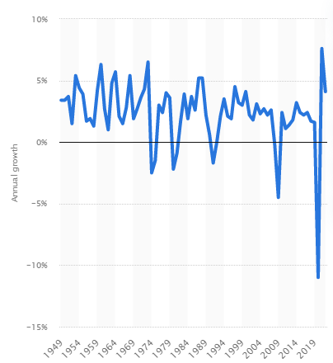
Figure 1: Annual growth of gross domestic product in the United Kingdom from 1949 to 2022
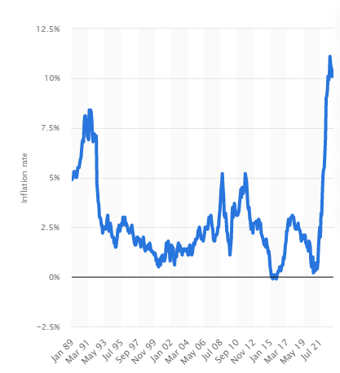
Figure 2: Inflation rate for the Consumer Price Index (CPI) in the United Kingdom from January 1989 to March 2023
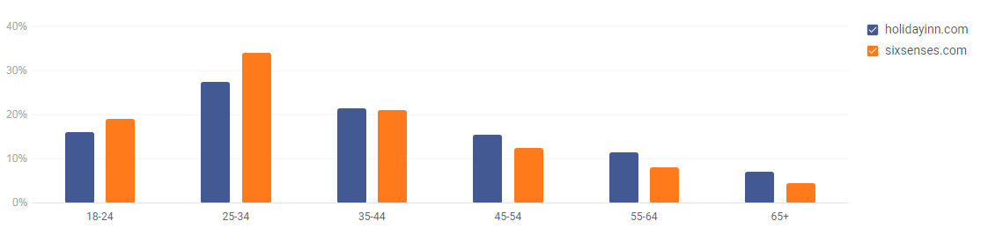
Figure 3: Age Distribution
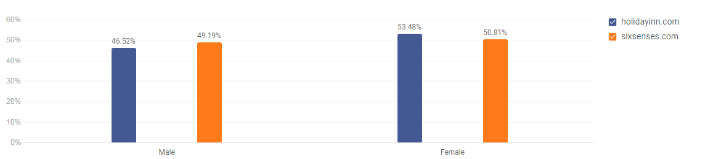
Figure 4: Gender Distribution
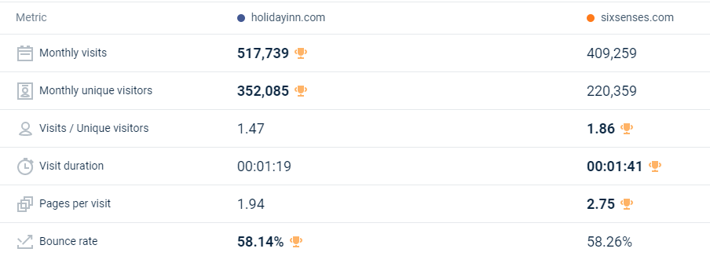
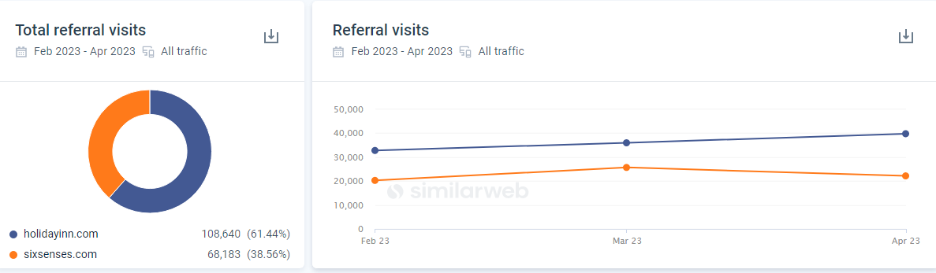
Figure 5: Incoming Traffic

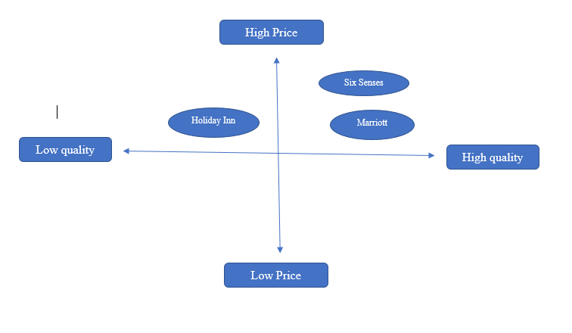
Figure 6: Perceptual Mapping

