DS 1 Template

My Screenshots/Photos
- Please add 4–6 screenshots or photos of your digital life.
- You can use your phone or laptop.
- For each screenshot, write one or two sentences explaining what it shows.

Screenshot/Photo 1
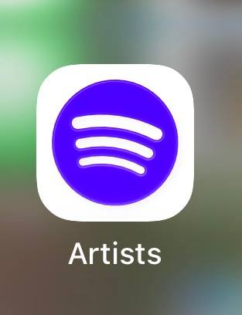
I use Spotify for Artist to verify my listener data and create my shows using the data provided by Spotify for Artist.

Screenshot/Photo 2
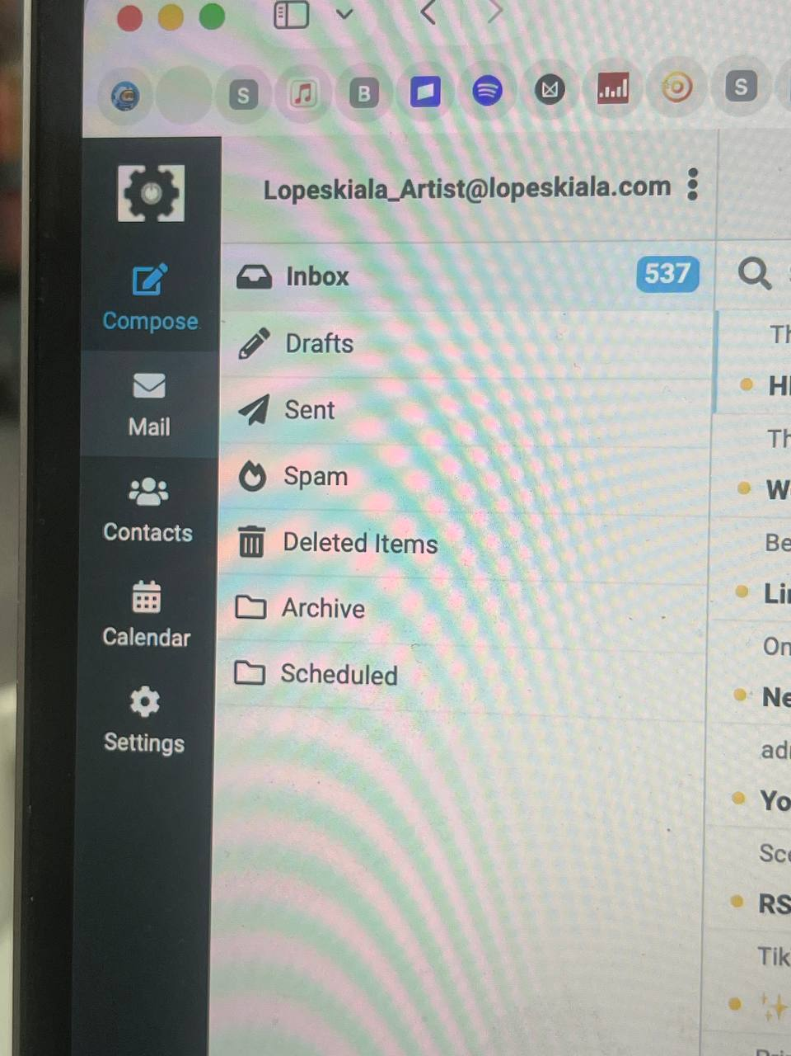
I use my own email domain for my music career; it helps me appear more professional.

Screenshot/Photo 3
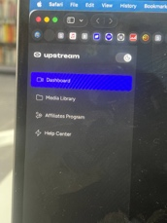
I use Upstream to promote my music daily; this platform helps me promote my music at a low cost.

Screenshot/Photo 4
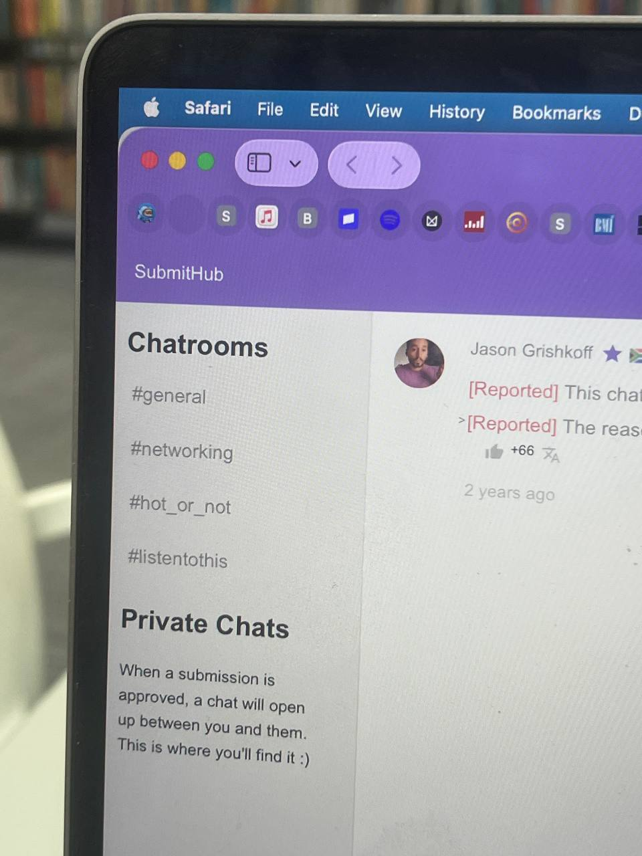
Submit is a tool for securing collaborations with major DJs and influencers. I love it.

Screenshot/Photo 5
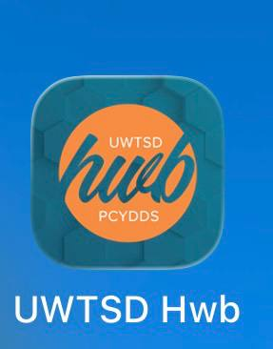
This app has become one of the best tools I use, helping me to read, understand, and explore the options that the university offers me.

Screenshot/Photo 6
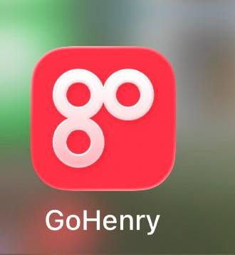
This tool helps me control my daughters' spending.

My Short Reflection
- Write 5–8 simple sentences about your digital life.
- You can use the sentence starters below if helpful.
I have an active digital life and use various tools to carry out my daily activities.
I use alarm apps to organize my routine.
I use digital tools to manage business, relationships, and much more.
I feel confident watching documentaries on YouTube with good company.
I usually use YouTube, Instagram, WhatsApp, and email.
I want to improve my skills with voice recorders, TikTok, and Snapchat.
Sometimes I get nervous with Snapchat because I find it a bit complicated.
I hope this module helps me better understand the importance of using digital skills correctly.
Digital skills are important to me because they help me manage many things, saving energy and time.

Submission Checklist
Before you submit, please check:
​​​ ☐ I added 4–6 screenshots
☐ I wrote short sentences for each screenshot
☐ I wrote my short reflection
☐ My work is my own
☐ My file opens correctly
​​☐ My file opens correctly

