Research Proposal

A critical analysis of veganism and KFC.

Chloe Ferraro
1802459

Table of Contents

Introduction
  - Rationale......................................................................................................... 4, 5, 6 &7
1.2 Background ................................................................................................. ..... 7 & 8
1.3 Aims and Objectives ......................................................................................... 8 & 9

Research Design
2.1 Methodology ..................................................................................................... 8 & 9
2.2 Philosophy.......................................................................................................... 9 & 10
2.3 Research Approaches .......................................................................................... 10
2.4 Research Method and strategy ............................................................................ 10
2.5 Sample ................................................................................................................. 11
2.6 Data collection ..................................................................................................... 11
2.7 Data analysis ........................................................................................................ 11

2.8 Limitations and Ethical Considerations
2.8.1Time management .............................................................................................. 11 & 12
2.8.2Ethical consideration .......................................................................................... 12

Resources.................................................................................................12

Bibliography ....................................................................................... 13, 14 & 15

Appendix ............................................................................................ 16

Introduction
A critical analysis of veganism and KFC.

1.1Rationale
According to The Guardian, ‘one in eight Britons are now vegetarian or vegan… a further 21% claim to be flexitarian.’ (Smithers, 2018) This is mainly concerned with how the UK are trying to reduce the amount of meat they produce due to a number of underlying issues regarding to the reduction of meat consumption.
But how is veganism continuing to rise? According to the vegan society. ‘over half (56%) of Brits adopt vegan buying behaviours such as buying vegan products and checking if their toiletries are cruelty- free. 50% of Brits said they know someone who is vegan. 1 in 5 Brits (19%) would consider going vegan.’ (The Vegan Society, n.d.)
But why are people so invested into the new vegan lifestyle? According to he BBC, social media plays a great role in the rise of veganism, as well as total of ‘49% of those interested in cutting down on their meat consumption said they would do so for health reasons.’ Which is shown in the graph below. (Jones, 2020)This also includes the concerns for the ‘responsibility for animal welfare, human health, and environmental concerns.’ (Wilson, 2019) These would be the ‘Hard veganism’s’ which focuses of the moral reasoning of not using animal products whereas ‘soft veganism’ is the health benefits and making the vegan diet accessible.
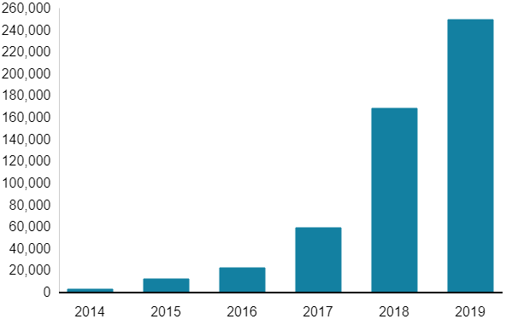

Figure 1. Veganuary. BBC News (2020)

According to public health, nutrition, governance and environmental sustainability, ‘a radical transformation of the global food system is urgently needed. Without action, the world risks failing to meet the UN Sustainable Development Goals (SDGs) and the Paris Agreement, and today’s children will inherit a planet that has been severely degraded and where much of the population will increasingly suffer from malnutrition and preventable disease.’ (EAT- Lancet, 2019)
‘Steadily on its way to becoming mainstream, veganism is no longer a counter culture, a fad, a gimmick. More and more people are finding credibility in the movement and are opting for a vegan lifestyle.’ (FMCG Industry Snapshot, n.d.) As stated before, social media plays a big role and has helped with the justification of going vegan. For instance; influencers seem to base their content particularly on veganism which shares tips, recipes, which can further convince people to follow the trend. This includes cook books, Instagram themed food bloggers, etc. According to the Guardian, ‘Normalising veganism by offering more choices will surely make it less unusual to be vegan, and therefore less “bangonaboutable”.’ (The Guardian, 2020)
However, many chefs are passionate in the change of diets; such as Jamie Oliver who agrees that ‘we must keep putting pressure on the Government to consider these measures and be bold once again in their own strategy to protect the future health of our children.’ (Oliver, 2016)
As well as this, it seems that more and more people are turning to the new lifestyle due to the fact that vegan food is now more accessible than ever. For instance; the endless amount of meat-free replacements in supermarket, soy based ‘dairy’ products, vegan and vegetarian options in typically meat-based restaurants, such as KFC.
The chief executive of Greggs is now working on vegan options on their best- selling food such as,’ steak bakes to pasties and doughnuts, as the high-street baker looks to repeat the runaway success of its vegan sausage roll.’ (The Guardian, 2019)
Although the rise in vegan options in fast food restaurants are continuously increasing, some individuals can be concerned over the animal welfare of these big corporations. Like stated before; KFC have rolled out on their new popular vegan burger, however animal welfare is a big factor standing in the way.
According to KFC, they follow the ‘Better Chicken Commitment’. This is where it complies with all EU animal welfare laws, implementing a maximum stocking density of ‘30kg/m2 or less, adopt breeds that demonstrate higher welfare outcomes, to meet improved environmental standards (cages, air quality, spacing, etc), adopt controlled atmospheric stunning and finally demonstrate compliance with the above standards ‘via third-party auditing and annual public reporting on progress towards this commitment.’ (KFC assets, n.d.)
As well as this, according to the KFC websites, ‘signing up to the European Chicken Commitment isn’t just a box-ticking exercise for us, we’re doing this because we truly believe it’s the right thing to do. Chicken is our business and we’ve a responsibility as the number one chicken restaurant to work with our farms and make sure we’re always pushing improvements to chicken welfare standards across our supply chain.’ (KFC Better Chicken Commitment, 2020)
This research project will critically analyse how the rise of veganism’s has actively changed how fast foods like KFC operate and whether vegans’ moral high grounds concerns regarding responsibility stand in the way of purchasing from said typically meat-based restaurants.

1.2 Background
Responsibility within a business is considered to an important factor as it is what shapes the businesses ethics and moral. Conversely, Ha- Brookshire believes that ‘The reality of corporations’ moral responsibility, however, is that most businesses still put financial gains as their priority above social and environmental bottom lines.’ (2015)
The main question is that why is KFC offering vegan products? Like stated above; responsibility of said businesses are a massive concern to vegetarians and vegans. Although KFC are in the ‘European Chicken Commitment’, some are worried that this still isn’t the case.
According to KFC innovation director ‘The colonel was all about welcoming everyone to his table- now vegans. Flexitarians and our fried chicken fans can all enjoy the taste of our original recipe together. We’ve worked hard to perfect the flavour and make a vegan burger the colonel would be proud of. It’s the same flavour of KFC, just with Zero chicken.’ (2020)
In the ethical consumer fast food guide, KFC had a ranking of 2nd worst from McDonalds in terms of responsibility to the environment, the consumers, animals as well as politics.
But is KFC more concerned with their profits or their moral responsibility? According to Schroder, the UK fast-food market is said to be worth ‘an estimated £7.82 billion annually, amounting to an average spend of £20/ month per adult.’ (Schroder, 2005)
So keeping up with trends can be important to big fast-food corporations in terms of keeping the consumer happy. Organisations such as PETA try to target these said companies to argue about animal welfare to help draw attention. Consumer value can be particularly important to powerful global companies in terms of marketing activity to help keep up the businesses brand image, as well as keep ‘an attractive focus for socio-political complaints and campaigns.’ (Schroder, 2005)

1.3 Aims and Objectives
The aim of this report is to critically analyse how the rise of veganism has actively changed how fast foods operate and whether vegans’ moral high grounds stand in the way of purchasing from said typically meat-based restaurants.
The following objectives will be achieved through carrying out the said research:
- To identify why KFC are providing vegan options.
- Conduct interviews with KFC vegan and vegetarian customers to identify why they chose to buy from the chain and what their views are on the vegan options.
These aims and objectives will be achieved by using a range of data collection methods.

Research Design

Methodology

The concept of research, defined by (DePoy and Gitlin, 2015) is defined research as ‘an important professional responsibility that develops and advances knowledge from which to base practice.’
The reason this is Important as it ‘will strengthen your ability to assess the quality and utility of the evidence presented before you.’ (Gooden and Berry- James, 2018)
In order to provide efficient research data, Saunders et al (2009) had developed ‘The Research Onion’. This is a model which summaries the number of layers which must be thought of when conducting research. In order for the method to work, one aspect must be chosen from each layer for the research to be effective. The figure shown below is the chosen layers in which this research will be conducted.

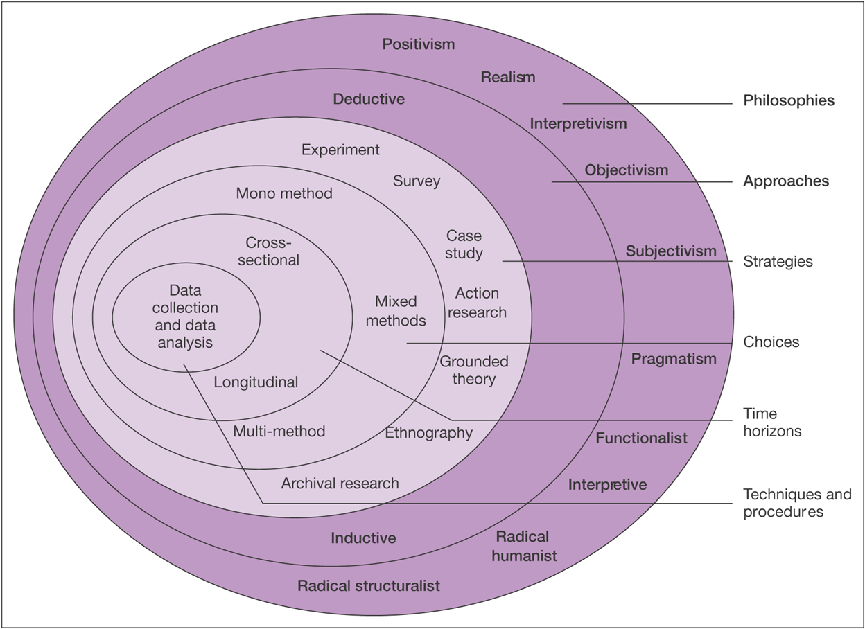

Figure 1.1. The Research Onion (Saunders et al. 2009)

Philosophy
According to Feinberg and Soltis, ‘Interpretivism is often advanced as a way to counter what is seen to be overly mechanical and deterministic model that is found in certain forms of both functionalism and Marxism.’ (2004)
The main goal of philosophy is to explore the number of different perceptive which is to be compared and contrasted.

Research Approaches
The research approach which will be used in this project is the inductive research approach, also known as the inductive reasoning. ‘Inductive analysis aims to systematically generate theory grounded in specific instances of empirical observation.’ (Thorpe and Holt, 2007)
The inductive research is seen to be one of the best suitable approaches due to the fact that is allows data to be collected which will then be analysed and identified from the set of results.

Research Method and strategy
As shown in the research Onion diagram above, the survey method of research is what this project will be using. According to Kotler, ‘surveys are best suited for descriptive research. Companies undertake surveys to learn about people’s knowledge, beliefs, preferences and satisfaction...’ (2012)The surveys will help this project to help identify the participant’s views and attitudes on the information of the survey.

2.5 Sample
‘A sample is a subset of the population to which the researcher intends to generalize the results.’ This usually means that ‘the researcher will want the sample or the individuals actually involved in the research, then are representative of the larger population.’ (Dhivyadeepa, n.d)
One kind of sampling method is would be the convenience or opportunity sampling method. This is when it’s easiest and convenient to reach people for the survey. This project will be using a convenient sample as it will help in the collecting data from a wide variety of people. This sample will consist of interview participants who follow the vegan or vegetarian diet which will mainly be based in Llanelli and potentially Swansea.

Data Collection
The main types of surveys this project will be using will be interviews. According to King and Horrocks, ‘Undoubtedly, interviewing is the most commonly used method of data collection in qualitative research...’ (2010)
Interviews can be quite effective in terms of gaining responses in an efficient time period. As well as this, it allows the researcher to ‘really analyse’ the set of data, which can be quite beneficial. (Kaar, 2009)
Using interviews, the proposed qualitative method, it implies that the mono-method is being used in the research project. ‘A mono-method study uses only one type of method, one quantitative or one qualitative.’(Azorin and Cameron, 2010)

Data Analysis

The data which would be deduced will be clearly represented through tables, figures as well as spreadsheets. This will help to illustrate the main findings from the research project. This will also be able to help present the findings in a way which will be effective as well as help outline the important findings.

2.8 Limitations and Ethical Consideration
2.8.1 Time management
Using a time management is essential to adhere to during the duration of the research project. This time factor could limit in which research will take place in terms of the amount of research which could be conducted.
In order to adhere to a time schedule, a Gantt chart can be quite beneficial in ensuring that everything runs smoothly and is spread out effectively throughout the project. This Gantt chart can be shown in the appendix.
2.8.2 Ethical considerations
Ethical considerations are important when it comes to the research project. For instance, no one of the age of 18 will be included nor related to the project at any stage. This is because the nature of the project is intended to be a marketing exploration and only a marketing exploration. Adding to this, it is very unlikely that it going to cause any physiological harm to any individuals during the interview process.
To ensure that all bases have been met, an ethical consideration form has been written.

Resources

In order to ensure that the research gets the best possible results, it’s important to get credible sources and to use the correct resources. For instance; the universities online library data base which looks at a number of books, journals as well as a number of case studies. As well as this, a number of sources can come from Google scholar as well as Google books. These are mostly online but gives online access to books, journals, etc.

Bibliography

Azorin, J. and Cameron, R., 2010. The Application Of Mixed Methods In Organisational Research: A Literature Review. 8th ed. [ebook] Available at: http://file:///C:/Users/Chloe/Downloads/ejbrm-volume8-issue2-article250.pdf [Accessed 6 March 2020].
DePoy, E. and Gitlin, L., 2015. Introduction To Research - E-Book: Understanding And Applying Multiple Strategies. 5th ed. Elsevier Health Sciences, 2015.
Dhivyadeepa, D., n.d. Sampling Techniques In Educational Research. Lulu.com.
EAT-Lancet Commission, 2019. Our Food in The Anthropocene: Healthy Diets from Sustainable Food Systems. [online] EAT- Lancet Commission. Available at: https://eatforum.org/content/uploads/2019/07/EAT-Lancet_Commission_Summary_Report.pdf [Accessed 8 March 2020].
Feinberg, W. and Soltis, J., 2004. School And Society. Teachers College Press, 2004.
Gooden, S. and Berry- James, R., 2018. Why Research Methods Matter. Melvin & Leigh, Publishers, 2018.
Ha- Brookshire, J., 2015. oward Moral Responsibility Theories of Corporate Sustainability and Sustainable Supply Chain. [online] Available at: https://link.springer.com/article/10.1007/s10551-015-2847-2#author-information [Accessed 7 March 2020].
Jones, L., 2020. Why Are More People Going Vegan?[online] BBC News. Available at: https://www.bbc.co.uk/news/business-44488051#:~:text=Weight%20management%2C%20animal%20welfare%20and,fixture%20in%20many%20people's%20lives [Accessed 6 March 2020].
Kaar, M., 2009. A Critical Investigation Of The Merits And Drawbacks Of In-Depth Interviews. GRIN Verlan, 2009.
Kfc.co.uk. 2020. Better Chicken Commitment. [online] Available at: https://www.kfc.co.uk/better-chicken-commitment [Accessed 7 March 2020].
King, N. and Horrocks, C., 2010. Interviews In Qualitative Research. SAGE, 2010.
Kotler, P., 2012. Kotler On Marketing. Simon and Schuster, 2012.
n.d. FMCG Industry Snapshot. [eBook] Available at: https://web-a-ebscohost-com.ezproxy.uwtsd.ac.uk/ehost/pdfviewer/pdfviewer?vid=1&sid=c6c21c2a-a14d-4f67-b035-f8a0c4468b6d%40sdc-v-sessmgr03 [Accessed 6 March 2020].
n.d. KFC. [eBook] Available at: https://assets.kfc.co.uk/1d028ff7-8f88df22/kfc-draft-language-docx-1.pdf [Accessed 7 March 2020].
Oliver, J., 2016. What’s Jamie’s Plan to Tackle Childhood Obesity? - Daring Kitchen. [online] Daring Kitchen. Available at: https://thedaringkitchen.com/whats-jamies-plan-to-tackle-childhood-obesity/ [Accessed 4 March 2020].
Ranganathan. R. (2020). Vegan options at KFC and Greggs? They’re just a plant. The Guardian. [online] Available at: https://www.theguardian.com/lifeandstyle/2020/jan/11/vegan-options-kfc-greggs-real-purpose-romesh-ranganathan [Accessed 8 Mar.2020]
Saunders, M., Lewis, P. and Thornhill, A., 2009. Research Methods For Business Students. 8th ed. Pearson.
Schroder, M., 2005. Fast foods and ethical consumer value: a focus on Mcdonalds and KFC. British Food Journal, [online] 107(4/5). Available at: https://search-proquest-com.ezproxy.uwtsd.ac.uk/docview/225137001/fulltextPDF/F8A6DFC574724D7CPQ/1?accountid=130472 [Accessed 11 March 2020].
Smithers, R. (2018). Third of Britons have stopped or reduced eating meat - report. The Guardian. [online] Available at: https://www.theguardian.com/business/2018/nov/01/third-of-britons-have-stopped-or-reduced-meat-eating-vegan-vegetarian-report [Accessed 1 Mar. 2020].
The Vegan Society. n.d. Statistics. [online] Available at: https://www.vegansociety.com/news/media/statistics [Accessed 8 March 2020].
Thrope, R. and Holt, R., 2007. The SAGE Dictionary Of Qualitative Management Research. SAGE, 2007.
Wilson, A., 2019. #Vegan. [eBook] Wageningen University. Available at: https://edepot.wur.nl/475593 [Accessed 8 March 2020].
Wood. Z. (2019). Greggs working on vegan versions of all its bestselling foods. The Guardian. [online] Available at: https://www.theguardian.com/business/2019/aug/23/greggs-to-develop-vegan-versions-of-all-its-bestselling-foods [Accessed 8 Mar. 2020]

Appendix


Figure 1.2. Gantt chart.

