Total Word Count 2,670
University of Wales Trinity Saint David

Mechanical Engineering
Luke David Robert John
2320124
Hand in Date 24/11/2025
Analyse and Simulate a Mechanical Energy Recovery System
ACMA 5010

Executive Summary

This report examines the historical origins, modern applications and technical evolution of flywheels as mechanical energy storage devices. They originated as far back as 6000 BCE in ancient China and Mesopotamia. Early flywheels were used on potters' wheels to maintain the rotational motion required to shape the clay. Over time, the flywheel became a crucial mechanical storage system, enabling the Industrial Revolution. They remain a critical component of modern internal combustion engines, used to smooth torque delivery and aid rotation at low power. Technological advancements have made the flywheel a viable energy solution for supporting power grids and vehicles. Modern flywheel energy storage systems (FESS) provide rapid energy release coupled with high charge and discharge cycles. Which have been used to reduce CO2 emissions and improve efficiency, as well as buffer against fluctuations in power grids. In vehicles, they are used in regenerative braking systems, where kinetic energy that would otherwise be lost through braking is stored and used to improve fuel efficiency and provide a temporary increase in power output. The kinetic energy recovery system (KERS), first developed by Williams F1, has later been adapted for road-going vehicles under Williams Hybrid Power (WHP). These modern high-speed flywheel systems require specialised composite rotors spinning within a robust, vacuum-sealed housing to operate, in some cases, with advanced magnetic bearings. Mechanical batteries (flywheels) offer a distinct advantage over chemical batteries due to their ability to provide high power density, discharge power rapidly, and have a long cycle life. They are also far easier to recycle and have far greater environmental sustainability, reinforcing their relevance in modern energy storage applications

Contents
Executive Summary 1
List of Figures 3
List of Tables 4
1. TASK A 5
1.1 Origins of the flywheel 5
1.2 Modern-day uses of flywheels 6
1.3 Kinetic Energy Recovery System (KERS) 8
1.4 Design Considerations and Components 10
1.5 Mechanical Batteries 11
TASK B 12
2.1 Kinetic Energy Before Breaking 12
2.2 Energy Stored in Flywheel 12
2.3 Rotational Speed of Flywheel After Breaking 13
2.4 Acceleration Using Only Stored Energy 14
2.5 Different Breaking Speeds and Their Effect on Re-acceleration 15
2.6 Re-acceleration Using Only KERS in 6.5 Seconds 16
2.7 KERS System for Smaller Vehicle 17
2.8 Assumptions made 19
Bibliography 20

List of Figures
Figure 1 Wooden Potter's Wheel (Lesley, 2021) 5
Figure 2 Williams Formula One KERS (Racecar Engineering, 2009) 8
Figure 3 Volvo KERS system (Evans, 2013) 9
Figure 4 Breaking Vs Re-acceleration Graph 15
Figure 5 Rotational Speed Vs Flywheel Diameter Graph 18

List of Tables
Table 1 Reduction in CO2 From Power Production (Spindel, 2016) 6
Table 2 Bearing Comparison (Eltaweel and Herfatmanesh, 2024) 10
Table 3 Energy Stored from Breaking Vs Re-acceleration 15
Table 4 Rotational Speed Vs External Diameter of 4.5 kg Flywheel 18

TASK A

Origins of the flywheel

The flywheel is believed to have been used for manufacturing as far back as 6,000 BCE. It was used in ancient China and Mesopotamia as a potter's wheel. This would serve to keep the pottery spinning between kicks from the potter. They were usually made from Wood, Stone, or Clay, such as Figure 1. It is believed that composite flywheels were also used, composed of bamboo laid into clay (Bender, 2015).
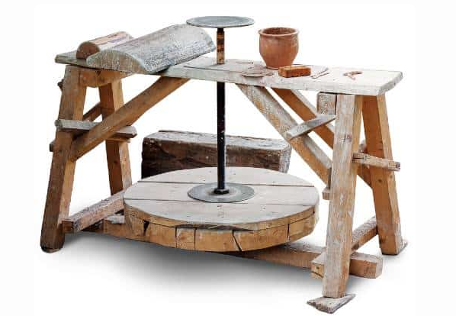
Figure 1 Wooden Potter's Wheel (Lesley, 2021)

The flywheel has found many other uses in history since the potters' wheel, which have all led to the mechanical developments that made the Industrial Revolution possible. The factories and mills of the day couldn’t have functioned without the flywheel steadying the steam engines that powered them. The largest influence that the flywheel has had in history is on transport, such as cars, trucks, and diesel locomotives. Internal combustion engines rely on flywheels to complete the rotation of the crankshaft between pulses of power from the pistons (Yalsin Gogus and Kaftanoğlu, 2009, pp.300–303).

Modern-day uses of flywheels

One of the most promising modern uses for flywheels as energy storage devices is their use off-grid. They can be used as a hybrid system in conjunction with solar panels, wind turbines, and generators. They help to smooth out the microgrid. When energy output is high, the spare power is used to spin up the flywheel via an electric motor and is stored mechanically. This stored energy can then be rapidly discharged by using the motor as a generator to smooth out fluctuations in the power grid, similarly to how it is used to smooth mechanical power transmissions (Matos et al., 2025). In small, remote grids that rely on solar panels and diesel generators for their power, according to Soomro, Pullen, and Amiryar (2021), “The integration of an energy storage system (ESS) in an islanded system, along with a generator, not only reduces generator maintenance costs but also reduces the CO2 emissions by limiting its operating hours.” It is proposed that flywheels are a viable alternative to batteries and would work in this scenario, meaning the diesel generators would only need to come on when the solar and flywheel system couldn’t power the grid. This would greatly reduce the generator's cost and CO2 footprint. Systems like this are also used on large national grids and to support power stations. One such large Flywheel Energy Storage System (FESS) is Beacon Power's facility in Hazel, Pennsylvania. This 20MW Flywheel storage plant charges when demand drops and provides instant power to the grid when demand increases and supply drops below 60Hz. It is also used to smooth out any fluctuations. This facility aims to reduce reliance on fossil fuels and promote the use of renewable energy sources, as seen in Table 1 (Spindel, 2016).
Table 1 Reduction in CO2 From Power Production (Spindel, 2016)
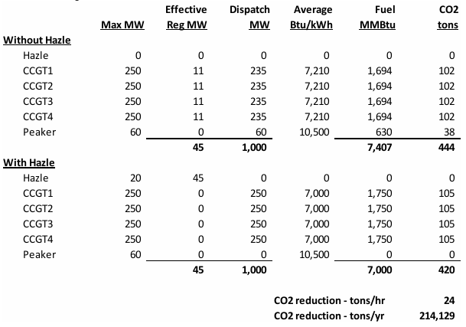
Another common modern-day application of flywheels is in regenerative braking systems for vehicles. The excess power used to spin the flywheel is direct torque from the vehicle's wheels. This occurs during braking or when the throttle is lifted. A separate clutch and transmission system fitted to the drivetrain engages and spins the flywheel. While this is engaged, it also aids in slowing the vehicle (Raju et al., 2022). This power is then delivered back to the vehicle during acceleration, mainly in one of two ways: directly from the flywheel, typically utilising a CVT (continuously variable transmission), or through two generators/motors working in tandem (Eltaweel and Herfatmanesh, 2024). The use of a flywheel regenerative braking system attached to the drivetrain has resulted in a 30% reduction in fuel consumption. A 1800kg vehicle using a 65kg flywheel regenerative braking system can produce 60kw of power and 580kJ of energy (Toh Xiang Wen and Tong Kum Tien, 2018)

Kinetic Energy Recovery System (KERS)

KERS refers to a specific type of regenerative braking system. In 2009, the F1 regulations permitted an additional boost to the cars from a hybrid KERS system. Most Formula One teams opted for a KERS system that used batteries, but Williams F1 designed an electro-mechanical flywheel system shown in Figure 2 (Staff, 2021). This system was never raced in Formula One, but the Williams group began producing it under the name Williams Hybrid Power (WHP). This KERS system was used in the Porsche 911 GT3 R Hybrid endurance car in 2010. The Audi R8 e-tron quattro utilised an entirely new design of the WHP flywheel, which produced 150 kW of power and spun at a speed of 45,000 RPM. This led Audi to become the first hybrid car to win the Le Mans (Amiryar and Pullen, 2017).
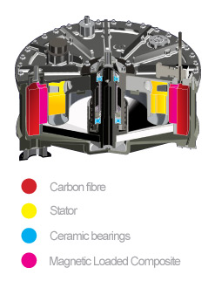
Figure 2 Williams Formula One KERS (Racecar Engineering, 2009)

In road-going vehicles such as the Volvo S60 T5, the KERS system utilises kinetic energy that would normally be lost as heat through braking to spin the flywheel, much like its Formula One predecessor, as seen in Figure 3. This can then be used to reduce fuel consumption by aiding the engine or as one big 80 HP boost for overtaking. This power can be gathered from breaking in around eight seconds and be stored in the flywheel for up to half an hour (Gear, 2014). As a result, this lowers the vehicle's emissions and increases its fuel economy by 20%. KERS has also been fitted to many different buses. London buses equipped with a Flybrid KERS system have seen a 45% reduction in fuel consumption. In 2015, London buses deployed 500 buses equipped with a 0.4kW flywheel system capable of accelerating the bus from 0 km/h to 50 km/h. This resulted in an annual fuel savings of around 5,300 litres of diesel per bus (Eltaweel and Herfatmanesh, 2024).

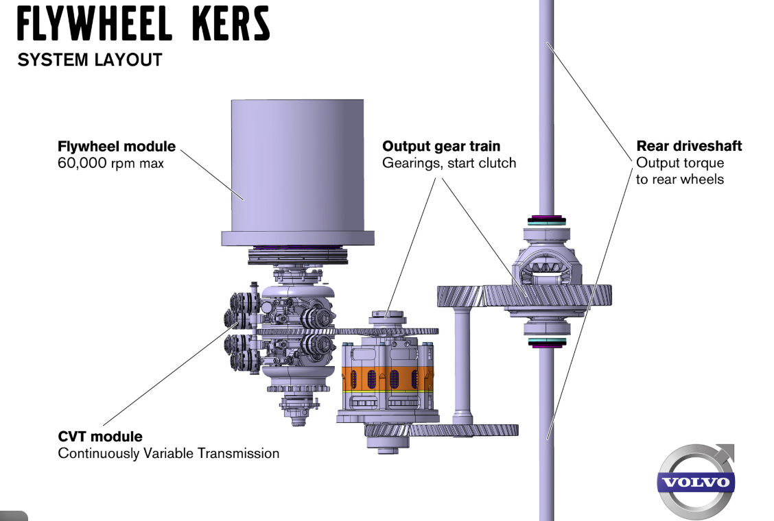
Figure 3 Volvo KERS system (Evans, 2013)

1.4 Design Considerations and Components

Essentially, a flywheel is a disk that spins on a shaft in its most basic form; however, with FESS and KERS systems, the flywheel is required to spin at far higher speeds, which puts the system under considerable stress. This requires specialist rotors, housing, environments and bearings. The rotor design of the system has a significant impact on its performance. Thin hollow flywheels have been identified as being the most effective for high-speed applications. These are generally constructed from composite materials that utilise their unidirectional tensile strength. Hybrid flywheel can also be used for such applications, which consist of a steel hub with a composite rim. These flywheels are able to handle high stresses due to the combination of materials. The materials chosen to construct the flywheel are also of great importance, as considerations must be made for the material's ultimate tensile strength and in which direction the strength is. Strong consideration must be given to the density of the material and its operational speed, as high-density materials can store more energy at low speed but have higher internal stresses, which limit their speed. The primary task of the flywheel housing is to contain the flywheel within a vacuum, thereby maintaining optimum performance and preventing losses due to air resistance. It must also be able to contain the flywheel if it catastrophically fails, as fragments of the flywheel will be travelling with phenomenal energy and speed. Lastly, the bearings must be considered; they must not only support the rotor and shaft, let it spin freely to reduce losses as much as possible, but also withstand the dynamic loads to which the flywheel is exposed. This leaves only two viable options for bearings currently: roller type and magnetic bearings. Table 2 shows a comparison of the two (Eltaweel and Herfatmanesh, 2024).

Table 2 Bearing Comparison (Eltaweel and Herfatmanesh, 2024)
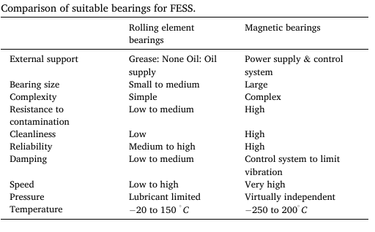

1.5 Mechanical Batteries
A mechanical battery is a form of energy storage that stores kinetic energy. This can be charged either by electrical means, such as a motor, or by using direct kinetic energy, such as a car's inertia under braking or an engine. The energy is then stored within the flywheel, which spins at very high speeds in a low-friction environment. The fundamental principle on which these operate is$E=\frac{1}{2}Ιω^{2}$where $E$ is stored energy, $I$ is the moment of inertia, and $ω$ is angular velocity. From this equation, the energy stored within the flywheel can be optimised either by increasing the moment of inertia or by increasing the angular velocity. The useful energy within a speed range of a flywheel can be found by using $E=\frac{1}{2} I \left(ω\max^{2}-ω\min^{2}\right)= \frac{1}{2}Iω\max^{2}(1-\frac{{ωmax}^{2}}{{ωmin}^{2}})$ (Amiryar and Pullen, 2017).

Mechanical batteries have a distinct advantage over chemical batteries due to the fact that they can discharge their energy rapidly, giving an instant power boost. They can also undergo almost infinite charge and discharge cycles, unlike chemical batteries, which deteriorate with charge and discharge cycles. Mechanical batteries are environmentally friendly and sustainable, unlike chemical batteries. The disposal of chemical batteries can cause water and air pollution as the batteries corrode. Approximately 4% of landfill is e-waste, which includes chemical batteries. Chemical batteries also have high manufacturing costs and high maintenance costs (Z and A, 2024).

Word Count 1632

TASK B

2.1 Kinetic Energy Before Breaking

Given that the gross mass of the vehicle is 2080 kg, and the initial braking speed is 55 MPH. Then, to work out the kinetic energy of the vehicle before braking, firstly, the velocity needs to be converted to meters per second (m/s)
One mile = 1609.34 m
One hour contains 3600 s
So $55×1609.34=88513.7$ then divide by seconds $\frac{88513.7}{3600}=24.59 m/s$.
Then, using the formula $KE=\frac{1}{2}mv^{2}$ the car's kinetic energy can be found $\frac{1}{2}×2080×{24.59}^{2}=628.85{×10}^{3}J or 628.85 kJ$

2.2 Energy Stored in Flywheel

Given that the combined efficiency for the flywheel ($η$) is given at 80% then to work out the energy stored in the flywheel ($E_{s}$)
$E_{s}=KE×η$ therefore $628.85{×10}^{3}×0.8=503.08{×10}^{3}J or 503.08kJ$
The flywheel won’t be able to harness all the vehicle's kinetic energy due to losses, such as those from the CVT transferring power to spin the flywheel, frictional losses in bearings, and energy lost as heat from braking.

2.3 Rotational Speed of Flywheel After Breaking

Given that the kinetic energy in the flywheel can be worked out from $E_{k}=\frac{1}{2}Iω^{2}$. Then, rearranging this formula will give the angular velocity ($ω$). First, the inertia of the flywheel must be found. Given that it is a thin ring design $I=mr^{2}$ must be used. Where the mass of the flywheel ($m$) is 6.5 kg and radius ($r$) is 150mm or 0.15 M.
$$6.5×{0.15}^{2}=0.146kgm^{2}$$
After rearrangement
$ω=\sqrt{\frac{2×E_{k}}{I}}$

Once the figures are put in
$\sqrt{\frac{2×503.08×{10}^{3}}{0.146}}=2.63{×10}^{3} rad s$

To convert to rpm ($n$)
$n=ω×\frac{60}{2π}$ therefore $2.63{×10}^{3}×\frac{60}{2π}=25.11{×10}^{3}$ or 25,114 rpm
This speed is well within the flywheel's given maximum rotational speed of 50,000.

2.4 Acceleration Using Only Stored Energy

Given that the KERS system has been assigned a combined efficiency of 80%, the combined braking and acceleration losses have already been removed in section 2.2; therefore, the acceleration can be treated as perfect with no losses. Then, using the formula from section 2.1, it can be rearranged to find the car's velocity.
$v=\sqrt{\frac{2×KE}{m}}$ using the figures $\sqrt{\frac{2×503.08{×10}^{3}}{2080}}=21.99 m/s$

Converted to mph

$21.99×\frac{3600}{1609.34}=49.19 mph$

2.5 Different Breaking Speeds and Their Effect on Re-acceleration

To obtain the figures in Table 3, the formulas from sections 2.1, 2.2, and 2.4 were used. The only value changed was the initial breaking speed. Table 3 shows the correlation between different breaking speeds and the speed at which the energy available from the KERS system can accelerate the car to.
Table 3 Energy Stored from Breaking Vs Re-acceleration
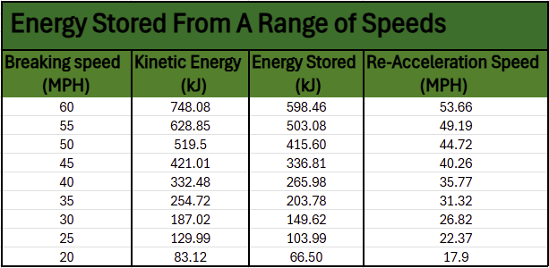
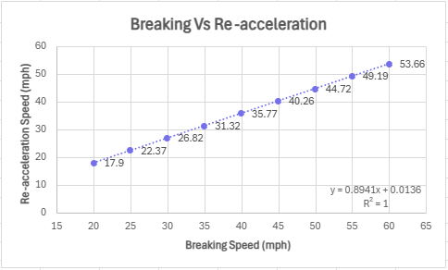
Figure 4 Breaking Vs Re-acceleration Graph
The graph in Figure 4 shows a steady, linear increase in potential acceleration speed with increasing breaking speed. The graph shows that the re-acceleration speed increases by around 4.5 (mph) as the breaking speed increases by 5 (mph). This is around 89.4% of the breaking speed, not the 80% expected. This is also demonstrated by the trend line equation in Figure 4, which shows the points plotted in relation to the y-axis. It can also be seen from the scatter graph that all the points fall on the trend line, indicating a linear and even increase. From this, we can safely assume that if the car were to break at 100 mph, the re-acceleration speed would be 89.4 mph.

2.6 Re-acceleration Using Only KERS in 6.5 Seconds

From Table 3, it can be seen that when breaking occurs at 60 mph, the re-acceleration final speed is 53.66 mph. To convert this to m/s, the conversion formula from 2.4 must be rearranged $\frac{53.66×1609.3}{3600}=23.99 m/s$.
To determine acceleration, the change in velocity is divided by the time interval. This gives you the rate at which an object, in this case, the car's speed and direction, changes per unit of time.
$$\frac{23.99-0}{6.5}=3.69 m/s^{2}$$

2.7 KERS System for Smaller Vehicle

The new vehicle mass is 1510kg.
Then the new flywheel mass is 4.5kg.
Breaking speed is 60mph, and efficiency remains at 80%.

If a graph to plot out the rotational speed of the new flywheel in relation to its external diameter is to be produced, firstly, the kinetic energy for the smaller car must be found. This time, the breaking speed is 60 mph, which must be converted into meters per second. $\frac{60×1609.3}{3600}=26.82 m/s$

The same formula as in section 2.1 can then be used to find the kinetic energy.
$KE=\frac{1}{2}MV^{2}$
$$\frac{1}{2}×1510×{26.82}^{2}=543.08{×10}^{3}or 543.08kJ$$

Given that the system has a combined efficiency of 80% then the stored energy will be. $543.08×0.8=434.46kJ$

The rearranged formula in section 2.3 can then be used $ω=\sqrt{\frac{2×E_{k}}{I}}$ . But, as in section 2.4, the inertia must be found assuming that this is also a thin ring design flywheel, then this is found using$I=mr^{2}.$
So, for a flywheel 120mm in diameter.
$4.5×{0.060}^{2}=0.0162 kgm^{2}$

The rotational velocity would be. $\sqrt{\frac{2×434.46×{10}^{3}}{0.0162}}=7.32{×10}^{3} rad s$.

To convert to rpm as in section 2.3 $n=ω\frac{60}{2π}$ so $7.32{×10}^{3}×\frac{60}{2π}=69900 rpm$.

Table 4 uses the same calculations as above for a range of diameters from 120mm to 240mm.
Table 4 Rotational Speed Vs External Diameter of 4.5 kg Flywheel
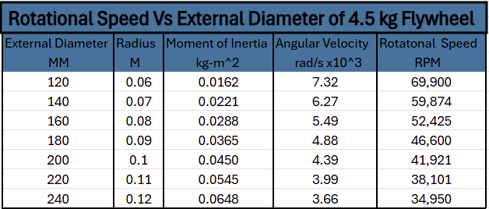

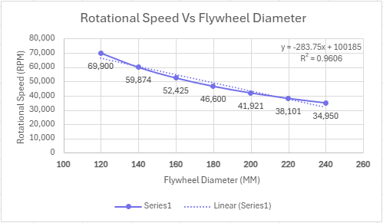
Figure 5 Rotational Speed Vs Flywheel Diameter Graph
Figure 5 shows that as the flywheel diameter gets larger, the rotational speed required to store the $434.46kJ$ (kinetic energy) becomes slower. This is due to the greater moment of inertia. As seen from previous sections, the moment of inertia depends on two variables $m$ the mass and $r^{2}$ the radius squared. Increase one of these, and the moment of inertia increases.

2.8 Assumptions made

In the analysis of KERS systems, assumptions were made to simplify the mathematics and provide general answers rather than exact ones, but they can still be used to model real-world situations. Without the assumptions, the mathematics and analysis would be far more complicated.
Loses
These were one of the largest assumptions, as the losses were just put as an 80% efficiency. In reality, there would be far more losses, such as aerodynamic drag, which would slow the car, in turn affecting its acceleration and the speed it could reach from KERS alone. Mechanical losses, such as drivetrain and bearings, would affect the power that could be stored and reused. Resistance from these would also slow the car. Frictional losses from the tyres have also been ignored; these would have also slowed the car and reduced acceleration, and top end.

Thin Ring Design
When working out the moment of inertia for the flywheel $I=MR^{2}$ was used, which is for a thin ring. In reality, the ring would be connected by spokes or a hub section. The mass of the ring could be a composite layup, with non-uniform mass distribution.

Breaking and Acceleration
These were taken as even and uniform, even though in real-world driving situations, the force of breaking varies. This is also true of acceleration; therefore, energy stored and released from the KERS would change each time, even if the speed was the same.

Word count 1038

Bibliography
Amiryar, M. and Pullen, K. (2017). A Review of Flywheel Energy Storage System Technologies and Their Applications. Applied Sciences, [online] 7(3), p.286. doi:https://doi.org/10.3390/app7030286.
Bender, D. (2015). SANDIA REPORT Flywheels. [online] www.sandia.gov, U.S. Department of Energy, pp.0–32. Available at: https://www.sandia.gov/ess-ssl/publications/SAND2015-3976.pdf?utm_source=chatgpt.com [Accessed 7 Sep. 2025].
Eltaweel, M. and Herfatmanesh, M.R. (2024). Enhancing vehicular performance with flywheel energy storage systems: Emerging technologies and applications. Journal of Energy Storage, 103, p.114386. doi:https://doi.org/10.1016/j.est.2024.114386.
Evans, S. (2013). Volvo S60 Flywheel KERS Prototype First Drive - Motor Trend. [online] MotorTrend. Available at: https://www.motortrend.com/reviews/volvo-s60-flywheel-kers-prototype-first-drive [Accessed 12 Nov. 2025].
Gear, T. (2014). Why we need cars with KERS. [online] Top Gear. Available at: https://www.topgear.com/car-news/future-tech/why-we-need-cars-kers?utm [Accessed 11 Nov. 2025].
Lesley (2021). Potter’s Wheel History | How Ancient Pottery Wheels Evolved. [online] Pottery Tips by the Pottery Wheel. Available at: https://thepotterywheel.com/potters-wheel-history/.
Matos, C., Rosales-Asensio, E., Carta, J.A. and Cabrera, P. (2025). Flywheels in renewable energy Systems: An analysis of their role in managing intermittency. Journal of Energy Storage, [online] 122, p.116674. doi:https://doi.org/10.1016/j.est.2025.116674.
Racecar Engineering (2009). Williams F1 KERS explained. [online] Racecar Engineering. Available at: https://www.racecar-engineering.com/articles/f1/williams-f1-kers-explained [Accessed 12 Nov. 2025].
Raju, J., Dinesh Kumar, M., Yadav, B., Kumar, L. and Nikhith Kumar, M. (2022). Fabrication of Flywheel Regenerative Braking System. INTERNATIONAL JOURNAL OF INNOVATIVE RESEARCH IN TECHNOLOGY, [online] 8(12). Available at: https://ijirt.org/publishedpaper/IJIRT154701_PAPER.pdf?utm [Accessed 2 Nov. 2025].
Soomro, A., Pullen, K.R. and Amiryar, M.E. (2021). Hybrid PV System with High Speed Flywheel Energy Storage for Remote Residential Loads. Clean Technologies, 3(2), pp.351–376. doi:https://doi.org/10.3390/cleantechnol3020020.
Spindel, H. (2016). Final Technology Performance Report 20 MW FLYWHEEL FREQUENCY REGULATION PLANT. [online] Available at: https://www.energy.gov/sites/prod/files/2017/01/f34/02%2005%202016%20-%20Final%20TPR_Hazle%20Spindle%20LLC.pdf?utm [Accessed 29 Oct. 2025].
Staff, A. (2021). Why did the flywheel hybrid system never catch on for road cars? [online] Ars Technica. Available at: https://arstechnica.com/cars/2021/02/whatever-happened-to-williams-f1s-flywheel-hybrid-idea/?utm [Accessed 7 Nov. 2025].
Toh Xiang Wen, M. and Tong Kum Tien, D. (2018). Analysis of a Hybrid Mechanical Regenerative Braking System. MATEC Web of Conferences, [online] 152, p.02011. doi:https://doi.org/10.1051/matecconf/201815202011.
Yalsin Gogus and Kaftanoğlu , B. (2009). Energy Storage Systems - Volume I. Oxford: EOLSS Publications, pp.300–303.
Z, N.N. and A, A.A. (2024). Flywheel Energy Storage Systems and their Applications: A Review. International journal of engineering trends and technology, 72(4), pp.209–215. doi:https://doi.org/10.14445/22315381/ijett-v72i4p122.

