Kian Nightingale (2108732)
21032@student.uwtsd.ac.uk
Abstract
This report will cover some of the key aspects of object orientated programming that I had to work with during this assignment to succeed.
Assignment 1 Object orientated Programming

Contents
Brief 2
Testing 2
Video Demonstration 2
C++ Essential Certificate 2

Brief
In This report I was asked to complete an object orientated program. In turn I created a banking system, which can create a new account, show the user their balance, add and subtract funds from their account.
To This I created three classes, one class was responsible for handling the introduction to the user and explaining how to effectively use the program.
I also created another class that held all the essential methods that were responsible for the code to operated correctly.
For example:
This class held the methods that allowed a user to create and account within the banking system, withdraw, deposit, and check their current balance.

The final class was responsible for the logic behind the user’s choices and handling the user’s input and error handling, for example if a user tries to withdraw money before the account has been created, it then prompts the user to create an account. This method was then called in the main body of code to allow the program to run smoothly without needing multiple objects. This is possible because I used inheritance to allow this class to inherit the functions from the previous class. The reason that I did this was due to it allowing me to keep the functions separate from the logic which also allows me to maintain the code easily in the future whether it to be add or remove methods.

Testing
Test | Expected Outcome | Actual Outcome
Test to see when the user picks choice 1 it enters the if statement in the correct place. | Will enter the program at the create account method and allow the user to create and account without issue. | 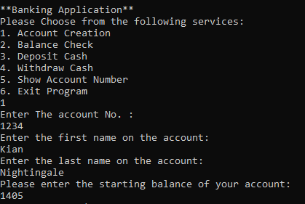
Test to see when the user picks choice 2 it enters the if statement in the correct place. | Will enter the program at the balance check method. | 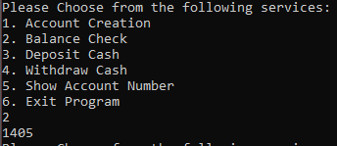
Test to see when the user picks choice 3 it enters the if statement in the correct place. | Will enter the program at the deposit cash method. | 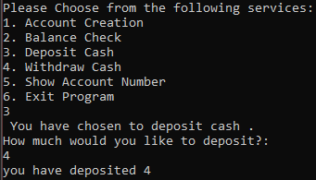
Test to see when the user picks choice 4 it enters the if statement in the correct place. | Will enter the program at the withdraw method. | 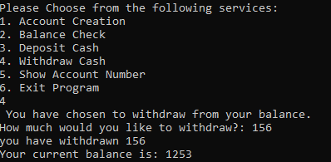
Test to see when the user picks choice 5 it enters the if statement in the correct place. | Will enter the program at the show account number method and print user’s account number. | 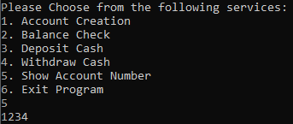
Test to see when the user picks choice 6 it thanks the user for using the program and closes. | Will exit program after thanking user. | 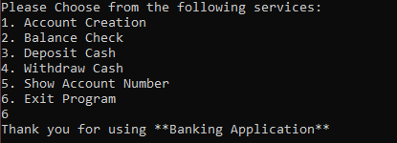
Test to determine if the user does not create an account how the program handles choice 2. | The program should prompt the user that no account has been created and ask the user to create one. | 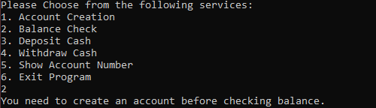
Test to determine if the user does not create an account how the program handles choice 3. | The program should prompt the user that no account has been created and ask the user to create one. | 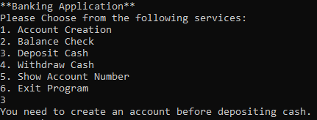
Test to determine if the user does not create an account how the program handles choice 4. | The program should prompt the user that no account has been created and ask the user to create one. | 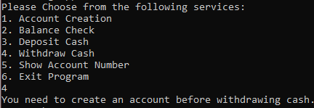
Test to determine if the user does not create an account how the program handles choice 5. | The program should prompt the user that no account has been created and ask the user to create one. | 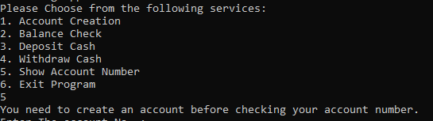

Video Demonstration
OOP.mp4

C++ Essential Certificate


