PROBLEM SOLVING AND DECISION MAKING

BMSW4004

Student: Edit Tingyela
Student ID: 1917242
Tutor`s Name: Syed Jaffery

Table of Content
Introduction: 4
Define a complex problem in the workplace: 4
Scope: 5
Impact: 5
Analyse information: 5
Pestle Analyses: 7
Propose a range of alternative solutions to the problem: 7
Use a decision-making technique to evaluate a range of solutions to identify the most appropriate option: 8
Develop a plan for implementing the solution 10
Communicate the plan to stakeholders 12
Asses appropriate monitoring and review techniques to ensure successful implementation of the solution 12
Conclusion 14
References 15

Introduction:

Problem-solving end decision-making are important elements of everyday life. More challenges have to resolve in the workplace. Organisations need to solve the problems very quickly and creatively in effective ways. To achieve this, regarding the complex problems, need to use different problem-solving end decision-making process, models, and techniques. The report aims to discuss the communication conflict in the workplace of The Massage Company a franchise company within the Health Leisure and Wellness of the UK. First of all, it classifies a multifaceted problem and shows the impact of the company. After all, analyse information, uses Pestle Analyses. The report shows throwe different decision-making technique how can-do organisation to choose the appropriate one. Introduce three different brainstorming techniques and shows the Decision Matrix. The report introduces different tools to implement the solutions. Finally, it will show the results in The Massage Company.

Define a complex problem in the workplace:

Defining the problem is the first and very crucial step for the successful implementation of the solution. There are some strategies to help identify the cause of a problem such as an Interrelationship Diagram, Fishbone Diagram, 5 WHY`s Template, Root Cause Analysis Tree Diagram. In the workplace of The Massage Company, a human service provider in the UK in this case the management used the Root Cause Analysis Tree Diagram.

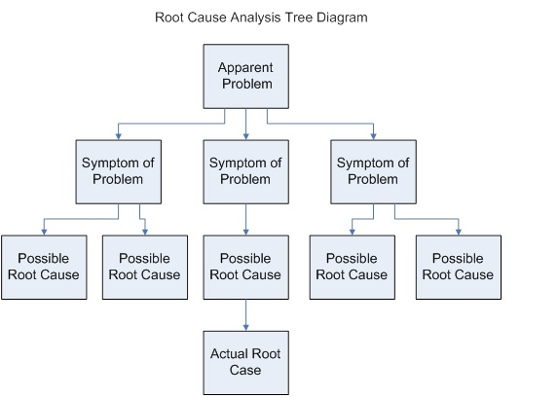
Lawles, K. 2013.
Figure 1: Root Cause Analysis Tree Diagram

The most critical cause has to remove to prevent the problem from recurring. (Eby, 2017). The diagram showed that the actual root cause was the communication problem between the management and the therapists. It is the most important complex problem for the organisation. The feedback from the customers was not allowed to flow into the managers. There was not any procedure for it. The therapists were frustrated because managers do not pay attention to employee feedback and needs. The therapist s stood between customers and management in a complaint from the two sides. There was a lack of staff support and poor management.

Scope:

The problem increases with the fewer number of massage upgrades because it is the effect on the therapist salary. Therapists fighting for costumers among co-workers to raises that kind of the number of massages where more upgrade was bought. Discrimination within the costumers growths the problems between the staff. The problem also increases with the therapists have no minimum decision-making power. The lack of recognition from the costumers and also from the managers led to no make employees feel inclouded empowered and supported. Strong organizational culture can help for that kind of feeling. The Massage Company is a quiet new company that has Clan Culture, The characteristics are a cooperative work environment where the individuals are respected, feedback from the employees very important, and prioritize for the communication. (K. Heinz, 2020) If the company grows it is difficult to uphold this type of organisational culture. In the last year started to grow up the business, opened three new centers.

Impact:

The management did not listen to the feedback of customers by the therapists it impacted the behavior of employees. Unhappy relationships between managers and therapists negatively affect the organisation`s working conditions. Disappointed and demotivated stressed therapists can not give high quality, professional therapy for the clients. The therapists burned out, some of them left the company. According to Maslach (2001), inefficacy is one of the three dimensions of burnout. It led the therapist to be uninterested in the needs of the client. The impact of dissatisfied clients was the reason for the revenue decline in the company. The organisation of growth and progress were suffered. Another of the area of stakeholders damaged as well. Suppliers turnover decreased regarded to use fewer aromatherapy products for the upgrades.

Analyse information:

The entire method, how made the organisation an effective problem-solving strategy depends on the right information about the conflict. The management gathered data and analysed information. Pestel Analysis was made. After that based on the information examined alternatives potential decisions were developed and selected the best alternative to control the situation. Assessed different techniques to evaluate and chose the most applicable decision-making process to overcome the situation. During the analysis, the management examined the management rules. There are three different categories such as interpersonal, informational, decisional on the Mintzberg Ten Manager Rules.

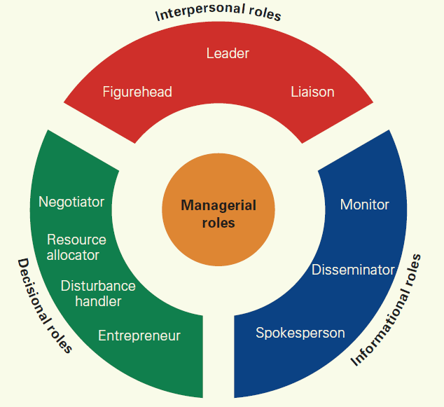
wisdomjobs.com, 2020.
Figure 2: Mintzberg Ten Manager Rules

As shown in the image (wisdomjobs.com,2020) Mintzberg Identified the managerial work, there are some areas where the rules were broken in the TMC. The main area is the informational roles. The managers should monitor the teams, their productivity, and also well-being.

Pestle Analyses:

Political:
Brexit has a high impact on the organisation. Legislation and taxation may change. Also, family and personal circumstances can be affected. ( GOV.UK 2020).
Economical:
Brexit effect on the economical environment. According to McFarlin (2019). Globalization can also lead to reduced earning potential for employees Third world companies can offer their services at lower prices. Covid has a big impact on the economy of companies.
Socio-cultural:
Employees from attitudes of different age groups can be affected for the company work environment.
Technological:
The new technology needs training support and the lack of manager support can bad effect on using the new tools.
Legal:
Health and safety legislation during the covid is effect to workplace cleaning and sanitising rules. The companies must follow the Government guidelines during the Covid situation.

Propose a range of alternative solutions to the problem:

Before making an effective decision, the management must investigate the challenges and impact of the communication problem in TMC. During the examination came up with several alternative solutions.
Positive psychology in the workplace can help the employees to feel important, improve psychological wellbeing and, the development of employee strengths. Reducing psychological risks and brings healing energy to the organisation's environment. Above all increases organisational performance. ( Souders, 2020).
The Kaizen Philosophy fights against burnout. The employees have thousand of small ideas about the work which bring more control for them. Their workload was cut down to size. Burnout has the polar opposite site which is engagement. Engaged employees are more effective and energetic. (Gerencer, 2020).

Use a decision-making technique to evaluate a range of solutions to identify the most appropriate option:

A range of decision-making techniques was identified by the management and the appropriate technique was used to solve the problem. There are some types of decision-making processes, Rational, Bounded Rationality Model, Intuitive Decision-Making Model, and Creative Decision-Making Model. The creative method holistically highlights innovation, and it has less regulation. Three factors show the level of creativity in the decision-making process.

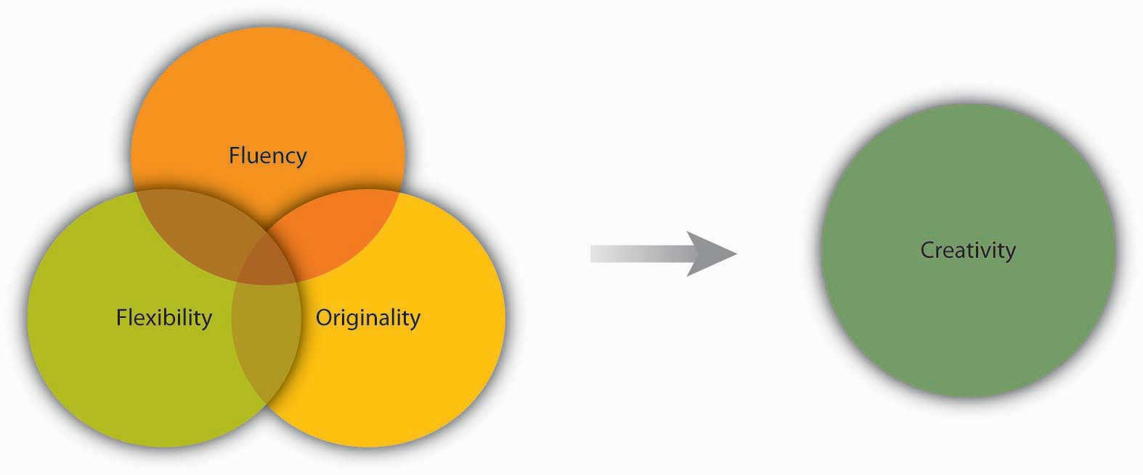

Granite State College, 2015.
Figure 3: Dimension of creativity

Fluency: generated number of ideas
Flexibility: how different the ideas are from one another
Originality: idea’s uniqueness. ( Granite State College, 2015).

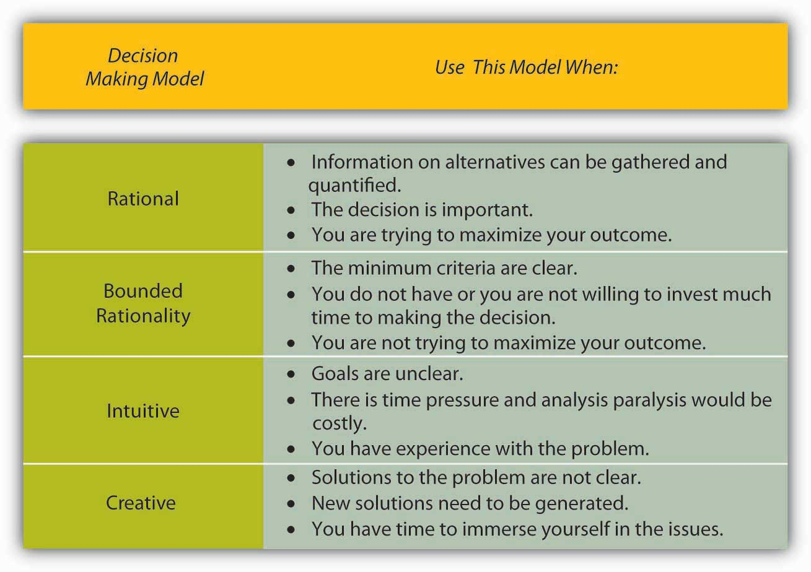
Granite State College, 2015.
Figure 4: Which decision-making process should I use?

The management decided to use the Creative Decision-Making model to be more effective.
There are some technics to generate ideas:

Brainstorming: It is the group technics where should follow the guidelines. No criticism of ideas, any suggestion can not be too wild. A high quantity of ideas leads to the best solution. More people have a better decision outcome, because of the different background. The group of leader accepts the appropriate idea. ( Granite State College, 2015).

Delphi Technique: This technique uses multiple rounds of the questioner that responded by the experts. Aggregate the answers and share them with the group. When the team reaches a consensus, the final result will show, what the group thinks as a whole. (Twin, 2020).

Nominal Group Technique: The facilitator prepares the questionnaire related to the conflict for the small group to gather information. The participants should write ideas silently and independently. Every idea will record and discuss. After that different voting techniques can use such as rating and ranking. The final vote defines the outcome, where the individual and group decisions on the ideas are mixed. (NIATX, 2020).

The Delphi method and the Nominal group technique have some limitations. In the Delphi method, participants never meet and the group leader chooses the final solution by conducting questionnaires. The disadvantages of the Nominal group technique are, it is a long procedure from the beginning to the final and, only one problem can be addressed at a time.

Brainstorming is the most common technique to make alternative solutions, there are a lot of experiences with it in the field. Organisations can use it for all types of problems. It is the best technique to solve the communication problem in The Massage Company. The advantages of using this technique are discussed below.

The Brainstorming session as opposed to the traditional method of group debate generates the group members to come up with a different, new even creasy range of ideas. This leads to more effective and innovative solutions. The Brainstorm can inspire fresh thinking with the help of this possible to avoid repeating the same mistakes. In the well-run brainstorming session, the members are inspired to work well together, communicate freely, and be opened. The members are encouraged to suspend judgment by the method. The technique allows the brainstorming session`s members to sort through the new ideas and prioritise them. (smartsheet, 2020).

In this case, The Massage Company`s facilitator prepared the brainstorming session, from all centers, and all different team representatives were delegated.

Develop a plan for implementing the solution

The process of conducting and implementing the solution starts to make a welcoming, friendly environment for the session. The ideal number of the group is twelve. In this case, the management in the TMC decided to stand up for more than one group regarding the number of group members. In every group, the members come from different roles and experience. Usually, the facilitator defines the objectives and lays down the ground rules. Guides the session and other people should take notes. The proper music can help to loosen up the group. The central component in the brainstorming session is the generate ideas. There are some different successful approaches: Six Thinking Hats, Trigger Statement, Five Whys, POV Reassignment,
S.C.A.M.P.E.R., Starbursting, At The Massage Company, in this case, were three different groups, and the facilitators of groups picked up different approaches to generate ideas.

Starbursting:

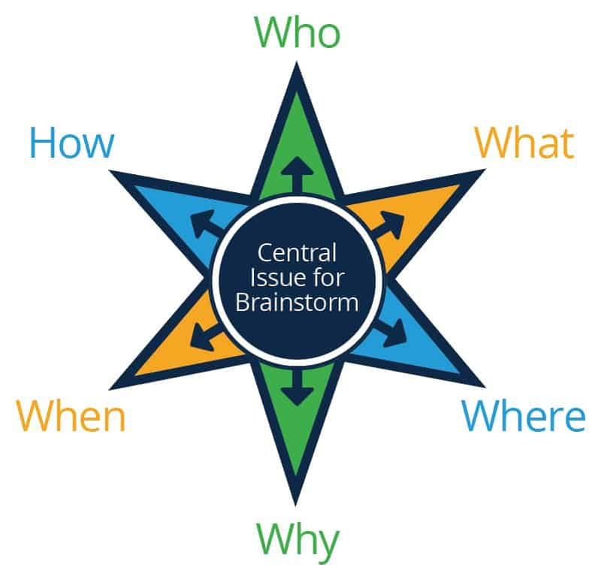
smartsheet, 2020.
Figure 5: starbursting
This approach is within the Discrete Factor Analysis, which means focus on the specific aspect of the issue. The central issue is on the mid of the star and the question words are each point of the star. Use the questions to generate discussion.

Six Thinking Huts:

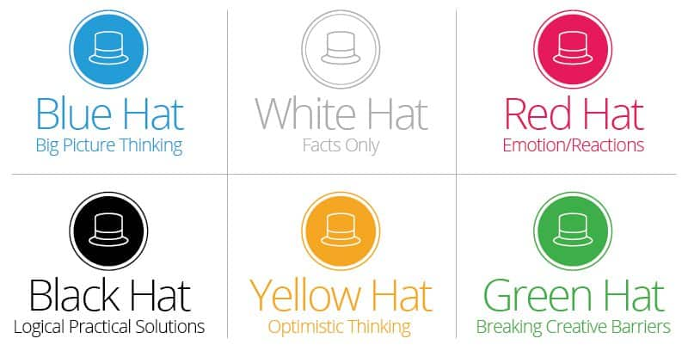
smartsheet, 2020.
Figure 6: Six Thinking Hats

This approach is within the POV (Point of View), which means, changing the perspective of thinking ways. The members put on a specific hut and from this perspective approach will analyse the problem. It was done then switch the hut and see the problem from a different angle.

In this case, the third facilitator agrees with the management to chose for the third group Brainstorming in writing.
With the help of the Mind Map easily can see the connection between different ideas. Firstly should write down the objective of the Brainstorm, and after that write down related issues, concepts.
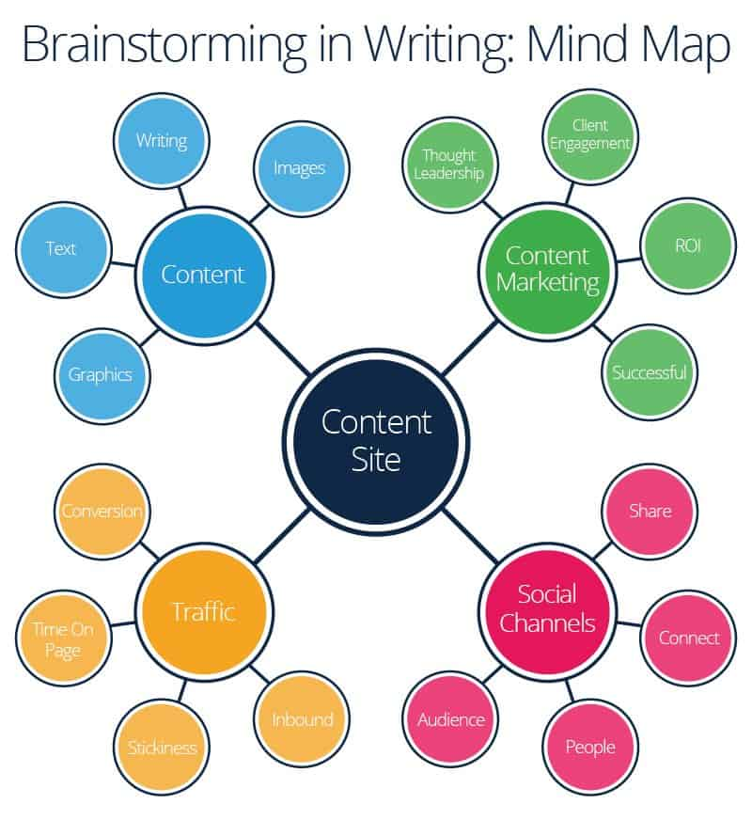
smartsheet, 2020.
Figure 7: Brainstorming in Writing: Mind Map
Delivery to the results the next step is to evaluate and prioritise the new ideas. In this case, the teams joined each other and worked together. Prepared Pros and Cons lists and Decision Matrix.

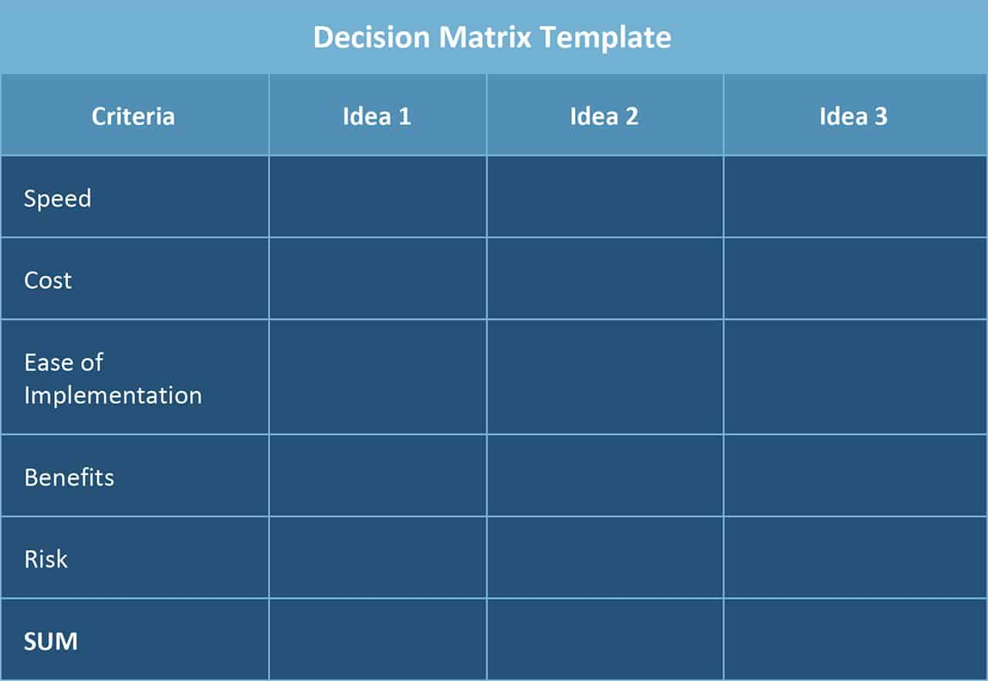

smartsheet, 2020.
Figure 7: Decision Matrix

The ideas were ranked against the matrix and voted for the best one by the members as
an anonymous.

Communicate the plan to stakeholders

In this case, the facilitator documented all the ideas and distributed them to all participants. The summary of the project includes decisions and actions as well. The questioner was sent after the session to the employees to get feedback. The management involving the stakeholders and scheduled screen to screen meeting to communicate with them, increase the effectiveness of the company.

Asses appropriate monitoring and review techniques to ensure successful implementation of the solution

The communication problem is solved by the creative problem-solving method use the Brainstorming at The Massage Company. The Brainstorming technique allows the workers to cooperate and provide their feedback. There are several tools to monitor and review the technique such as the GANTT chart, Kotter`s mode.
GANTT Chart is a plan implementation timeline. Help to monitor progress.
( ProductPlan, 2020).

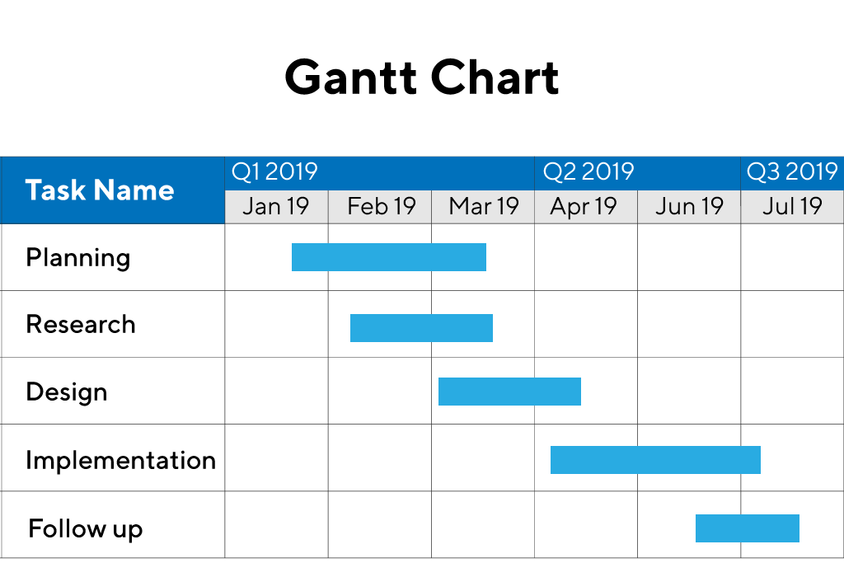
ProductPlan, 2020.
Figure 8: Gantt Chart

Kotter`s model is a step-by-step model, easy to implement. In this case, it is very useful because the main emphasis is on the acceptability of employees. Involvement of the employees indispensable. (MSG, 2020).

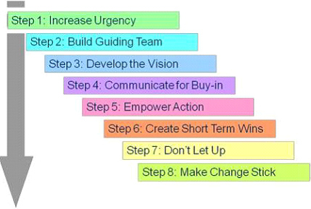
MSG, 2020.
Figure 9: Kotter`s Model

In The Massage Company, the therapists started to feel included themselves, which was the impact of the working environment and the quality of the work as well. The customers step by step started to be satisfied and the satisfaction feedback has earned the company a good reputation on social media. The company started to progress.

Conclusion

The report has already shown the proper problem-solving and decision-making process important for the organisation to successfully overcome the challenges. The report introduced different decision-making processes and tools, gathering data, and analysed information. We already know how the Pestel Analysis works. After analysing the report, we already know how important can be communicated with the stakeholders in the organisation. Lack of communication leads the organisation to problems at different levels. By implementing the Creative Decision-Making process and Brainstorming technique in The Massage Company the communication problem successfully was resolved.

References

Eby, K. (2017) Learn creative Problem Solving Techniques to Stimulate Innovation in Your Organisation [Online] Available at:
https://www.smartsheet.com/problem-solving-techniques
(Accessed:16 December).

Smartsheet(2020)Discover the Best Brainstorming Approaches and Techniques to Motivate Your Team [Online] Available at:
https://www.smartsheet.com/brainstorming-techniques-activities-and-exercises
(Accessed:16 December).

wisdomjobs.com (2020) Managerial Roles in Management [Online] Available at: https://www.wisdomjobs.com/e-university/principles-of-management-tutorial-293/managerial-roles-9220.html
(Accessed:16 December)

Heinz, K. (2020) The 4 Types of Organizational Culture You Should Know [Online] Available at:
https://builtin.com/company-culture/types-of-organizational-culture
(Accessed:16 December).

Maslach, K., Schaufeli, B. W. and Leiter, P. M. (2001) Job Burnout [Online] Available at:
https://www.annualreviews.org/doi/10.1146/annurev.psych.52.1.397
(Accessed:16 December).

Gerencer, T. (2020) Burnout: Prevention, Treatment, and Advice for Employees and Employers [Online] Available at:
https://zety.com/blog/burnout#what-is
(Accessed:17 December).

Lawles, K. (2013) Root Cause Analyses Tree Diagramm [online image] Available at:
https://commons.wikimedia.org/wiki/File:Root_Cause_Analysis_Tree_Diagram.jpg
(Accessed:17 December).

Sauders, B. (2020) What is Organizational Positive Psychology? [online image] Available at:
https://positivepsychology.com/positive-organizational-psychology/
(Accessed:17 December).

Twin, A. (2020) What is the Delphy Method? [online image] Available at:
https://www.investopedia.com/terms/d/delphi-method.asp
(Accessed:17 December).

NIATX (2020) Nominal Group Technique [online image] Available at:
https://chess.wisc.edu/niatx/content/contentpage.aspx?NID=147
(Accessed:18 December).
ProductPlan (2020) What is a Gantt Chart? [Online] Available at:
https://www.productplan.com/glossary/gantt-chart/
(Accessed:18 December).

ProductPlan (2020) Gantt Chart [online image] Available at:
https://www.productplan.com/glossary/gantt-chart/
(Accessed:18 December).

MSG (2020) Kotter`s 8 Change Model of Change [Online] Available at:
https://www.managementstudyguide.com/kotters-8-step-model-of-change.htm
(Accessed:18 December).

MSG (2020) Kotter`s 8 Change Model of Change [online image] Available at:
https://www.managementstudyguide.com/kotters-8-step-model-of-change.htm
(Accessed:18 December).

Granite State College (2015) Understanding Decision Making [Online] Available at:
https://granite.pressbooks.pub/principlesmanagement/chapter/11-3-understanding-decision-making/ (Accessed:18 December).

Granite State College (2015) Which Decision Making should I Use? [online image] Available at:
https://granite.pressbooks.pub/principlesmanagement/chapter/11-3-understanding-decision-making/
(Accessed:18 December).

Granite State College (2015) Decisions of Creativity [online image] Available at:
https://granite.pressbooks.pub/principlesmanagement/chapter/11-3-understanding-decision-making/
(Accessed:18 December).

GOV.UK (2020) Brexit Transition: Time is Running Out [Online] Available at:
https://www.gov.uk/transition
(Accessed: 07 December).

McFarli, K. (2019) The Effects of Globalisation in The Workplace [Online] Available at:
https://smallbusiness.chron.com/effects-globalization-workplace-10738.html
(Accessed: 07 December).

wisdomjobs.com (2020) Mintzberg Ten Manager Roles [online image] Available at: https://www.wisdomjobs.com/e-university/principles-of-management-tutorial-293/managerial-roles-9220.html
(Accessed:16 December)

Smartsheet(2020)Starbursting [online image] Available at:
https://www.smartsheet.com/brainstorming-techniques-activities-and-exercises
(Accessed:16 December).

Smartsheet(2020)Six Thinking Hats [online image] Available at:
https://www.smartsheet.com/brainstorming-techniques-activities-and-exercises
(Accessed:16 December).

Smartsheet(2020)Brainstorming in Writing: Mind Map [online image] Available at:
https://www.smartsheet.com/brainstorming-techniques-activities-and-exercises
(Accessed:16 December).

Smartsheet(2020)Decision Matrix Template [online image] Available at:
https://www.smartsheet.com/brainstorming-techniques-activities-and-exercises
(Accessed:16 December).

